**Results**

**Experiment 1**

We wanted to determine whether inducing episodic memory or the first outcome following a risky choice altered preferences toward risk. To do so, we performed a two-way independent groups ANOVA on the total amount of risky choices for each participant. There was a significant main effect of memory condition on risk-taking (p = 0.0149, R2 = 0.127), with risk-taking in the episodic condition (mean = 0.485, sd =0.179) being higher than in the general condition (mean = 0.311, sd = 0.198). There was no significant main effect of first outcomes on risk-taking (p-value = 0.566, R2 = 0.0047) and no significant interaction between memory condition and first outcomes on risk-taking (p-value = 0.784, R2 = 0.007).

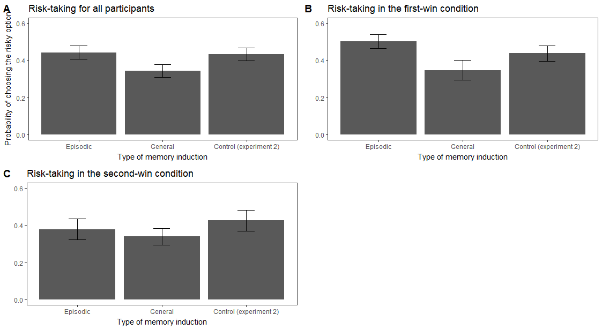

Figure 2: Proportion of risky choices for the three induction conditions (Episodic, General impressions and Control) from trial 40 to 100. Figure 2A represents the data aggregated across the first-win and second-win conditions. Figures 2B and 2C show the proportion of risky choices in the first-win and second-win conditions, respectively.

However, computing statistics over the total amount of risky choices does not inform us about how people learn which option they prefer. Since the gambling task is learned from experience, we suspected memory might affect how people remember previous outcomes and learn from them. To answer this question, we performed a growth-curve model with random slopes on each of the participants’ choices and compared the slopes between the two groups. Participants in the episodic condition became significantly more risk-taking over time than participants from the general condition (p-value = 0.0049). More specifically, risk-taking in the episodic specificity condition tended to increase over time while it tended to decrease in the general condition (see figure 2B). Thus, the two groups were different in how they learned which option to prefer over time.

We replicated the same growth-curve analysis with the effect of the first-outcomes over time instead of memory condition. We found no significant effect of the first-outcomes on the slopes of risk-taking over time (p-value = 0.413). Since the first outcomes did not seem to influence risk preferences, we dropped this part of the analysis in experiment 2 (see below).

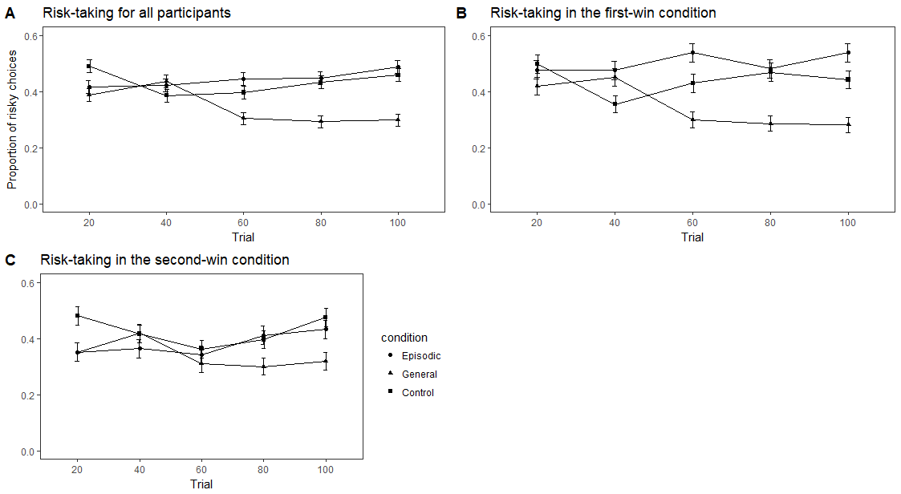

Figure 3: Changes in risky preferences over time in the three conditions (Episodic, General impressions and Control). Figure 3A represents the data aggregated across the first-win and second-win conditions. Figures 3B and 3C show the proportion of risky choices in the first-win and second-win conditions, respectively.

**Experiment 2**

**Episodic and Control**

The general impressions interview is meant to serve as a control condition. However, we wanted to investigate whether inducing episodic specificity increased risk-taking relative to people’s baseline risk preferences. To do so, we performed a t-test between the total amount of risky choices in the episodic (mean = 0.485, sd = 0.179) and control (mean = 0.443, sd = 0.216) conditions. We failed to find a significant difference between the two groups (p-value = , R2 = ). There also was not any significant differences in the slopes of the growth-curve models (p-value = ).

**General and Control**

To check whether risk-taking in the general and control conditions were different, we performed a t-test on the total amount of risk-taking for each participant between the general (mean = 0.311, sd = 0.198) and control (mean = 0.443, sd = 0.216) groups. We failed to find a significant difference between the two groups (p-value = , R2 = ). There also was not any significant differences in the slopes of the growth-curve models (p-value = ).