Engaging episodic memory processes influence risky decision-making

David St-Amand, Signy Sheldon, & A. Ross Otto

Department of Psychology

McGill University

Address all correspondence to:

A. Ross Otto

Department of Psychology, McGill University

2001 McGill College, 7th floor

Montreal QC H3A 1G1

email: ross.otto@mcgill.ca

**Introduction**

We do not always know what will happen after making a choice. Many decisions in our daily lives – whether to go at that new fancy restaurant, to ask someone on a date or to invest in the market – involve choosing between options that differ in risk, in the likelihood that the desired outcome will be reached. This likelihood is most often not known, and we must draw on our memory of similar situations in order to make a decision (Hertwig & Erev, 2009). Episodic memory (Tulving, 1983, 2002) encodes such specific information and has been shown to play an adaptive role in decision-making , FeldmanHall, Hunter, Phelps & Davachi, Consistent with these findings, a selective deficit in episodic memory (amnesia) prevents episodic memory from reducing temporal discounting – the bias we have towards immediate rewards relative to future ones (Palombo, Keane & Verfaellie, 2014). Patients with lesions in the medial temporal lobes are also impaired in making adaptive value-based decisions in the Iowa Gambling Task (Gutbrod et al., 2006; Gupta et al., 2009). These findings highlight how episodic memory deficits can affect choice, but there is also evidence that episodic memory processes can alter risky decision-making.

Underlining the consequences of biased memory representations, in risky decision-making from experience, Madan and colleagues (2013) posited an extreme-outcome rule where extreme outcomes in risky choice are overweighted in memory (Talarico & Rubin, 2003) and consequently are given more weight when choosing from experience. In a decision-from-experience task where the expected values between the certain and risky action were equal, the extreme outcome was most frequently reported to be the first “to come to mind." This memory salience for the extreme outcome was also associated with more risk-taking in decisions from experience (Madan et al., 2013). Similar to this idea, studies using similar gambling tasks reveal that initial outcomes carry a disproportionately large influence on further decisions (Shteingart, Neiman & Loewenstein, 2013), which might possibly be due to our better memory for events that occurred at the beginning of a sequence (Murdock, 1960; Tan & Ward, 2000).

Intriguingly, a recent body of memory research suggests that an episodic specificity induction episodic technique that promotes episodic memory processes has downstream consequences on subsequent tasks ranging from autobiographical remembering (Madore, Gaesser & Schacter, 2014) to divergent thinking (Madore, Addis & Schacter, 2015) and solving of hypothetical social problems (Madore and Schacter, 2014). This technique compares an episodic specificity condition where participants are trained to recall specific details to a control condition where participants are trained to recall general details. Relative to the control induction condition, the episodic specificity induction technique has been shown to increase the amount of recalled and imagined specific details of viewed pictures, but not the amount of general details recalled and imagined (Madore et al., 2014). To this end, the episodic specificity induction procedure developed by these researchers allows direct experimental manipulation of an individual’s tendency to focus on specific details, taken in comparison to a control induction procedure.

Here we leverage the episodic specificity induction procedure to shed light upon the extreme-outcome effects observed by Madan, Ludvig and Spetch. (2013), and how enhancing episodic processes alters the way we learn to make risky decisions from experience. (Schacter, Welker, Schacter, & Madore, 2016). We test the specific hypothesis that episodic memory processes supported by the hippocampus will spread the positive value of rewarded decisions across associated instances during decision-making learning (Wimmer & Shohamy, 2012), acting as a potential cause of the extreme-outcome effect. To investigate this, we designed an experiment in which we combined a risky-decision making task that measures choices made from experience (following the procedure of Madan et al.,, 2013; Ludvig, Madan & Spetch, 2014) with the above-noted episodic specificity induction procedure. To this end, we tested that if episodic specificity induction engages episodic memory processes to the extent that it could potentiate the observed overweighting of extreme outcomes, this would increase the apparent preference for the risky (as opposed to sure-thing) action when compared to a general induction procedure. To further examine the effects of the episodic specificity induction upon learning, we fit a simple RL model that quantifies the extent to which an individual participant weighs positive versus negative prediction errors (PEs) in learning the values of the two actions.

**Methods**

In Experiment 1, we used a design in which half of the tested participants were first trained to recollect specific details from a viewed video (episodic specificity induction) or were first trained to describe gist and general information about a viewed video (Jing, Madore, & Schacter, 2016; Madore, Szpunar, Addis, & Schacter, 2016; Madore et al., 2015; Madore & Schacter, 2014) before completing a risky decision-making test. Experiment 2 served as a control condition in which a new set of participants performed the a risky decision-making without any prior induction task.

*Experiment 1*

Experiment 1 was conducted as a within-subject design, with every participant undergoing both the control and episodic specificity induction procedures. Participants performed the episodic or control interview and then performed the gambling task. The experimental procedure can be seen in figure 1A. Due to apparent carryover effects between across the two sessions, below we report only the results from the first session of the experiment, thus our study is effectively a between-subjects design.



Figure 1: Experimental procedure in experiment 1 (A) and the stimuli shown to participants during the gambling task (B).

*Participants*

We collected data from 47 participants who were recruited through McGill’s classified ads system. This study was approved by McGill’s Research Ethics Office (REB). We excluded participants who had insufficient levels of early exploration (i.e. 10% of risky choices or less during the first 30 trials) or outliers who were at least 1 standard deviations away from any other participant in their respective condition. In experiment 1, we excluded 4 participants with insufficient levels of early exploration and 1 outlier from the control condition. Of the remaining 41 participants, 21 participants were randomly assigned to the Episodic condition, and 20 participants were randomly assigned to the Control condition. 22 participants were randomly assigned to the first-win condition, and 19 participants to the second-win condition. Participants were compensated $10 CAD for one hour, and received an average of $1.25 CAD, (*SD*= 0.069) for each of the two sessions. We administered the Positive and Negative Affect Schedule (PANAS; Watson, Clark & Tellegen, 1988) both at the beginning of the experimental session and at the end, and the Offer Self-Image Questionnaire (OSIQ; Patton & Noller, 1991) at the end of the experimental session.

*Episodic specificity induction*

The experimental procedure began with an episodic specificity or control (“general”) induction, following the procedure outlined in Madore et al. (2014). The episodic specificity induction is an experimental manipulation based on an established eyewitness testimony interview technique known to enhance the number of details people can recall from witnessed events (Memon, Meissner, & Fraser, 2010). In short, both the specificity and control induction conditions begin with the participants watching a 4-minutes long video of a video involving actions of people in everyday settings (here we used clips of “Mr. Bean” ). They were told to pay close attention to the video since questions would be asked afterward. At the end of the video, participants were interviewed about the views. In the episodic specificity condition, (Jing et al., 2016; Madore et al., 2016), participants were first asked to get a strong mental image of the video in mind and then describe as many specific details from that video. They were first asked to recall details about the surroundings, the physical appearances of the participants in the scene and the actions in the video in chronological in as much detail as they could remember. In the control (i.e., “General Impressions”) condition, participants were instructed to describe the video using adjectives to describe the setting/people/actions or their general impressions of the video and not descrie specific details. They were asked general questions about the video (e.g. What adjectives would you use to describe the actions in the video?). Both conditions lasted approximately 25 minutes.

*Gambling task*

Immediately after the induction procedure, participants performed the gain-version of the gambling task used by Madan et al. (2014). In general, over 100 trials, participants were presented with two doors that both yielded real-monetary rewards. One of the doors was considered “safe” and always yielded a reward of 1.25 cents, while the other door was designated as the “risky” door and had a 50% chance to give a higher reward in the context of the experiment (2.5 cents) and a 50% chance to yield no reward (see figure 1B). After choosing a door, participants were shown the reward they received from that door on that particular trial. Participants were not told beforehand the possible outcomes associated with each door. Put another way, the participants had to learn the outcomes associated with each door as they made decisions during the task.

Across participants we manipulated the outcome information learned from first four trials of the experiment were good or bad outcomes, such that half of the participants where given a “first win” trial order (lossand the other half were given a first-loss trial order (is “first outcome”

*Memory Recall*

Immediately after the gambling task, particiapnts were asked to report the first outcome that came to their mind when thinking about the risky door, following the procedure from Madan et al. (2014). Participants were shown each of the two doors, in random order, and were asked to indicate the first outcome that came to mind when seeing each door. This manipulation allowed us to examine the influence participants’ explicit memory of the outcomes they received in the task on behavior. After reporting these outcomes, participants were instructed to draw the two doors to the best they could remember with a paper and pencil and label the colors.

*Data Analysis*

To compare risk preferences across induction groups (episodic versus control), we computed the mean level of risk excluding the first 24 trials (Madan et al., 2013; Ludvig et al., 2014). Excluding early trials allowed us to compare decisions that were made after having sufficient prior experience with the task. Risk preferences across groups were compared by conducting ANOVAs upon proportions of risky choices. Learning effects were tested using mixed-effects logistic regressions with random intercepts and slopes for each participant. This was done using the lme4 package (Pinheiro & Bates, 2000) for the R programming language.

*Reinforcement Learning (RL) Model*

Following basic formulations of RL models (Gershman, 2015; Sutton & Barto, 1998), this model operates by developing and updating expected reward values for each option, *aj,* on each trial, *t.* these *Q-values* aredenoted here and elsewhere as *Q(aj, t)*. The Q-values for each option (in the present task there are two options) are used to determine the model’s probability for selecting each option via a softmax decision rule:

(1)

Here  is an exploitation parameter that determines the degree to which the option with the highest Q-value is chosen. As  approaches infinity the highest valued option is chosen more often, and as  approaches 0 all options are chosen equally often.

On each trial the option that is chosen ($a_{i}$) is updated for the next trial (*t*+1) based on a simple incremental updating rule:

$δ_{t}= r\left(t\right)- Q\left(a_{i}, t\right)$ (2)

$Q\left(a_{i}, t+1\right)= \left\{\begin{aligned}Q\left(a_{i}, t\right)+ α_{pos}{∙δ}_{t} , δ_{t }> 0 \\ Q\left(a_{i}, t\right)+ α_{neg}{∙δ}_{t} , δ_{t }< 0 \end{aligned}\right.$ (3)

In Equation 2 above $α_{pos}$  and $α_{neg}$ are learning rate parameters for positive and negative prediction errors (PE), and *r*(*t*) is the reward received from the chosen option on trial *t*. As these learning rate parameters approach 1, greater weight is given to the most recent rewards in updating Q-values indicative of more active updating of Q-values on each trial, and as the learning rate parameters approach 0, recent rewards are given less weight.

Our model fitting procedure used the Nelder-Mead optimization algorithm to find parameter values that maximized the likelihood of participants’ choices given their previous rewards and choices. To avoid estimates at parameter range boundaries, we imposed a ‘pseudo-prior’ over parameters, which for the learning rates, took the form of a beta distribution with *a* = *b* = 2, and for the inverse temperature parameter ( )*,*a gamma distribution with *k*=1 and *θ*=3.

*Experiment 2*

Experiment 2 was comprised of a single “control” condition to assess people’s baseline levels of risk-taking. In this condition, 24 participants completed the gambling task without any prior induction. One participant was excluded from the analysis for having insufficient levels of exploration and not choosing the risk option at all until trial. Of the remaining 23 participants, 12 were randomly assigned to the first-win condition and 11 were assigned to the second-win condition. Participants were paid $8 CAD for approximately 20 minutes of their time, plus a bonus averaging $1.242 CAD (*SD* = 0.076). The gambling task and memory recall procedure was identical to that of Experiment 1 except that they were performed in the absence of an episodic or control impressions induction. The same data analysis and modeling procedure from Experiment 2 was used.

**Results**

*Experiment 1*

*Gambling*

We first sought to determine if apparent risk preferences differed across induction groups and the first risky outcome. Upon examining the mean level of risky choices for each participant after trial 24 (Madan et al., 2013; Madan et al., 2014), we found that risk-taking in the episodic induction group (*M* = 0.479, *SD*=0.173) was significantly higher than in the control induction group (M = 0.34, SD = 0.122; F(1, 39) = 8.8, p = 0.0051; see figure 2A).

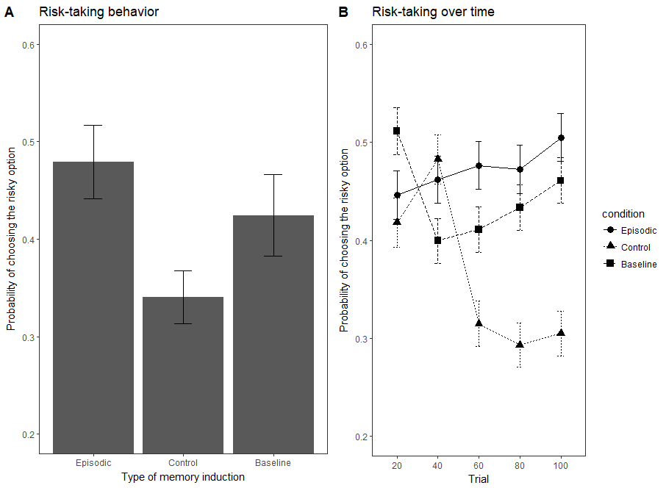

Figure 2: Panel A depicts the proportion of risky choices for the three induction conditions (Episodic, Control and Baseline) from trial 40 to 100. Panel B depicts the time course of risky preferences over 20-trial blocks in the three conditions: Episodic, Control and Baseline (Experiment 2)

Examining choice behavior across blocks, we found that risk-taking developed differently over time in the episodic specificity and control induction groups (Figure 2B). A mixed-effects logistics regression revealed that participants in the control induction group became significantly more risk-averse over time than participants in the episodic induction grou (group X trial interaction; *β* = 1.25, SE = 0.349, *p*= 0.000346). Thus, the two groups exhibited apparent differences in their time courses of apparent risk preference. Put another way, risk-taking tended to decrease over time in the control condition (*β* = -1, SE = 0.253, p = 0.0000767) but did not significantly change over time in the episodic condition (*β =* 0.222, SE = 0.241, p = 0.36).

*Memory for Outcomes*

When asked which outcome first comes to their mind, participants in the episodic induction group were significantly more likely to report the positive outcome, χ2(1, N = 21) = 3.86, p= 0.0495 (see figure 4). This was not the case for the control induction group χ2 (1, N = 20) = 0.2, p= 0.655. However, the episodic condition did not significantly report the positive outcome more than the control condition χ2(1, N = 21) = 1.96, p = 0.16. The first outcome that came to mind was not significantly correlated with risky behavior across the episodic and control induction condition groups F(1,39) = 0.637, p = 0.43.

*Experiment 2*

We analyzed the baseline condition the same way as in the episodic and control induction groups. Upon examining the mean level of risky choices for each participant after trial 40 (Figure 2A), we found that risk-taking in the episodic induction group (*M* = 0.479, *SD*=0.173) was not significantly different than in the baseline group (M = 0.424, SD = 0.199; F(1,42) = 0.94, p = 0.337) and that risk-taking in the baseline group was significantly higher than in the control induction group (M = 0.34, SD = 0.122; F(1, 41) = 2.7, p = 0.108) A mixed-effects logistic regression revealed that learning of risk preferences over time (condition X trial interaction) in the episodic and baseline condition were not significantly different from each other (Figure 2B*; β* = 0.41, SE = 0.531, p = 0.42). This interaction was not significant either between the control and baseline conditions (*β* = 0.86, SE = 0.53, p = 0.11).

Participants in the baseline group were not significantly more likely to report the positive outcome as the first one to come to mind χ2(1, N = 23) = 2.13, p= 0.144 (see Figure 3A). Within the baseline condition, participants with positive recall were more likely to choose the risky option after trial 24 (F(1,21) = 9.33, p = 0.006; see figure 3B).

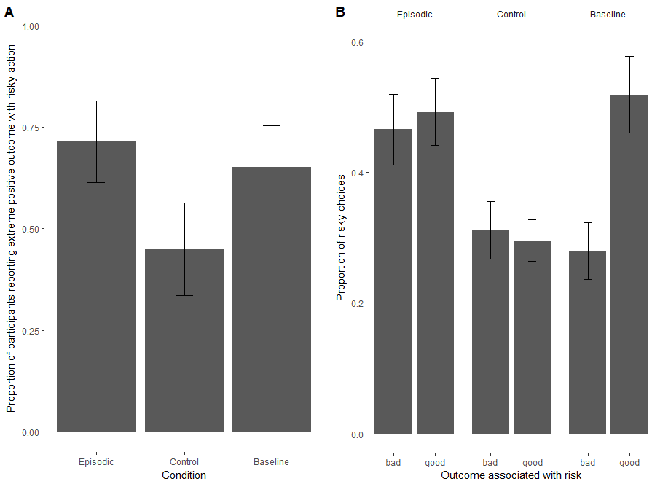

Figure 3: Panel A depicts the proportion of participants reporting that the extreme positive outcome in the first-outcome question. Panel B represents average risk-taking (without the first 24 trials)as a function of the first outcome that comes to mind when thinking of the risk option, in different groups.

*Effects of Episodic Specificity Manipulation on RL Model Parameters*

The best-fitting RL model parameter estimates are reported in Table 1. Considering the entire sample, we found a significant main effect of PE valence (positive versus negative PEs) such that negative PE learning rates were significantly larger than positive PE learning rates (mixed-effects regression *β* = -0.15, *SE=*0.05, *p* = 0.026). Indeed, this observation corroborates previous observations of a ‘negativity bias’—a tendency to weigh negative PEs more strongly than positive PEs— in RL updating in similar tasks (Christakou et al., 2013; Gershman, 2015; Niv, Edlund, Dayan, & O’Doherty, 2012).

|  |  |  |  |  |
| --- | --- | --- | --- | --- |
| **Condition** | **Learning Rate (Positive PE)** | **Learning Rate (Negative PE)** | **Inverse Temperature** | **Mean Log Likelihood** |
| *Episodic* | 0.385 | 0.395 | 2.776 | -60.371 |
| *Control* | 0.242 | 0.401 | 3.759 | -56.223 |
| *Baseline (Experiment 2)* | 0.309 | 0.357 | 2.847 | -61.283 |

Table 1: Positive and negative learning prediction error rates for the episodic, control and baseline conditions.

However, examining the Episodic and Control induction groups separately, we found that positive and negative PE learning rates exhibited less asymmetry in the Episodic Specificity condition than in the Control condition (Figure 4). In other words, participants who underwent the Episodic specificity induction appeared to weigh positive and negative what? more equally than participants who underwent the Control induction, who exhibited the typical negativity bias in learning rates (condition × PE type interaction *β* = .16, *SE=*0.06, *p* = 0.017).

../../../Downloads/pe_lr_v3.pdf

Figure 4: Best-fitting learning rate parameters for positive prediction errors and negative prediction errors, by condition. Error bars depict standard error of the mean.

**Discussion**

We examined how inducing an episodic specificity state—which is thought to bias participants to focus on specific event details—bears upon risk preferences in a decision-from-experience task. This was achieved by combining an episodic induction (Madore et al., 2014) with a gambling task learned from experience (Madan et al., 2013). We found that the episodic specificity induction increased apparent risk-taking compared to a control induction wherein participants were instructed to rely upon general impressions and putatively non-episodic memory processes. Further, the difference in risk preferences between these two conditions grew over time: while the episodic condition appeared to engender relatively stable their risk-preferences over time, participants in the control condition became progressively more risk-averse in their choices after an apparent initial period of exploration (Figure 2B).

Applying a model-based approach to understanding how PEs shaped subsequent risk-taking, we revealed that the episodic specificity induction attenuated the typical ‘negativity bias’—whereby negative PEs are more strongly weighted than positive PEs (Christakou et al., 2013; Gershman, 2015)—which was observed in the control induction. Further, participants in the episodic specificity condition were more likely to recall the positive extreme outcome when asked about the risky action suggesting a memory bias whereby these extreme positive outcomes are overweighted—indeed, the true rate of positive and negative outcome occurrences was 50/50. This memory bias was absent in the control induction group. Taken together, these results suggest that episodic memory processes play a critical role in the establishing risk preferences from direct experience.

These findings are also interesting in light of the results of Madan et al. (2013) and Ludviget al. (2014). In the gains conditions of these studies (which our procedure replicates), risk-taking did not significantly change over time. Because of this, we wondered whether the difference between the two groups might have been due not to the episodic specificity induction but to the control induction (which still probes general impressions). In Experiment 2, the absence of an induction procedure did not led to lessrisk-taking than the episodicinduction in Experiment 1 (Figure 2). This suggests that the differences between the episodic and control induction conditions of Experiment 1 might possibly not be the result of the episodic specificity induction enhancing risk-taking, but to the control condition lowering risk-taking.

Why would this happen? When learning a task purely from experience, the only information we have are previous outcomes and we are forced to rely on our memory of these outcomes. One possibility is that learning choices from experience already requires and induces episodic memory, and the episodic specificity induction could not enhance the use of episodic memory much beyond that point. However, even though the control induction was meant as a control, it requires participants to recall information in a general manner. It is possible that doing so dampens the normal use of episodic retrieval or enhances semantic retrieval in learning from experience. This would be coherent with results by Madan et al. (2013), which were closer to the baseline and the episodic conditions than to the control condition.

Madore et al.(2014) have previously addressed this issue by showing that the episodic specificity induction increases the number of episodic content and not general content when recalling memories or solving problems, even in a second control condition where participants had to solve mathematical problems. However, this second control (or baseline) group had a small sample size (N = 12) and there was no explicit comparison between the two control conditions to see whether these were significantly different from each other. The task we used measured something quite different (learning from experience) and it is also possible that the control induction interacted with our task but not theirs.

Regarding recall, we could only replicate overweighting of the positive outcome in memory for the episodic condition but not for the baseline condition (see figure 3A). Similarly, the tendency for participants who reported the positive outcome to be more risk-seeking could only be observed in the baseline condition (see figure 3B).

**References**

Christakou, A., Gershman, S. J., Niv, Y., Simmons, A., Brammer, M., & Rubia, K. (2013). Neural and Psychological Maturation of Decision-making in Adolescence and Young Adulthood. *Journal of Cognitive Neuroscience*, *25*(11), 1807–1823. https://doi.org/10.1162/jocn\_a\_00447

Duncan, K. D., & Shohamy, D. (2016). Memory states influence value-based decisions. *Journal of Experimental Psychology: General*, *145*(11), 1420.

Gershman, S. J. (2015). Do learning rates adapt to the distribution of rewards? *Psychonomic Bulletin & Review*, *22*(5), 1320–1327. https://doi.org/10.3758/s13423-014-0790-3

Nelder, J. A., & Mead, R. (1998). A simplex method for function minimisation. *Computer Journal*, *7*, 308–313

Hertwig, R., & Erev, I. (2009). The description–experience gap in risky choice. *Trends in cognitive sciences*, *13*(12), 517-523.

Jing, H. G., Madore, K. P., & Schacter, D. L. (2016). Worrying about the future: An episodic specificity induction impacts problem solving, reappraisal, and well-being. *Journal of Experimental Psychology: General*, *145*(4), 402.

Kahneman, D., & Tversky, A. (1979). Prospect theory: An analysis of decision under risk. *Econometrica: Journal of the econometric society*, 263-291.

Ludvig, E. A., Madan, C. R., & Spetch, M. L. (2014). Extreme outcomes sway risky decisions from experience. *Journal of Behavioral Decision Making*, *27*(2), 146-156.

Ludvig, E. A., Madan, C. R., & Spetch, M. L. (2015). Priming memories of past wins induces risk seeking. *Journal of Experimental Psychology: General*, *144*(1), 24.

Madan, C. R., Ludvig, E. A., & Spetch, M. L. (2014). Remembering the best and worst of times: Memories for extreme outcomes bias risky decisions. *Psychonomic bulletin & review*, *21*(3), 629-636.

Madore, K. P., Addis, D. R., & Schacter, D. L. (2015). Creativity and memory: effects of an episodic-specificity induction on divergent thinking. *Psychological science*, *26*(9), 1461-1468.

Madore, K. P., Gaesser, B., & Schacter, D. L. (2014). Constructive episodic simulation: Dissociable effects of a specificity induction on remembering, imagining, and describing in young and older adults. *Journal of Experimental Psychology: Learning, Memory, and Cognition*, *40*(3), 609.

Madore, K. P., Jing, H. G., & Schacter, D. L. (2016). Divergent creative thinking in young and older adults: Extending the effects of an episodic specificity induction. *Memory & cognition*, *44*(6), 974-988.

Madore, K. P., & Schacter, D. L. (2014). An episodic specificity induction enhances means-end problem solving in young and older adults. *Psychology and aging*, *29*(4), 913.

Madore, K. P., & Schacter, D. L. (2016). Remembering the past and imagining the future: Selective effects of an episodic specificity induction on detail generation. *The Quarterly Journal of Experimental Psychology*, *69*(2), 285-298.

Madore, K. P., Szpunar, K. K., Addis, D. R., & Schacter, D. L. (2016). Episodic specificity induction impacts activity in a core brain network during construction of imagined future experiences. *Proceedings of the National Academy of Sciences*, 201612278.

Memon, A., Meissner, C. A., & Fraser, J. (2010). The Cognitive Interview: A meta-analytic review and study space analysis of the past 25 years.

Murty, V. P., FeldmanHall, O., Hunter, L. E., Phelps, E. A., & Davachi, L. (2016). Episodic memories predict adaptive value-based decision-making. *Journal of Experimental Psychology: General*, *145*(5), 548.

Niv, Y., Edlund, J. A., Dayan, P., & O'Doherty, J. P. (2012). Neural prediction errors reveal a risk-sensitive reinforcement-learning process in the human brain. *Journal of Neuroscience*, *32*(2), 551-562.

Shteingart, H., Neiman, T., & Loewenstein, Y. (2013). The role of first impression in operant learning. *Journal of Experimental Psychology: General*, *142*(2), 476.

Sutton, R. S., & Barto, A. G. (1998). *Reinforcement Learning*. Cambridge, MA: MIT Press

Talarico, J. M., & Rubin, D. C. (2003). Confidence, not consistency, characterizes flashbulb memories. *Psychological Science*, *14*(5), 455-461.

Watson, D., Clark, L. A., & Tellegen, A. (1988). Development and validation of brief measures of positive and negative affect: the PANAS scales. *Journal of personality and social psychology*, *54*(6), 1063.

Wimmer, G. E., & Shohamy, D. (2012). Preference by association: how memory mechanisms in the hippocampus bias decisions. *Science*, *338*(6104), 270-273.