Engaging episodic memory processes influence risky decision-making

David St-Amand, Signy Sheldon, & A. Ross Otto

Department of Psychology

McGill University

Address all correspondence to:

A. Ross Otto

Department of Psychology, McGill University

2001 McGill College, 7th floor

Montreal QC H3A 1G1

email: ross.otto@mcgill.ca

**Abstract**

When choosing between options that vary in risk, we often must remember what happened in the past. Episodic memory has previously been shown to be adaptive and improve decisions from experience. However, what is not so clear is how episodic memory might influence risk preferences when there is no best option. Because of this, here we tested the effect of a novel episodic specificity induction on a risky decision-making test with constant expected value across options. We found the episodic specificity induction to increase risk preferences relative to a control induction. Similarly, participants in the episodic induction condition, but not in the control induction condition, were biased in remembering the positive outcome as the first one to come to mind. Overall, these findings suggest episodic memory processes can alter attitudes toward risk.

**Introduction**

Many decisions in our daily lives – whether it is picking a restaurant for a Friday dinner, deciding whether to ask a neighbor out on a date or picking a stock to invest in the market – involve choosing between options that differ in risk, in the likelihood that the desired outcome will be reached. Since this likelihood is typically not known, we may draw on memories of similar experiences to help choose between given options and make a decision (Hertwig & Erev, 2009). The ability to learn and remember past experiences in detail is supported by episodic memory (Tulving, 1983, 2002), which has been implicated in adaptive decision-making (Murty, Feldman, Hall, Hunter, Phelps & Davachi 2016; Duncan & Shohamy, 2016). For example, research has found that a selective deficit in episodic memory resulting from brain injury results in less effective decision-making by strengthening temporal discounting – the bias we have towards immediate rewards relative to future ones (Palombo, Keane & Verfaellie, 2014) – and by impairing the ability to make adaptive value-based decisions on the Iowa Gambling Task (Gutbrod et al., 2006; Gupta et al., 2009). In line with these findings, episodic memory processes – particularly those supported by the hippocampus – are thought to not only enhance the associations between an experienced event and a given reward outcome, but will also associate the reward outcome with similar events to the event that was rewarded (Wimmer & Shohamy, 2012).

There is also evidence episodic memory processes can alter risky decision-making. Madan, Ludvig and Spetch (2013) posited an ‘extreme-outcome rule’ where extreme outcomes in risky choice are overweighed in memory (Talarico & Rubin, 2003) and consequently are given more leverage when choosing from experience. To test this idea, they ran a decision-from-experience task where the expected values between the certain and risky actions were equal and found the extreme outcome was most frequently reported to be the first “to come to mind.” This memory salience for the extreme outcome was also associated with more risk-taking in decisions from experience (Madan et al., 2013; Ludvig, Madan & Spetch, 2015). Like this idea, studies using similar gambling tasks reveal that initial outcomes carry a disproportionately large influence on further decisions (Shteingart, Neiman & Loewenstein, 2013), which might possibly be due to better memory for events that occurred at the beginning of a sequence (Murdock, 1960; Tan & Ward, 2000).

A recent body of memory research has begun to use an ‘episodic specificity induction technique’ that promotes the use episodic memory processes. In short, this technique involves training participants to focus on and recall specific details from a presented scenario and then examining how this affects the ability to perform subsequent tasks like autobiographical remembering (Madore, Gaesser & Schacter, 2014), problem solving (Madore and Schacter, 2014) and divergent thinking (Madore, Addis & Schacter, 2015). A common finding is that, relative to the control condition in which participants focus on the general impressions of a presented scenario, the episodic specificity induction increases the amount of episodic content used to recall the past, imagine the future and solve problems (Madore et al., 2014; Gaesser et al., 2011; also see Schacter & Madore, 2016 for a review). Thus, the episodic specificity induction technique is an opportunity to experimentally manipulate the likelihood that episodic memory processes are being used during a behavioral task.

Here we combined the episodic specificity induction procedure with a risky-decision making task that measures choices made from experience (following the procedure of Madan et al, 2013; Ludvig, Madan & Spetch, 2014) to shed light upon the extreme-outcome effects observed by Madan and colleagues. (2013), and to determine how enhancing episodic memory processes alters the way we learn to make risky decisions (Schacter, Welker, Schacter, & Madore, 2016). Based on prior findings, we test the specific hypothesis that episodic memory processes will spread the positive value of rewarded decisions to new and similar instances during decision-making learning (Wimmer & Shohamy, 2012), acting as a potential cause of the extreme-outcome effect. We predicted that if the episodic specificity induction engages episodic memory processes to the extent that it could potentiate the observed overweighing of extreme outcomes, this would increase the apparent preference for the risky (as opposed to sure-thing) action when compared to a control induction condition. To further examine the effects of the episodic specificity induction upon learning, we fit a simple RL model that quantifies the extent to which an individual participant weighs positive versus negative prediction errors (PEs) in learning the values of the two actions.

**Methods**

In Experiment 1, we used a design in which half of the tested participants were first trained to recollect specific details (episodic specificity induction) or to describe gist and general information about a viewed video (Jing, Madore, & Schacter, 2016; Madore, Szpunar, Addis, & Schacter, 2016; Madore et al., 2015; Madore & Schacter, 2014) before completing a risky decision-making test. Experiment 2 served as a second control condition in which a new set of participants performed the risky decision-making test without any prior induction.

For both studies, we introduced a “first outcome” manipulation that allowed us to systematically evaluate the impact of the very first outcome given on the risky decision-making test on risk preferences. Half of the participants were given a “first win” trial order (win-loss-win-loss) and the other half were given a first-loss trial order (loss-win-loss-win). This “first outcome” manipulation allowed us to systematically evaluate the impact of the very first outcome on risk preferences while controlling for unrepresentative early events (Shteingart et al., 2013).

*Experiment 1*

Experiment 1 was conducted as a within-subject design, with every participant undergoing both the control and episodic specificity induction procedures and then a version of the risky decision-making test (Figure 1A). Due to apparent carryover effects across the two sessions, however, we report only the results from the first session of the experiment, thus, our study is effectively a between-subjects design.

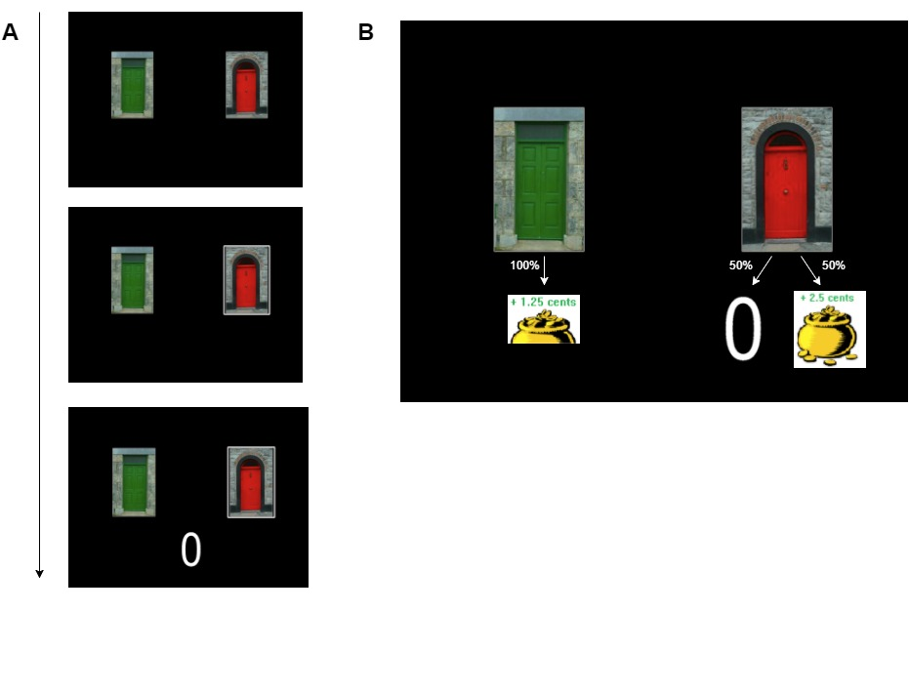

Figure 1: Example of stimuli shown to participants during the gambling task (A) and possible outcomes (B).

*Participants*

We collected data from 47 participants who were recruited through McGill’s classified ads system. We excluded participants who had insufficient levels of early exploration (i.e. 10% of risky choices or less during the first 30 trials), participants who experienced risk less than 10% of the time or outliers with risk-taking behavior) or outliers who were at least 1 standard deviation away from any other participant in their respective condition. In experiment 1, we excluded 4 participants with insufficient levels of early exploration and/or insufficient risk experience. We also excluded 1 outlier from the control condition. Of the remaining 41 participants, 21 participants were randomly assigned to the episodic induction condition, and 20 participants were randomly assigned to the control induction condition. 22 participants were randomly assigned to the first-win condition, and 19 participants to the second-win condition. Participants were compensated $10 CAD for one hour, and received an average bonus of $1.24 CAD, (*SD*= 0.069) for each of the two sessions. We administered the Positive and Negative Affect Schedule (PANAS; Watson, Clark & Tellegen, 1988) both at the beginning of the experimental session and at the end, and the Object-spatial Imagery Questionnaire (OSIQ; Patton & Noller, 1994) at the end of the experimental session, however these questionnaire data are not reported in the following analyses. This study was approved by McGill’s Research Ethics Office (REB).

*Episodic specificity induction*

The experimental procedure began with an episodic specificity or control (“general”) induction, following the procedure outlined in Madore et al. (2014). The episodic specificity induction is an experimental manipulation based on an established eyewitness interview technique known to enhance the number of details people can recall from witnessed events (Memon, Meissner, & Fraser, 2010). In short, both the specificity and control induction conditions begin with the participants watching a 4-minute long video involving actions of people in everyday settings (here we used clips of “Mr. Bean”). They were told to pay close attention to the video. After the video ended, participants were interviewed about the content of the video. In the episodic specificity condition (Jing et al., 2016; Madore et al., 2016), participants were asked to get a strong mental image of the video in mind and then describe as many specific details from that video in terms of the surroundings/setting, the physical appearances of the participants in the scene and the actions in the video. In the control condition, participants were instructed to describe the video using adjectives referring to the setting/people/actions, that is provide their general impressions of the video and not describe any specific details. Both inductionslasted approximately 9 to 12 minutes.

*Risky decision-making test*

Immediately after the induction procedure, participants performed the gain-version of the risky decision-making test (i.e., gambling task) used by Madan et al. (2014). In general, over 100 trials, participants were presented with two doors that both yielded real-monetary rewards. One of the doors was considered “safe” and always yielded a reward of 1.25 cents, while the other door was designated as the “risky” door and had a 50% chance to give a higher reward in the context of the experiment (2.5 cents) and a 50% chance to yield no reward (see figure 1B). After choosing a door, participants were shown the reward they received from that door on that trial. Participants were not told beforehand the possible outcomes associated with each door. Thus, the participants had to learn the outcomes associated with each door as they made decisions during the task.

*Memory Recall*

Immediately after the risky decision-making test, participants were asked to report the first outcome that came to their mind when thinking about the doors, following the procedure from Madan et al. (2014). Participants were shown each of the two doors, in random order, and were asked to indicate the first outcome that came to mind when seeing each door. This manipulation allowed us to examine the influence participants’ explicit memory of the outcomes they received in the task on behavior. After reporting these outcomes, participants were instructed to draw the two doors to the best they could remember with a paper and pencil and label the colors.

*Data Analysis*

*Risk preference measurements*

To compare risk preferences across induction groups (episodic versus control), we computed the mean level of risk excluding the first 24 trials (Madan et al., 2013; Ludvig et al., 2014). Excluding early trials allowed us to compare decisions that were made after having sufficient prior experience with the task. Risk preferences across groups were compared by conducting ANOVAs upon proportions of risky choices. Learning effects were tested using mixed-effects logistic regressions with random intercepts and slopes for each participant. This was done using the lme4 package (Pinheiro & Bates, 2000) for the R programming language.

*Reinforcement learning (RL)*

Following basic formulations of RL models (Gershman, 2015; Sutton & Barto, 1998), this model operates by developing and updating expected reward values for each option, *aj,* on each trial, *t.* these *Q-values* aredenoted here and elsewhere as *Q(aj, t)*. The Q-values for each option (in the present task there are two options) are used to determine the model’s probability for selecting each option via a softmax decision rule:

(1)

Here  is an exploitation parameter that determines the degree to which the option with the highest Q-value is chosen. As  approaches infinity the highest valued option is chosen more often, and as  approaches 0 all options are chosen equally often.

On each trial the option that is chosen ($a_{i}$) is updated for the next trial (*t*+1) based on a simple incremental updating rule:

$δ_{t}= r\left(t\right)- Q\left(a_{i}, t\right)$ (2)

$Q\left(a_{i}, t+1\right)= \left\{\begin{aligned}Q\left(a_{i}, t\right)+ α_{pos}{∙δ}_{t} , δ_{t }> 0 \\ Q\left(a_{i}, t\right)+ α_{neg}{∙δ}_{t} , δ_{t }< 0 \end{aligned}\right.$ (3)

In Equation 2 above $α_{pos}$  and $α_{neg}$ are learning rate parameters for positive and negative prediction errors (PE), and *r*(*t*) is the reward received from the chosen option on trial *t*. As these learning rate parameters approach 1, greater weight is given to the most recent rewards in updating Q-values indicative of more active updating of Q-values on each trial, and as the learning rate parameters approach 0, recent rewards are given less weight.

Our model fitting procedure used the Nelder-Mead optimization algorithm to find parameter values that maximized the likelihood of participants’ choices given their previous rewards and choices. To avoid estimates at parameter range boundaries, we imposed a ‘pseudo-prior’ over parameters, which for the learning rates, took the form of a beta distribution with *a* = *b* = 2, and for the inverse temperature parameter ( )*,* a gamma distribution with *k*=1 and *θ*=3.

*Experiment 2*

Experiment 2 was comprised of a second “control” condition to assess people’s baseline levels of risk-taking. In this condition, 24 participants completed the gambling task without any prior induction. One participant was excluded from the analysis for having insufficient levels of early exploration (i.e. less than 10% of risky choices during the first 30 trials). Of the remaining 23 participants, 12 were randomly assigned to the first-win condition and 11 were assigned to the second-win condition. Participants were paid $8 CAD for approximately 20 minutes of their time, plus a bonus averaging $1.24 CAD (*SD* = 0.076). The gambling task and memory recall procedures were identical to that of Experiment 1 except that they were performed in the absence of an episodic or control impressions induction. The Positive and Negative Affect Scale was not administered prior to the experiment, neither did we ask participants to draw the doors or to complete the Offer Self-Image Questionnaire after the risk decision-making test. The same data analysis and modeling procedure from Experiment 1 was used.

**Results**

*Experiment 1*

*Risky decision-making* *behavior*

We first sought to determine if apparent risk preferences differed across induction groups. Upon examining the mean level of risky choices for each participant after trial 24 (Madan et al., 2013; Madan et al., 2014), we found that risk-taking in the episodic induction group (*M* = 0.479, *SD*=0.173) was significantly higher than in the control induction group (M = 0.34, SD = 0.122; F(1, 39) = 8.8, p = 0.0051; see figure 2A).

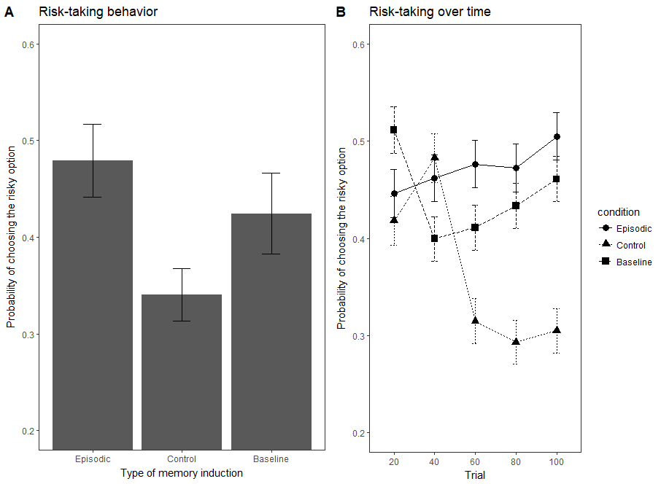

Figure 2: Panel A depicts the proportion of risky choices for the three induction conditions (Episodic, Control and Baseline) from trial 40 to 100. Panel B depicts the time course of risky preferences over 20-trial blocks in the three conditions: Episodic, Control and Baseline (Experiment 2)

Examining choice behavior across blocks, we found that risk-taking developed differently over time in the episodic specificity and control induction groups (Figure 2B). A mixed-effects logistics regression revealed that participants in the control induction group became significantly more risk-averse over time than participants in the episodic induction group (group X trial interaction; *β* = 1.25, SE = 0.349, *p*= 0.000346). Thus, the two groups exhibited apparent differences in their time courses of apparent risk preference. Put another way, risk-taking tended to decrease over time in the control condition (*β* = -1, SE = 0.253, p = 0.0000767) but did not significantly change over time in the episodic condition (*β =* 0.222, SE = 0.241, p = 0.36).

*Memory for Outcomes*

When asked which outcome first comes to their mind, participants in the episodic induction group were marginally significantly more likely to report the positive outcome, χ2(1, N = 21) = 3.86, p= 0.0495 (Figure 3A). This was not the case for the control induction group χ2 (1, N = 20) = 0.2, p= 0.655. However, the episodic condition did not significantly report the positive outcome more than the control condition χ2(1, N = 21) = 1.96, p = 0.16. The first outcome that came to mind was not significantly correlated with risky behavior across the episodic and control induction condition groups F(1,39) = 0.637, p = 0.43.

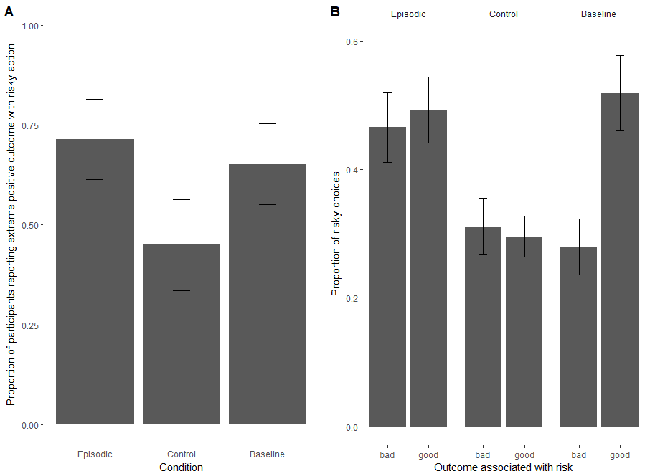

Figure 3: Panel A depicts the proportion of participants reporting that the extreme positive outcome in the first-outcome question. Panel B represents average risk-taking (without the first 24 trials) as a function of the first outcome that comes to mind when thinking of the risk option, in different groups.

*Effects of Episodic Specificity Manipulation on RL Model Parameters*

The best-fitting RL model parameter estimates are reported in Table 1. Considering the entire sample, we found a significant main effect of PE valence (positive versus negative PEs) such that negative PE learning rates were significantly larger than positive PE learning rates (mixed-effects regression *β* = -0.15, *SE=*0.05, *p* = 0.026). Indeed, this observation corroborates previous observations of a ‘negativity bias’—a tendency to weigh negative PEs more strongly than positive PEs— in RL updating in similar tasks (Christakou et al., 2013; Gershman, 2015; Niv, Edlund, Dayan, & O’Doherty, 2012).

|  |  |  |  |  |
| --- | --- | --- | --- | --- |
| **Condition** | **Learning Rate (Positive PE)** | **Learning Rate (Negative PE)** | **Inverse Temperature** | **Mean Log Likelihood** |
| *Episodic* | 0.385 | 0.395 | 2.776 | -60.371 |
| *Control* | 0.242 | 0.401 | 3.759 | -56.223 |
| *Baseline (Experiment 2)* | 0.309 | 0.357 | 2.847 | -61.283 |

Table 1: Positive and negative learning prediction error rates for the episodic, control and baseline conditions.

However, examining the Episodic and Control induction groups separately, we found that positive and negative PE learning rates exhibited less asymmetry in the Episodic Specificity induction condition than in the Control induction condition (Figure 4). In other words, participants who underwent the Episodic specificity induction appeared to weigh positive and negative prediction errors more equally than participants who underwent the Control induction. The later exhibited the typical negativity bias in learning rates (condition × PE type interaction *β* = .16, *SE=*0.06, *p* = 0.017).

../../../Downloads/pe_lr_v3.pdf

Figure 4: Best-fitting learning rate parameters for positive prediction errors and negative prediction errors, by condition. Error bars depict standard error of the mean.

*Experiment 2*

*Risky decision-making* *behavior*

We analyzed the baseline condition the same way as in the episodic and control induction groups. Upon examining the mean level of risky choices for each participant after trial 24 (Madan et al., 2013; Madan et al., 2014), we found that risk-taking in the episodic induction group (*M* = 0.479, *SD*=0.173) was not significantly different than in the baseline group (M = 0.424, SD = 0.199; F(1,42) = 0.94, p = 0.337) and that risk-taking in the baseline group was not significantly higher than in the control induction group (M = 0.34, SD = 0.122; F(1, 41) = 2.7, p = 0.108; Figure 2A). A mixed-effects logistic regression revealed that learning of risk preferences over time (condition X trial interaction) in the episodic and baseline conditions were not significantly different from each other (Figure 2B*; β* = 0.41, SE = 0.531, p = 0.42). This interaction between the control and baseline conditions was not significant either but trending (*β* = 0.86, SE = 0.53, p = 0.11).

*Memory for Outcomes*

Participants in the baseline group were not significantly more likely to report the positive outcome as the first one to come to mind χ2(1, N = 23) = 2.13, p= 0.144 (see Figure 3A). Within the baseline condition, participants with positive recall were more likely to choose the risky option after trial 24 (F(1,21) = 9.33, p = 0.006; Figure 3B).

**Discussion**

We examined how inducing an episodic specificity state — which is thought to bias participants towards using episodic memory processes— bears upon risk preferences in a risky decision-making task. This was achieved by combining an episodic induction (Madore et al., 2014) with a gambling task in which risk is learned from experience (Madan et al., 2013). We found that the episodic specificity induction increased apparent risk-taking compared to a control induction wherein participants were instructed to rely upon general impressions and putatively non-episodic memory processes. Further, the difference in risk preferences between these two induction techniques grew over time: while the episodic condition appeared to engender relatively stable their risk-preferences over time, participants in the control condition became progressively more risk-averse in their choices after an apparent initial period of exploration (Figure 2B). This suggests that the episodic specificity induction technique does not inherently make people more risk-seeking, but that the two groups differ in how they learn which option to prefer, which may be due to differences in how previous outcomes are remembered (Wimmer & Shohamy, 2012).

We revealed the episodic specificity induction to attenuate the typical ‘negativity bias’—whereby negative PEs are more strongly weighted than positive PEs (Christakou et al., 2013; Gershman,g 2015)—which was observed in the control induction. Similarly, participants in the control induction condition were risk-averse but not so much in the episodic induction condition (see figure 2). Since episodic memory contributes to adaptive decision-making (Murty et al., 2016; Duncan & Shohamy, 2016), it is possible that episodic memory plays a role in reducing inherent bias against risk.

Further, participants in the episodic specificity but not in the control induction condition were more likely to recall the positive extreme outcome when asked about the risky action, suggesting a memory bias whereby these extreme positive outcomes are overweighed—indeed, the true rate of positive and negative outcome occurrences was 50/50. This could possibly be due to the role of episodic memory in enhancing associations between experienced events and their associated outcomes (Wimmer & Shohamy, 2012). Taken together, these results suggest that episodic memory processes play a critical role in establishing risk preferences from direct experience.

We can compare our findings to those reported by Madan et al. (2013) and Ludvig et al. (2014) who used the same risky decision-making, and found that in the gains conditions, risk-taking did not significantly change over time. In light of these findings, it may be that the difference reported between our induction groups is because the control induction lowered risk-taking. In other words, individuals may naturally approach risk-taking behavior through an ‘episodic lens’, thus when biased towards non-episodic recall, risk choice is altered. In other words, learning choices from experience already requires and induces episodic memory to a certain extent, and the episodic specificity induction could not enhance the use of episodic memory much beyond that point. Even though the control induction was meant as a control, it requires participants to recall information in a general manner. It is possible that doing so dampens the normal use of episodic retrieval in learning from experience (Madore & Shacter, 2014; but see Madore et al., 2014). The task we used measured something quite different, and if learning from experience already induces the use of episodic processes, it would seem plausible that the control induction interacted with our task but not theirs. This would be coherent with results by Madan et al. (2013), which were closer to the baseline and the episodic conditions than to the control condition.

Regarding recall, we could replicate overweighing of the positive outcome in memory for the episodic induction condition but not for the baseline condition (Madan et al., 2013; see figure 3A). However, this difference was trending in the baseline condition, but not in the control induction condition. This is consistent with the idea that episodic memory processes strengthen memory for extreme outcomes. The tendency for participants who reported the positive outcome to be more risk-seeking could be observed in the baseline condition (Madan et al., 2013), but not in the episodic and baseline conditions (see figure 3B). This suggests the episodic specificity induction procedure might possibly intercept the relationship between risk preferences and the reported first outcome that comes to mind.

In conclusion, we have shown the episodic specificity induction to enhance risk-taking behavior relative to a control induction. This research suggests episodic memory processes can play a role in reducing risk-aversion when choosing between rewards.

**Acknowledgments**

We thank Kevin Madore and Daniel Schacter for developing and sharing with us the episodic specificity induction procedure, as well as Christopher Madan and Marcia Spetch for the risk-taking behavior test used in this study. We are also grateful to Kiera Hooper who has been an immense help in data collection.

**References**

Christakou, A., Gershman, S. J., Niv, Y., Simmons, A., Brammer, M., & Rubia, K. (2013). Neural and Psychological Maturation of Decision-making in Adolescence and Young Adulthood. *Journal of Cognitive Neuroscience*, *25*(11), 1807–1823. https://doi.org/10.1162/jocn\_a\_00447

Duncan, K. D., & Shohamy, D. (2016). Memory states influence value-based decisions. *Journal of Experimental Psychology: General*, *145*(11), 1420.

Gershman, S. J. (2015). Do learning rates adapt to the distribution of rewards? *Psychonomic Bulletin & Review*, *22*(5), 1320–1327. https://doi.org/10.3758/s13423-014-0790-3

Nelder, J. A., & Mead, R. (1998). A simplex method for function minimisation. *Computer Journal*, *7*, 308–313

Gupta, R., Duff, M. C., Denburg, N. L., Cohen, N. J., Bechara, A., & Tranel, D. (2009). Declarative memory is critical for sustained advantageous complex decision-making. *Neuropsychologia*, *47*(7), 1686-1693.

Gutbrod, K., Kroužel, C., Hofer, H., Müri, R., Perrig, W., & Ptak, R. (2006). Decision-making in amnesia: do advantageous decisions require conscious knowledge of previous behavioural choices?. *Neuropsychologia*, *44*(8), 1315-1324.

Hertwig, R., & Erev, I. (2009). The description–experience gap in risky choice. *Trends in cognitive sciences*, *13*(12), 517-523.

Jing, H. G., Madore, K. P., & Schacter, D. L. (2016). Worrying about the future: An episodic specificity induction impacts problem solving, reappraisal, and well-being. *Journal of Experimental Psychology: General*, *145*(4), 402.

Kahneman, D., & Tversky, A. (1979). Prospect theory: An analysis of decision under risk. *Econometrica: Journal of the econometric society*, 263-291.

Ludvig, E. A., Madan, C. R., & Spetch, M. L. (2014). Extreme outcomes sway risky decisions from experience. *Journal of Behavioral Decision Making*, *27*(2), 146-156.

Ludvig, E. A., Madan, C. R., & Spetch, M. L. (2015). Priming memories of past wins induces risk seeking. *Journal of Experimental Psychology: General*, *144*(1), 24.

Madan, C. R., Ludvig, E. A., & Spetch, M. L. (2014). Remembering the best and worst of times: Memories for extreme outcomes bias risky decisions. *Psychonomic bulletin & review*, *21*(3), 629-636.

Madore, K. P., Addis, D. R., & Schacter, D. L. (2015). Creativity and memory: effects of an episodic-specificity induction on divergent thinking. *Psychological science*, *26*(9), 1461-1468.

Madore, K. P., Gaesser, B., & Schacter, D. L. (2014). Constructive episodic simulation: Dissociable effects of a specificity induction on remembering, imagining, and describing in young and older adults. *Journal of Experimental Psychology: Learning, Memory, and Cognition*, *40*(3), 609.

Madore, K. P., Jing, H. G., & Schacter, D. L. (2016). Divergent creative thinking in young and older adults: Extending the effects of an episodic specificity induction. *Memory & cognition*, *44*(6), 974-988.

Madore, K. P., & Schacter, D. L. (2014). An episodic specificity induction enhances means-end problem solving in young and older adults. *Psychology and aging*, *29*(4), 913.

Madore, K. P., & Schacter, D. L. (2016). Remembering the past and imagining the future: Selective effects of an episodic specificity induction on detail generation. *The Quarterly Journal of Experimental Psychology*, *69*(2), 285-298.

Madore, K. P., Szpunar, K. K., Addis, D. R., & Schacter, D. L. (2016). Episodic specificity induction impacts activity in a core brain network during construction of imagined future experiences. *Proceedings of the National Academy of Sciences*, 201612278.

Memon, A., Meissner, C. A., & Fraser, J. (2010). The Cognitive Interview: A meta-analytic review and study space analysis of the past 25 years.

Murdock Jr, B. B. (1960). The immediate retention of unrelated words. *Journal of Experimental Psychology*, *60*(4), 222.

Murty, V. P., FeldmanHall, O., Hunter, L. E., Phelps, E. A., & Davachi, L. (2016). Episodic memories predict adaptive value-based decision-making. *Journal of Experimental Psychology: General*, *145*(5), 548.

Niv, Y., Edlund, J. A., Dayan, P., & O'Doherty, J. P. (2012). Neural prediction errors reveal a risk-sensitive reinforcement-learning process in the human brain. *Journal of Neuroscience*, *32*(2), 551-562.

Patton, W., & Noller, P. (1994). The Offer Self-Image Questionnaire for adolescents: Psychometric properties and factor structure. *Journal of Youth and Adolescence*, *23*(1), 19-41.

Shteingart, H., Neiman, T., & Loewenstein, Y. (2013). The role of first impression in operant learning. *Journal of Experimental Psychology: General*, *142*(2), 476.

Sutton, R. S., & Barto, A. G. (1998). *Reinforcement Learning*. Cambridge, MA: MIT Press

Tan, L., & Ward, G. (2000). A recency-based account of the primacy effect in free recall. *Journal of Experimental Psychology: Learning, Memory, and Cognition*, *26*(6), 1589.

Talarico, J. M., & Rubin, D. C. (2003). Confidence, not consistency, characterizes flashbulb memories. *Psychological Science*, *14*(5), 455-461.

Watson, D., Clark, L. A., & Tellegen, A. (1988). Development and validation of brief measures of positive and negative affect: the PANAS scales. *Journal of personality and social psychology*, *54*(6), 1063.

Wimmer, G. E., & Shohamy, D. (2012). Preference by association: how memory mechanisms in the hippocampus bias decisions. *Science*, *338*(6104), 270-273.