# Objective

In this assignment you will be practicing breaking down a problem into smaller problems, writing static methods for each smaller problem, calling the static methods in the main method to create the desired output.

# Problem

Write a program to display the word **TENNESSEE** on the screen as shown below. Here is the sample output. A java shell has been provided for you to fill in with the required code.

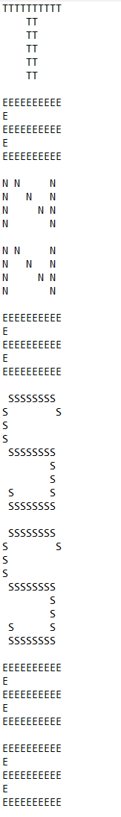

Figure 1, shows the word TENNESSEE

# Requirements

You need to break down the problem into smaller problems and write a static method for each smaller problem. In order to break down the problem into smaller pieces you need to

* identify the letters: T, E, N, S
* Write a method to display each of these letters
* Call those methods in the main method to generate the desired output
* no repeated code should appear in your program
* you must have a total of 5 methods
  + main method
  + a method to display T T
  + a method to display E E
  + a method to display N N
  + a method to display S S
* include block comments at the top of your program with your name, description of the program, and the date the program was written.
* include block comments before each method describing in one line what the method does.
* choose meaningful names for your class name and the method names.
* feel free to be creative, however you need to generate the given output.