PROJECT SUMMARY
RIM Automation and Legal Hold Administration
A proposed UI and database-backed workflow for protecting legal hold records while automating the 10-year purge process.
Status | Draft for team review
Scope | Business workflow, database logic, UI requirements, Blazor architecture, implementation phases

Recommendation
Use CustomerID as the source-of-truth key across the Legal Hold UI, SQL purge logic, and customer lookup workflow. Search can accept account number, access number, or name, but the system should resolve the customer first and evaluate the legal hold by CustomerID.

Summary
The RIM automation project should combine a SQL Server purge process with a focused Legal Hold Administration UI. The purge process removes Electronic Journal records older than 10 years, while the Legal Hold UI gives authorized users a controlled way to protect customer records from deletion.
The most important design decision from the meeting is that the application should resolve all searches to CustomerID. Account Number and Access Number are useful search inputs, but CustomerID is the stable business key that connects tblCustomers, EJHeader, and EJLegalHold.

Project Objectives
- Automate the Electronic Journal purge process for records older than 10 years.
- Prevent deletion of records for customers with an active legal hold.
- Provide a simple UI for searching customers and adding, editing, or ending legal holds.
- Keep legal hold administration auditable through created date, user, start date, and end date fields.
- Reduce manual effort while keeping the purge logic fast, transparent, and database-driven.

Business Workflow
- A legal hold request is received, typically from the legal or records management process.
- An authorized user searches for the customer by CustomerID, Account Number, Access Number, or name.
- The UI displays customer details and any current or historical legal hold information.
- The user adds a new hold or updates the hold dates as needed.
- The SQL Agent purge job runs on schedule and skips records tied to customers with active holds.
- When a legal hold ends, the user enters an EndDate rather than deleting the hold record.

Database Architecture
The proposed architecture separates customer master data, Electronic Journal transaction data, and legal hold metadata. This keeps the UI maintainable and keeps the purge job focused on a small, efficient lookup.
Table | Role | Important Columns
tblCustomers | Customer master record and display details. | CustomerID, Title, FirstName, MiddleName, LastName, SSNTIN, Address, Email
EJHeader | Parent Electronic Journal transaction record. | RecordID, EJTime, CustomerID, AccountNum, AccessNo, BranchID, UserID
EJDetail | Child transaction detail rows tied to EJHeader. | RecordID, FieldSequence, FieldName, FieldType, FieldValue
EJLegalHold | Customer-level legal hold records used by UI and purge process. | CustomerID, Name, StartDate, EndDate, DateCreated, UserInserted

Table Relationships
tblCustomers.CustomerID
|
+--> EJHeader.CustomerID --> EJDetail.RecordID
|
+--> EJLegalHold.CustomerID

The relationship should be evaluated through CustomerID. EJHeader stores the customer association for transaction records, EJDetail depends on EJHeader through RecordID, and EJLegalHold stores which customers are protected from purge.

Recommended Lookup Query
SELECT
c.CustomerID,
c.FirstName,
c.LastName,
h.AccountNum,
h.AccessNo,
l.StartDate,
l.EndDate
FROM tblCustomers c
LEFT JOIN EJHeader h
ON h.CustomerID = c.CustomerID
LEFT JOIN EJLegalHold l
ON l.CustomerID = c.CustomerID;

Purge Process
The purge job should remain in SQL Server for performance and operational control. The UI does not delete Electronic Journal records; it only maintains legal hold data that the purge process checks.
SQL Agent Job
-> Execute stored procedure
-> Delete eligible EJDetail rows first
-> Delete eligible EJHeader rows second
-> Skip customers with active legal holds
-> Commit transaction
-> Log success or failure

Purge rule
Delete records where EJTime is older than 10 years only when no active legal hold exists for the related CustomerID.

Legal Hold Logic
A separate Status column is optional and may create inconsistency. The cleanest design is to calculate status from StartDate and EndDate.
Condition | Status | Meaning
StartDate <= Today and EndDate is blank | Active | The hold is indefinite until an end date is entered.
StartDate <= Today and EndDate >= Today | Active | The hold is active through the end date.
EndDate < Today | Expired | The hold is historical and no longer blocks purge.
No row in EJLegalHold | No Hold | The customer is eligible for normal retention rules.

If the business needs to preserve the exact name used when a legal hold was created, the Name column can remain in EJLegalHold as historical audit text. Otherwise, display the customer name from tblCustomers to avoid duplicate data getting out of sync.

UI Requirements
Area | Required Behavior
Search | Allow lookup by CustomerID, Account Number, Access Number, first name, last name, and optional SSN/TIN according to security policy.
Results | Show CustomerID, customer name, account number, access number, legal hold status, start date, end date, and edit action.
Selected Record | Display read-only customer identity fields and editable StartDate and EndDate fields.
Actions | Support Add, Save, Clear, Cancel, and End Hold. End Hold should set EndDate instead of deleting the row.
Security | Restrict add, edit, and end-hold actions to authorized Records Management or compliance users.
Audit | Record DateCreated and UserInserted for every new hold, and consider logging updates to EndDate.

Proposed Screen Layout
The UI should be functional and work-focused: search at the top, results on the left, and the selected hold form on the right.
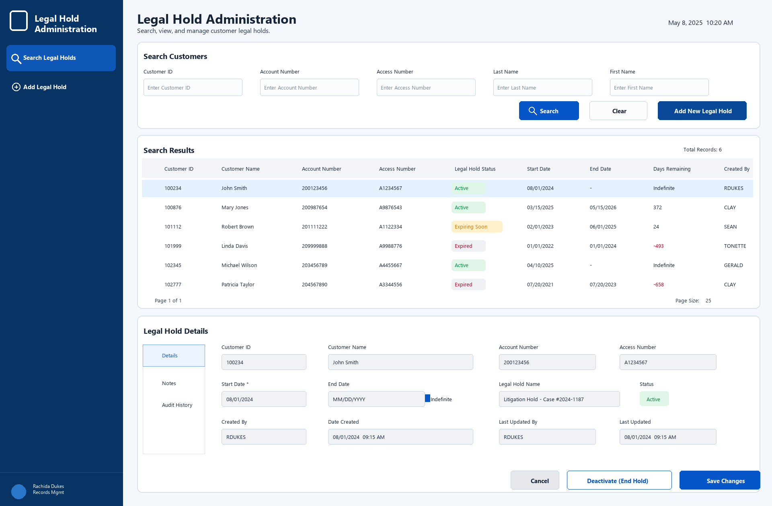
Figure 1. Proposed Legal Hold Administration screen.

Recommended Blazor Architecture
LegalHoldManager
|
+-- Blazor UI
| +-- Search page
| +-- Results grid
| +-- Add/Edit Legal Hold dialog or detail panel
|
+-- Application Layer
| +-- LegalHoldService
|
+-- Data Access Layer
| +-- CustomerRepository
| +-- LegalHoldRepository
|
+-- SQL Server
+-- tblCustomers
+-- EJHeader / EJDetail
+-- EJLegalHold
+-- Stored procedures and SQL Agent job

- Use Blazor Server if the application is internal, data access is close to SQL Server, and Windows authentication is preferred.
- Keep purge execution in SQL Server; the UI should not perform purge deletes directly.
- Expose stored procedures or repository methods for search, insert legal hold, update legal hold, end legal hold, and audit retrieval.
- Use a service layer to centralize active-hold calculation, validation rules, authorization checks, and user-facing error messages.

Development Phases
Phase | Focus | Deliverables
1. Confirm requirements | Finalize searchable fields, roles, audit rules, and Legal Hold table design. | Approved requirements, field list, security assumptions.
2. Database work | Create or update stored procedures, indexes, and purge job logic. | Search procedures, legal hold procedures, purge procedure, job logging.
3. UI prototype | Build the Blazor search screen, results grid, and selected-record panel. | Clickable internal prototype using test data.
4. Integration | Connect the UI to SQL Server and role-based authentication. | Working application in development environment.
5. Validation | Test active/expired/indefinite holds and purge exclusion rules. | Test evidence, DBA review, stakeholder signoff.
6. Deployment | Release to production with monitoring and support plan. | Production app, scheduled SQL Agent job, operational runbook.

Risks
Risk | Impact | Mitigation
Incorrect key mapping | Records could be purged even though a legal hold exists. | Resolve searches to CustomerID and have DBA validate joins and indexes.
Duplicate customer names | Searching by name alone may return ambiguous results. | Show CustomerID, account, access number, and identifying metadata in results.
Status stored separately from dates | Status may conflict with StartDate or EndDate. | Calculate active/expired status from dates in one service/query.
Insufficient audit history | Difficult to prove who created or ended a hold. | Capture user, creation date, update date, and consider a legal hold history table.
Over-permissive UI access | Unauthorized users may change legal hold protections. | Use role-based access and disable write actions for read-only users.

Open Questions
- Should EJLegalHold keep the Name column for historical audit purposes, or should the UI always display names from tblCustomers?
- Should End Hold update only EndDate, or should there also be an audit/history table for changes?
- Which roles are allowed to add, edit, or end legal holds?
- What exact schedule should the SQL Agent purge job follow?
- Should the search screen include SSN/TIN, and if so, should it be masked or permission-gated?
- What logging is required for purge counts, skipped records, failures, and DBA review?

Next Steps
Step | Action
1 | Confirm that CustomerID is the final legal hold key with the DBA and business stakeholders.
2 | Approve the Legal Hold table fields and whether Name is retained for audit history.
3 | Finalize search requirements and security roles.
4 | Create SQL stored procedures for search, insert, update, end hold, and purge.
5 | Build a Blazor prototype using the proposed screen layout.
6 | Review prototype with Records Management, Legal, DBA, and IT before production implementation.

