LegalHoldAdmin System Design Brief
Generated August 30, 2026 | .NET Blazor Server / SQL Server LocalDB

Purpose
LegalHoldAdmin is a focused internal web application for searching customers and legal holds, creating or updating legal hold records, and comparing a current inline-edit workflow with a V2 modal-based workflow for team review.

System Context
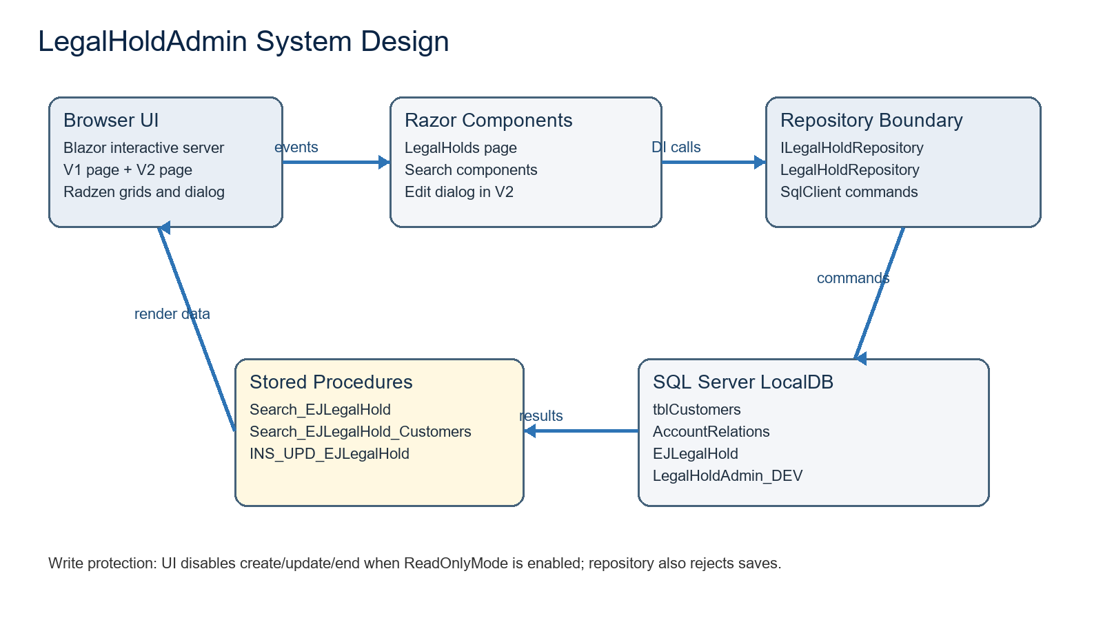
Figure 1. Runtime boundary between Blazor UI, repository, stored procedures, and SQL Server data.

Architecture Summary
Area | Design
Runtime | ASP.NET Core Razor Components with Interactive Server rendering on .NET 9.
UI libraries | Radzen.Blazor provides DataGrid, dialog services, modal host components, and material styling.
Composition | MainLayout owns the shell and navigation. Routes maps pages into the layout. App loads Bootstrap, Radzen CSS/JS, app CSS, and Blazor.
Application boundary | Pages and components depend on ILegalHoldRepository rather than SQL directly.
Persistence | LegalHoldRepository uses Microsoft.Data.SqlClient and configured stored procedure names against SQL Server LocalDB.
Configuration | appsettings.json provides the LegalHoldAdmin_DEV connection string, procedure names, and LegalHold:ReadOnlyMode.
Diagnostics | Console logging is enabled. Repository SQL failures are logged and rethrown as InvalidOperationException for UI display.

Component Map
Component | Route / location | Responsibility
MainLayout | Components/Layout | Provides sidebar navigation for Home, Legal Holds, and Legal Holds V2; hosts RadzenComponents for dialogs.
LegalHolds | /legal-holds | Original workflow. Hosts legal-hold search, customer search, and an inline legal-hold detail form.
LegalHoldSearch | Components/LegalHolds | Searches legal holds by account/access/name filters and displays results in a RadzenDataGrid.
CustomerSearch | Components/LegalHolds | Searches customer records, validates at least one filter, logs count and first result, then displays a RadzenDataGrid.
LegalHoldsV2 | /legal-holds-v2 | Team-demo workflow. Hosts V2 search, customer search, and a local RadzenComponents host for modal dialogs.
LegalHoldSearchV2 | Components/LegalHoldsV2 | Adds Create Legal Hold and Detail / Edit actions. Uses Radzen dialog flow for insert/update.
LegalHoldEditDialog | Components/LegalHoldsV2 | Modal edit form used by V2 for both create and update operations.

Data Contracts
Model | Fields | Business meaning
LegalHoldSearchRequest | AccountNumber, AccessNumber, FirstName, LastName | Search filters accepted in any combination by the search stored procedures.
LegalHoldResult | ID, CustomerID, customer name parts, AccessNumber, AccountNumber, LegalHoldName, StartDate, EndDate, Active, DateCreated, UserInserted | Read model returned by legal-hold search and selected for editing.
CustomerSearchResult | CustomerID, customer name parts, AccessNumber, AccountNumber, SocialSecurityNumber | Read model returned by customer search.
LegalHoldEditModel | Nullable ID, AccessNumber, Name, StartDate, EndDate, Active | Write model passed to INS_UPD_EJLegalHold. IsInsert is true when ID is missing or non-positive.

Repository and Stored Procedure Boundary
Repository method | Stored procedure | Input parameters
SearchLegalHoldsAsync | dbo.Search_EJLegalHold | @AccountNo, @HostCIFKey, @FirstName, @LastName
SearchCustomersAsync | dbo.Search_EJLegalHold_Customers | @AccountNo, @HostCIFKey, @FirstName, @LastName
SaveLegalHoldAsync | dbo.INS_UPD_EJLegalHold | @IsInsert, @AccessNo, @Name, @StartDate, @EndDate, @Active, @ID
The repository is intentionally thin: it resolves procedure names from configuration, opens a SQL connection, adds typed parameters, executes the stored procedure, and maps returned column names into nullable model properties.

Database Shape
Table | Role in the app | Important fields
tblCustomers | Customer source table used by search procedures. | CustomerID, FirstName, MiddleName, LastName, SSNTIN, HostCIFKey, EmailAddress
AccountRelations | Account relationship table used to connect customers to accounts. | AccountNumber, CustomerID, AccountType, Status, Relationship
EJLegalHold | Legal hold table used for legal-hold search and insert/update. | ID, AccessNo, Name, StartDate, EndDate, Active, DateCreated, UserInserted

Business Rules
- Legal hold and customer searches use account number, access number, first name, last name, or any combination of those values.
- Customer search requires at least one search value before it calls the customer stored procedure.
- Legal-hold create/update requires Access Number and Hold Name.
- Access Number and Hold Name are limited to 30 characters by LegalHoldEditModel.
- A legal hold is treated as an insert when ID is missing or less than or equal to zero.
- ReadOnlyMode disables create/update/end actions in the UI and also blocks SaveLegalHoldAsync in the repository.
- The original page supports End Hold by asking for confirmation, setting Active to false, and defaulting EndDate to today when it is blank.
- V2 keeps search results visible while create/edit happens in a Radzen modal dialog.
- V2 row selection is separate from editing: select a row, then click Detail / Edit to open the modal.

Primary Workflows

Search Legal Holds
- User enters one or more filters in the Legal Hold Search panel.
- Component calls Repository.SearchLegalHoldsAsync with LegalHoldSearchRequest.
- Repository executes dbo.Search_EJLegalHold using the configured connection string.
- Results are mapped into LegalHoldResult and displayed in a RadzenDataGrid.
- Selecting a row notifies the parent component or enables the V2 Detail / Edit action.

Create or Update Legal Hold
- V1 edits in the inline Legal Hold Detail section below the search components.
- V2 opens LegalHoldEditDialog for Create Legal Hold or Detail / Edit.
- The edit model validates required Access Number and Hold Name.
- Repository.SaveLegalHoldAsync checks ReadOnlyMode before calling dbo.INS_UPD_EJLegalHold.
- After a successful save, the legal-hold grid refreshes and a success message is shown.

Operational Notes and Risks
- The current development connection string points to (localdb)\MSSQLLocalDB and database LegalHoldAdmin_DEV.
- The production/unit EncoreUnit connection string is commented out in appsettings.json, which is safer for local testing.
- ReadOnlyMode is currently false in the local configuration, so create/update calls are enabled.
- Stored procedure parameter names are centralized in LegalHoldRepository. If the real database differs, adjust the four search parameter names there.
- No authentication or role-based authorization is visible in the current solution. Add it before broader deployment.
- There is no EF Core migration layer; database schema and stored procedures are managed outside the app.
- The app relies on Radzen static assets and RadzenComponents hosts for grid/dialog behavior.

Team Demo Talking Points
Topic | V1 | V2
Editing surface | Inline form stays visible below search. | Modal dialog focuses the user on create/update.
Comparison goal | Shows baseline implementation. | Shows proposed interaction model for team feedback.
Search results | RadzenDataGrid with paging/sorting. | Same grid behavior, with explicit Detail / Edit action.
Cleanup | Core app folder remains in place. | V2 is isolated under Components/LegalHoldsV2 and can be removed later.

Recommended Next Steps
- Confirm stored procedure parameter names and returned column names against the work database.
- Decide whether V2 should replace V1 after team review or remain as an optional route during rollout.
- Add authentication/authorization rules if the app will run outside a trusted local environment.
- Add lightweight integration tests around repository parameter mapping and ReadOnlyMode behavior.
- Consider replacing browser confirm in V1 End Hold with a Radzen confirmation dialog if V2 is accepted.

