CYB 691 / IT 691 Cybersecurity Capstone Project
Team Progress Report 1: Planning and Design Gate
Team 4: Cyber-Physical & Network Defense Monitoring in Operational Technology (OT)
Course & Term: | CYB691 / IT691 Fall 2026 | Milestone Gateway Submission (Week 6)
Team Members & Roles: | Erick Espinosa (Layer 1), Rachid Afaf (Layers 2 & 3), Anil Kumar (Layer 4)
Public Repository URL: | https://github.com/rachidafaf/CYB691-IT691-CapstoneProjectFall2026.git
Evaluated Commit / Branch: | main / commit 707f8f0 (OWASP Threat Dragon v2.3.0 Standard)
Submission Date: | Fall 2026
1. Project Identification & Current Direction
Following the evaluation and integration of individual project proposals, Team 4 established a unified, multi-layered capstone direction focused on protecting Operational Technology (OT) and Industrial Control System (ICS) environments operating legacy Modbus TCP protocols. Our integrated pipeline connects Erick Espinosa's host-virtualized Purdue Model testbed (featuring pfSense virtual firewalls, Dockerized OpenPLC/Conpot emulators, and Suricata Deep Packet Inspection), Rachid Afaf's automated telemetry normalization engine, incident triage generator, and machine learning detection models (log_parser.py, timeline_generator-v2.py, and ml_detector.py), and Anil Kumar's pfSense boundary hardening policies aligned with NIST SP 800-82 Rev. 3.
As of Week 6, all three team members have fulfilled active, specialized technical responsibilities across the four operational layers. All software modules, normalizers, machine-learning classification scripts, security policies, and threat model specifications are published and version-controlled in our public GitHub repository. To date, the project has completed initial testbed provisioning, established the telemetry normalization architecture, initiated supervised machine learning pipeline scripts, and structured a comprehensive OWASP Threat Dragon v2.3.0 threat model to guide security hardening during the upcoming implementation phase.
2. Problem, Significance, Goals, Research Question, Scope, and Expected Contribution
2.1 Cybersecurity Problem
Operational Technology (OT) and Industrial Control System (ICS) environments have historically relied on flat, under-segmented networks that use legacy protocols such as Modbus TCP. Specified for closed, trusted networks, Modbus TCP inherently lacks built-in cryptographic authentication, session encryption, or state verification. Consequently, unauthorized write commands, such as malicious register overwrites or state-altering function codes (0x05, 0x06, 0x10), can be injected directly by compromised internal endpoints, rogue HMI nodes, or lateral attackers, resulting in physical process disruption without triggering standard IT perimeter firewalls.
2.2 Affected Stakeholders & Critical Systems
Affected stakeholders include critical infrastructure operators, industrial plant managers, and SCADA engineers responsible for safeguarding Purdue Model Level 1 through Level 3 architectures, specifically Programmable Logic Controllers (PLCs, such as OpenPLC), Human-Machine Interfaces (HMIs), remote telemetry units (RTUs), and supervisory control conduits.
2.3 Significance
As IT/OT convergence bridges enterprise IT networks with operational field networks, standard perimeter firewalls fail to block internal lateral movement or payload-level command manipulation. Empirically evaluating multi-layered security controls combining Purdue microsegmentation, deep packet inspection, and machine learning provides actionable, data-driven security validation for critical infrastructure defense.
2.4 Project Goals & Primary Research Question
Project Goals: Deploy a host-virtualized Purdue Model testbed, automate multi-source telemetry normalization, enforce firewall microsegmentation, and benchmark supervised machine learning anomaly detectors.
PRIMARY RESEARCH QUESTION
In a virtualized Industrial Control System (ICS) environment running Modbus TCP, how effectively does a multi-layered defense architecture (Purdue Model microsegmentation, Suricata DPI, and supervised machine-learning classifiers) detect, alert, and contain unauthorized state-altering write commands compared to an unsegmented flat network baseline?
2.5 Project Scope Boundaries
To ensure technical rigor and feasibility within the 14-week capstone timeline, Team 4 maintains strict project boundaries:
Inside Project Scope | Outside Project Scope
Multi-Subnet Purdue Model Virtual Topology (snet-enterprise, snet-hmi, snet-plc) via pfSense firewalls. | Physical PLCs, RTUs, or live utility grid connections.
Containerized Modbus TCP Emulators (Conpot and OpenPLC) listening on Port 502 / 5020. | Proprietary vendor SCADA software requiring commercial licenses.
Custom Suricata DPI signatures inspecting MBAP headers and function codes (0x05, 0x06, 0x10). | WAN routing, unconfirmed CyberRange infrastructure, or paid cloud services.
Automated Python scripts (traffic_generator.py) simulating routine reads and write attacks. | Deep cryptographic protocol modifications or hardware side-channel analysis.
Telemetry Normalization Pipeline exporting structured ISO 8601 JSON and CSV datasets. | Penetration testing against external or production networks.
Supervised Machine Learning Classifiers (Random Forest, SVM), evaluating rule vs. ML detection. | Live operational vehicle testing or physical hazard simulations.

2.6 Expected Contribution
Team 4 delivers a fully reproducible, open-source testing pipeline, an automated telemetry parser, a formal OWASP Threat Dragon threat model, and a benchmarked machine-learning evaluation framework that establishes baseline precision, recall, false-positive rates, and processing latency for OT anomaly detection.
3. Initial Research Foundation
To establish a defensible technical baseline, Team 4 synthesizes peer-reviewed literature and authoritative standards across three core thematic domains:
3.1 Industrial Control System Architecture and Standardization
Foundational architectural standards, such as the Purdue Reference Model for Industrial Control Systems (PRM), establish structural segmentation principles separating enterprise IT layers from sensitive operational field levels. Complementing this, NIST Special Publication 800-82 Rev. 3 (Guide to Operational Technology Security) provides guidelines on risk management, zoning, and conduit security. Together, these standards demonstrate that traditional IT perimeters fail when applied directly to industrial systems, necessitating microsegmentation across Purdue Levels 1 through 3.
3.2 Legacy Protocol Vulnerabilities and Threat Landscapes
Industrial protocols like Modbus TCP, specified by the Modbus Organization, were engineered for operational efficiency in closed networks rather than security. Consequently, they lack cryptographic authentication, session encryption, or state verification. Case studies and forensic analyses, such as Ralph Langner's analysis of Stuxnet, demonstrate how unauthenticated command injection and the lack of packet inspection enable sophisticated adversaries to manipulate physical processes without triggering standard network alarms.
3.3 Deep Packet Inspection and Machine Learning Defense Mechanisms
To counter legacy protocol vulnerabilities, modern monitoring frameworks combine signature-based tools with behavioral analytics. Documentation from the Open Information Security Foundation (OISF) on Suricata highlights the utility of Deep Packet Inspection (DPI) for examining Modbus Application Protocol (MBAP) headers and function codes (0x05, 0x06, 0x10). Furthermore, recent literature in industrial cybersecurity explores supervised machine learning for anomaly detection to classify state-altering traffic patterns, aiming for high recall and low false-positive rates when distinguishing automated HMI polling from unauthorized script-based writes.

4. Methodology and 4-Layer System Architecture
The technical architecture follows a strict 4-layer pipeline where each team member leads one functional stage while collaborating across boundaries:
- Layer 1 - Virtualized OT Testbed: Erick Espinosa leads host-virtualized Purdue Model testbed setup, pfSense virtual firewalls, OpenPLC and Conpot emulators, and Suricata DPI rules. Generates raw PCAPs, CSVs, and EVE JSON logs.
- Layer 2 - Telemetry Normalization & Triage: Rachid Afaf leads multi-log handoff ingestion (.tar.gz), ISO 8601 JSON standardization (normalized_telemetry.json), inter-arrival delta time (Δt) calculation, and automated incident triage timeline generation (timeline_generator-v2.py).
- Layer 3 - Machine Learning Detection Analytics: Rachid Afaf leads 8-dimensional feature vector extraction, class imbalance handling, ml_detector.py training (Random Forest, Decision Tree, SVM), and recall/latency benchmarking.
- Layer 4 - Boundary Hardening & Security Validation: Anil Kumar and Rachid Afaf lead pfSense Layer 3/4 ACL boundary enforcement, OWASP Threat Dragon v2.3.0 STRIDE mapping (Team_4_Threat_Model.json), and automated threat audit verification (validate_stride_threats.py).
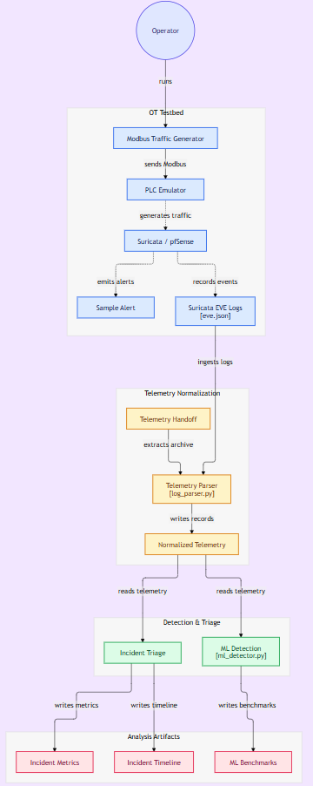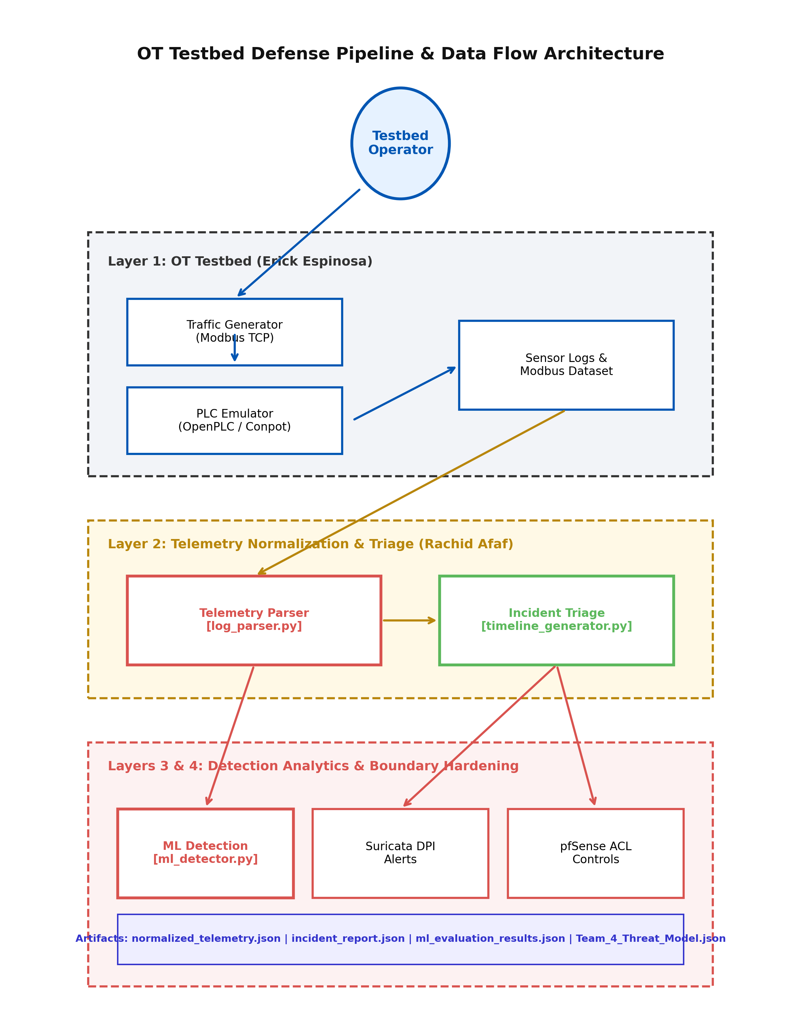
Figure 1: Team 4 OT Testbed Defense Pipeline and Data Flow Architecture. https://gitdiagram.com/rachidafaf/cyb691-it691-capstoneprojectfall2026
5. Threat Model and Security Requirements
To systematically evaluate vulnerabilities in legacy industrial protocols and validate our multi-layered defense architecture, Team 4 established a formal threat model saved as Team_4_Threat_Model.json, compliant with OWASP Threat Dragon v2.3.0.
5.1 Assets, Actors, and Trust Boundaries
- Critical Assets: PLC memory coils and registers (OpenPLC/Conpot), Modbus MBAP headers, telemetry archives, normalized JSON records, and triage reports.
- Actors & Threat Vectors: Authorized HMI operators, automated polling scripts, internal lateral movement actors, and non-whitelisted enterprise hosts.
- Trust Boundaries: 1) OT Network Boundary (curve-ot-boundary) segregating Level 1-3 field components; 2) Analysis Evidence Boundary (curve-analysis-boundary) protecting log ingestion, parsing, triage, ML execution, and report artifacts.

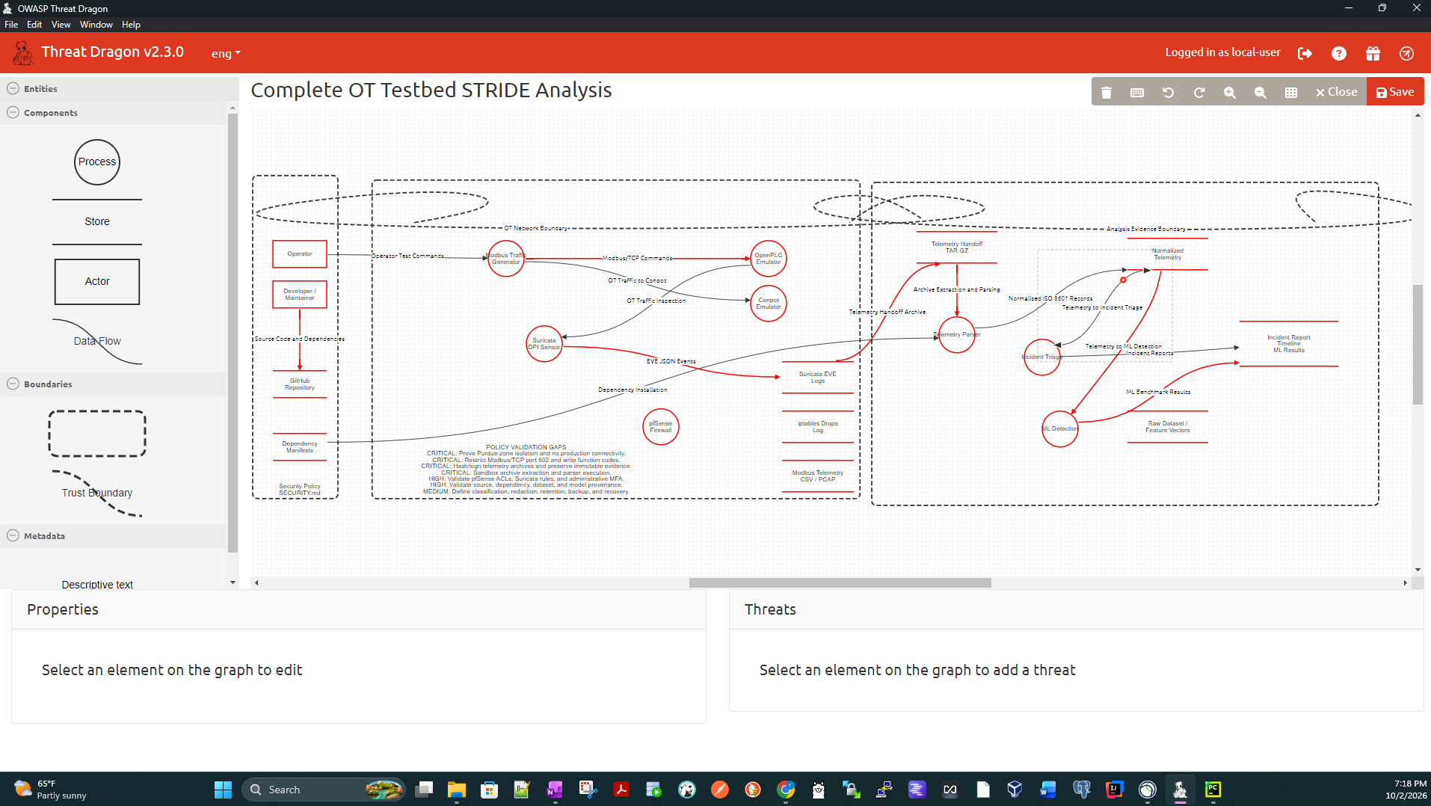
Figure 2: Complete OT Testbed STRIDE Analysis Diagram in OWASP Threat Dragon v2.3.0.

5.2 STRIDE Threat Breakdown & Audit Verification
The threat model tracks 37 open STRIDE threats across 32 diagram components:
STRIDE Category | Open Threats | Primary Mitigation Focus
Spoofing | 2 | Named user accounts, MFA, RBAC, operator command audit logging.
Tampering | 19 | pfSense ACLs, Suricata write blocking, SHA-256 hashes, signed manifests.
Repudiation | 2 | Source file SHA-256 hashes, git commit IDs, execution timestamps.
Information Disclosure | 3 | Gitleaks scanning, RFC 1918 private IPs, restricted storage permissions.
Denial of Service | 5 | Rate limits, SPAN/TAP drop monitoring, bounded batch limits, and memory quotas.
Elevation of Privilege | 6 | Non-privileged Docker sandboxing, strict path verification, pinned package hashes.

5.3 Testable Security Requirements
- Requirement 1 (Network Microsegmentation): The pfSense firewall architecture must block all direct, unauthenticated Modbus TCP traffic originating from non-whitelisted subnets attempting to access Level 1 control endpoints.
- Requirement 2 (Deep Packet Inspection): Suricata DPI must actively inspect MBAP headers and payload function codes to detect and log unauthorized write attempts (codes 0x05, 0x06, 0x10) with zero blind spots.
- Requirement 3 (Behavioral Anomaly Detection): Supervised machine learning classifiers (Random Forest, Decision Tree, SVM) must achieve a detection recall of ≥95.0% and a false positive rate (FPR) of ≤2.0% when distinguishing automated script-based write bursts from legitimate HMI polling traffic.
6. Environment, Data, Ethics, and Authorization
The experimental environment is entirely containerized and host-virtualized locally within student testbeds, using Dockerized OpenPLC and Conpot emulators listening on industrial ports (502 / 5020) coupled with virtualized pfSense firewalls. All test traffic, comprising benign polling data and unauthorized Modbus write attempts, is artificially generated using traffic_generator.py and grounded in modbus_telemetry_dataset.csv (20,075 events). In accordance with course policy, no CyberRange access is assumed, and no live production machinery, PII, or proprietary records are targeted. All custom scripts and schemas are released under the MIT License in our public GitHub repository.
7. Evaluation, Evidence, and Expected-Outcomes Plan
Evaluation centers on quantifying classification recall (target ≥95.0%), false positive rate (target ≤2.0%), execution latency (ms), firewall drop counts, and Suricata alert coverage. Evaluation includes testing explicit negative/boundary cases such as high-frequency polling bursts, malformed MBAP headers, and protocol exception flags (IllegalDataAddr). Baseline comparison evaluates the multi-layered defense against an unsegmented flat network baseline and an unsupervised Isolation Forest baseline.
7.1 Preserved Evidence Products per Major Task
Defense Layer | Lead Responsibility | Preserved Evidence Artifacts
Layer 1 (OT Testbed) | Erick Espinosa | Raw PCAP capture files, Suricata eve.json, iptables_drops.log, traffic generator specs.
Layer 2 (Normalization) & 3 (Analytics) | Rachid Afaf | Layer 2: normalized_telemetry.json (ISO 8601 schema), incident_report.json, incident_timeline.md.  Layer 3: ml_evaluation_results.json, feature importances, Random Forest/SVM model artifacts.
Layer 4 (Hardening) | Anil Kumar & Rachid Afaf | Team_4_Threat_Model.json, validate_stride_threats.py, stride_validation_report.json, SECURITY.md.

8. Working Agreement, Roles, Project Task Schedule, Risks, and Fallback
8.1 Working Agreement & Workflow
Primary team communication occurs via Discord channel with a 24-hour response SLA. Check-ins occur bi-weekly. All code, normalization pipelines, ML models, and milestone documents are version-controlled in our public GitHub repository using feature branches and pull request reviews.

8.2 Project Task Schedule
Task Description | Lead / Reviewer | Target Date | Status & Evidence Output
Task 1: Testbed Architecture & Emulation Design (Deploying Dockerized OpenPLC/Conpot and pfSense microsegmentation topology) | Erick Espinosa | Week 4 | Complete — Docker container topology, OpenPLC/Conpot emulators, and traffic generator scripts deployed.
Task 2: Telemetry Normalization, Triage Engine, & ML Detection Framework (Developing log_parser.py, timeline_generator-v2.py, and training Scikit-learn classifiers via ml_detector.py) | Rachid Afaf | Week 5 | Complete — Telemetry extraction pipeline built, structured JSON/Markdown execution summaries established, and feature extraction framework structured.
Task 3: STRIDE Threat Model & Security Hardening (Constructing OWASP Threat Dragon v2.3.0 model, audit rules, and NIST mapping) | Rachid Afaf | Week 6 | Complete — Formal threat model architecture, validator scripts, and NIST SP 800-82r3 compliance maps finalized.
Task 4: Comprehensive Research, Documentation, & Report Synthesis (Gathering deep scholarly research, synthesizing authoritative literature, integrating notebook sources, and authoring the final progress report document) | Anil Kumar | Week 6 | Complete — In-depth literature review synthesized, notebook sources incorporated, and fully integrated Team Progress Report documentation finalized

8.3 Project Risks & Reduced-Scope Fallback
- Risk 1 (Extreme Class Imbalance): Disproportionate benign read polling versus rare state-altering write attacks could destabilize ML model training. Mitigation: Implemented handle_class_imbalance() oversampling for StratifiedKFold stability.
- Risk 2 (Log Ingestion Discrepancies): Variations in multi-log tarball naming or timestamp formatting could break parsing. Mitigation: Implemented dynamic glob search in log_parser.py.
- Reduced-Scope Fallback Plan: If container latency blocks real-time execution, the team falls back to evaluating static, pre-captured multi-source PCAP and EVE JSON datasets (ot_telemetry_handoff.tar.gz) through the offline normalization and ML pipeline, fully satisfying core capstone requirements.

9. Current Work Completed & Next Actions
As of Week 6, Team 4 has achieved significant technical milestones across all project components, establishing a fully functional, end-to-end data processing, triage, and machine learning detection pipeline:
9.1 Technical Accomplishments
- 1. Telemetry Normalization Pipeline (log_parser.py): Engineered log_parser.py to dynamically extract ot_telemetry_handoff_*.tar.gz archives, parse Suricata eve.json, iptables_drops.log, and raw CSVs, standardizing 20,075 telemetry events into normalized_telemetry.json with inter-arrival delta times (Δt).
- 2. Incident Triage Generator (timeline_generator.py): Developed timeline_generator-v2.py to ingest normalized JSON records and generate structured incident_report.json and executive Markdown triage summaries (incident_timeline.md).
- 3. Machine Learning Detection Engine (ml_detector.py): Built ml_detector.py extracting an 8-dimensional feature matrix, addressing severe class imbalance, and benchmarking Random Forest, Decision Tree, and SVM classifiers alongside an unsupervised Isolation Forest baseline.
- 4. Formal OWASP Threat Model: Constructed Team_4_Threat_Model.json compliant with OWASP Threat Dragon v2.3.0, mapping 37 open STRIDE threats across 32 components and 2 trust boundaries.
- 5. Automated STRIDE Verification Auditor: Created validate_stride_threats.py to automatically parse the threat model JSON, verify all 37 threats against codebase modules and datasets, and export stride_validation_report.json and stride_validation_report.md.
9.2 Preliminary Setup & Scripting Status
As of Week 6, Team 4 has completed initial baseline environment preparation and established the core processing script architecture:
- Testbed Environment Provisioning: Deployed local Docker container environments for OpenPLC and Conpot emulators alongside virtualized pfSense firewalls, establishing the multi-subnet Purdue Model topology.
- Scripting Architecture & Parsing Routines: Structured the initial ingestion routines in log_parser.py for dynamic multi-log extraction, drafted the feature extraction pipeline in ml_detector.py, and built timeline_generator-v2.py for structured Markdown reporting.
- Repository & Threat Model Initialization: Published all baseline scripts, documentation, and the OWASP Threat Dragon v2.3.0 STRIDE model in the public GitHub repository. Full model training, empirical performance benchmarking, and quantitative evaluation metrics are reserved for the implementation phase leading into Team Progress Report 2.
9.3 Next Assigned Actions per Member
- Erick Espinosa: Finalize Docker Compose deployment scripts and traffic generator bursts.
- Rachid Afaf: Extend telemetry parser to ingest additional network log formats and refine triage report visualizations.
- Anil Kumar: Finalize pfSense Layer 3/4 ACL rule definitions and complete NIST SP 800-82 Rev. 3 mapping documentation.
10. References
[1] K. Stouffer, V. Pillitteri, S. Lightman, M. Abrams, and A. Hahn, 'Guide to Operational Technology (OT) Security,' NIST Special Publication 800-82, Rev. 3, Sep. 2023.
[2] Purdue University Consortium for Computer-Aided Engineering, 'Purdue Reference Model for Industrial Control Systems Architecture,' Enterprise Integration Architecture Standards, 1992.
[3] Modbus Organization, 'Modbus Application Protocol Specification v1.1b3,' Modbus.org, Dec. 2012.
[4] R. Langner, 'To Kill a Centrifuge: A Technical Analysis of What Stuxnet Achieved,' The Langner Group, Nov. 2013.
[5] Suricata User Guide, 'Open Source IDS/IPS and Network Security Monitoring Engine,' Open Information Security Foundation (OISF), 2024.
[6] MITRE ATT&CK, 'ATT&CK Matrix for Industrial Control Systems (ICS),' MITRE ATT&CK Knowledge Base, 2024.
Appendix: Generative AI Use Statement and Prompt Record
Generative AI Use Statement: In accordance with course guidelines, generative AI tools (Gemini Deep Research and Glean AI) were used for drafting, structural organization, and formatting assistance of this Team Progress Report. Specifically, AI assistance was employed to synthesize technical descriptions of the Purdue Model testbed, refine the threat model to align with NIST SP 800-82 Rev. 3, and format project schedules. All technical architecture designs, code implementations (log_parser.py, ml_detector.py), evaluation criteria, and final editorial reviews were independently verified and validated by Team 4.
Representative Prompt Record
Complete Prompt Text | Verification Performed
Review our 4-layer architecture for an OT Modbus TCP defense capstone project and help structure Section 5 (Threat Model and Security Requirements) to align with NIST SP 800-82 Rev. 3 guidelines. | Verified against actual testbed topology, OWASP Threat Dragon JSON schema, and pfSense firewall rule specs.
Help format the project task schedule table for the Week 6 planning gate, ensuring it separates completed design tasks from ongoing implementation goals without including premature Report 2 benchmark results. | Verified against team working agreement, repository commit logs, and course milestone rubrics.

