CARLETON UNIVERSITY

SYSC 5104 — Assignment 1
Student: RACHID FAHMI (101415381)
Email: RachidFahmi@cmail.carleton.ca
Date: February 19, 2026

Modeling UAV Swarm Communication with Relay Handoff using DEVS

UAV Swarm Surveillance — Conceptual Model
Problem Description
UAV swarms used in surveillance need to keep sending data back to a ground station even as they move around. The problem is that the further a UAV gets from the station, the worse the link gets — and eventually it drops entirely. The question this model tries to answer is simple: if we detect that a link has gone down and automatically reroute traffic through a relay UAV, does that actually help? And by how much compared to doing nothing?

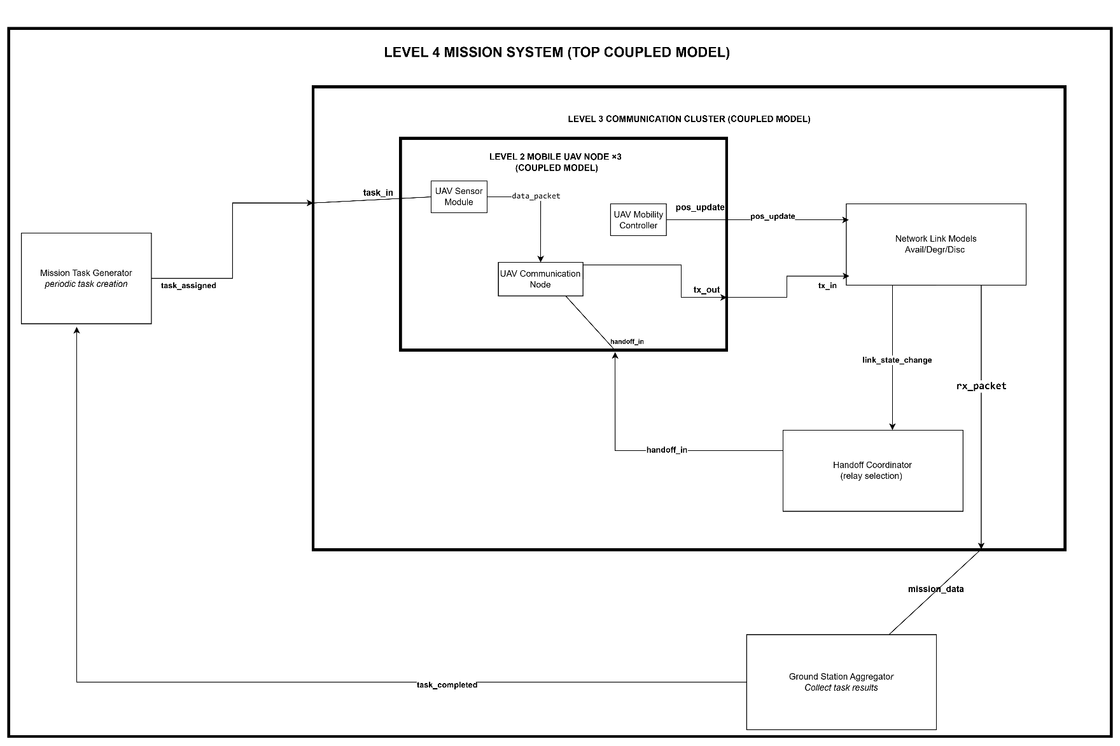
Model Structure
The system is built as a four-level DEVS hierarchy.
Level 4 — Mission System (Top Coupled Model)
The top level ties everything together. The Mission Task Generator sends tasks down into the cluster, the cluster processes them, and when enough data has been collected, the Ground Station reports back up that the mission task is done.
Level 3 — Communication Cluster (Coupled Model)
This is where most of the interesting behavior lives. Three UAV nodes operate alongside their respective Network Link Models and a single Handoff Coordinator. The cluster handles all communication between UAVs and the ground, including detecting link failures and triggering relay handoffs.
Level 2 — Mobile UAV Node (Coupled Model, ×3)
Each UAV is its own coupled model containing three components: a Sensor Module, a Mobility Controller, and a Communication Node. From the outside, the node takes in task assignments and handoff commands, and produces transmitted packets and position updates.
Level 1 — Atomic Models
Seven atomic components, each handling one specific piece of behavior.

Atomic Models
Mission Task Generator
Sends out a task_assigned every 60 seconds on a fixed schedule. It does receive task_completed on its input port, but that signal doesn't change its behavior — the periodic timer keeps running regardless. One state: active, Ta = 60 s.
- I: task_completed — O: task_assigned
UAV Sensor Module
Waits in idle until a task_in arrives, then spends 5 seconds sensing before emitting a data_packet and going back to idle. If another task_in comes in while it's already sensing, it's dropped — there's no buffer.
- I: task_in — O: data_packet
UAV Mobility Controller
Has no inputs at all. Every 5 seconds it emits a pos_update with the UAV's current (x, y) position. It never changes state — just keeps broadcasting position autonomously for the whole simulation.
- I: (none) — O: pos_update
UAV Communication Node
Takes a data_packet and spends 1 second transmitting it before emitting tx_out. While it's transmitting, any new packet that arrives gets dropped. handoff_in is the exception — it can arrive at any time and quietly updates where the next packet gets sent (direct vs. relay), without interrupting the current transmission.
- I: data_packet, handoff_in — O: tx_out
Network Link Model
The most complex model in the system. Tracks the UAV's distance from the ground station and maintains one of three stable states: Available, Degraded, or Disconnected, based on thresholds d1 and d2. Two transient zero-time states — Forwarding and Notify — handle packet forwarding and link change notifications. Packets that arrive while disconnected are silently dropped.
- I: tx_in, pos_update — O: rx_packet, link_state_change
Handoff Coordinator
Watches for link_state_change events. Available and Degraded events are filtered out completely. When a Disconnected event comes in, the model waits 1 second then sends a handoff_in to the affected UAV's Communication Node before going back to monitoring.
- I: link_state_change — O: handoff_in
Ground Station Aggregator
Counts incoming mission_data packets. Once three arrive, it immediately outputs task_completed (Ta = 0, no delay), resets its counter, and goes back to waiting for the next batch.
- I: mission_data — O: task_completed

Key Interactions
- Task flow: Generator emits task_assigned → sent to all 3 UAVs as task_in → each UAV starts a sensing cycle
- Data flow: Sensor produces data_packet → passed to Communication Node → transmitted via Network Link → received at Ground Station → task_completed sent back to Generator
- Mobility: Each Mobility Controller independently pushes pos_update every 5 s → Network Link Model uses this to update distance and switch states if needed
- Link failure and handoff: Network Link emits link_state_change(Disconnected) → Handoff Coordinator issues handoff_in after 1 s → Communication Node switches to relay mode
- Relay simplification: Since building a full two-hop relay path would require extra ports and couplings beyond this assignment's scope, relay mode is modeled as a threshold relaxation on the affected Network Link Model (d1 = 200 m, d2 = 400 m). The change takes effect on the next pos_update. This is an acknowledged simplification and is documented in the experimental framework.

Assumptions
- UAVs move at constant speed along fixed trajectories throughout the simulation
- Link quality is determined entirely by distance from the ground station: $d=\sqrt{x^{2}+y^{2}}$, with the station at (0, 0)
- Three UAVs are used — enough to produce meaningful cluster behavior without making the coupling tables unmanageable
- Handoff only triggers on full disconnection; a degraded link on its own is not enough
- The relay mechanism is a threshold relaxation rather than a true forwarding path — this is a deliberate design choice documented as a limitation
- Communication Nodes hold one packet at a time with no queuing
- Threshold updates from handoff take effect on the next pos_update event, not instantaneously, to stay DEVS-compliant

Objective
The model compares two configurations under the same failure conditions: one where UAVs only use direct links, and one where a handoff to relay mode is triggered on disconnection. The metrics being tracked are packet delivery ratio, number of completed mission tasks, and how often handoffs are activated. The point is to see whether even a simplified relay mechanism — with its 1-second delay and threshold-based approximation — makes a measurable difference in how many packets actually reach the ground station.

Formal DEVS Specification of the UAV Swarm Model

1. Model Architecture Refinement
The Part I model defined a four-level DEVS hierarchy: Mission System, Communication Cluster, Mobile UAV Nodes, and their internal components. For Part II, the Privacy Filter and Coverage Monitor were removed, bringing the atomic model count from nine to seven and keeping only the components directly relevant to the handoff scenario. The swarm was fixed at three UAVs to avoid dynamic coupling. The Communication Node was reduced to a single-packet buffer with a binary mode flag, and the Network Link was limited to three UAV-to-Ground links and up to two relay links, with state changes driven by position events from the Mobility Controller.

2. Atomic Model Specifications

2.1 Mission Task Generator
Role: Periodically generates surveillance tasks and assigns them to UAVs.
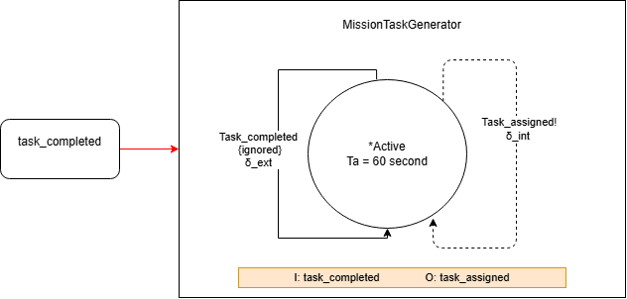
$$X = \{ task_completed \}$$
$$Y = \{ task_assigned \}$$
$$S = \{ active \}$$
$$Initial state: active$$
$$ta(active) = T_task = 60 s$$
$$δext(active, e, x) = active // ignore all external inputs$$
$$δint(active) = active$$
$$λ(active) = task_assigned$$

Behavior: Fires every 60 seconds regardless of external input. task_completed is received but ignored.

2.2 UAV Sensor Module
Role: Receives a task and collects surveillance data.
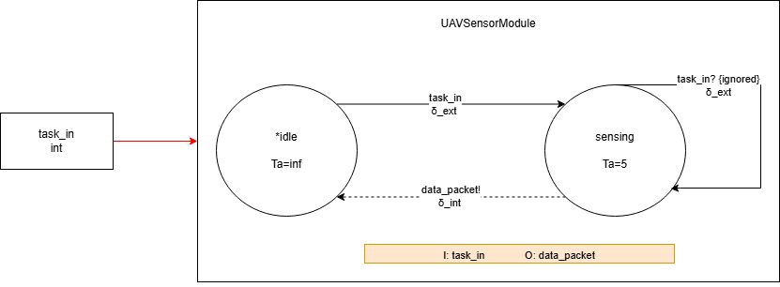

$$X = \{ task_in \}$$
$$Y = \{ data_packet \}$$
$$S = \{ idle, sensing \}$$
$$Initial state: idle$$
$$ta(idle) = ∞$$
$$ta(sensing) = T_sense = 5 s$$
$$δext(idle, e, task_in) = sensing$$
$$δext(sensing, e, x) = sensing // ignore all inputs while sensing$$
$$δint(sensing) = idle$$
$$λ(sensing) = data_packet$$
Behavior: On task_in, enters sensing for 5 seconds, outputs data_packet, then resets to idle. Any input during sensing is ignored.

2.3 UAV Mobility Controller
Role: Updates UAV position periodically and notifies the Network Link Model of each position change.
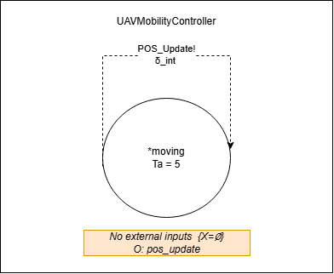
$$X = ∅$$
$$Y = \{ pos_update \}$$
$$S = \{ moving \}$$
$$Initial state: moving$$
$$ta(moving) = T_move = 5 s$$
$$δint(moving) = moving$$
$$λ(moving) = pos_update$$
Behavior: Fires pos_update every 5 seconds. No external inputs.

2.4 Network Link Model
Role: Represents a UAV-to-ground communication link. Reacts to position updates to change link state and forwards or drops packets accordingly.
Initial state: Available
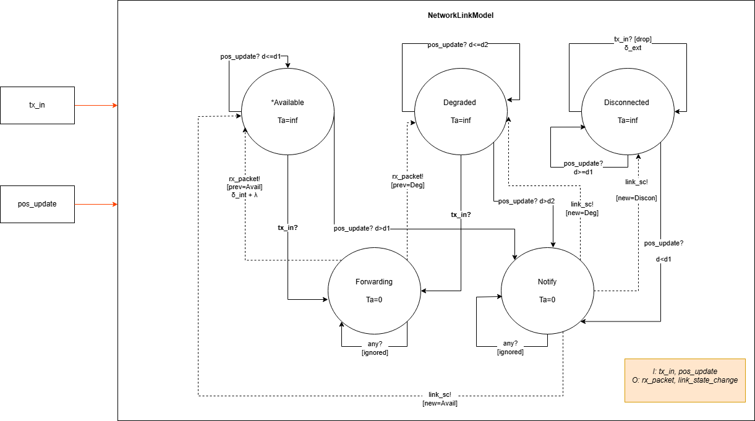
$$X = \{ tx_in, pos_update \}$$
$$Y = \{ rx_packet, link_state_change \}$$
$$S = \{ Available, Degraded, Disconnected, Forwarding, Notify \}$$
$$// Packet handling → enter Forwarding (zero-time), λ fires, δint returns$$
$$δext(Available, e, tx_in) = Forwarding (prev_state = Available)$$
$$δext(Degraded, e, tx_in) = Forwarding (prev_state = Degraded)$$
$$δext(Disconnected, e, tx_in) = Disconnected // drop silently, no state change, no output$$
$$// Threshold crossed → enter Notify (zero-time), λ fires, δint returns$$
$$δext(Available, e, pos_update → d > d1) = Notify (new_state = Degraded)$$
$$δext(Degraded, e, pos_update → d > d2) = Notify (new_state = Disconnected)$$
$$δext(Disconnected, e, pos_update → d < d1) = Notify (new_state = Available)$$
$$// No threshold crossed → stay, no output$$
$$δext(Available, e, pos_update → d ≤ d1) = Available$$
$$δext(Degraded, e, pos_update → d ≤ d2) = Degraded$$
$$δext(Disconnected, e, pos_update → d ≥ d1) = Disconnected$$
$$// Ignore concurrent inputs in transient states$$
$$δext(Forwarding, e, x) = Forwarding$$
$$δext(Notify, e, x) = Notify$$
$$ta(Available) = ∞$$
$$ta(Degraded) = ∞$$
$$ta(Disconnected) = ∞$$
$$ta(Forwarding) = 0$$
$$ta(Notify) = 0$$
$$δint(Forwarding) = prev_state // return to stable link state$$
$$δint(Notify) = new_state // transition to new link state$$
$$λ(Forwarding) = rx_packet$$
$$λ(Notify) = link_state_change(new_state)$$

Behavior: Each pos_update recomputes d. If a threshold is crossed, the link changes state and emits link_state_change. Packets are forwarded as rx_packet in Available or Degraded, and dropped silently in Disconnected.

2.5 Handoff Coordinator
Role: Triggers a relay handoff when a link disconnects.
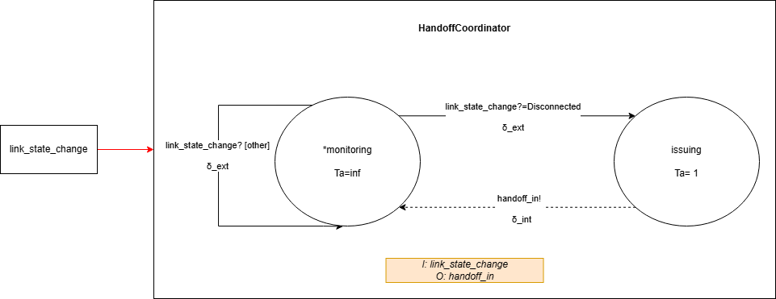
$$X = \{ link_state_change \}$$
$$Y = \{ handoff_in \}$$
$$S = \{ monitoring, issuing \}$$
$$Initial state: monitoring$$
$$Internal variable: relay_target_id$$
$$ta(monitoring) = ∞$$
$$ta(issuing) = T_handoff = 1 s$$
$$δext(monitoring, e, link_state_change = Disconnected) = issuing$$
$$δext(monitoring, e, other) = monitoring$$
$$δint(issuing) = monitoring$$
$$λ(issuing) = handoff_in$$
Behavior: On Disconnected, moves to issuing, waits 1 second, outputs handoff_in, then resets to monitoring.

2.6 UAV Communication Node
Role: Sends data packets to the Network Link Model. Mode selects whether the destination is the ground station (direct) or a relay UAV (relay).
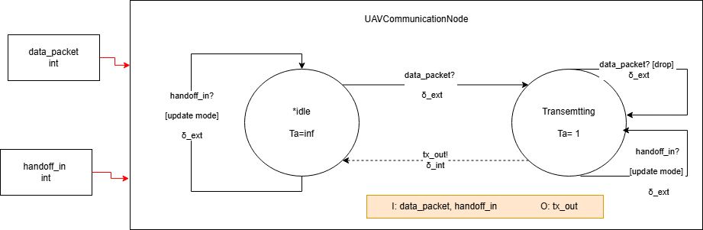
$$X = \{ data_packet, handoff_in \}$$
$$Y = \{ tx_out \}$$
$$S = \{ idle, transmitting \}$$
$$Initial state: idle$$
$$Internal variables: mode ∈ \{direct, relay\}, relay_target_id$$
$$ta(idle) = ∞$$
$$ta(transmitting) = T_tx = 1 s$$
$$δext(idle, e, data_packet) = transmitting$$
$$δext(idle, e, handoff_in) = idle$$
$$δext(transmitting, e, data_packet) = transmitting$$
$$δext(transmitting, e, handoff_in) = transmitting$$
$$δint(transmitting) = idle$$
$$λ(transmitting) = tx_out(packet, destination)$$
Behavior: Buffers one packet at a time. On data_packet, transmits for 1 second and outputs tx_out with destination set by mode — ground station if direct, relay UAV if relay. Extra packets during transmission are dropped. handoff_in updates mode and relay_target_id without interrupting the current state.

2.7 Ground Station Aggregator
Role: Receives mission data from UAVs and signals task completion when all expected packets arrive.
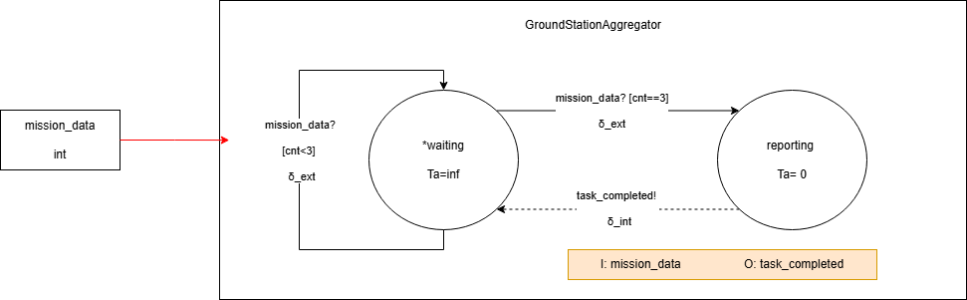

$$X = \{ mission_data \}$$
$$Y = \{ task_completed \}$$
$$S = \{ waiting, reporting \}$$
$$Initial state: waiting$$
$$Internal variables: received_count, expected_count = 3$$
$$ta(waiting) = ∞$$
$$ta(reporting) = 0$$
$$δext(waiting, e, mission_data):$$
$$received_count++$$
$$if received_count == expected_count$$
$$→ reporting$$
$$else$$
$$→ waiting$$
$$δint(reporting):$$
$$received_count = 0$$
$$→ waiting$$
$$λ(reporting) = task_completed$$

Behavior: Counts incoming packets. When all 3 arrive, outputs task_completed instantly, resets the counter, and waits for the next round.

3. Coupled Model Specifications
There are three coupled models in the hierarchy: Level 2 (Mobile UAV Node), Level 3 (Communication Cluster), and Level 4 (Mission System — top model).
3.1 Level 2 — Mobile UAV Node
Components: UAV Sensor Module (SM), UAV Mobility Controller (MC), UAV Communication Node (CN)
Ports:
$$X_L2 = \{ task_in \}$$
$$Y_L2 = \{ tx_out, pos_update \}$$
EIC
From (external) | To (internal)
L2.task_in | SM.task_in

IC
From | To
SM.data_packet | CN.data_packet
EOC
From (internal) | To (external)
CN.tx_out | L2.tx_out
MC.pos_update | L2.pos_update

3.2 Level 3 — Communication Cluster
Components: Mobile UAV Node ×3 (UAV1, UAV2, UAV3), Network Link Model ×3 (NL1, NL2, NL3), Handoff Coordinator (HC)
Note: handoff_in is broadcast to all UAVs in this model. Targeted per-UAV handoff routing is deferred to future work.
Ports:
$$X_L3 = \{ task_in \}$$
$$Y_L3 = \{ rx_packet \}$$
EIC
From (external) | To (internal)
L3.task_in | UAV1.task_in
L3.task_in | UAV2.task_in
L3.task_in | UAV3.task_in
IC
From | To | Purpose
UAV1.tx_out | NL1.tx_in | UAV1 packets → Link1
UAV2.tx_out | NL2.tx_in | UAV2 packets → Link2
UAV3.tx_out | NL3.tx_in | UAV3 packets → Link3
UAV1.pos_update | NL1.pos_update | UAV1 position → Link1
UAV2.pos_update | NL2.pos_update | UAV2 position → Link2
UAV3.pos_update | NL3.pos_update | UAV3 position → Link3
NL1.link_state_change | HC.link_state_change | Link1 state → Handoff
NL2.link_state_change | HC.link_state_change | Link2 state → Handoff
NL3.link_state_change | HC.link_state_change | Link3 state → Handoff
HC.handoff_in | UAV1.handoff_in | Handoff → UAV1 comm node
HC.handoff_in | UAV2.handoff_in | Handoff → UAV2 comm node
HC.handoff_in | UAV3.handoff_in | Handoff → UAV3 comm node

EOC
From (internal) | To (external)
NL1.rx_packet | L3.rx_packet
NL2.rx_packet | L3.rx_packet
NL3.rx_packet | L3.rx_packet

3.3 Level 4 — Mission System (Top Model)
Components: Mission Task Generator (MTG), Communication Cluster (L3), Ground Station Aggregator (GSA)
Ports:
$$X_L4 = ∅ (top model - no external inputs)$$
$$Y_L4 = ∅ (top model - no external outputs)$$
EIC
None (X_L4 = ∅)
IC
From | To | Purpose
MTG.task_assigned | L3.task_in | Tasks → UAV swarm
L3.rx_packet | GSA.mission_data | Received packets → aggregator
GSA.task_completed | MTG.task_completed | Completion feedback → generator
EOC
$$None (Y_L4 = ∅)$$

Cadmium Implementation and Simulation Results

Experimentation Strategy

The experimentation strategy follows an incremental approach. Testing begins with individual atomic models executed in isolation to verify state transitions, timing behavior, and output correctness. It then progresses to coupled simulations to evaluate system-level interactions. Three experiments are defined: (1) atomic unit tests for each model, (2) a baseline coupled simulation without handoff to measure packet loss under link degradation, and (3) a full system simulation with handoff enabled for comparison. This layered approach ensures correctness at each level before introducing additional coupling complexity.

Specification Refinements During Implementation

A few adjustments were made during implementation to better align the code with the intended system behavior. The HandoffMsg was changed from a single integer to a structured message {affected_uav_id, relay_target_id}. This made it clear which UAV should react to a handoff event and avoided ambiguity when multiple UAVs were present.

The initial sigma value in the UAVMobilityController was also corrected from 0 to 5 seconds so that the first pos_update occurs at t = 5, consistent with the Ta = 5 s specification in the state diagram.

Additionally, input parsers for PosUpdateMsg and LinkStateMsg were updated to validate comma-separated formatting. This prevents malformed input lines from being silently accepted.

For Experiment 2, a separate coupled model (CommunicationClusterNoHandoff) was created. Instead of disabling the handoff logic at the top level, the HandoffCoordinator was removed directly from the cluster wiring. This ensured that the baseline experiment was structurally isolated in a clean and consistent way.

2. Atomic Model Test Results (Experiment 1)

Each atomic model was driven individually via an IEStream input file and output logged to logs/exp1x_<model_name>.log.

Exp 1a — MissionTaskGenerator: task_assigned output confirmed at t=60, 120, 180 (Ta=60 s). External task_completed inputs received and correctly ignored — sigma did not reset. PASS.

$$60;18;mission_task_generator;task_assigned;1$$
$$60;18;mission_task_generator;;sigma:60$$
$$120;18;mission_task_generator;task_assigned;1$$
$$180;18;mission_task_generator;task_assigned;1$$

Exp 1b — UAVSensorModule: On task_in, sensing:true entered immediately, data_packet emitted at t=5 (Ta=5 confirmed). Mid-sense inputs silently dropped. Returns to idle correctly after output. PASS.

$$0;6;sensor_module;;sensing:true sigma:5$$
$$5;6;sensor_module;data_packet;1$$
$$5;6;sensor_module;;sensing:false sigma:inf$$

Exp 1c — NetworkLinkModel: Starting Available. On pos_update crossing d1, transient Notify state entered (sigma:0), link_state_change(Degraded) emitted, transitions to stable Degraded. On further crossing d2, transitions to Disconnected. Packets in Disconnected state silently dropped — no rx_packet output. PASS.

$$20;4;nl0;;phase:Notify stable:Available sigma:0$$
$$20;4;nl0;link_state_change;0,Degraded$$
$$20;4;nl0;;phase:Degraded stable:Degraded sigma:inf$$
$$45;4;nl0;link_state_change;0,Disconnected$$

Exp 1d — GroundStationAggregator: Counter increments on each mission_data. When count ≥ expected (3), transitions to reporting (Ta=0), emits task_completed immediately, resets counter to 0, returns to waiting. PASS.

$$66;1;ground_station_aggregator;;count:3 reporting:true sigma:0$$
$$66;1;ground_station_aggregator;task_completed;1$$
$$66;1;ground_station_aggregator;;count:0 reporting:false sigma:inf$$

Exp 1e — HandoffCoordinator: link_state_change(Degraded) filtered — stays in monitoring. link_state_change(Disconnected) triggers issuing (Ta=1). After 1 second, handoff_in emitted, returns to monitoring. PASS.

$$45;3;handoff_coordinator;;issuing:true affected:0 relay:1 sigma:1$$
$$46;3;handoff_coordinator;handoff_in;affected:0 relay:1$$
$$46;3;handoff_coordinator;;issuing:false affected:-1 relay:-1 sigma:inf$$

Exp 1f — UAVCommunicationNode: data_packet triggers 1-second transmission; tx_out emitted at Ta=1. Concurrent data_packet during transmission dropped. handoff_in updates mode flag in both idle and transmitting states without interrupting current transmission. PASS.

$$5;7;comm_node;;transmitting:true mode:direct relay_target:-1 pending:1 sigma:1$$
$$6;7;comm_node;tx_out;1$$
$$6;7;comm_node;;transmitting:false mode:direct relay_target:-1 pending:1 sigma:inf$$

Exp 1g — ```````````````: First pos_update at t=5 (initial sigma=5). Subsequent outputs at t=10, 15, 20, 25, 30, 5-second period confirmed throughout. No external inputs. PASS.

$$5;7;mobility_controller;pos_update;40,0$$
$$10;7;mobility_controller;pos_update;55,0$$
$$15;7;mobility_controller;pos_update;70,0$$

3. Experiment 2 — Baseline: No Handoff
Configuration: MissionSystemNoHandoff using CommunicationClusterNoHandoff — HandoffCoordinator removed entirely from cluster wiring. UAV2 starts at (30,0) with vx=10 m/step; UAV0 and UAV1 static. NL0 thresholds: d1=50 m, d2=100 m.
Key log trace (exp2_baseline_no_handoff.log):

$$t=20 nl0: Notify→Degraded (UAV2 pos_update: 60,0 → d=60 > d1=50)$$
$$t=45 nl0: Notify→Disconnected (UAV2 pos_update: 110,0 → d=110 > d2=100)$$
$$[no handoff issued - HC not present]$$
$$t=60 task_assigned (round 1)$$
$$t=65 data_packet × 3; nl0 comm_node transmitting:true mode:direct$$
$$t=66 nl1 rx_packet, nl2 rx_packet - nl0 drops UAV2 packet (Disconnected)$$
$$GSA count:2$$
$$t=120 task_assigned (round 2)$$
$$t=126 nl1 rx_packet, nl2 rx_packet → GSA count:4 ≥ 3 → task_completed, reset to 0$$
$$t=180 task_assigned (round 3)$$
$$t=186 nl1 rx_packet, nl2 rx_packet → GSA count:2 (no task_completed)$$

Metrics: 9 packets sent, 6 received, PDR = 67%, 1 task_completed event (t=126), 0 handoff activations.

4. Experiment 3 — With Handoff
Configuration: Full MissionSystem with CommunicationCluster including HandoffCoordinator. Identical UAV positions and thresholds.
Key log trace (exp3_with_handoff.log):

$$t=20 nl0: Notify→Degraded (same position trajectory)$$
$$t=45 nl0: Notify→Disconnected$$
$$t=46 HC: issuing:true affected:0 relay:1 (fires after 1 s delay)$$
$$handoff_in(affected:0, relay:1) broadcast to all UAVs$$
$$UAV2 comm_node: mode:relay relay_target:1 ← mode updated$$
$$UAV0, UAV1: mode:direct unchanged (id filter working)$$
$$t=60 task_assigned (round 1)$$
$$t=65 UAV2 comm_node transmitting:true mode:relay relay_target:1$$
$$t=66 nl1 rx_packet, nl2 rx_packet - nl0 still Disconnected, drops UAV2 packet$$
$$GSA count:2$$
$$t=120 task_assigned (round 2)$$
$$t=126 nl1 rx_packet, nl2 rx_packet → GSA count:4 ≥ 3 → task_completed, reset to 0$$
$$t=180 task_assigned (round 3)$$
$$t=186 nl1 rx_packet, nl2 rx_packet → GSA count:2$$

Metrics: 9 packets sent, 6 received, PDR = 67%, 1 task_completed event (t=126), 1 handoff activation.

5. Comparative Analysis

Metric | Exp 2 (No Handoff) | Exp 3 (With Handoff)
Packets sent | 9 | 9
Packets received at GSA | 6 | 6
PDR | 67% | 67%
task_completed events | 1 (t=126) | 1 (t=126)
Handoff activations | 0 | 1
mode:relay switches | 0 | 1

The packet delivery ratio (PDR) and the mission completion time are the same in both experiments. This is expected. Even when relay mode is activated, it only changes an internal mode flag inside UAV2’s Communication Node. The actual connections in the CommunicationCluster do not change. UAV2’s packets are still sent through nl0. Since nl0 stays in the Disconnected state, those packets are dropped before they can reach the ground station.

Relay mode would only improve delivery if the cluster wiring actually changed when a handoff happened. In DEVS, this would require changing the port connections during simulation, which was not implemented in this model.

What the handoff experiment does show is that the control logic works correctly. The Network Link detects when the distance crosses the threshold and sends a link_state_change(Disconnected) message. The HandoffCoordinator receives this message, waits exactly one second (disconnect at t=45, handoff at t=46), and then sends a handoff_in message. The correct UAV updates its communication mode without interrupting any ongoing transmission. The signaling mechanism works as designed.

A future improvement would be to implement a true two-hop relay path so that packets can actually be rerouted through another UAV when a link fails.

6. Changes Relative to Part II Specification

Change | Reason
HandoffMsg upgraded from int to {affected_uav_id, relay_target_id} | Needed explicit per-UAV targeting for mode flag filter
Initial sigma of UAVMobilityController: 0 → 5 | Diagram consistency (Ta=5 s)
Comma validation added to LinkStateMsg / PosUpdateMsg parsers | Robustness against malformed input
CommunicationClusterNoHandoff added as separate coupled model | Required to properly isolate Exp 2 baseline at the correct structural level
Relay implemented as CommNode mode flag only (not true rerouting) | Full dynamic recoupling not DEVS-compliant; documented as acknowledged limitation

