REPUBLIC OF CAMEROON  Peace-Work-Fatherland  *****************  MINISTRY OF HIGHER EDUCATION  *****************  INSTITUT UNIVERSITAIRE DE LA CÔTE  *****************  SCHOOL OF ENGINEERING & APPLIED SCIENCES  ***************** | REPUBLIQUE DU CAMEROUN  Paix-Travail-Patrie  *****************  MINISTERE DE L'ENSEIGNEMENT SUPERIEUR  *****************  INSTITUT UNIVERSITAIRE DE LA CÔTE  *****************  SCHOOL OF ENGINEERING & APPLIED SCIENCES  *****************

  [[Soro Nua Agency logo]]
INTERNSHIP REPORT
DEVELOPMENT OF AN ADVERTISING CAMPAIGN PERFORMANCE PREDICTION TOOL FOR SORO NUA AGENCY (SORO NUA CAMPAIGN PREDICTOR)

An internship done from the 22nd of June to the 27th of August 2026, with report submitted to the Department of Engineering, SEAS-IUC, in partial fulfilment of the requirements for the award of a Bachelor of Engineering (B. Eng.) degree in Computer Science and Engineering
Written and Presented by:
MEKA-MEVOUNG JEAN DAUNICK, IUC………… (matricule)
Cycle: Bachelor of Engineering (B. Eng.)
Speciality: Computer Science and Engineering (CSE)
Under the supervision of:
Mr./Mrs. ACADEMIC SUPERVISOR NAME  ACADEMIC SUPERVISOR | Mr./Mrs. PROFESSIONAL SUPERVISOR NAME  PROFESSIONAL SUPERVISOR

2025/2026

APPROVAL
This internship report has been approved and accepted in partial fulfilment of the requirements for the Award of a Bachelor of Engineering (B. Eng.) degree in Computer Science and Engineering (CSE).
PROFESSIONAL SUPERVISOR:
Mr./Mrs. PROFESSIONAL SUPERVISOR NAME
Signature: ___________________________
Date: _______________________
ACADEMIC SUPERVISOR:
Mr./Mrs. ACADEMIC SUPERVISOR NAME
Signature: ___________________________
Date: _______________________
HEAD OF DEPARTMENT:
Mr./Mrs. HEAD OF DEPARTMENT NAME
Signature: ___________________________
Date: _______________________

CERTIFICATION
I, MEKA-MEVOUNG JEAN DAUNICK, declare that I am the author of this report. I declare that this is an original work by me, containing no material previously published by another individual, except where legitimate acknowledgement has been made.

DEDICATION

I dedicate this work to my Family
Edit this dedication as you wish.

ACKNOWLEDGEMENT
This report is the product of individual research, weeks of work, assistance and support, which allowed me to reach my goals in studies and professional experience. Its accomplishment required the help of several people who, from near or far, provided their professional, moral, material and intellectual support. I wish to express my gratitude to the following persons:
- Mr. GUIMEZAP Paul, Founder and President of IUC, for the establishment of this institution devoted to training students.
- Academic supervisor name, my Academic supervisor, for his/her guidance, advice and availability throughout this internship and the writing of this report.
- Professional supervisor name, my Professional supervisor at Soro Nua Agency, for giving me the opportunity to carry out this project, for his/her trust, attention and precious remarks.
- Names, the management and the marketing team of Soro Nua Agency, whose daily work inspired the problem addressed by this project.
- My teachers at SEAS-IUC, who taught me the science of my field of study, and all my friends and colleagues who contributed to this work.
I am very grateful to my beloved family, most especially my mother/parents, for their persistent moral and financial support in every aspect of my education. Edit this paragraph as you wish.

ABSTRACT
This internship report presents the design and implementation of Soro Nua Campaign Predictor, an internal web tool that predicts the performance of online advertising campaigns for Soro Nua Agency, a company based in Douala, Cameroon. The project was carried out as part of the requirements for the Bachelor of Engineering (B.Eng.) degree in Computer Science and Engineering (CSE) at the Institut Universitaire de la Côte (IUC), during an internship held from 22nd June to 27th August 2026.
Before launching a campaign, the agency decides on the budget, the channel, the campaign type and the target audience from experience and guesswork: nobody can tell beforehand which results the campaign will produce. The implemented solution lets a member of the marketing team describe a campaign and obtain three predicted figures — the click-through rate, the conversion rate and the number of website visits — together with an expected performance level (low, medium or high), the factors that weigh most on each figure, and up to three suggested changes that would improve the result. Administrators can import the agency's own data in CSV format, train new versions of the model and activate them.
The system is built with Python, FastAPI and XGBoost for the prediction service, Next.js, TypeScript and Tailwind for the interface, and a self-hosted Supabase stack (PostgreSQL, authentication, storage) with row-level security for the data. Every component runs in a Docker container. The work followed an incremental, test-first approach with phases documented in a roadmap. Because the starting dataset (8,000 rows) is synthetic and almost free of signal, the measured reliability of the model is honestly reported as low; the value of the tool will appear when the agency feeds it with its real campaign data. The project demonstrates a complete, secure and reproducible machine-learning application, from data to interface.
Keywords: Campaign performance prediction, Online advertising, Machine learning, XGBoost, FastAPI, Next.js, Supabase, Docker, Soro Nua Agency.

RESUME
Ce rapport de stage présente la conception et la réalisation de Soro Nua Campaign Predictor, un outil web interne qui prédit la performance des campagnes publicitaires en ligne de Soro Nua Agency, entreprise basée à Douala (Cameroun). Ce projet a été réalisé dans le cadre de l'obtention du Diplôme de Bachelor en Ingénierie (B.Eng.) en Informatique et Génie Informatique à l'Institut Universitaire de la Côte (IUC), lors d'un stage effectué du 22 juin au 27 août 2026.
Avant de lancer une campagne, l'agence fixe le budget, le canal, le type de campagne et l'audience visée à partir de l'expérience et de suppositions : personne ne peut savoir à l'avance quels résultats la campagne produira. La solution réalisée permet à un membre de l'équipe marketing de décrire une campagne et d'obtenir trois chiffres prédits — le taux de clic, le taux de conversion et le nombre de visites sur le site — ainsi qu'un niveau de performance attendu (faible, moyen ou élevé), les éléments qui pèsent le plus sur chaque chiffre et jusqu'à trois changements proposés pour améliorer le résultat. Les administrateurs peuvent importer les données de l'agence au format CSV, entraîner de nouvelles versions du modèle et les activer.
Le système repose sur Python, FastAPI et XGBoost pour le service de prédiction, Next.js, TypeScript et Tailwind pour l'interface, et une pile Supabase auto-hébergée (PostgreSQL, authentification, stockage) avec sécurité au niveau des lignes. Chaque composant tourne dans un conteneur Docker. Le travail a suivi une démarche incrémentale, où les tests sont écrits avant le code, découpée en phases consignées dans une feuille de route. Le jeu de données de départ (8 000 lignes) étant synthétique et quasiment sans signal, la fiabilité mesurée du modèle est présentée honnêtement comme faible ; l'intérêt de l'outil apparaîtra lorsque l'agence l'alimentera avec ses vraies données de campagnes.
Mots-clés : Prédiction de performance publicitaire, Publicité en ligne, Apprentissage automatique, XGBoost, FastAPI, Next.js, Supabase, Docker, Soro Nua Agency.

PREFACE
In today's competitive landscape, employers are seeking individuals who not only have the right qualifications but also demonstrate the ability to apply their knowledge effectively. To stay ahead in a rapidly changing job market, it is crucial to acquire practical, high-quality technical skills that align with both personal growth and the needs of the industry. To address this demand, various Private Institutions of Higher Education (PIHE) have emerged in Cameroon, with the Higher Institute of Technologies and Industrial Design (ISTDI) at the forefront, dedicated to training a new generation of skilled technicians and engineers prepared to meet the challenges of a dynamic workforce.
The Minister of Higher Education in Cameroon has facilitated this by authorizing the creation of several institutes, including ISTDI, through the following ministerial orders:
- Authorization of creation: No 02/0094/INESUP/DDES/ESUP of 13 September 2002
- Authorization to open: No 0102/MINEWSSUP/DDES/ESUP of 18 September 2002
ISTDI was officially recognized as a "University Institute of the Coast" (IUC) by Order No 1/0556/N/MMINESUP/DDES/ESUP/SAC/EBM on 24 October 2011. The institution is part of a broader network of specialized training centres under IUC, which includes:
- ISTDI — Higher Institute of Technologies and Industrial Design (BTS, HND, professional licences and masters, engineering course in industrial engineering);
- ICIA — Business Engineering Institute (commercial BTS, business professional licences, ISUGA-France master);
- 3IAC — Institute of Computer Engineering of Central Africa (preparatory classes, ICT cycle, European master, computer engineering course);
- PISTI — International Programme of Science and Technology Innovations (preparatory classes, licence in science and technology, aviation, engineering cycles with partner universities);
- SEAS — School of Engineering and Applied Science.
The School of Engineering and Applied Science (SEAS), in which this internship report is submitted, trains in the following cycles: HND commercial fields (accounting, marketing, international trade, banking and finance, project management, human resource management, logistics and transport management); HND industrial fields (civil engineering, chemical engineering, software engineering, networks and security, telecommunication, electrical power system, mechanical fabrication, welding and boiler making, industrial automation and computing); Bachelor of Engineering (B.Eng.) in computer engineering, civil and environmental engineering, electromechanical engineering, and chemical and process engineering; Bachelor of Technology (B.Tech.); Bachelor of Business Administration (B.BA); Bachelor of Health Science (B.HES) and Bachelor of Agriculture (B.Agri.).
The training of the B.Eng. degree in Computer Science and Engineering includes a compulsory professional internship, which allows students to put into practice, in a company, the knowledge acquired in class. This report is the outcome of that internship.

TABLE OF CONTENTS
APPROVAL i
CERTIFICATION ii
DEDICATION iii
ACKNOWLEDGEMENT iv
ABSTRACT v
RESUME vi
PREFACE vii
GENERAL INTRODUCTION 1
PART ONE: CONCEPTUAL FRAMEWORK 1
CHAPTER 1: PRESENTATION OF THE COMPANY — SORO NUA AGENCY — AND ACTIVITIES CARRIED OUT DURING THE INTERNSHIP PERIOD 3
1. PRESENTATION OF THE COMPANY 3
1.1 COMPANY DESCRIPTION 3
1.2 ORGANIZATION AND FUNCTIONING 3
1.3 ORGANIZATIONAL STRUCTURE 3
1.4 LOCATION 3
1.5 MISSION AND VISION 3
1.6 PRODUCTS AND SERVICES 3
1.7 CORE VALUES 4
2. EVOLUTION OF INTERNSHIP ACTIVITIES AT SORO NUA AGENCY 4
2.1 WELCOME AND CONTACT 4
2.2 WORKS CARRIED OUT 4
2.3 WORKING METHOD 5
3. CHOICE AND JUSTIFICATION OF THE RESEARCH TOPIC 6
CHAPTER 2: OVERVIEW AND GENERALITIES ON THE TOPIC 7
INTRODUCTION 7
1. PROBLEM CONTEXT AND BACKGROUND 7
2. RELEVANCE AND MOTIVATION 7
3. OVERVIEW OF EXISTING SYSTEMS 7
4. BASIC CONCEPTS 8
4.1 SUPERVISED REGRESSION 8
4.2 GRADIENT BOOSTING AND XGBOOST 8
4.3 EVALUATION ON HELD-OUT DATA 8
4.4 EXPLAINING A PREDICTION 8
4.5 ROW-LEVEL SECURITY 8
PART TWO: EMPIRICAL STUDY 1
CHAPTER 3: METHODOLOGY AND MATERIAL USED 10
1. METHODOLOGY OVERVIEW 10
1.1 REQUIREMENT ANALYSIS 10
1.2 TOOLS AND MODEL SELECTION & JUSTIFICATION 10
1.3 SYSTEM ARCHITECTURE DESIGN 12
1.4 DATA USED 12
1.5 IMPLEMENTATION OF CORE MODULES 13
1.5.1 DATA LOADING AND CSV VALIDATION 13
1.5.2 TRAINING THE THREE MODELS 13
1.5.3 PREDICTION AND DERIVED FIGURES 13
1.5.4 PERFORMANCE LEVEL 14
1.5.5 FACTORS BEHIND A PREDICTION 14
1.5.6 RECOMMENDATIONS 14
1.5.7 AUTHENTICATION, ROLES AND ISOLATION 14
1.5.8 HISTORY 14
1.5.9 USER INTERFACE 14
1.5.10 IMPORT OF AGENCY DATA AND RETRAINING 17
2. UML DIAGRAMS 17
2.1 USE-CASE DIAGRAM 17
2.2 DATA MODEL (CLASS DIAGRAM) 18
2.3 SEQUENCE DIAGRAM 18
3. TESTING & VALIDATION 19
4. ITERATION & OPTIMIZATION 19
5. TECHNOLOGICAL ADVANCEMENTS AND FEASIBILITY 19
6. EXPECTED IMPACT 19
CHAPTER 4: RESULT ANALYSIS AND DISCUSSION 21
1. RESULTS OBTAINED 21
2. MODEL RESULTS 21
3. DISCUSSION 21
4. LIMITATIONS AND PROPOSED IMPROVEMENTS 22
5. PERSPECTIVES 22
CONCLUSION 23
BIBLIOGRAPHY AND WEBOGRAPHY 24
I. WEB REFERENCES AND DOCUMENTS 24
II. SCIENTIFIC REFERENCES 24
III. REPORTS 24
APPENDICES 25
APPENDIX A: FIXED PARAMETERS OF THE THREE MODELS 25
APPENDIX B: DETERMINISTIC RULE FOR TEST ROWS 25
APPENDIX C: RUNNING THE DEMONSTRATION 25
APPENDIX D: REPOSITORY STRUCTURE (MAIN FOLDERS) 25

LIST OF FIGURES
Figure 1: Architecture of the solution (local demonstration environment) 12
Figure 2: Predict page (interface prototype; values are illustrative) 15
Figure 3: Model page: reliability on held-out test rows and importance of the variables (prototype, illustrative values) 16
Figure 4: Models page (administrator): versions, status, comparison with the active version 16
Figure 5: History page: a user sees only their own saved predictions 17
Figure 6: Use-case diagram 17
Figure 7: Data model of the application 18
Figure 8: Sequence diagram of a prediction 18

LIST OF TABLES
Table 1: Overview of activities carried out 5
Table 2: User roles 10
Table 3: Software materials used 11
Table 4: Hardware tools 11
Table 5: APIs and services 12
Table 6: Variables of the starting dataset 13
Table 7: Testing levels 19
Table 8: Success criteria of the brief and their status 21
Table 9: Limitations and proposed improvements of the designed system 22
Table 10: Main folders of the repository 26

LIST OF ACRONYMS
API: Application Programming Interface
CORS: Cross-Origin Resource Sharing
CSV: Comma-Separated Values
CTR: Click-Through Rate
DB: Database
HTTP(S): HyperText Transfer Protocol (Secure)
JSON: JavaScript Object Notation
JWT: JSON Web Token
MAE: Mean Absolute Error
ML: Machine Learning
PRD: Product Requirements Document
R²: Coefficient of determination
RLS: Row-Level Security
SHAP: SHapley Additive exPlanations
SME: Small and Medium-sized Enterprise
TDD: Test-Driven Development
UI / UX: User Interface / User Experience
UML: Unified Modeling Language
XGBoost: eXtreme Gradient Boosting
pgTAP: Unit testing framework for PostgreSQL

GENERAL INTRODUCTION
Online advertising has become one of the main ways in which companies reach their customers. Every day, agencies decide how much money to spend on a given channel — email, paid search, organic search, social media or referral — for a given type of campaign (awareness, consideration, conversion or retention) and for a given audience. These decisions are costly, and their consequences are known only afterwards: once the budget is spent, the campaign is already running or over. In many agencies of the sub-region, including in Douala, such choices still rest mostly on the experience of the team and on assumptions.
Machine learning offers an alternative: by learning from the results of past campaigns, a statistical model can estimate, before launching, what a new campaign is likely to produce. This does not replace the expertise of the marketing team; it gives it a figure to discuss, to compare and to challenge.
This is the context of the project carried out during my internship at Soro Nua Agency, from 22nd June to 27th August 2026. The project, named Soro Nua Campaign Predictor, is an internal web tool through which a member of the marketing team describes an online advertising campaign and obtains the predicted click-through rate, conversion rate and number of website visits, an expected performance level, the factors that weigh most on each figure and up to three suggested changes. The agency can later import its own data, in the same format as the starting dataset, and retrain the model.
The main objectives of this internship were:
- to understand the needs of the agency and translate them into a validated product brief;
- to design and build a secure, containerized web application around three XGBoost prediction models;
- to explain every prediction (performance level, factors, advice) in language a non-developer can use;
- to measure and present honestly the reliability of the predictions on data kept aside during training.
The report is divided into two parts:
PART ONE: CONCEPTUAL FRAMEWORK
Chapter 1: Presentation of the company and activities carried out during the internship period
Chapter 2: Overview and generalities on the topic studied
PART TWO: EMPIRICAL STUDY
Chapter 3: Methodology and material used
Chapter 4: Result analysis and discussion
The report ends with a general conclusion, followed by the bibliography and the appendices.

PART ONE: CONCEPTUAL FRAMEWORK

CHAPTER 1
PRESENTATION OF THE COMPANY — SORO NUA AGENCY — AND ACTIVITIES CARRIED OUT DURING THE INTERNSHIP PERIOD
Sections 1.1 to 1.7 below were written from the information available in the project documents (Soro Nua Agency, Douala, online advertising). Every highlighted passage is an assumption: replace it with the real information of the company, then remove the highlight.

1. PRESENTATION OF THE COMPANY

1.1 COMPANY DESCRIPTION
Ets Soro Nua Agency is an advertising and digital marketing agency based in Douala, the economic capital of Cameroon. The agency plans and runs online advertising campaigns for its clients. Founded in (year), the agency … (add legal form, size, number of employees and main clients sectors).

1.2 ORGANIZATION AND FUNCTIONING
The organization of the agency is designed to ensure efficient management of operations and smooth collaboration between its areas of expertise. It is made up of the following departments: Management, Marketing and campaign planning, Creative and content, Data / administration, Accounting. (Replace by the real departments.)
For this project, two profiles of the agency are concerned: the marketing team, which prepares and plans the online campaigns and will use the tool every day, and the person in charge of data, who will import the agency's campaign files and manage the model versions.

1.3 ORGANIZATIONAL STRUCTURE
Insert here the organizational chart of Soro Nua Agency (Management → departments → teams), as a figure captioned "Figure: Hierarchical architecture of Soro Nua Agency".

1.4 LOCATION
The head office of the agency is located in Douala, Cameroon. Add the exact address, telephone and e-mail, and a map figure sourced from Google Maps if you wish.

1.5 MISSION AND VISION
Mission. To help its clients reach their audience and grow through well-planned, measurable online advertising campaigns.
Vision. To become a reference agency of data-driven advertising in Cameroon and in Central Africa.

1.6 PRODUCTS AND SERVICES
Typical services of such an agency (to be adjusted):
- Online campaign planning and management: channel, budget and audience choices for email, paid search (PPC), organic search (SEO), social media and referral campaigns.
- Digital marketing strategy: awareness, consideration, conversion and retention campaigns.
- Reporting: follow-up of clicks, conversions and visits on the clients' websites.

1.7 CORE VALUES
Creativity, transparency, expertise and client satisfaction (replace by the values stated by the agency).

2. EVOLUTION OF INTERNSHIP ACTIVITIES AT SORO NUA AGENCY
The internship consisted of the study, design and development of the Soro Nua Campaign Predictor, which allowed me to put my classroom knowledge into practice: software engineering, databases, web development, machine learning and DevOps. This section details the activities carried out from the first day to the last, the tools used, the skills acquired and the challenges met.

2.1 WELCOME AND CONTACT
I arrived at the agency on 22nd June 2026, where I was received by professional supervisor name and title. I was introduced to the team, to the way the agency prepares its campaigns, to the working rules and to the project expected from me. The need was explained: give the marketing team a figure — and not only an intuition — before a campaign is launched.

2.2 WORKS CARRIED OUT
The internship lasted ten weeks, from 22 June to 27 August 2026. The table below presents the activities by week.
The weekly distribution below is a reconstruction based on the order of the project phases. Compare it with your logbook and correct the dates, challenges and tools if needed.
Period | Activities carried out | Tools / technologies | Achievements / skills acquired | Challenges / problems faced | Results / deliverables
Week 1  22–26 Jun | Welcome, discovery of the agency, understanding of the problem and of the users | Meetings, notes | - Knowledge of the agency and its way of planning campaigns  - Identification of the users and their needs | Turning a vague need into a precise one | Project brief (problem, users, success criteria)
Week 2  29 Jun–3 Jul | Requirements analysis, product requirements document, choice of the stack | Markdown documents, Git | - Writing functional requirements and user stories  - Choice of an imposed, coherent stack | Deciding what is in and out of the first version | PRD, architecture and data model documents
Week 3  6–10 Jul | Study of the starting dataset (8,000 rows) and of the first models | Python, pandas, XGBoost, Jupyter notebooks (in Docker) | - Data profiling, train/test splitting  - Honesty checks (shuffled target, cross-validation) | Dataset is synthetic: almost no relation between inputs and results | Three analysis notebooks, measured baseline (R² ≈ 0)
Week 4  13–17 Jul | Repository foundation, Docker environment, API and web skeletons, self-hosted Supabase stack | Docker Compose, FastAPI, Next.js, Supabase, Makefile | - Containerizing every component  - Reproducible environments with one command | Configuring the Supabase services and keys without leaking secrets | Application starting with make up; health and readiness pages
Week 5  20–24 Jul | Authentication, user management, audit log, row-level security | Supabase Auth, PostgreSQL RLS, pgTAP, pytest | - Roles (admin, marketer), invitations  - Writing database tests before the policies | Guarantee that a user never sees another user's data | Sign-in, password screens, admin users page, audit log
Week 6  27 Jul–31 Jul | Loading of the starting dataset, training of the three XGBoost models, evaluation | Python, XGBoost, pandas, Supabase Storage | - Deterministic test rows (about 20 %)  - Model versioning and artifacts | Reliability is low with synthetic data; how to present it honestly | Models page: train, review and activate a version
Week 7  3–7 Aug | Campaign form, prediction of the three figures, derived metrics and performance level | Next.js, React Hook Form, Zod, FastAPI, Pydantic | - Validation at the boundary (Zod, Pydantic)  - Scoring against campaigns of the same type | Defining a fair score for different campaign types | Predict page with figures, level and score
Week 8  10–14 Aug | Factors behind each prediction and advice engine (up to three changes) | XGBoost contributions, NumPy, Recharts | - Explaining model outputs  - Testing alternative values lever by lever | Advice often limited to the budget because of the synthetic data | Factors charts and recommendations with Apply button
Week 9  17–21 Aug | Prediction history, user isolation, import of agency CSV files, alignment with the UI prototype, one-command demonstration | Playwright, Vitest, Docker, CSV validation | - End-to-end tests of user journeys  - Safe import (formula-injection checks) | Rejecting invalid files with clear messages | History page, Data page, make demo / start.sh
Week 10  24–27 Aug | Final tests, documentation, demonstration, drafting of the report | Make, pytest, pgTAP, Markdown | - Consolidating documentation and decisions log  - Presenting results honestly | Time management for the final deliverables | Demonstration route, documentation, this report
Table 1: Overview of activities carried out

2.3 WORKING METHOD
Throughout the internship, the work followed a few rules that structured the project:
- Documents first. Thirteen reference documents (brief, product requirements, architecture, data model, API specification, low-level design, conventions, environment, testing, security, CI/CD, roadmap and decisions log) were written before the code.
- Tests before code. For each behaviour, the test is written first, seen failing, then the code is written until it passes.
- Small phases. The roadmap cuts the project into phases, each producing a visible result on screen.
- Decisions log. Every technical choice not covered by the documents is recorded with its date, reason and the documents updated.
- Everything in containers. No component is installed directly on the machine: tests, checks and migrations run through the Makefile in Docker images.

3. CHOICE AND JUSTIFICATION OF THE RESEARCH TOPIC
Marketing teams deal every day with the same uncertainty: how much to spend, on which channel and for which audience, without knowing what the campaign will bring. The choice of this topic comes from this observation, made at Soro Nua Agency, and from the fact that the agency does not yet own a structured history of its campaigns, which makes any numerical support valuable.
The topic combines several fields studied during the training — databases, web development, software security, machine learning and deployment with containers — in a single realistic product, built for a real user who is not a developer. It also forces to deal with the real difficulties of data projects: scarce or synthetic data, honest evaluation of a model, explanation of its outputs and protection of users' data.
The chosen topic is therefore: Development of an advertising campaign performance prediction tool for Soro Nua Agency (Soro Nua Campaign Predictor).

CHAPTER 2
OVERVIEW AND GENERALITIES ON THE TOPIC

INTRODUCTION
The project rests on three pillars: the description of a campaign by the user, the prediction of its results by a model learned from past campaigns, and the explanation and advice that make these predictions usable. Before presenting the solution, this chapter explains the problem, the relevance of the topic, the existing approaches and the basic concepts needed to understand the rest of the report.

1. PROBLEM CONTEXT AND BACKGROUND
At Soro Nua Agency, online advertising campaigns are planned from the experience of the team or from assumptions. When the budget, the channel, the campaign type and the target audience are chosen, nobody can know in advance what results the campaign will produce. Three limits follow:
- Experience and intuition do not give a numerical or verifiable answer. They do not say how many clicks, conversions or visits to expect.
- Real results arrive after the fact. One learns whether the choices were good only when the campaign has run and the budget is spent.
- The agency has no data of its own yet. It has no numerical base on which to rest its decisions.
The product must therefore estimate three figures for a described campaign — the click-through rate, the conversion rate and the number of website visits —, deduce an expected performance level, show what influences the figures and advise on what to change.

2. RELEVANCE AND MOTIVATION
Small and medium agencies rarely have a data-science team. A simple, internal and explainable tool gives them:
- a numerical estimate before spending the budget;
- a way to compare several campaign plans in a few seconds;
- a shared language (the performance level and the factors) between team members;
- a base that improves as soon as the agency adds its own campaign results;
- full control of its data, since the tool is self-hosted and internal.

3. OVERVIEW OF EXISTING SYSTEMS
Advertising platforms such as Google Ads or Meta Ads Manager offer forecasting or estimation features. They are however tied to one platform and to the history of an advertiser's account, and they estimate results of the platform's own delivery system. General marketing-analytics suites and business-intelligence tools provide reporting on past campaigns but do not predict the result of a campaign that has not started. Finally, building a custom model for each agency usually requires data-science skills that small agencies do not have.
Soro Nua Campaign Predictor answers a different need: an internal tool, not tied to one advertising platform, that learns from the data the agency will provide, explains its answers and keeps the data inside the agency's own infrastructure.

4. BASIC CONCEPTS

4.1 SUPERVISED REGRESSION
Predicting a number (a rate, a count) from known inputs is a regression problem. The model learns from past examples, where both the inputs and the result are known, and is then applied to a new case. Here, three independent models are trained, one for each figure to predict.

4.2 GRADIENT BOOSTING AND XGBOOST
XGBoost (Chen and Guestrin, 2016) builds a sequence of small decision trees, each correcting the errors of the previous ones. It handles numerical and categorical data well, trains quickly on tables of a few thousand rows and provides, for each prediction, the contribution of every input variable. It is the method retained as the starting point of the project.

4.3 EVALUATION ON HELD-OUT DATA
A model must be tested on examples it has not seen. About 20 % of the rows are therefore kept aside as test rows. The reliability is measured with the coefficient of determination R²: 1 means a perfect prediction, 0 means a model no better than always guessing the average, and a negative value means worse than the average. The tool classifies the reliability as low (R² below 0.10), moderate (0.10 to 0.40) or good (0.40 and above).

4.4 EXPLAINING A PREDICTION
For each campaign, the contribution of each input to each predicted figure is computed from the trees (the principle of Shapley values, Lundberg and Lee, 2017). The interface shows the five inputs that pushed a figure up or down the most, with the direction of the effect.

4.5 ROW-LEVEL SECURITY
Row-level security (RLS) is a PostgreSQL mechanism by which the database itself decides which rows each user may read or write. Even if the application code had a flaw, a marketer could not read another user's saved predictions. In this project, RLS is enabled and forced on every table.

PART TWO: EMPIRICAL STUDY

CHAPTER 3
METHODOLOGY AND MATERIAL USED

1. METHODOLOGY OVERVIEW
The project follows an incremental and iterative approach. Each phase of the roadmap adds a visible capability — sign-in, data, models, prediction, performance level, factors, advice, history — and ends only when its tests pass and its behaviour can be checked on screen. The reference documents are updated before the code, and every decision not covered by them is written in the decisions log.
The key steps of the methodology are:
- requirement analysis;
- choice of tools and justification;
- system architecture design;
- implementation of the core modules, test first;
- testing and validation;
- iteration and optimization.

1.1 REQUIREMENT ANALYSIS
The brief defines eight success criteria: describe a campaign in an interactive English dashboard; display the three predicted figures; display a performance level; show what weighs most; propose up to three changes; let the user edit any value; test the predictions on rows kept aside; and let an administrator import data and retrain, replacing the old model only if the new one is at least as reliable. The product requirements document turns them into functional requirements for two roles.
Role | Technical name | Main capabilities
Marketing team member | marketer | Describe campaigns, see predicted figures, performance level, factors and advice, save and delete own predictions, see the reliability of the active model.
Administrator | admin | Everything a marketer does, plus: invite and manage users, import agency CSV data, train and activate model versions, read the audit log.
Table 2: User roles
The main non-functional requirements are: an English interface; data isolation between users (a resource of another user is answered with “not found”); validation of every input at the boundary; standard error format; no secret in the code or in Git; reproducible environments with one command; and no technical trace displayed to the user.

1.2 TOOLS AND MODEL SELECTION & JUSTIFICATION
The stack was imposed by the project documents so that components remain coherent and maintainable. The tables below list the software used and the justification of each choice.
Layer | Tool | Version | Justification
Prediction service | Python, FastAPI, Pydantic | 3.12 / 0.142.2 / 2.10.6 | Fast, typed API with automatic OpenAPI documentation; Pydantic validates every input strictly.
Machine learning | XGBoost, pandas, NumPy | 2.1.4 | Accurate on tabular data; provides per-prediction contributions; trains in seconds.
Interface | Next.js, React, TypeScript, Tailwind CSS, shadcn/ui | 15.5 / 19.0 | Modern, typed web framework; consistent and accessible components.
Forms and data fetching | React Hook Form, Zod, TanStack Query | pinned | Reliable forms with schema validation; cache and refresh of server data.
Charts | Recharts | 2.15.4 | Declarative charts for factors and model importance.
Database, authentication, storage | Self-hosted Supabase (PostgreSQL, Auth, Storage, Kong, PostgREST) | images pinned by digest | Open-source, runs in containers, native row-level security; data stays under the agency's control.
Cache | Redis | 7.4 | Cache of user profiles and of the active-model version.
Containers | Docker, Docker Compose, Makefile | — | Same environment everywhere; no component installed on the host.
Tests | pytest, Vitest, Playwright, pgTAP | pinned | One tool per level: unit, integration, interface, end-to-end and database policies.
Analysis | Jupyter notebooks (in Docker) | — | Exploration and honest evaluation of the dataset and models.
Mail (local) | Mailpit | — | Local mailbox to read invitation and password-reset e-mails.
Versioning | Git, GitHub | — | History of the work; three-branch rule (dev, staging, main).
Table 3: Software materials used
Item | Description
Development computer | Model, processor, RAM, operating system (e.g. 16 GB RAM, Windows 11 with Docker Desktop).
Browser | Chrome / Edge version used for tests.
Table 4: Hardware tools
Service | Role | Used in this demonstration
Supabase Auth API (/auth/v1) | Sign-in, sessions, invitations, password reset | Yes (container)
Platform API (/api/v1) | Predictions, model versions, data, users, audit | Yes (container)
Amazon SES, Sentry, AWS (ECS, CodePipeline) | E-mails, error monitoring, hosting and CI/CD | Planned, out of the demonstration scope
Gemini / other language models | Generative AI | Not used in the first version
Table 5: APIs and services

1.3 SYSTEM ARCHITECTURE DESIGN
Every component of the solution runs in a Docker container. The browser talks only to the web container; the web container relays /api/* calls to the api container and sign-in calls to the Supabase gateway. The api container verifies the user's token, queries the database with the user's own token so that row-level security applies, and keeps the active model in memory to answer predictions. The Supabase service key is used only by a closed list of modules (user administration, model registry, command-line commands) and never reaches the browser.
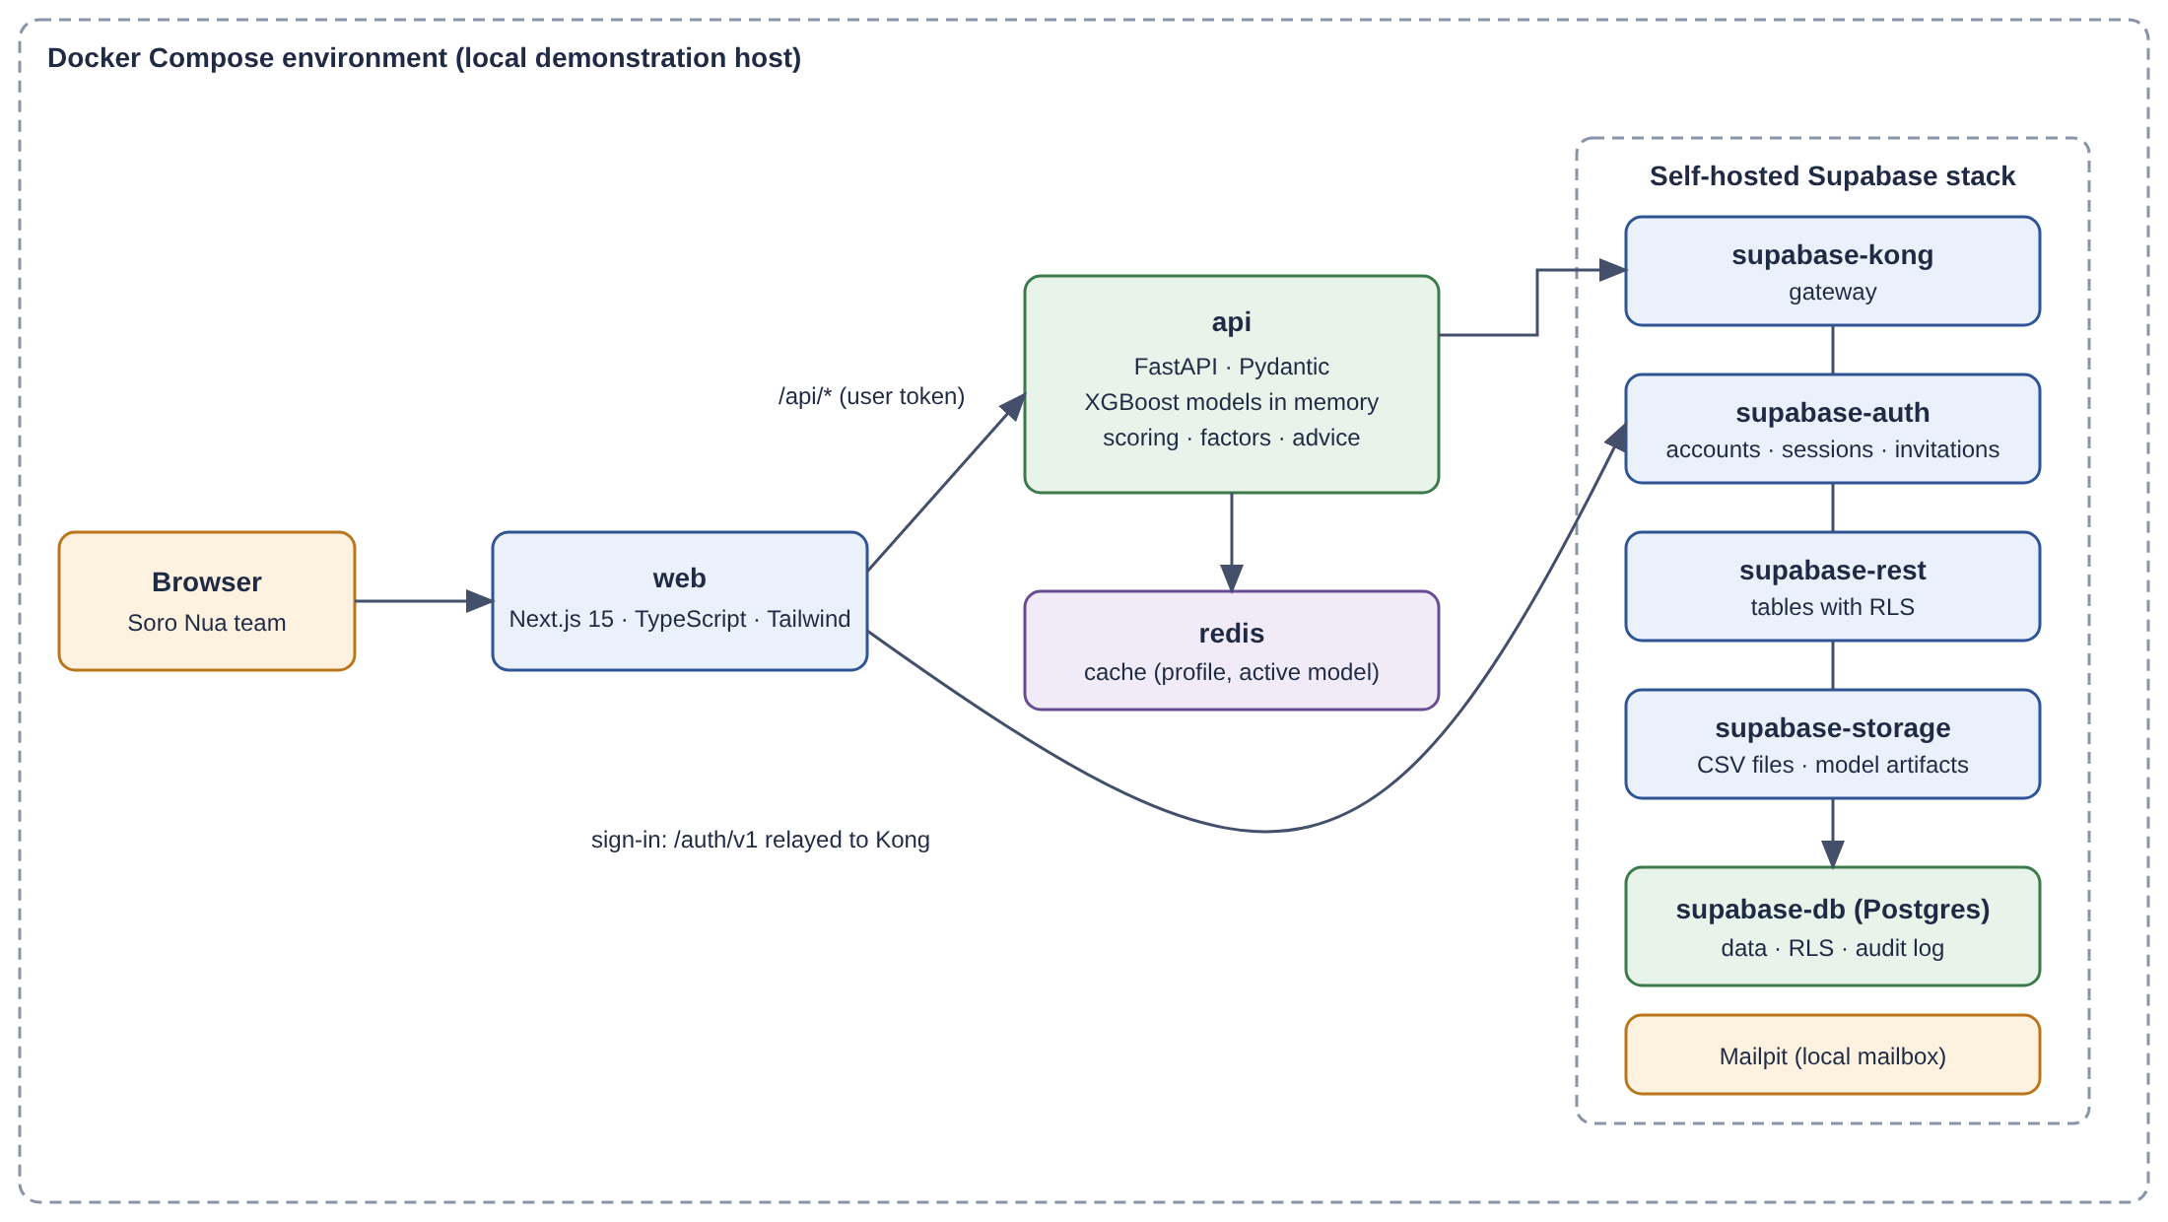
Figure 1: Architecture of the solution (local demonstration environment)
Only the website, /api/* and /auth/v1/* are meant to be exposed; direct access to tables, to storage or to Postgres is never exposed. Responses carry security headers, and rate limits protect the sensitive routes.

1.4 DATA USED
The starting dataset is the public “Predict Conversion in Digital Marketing Dataset” (Kaggle): 8,000 rows and 20 columns, which serves only to train the first models. Its main variables are summarized below.
Group | Variables | Use
Campaign plan (known before launch) | CampaignChannel (Email, PPC, SEO, Social Media, Referral), CampaignType (Awareness, Consideration, Conversion, Retention), AdSpend (100 to 10,000) | Input, and advice levers
Target audience profile | Age (18–69), Gender, Income (20,014–149,986), PreviousPurchases, LoyaltyPoints | Input, and advice levers
Expected engagement (known after launch) | PagesPerVisit, TimeOnSite, SocialShares, EmailOpens, EmailClicks | Input; pre-filled with the average of the same channel and type; not an advice lever
Figures to predict | ClickThroughRate (0.01–0.30), ConversionRate (0.01–0.20), WebsiteVisits (0–49) | Three targets
Discarded | CustomerID, Conversion, AdvertisingPlatform and AdvertisingTool (constant values) | Not used (the last two will be used automatically if the agency data varies)
Table 6: Variables of the starting dataset
The dataset has known limits, which are presented honestly: it is synthetic, every row describes a person rather than a campaign, the advertising platform is masked, and — most importantly — an analysis showed that the three figures to predict have no exploitable relation with the other variables (absolute correlation below 0.025). The model cannot do better than an average on this data; the predictions become meaningful only with the real data of the agency.

1.5 IMPLEMENTATION OF CORE MODULES

1.5.1 DATA LOADING AND CSV VALIDATION
A command loads the starting file into the database once per environment. Agency files go through a validation that checks the whole file before accepting it: exact column names, types, bounds, allowed values for channel and type, duplicate identifiers and cells that could execute formulas when opened in a spreadsheet (starting with =, +, - or @). If one line is wrong, nothing is imported and the list of errors (line, column, reason) is shown. The administrator must also confirm that client names are anonymized.

1.5.2 TRAINING THE THREE MODELS
Three independent XGBoost regressors are trained, one per figure, with the same fixed parameters (300 trees, depth 4, learning rate 0.05, seed 42). The test rows are chosen deterministically from a hash of the source and the identifier of each row (about one row in five), so a row is always a test row whatever the version. Each version stores its metrics, the global importance of the variables and its artifacts (model files, reference tables), and only one version is active at a time. Training can use all the data or only the agency's data once enough rows exist.

1.5.3 PREDICTION AND DERIVED FIGURES
From the described campaign, the api container predicts the three figures with the active version, bounds them to valid ranges and derives: the estimated leads = visits × conversion rate, and the estimated cost per result = budget ÷ estimated leads (the worst possible note if there is no lead).

1.5.4 PERFORMANCE LEVEL
Three notes out of 100 (click-through rate, estimated leads, estimated cost per result) are computed by ranking the campaign among the recorded examples of the same campaign type; 100 is the best. The global score is their simple average. The limits between levels are placed so that a third of the recorded examples is low, a third medium and a third high, and are recomputed at each training. Comparing only with campaigns of the same type avoids judging an awareness campaign with the expectations of a conversion campaign.

1.5.5 FACTORS BEHIND A PREDICTION
For each of the three figures, the tool displays the five inputs that pushed the figure up or down the most for the described campaign, with the direction of the effect. The Model page also shows, for everyone, the global importance of the variables across all campaigns.

1.5.6 RECOMMENDATIONS
The advice engine tries other values for each decision lever — each other channel, each other campaign type, a budget from 50 % lower to 50 % higher in steps of 10 %, other age and income ranges, the other gender, other levels of past purchases and loyalty —, recomputes the predictions and the score for each trial, and keeps at most three changes (one per lever) that improve the global score by at least 5 points out of 100. For each, the before/after values of the three figures and of the level are displayed, and an Apply button applies the change and relaunches the prediction. When nothing helps, the tool says so: “No tested change improves the result significantly.”

1.5.7 AUTHENTICATION, ROLES AND ISOLATION
There is no free sign-up: accounts are created by an administrator's invitation. Sign-in, sign-out, invitation acceptance and password reset rely on Supabase Auth. The api container verifies the token signature, expiry, audience and issuer, and loads the profile (role, active status). Safeguards prevent an administrator from deactivating or demoting themselves and forbid any action that would leave the agency with no active administrator. Sensitive actions are written to an audit log that only administrators can read. A prediction belonging to another user always answers “Prediction not found.”, never “forbidden”.

1.5.8 HISTORY
A user can save a prediction with an optional name, list their own saved predictions, reopen one exactly as it was when saved (a saved prediction is frozen and keeps the model version that produced it) or delete it.

1.5.9 USER INTERFACE
The interface, in English, follows a prototype designed for the project. The Predict page has three blocks (Campaign plan, Target audience profile, Expected engagement) on the left and the results on the right: the three figures compared with the dataset average, the performance level with its score and notes, the factors (one tab per figure) and the suggested changes. A banner warns the user when the model has low accuracy or when no model is active. All displayed texts are centralized in one labels file.
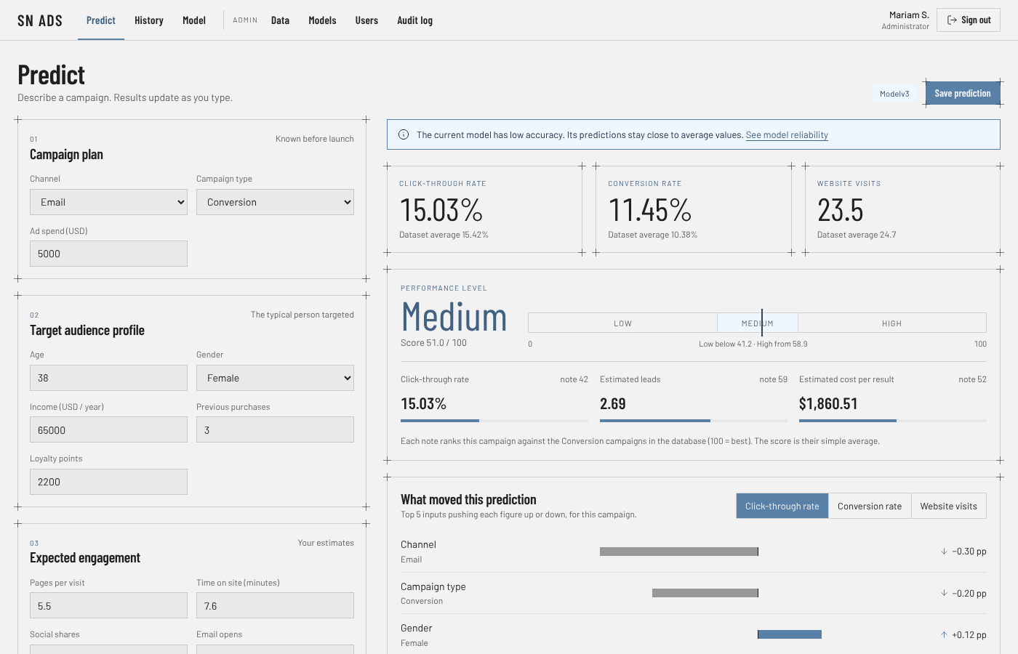
Figure 2: Predict page (interface prototype; values are illustrative)
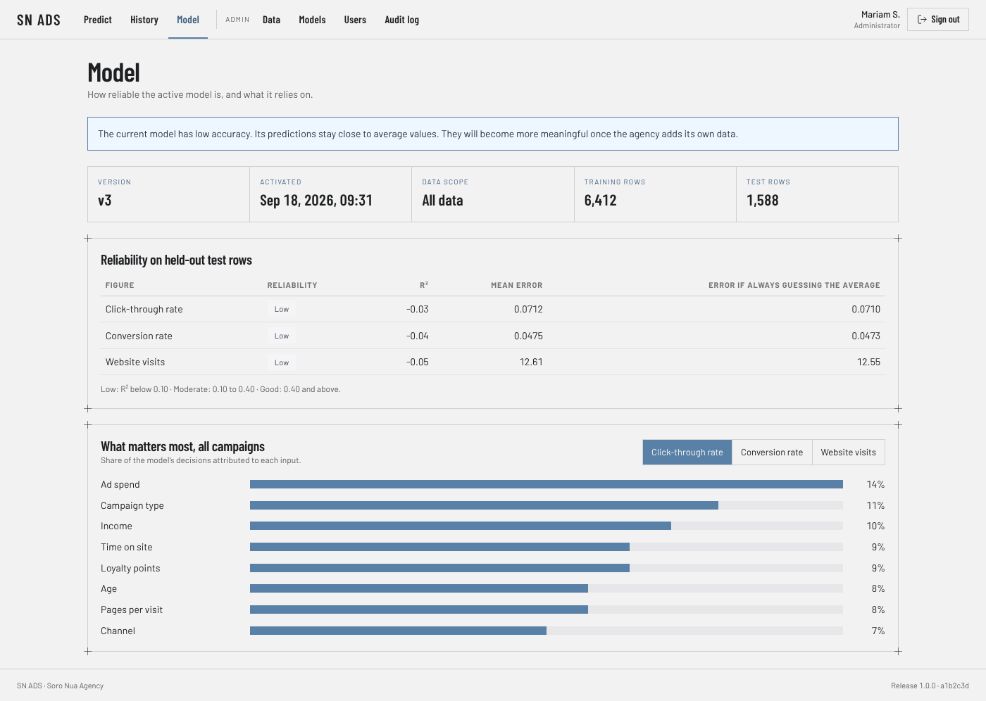
Figure 3: Model page: reliability on held-out test rows and importance of the variables (prototype, illustrative values)
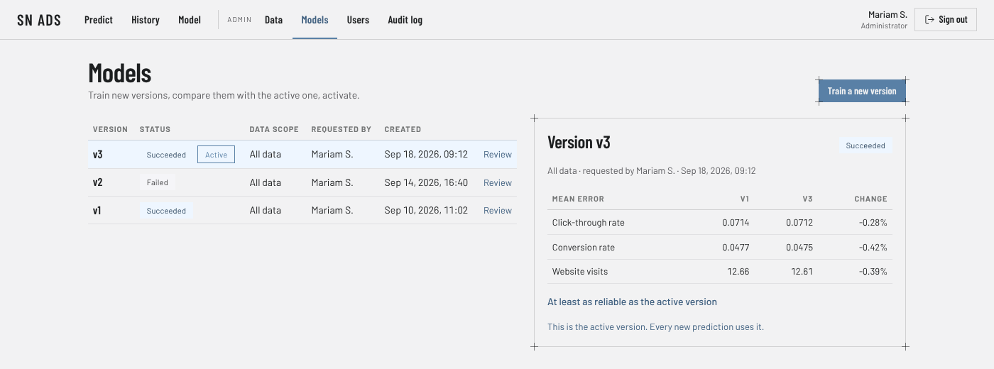
Figure 4: Models page (administrator): versions, status, comparison with the active version
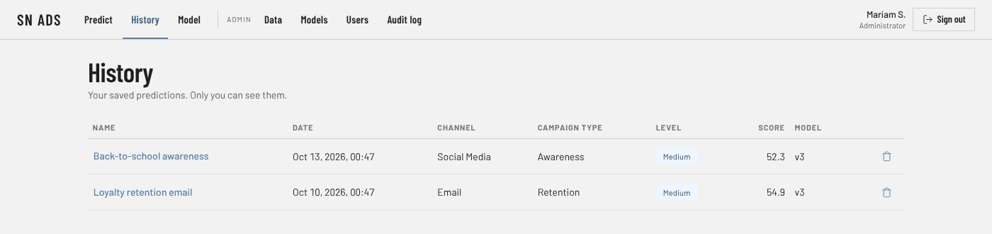
Figure 5: History page: a user sees only their own saved predictions
The figures above are taken from the interface prototype of the project. Replace them with screenshots of the running application (./start.sh, then http://localhost:3000) before submitting.

1.5.10 IMPORT OF AGENCY DATA AND RETRAINING
The administrator uploads a CSV with the same 20 columns as the starting dataset (one row per campaign, described by the typical profile of its target and by its real results). Each row remembers its origin (starting dataset or agency). The new training can use all data or only the agency's data (at least 250 agency rows are required for the second option). The administrator then reviews the new version and activates it, or keeps the old one.

2. UML DIAGRAMS

2.1 USE-CASE DIAGRAM
The use-case diagram shows the two actors and what each can do. The administrator inherits all the marketer's use cases (dashed lines).
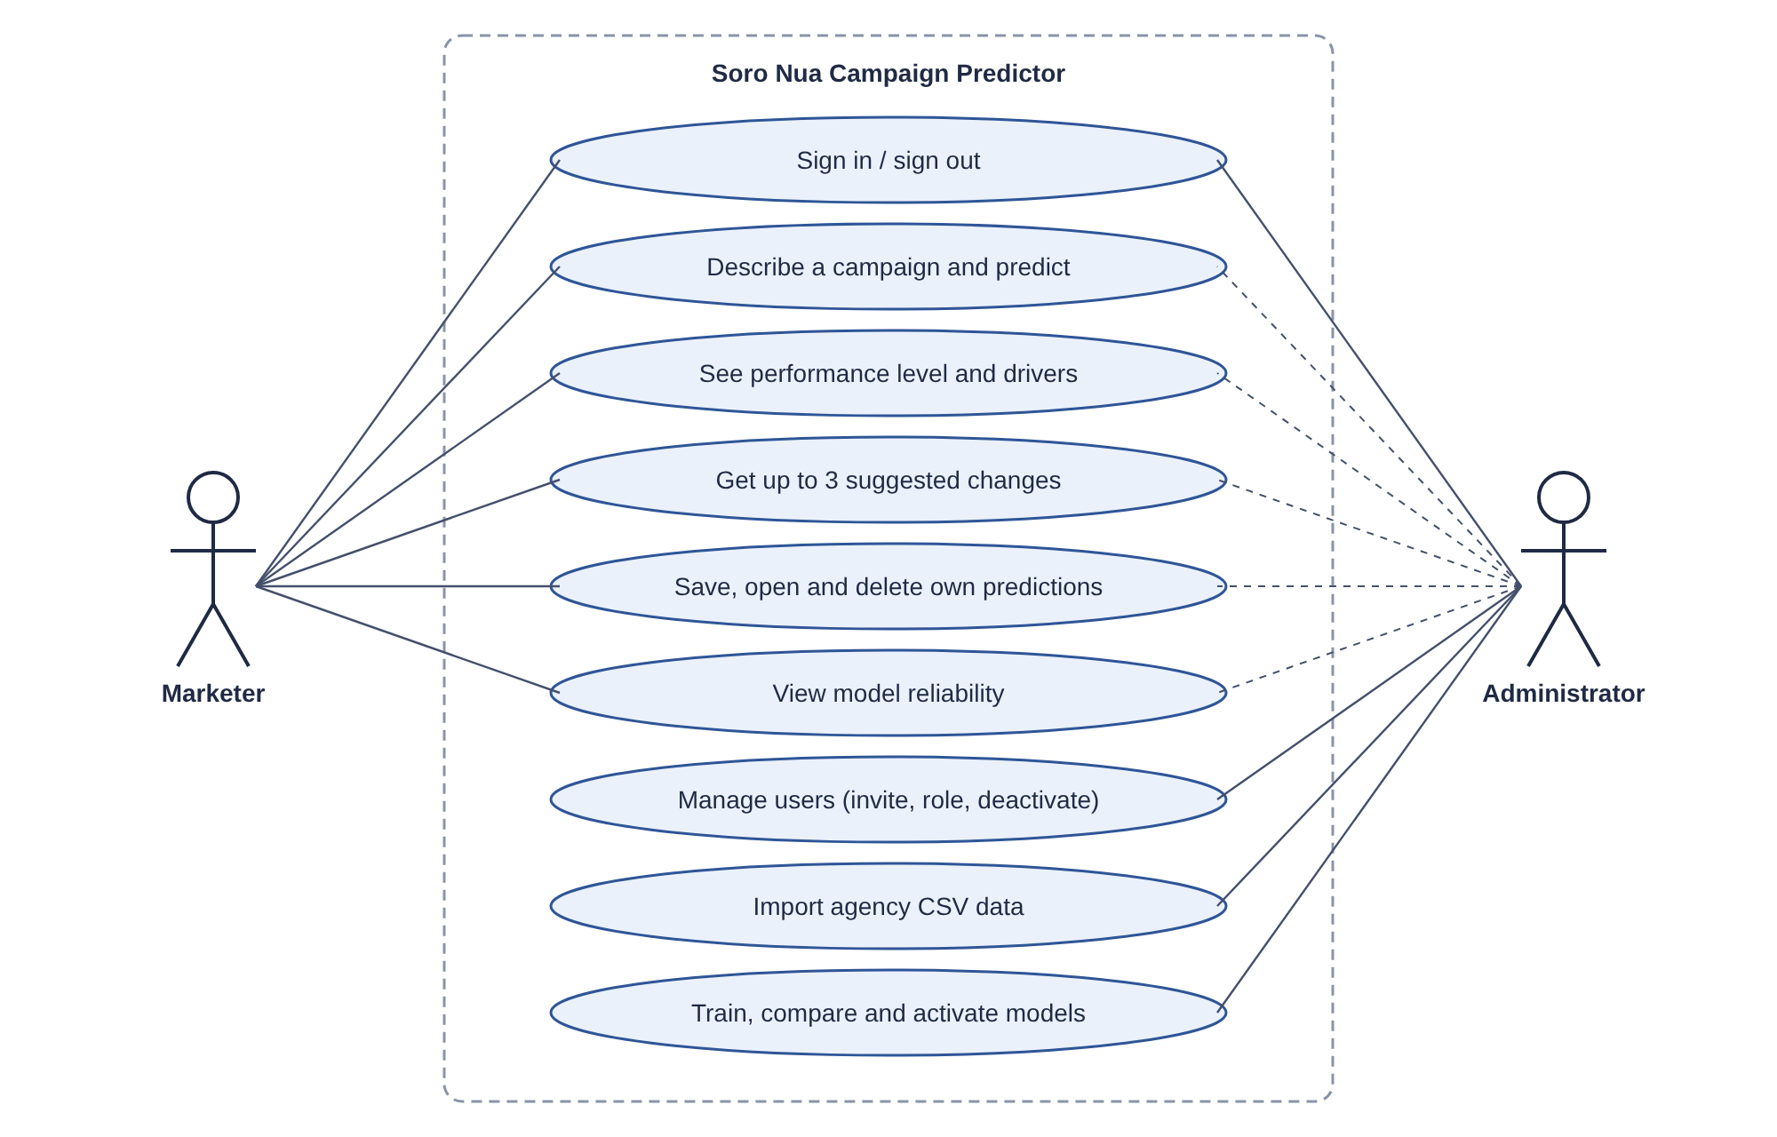
Figure 6: Use-case diagram

2.2 DATA MODEL (CLASS DIAGRAM)
The database has six tables: profiles, audit_log, dataset_uploads, dataset_rows, model_versions and predictions. Row-level security is enabled and forced on each of them, with a positive and a negative pgTAP test for every policy.
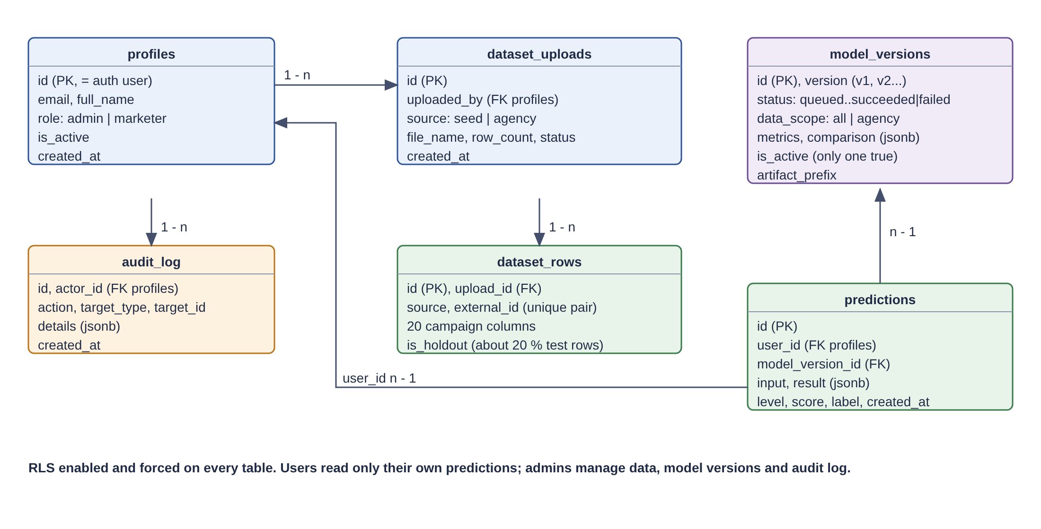
Figure 7: Data model of the application

2.3 SEQUENCE DIAGRAM
The sequence below describes the most important scenario: a marketer describes a campaign and obtains a prediction.
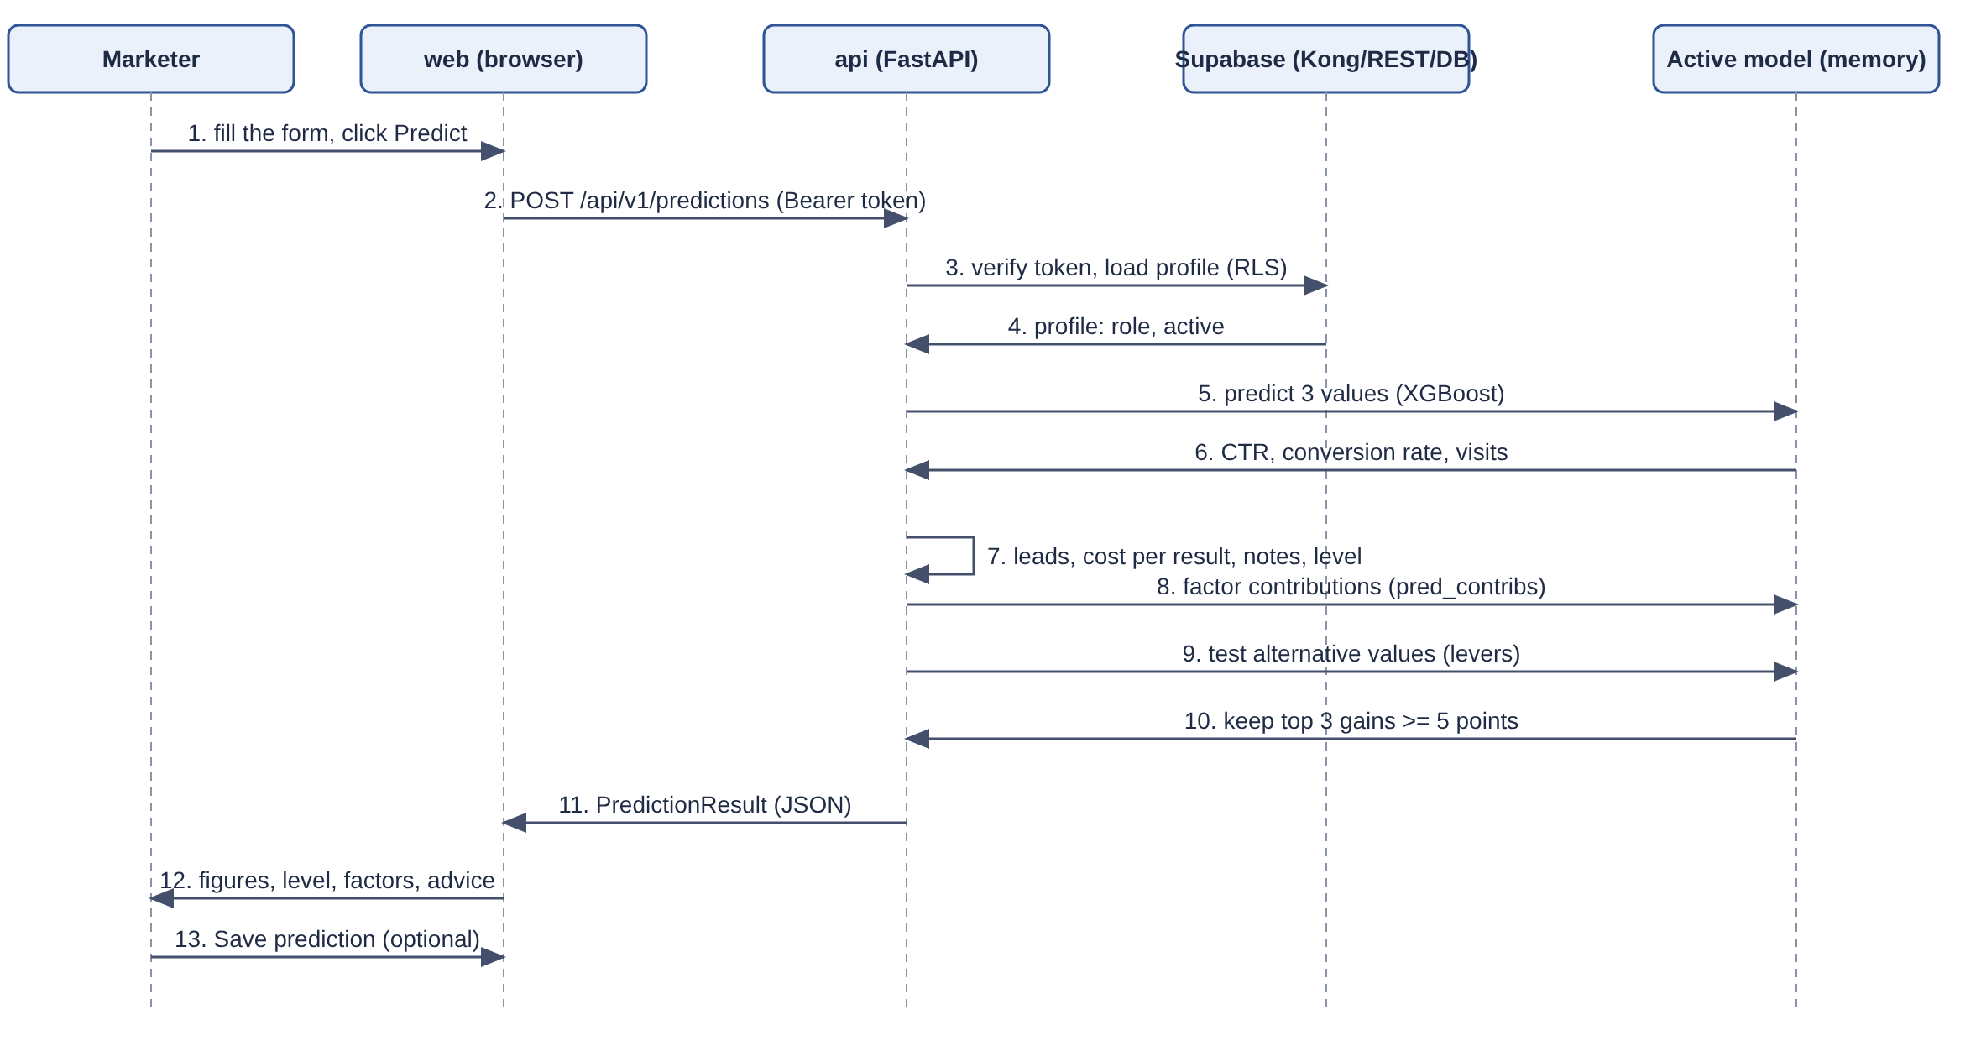
Figure 8: Sequence diagram of a prediction

3. TESTING & VALIDATION
Tests were written before the code. They are organized in levels, each with its own tool, and run through the Makefile in containers.
Level | Tool | What it covers
API unit | pytest | CSV validation, test-row rule, derived figures, notes and score, advice engine, configuration, error format, architecture guards (about 600 test functions in total for the API).
API integration | pytest + FastAPI TestClient | Every route: authentication, roles, validation, status codes, isolation, upload and model routes.
Database | pgTAP | 15 test files: every RLS policy (allowed and refused cases), triggers, last-administrator guard, privileges of the service role.
Web unit | Vitest, Testing Library, MSW | Form schema, formatting, API client, components, role guard.
End-to-end | Playwright | Sign-in, sessions, admin users, prediction journey, isolation between users, demonstration route.
Table 7: Testing levels
Beyond functional tests, honesty checks were carried out in the notebooks: training on a shuffled target, cross-validation, and a synthetic dataset with a real signal. They show that the training chain is sound: with a signal the models reach R² above 0.9, while the starting dataset gives R² close to 0. The limitation therefore comes from the data, not from the code.

4. ITERATION & OPTIMIZATION
Several decisions made along the way improved the project; each is recorded in the decisions log. Among them: the measured facts on the starting dataset (1,602 test rows, score thresholds around 40 and 61, expected low reliability) were recorded early to detect a data leak later; the demonstration mode (a local demonstration without cloud services) simplified the scope while keeping security rules mandatory; the website is served in production mode so that pages open quickly; and a one-command launcher (./start.sh) was added for the presentation.

5. TECHNOLOGICAL ADVANCEMENTS AND FEASIBILITY
Open-source tools now make it possible to build, at no licence cost, a complete machine-learning application: gradient-boosting libraries, typed Python and TypeScript frameworks, a self-hostable database with built-in security and containers for reproducible deployment. The whole project runs on a single laptop with Docker, which proves its feasibility for a small agency.

6. EXPECTED IMPACT
Once fed with the agency's real campaign data, the tool is expected to:
- help to compare campaign plans before spending the budget;
- reduce the time spent on trial and error;
- create a habit of recording campaign results in a common format;
- give the agency a base that improves with each new import.

CHAPTER 4
RESULT ANALYSIS AND DISCUSSION

1. RESULTS OBTAINED
The table below compares the result with the eight success criteria of the brief.
# | Success criterion | Status in the demonstration
1 | Describe a campaign in an interactive English dashboard (plan, audience, expected engagement pre-filled) | Achieved
2 | Display click-through rate, conversion rate and website visits | Achieved
3 | Display a performance level (low, medium, high) | Achieved
4 | Show what weighs most (general view and view of the described campaign) | Achieved (Model page and factors tabs)
5 | Propose up to three changes with before/after, or say clearly that none helps | Achieved
6 | Modify any value and see the new figures | Achieved by the Predict button; live recalculation while typing is planned
7 | Test predictions on rows kept aside and present the measured reliability | Achieved
8 | Import agency data, retrain, replace the old model only through an explicit activation | Achieved in a simplified form (import, agency-only training, review and activation)
Table 8: Success criteria of the brief and their status

2. MODEL RESULTS
On the 1,602 test rows of the starting dataset, the coefficient of determination of the three models is about −0.03, that is, no better than always predicting the average. The tool therefore classifies the reliability of the three figures as low and displays a warning banner. This result is expected and honest: the starting dataset is synthetic and has no exploitable relation between the inputs and the results. In consequence, most campaigns are classified “medium” and the advice is dominated by the budget lever.
The same training chain, applied to a synthetic dataset where a real relation was introduced on purpose, reaches R² above 0.9. The pipeline — splitting, training, evaluation, scoring, explanation, advice — is therefore functionally validated, and ready to learn real relations as soon as the agency provides its data.

3. DISCUSSION
The project addresses a real business need by offering a prediction, a performance level, explanations and advice in a single interface, while keeping data inside the agency. The architecture is modular (interface, api, database, authentication, storage), secure by design (user token, row-level security, validated inputs, standard errors) and reproducible (everything in containers, one command to start). The main lesson is that the quality of a prediction tool is limited by the quality of its data: a large part of the effort went into presenting this limit transparently rather than hiding it. But a good project cannot exist without limitations; they are summarized below.

4. LIMITATIONS AND PROPOSED IMPROVEMENTS
Limitation | Explanation | Proposed improvement
Synthetic starting data | No exploitable relation between inputs and results; reliability is low; advice limited to the budget. | Import real campaign data of the agency (at least 250 campaigns) and retrain.
One row per person in the starting data | The starting file describes persons, not campaigns; the platform is masked. | Agency data with one row per campaign and the advertising platform filled in.
Training inside the API | In the demonstration, training runs in the api container, with no queue. | Dedicated worker with a queue (Redis) and a heartbeat.
No live recalculation | The figures are updated on the Predict button, not while typing. | Live simulation with a short typing pause, and draft restoration after session expiry.
Local demonstration only | No cloud deployment, no e-mail service, no monitoring service. | Deployment on a cloud environment, real e-mail delivery and error monitoring.
Limited advice levers | Advice covers only the decisions the agency really takes (budget, channel, type, target profile). | Add content and platform advice when such data exists.
Table 9: Limitations and proposed improvements of the designed system

5. PERSPECTIVES
- Import of the real campaign data of Soro Nua Agency, then evaluation of the real reliability of the model;
- Automatic comparison of a new version with the active one on the same test rows, with an activation allowed only if the new version is at least as reliable;
- Live simulation while typing and draft conservation;
- Dedicated training worker with a queue, and a complete end-to-end robustness suite;
- Deployment in the cloud with continuous integration and delivery, real e-mails and error monitoring;
- Automatic retrieval of data from advertising platforms, and, later, advice on advertisement content.

CONCLUSION
This report presented the study, design and implementation of Soro Nua Campaign Predictor, carried out during my internship at Soro Nua Agency from 22 June to 27 August 2026. The tool answers a concrete need of the agency: before launching an online advertising campaign, obtain the predicted click-through rate, conversion rate and number of visits, an expected performance level, the factors that weigh most and up to three changes that would improve the result.
The solution is built as a set of containers — interface, prediction service, database, authentication and storage — with three XGBoost models, a transparent scoring method, an explanation and advice engine, and strict data isolation based on row-level security. The project followed a test-first, phase-by-phase method supported by a complete set of reference documents and a decisions log.
The main finding is also the most instructive one: with the synthetic dataset available at the start, the predictions cannot be better than an average, and the tool says so clearly. The technical chain has nevertheless been validated, and it will become truly useful as soon as the agency feeds it with its own campaign data. Future work will therefore concentrate on real data, automatic comparison of model versions, live simulation and cloud deployment.
On a personal level, this internship allowed me to master a complete application lifecycle — from the analysis of a need to a secure, tested and reproducible product — and to use tools that were new to me: XGBoost in production, a self-hosted Supabase stack with row-level security, Docker Compose and end-to-end testing. It also taught me to present the limits of a model honestly to its future users. I step out of this internship with solid knowledge in software development, machine learning and DevOps, and a more mature view of how software serves a business.

BIBLIOGRAPHY AND WEBOGRAPHY

I. WEB REFERENCES AND DOCUMENTS
- XGBoost documentation — https://xgboost.readthedocs.io (gradient-boosted trees library).
- FastAPI — https://fastapi.tiangolo.com (Python web framework).
- Pydantic — https://docs.pydantic.dev (data validation).
- Next.js — https://nextjs.org/docs (React framework).
- Tailwind CSS — https://tailwindcss.com ; shadcn/ui — https://ui.shadcn.com ; Recharts — https://recharts.org.
- Supabase self-hosting with Docker — https://supabase.com/docs/guides/self-hosting/docker.
- PostgreSQL Row Security Policies — https://www.postgresql.org/docs/current/ddl-rowsecurity.html.
- Docker and Docker Compose documentation — https://docs.docker.com.
- Playwright — https://playwright.dev ; pgTAP — https://pgtap.org.
- Kaggle — “Predict Conversion in Digital Marketing Dataset” — https://www.kaggle.com/datasets/rabieelkharoua/predict-conversion-in-digital-marketing-dataset.
- Project reference documents of Soro Nua Campaign Predictor (brief, PRD, architecture, data model, API specification, low-level design, security notes, testing, roadmap, decisions log).

II. SCIENTIFIC REFERENCES
Chen, T. and Guestrin, C. (2016). XGBoost: A Scalable Tree Boosting System. Proceedings of the 22nd ACM SIGKDD International Conference on Knowledge Discovery and Data Mining, pp. 785–794.
Lundberg, S. M. and Lee, S.-I. (2017). A Unified Approach to Interpreting Model Predictions. Advances in Neural Information Processing Systems 30 (NeurIPS).

III. REPORTS
Add the internship reports of previous students you used as a model, with author, year, title, supervisor and company.

APPENDICES

APPENDIX A: FIXED PARAMETERS OF THE THREE MODELS
XGB_PARAMS = {
"n_estimators": 300,
"max_depth": 4,
"learning_rate": 0.05,
"subsample": 0.8,
"colsample_bytree": 0.8,
"min_child_weight": 1,
"reg_lambda": 1.0,
"objective": "reg:squarederror",
"tree_method": "hist",
"random_state": 42,
"n_jobs": 2,
}
Source: apps/api/app/ml/params.py

APPENDIX B: DETERMINISTIC RULE FOR TEST ROWS
import hashlib

def is_holdout(source: str, external_id: int) -> bool:
digest = hashlib.sha256(f"{source}:{external_id}".encode()).hexdigest()
return int(digest[:8], 16) % 5 == 0 # about 20 % of the rows
Source: apps/api/app/domain/holdout.py

APPENDIX C: RUNNING THE DEMONSTRATION
- Start Docker Desktop (at least 6 GB of memory for Docker).
- In the project folder, run ./start.sh (or make env-local, make build, make demo).
- Open http://localhost:3000 and sign in with the administrator account listed in the file .demo-accounts.txt.
- Menu Data: check the 8,000 starting rows. Menu Models: train a new version and activate it.
- Menu Predict: describe a campaign and click Predict; read the figures, the level, the factors and the suggested changes; click Save prediction.
- Menu History: reopen or delete the saved prediction. Sign in as the marketer account to check that the administration menus are not visible and that another user's prediction answers “Prediction not found.”.

APPENDIX D: REPOSITORY STRUCTURE (MAIN FOLDERS)
Folder | Content
apps/api | FastAPI application: routes, domain rules, machine-learning modules, repositories, command-line commands and tests
apps/web | Next.js interface, labels file, unit tests and Playwright end-to-end tests
supabase | SQL migrations and pgTAP database tests
deploy/supabase | Self-hosted Supabase stack (Docker Compose, gateway configuration, key generation)
data | Starting dataset and two sample agency files (one valid, one invalid)
notebooks | Three analysis and training notebooks
docs | The thirteen reference documents and the decisions log
ui_prototype | Interface prototype used as a reference
Table 10: Main folders of the repository

