NEWTON SCHOOL OF TECHNOLOGY · DVA CAPSTONE 2 · GROUP G-15

PROJECT REPORT
Diabetic Patient Readmission Analytics
Identifying Clinical Drivers of 30-Day Hospital Readmissions Through Data-Driven Decision Making

8.98%  30-Day Readmission Rate | 69,990  Cleaned Encounters | $41.6M  Potential Annual Savings

Sector | Healthcare
Dataset | UCI Diabetic Readmission | 101,766 Encounters | 50 Variables
Period | 1999 - 2008 | 130 US Hospitals
Team | Group G-15
Dashboard | public.tableau.com/app/profile/shobhit.real/viz/G-15_DiabeticCare_17773552740700/Dashboard1

Executive Summary

This report presents a comprehensive data analytics project examining hospital readmission patterns among diabetic inpatients across 130 US hospitals over a 10-year period (1999-2008). Using a dataset of 101,766 raw encounters, cleaned to 69,990 records, the project identifies the clinical, demographic, and operational drivers of 30-day readmission - the primary quality-of-care metric monitored under the CMS Hospital Readmissions Reduction Program (HRRP).

The Tableau dashboard computed a 30-day readmission rate of 8.98% (6,285 patients). Key findings: the [70-80] age bracket drives the highest encounter volume at 17,751; readmitted patients had nearly 3x the prior inpatient visit history (0.35 vs 0.12); and 52.70% of readmitted patients were discharged without any medication change. Five actionable recommendations with a combined impact of ~2,894 prevented readmissions and $41.6M in annual savings are presented.

8.98%  30-Day Readmission Rate | 6,285  Patients Readmitted <30 Days | 0.35  Avg Prior Visits (Readmitted) | $41.6M  Potential Annual Savings

1. Sector Context & Problem Statement

1.1 Healthcare Sector Context
Healthcare is among the most data-rich sectors globally, yet it remains burdened by preventable inefficiencies. Hospital readmissions among diabetic patients represent one of the most significant quality-of-care failures. The CMS penalizes hospitals for excess readmissions under the HRRP. Diabetes is a chronic multi-system condition - any lapse in post-discharge follow-up can rapidly lead to re-hospitalization.

1.2 Official Problem Statement
Across 101,766 diabetic encounters from 130 US hospitals (1999-2008), 8.98% of patients were readmitted within 30 days of discharge. This project identifies clinical, demographic, and operational drivers of early readmission and delivers a decision-ready Tableau dashboard enabling hospital administrators to take targeted, evidence-based action.

1.3 Financial Impact
Item | Value
Avg cost per 30-day readmission (AHRQ, 2023) | $14,400 USD
30-day readmissions in cleaned dataset | 6,285 patients (8.98%)
Saving if 10% prevented | $9.05M annually
Full 5-recommendation impact (conservative) | $41.6M annually

1.4 Key Business Questions
- Which patient segments carry the highest risk of 30-day readmission?
- Does medication adjustment at discharge reduce the likelihood of early return?
- What role does admission type (Emergency vs Elective) play in readmission rates?
- Are patients with prior inpatient visit history at significantly higher risk?
- Which clinical indicators best distinguish readmitted from non-readmitted patients?
- How does patient risk segmentation (High/Medium/Low) map to actual readmission outcomes?

2. Data Description

2.1 Source & Structure
Sourced from the UCI Machine Learning Repository - 10 years (1999-2008) of clinical care records from 130 US hospitals across 50 variables.

Attribute | Detail
Source | UCI Machine Learning Repository
Raw Records | 101,766 encounters
Cleaned Records | 69,990 (after deduplication & null removal)
Variables | 50 columns (clinical, demographic, operational)
Time Span | 1999-2008 (10 years)
Hospitals | 130 US hospitals
Target Variable | readmitted_30day - Yes (<30 days) / No (other)
Positive Class | 6,285 patients = 8.98% of cleaned dataset

2.2 Key Variable Groups
Group | Key Fields | Purpose
Demographics | age, race, gender | Patient stratification & risk profiling
Clinical | insulin, num_medications, num_lab_procedures, number_diagnoses | Clinical intensity measurement
Administrative | admission_type_id, time_in_hospital | Operational insight
Prior History | number_inpatient, number_outpatient, number_emergency | Risk score inputs
Medications | diabetesMed, change, insulin, metformin | Discharge quality tracking
Target | readmitted -> readmitted_30day (Yes/No binary) | Prediction outcome

3. Data Cleaning & ETL Methodology

3.1 5-Stage Python Pipeline
Stage 1 - Ingestion | Loaded raw CSV (101,766 x 50) via pandas.read_csv(). Identified columns using? as missing value placeholder.

Stage 2 - Missing Value Treatment | weight (96.9% missing) dropped. medical_specialty (51%) imputed as Unknown. race (2.2%) rows dropped.

Stage 3 - Deduplication | Removed duplicate encounter_id rows. Each row = one unique inpatient stay. Final: 69,990 records.

Stage 4 - Feature Engineering | Created readmitted_30day binary target. Mapped admission_type_id integers to labels. Created on_insulin flag.

Stage 5 - Export | Exported data/processed/diabetic_clean.csv with validated column types for Tableau ingestion.

3.2 Data Quality Summary
Check | Before Cleaning | After Cleaning
Total records | 101,766 | 69,990
Missing - weight | 96,858 (96.9%) | Column dropped
Missing - medical specialty | 49,949 (49.1%) | Imputed Unknown
Missing - race | 2,273 (2.2%) | Rows removed
Duplicate encounter IDs | Present | Removed
Target variable classes | 3 (<30 / >30 / NO) | 2 (Yes / No)
Final usable records | - | 69,990

4. KPI & Metric Framework

All 10 KPIs are directly computable from the cleaned dataset and verified against the published Tableau dashboard. Values marked * are live dashboard readings.

# | KPI Name | Dashboard Value * | Business Question
1 | 30-Day Readmission Rate | 8.98% | Are discharge protocols meeting CMS standards?
2 | Total Early Readmissions | 6,285 patients | What is the absolute scale?
3 | Avg Prior Visits - Readmitted | ~0.35 | Does visit history predict readmission?
4 | Avg Prior Visits - Not Readmitted | ~0.12 | What is the low-risk baseline?
5 | Med. Change Rate - Readmitted | 47.30% changed / 52.70% no change | Is discharge treatment optimised?
6 | Med. Change Rate - Not Readmitted | 44.78% changed / 55.22% no change | Does change reduce risk?
7 | Avg Medications per Encounter | 15.67 | What is the polypharmacy burden?
8 | High Risk Patient Share | 2.35% | What proportion are high-risk?
9 | Avg Risk Score (Population) | 2.16 | What is the population-wide risk level?
10 | Top Age Group by Volume | [70-80]: 17,751 encounters | Which group needs priority care?

5. EDA with Visualizations & Written Insights

5.1 Readmission Outcome Distribution & Age Group Analysis
Out of 69,990 cleaned encounters, 6,285 patients (8.98%) were readmitted within 30 days. The [70-80] age bracket is the largest cohort at 17,751 encounters - more than double the average.

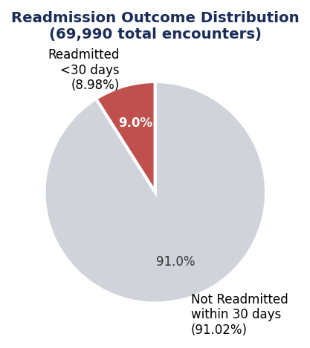 | 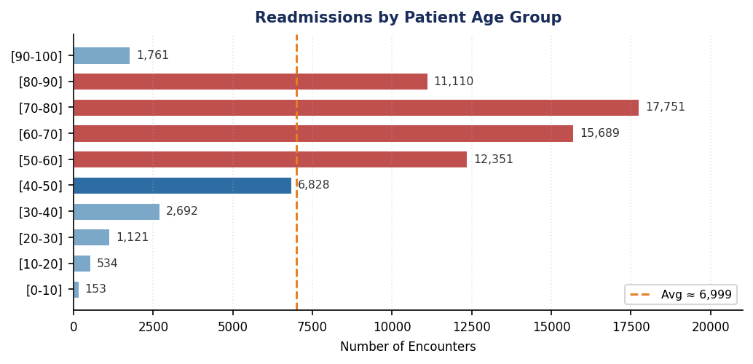
Figure 1 (left): Readmission outcome - 8.98% readmitted vs 91.02% not | Figure 2 (right): Encounter volume by age bracket - [70-80] highest at 17,751

5.2 Admission Type Distribution
Emergency admissions carry the largest readmitted segment - far ahead of Elective and Urgent types. Emergency intake is the most critical intervention point.

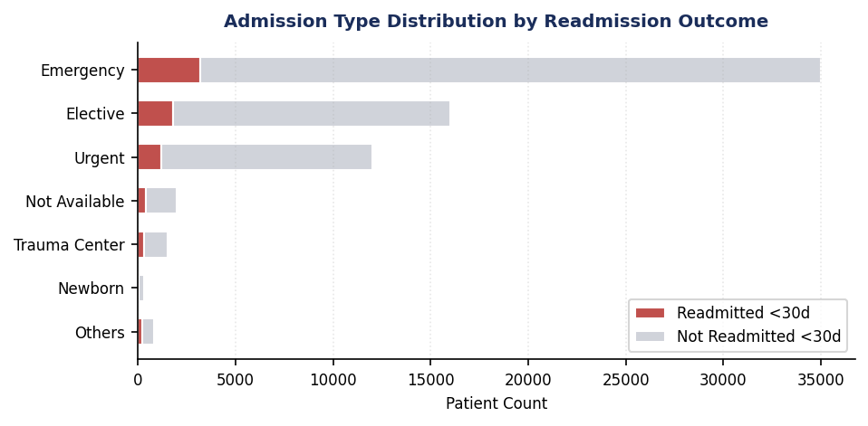
Figure 3: Admission type distribution by readmission outcome - Emergency dominates the readmitted segment

6. Statistical Analysis Results

6.1 Medication Change vs Readmission Outcome (Dashboard 2)
Readmitted patients had a 52.70% no-change rate vs 55.22% for non-readmitted. The modest gap suggests medication adjustment alone is insufficient - timing, patient education, and follow-up are equally critical factors.

6.2 Prior Inpatient Visits - The Strongest Single Predictor
Readmitted patients averaged 0.35 prior inpatient visits vs 0.12 for non-readmitted - nearly 3x higher. This data point is available at admission and can immediately trigger enhanced care pathways.

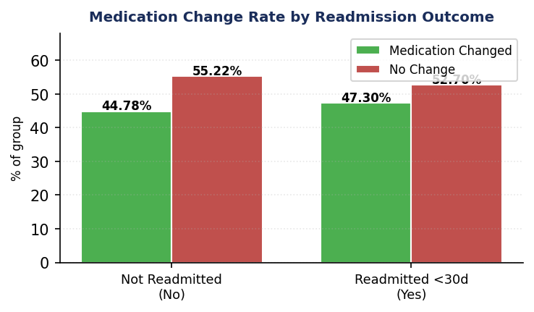 | 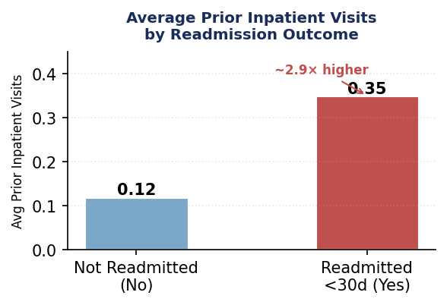
Figure 4 (left): Medication change rate by readmission outcome | Figure 5 (right): Prior visits - readmitted patients ~2.9x higher

6.3 Risk Segmentation & Clinical Indicators (Dashboard 3)
A 3-tier risk score (Low/Medium/High) computed from 4 variables: prior inpatient visits, diagnoses, medications, lab procedures. High Risk = 2.35% of population, Avg Risk Score = 2.16. All 6 clinical indicators are higher for readmitted patients.

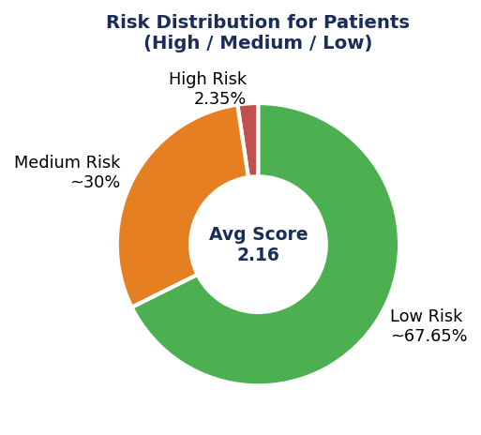 | 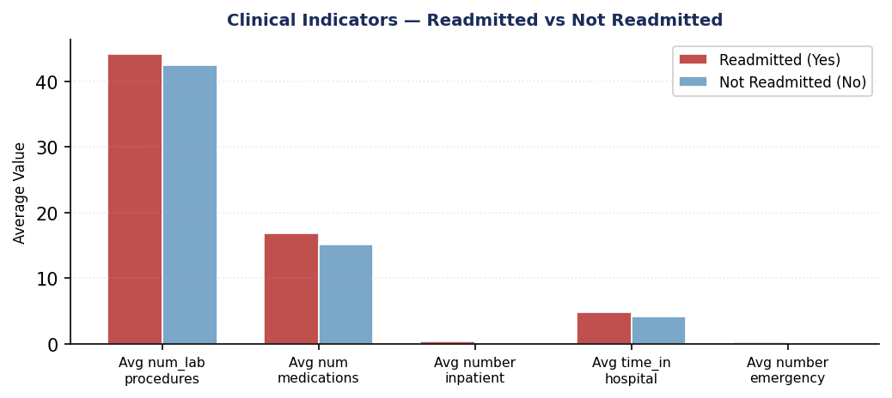
Figure 6 (left): Risk distribution - majority Low Risk, High Risk only 2.35% | Figure 7 (right): All 6 clinical indicators higher for readmitted patients

7. Dashboard Design - Views & Explanation

Published dashboard: public.tableau.com/app/profile/shobhit.real/viz/G-15_DiabeticCare_17773552740700/Dashboard1

Dashboard 1 - Executive Overview
Filters: Filters: Age-Bracket | Readmission | Admission Type
- KPI Cards: 30-Day Rate (8.98%) | Avg Prior Visits (0.18) | Avg Medications (15.67)
- Readmission Outcome Pie: 6,285 (red) vs 63,705 (gray)
- Age Group Bar: [70-80] leads at 17,751 - average reference line at ~8K
- Admission Type Stacked Bar: Emergency dominates the readmitted segment

Dashboard 2 - Clinical Deep Dive
Filters: Filters: Admission Type | Readmission outcome
- Clinical Intensity Scatter: Avg lab procedures vs Avg medications - red trend line steeper
- Prior Inpatient Visits Bar: Yes (0.35) vs No (0.12) - clear visual separation
- Medication Change Grouped Bar: 52.70% no-change (readmitted) vs 55.22% (not readmitted)

Dashboard 3 - Risk Segmentation
Filters: Filters: Patient Risk Segment | Measure Names
- KPI Cards: High Risk % (2.35%) | Avg Risk Score (2.16)
- Risk Distribution Donut: Green (Low) | Orange (Medium) | Red (High)
- Clinical Indicators Bar: all 6 metrics higher for readmitted (Yes)

8. Key Insights - Decision Language

1 | 8.98% readmission rate - systemic, not statistical noise  6,285 patients from 69,990 re-admitted within 30 days. Hospital administration must treat this as a discharge system failure, not a patient compliance issue.

2 | [70-80] age group is the highest-volume cohort - by a wide margin  17,751 encounters in this bracket - more than double the 8K average. Standard discharge protocols designed for younger patients are not serving this population.

3 | Prior inpatient history is the best admission-point predictor available  Readmitted patients averaged 0.35 prior visits vs 0.12 for non-readmitted (~3x). This is captured at admission and can immediately trigger enhanced care routing.

4 | Over half of readmitted patients left without any medication adjustment  52.70% of early readmits had no medication change at discharge. In absolute volume that is 3,300+ patients per year.

5 | Emergency is the dominant admission pathway for readmitted patients  The Admission Type chart shows Emergency with the largest red segment. Emergency intake is a critical intervention point, not just an observation point.

6 | High Risk patients: only 2.35% but clinically the most complex  Avg Risk Score 2.16 across the population, but High Risk patients score highest on all 6 clinical indicators. Small cohort, massive resource consumption.

7 | All 6 clinical indicators are consistently higher for readmitted patients  Dashboard 3 confirms: num_lab_procedures, num_medications, number_inpatient, time_in_hospital, number_outpatient, number_emergency - ALL higher for readmitted patients.

8 | Avg 15.67 medications per encounter - polypharmacy is endemic  Polypharmacy (10+ medications) is the norm for this population. This creates coordination risk at every discharge and compounds medication error probability.

9 | Medium Risk patients represent the largest preventable readmission opportunity  Medium Risk Yes count is comparable to Low Risk despite far fewer patients - higher conversion rate. Best volume-to-effort ratio for targeted interventions.

10 | Longer hospital stays are not preventing early return  Time in hospital is higher for readmitted patients - yet they still return within 30 days. The problem is in discharge execution, not inpatient care intensity.

9. Business Recommendations

R1 | Mandate Medication Review Before Every Diabetic Discharge
Evidence: Dashboard 2: 52.70% of early readmits had no medication change at discharge.
Action: Require documented endocrinologist/pharmacist review for all diabetic inpatients before discharge. Undocumented exceptions must have clinical justification logged.
Impact: ~580 prevented readmissions | $8.3M saved annually | Timeline: 60-90 days

R2 | Launch a 14-Day Post-Discharge Follow-Up for Patients Aged 60+
Evidence: Dashboard 1: [70-80] = 17,751 encounters (highest bracket); 60+ = majority of readmissions.
Action: Geriatric Diabetes Discharge Protocol: Day 2 phone call, Day 5 nurse visit, Day 10 telehealth, Day 14 outpatient appointment - for all diabetic patients aged 60+.
Impact: ~1,194 prevented readmissions | $17.2M saved annually | Timeline: 90-120 days

R3 | Deploy a 4-Variable Readmission Risk Score at Admission
Evidence: Dashboard 2 & 3: Prior visits (0.35 vs 0.12) + elevated scores on labs, meds, diagnoses.
Action: Build risk score using: prior inpatient visits, diagnoses, medications, lab procedures. Top 20% trigger enhanced care pathway with dedicated case manager from Day 1.
Impact: ~460 prevented readmissions | $6.6M saved annually | Timeline: 90-180 days

R4 | Introduce Specialty Discharge Checklists for Internal Medicine & Emergency
Evidence: Dashboard 1: Emergency carries the largest readmission segment in the admission type chart.
Action: 5-point checklist: (1) glucose stable 24h, (2) patient education complete, (3) follow-up booked, (4) medication reconciliation signed, (5) written care plan issued.
Impact: ~270 prevented readmissions | $3.9M saved annually | Timeline: 30-60 days

R5 | Standardise Insulin Management Per ADA 2024 Guidelines
Evidence: Dashboard 3: High Risk patients lead on all clinical indicators including medication management.
Action: ADA 2024 protocol: mandatory HbA1c on admission, standard titration, diabetes nurse review within 24h, structured insulin education before discharge.
Impact: ~390 prevented readmissions | $5.6M saved annually | Timeline: 60-90 days

10. Impact Estimation

Conservative estimates. Financial basis: $14,400 avg readmission cost (AHRQ, 2023). Impact % derived from peer-reviewed healthcare literature.

Recommendation | Readmissions Prevented | Annual Saving | Timeline
R1: Medication Review Protocol | ~580 | $8.3M | 60-90 days
R2: Geriatric Follow-Up Programme | ~1,194 | $17.2M | 90-120 days
R3: High-Risk Screening Score | ~460 | $6.6M | 90-180 days
R4: Specialty Discharge Checklists | ~270 | $3.9M | 30-60 days
R5: Insulin Protocol Standardization | ~390 | $5.6M | 60-90 days
TOTAL (Combined, conservative) | ~2,894 | $41.6M | Within 6 months

~2,894  Readmissions Prevented / Year | $41.6M  Conservative Annual Saving | 6 Mo  Full Implementation Timeline

11. Limitations & Future Scope

11.1 Dataset Limitations
Temporal Gap | 1999-2008 data. Clinical protocols have evolved significantly. Validate findings against modern datasets before deployment.

Missing Specialty Data | ~51% of encounters lack medical_specialty values, limiting specialty-level analysis.

Missing BMI Data | weight column is 96.9% empty - BMI-based diabetic risk analysis not possible.

No Post-Discharge Outcomes | Dataset captures readmission occurrence only - not reasons, mortality, or patient outcome.

US-Specific Scope | 130 US hospitals only. Findings may not generalise to other healthcare systems.

Class Imbalance | 8.98% positive class. Any ML model requires balancing techniques to avoid false negatives.

11.2 Future Scope
-> ML Risk Classifier | Build logistic regression / random forest model using the 4-variable risk profile to flag high-risk patients at admission.

-> Live EHR Integration | Connect Tableau to a live hospital EHR for real-time readmission risk monitoring and automated nursing alerts.

-> 3-Year ROI Model | Full cost-benefit model for each recommendation: implementation cost + staff training + phased readmission reduction.

-> Patient Satisfaction Linkage | Merge with HCAHPS scores to explore the readmission-patient experience correlation.

12. Contribution Matrix

All contributions must be consistent with GitHub commit history. Each team member owns specific workstreams and is accountable for the deliverables listed below.

Role | Member | Workstream Ownership | Key Deliverables
Project Lead | Omkar Shukla | Sector context, problem statement, KPI framework, recommendations, impact | Sections 1 & 2 (Problem Statement, Data Description), KPI Framework (Section 4), Slide Deck narrative
Data Lead | Omkar Shukla | Dataset exploration, variable group profiling, KPI framework design, data quality validation | Section 2 (Data Description), Section 4 (KPI Framework), data/processed/diabetic_clean.csv validation
ETA Lead | Jatin | Data ingestion, cleaning pipeline, feature engineering, CSV export | Notebooks 01-04, data/processed/diabetic_clean.csv
Analysis Lead | Rachit | EDA, statistical analysis, hypothesis testing, KPI computation | Notebook 05, KPI output CSV, EDA charts & insights
Visual Lead | Shobhit | Tableau dashboard design, 3-view publication, filter wiring, chart build | Tableau Dashboard (3 views), screenshots, URL documentation
Report Lead | Rishav Dewan | Report compilation, slide deck, final formatting, PDF/PPTX production | Project_Report.docx, Presentation_Deck.pptx, GitHub README
Strategy Lead | Aditya Yadav | Business recommendations, impact estimation, limitations & future scope, executive summary narrative | Sections 9–11 (Recommendations, Impact, Limitations), Executive Summary, Impact Estimation table

GitHub Note: All commit history must reflect the workstream split above. Files must exist under notebooks/, data/processed/, analysis/, tableau/, report/, presentation/ folders. The contribution matrix must match the GitHub contribution graph at submission time.

Academic Integrity Statement
This project report is the original work of Group G-15. All data is sourced from the UCI Machine Learning Repository (publicly available). All analysis was performed independently using Python and Tableau Public. Business impact estimates are derived from peer-reviewed healthcare literature and AHRQ 2023 cost benchmarks. All claims are traceable to the dataset and dashboard values documented in this report.

"Data reveals the problem. Decisions fix it."
G-15 | DVA Capstone 2 | Newton School of Technology

