**Processing Environment**

**Subject - Unix Operating System**

**Name – Rachit Bhat**

**PRN – 22610007 Class – TYIT**

**Assignment No – 1c**

**Title-** Write the program to use fork/vfork system call. Justify the difference by using suitable application of fork/vfork system calls.

**Objectives-**

1. To learn about Processing Environment.
2. To know the difference between fork/vfork and various execs variations.
3. Use of system call to write effective programs.

**Theory-**

1. **fork():**

The fork() is a system call use to create a new process. The new process created by

the fork() call is the child process, of the process that invoked the fork() system call.

The code of child process is identical to the code of its parent process. After the

creation of child process, both process i.e. parent and child process start their

execution from the next statement after fork() and both the processes get executed

simultaneously.

1. **vfork():**

The modified version of fork() is vfork(). The vfork() system call is also used to

create a new process. Similar to the fork(), here also the new process created is the

child process, of the process that invoked vfork(). The child process code is also

identical to the parent process code. Here,the child process suspends the execution of parent process till it completes its execution as both the process share the same

address space to use.

|  |  |  |
| --- | --- | --- |
| Basis of  comparison | Fork() | Vfork() |
| Basic | Child process and parent  process has separate address spaces. | Child process and parent process shares the same address space. |
| Execution | Parent and child process execute simultaneously. | Parent process remains suspended till child process completes its execution |
| Modification | If the child process alters any page in the address space, it is invisible to the parent process as the address space are separate | If child process alters any page in the address space, it is visible to the parent process as they share same address sapce |
| Copy-on-write | fork() uses copy-on-write as an alternative where the parent and child shares same pages until any one of them modifies the shared page | vfork() does not use copy-on-write |

**Program:**

#include <stdio.h>

#include <sys/types.h>

#include <unistd.h>

int main()

{

fork();

printf("Hello world!\n");

return 0;

}

--------------------------------------

#include <stdio.h>

#include <sys/types.h>

#include <unistd.h>

void forkexample()

{

if (fork() == 0)

printf("Hello from Child!\n");

else

printf("Hello from Parent!\n");

}

int main()

{

forkexample();

return 0;

}

---------------------------------------

#include <sys/types.h>

#include <unistd.h>

#include <stdio.h>

int main()

{

int n =10;

pid_t pid = vfork();

if (pid == 0)

{

printf("Child process started\n");

}

else

{

printf("Now i am coming back to parent process\n");

}

printf("value of n: %d \n",n);

return 0;

}

**Output:**

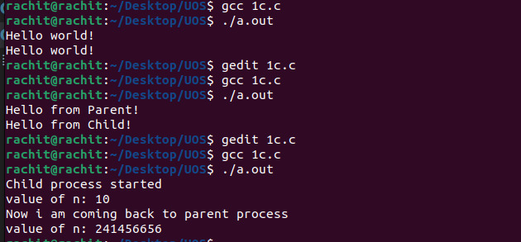

**Conclusion:**

fork() and vfork() system calls have some differences which allows different type of execution of child processes.