**File System Internals**

**Subject - Unix Operating System**

**Name – Hemant Sharma**

**PRN – 22610001 Class – TYIT**

**Assignment No – 3A(a)**

**Title-** Write the program to show file statistics using the stat system call. Take the filename / directory name from user including path.

**Objective-**

1. To learn about File system Internals.

**Theory:**

Name:  
 stat, fstat, lstat - get file status

Syntax:

#include <sys/types.h>

#include <sys/stat.h>

#include <unistd.h>

int stat(const char *path, struct stat *buf);

int fstat(int fd, struct stat *buf);

int lstat(const char *path, struct stat *buf);

Description:

These functions return information about a file. No permissions are required on the file itself, but-in the case of stat() and lstat() - execute (search) permission is required on all of the directories in path that lead to the file.

stat() stats the file pointed to by path and fills in buf.

lstat() is identical to stat(), except that if path is a symbolic link, then the link itself isstat-ed, not the file that it refers to.

fstat() is identical to stat(), except that the file to be stat-ed is specified by the file descriptor fd.

All of these system calls return a stat structure, which contains the following fields :

struct stat {

dev_t st_dev; /* ID of device containing file */

ino_t st_ino; /* inode number */

mode_t st_mode; /* protection */

nlink_t st_nlink; /* number of hard links */

uid_t st_uid; /* user ID of owner */ gid_t

st_gid; /* group ID of owner */

dev_t st_rdev; /* device ID (if special file) */

off_t st_size; /* total size, in bytes */

blksize_t st_blksize; /* blocksize for file system I/O */

blkcnt_t st_blocks; /* number of 512B blocks allocated */

time_t st_atime; /* time of last access */

time_t st_mtime; /* time of last modification */

time_t st_ctime; /* time of last status change */

};

**Flowchart-**

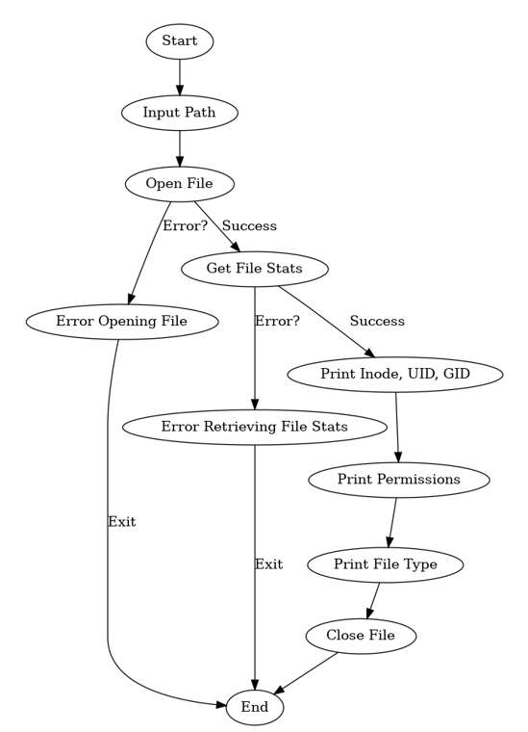

**Program-**

#include<stdio.h>

#include<unistd.h>

#include<sys/types.h>

#include<sys/stat.h>

int main(int argc, char **argv)

{

struct stat fileStat;

stat("/home/sumit/Documents/UOS/abc.txt",&fileStat)

if(stat("/home/sumit/Documents/UOS/abc.txt",&fileStat) < 0)

{

printf("Failed\n");

return 1;

}

printf("---------------------------\n");

printf("File Size: \t\t%ld bytes\n",(long)fileStat.st_size);

printf("Number of Links: \t%ld\n",(long)fileStat.st_nlink);\

printf("File inode: \t\t%ld\n",(long)fileStat.st_ino);

printf("File Permissions: \t");

printf( (S_ISDIR(fileStat.st_mode)) ? "d" : "-");

printf( (fileStat.st_mode & S_IRUSR) ? "r" : "-");

printf( (fileStat.st_mode & S_IWUSR) ? "w" : "-");

printf( (fileStat.st_mode & S_IXUSR) ? "x" : "-");

printf( (fileStat.st_mode & S_IRGRP) ? "r" : "-");

printf( (fileStat.st_mode & S_IWGRP) ? "w" : "-");

printf( (fileStat.st_mode & S_IXGRP) ? "x" : "-");

printf( (fileStat.st_mode & S_IROTH) ? "r" : "-");

printf( (fileStat.st_mode & S_IWOTH) ? "w" : "-

"); printf( (fileStat.st_mode & S_IXOTH) ? "x" : "-

"); printf("\n\n");

printf("The file %s a symbolic link\n", (S_ISLNK(fileStat.st_mode)) ? "is" : "is

not"); return 0;

}

**Output-**

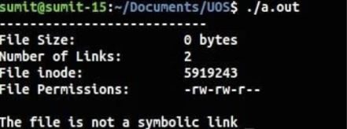

**Conclusion-**

* Stats of file like file size,links, permissions, inode number and type of link can

be retrieved using stat() and stored in a structure.