**File System Internals**

**Subject - Unix Operating System**

**Name – Hemant Sharma**

**PRN – 22610001 Class – TYIT**

**Assignment No – 3A(b)**

**Title-**  Write the program to show file statistics using the fstat system call. Take the file name / directory name from user including path. Print only inode no, UID, GID, FAP and File type only.

**Objective-**

1. To learn about File system Internals.

**Theory-**

Name

stat, fstat, lstat - get file status

Syntax

#include <sys/types.h>

#include <sys/stat.h>

#include <unistd.h>

int stat(const char *path, struct stat *buf);

int fstat(int fd, struct stat *buf);

int lstat(const char *path, struct stat *buf);

Description:

These functions return information about a file. No permissions are required on the file itself, but-in the case of stat() and lstat() - execute (search) permission is required on all of the directories in path that lead to the file.

stat() stats the file pointed to by path and fills in buf.

lstat() is identical to stat(), except that if path is a symbolic link, then the link itself isstat-ed, not the file that it refers to.

fstat() is identical to stat(), except that the file to be stat-ed is specified by the file descriptor fd.

All of these system calls return a stat structure, which contains the following fields :

struct stat {

dev_t st_dev; /* ID of device containing file */

ino_t st_ino; /* inode number */

mode_t st_mode; /* protection */

nlink_t st_nlink; /* number of hard links */

uid_t st_uid; /* user ID of owner */ gid_t

st_gid; /* group ID of owner */

dev_t st_rdev; /* device ID (if special file) */

off_t st_size; /* total size, in bytes */

blksize_t st_blksize; /* blocksize for file system I/O */

blkcnt_t st_blocks; /* number of 512B blocks allocated */

time_t st_atime; /* time of last access */

time_t st_mtime; /* time of last modification */

time_t st_ctime; /* time of last status change */

};

**Flowchart-**

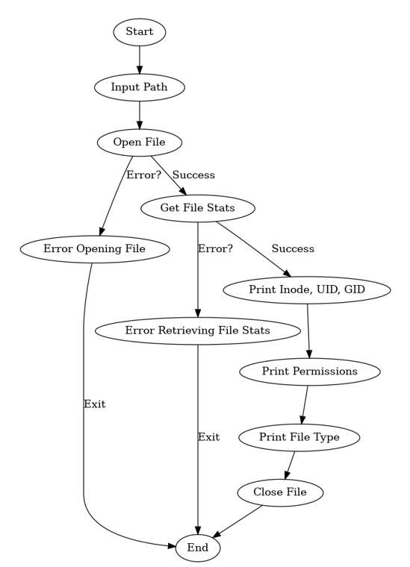

**Program-**

#include<stdio.h>

#include<stdlib.h>

#include <sys/stat.h>

#include <sys/types.h>

#include <unistd.h> int

int main(){

char s[100]; gets(s);

//printf("%s",s);

FILE *fp;

if((fp=fopen(s,"r"))==NULL) return 1;

int fn=0; fn=fileno(fp);

struct stat sta;

if(fstat(fn,&sta) < 0) return 1;

printf("File size : %ld\n",(long)sta.st_size); printf("File

INode Number : %ld\n",sta.st_ino); printf("File UID :

%ld\n",(long)sta.st_uid); printf("File GID : %ld\n",

(long)sta.st_gid);

printf("File Permissions: \t");

printf( (S_ISDIR(sta.st_mode)) ? "d" : "-");

printf( (sta.st_mode & S_IRUSR) ? "r" : "-");

printf( (sta.st_mode & S_IWUSR) ? "w" : "-");

printf( (sta.st_mode & S_IXUSR) ? "x" : "-");

printf( (sta.st_mode & S_IRGRP) ? "r" : "-");

printf( (sta.st_mode & S_IWGRP) ? "w" : "-");

printf( (sta.st_mode & S_IXGRP) ? "x" : "-");

printf( (sta.st_mode & S_IROTH) ? "r" : "-");

printf( (sta.st_mode & S_IWOTH) ? "w" : "-");

printf( (sta.st_mode & S_IXOTH) ? "x" : "-"); printf("\n\

n");

printf("File type: ");

switch (sta.st_mode & S_IFMT)

{

case S_IFBLK: printf("block device\n"); break;

case S_IFCHR:

printf("character device\n");

break;

case S_IFDIR:

printf("directory\n");

break;

case S_IFIFO:

printf("FIFO/pipe\n"); break;

case S_IFLNK:

printf("symlink\n");

break;

case S_IFREG:

printf("regular file\n");

break;

case S_IFSOCK:

printf("socket\n");

break;

default: printf("unknown?\

n"); break;

}

**Output-**

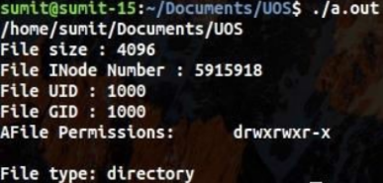

**Conclusion-**

Stats of file like UID, GIDfile size,links, permissions, inode number and type of link can be retrieved using stat(),fstat() and link() and stored in a structure.