**File System Internals**

**Subject - Unix Operating System**

**Name – Hemant Sharma**

**PRN – 22610001 Class – TYIT**

**Assignment No – 3A(d)**

**Title-** Program to Print Various Types of Files in Linux

**Objectives-**

1. To learn about File system Internals.

**Theory-** This program demonstrates how to identify and print various types of files in Linux. It uses the `stat` system call to retrieve file metadata and determines the file type based on the mode field. Linux files can be of different types, such as:  
1. Regular file  
2. Directory  
3. Character device  
4. Block device  
5. FIFO (named pipe)  
6. Socket  
7. Symbolic link

This program is a practical example of how file systems classify and manage different file types.

**Flowchart-**

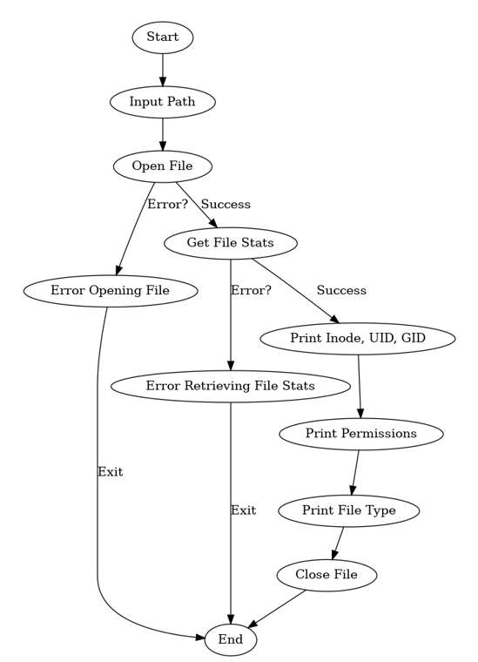

**Program-**

#include <stdio.h>  
#include <stdlib.h>  
#include <sys/types.h>  
#include <sys/stat.h>  
#include <unistd.h>  
  
void print_file_type(const char *path) {  
 struct stat fileStat;  
  
 // Get file metadata  
 if (stat(path, &fileStat) == -1) {  
 perror("Error retrieving file statistics");  
 exit(EXIT_FAILURE);  
 }  
  
 // Determine the file type  
 printf("File: %s\n", path);  
 if (S_ISREG(fileStat.st_mode)) {  
 printf("Type: Regular File\n");  
 } else if (S_ISDIR(fileStat.st_mode)) {  
 printf("Type: Directory\n");  
 } else if (S_ISCHR(fileStat.st_mode)) {  
 printf("Type: Character Device\n");  
 } else if (S_ISBLK(fileStat.st_mode)) {  
 printf("Type: Block Device\n");  
 } else if (S_ISFIFO(fileStat.st_mode)) {  
 printf("Type: FIFO/Pipe\n");  
 } else if (S_ISLNK(fileStat.st_mode)) {  
 printf("Type: Symbolic Link\n");  
 } else if (S_ISSOCK(fileStat.st_mode)) {  
 printf("Type: Socket\n");  
 } else {  
 printf("Type: Unknown\n");  
 }  
}  
  
int main() {  
 char path[256];  
  
 // Prompt the user for the file path  
 printf("Enter the file path: ");  
 scanf("%s", path);  
  
 // Print the file type  
 print_file_type(path);  
  
 return 0;  
}

**Output-**

Enter the file path: /dev/null  
File: /dev/null  
Type: Character Device

**Conclusion-**

This program demonstrates how to classify and print various types of files in Linux using the `stat` system call. By analyzing the mode field of the file's metadata, it is possible to distinguish between different file types such as regular files, directories, character devices, block devices, FIFOs, sockets, and symbolic links. This information is essential for understanding file system behavior and structure.