**Processing Environment**

**Subject - Unix Operating System**

**Name – Rachit Bhat**

**PRN – 22610007 Class – TYIT**

**Assignment No – 1d**

**Title-** Write the program to use wait/waitpid system call and explain what it do when call in parent

**Objectives-**

1. To learn about Processing Environment.
2. To know the difference between fork/vfork and various execs variations.
3. Use of system call to write effective programs.

**Theory-**

Difference between wait() abd waitpid()

|  |  |
| --- | --- |
| Wait() | Waitpid() |
| Wait blocks the caller until a child process terminates | Waitpid can be either blocking or nonblocking:   * If option is 0, then it is blocking. * If option is WNOHANG, then it is non-blocking |
| If more than one child is running then wait() returns the first time one of the parent’s offspring exits. | Waitpid is more flexible:   * If pid==-1, it waits for any child process. In this respect, waitpid is equivalent to wait. * If pid>0, it waits for the child whose process ID equals pid. * If pid==0, it waits for any child whose process group ID equals that of the calling process. * If pid<-1, it waits for any child whose process group ID equals that absolute value of pid. |

**Program:**

#include<stdlib.h>

#include<stdio.h>

#include<unistd.h>

#include<sys/wait.h>

void main()

{

pid_t id=fork();

if(id==0)

{

printf("Child Process Started..ProcessID = %d\n", getpid());

printf("In Child\n");

for(int i=0;i<5;i++)

{

printf("In Child : %d\n",i);

}

printf("Child Finished\n");

exit(0);

}

else

{

printf("Parent Process Started..ProcessID = %d\n", getpid());

printf("In Parent\n");

printf("Parent waiting\n");

wait(NULL);

printf("Parent Resumed\n");

for(int i=0;i<5;i++)

{

printf("In parent : %d\n",i);

}

printf("Parent Finished\n");

}

}

**Output:**

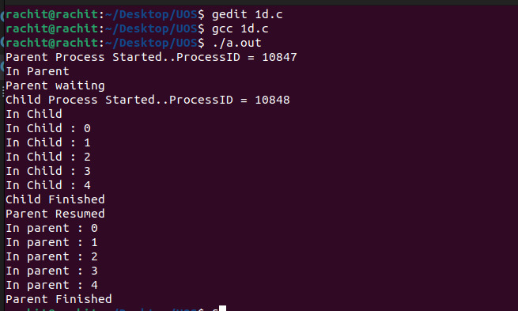

**Conclusion:**

The waitpid() call is more flexible than wait() system call as wait() would block the parent until child processes complete, while waitpid() can be implemented in blocking or unblocking ways