**Python: As a scripting language**

**Subject - Unix Operating System**

**Name – Hemant Sharma**

**PRN – 22610001 Class – TYIT**

**Assignment No – 10(f)**

**Title-** Generate a word frequency list for wonderland.txt.

**Objective:**

1. To learn about python as scripting option.

**Theory:**

A word frequency list is a count of how often each unique word appears in a text file. This analysis is useful in text processing, linguistic studies, and data analysis.

To generate a word frequency list from wonderland.txt, we follow these steps:

* **Read the file:** Open and read the contents of wonderland.txt.
* **Tokenization:** Split the text into individual words by removing punctuation and converting all words to lowercase for consistency.
* **Count occurrences:** Use a dictionary or the collections. Counter module in Python to count the occurrences of each word.
* **Sort the results:** Display the most frequently used words in descending order.

This process helps analyse word usage patterns and extract meaningful insights from the text.

**Program:**

import re

from collections import Counter

# Open and read the content of the file

with open('wonderland.txt', 'r') as file:

    text = file.read()

# Use regex to find all words (alphanumeric characters)

words = re.findall(r'\w+', text.lower())  # Convert to lowercase to ensure case insensitivity

# Use Counter to count word frequencies

word_counts = Counter(words)

# Sort the word frequencies by count

sorted_word_counts = word_counts.most_common()

# Print the results

for word, count in sorted_word_counts:

    print(f"{word}: {count}")

**Output:**

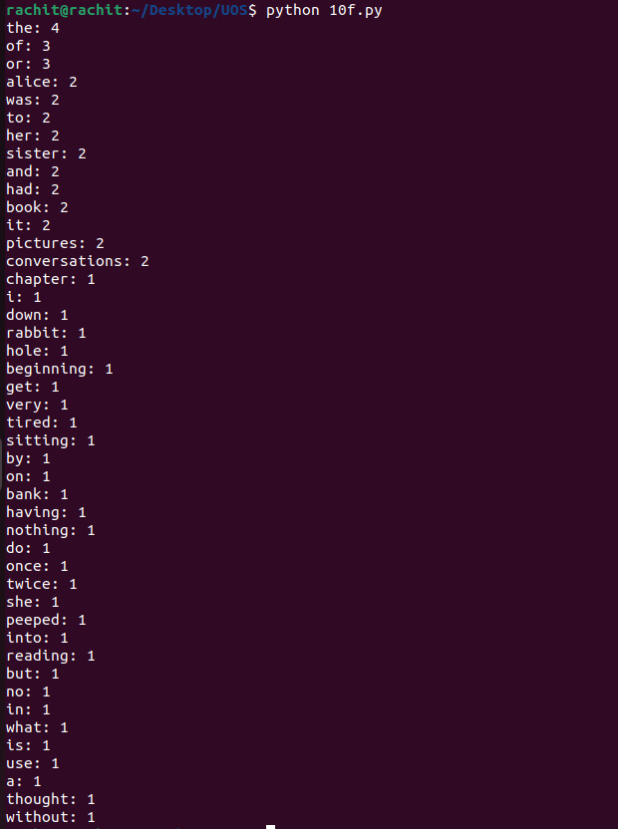

**Conclusion:**

Generating a word frequency list provides a structured way to analyze text content. It helps in understanding word distributions, identifying common words, and detecting patterns in the text. This method is widely used in natural language processing (NLP), search engine optimization (SEO), and textual data analysis. By applying this technique to wonderland.txt, we can explore the vocabulary and writing style used in *Alice’s Adventures in Wonderland*.