**Python: As a scripting language**

**Subject - Unix Operating System**

**Name – Hemant Sharma**

**PRN – 22610001 Class – TYIT**

**Assignment No – 10(c)**

**Title-** Take any txt file and count word frequencies in a file.

**Objective:**

1. To learn about python as scripting option.

**Theory:**

**File handling:**

A file is some information or data which stays in the computer storage devices. You already know about different kinds of file, like your music files, video files, text files. Python gives you easy ways to manipulate these files. Generally, we divide files in two categories, text file and binary file. Text files are simple text whereas the binary files contain binary data which is only readable by computer.

**File opening:**

To open a file we use open() function. It requires two arguments, first the file path or file name, second which mode it should open. Modes are like “r” -> open read only, you can read the file but cannot edit / delete anything inside

* “w” -> open with write power, means if the file exists then delete all content and open it to write
* “a” -> open in append mode

The default mode is read only, i.e. if you do not provide any mode, it will open the file as read only. Let us open a file

fobj = open("love.txt")

fobj

<_io.TextIOWrapper name='love.txt' mode='r' encoding='UTF-8'>

**Closing a file:**

After opening a file, one should always close the opened file. We use method close() for this.

fobj = open("love.txt")

fobj

<_io.TextIOWrapper name='love.txt' mode='r' encoding='UTF-8'>

>>> fobj.close()

**Reading a file:**

To read the whole file at once use the read() method.

fobj = open("sample.txt")

fobj.read()

'I love Python\nPradeepto loves KDE\nSankarshan loves Openoffice\n'

**Program:**def count_word_frequencies(filename):

    try:

        # Open the file in read mode

        with open(filename, 'r') as file:

            # Read the content of the file

            text = file.read()

            # Convert the text to lowercase and split into words

            words = text.lower().split()

            # Create a dictionary to store the frequency of each word

            word_freq = {}

            # Iterate through the list of words and count their frequency

            for word in words:

                # Remove punctuation (if any)

                word = word.strip(".,!?()[]{}:;\"'")

                # If the word is already in the dictionary, increment its count

                if word in word_freq:

                    word_freq[word] += 1

                else:

                    word_freq[word] = 1

            # Print the word frequencies

            for word, freq in word_freq.items():

                print(f"{word}: {freq}")

    except FileNotFoundError:

        print("The file was not found. Please check the file path.")

# Get the filename from the user

filename = input("Enter the path to the text file: ")

# Call the function to count word frequencies

count_word_frequencies(filename)

**Output:**

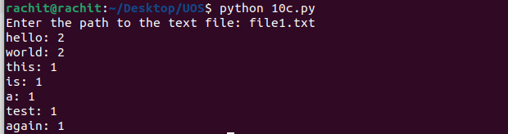

**Conclusion:**

1.File handling and manipulation of data using list and dictionary learnt.