**Shell Programming: Shell Scripts**

**Subject - Unix Operating System**

**Name – Rachit Bhat**

**PRN – 22610007 Class – TYIT**

**Assignment No – 5c**

**Title-**Using shell sort the given 10 number in ascending order (use of array).

**Objectives-**

1. To learn shell programming and use it for write effective programs.

**Theory-**

A shell in a Linux operating system takes input from you in the form of commands, processes it, and then gives an output. It is the interface through which a user works on the programs, commands, and scripts. A shell is accessed by a terminal which runs it.

When you run the terminal, the Shell issues a command prompt (usually $), where you can type your input, which is then executed when you hit the Enter key. The output or the result is thereafter displayed on the terminal.

The Shell wraps around the delicate interior of an Operating system protecting it from accidental damage. Hence the name Shell.

**Flowchart-**

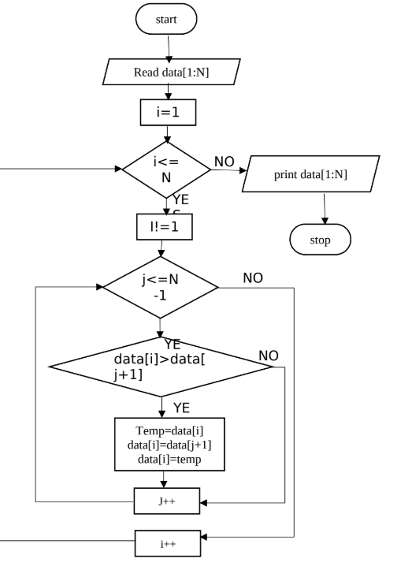

**Program-**

#!/bin/bash

echo "enter numbers"

read n;

declare -a a;

for((i=0;i<n;i++))

do

read a[$i];

done

for((i=0;i<n;i++))

do

for((j=i+1;j<n;j++))

do

{

if((a[i]>a[j]))

then

temp=${a[i]};

a[$i]=${a[j]};

a[$j]=$temp;

fi

}

done

done

for((i=0;i<n;i++))

do

echo ${a[i]}