**IPC: Sockets**

**Subject - Unix Operating System**

**Name – Hemant Sharma**

**PRN – 22610001 Class – TYIT**

**Assignment No – 9(f)**

**Title-** Implement chatting using TCP/UDP socket (between two or more users.)

**Objectives:**

1. To learn about fundamentals of IPC through C socket programming.
2. Learn and understand the OS interaction with socket programming.
3. Use of system call and IPC mechanism to write effective application programs.
4. To know the port numbering and process relation.
5. To knows the iterative and concurrent server concept.

**Theory:**

A very basic one-way Client and Server setup where a client connects, sends messages to server and the server shows them using socket connection. Java API networking package (java.net) takes care of all of that, making network programming very easy for programmers

CLIENT-SIDE PROGRAMMING:

Establish a Socket Connection

* To connect to other machine, we need a socket connection.
* A socket connection means the two machines have information about each other’s network location (IP Address) and TCP port. The java.net.Socket class represents a Socket.
* To open a socket: Socket socket = new Socket (“127.0.0.1”, 5000)

• First argument – IP address of Server. (127.0.0.1 is the IP address of localhost, where code will run on single stand-alone machine).

• Second argument – TCP Port. (Just a number representing which

application to run on a server. For example, HTTP runs on port 80.

Port number can be from 0 to 65535) To communicate over a socket

connection, streams are used to both input and output the data. Closing

the connection. The socket connection is closed explicitly once the

message to server is sent.

SERVER-SIDE PROGRAMMING:

Establish a Socket Connection

To write a server application two sockets are needed.

* A ServerSocket which waits for the client requests (when a client makes a new Socket())
* A plain old Socket socket to use for communication with the client getOutputStream() method is used to send the output through the socket. Close the Connection After finishing, it is important to close the connection by closing the socket as well as input/output streams

**Program:**

**Server:**#include <stdio.h>

#include <stdlib.h>

#include <string.h>

#include <unistd.h>

#include <arpa/inet.h>

#include <pthread.h>

#define PORT 12345

#define MAX_CLIENTS 10

#define MAX_MSG_SIZE 1024

int client_sockets[MAX_CLIENTS];

pthread_mutex_t client_sockets_mutex = PTHREAD_MUTEX_INITIALIZER;

void *client_handler(void *arg) {

    int client_socket = *(int *)arg;

    char message[MAX_MSG_SIZE];

    int recv_len;

    struct sockaddr_in client_addr;

    socklen_t addr_len = sizeof(client_addr);

    // Get client details (IP and port)

    getpeername(client_socket, (struct sockaddr *)&client_addr, &addr_len);

    char client_ip[INET_ADDRSTRLEN];

    inet_ntop(AF_INET, &client_addr.sin_addr, client_ip, sizeof(client_ip));

    int client_port = ntohs(client_addr.sin_port);

    printf("Client %s:%d connected\n", client_ip, client_port);

    while (1) {

        // Receive message from client

        recv_len = recv(client_socket, message, sizeof(message), 0);

        if (recv_len <= 0) {

            printf("Client %s:%d disconnected\n", client_ip, client_port);

            break;

        }

        message[recv_len] = '\0';

        // Print message with client identifier

        printf("Received message from %s:%d: %s\n", client_ip, client_port, message);

        // Broadcast message to all clients except the sender

        pthread_mutex_lock(&client_sockets_mutex);

        for (int i = 0; i < MAX_CLIENTS; i++) {

            if (client_sockets[i] != 0 && client_sockets[i] != client_socket) {

                send(client_sockets[i], message, strlen(message), 0);

                printf("Sent message to client %s:%d: %s\n", client_ip, client_port, message);

            }

        }

        pthread_mutex_unlock(&client_sockets_mutex);

    }

    // Close client socket

    close(client_socket);

    return NULL;

}

int main() {

    int server_socket, client_socket;

    struct sockaddr_in server_addr, client_addr;

    socklen_t client_len = sizeof(client_addr);

    pthread_t thread_id;

    // Initialize client sockets to 0

    memset(client_sockets, 0, sizeof(client_sockets));

    // Create TCP socket

    if ((server_socket = socket(AF_INET, SOCK_STREAM, 0)) == -1) {

        perror("Socket creation failed");

        exit(1);

    }

    memset(&server_addr, 0, sizeof(server_addr));

    server_addr.sin_family = AF_INET;

    server_addr.sin_addr.s_addr = INADDR_ANY;

    server_addr.sin_port = htons(PORT);

    // Bind socket

    if (bind(server_socket, (struct sockaddr *)&server_addr, sizeof(server_addr)) == -1) {

        perror("Bind failed");

        close(server_socket);

        exit(1);

    }

    // Listen for incoming connections

    if (listen(server_socket, 5) == -1) {

        perror("Listen failed");

        close(server_socket);

        exit(1);

    }

    printf("Chat Server is waiting for clients to connect...\n");

    while (1) {

        client_socket = accept(server_socket, (struct sockaddr *)&client_addr, &client_len);

        if (client_socket == -1) {

            perror("Accept failed");

            continue;

        }

        // Add client socket to list

        pthread_mutex_lock(&client_sockets_mutex);

        for (int i = 0; i < MAX_CLIENTS; i++) {

            if (client_sockets[i] == 0) {

                client_sockets[i] = client_socket;

                break;

            }

        }

        pthread_mutex_unlock(&client_sockets_mutex);

        // Create a new thread for the client

        if (pthread_create(&thread_id, NULL, client_handler, (void *)&client_socket) != 0) {

            perror("Thread creation failed");

            close(client_socket);

        }

    }

    close(server_socket);

    return 0;

}

**Client:**

#include <stdio.h>

#include <stdlib.h>

#include <string.h>

#include <unistd.h>

#include <arpa/inet.h>

#define SERVER_IP "127.0.0.1"

#define SERVER_PORT 12345

#define MAX_MSG_SIZE 1024

void *receive_messages(void *arg) {

    int client_socket = *(int *)arg;

    char message[MAX_MSG_SIZE];

    while (1) {

        int recv_len = recv(client_socket, message, sizeof(message), 0);

        if (recv_len <= 0) {

            printf("Connection closed by server\n");

            break;

        }

        message[recv_len] = '\0';

        printf("Received: %s\n", message);

    }

    return NULL;

}

int main() {

    int client_socket;

    struct sockaddr_in server_addr;

    pthread_t recv_thread;

    // Create TCP socket

    if ((client_socket = socket(AF_INET, SOCK_STREAM, 0)) == -1) {

        perror("Socket creation failed");

        exit(1);

    }

    memset(&server_addr, 0, sizeof(server_addr));

    server_addr.sin_family = AF_INET;

    server_addr.sin_port = htons(SERVER_PORT);

    if (inet_pton(AF_INET, SERVER_IP, &server_addr.sin_addr) <= 0) {

        perror("Invalid address");

        exit(1);

    }

    // Connect to the server

    if (connect(client_socket, (struct sockaddr *)&server_addr, sizeof(server_addr)) == -1) {

        perror("Connection failed");

        exit(1);

    }

    // Start a thread to receive messages from the server

    pthread_create(&recv_thread, NULL, receive_messages, (void *)&client_socket);

    // Send messages to the server

    char message[MAX_MSG_SIZE];

    while (1) {

        printf("Enter message: ");

        fgets(message, sizeof(message), stdin);

        // Remove the trailing newline character

        message[strcspn(message, "\n")] = '\0';

        if (strcmp(message, "exit") == 0) {

            break;

        }

        send(client_socket, message, strlen(message), 0);

    }

    close(client_socket);

    return 0;

}

**Output:**

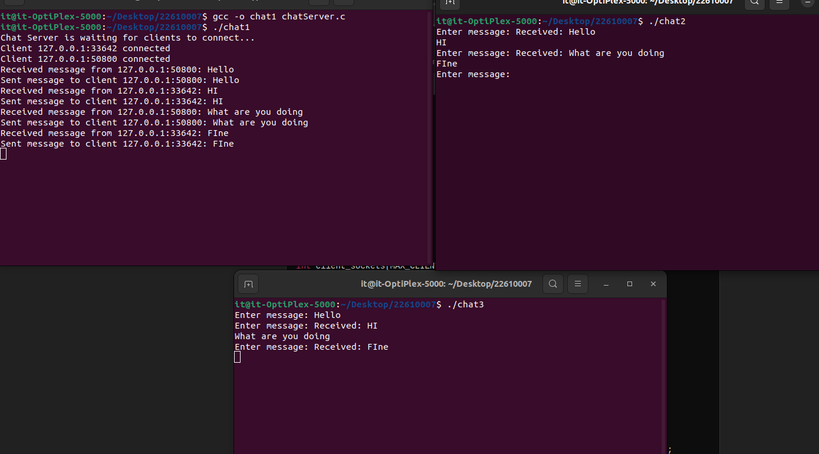

**Conclusion:**

Implementing a chat system with TCP or UDP allows users to exchange messages in real-time. TCP ensures reliable, ordered communication, making it suitable for multi-user chat applications, while UDP provides a faster, connectionless alternative, though with less reliability. TCP chat servers often use threads to manage multiple clients concurrently, while UDP servers handle each message individually. In both cases, clients can send and receive messages, and the server facilitates communication, broadcasting messages to all participants.