Capstone Project Weekly Progress Report
Semester | Fall-2024 Semester 3rd
Course Code | AML-3406
Section | Section 1
Project Title | Car Damage Detection
Group Name | Group B
Student names/Student IDs | Sakshi (C0908000) – TL  Bansil Patel (C0912873)  Harsh Mohile (C0912872)  Meet Patel (C0910378)  Rachit Bhatt (C0902810)
Reporting Week | Week 10
Faculty Supervisor | William Pourmajidi

Grade the level of collaboration from different aspects between team members:
(use: good, medium, below expectation)
Sakshi | Bansil Patel | Harsh Mohile | Meet Patel | Rachit Bhatt
Good | Good | Good | Good | Good

Tasks outlined in the previous Weekly Progress Report for this reporting week at the individual level and group level
  - Individual tasks (each team member)
Sakshi: Integrate GitHub Actions for automated testing and deployment within the project.
Bansil Patel & Meet Patel: Continue to refine the model’s hyperparameters and validate its performance with real-world datasets.
Harsh Mohile & Rachit Bhatt: Finalize and test the Deployment UI and backend to ensure smooth integration with the deployment pipeline.
2.2 Your team’s task
- Complete the deployment UI and backend integration, ensuring seamless functionality with the CI/CD pipeline.
- Finalize model performance evaluation and continue refining hyperparameters for optimization.

Progress made in Reporting Week at an individual level and group level
  - Individual progress
Sakshi: Successfully integrated GitHub Actions for continuous testing. Automated deployment for the testing environment is now functioning.
Bansil Patel & Meet Patel: Completed further hyperparameter optimization, achieving a noticeable improvement in model accuracy and speed. Began testing the model on additional datasets.
Harsh Mohile & Rachit Bhatt: Finished designing and implementing the Deployment UI, and integrated it with the backend for initial testing. The deployment process works across staging and production environments.
  - Your team’s progress
- Successfully deployed the first iteration of the model with automated testing and deployment via GitHub Actions.
- Hyperparameter optimization reached a key milestone, with performance benchmarks now established.
- Deployment UI and backend integration are almost complete, with full functionality confirmed in staging and production environments.

The areas/tasks you could not make progress and/or complete as scheduled or the difficulties encountered in this reporting week at individual level and group level.
  - Individual project blockers
Sakshi: Experienced minor issues with GitHub Actions failing intermittently due to repository configuration.
Bansil Patel: Encountered difficulty with large-scale dataset testing, resulting in slower than expected model performance evaluation.
Meet Patel: N/A
Harsh Mohile & Rachit Bhatt: Faced challenges when aligning the Deployment UI with backend API configurations, leading to delays in full integration.
Your team’s project blockers
- Encountered delays in configuring GitHub Actions for multi-branch CI/CD, which affected the consistency of the deployment workflow across different environments.
- Backend integration for the Deployment UI had to be revisited to ensure compatibility with production configurations.

Tasks to be completed in the next week at individual level and group level
  - Individual tasks
Sakshi: Finalize the integration of GitHub Actions for deployment in multiple environments (testing, staging, production).
Bansil Patel & Meet Patel: Focus on improving the model’s generalizability with further dataset evaluation and finalize the hyperparameter tuning.
Harsh Mohile & Rachit Bhatt: Optimize the Deployment UI and backend integration. Address the issues related to API communication for smoother deployment.
  - Your team’s tasks

- Complete the final evaluation of the model’s performance and ensure that the deployment workflow is fully automated and error-free.
- Conduct full-scale testing of the deployment process in various environments, ensuring consistency and stability.
- Continue refining the Deployment UI and backend functionalities to ensure compatibility with the CI/CD pipeline across all environments.

Include the tasks from your sprint planning (GitHub/ZenHub) for the present period.
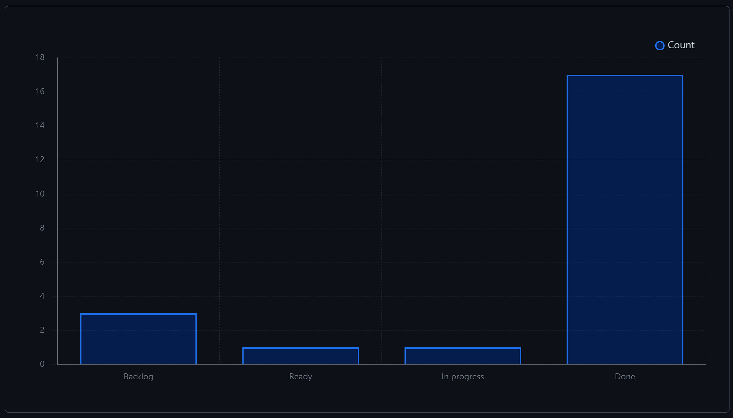
Figure 1: Weekly Activities
- In this week, there were a lot of issues resolved from the backlog, contributing to development.

Include charts/graphs (e.g., burn down charts) from your project management tool (Github/Zenhub) that shows your progress for the period of this report.
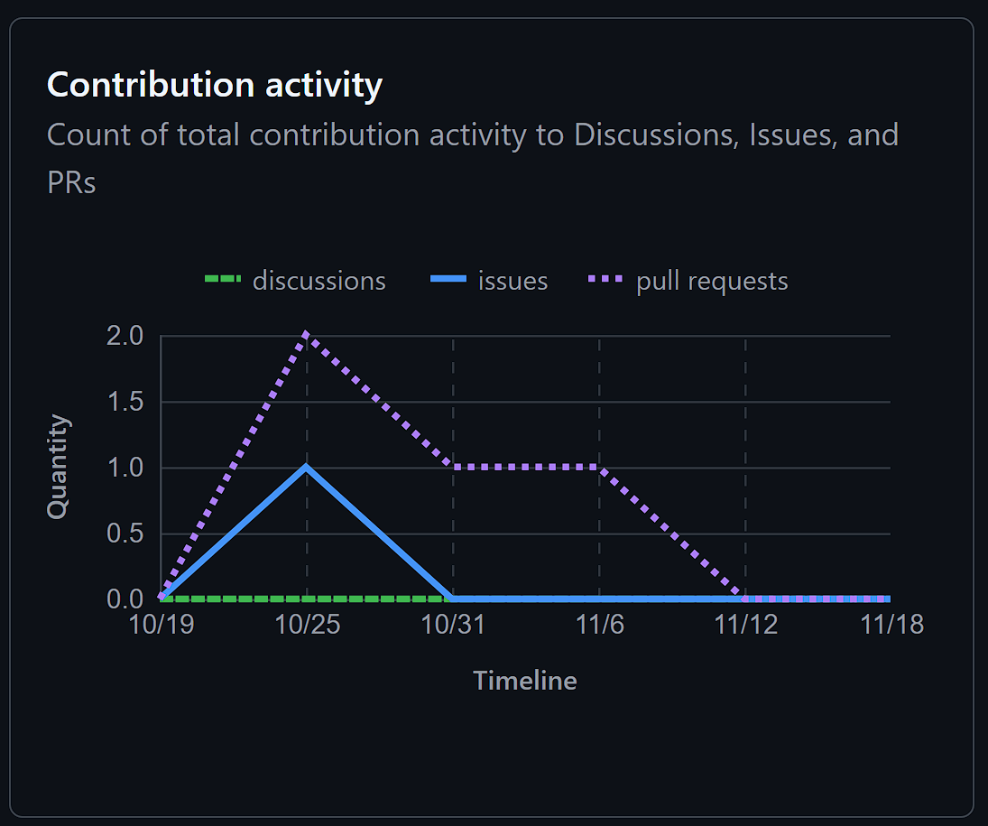
Figure 2: Contributors in the Week
- This week, we had a few PRs and issues resolved as compared to previous week, demonstrating team hard work and dedication.

Include a note and address to your project GitHub with list of codes uploaded/updated on GitHub in this reporting week.
GitHub: https://www.github.com/rachit-bhatt/Capstone-Project

