**StarContests.com**

***If it’s not here it’s not happening.***

***Software Requirements Specifications v1.0***

***Team 8***

**Instructor - Prof. Asim Banerjee**

# GROUP MEMBERS

|  |  |  |
| --- | --- | --- |
| **Serial No.** | **Name** | **ID** |
| 1. | HARDIK BELADIYA | 201201064 |
| 2. | ARCHIT GAJJAR | 201201066 |
| 3. | SOHAM DARJI | 201201070 |
| 4. | KRUPAL BAROT | 201201074 |
| 5. | DHAVAL CHAUDHARY | 201201075 |
| 6. | PRACHI KOTHARI | 201201077 |
| 7. | YASH KUMAR JAIN | 201201080 |
| 8. | RACHIT MISHRA | 201201092 |
| 9. | SHIVANI THAKKER | 201201108 |

# DOCUMENT DESCRIPTION

This document will define and illustrate the overall project and its requirements - functional and non-functional. In addition to it, it will document the formats of the inputs and outputs and the design constraints. It will define the users and their respective characteristics identified by the team. Efforts have been made so that this document can act as the basis for agreement between the client and the developing team.

# REVISION HISTORY

|  |  |  |  |  |
| --- | --- | --- | --- | --- |
| **Date** | **Document** | **Version** | **Created By** | **Reviewed By** |
| **15th February**  **2015** | System  Requirements  Specifications | 1.0 | Rachit, Shivani,  Yash, Krupal | Prachi, Soham,  Hardik, Archit,  Dhaval |

# TABLE OF CONTENTS

Introduction..............................................................................................5

Project Objective.......................................................................................5 Definitions, Acronyms & Abbreviations....................................................6

Project Scope ...........................................................................................7

References.....................................................................................7

Project Deliverables...........................................................................8

Intended Audience............................................................................8

Overall Description...........................................................................9

Product Perspective ..................................................................9

Product Functions ...................................................................9

User Classes and Characteristics .........................................................10

Operating System....................................................................10

Constraints............................................................................10

Assumptions and Dependencies...................................................10

Requirements.................................................................................11

Non-Functional Requirements.....................................................12

Performance Requirements.........................................................12

Safety and Security Requirements................................................................13

Software Quality Requirements........................................................13

Functional Requirements............................................................13

Hardware & Software Requirements .............................................18

System Features..............................................................................14

User Specifications........................................................................17

Survey Results and Analysis.......................................................25

# INTRODUCTION

## Project Objective-

It is not unusual to find lots of stories of rags to riches or stories about how small town people make it big. Local talent, spans the entire gamut from performing arts to sports. People, especially the school and college going students are always on the lookout for platforms to put their skills to display and to keep growing. At the same time there is no dearth of contests where they can do the same. Sports tournaments, music-dance drama competitions, quizzes, elocutions, debates, tech competitions, crafts or cooking contests are few of the better known. For the youth today it has become more about justifying their existence rather than simply existing. There have been numerous cases where given the proper platform these people have blossomed. Contests and tournaments take place, prizes in cash and kind are given and many a times it so happens that a person who might have been interested to participate in the same would not even know about it. For people organizing such events they are always on the lookout for volunteers and sub-organizers who would be ready to take up the work. If channelled in the right path there would be no stopping this talent. This is where we come in. The idea stemmed from the realization that such a system was needed to be put in place which would make this entire process more feasible and easy to use. So that the lack of awareness about contests in one's city or nearby or any other aspect related to it would not prove to be an impediment for people who are willing to prove their mettle.

The objective is to build a platform that facilitates a lot of tasks for local organizers, sub organizers, volunteers and participants. To build a website where people interested in participating in local tournaments/events/contests get notifications every time something comes in their area, according to their interests, they can register online, get all the details there and further follow the same contest on the same place, where organizers can put their contests with all the details, take registrations, perform the tasks of scheduling, budgeting and find participation as well as sub organizers/volunteers for various tasks, where sub-organizers/volunteers can find work if they are interested - in all a one-stop system for local contests/events.

## Definitions, Acronyms, Abbreviations-

1. Contest/tournament/event

Any event where people engage in a competition for supremacy in any field. Here it would be any field - literary, performing arts, sports, culinary to name a few.

1. Organizer

A person or a group of persons who arrange/host an event/activity. In this context, any entity who puts up a contest/tournament/event on the website along with all the details.

1. Participant

Any person who take part in something. Here, any person who registers on the website as a participant and registers for a contest/event and is willing to partake in the same.

1. Sub-organizer

Person who will work under the organizer. They can be more than one in number. They can take up various responsibilities like accommodation, hospitality, food etc. They will be approved by the organizer once they apply for some contest.

1. Volunteer

Person who offers to take part in an enterprise or undertake a task. These people willing to work for any event can register and the organizer would approve them and communicate accordingly. They would be unpaid or paid based on the organizer the details about which will be put beforehand.

## Project Scope-

Nowadays, the use of internet in each and every sector is growing rapidly. People have started using internet habitually. So our software which we’ve planned to launch on a small scale can rise efficiently on a large scale. Presently, the system will target local organizers, sub-organizers, volunteer and participants. It aims in making the entire process of contest organizing and its various aspects hassle-free.

## Document Conventions-

The following conventions would be followed throughout the document,

1. Title: Intense, 28 , Bold, Blue
2. Heading 1: Intense, 24, Bold, Maroon
3. Body: Calibri, 13, Black

## References-

1. Project Proposal
2. Feasibility Report
3. Project Plan
4. Questionnaires
5. Interview plans
6. IEEE Recommended Practice for Software Requirements Specifications, IEEE Std 830 – 1998, IEEE Computer Society.

## Project Deliverables-

The following documents will be submitted by the end of the project

1. Project Proposal
2. Feasibility Report
3. Software Development Life Cycle Model
4. System Requirements Specifications (SRS) document
5. Requirements traceability matrix
6. Software Design Document (SDD)
7. Gantt Chart
8. Software Quality Assurance Plan
9. Risk Management Plan
10. System Test Plan
11. User manual
12. Test report
13. Product code
14. Project Termination analysis
15. Installation Manual
16. The Final Tested System

## Intended Audience-

We are building our project keeping in mind the needs and interests of four major categories of consumers,

1. Organizers
2. Sub-organizers
3. Participants
4. Volunteers/referees/coaches etc.

# OVERALL DESCRIPTION

## Project Perspective-

Our project aims to build a website which will serve as an intermediate between tournament organizer and participators. Mostly, a person leading a normal life finds that the he is not able to participate in more and more tournaments like music, drama, sports, painting, singing etc. because of lack of awareness about appropriate tournaments which will make effective and honest use of their contributions/hobby/professional carrier. The outcome of our project will address this problem helping participators find appropriate tournament organizers to organize activities. Even sometimes organizers do want to host tournament but due to lack of sponsorship, work power they resist to do so. Also, the project outcome will serve as a huge platform for local talents to gain popularity and familiarity among people and organizer will get proper support so they can host a better tournament.

## Product Functions-

Major focus on the functionality of our project will be to provide suitable platforms to all the local talents and organizers to satisfy their necessary to host a tournament with proper support. Apart from these, the particular tournament organizer can get contacts of sponsors/coordinator/volunteer who have registered and mail/message the organizer who have enrolled for updates from that tournament preference, whenever they would carry out a tournament.

# USER CLASSES AND CHARACTERISTICS-

The users will be categorized in classes as below,

Tournament organizer: This user will have to compulsorily sign up to host a tournament if they want to. In the process of signing up the following data is going to be asked:

1. Full name of Organization
2. Legal Name of Organization
3. Logo (Optional)
4. Vision
5. Email for confirmation
6. Alternative email
7. Contact number/ Office Number
8. Address
9. Website of the organization (Optional)
10. Contact Person (his name, designation, contact number and email id)
11. Domain of work (checkboxes for music ,drama ,singing ,sport drawing etc.), orphanage, handicapped)
12. Description (further text to be publically shown to users)

Registered user: Usually, such users are regular, enthusiastic for their participation. This user can sign up and receive updates about subscribed tournament and get all details which they have marked as favourites. To become a subscribed user, you can sign up by giving your name, email id, phone number and password.

Guest user: Such users are usually occasional users of our product. This user can surf along the website and perform some operations that a subscribed user can without signing up. Although, they won’t be able to request for tournament.

## Operating Environment-

We will use HTML, JavaScript and CSS for the generic website development and front end coding. The back end coding of the server side information management system will be done in PHP. The main database creation will be done on SQLite and querying will be executed through PHP.

## Assumptions and dependencies-

We are assuming that English language, Personal computer and internet connectivity is available to our organizers and participators.

Our client has a domain server to host the website.

Information posted on the website by various entities is authentic.

## Constraints-

1. Standard modem and network adapter card are must for the internet connectivity of the system.
2. On server side, our system will require an Apache web server.
3. Web browsers Mozilla Firefox (version 20.0 and above) and Google Chrome (version 15.0 and above).
4. Approximate net speed should be 512 Kbps.

# REQUIREMENTS

## Non-functional Requirements-

* Performance Requirements

* 1. Our website is a multi-user web interface. Since there can be an uncertain increase of the application users, our system should be able to handle the sudden burden of login requests, from the side of tournament organizations as well as the participators. This is achievable by implementing the application at a server with high configuration, i.e. a system that will efficiently handle multiple client requests simultaneously.

* 1. Our website would offer an advanced search option that would enable users to search about any tournament based upon refining searches based upon categories, locations and domain of work.

* 1. The common database would be shared and updated by the users depending upon permission/restriction level.

* 1. Different category of users will be provided with different access/modify permissions.

* 1. The application would be accessible to users at all times-i.e. the server would be on all the time.

* Safety and Security Requirements

* 1. The end participators, organizers and administrators will be given unique user-name to access the user account.

* 1. If any user logs out, then the session is said to be closed and he has to login again to use the website i.e. he cannot get back with simply using back button of the web-based interface or application.

* 1. Different levels of authority and permission are allotted to different category of users.

* 1. The host computer/server must be well protected from viruses and other internet based threats in order to avoid crashing of server system, as it is the most crucial of all the components.

* 1. Database should be secured with appropriate passwords and data backup options.

* 1. Any change in the information of any registered user in the module shall be reflected immediately in the database.

* Software Quality Requirements-

1. Maintainability

* 1. The user must be able to browse through accessible part of the application without any difficulty.

* 1. All the requirements and system features are well documented in both, soft (in-built help) and hard versions user manuals which we intend to ship along with the product itself. Along with it, the user interface developed will be simple. Both these factors will attribute to efficient utilization of resources by user.

1. Portability

* 1. The website can be accessed from any web browser, mobile browsers on smart phones.

* 1. Having latest updated browsers is preferred for better experience.

* 1. Having a quick internet connection is preferred for a smooth experience.

1. Usability

* 1. The website shall provide a self-explicable user friendly interface such that it is usable with minimum extent of struggle.

* 1. All steps of the website development will be well documented to ensure maintenance of the product through lifetime.

1. Reliability

* 1. We intend to provide facility of backup of entire system along with information for the admin and user to deal with problems like power failure, disk failure, etc.

## Functional Requirements-

➢ External Interface Requirement

User Interface Description:

An interactive UI would be made. The specifications are-

1. Search box through which user can search a event location wise and/or category wise
2. Displaying the list of events according to the search
3. Details of event and category of event.
4. Showing the list of top rated events of particular region.
5. Details of each menu in the menu bar using a title window.
6. Account settings for subscribed users
7. Acknowledge form to reply to sponsor
8. Organizer can post about upcoming events
9. Organizer can view contact details and previous sponsorship of its event
10. If event happening on same time then organizers of those events can collaborate by their wish.
11. Contact Us
12. About Us

* Hardware Interface-

Any computing machine – PC, tablet, smart-phone, etc. with internet access is the only hardware requirement from the user side to access the website.

* Software Interface-

|  |  |
| --- | --- |
| Google groups and Google Drive | Team Coordination and Document Sharing |
| CSS/HTML, PHP | UI design and backend coding |
| XAMPP | Testing and Implementing |
| Notepad++/Aptana Studio | Text Editor |

* Communication Interface-

Our website could be accessed through any internet browser which is available on any computing device.

# SYSTEM FEATURES

The interfaces would be different for different categories of users.

Overview of those features is as follows –

For Registered User-

Organizers:

1. Registration: Registration using any Email id, Contact Person’s Name, Number, Address, Registration Proof, Field of interests.
2. The confirmation email will be send to the user on given Email id.
3. Login: User can login using their username and password.
4. Error message will be shown if the username or password is invalid.
5. If they forgot the password they can reset it.
6. View/Update profile: User can view and update their profile (change password etc.). Besides they can make posts publically visible.
7. An organizer hosts an event and puts up the details on the website under the category of the event. (For example, if the organizer wishes to host a singing competition, the details of the same can be put up under the ‘music’ section.
8. Updates the events on the calendar.
9. Can invite contacts over Gmail. Invites to an event hosted by the organizer can be sent to his/her friends over the Gmail.
10. View/Acknowledge Messages: User can view the messages sent to them by the sponsors and can acknowledge the sponsors regarding the sponsorship.
11. They can see 3 options after login (1) Organizer profile (2) Participant Profile and

(3) Sub organizer profile.

1. They can chat with their team (sub organizers, volunteers etc.) about planning and preparation of event.
2. They can promote the event on Facebook, send updates to registered users, put schedule, results, photos.

Sub organizers:

* 1. Registration: Registration using any Email id, Contact Person’s Name, Number, Address, Registration Proof, Field of interests.
  2. The confirmation email will be send to the user on given Email id.
  3. Login: User can login using their username and password.
  4. Error message will be shown if the username or password is invalid.
  5. If they forgot the password they can reset it.
  6. View/Update profile: User can view and update their profile (change password etc.). Besides they can make posts publically visible.
  7. A sub organizer hosts an event and puts up the details on the website under the category of the event. (For example, if the sub organizer wishes to host a singing competition, the details of the same can be put up under the ‘music’ section.
  8. Updates the events on the calendar.
  9. Can invite contacts over Gmail. Invites to an event hosted by the organizer can be sent to his/her friends over the Gmail.
  10. View/Acknowledge Messages: User can view the messages sent to them by the sponsors and can acknowledge the sponsors regarding the sponsorship.
  11. They can see 3 options after login (1) Organizer profile (2) Participant Profile and (3) Sub organizer profile.
  12. They can chat with their team (organizers, volunteers etc.) about planning and preparation of event.
  13. They can promote the event on Facebook, send updates to registered users, put schedule, results, photos.
  14. He can upload the bills for keep track of budgeting. This bills are visible to organizers and sub organizers only.

Participants:

1. Registration: Registration using Email id, Contact Person’s Name, Number, Address, Registration Proof, Field of interest.
2. The confirmation email will be send to the user on given Email id.
3. Login: User can login using their username and password.
4. Error message will be shown if the username or password is invalid.
5. If they forgot the password they can reset it.
6. View/Update profile: User can view and update their profile (change password etc.). Besides they can make posts publically visible.
7. They can see 3 options after login (1) Organizer profile (2) Participant Profile and

(3) Sub organizer profile.

1. Register for events based on their field of interest.

Volunteer's user registration:

* 1. Registration: Registration using any Email id, Contact Person’s Name, Number, Address, Registration Proof, Field of interests.
  2. The confirmation email will be send to the user on given Email id.
  3. Login: User can login using their username and password.
  4. Error message will be shown if the username or password is invalid.
  5. If they forgot the password they can reset it.
  6. View/Update profile: User can view and update their profile (change password etc.). Besides they can make posts publically visible.
  7. If an organizer has organized few events, he/she may receive notifications related to those events if they want to.
  8. They can chat with their team (organizers, sub organizers etc.) about planning and preparation of event.
  9. They can promote the event on Facebook, send updates to registered users, put schedule, results, photos.
  10. He/she can apply for organising event as sub organizer.

Guest user:

The guest can view the different events in their localities by entering his/her location.

1. Can view the calendar which would inform them about when the event would be taking place. Also, access to the event page containing all the details would be put up and can be seen by the guest.

1. Can view the news feed which would be putting up updated articles about recent events which have taken place in their localities?

1. Other details related to the event like *route to venue*, *sub-categories, event structures, team size, etc.* would be put up and can be viewed by the guest.

# USER SPECIFICATIONS

Any person visiting our website can view/register/host/sub-organize events under the following mentioned categories namely:

1. As a guest
2. As a participant
3. As an organizer 4. As a sub-organizer.

A detailed analysis of the steps involved in achieving the intended result or action would be mentioned in this section. Firstly,

If the user visits the website *as a guest,*

He/she can take a tour of the website and view the different events listed at the home page. This is the primary functionality we would be offering to a guest who visits our website.

|  |  |
| --- | --- |
| Actors | All users |
| DESCRIPTION | Discover events (button on home page), search for events in a particular category |
| Prerequisite | None |
| Input | category(search events), date, location |
| Output | A list of all the events in the category, according to the dates, location. |
| Error  Handling | None |

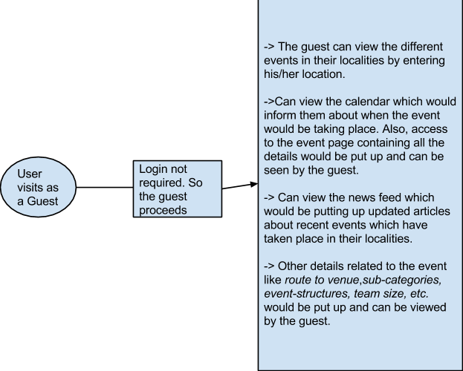

If the user visits the website and intends to host an event and be *An organizer*, the following flow chart would rightly describe the course of actions which would be taking place.

|  |  |
| --- | --- |
| Actors | All users(Except Guest) |
| DESCRIPTION | Either login(If already Registered) or Sign up by filling the required details, update profile, change password |
| Prerequisite | Name, Email id, Contact Address, Contact Number, fields of interests |
| Input | Fields Corresponding to all prerequisite |
| Output | Conformation Mail |
| Error  Handling | Invalid Password -> Re-enter password    Invalid-username -> Register with different email id.    Already registered account -> Option to reset the password |

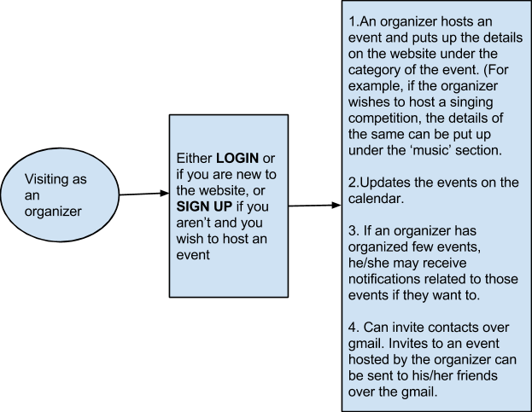

|  |  |
| --- | --- |
| Actors | organizer |
| DESCRIPTION | Create an event |
| Prerequisite | event title, start date, end date, location, logo, poster, fb page link, description, organizers name, registration details required by users, category of the contest, route to the venue, require volunteers?, require sub-organizers |
| Input | Fields Corresponding to all prerequisite |
| Output | Conformation Mail, the event is live and available for the users to register |
|  |  |
| Error  Handling | While entering the dates, alert if there is a clash. |

|  |  |
| --- | --- |
| Actors | organizer |
| DESCRIPTION | Manage a created event |
| Prerequisite | None |
| Input | promote the event on Facebook, send updates to registered users, put schedule, results, photos |
| Output | sub organizers get added in the event page, notifications to subscribed users about the updates |
| Error  Handling | None |

The above course of actions are valid in case of sub-organizers too. If a person volunteers wants to become a sub-organizer, then he/she can do that and help the organizer. A separate page would be created which would be containing the details of the billing, funding’s, etc. and this page would be visible only to the organizers and the sub-organizers.

|  |  |
| --- | --- |
| Actors | Sub organizers and organizers |
| DESCRIPTION | A committee page accessible to organizers and sub organizers in which they can update tasks, to do lists, budgeting, schedule meetings, and discuss about the event. |
| Prerequisite | budget, tasks, to do lists |
| Error  Handling | none |
|  |  |

If the user visits the website and wants to register for a particular event *as a participant*, the following flowchart would describe the course of actions:

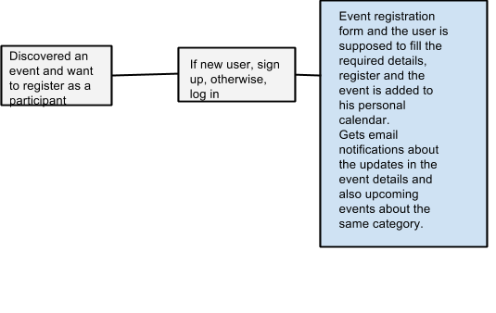

|  |  |
| --- | --- |
| Actors | Participant |
| DESCRIPTION | User will be able to see a calendar where the dates for the event registered will be highlighted. And While registering for an event user will be provided an option to get the notification of the details of the event. |
| Prerequisite | All taken from the user account if he/she has one or create an account for a newbie |
| Error  Handling | Invalid Password -> Re-enter password  Invalid-username -> Register with different email id.  Already registered account -> Option to reset the password. |
| Optional  Fields | Participants will also be able to update their profile regularly by adding their achievements. |

|  |  |
| --- | --- |
| Actors | Volunteers, Sub organizers |
| Description | Be a volunteer or sub organizers for an contest |
| Pre requisite | None |
| Input | a button on the home page |
| Output | list of all the events which require volunteers, sub organizers |

|  |  |
| --- | --- |
| Actors | Volunteers |
| Description | Apply as a volunteer for a contest |
| Pre requisite | None |
| Input | a button on the event page |
| Output | Request sent to the organizer with the profile and if accepted, a confirmation mail is sent to the volunteer |

For all of the above mentioned three four variants, (participant, organizer or a sub organizer) a profile can be created where the respective person can check their:

1. My organizer profile 2. My sub-organizer profile.

3. My participant profile.

There’s no use of creating a profile for a guest. The participant profile serves that purpose.

In addition to the above mentioned data, there are few actions any user can take irrespective of whether he/she is a guest, a participant, an organizer or a sub-organizer. These actions can be generalized as:

1. If the user signs up for hosting or registering for an event, he would provide email id and password.

1. A signed in user can update the profile mentioning the fields they are interested in their profiles.

1. My organizer’s profile would contain list of all the events hosted by the user.

My participant’s profile would contain list of all the events attended by the user and would accordingly show notifications of related events which the user has attended.

1. My sub organizer’s profile would contain the list of the events in which the user was a sub organizer.

1. In addition to these, the user can change the account ( change password, etc. ), view the calendar, can view the recent and upcoming events and sync in contacts(linked with Facebook or Gmail)

# SURVEY RESULTS AND ANALYSIS

As taught in the software engineering course, we divided the task of data collection further into three tasks,

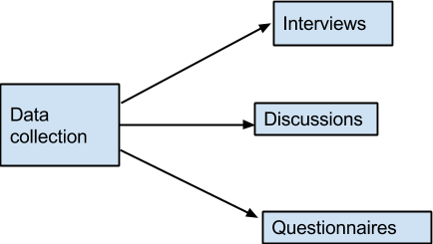

1. Interviews were mainly taken of the organizers who would be interested in putting up their contests/tournaments on the website and perform a lot of tasks on our system itself (registrations, scheduling, budgeting, getting volunteers/sub-organizers etc.) It helped us getting first-hand information as to what services/features would they find useful and the impediments they currently face in the existing processes. Also, it showed that such a system if implemented properly would be useful.

1. Discussions were done in the team as well as with friends/acquaintances to get some insights into what people thought about the website we wish to make.

1. Survey, an online survey was done with a questionnaire prepared targeting the audience who would be registering on the website as participants.

## Interviews/Discussions -

We prepared a very basic set of questions and interviewed people from almost all the fields (literary, performing arts, sports etc.) by asking them these questions. What we did was , we laid down our project idea right in front of them and asked them as to what they thought of our project idea and what else did they expected out of our project. We asked them if they were using a similar platform and if they were what things they would like added to it. In this way, we made sure we could accommodate suggestions from different people and at the same time make them realize the importance of a contest/tournament/event organizing platform such as this one. This exercise was done so that we could get a fresh approach to our idea, know the usefulness or the flaws. To garner constructive criticism was also the objective.

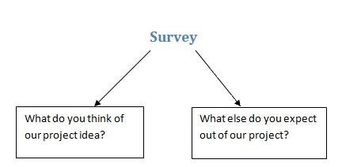

The survey was a very basic one and consisted of two different set of questions intended at giving us idea of what the people expect and would like to extract out of our project.

Every member in our group was supposed to survey at least an acquaintance of theirs. This system of work distribution is what we wish to employ throughout the project so that no one feels left out and every member gets an idea of what the project actually is all about. When we asked the people as to what did they think of our project idea, we received a variety of different answers, the excerpts from some have been listed as they were in the section below:

*"I think this is a great platform for the local enthusiasts. This can be brilliant and an original initiative if executed properly. All the functionalities of your project idea have been listed down very clearly. For someone who has newly arrived in a city and has a passion for any given event and wishes to find and mix up with the local folks and just showcase his/her talent, then this is an awesome platform to find contests/tournaments interest-wise."*

Person surveyed: **Takshak Parmar, B-Tech 3rd year, DA-IICT**

*"Also, this would accommodate interests of people from different walks of the society, not necessarily those who have all the resources and the funds needed to enrol themselves in a sports academy or the like. For a solo professional or a team which is running out of form, this is a nice platform where as a team, they can assess themselves or solo artists can assess themselves and revive their forms."*

Person surveyed: **Shubham Jaiswal, B-Tech 3rd year, SVNIT, Surat**

*“The whole idea is very good and it certainly very powerful. It will surely benefit the interested the participants, organizers and all other authorities involved in it. When we were handling concours or events like synapse, the main problem which we faced was to manage everything. To find sponsorship was difficult task."*

Person surveyed: **Archit Bakliwal, Sports committee member, Volley-ball**

**Co-ordinator at DA-IICT**

*"Your concept is extremely good. I am very happy that someone is aware of such problems and you think that we can solve it by making such website. It beneficial to everyone and it may generate interest in people to participate in events either just for fun or as an occupation. I don’t think there is any point missing in your idea, it is almost tensed to perfect."*

Person surveyed: **Mr. Raju Jani : (National Referee, Member-Sports Association of India (SAI), International Coach)**

"*As a player, I just want to say that this would be a great platform to encourage participation which would benefit both the participants as well as the organizers as this would invite much more participation and take the local events to a higher level. Also, my friends who participate in different events like dance, sports, etc. professionally face this problem of being uninformed about the events taking place. So this would be a very useful tool for us."*

Person surveyed: **Prashant (a district level participant)**

*“The main thing I think which would be useful is apart from providing notifications about the contests, registration, scheduling, budgeting, and looking for volunteers etc. are good add-on features. Some websites which exist simply provide the event details, but you are taking it further which can prove to be quite useful."*

Person surveyed: **Bhasha Maru (Nirma University)**

“A lot of times some competition gets over and after that I come to know about it. If I would get notifications every time something comes up in my area and if I can register and get all the details there itself it would be pretty cool!"

Person surveyed: **Samarth Sahni (Actor prepares - Bombay)**

Surprisingly, we received quite an optimistic response than we anticipated. Quite to our surprise, the people were largely hopeful about our project and heeded our idea with alacrity when we laid down the specifics of our project in front of them. According to our team and the people whom we surveyed (who represent the point of view of a general customer), our project would:

1. Prove to be a great platform for local sport enthusiasts, who are spread across a city and are looking for a platform to polish their talents and shine.

1. Be a great platform for someone who has newly arrived in a city and has a passion for any given sports and wishes to find and mix up with the local folks and just play, this is an awesome platform.

1. Be beneficial if it is implemented in well manner it will be like a boon to all the involved people. It is such a nice platform to them who want to play professionally and don’t get chance to do it.

1. Would be of great use in ensuring transparency and managing finances because the web-portal we will be able to provide a platform for the organizers and sub organizers where sub organizers can upload scanned copy of the bills of expenses they had.

Hence, this project intends to establish a platform where the organizers, the suborganizers, the users and various others entities would meet and organize/play/register tournaments and matches.

When asked, what additional features would supplement the popularity or simplify the complexity of our website, we received many genuine responses worthy of noting:

1. Some suggested that the referee should be official. They told us that it would make everything less tedious. They suggested that we get referees or coaches from district government's sports office (if it is a sports event).

1. We were suggested to include the list of all those who want to volunteer for a particular tournament at one place in our website. It would make easy for the organizer of the event to look for volunteers.

1. Some people wanted the teams to be rated on the basis of their performances.

## Scope of the Project-

1. Based on the assumptions of the survey, we could deduce that this project has a vast scope expanding beyond limited areas or cities.

1. This project intends to accommodate interests of various groups, teams or clubs who have sprung up in different areas in different cities and who are genuinely passionate for a given sport and wish to play matches with other teams.

1. A lot of people who were surveyed were convinced of the idea that this project would provide a lot of opportunities to the professional players and give them a platform.

## Online Survey-

* Introduction :

-This section contains an overview of the report structure.

-This report contains the detailed statistical results and analysis of the online survey done by the team. The target audience was mainly the participants (people who would be interested to participate in any contest/tournament/event). The questionnaire was prepared by the team after a discussion on the same in the meeting.

-This analysis contains all the results from the people who responded to the survey for StarContests.com in the 5 day period from February 12 to February 17.

-The primary aim of the questionnaire was to understand if people are in need of a system such as we aim to build and if it would be useful to them. Also, what features and services in addition to ours will they be needing?

* Results :

Here is the questionnaire,

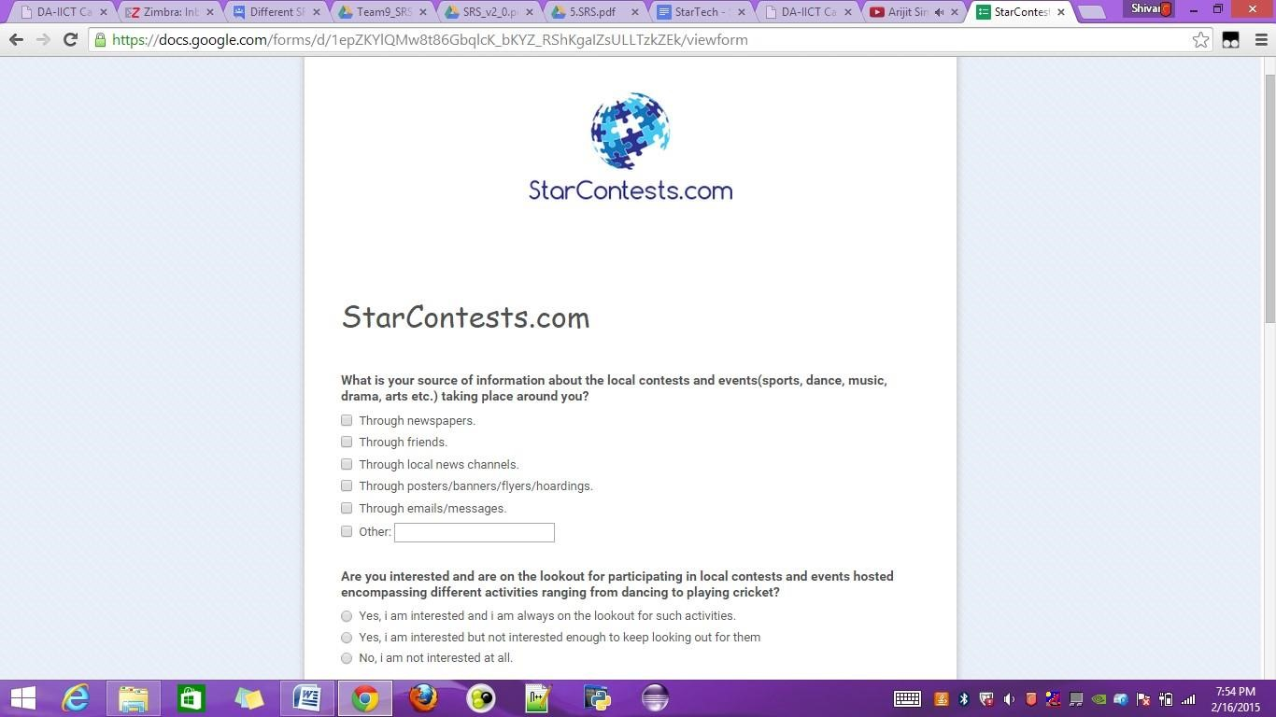

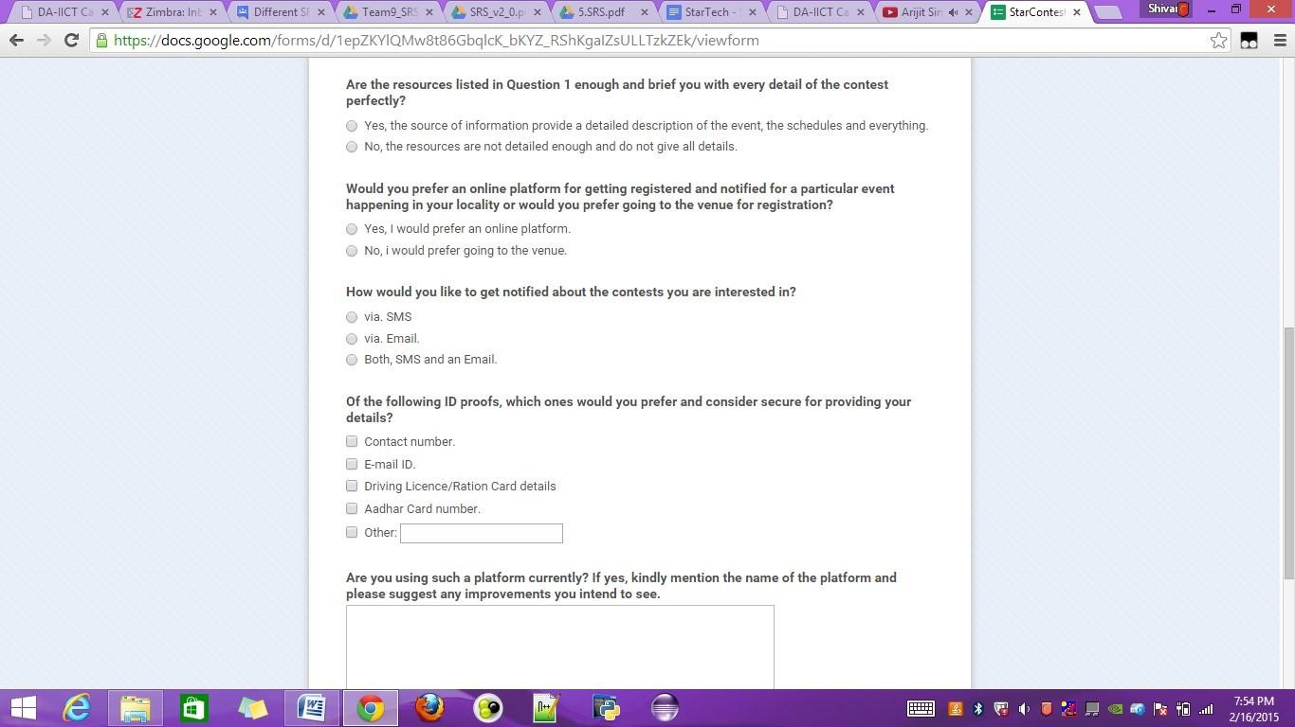

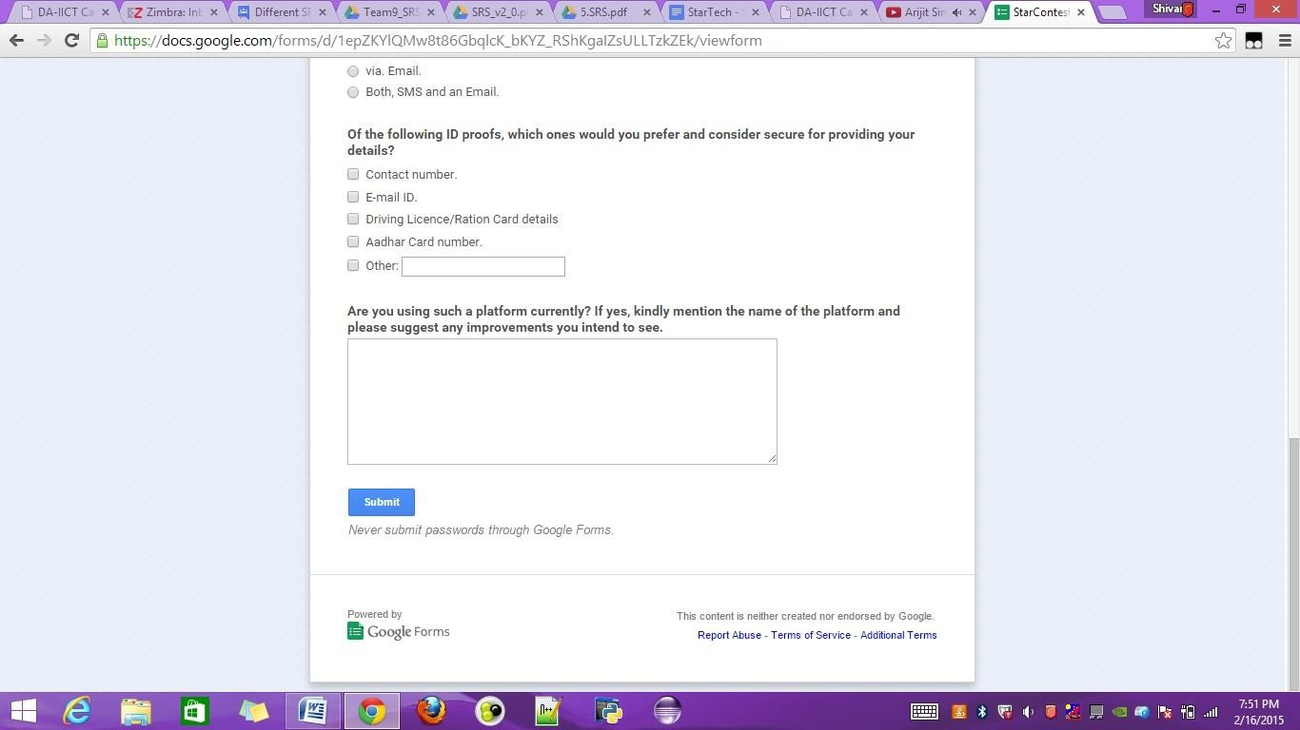

We asked a variety of questions building from whether the users were interested in exploring and using such a platform to taking their inputs on the credibility and the usage of features we would be putting up on our website. The questions asked and also the answers to the question, ‘**why were they asked?** Have been covered in the section below.

Q1) what is your source of information about the local contests and events (sports, dance, music, drama, arts etc.) taking place around you?

Reason - We asked this to get an idea of how the people got information about the local events happening in and around their localities. This would allow us to maybe integrate our project with few of these sources of information in the future so as to promote our venture.

Q2) Are you interested and are on the lookout for participating in local contests and events hosted encompassing different activities ranging from dancing to playing cricket?

Reason - An active user or a consumer is always essential because an active user would always be on the lookout for new events in order to showcase their talents. A passive user who wasn’t interested in looking up for such events was of no interest to us so we asked this question early in the survey in order to filter the interested from the uninterested.

Q3) Are the resources listed in Question 1 enough and brief you with every detail of the contest perfectly?

Reason - In the first question, there were a few resources listed and we asked the people if those resources were enough for them and briefed them with all the details they needed to participate in an event. Asking this question was necessary for us in order to make it easy for us to assess the functionalities our website would be needing and the extra sources our website would be needing to properly brief those who weren’t briefed properly by the sources mentioned above.

Q4) would you prefer an online platform for getting registered and notified for a particular event happening in your locality or would you prefer going to the venue for registration?

Reason - Going to the venue in order to get yourself registered to a given event sounds like a tedious and cumbersome process in itself. Still, we wanted to make sure that there isn’t a sufficient faction of crowd out there who resents the idea of developing an online platform for taking part in events or hosting events.

Q5) how would you like to get notified about the contests you are interested in?

Reason - Some people prefer SMS to email or vice-versa. It was only fair and needful to ask this question and on the basis of the answers, or the summary of responses, decide how to notify people about different events.

Q6) of the following ID proofs, which ones would you prefer and consider secure for providing your details?

Reason - When we were conducting our meetings on developing idea for this website, the problem of authentication was something which we encountered in almost every meeting. In order to get an idea of sharing what kind of ID would suitable to our users, we decided to ask this question, the responses to which will be covered and summarized in the next question.

Q7) Are you using such a platform currently? If yes, kindly mention the name of the platform and please suggest any improvements you intend to see.

Reason - This was the last question and this was kept subjective. Although we made sure that a platform with all the functionalities which we intended to include in our website didn’t existed, still, we wanted to make sure that any such platforms were not there and if they existed and were used by the people who were filling the survey, the mentioning of their name would help us in visiting that site and accordingly improvising ours.

➢ The statistical analysis of the responses to the survey,

Q1) what is your source of information about the local contests and events (sports, dance, music, drama, arts etc.) taking place around you?

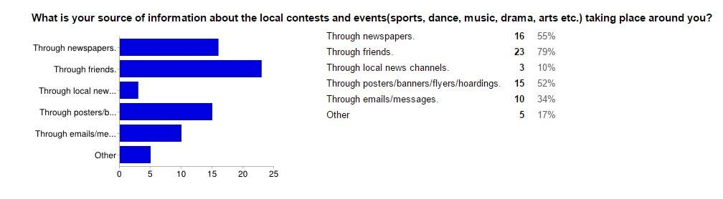

Q2) Are you interested and are on the lookout for participating in local contests and events hosted encompassing different activities ranging from dancing to playing cricket?

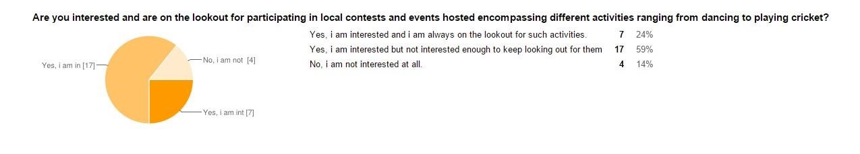

Q3) Are the resources listed in Question 1 enough and brief you with every detail of the contest perfectly?

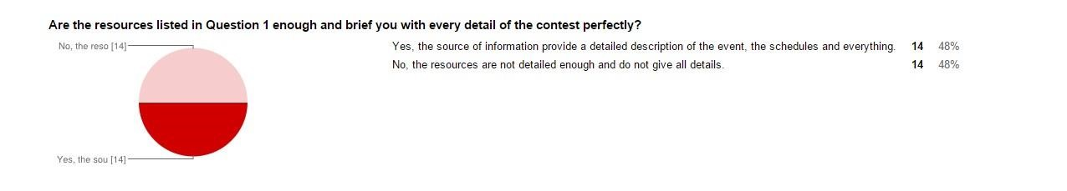

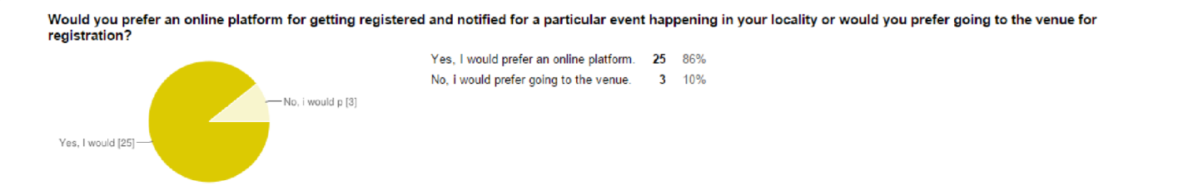

Q4) Would you prefer an online platform for getting registered and notified for a particular event happening in your locality or would you prefer going to the venue for registration?

Q5) How would you like to get notified about the contests you are interested in?

Q6) Of the following ID proofs, which ones would you prefer and consider secure for providing your details?

