tBits Collabwrite - Engineering Document Control and Project Monitoring System

Document Control Module – IMP.

User’s Guide - Version – DCM – 6.2
Document No – PowerDocs-DCM-User-Guide, R0

© Copyright 2010 - TransBit Technologies
Confidential computer software. Valid license from TransBit Technologies required for possession, use or copying. The information contained herein is subject to change without notice. The only warranties for TransBit Technologies products and services are set forth in the express warranty statements accompanying such products and services. Nothing herein should be construed as constituting an additional warranty. TransBit Technologies shall not be liable for technical or editorial errors or omissions contained herein.

TransBit Technologies Encourages Your Comments
TransBit Technologies welcomes your comments on this document. Please provide your comments and suggestions via email to feedback@tBitsGlobal.com

Support Information

If you have any queries or require support for any module of tBits-CollabWrite, please contact the below

Contact Information

If at any time you have questions or concerns regarding tBits Collabwtite, call or e-mail us.

General Inquiries
Telephone: +91-998-547-4558
E-mail: info@tbitsglobal.com
Web Site: http://www.tBitsGlobal.com

Customer Support
Email: support@tbitsglobal.com

Mandatory Information to be provided at the time of seeking support
Support may be required at various time by the end users from the IT or system administration team. We will request the user to mandatorily provide the following information at the time of seeking support.
- Screenshot of the error that they received: Use the Print Screen button on the keyboard and save the screenshot as .png file.
- The steps to replicate the error: If possible, provide the steps to the admin team to replicate the problem. If the problem can be replicated then it can be easily solved.
- The local logs on the browser should be copy pasted in the email.
- Copy paste the log in the email that you are sending
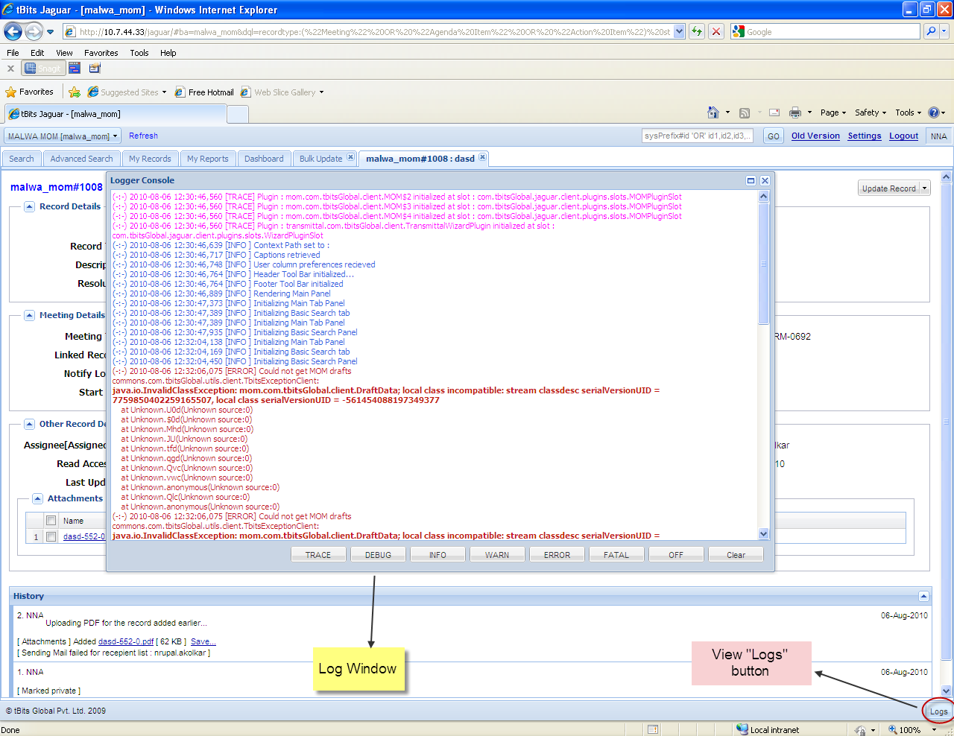
Screenshot 1: showing location of client side logs

General Topics

Key terminology
Business Area: This refers to the Project Activity Area of the Project where certain specific activities of the project take place such as document control register, document transmittal notes, document control etc
Document Record: It corresponds to certain document entry along with all of its meta-data in a particular business area.
Logger: This is the person who initiates or assigns a certain task.
Assignee: He is the person who is responsible for a certain task for which a document record is created.
Subscriber: This is the person whom we want to notify regarding all the actions taking place for that particular Document Record.
Document Control Index [DCI] – Methodology of sharing and giving access to the document in a regulated manner conforming to the business rules and ensuring tracking from origin to the ultimate destination to prevent the execution of a job using incorrect information is referred as Document Control.
Document Transmittal Notes [DTN] – The legally binding cover letter used for transferring the control of a document from one agency to other. The general characteristics of a DTN include conformance to agreed project protocols, clearly stating the enclosures and purpose of submission. The note has unique numbering system to unambiguously refer to the transaction. The details of the rules of engagement of the various parties are clearly stated in the Project Coordination Procedure.
Project Coordination Procedure [PCP] – A document that clearly list the basic rules of engagement between the various parties including the details of the project team, project communication protocol, templates to be used for correspondence and document transmittal notes, circulations lists, and other applicable project standards.

Acronyms
BA = Business Activity Area
EPC = Engineering Procurement and Construction.
DCM = Document Control Module
DTN = Document Transmittal Notes.
MDL = Master Document List
PCP = Project Coordination Procedure
PD = Project Director
PM = Project Manager

Section – 1: Overview of Common tBits Functions

How to Login?
Type the following in the address bar of the browser
http://hog.mytbits.com:81 - Testing Server [Within NCC]
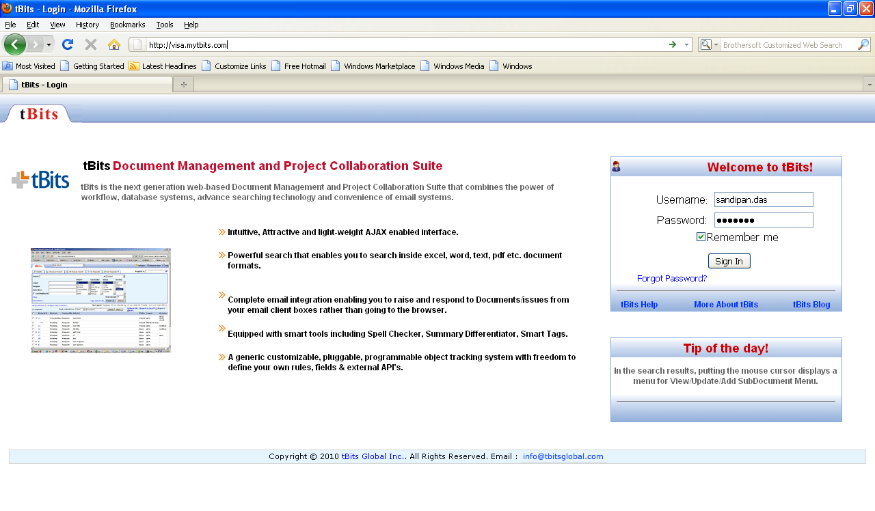
Screenshot 2: Login Page
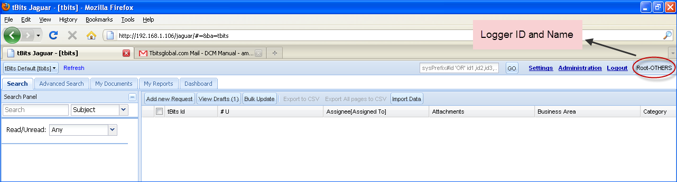
Screenshot 3: Home Page of the Logger

To Login into the System the user shall require a Username and Password, provided by system admin. Now user can login into the system from login page using this username and password. Once the user is logged in, the display name of the user is available in the top right corner of the page.

Upon login, the users arrives in the default business area [as specified by him under his personal settings].

In the center of the page, the complete lists of the business areas is available to the user for him.

What are the various Business Area’s that are available to user at the time of login?
All the business area’s where the user has been granted the control by virtue of his profile would be listed in the BA drop-down. The complete objective of each of these business area’s and the permissions of the user in the concerned module would be available in the concerned module details.

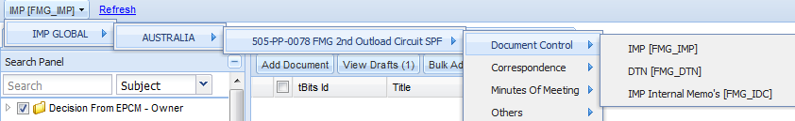
Screenshot 4: List of various modules and concern business areas
How to change the Password and other settings?
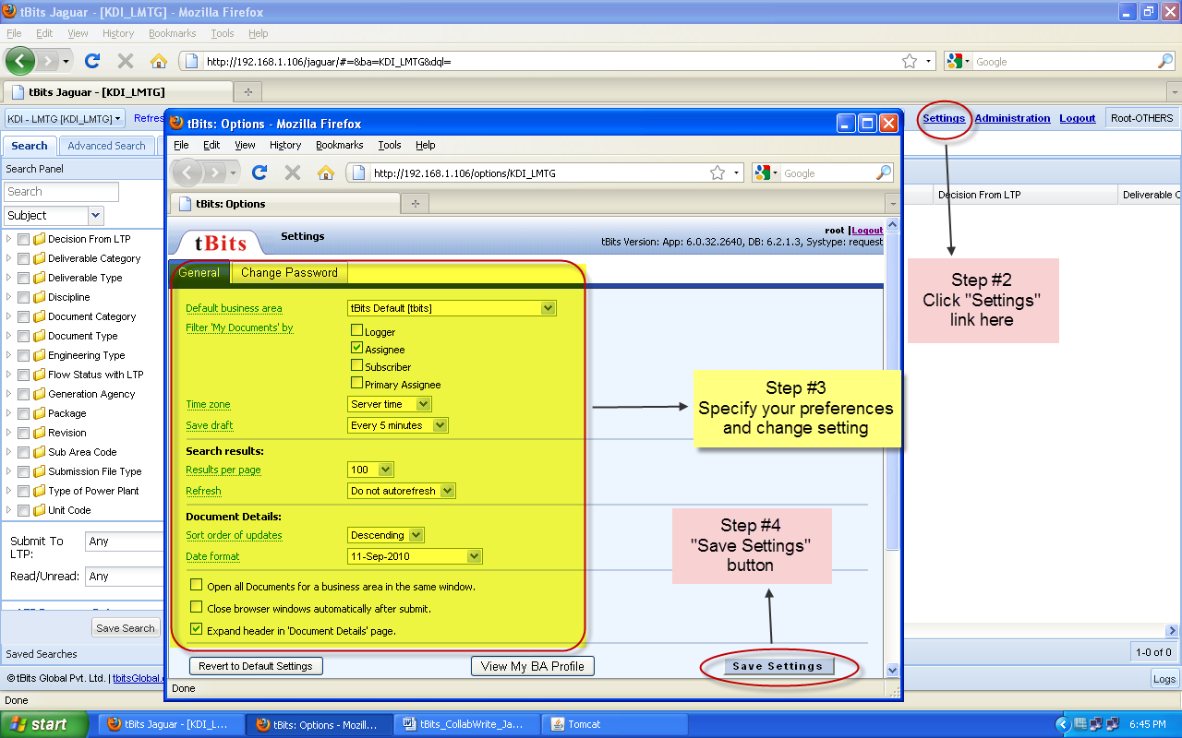
Screenshot 5: User’s setting Page

Steps
- Login into the system
- On the top right side of the page click on settings.
- There user can specify his/her preference and also change the login password.
- Click Save Settings

How to select the appropriate Business Activity Area?
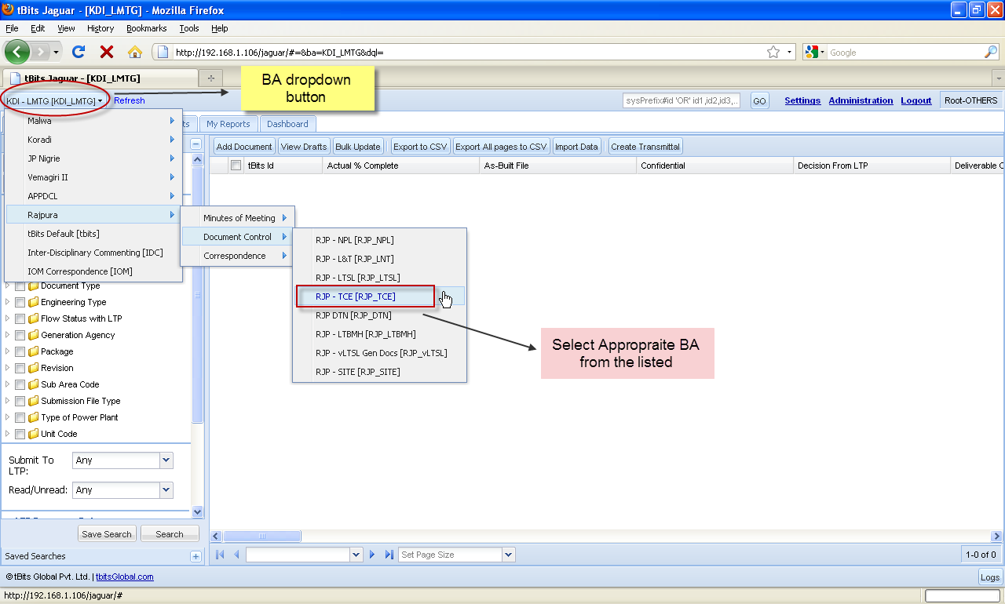
Screenshot 6: Select appropriate Business Area
After you Login into the system on the top of the page in drop down you can select appropriate project activity area.

A project may comprise of one or many project area’s including – Documents [Internal Document Control Register, Document transmittal notes, etc], Document control etc. The required project areas are created by the local tBits administrator – either from scratch or by using the previous project business activity area.

Each business area is specific for a business activity. Each business area can have his own set of fields, users, roles and permission.

When the user login’s, given his access rights, the allowed business areas are shown to him.

How to open a record?
- A document can be opened by right clicking on the row and select “View Document” as it appears in the search results.
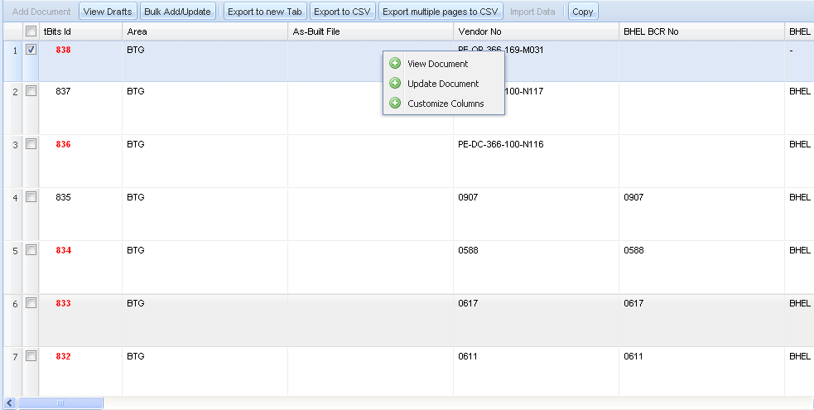

How to identify the record using the tBits ID?
For all the records in tBits, there is an automated numbering system. The automated numbering system works as follows:
A. Each business area has its own unique prefix. Say for Internal VISA area of VPL its VRSTPP_VPL..
B. For each record that is added in the concerned business area, a serial number is generated.
All the records in the tBits can be addressed as <Record Serial No>
Example to refer to the VPL BA with record tBits ID 3 you can type “3” in the quick search panel that is available to you.
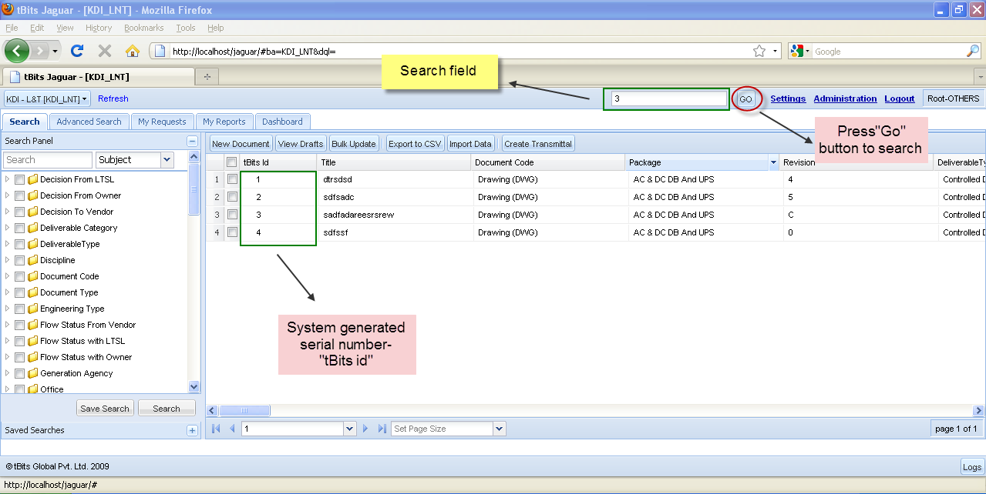

How to search for a document using various basic search options?
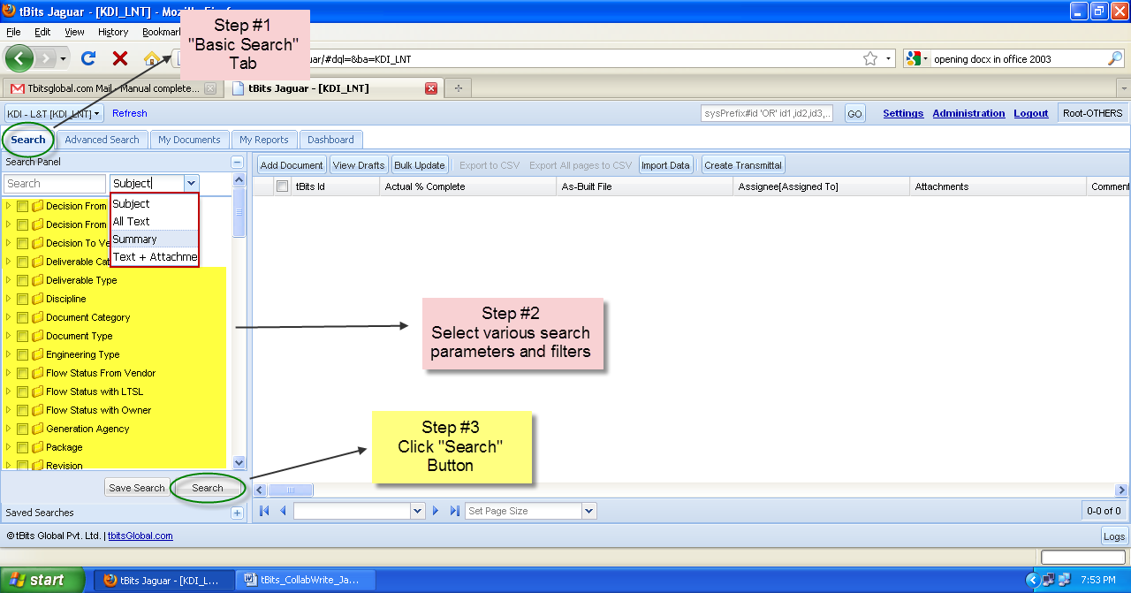
Screenshot 7: Steps for basic search
The basic search provides a simple interface for any user of the system to search for a document using the specified variables. These variables can be different for different business area’s.

The person can specify the general attributes on the basis of which he wants to filter the database as logger, assignee, subscriber, document category, Discipline, Status, related unit etc. Potentially, all types of fields can be provided in the basic search panel.

In basic search you can specify options “Text String” either to search only in
a) Document Title (Subject) b) All Text c) Text +Attachment

The more options provide further filtering options to the user to get exact results.
Steps:
- Go to “Search” Tab
- Select the filters. Multiple selection is possible by mouse drag or using the Ctrl Key.
- Click “Search” button below the filter to get the results.

How to search for a document using various known meta-data and Advance Search?
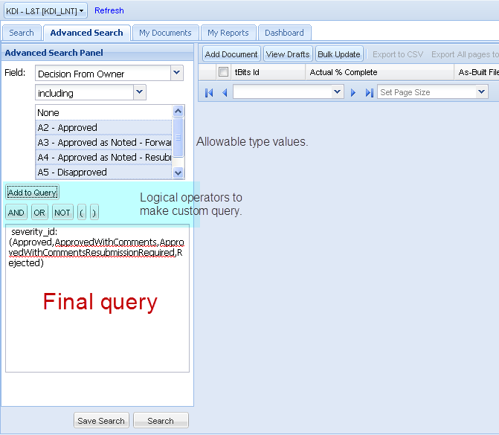
Screenshot :8 Advanced Search Panel

Steps
- In Advanced Search users can search using various parameters and combination of them.
E.g. If you want to search a document with a certain “Decision from Owner” and having status = “Approved, Approved as Noted – Forward Final Drawing, Approved as Noted – Resubmission Required, Disapproved”.
- So Go to Advanced Search Panel
- Select field = “Decision from Owner” and Select the allowable types “Approved, Approved as Noted – Forward Final Drawing, Approved as Noted – Resubmission Required, Disapproved” no to be searched, and click Add Query
- Click Search

If required, all the fields available to the search can be used with operators as OR/AND etc.
The benefit of the above search over Basic Search is the logical operator joining the filters is AND incase of basic search however in case of advance search, the person can himself select.

All the fields that are available in the system on which the user has permission to view are available in the advance search for the user to create his own customized query & filter the database. Only the document on which the user or the user’s firm has permission to view, will be available in his search results.

The standard metadata for the document records is available in the annexure.

How to Configure Search Grid Columns?
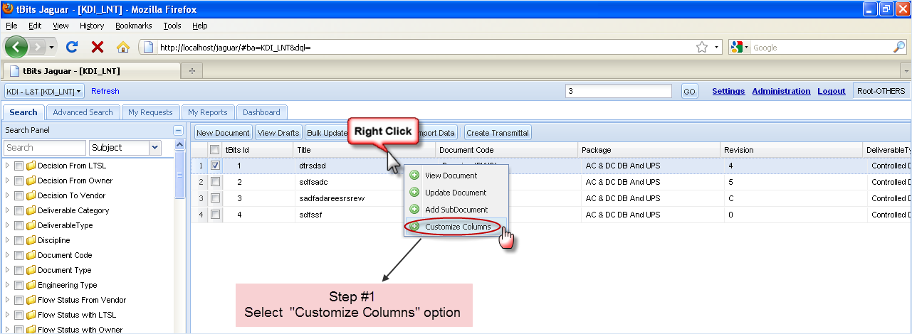
Screenshot 10:Customize search grid columns
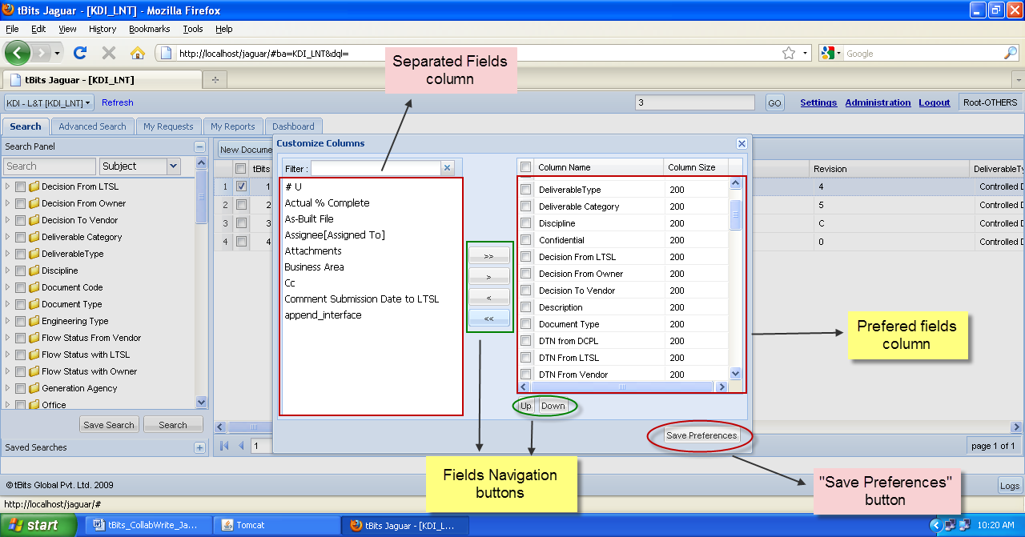
Screenshot 11: Customize Columns Window
Steps
- Click on Configure Result Column to configure as to which all meta-data of the document shall appear in search result and in what order.
- From the entire available columns user can select meta-data by clicking Right Arrow.
- To change the display order of columns in search result user has to move the arrow up and down after selecting a particular meta-data from selected columns.

How to do bulk edit?
- Move the columns to be edited to leftmost
- Select the desired records
- Click on ‘Bulk Edit’ button.
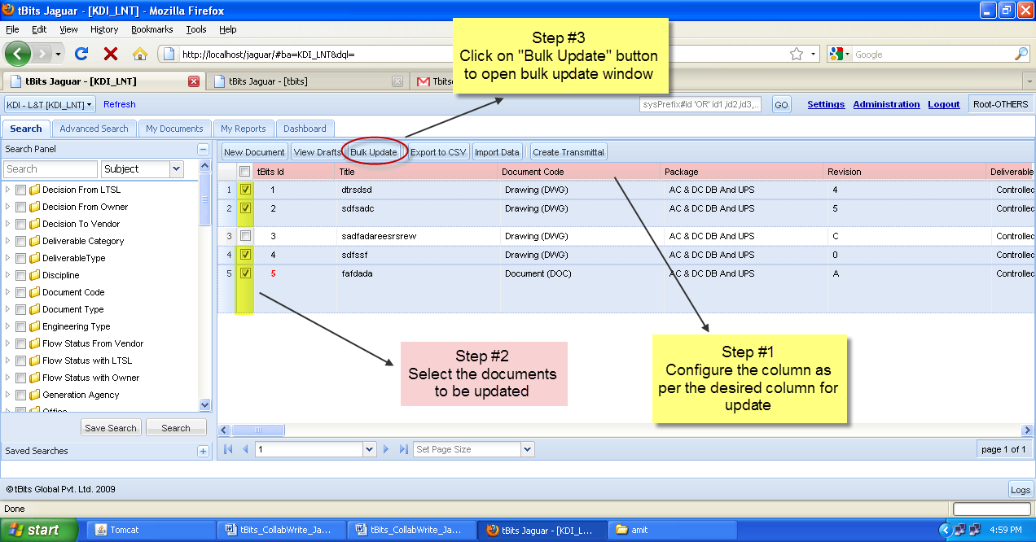
Screenshot 14-c: Moving desired columns to left most and opening bulk edit
This will open a new window as shown below. The functions are as described below.
- The window has two panes. The top pane lists all the records selected. You can select any record and change any field of the record. The bottom pane is used to set values for all records.
- Both panes have same field headings in same sequence, but can be scrolled independently.
- Any changes made in bottom pane will be affecting all records in the top pane.
- However changes made in top pane for individual record will over-write the common values.
- If the field is of list type, a drop-down list is provided. If it is date type, a calendar wizard is provided. If it is attachment type, you can browse and attach one or more files. Otherwise enter the values directly in the field.
- You can add new records by clicking on ‘Add New’ button at bottom right.
- You can delete the selected records from the display (not from the database) by clicking on the ‘Remove’ button at left.
- At any point, user can restore all original values by clicking on ‘Restore Original’ button at bottom right. This button will be effective only till the changes are not made into database by clicking on ‘Submit’ button.
- Once user is satisfied with changes he can click on the ‘Submit’ button and the changes will be effected in the database. However once the changes are done, they can’t be reversed.

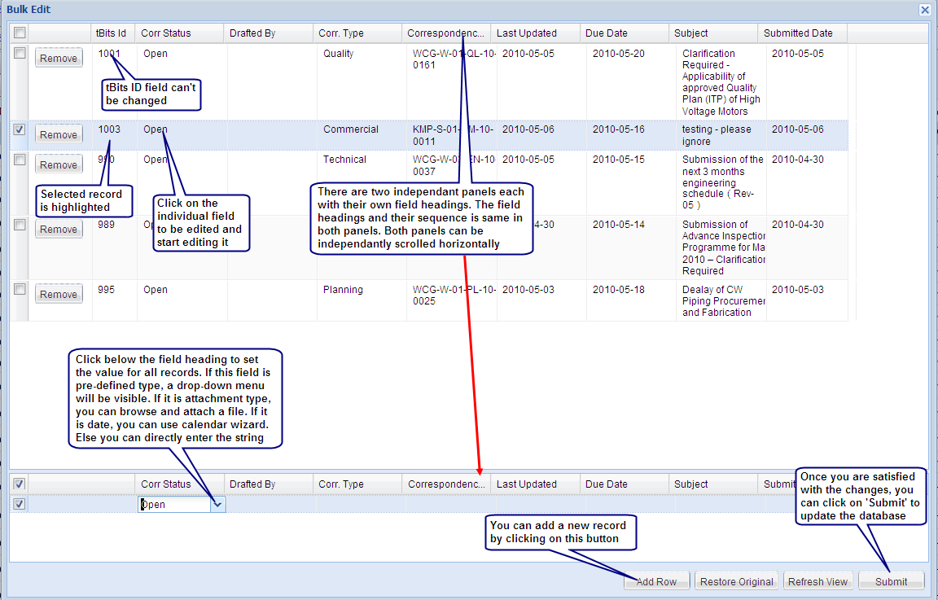
Screenshot 14-d: Making bulk edits on bulk update window

How to export the records in csv format?
The various steps involved in the process are as follows:
1. Search
2. Select the Records
3. Click Export to CSV
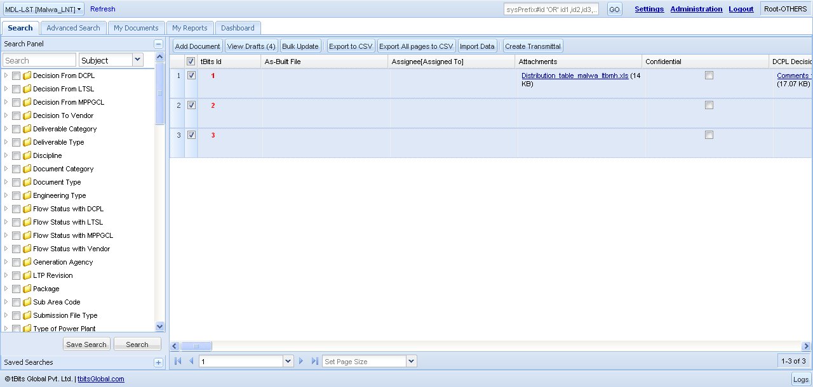

How to Copy/Paste Files?
tBits offer the facility to copy/paste the files from one record to another record.
Benefits of the above approach are :
1. The person can move the file from one record to another record without having to download the file.
2. The file reference is what is copied, on the server side, the data is not duplicated,
In the view document page – select the file and click on “Copy Selected” button.

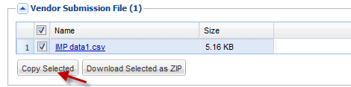
In the update record page, paste the file in the concerned file group.
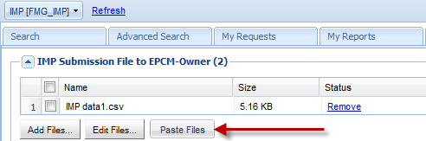

How to do a transmittal of a document?
The following steps are involved in the creation of the transmittal on the document.
A. Right Click the Document Record and View The Document.
.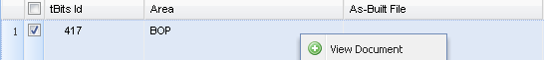
B. The View Document Is Opened, Now Click on Update Document which is at the top Right
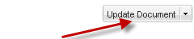
C. Now fill the following Details and click on Submit and close the page.
If Submitting to EPCM-OWNER [Following Fields are mandatory]
a. Submit to EPCM - should be true
b. IMP Submission File to EPCM-Owner - Add The Submission File
c. Document No should not be blank.
If Giving Decision/Comments to HERZOG [Following Fields are mandatory]
a. Submit to Vendor - should be true
b. IMP Decision / Comment File to Vendor - Add The Decision/Comment File
c. Document No should not be blank.
f. Decision to Vendor should be some value other than “None”
If Submitting to HERZOG for Info[Following Fields are mandatory]
a. Submit to Vendor - should be true
b. IMP file to Herzog [For Info] - Add The Submission File
c. Document No should not be blank.
After updating the values,Click on “Submit” do that the document gets Updated.
D Select all document or some of the documents that are to be transmitted.
E Click on create transmittal.
E. Check/Provide the circulation list and related information.
F. Select the attachments that are to sent.
G. Select the circulation list
H. Preview

Overview of Document Transmittal Process:
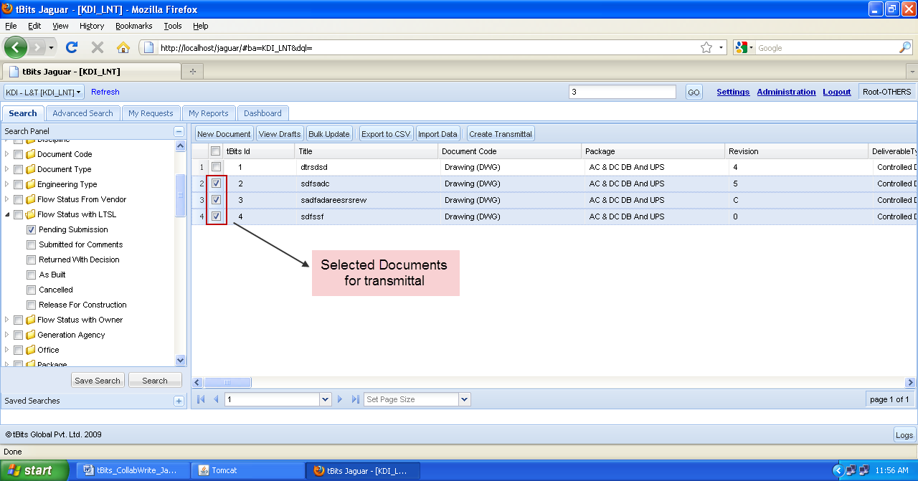
- The document Controller clicks on “Create Transmittal” after selecting the appropriate type of transmittal that he wants to create.
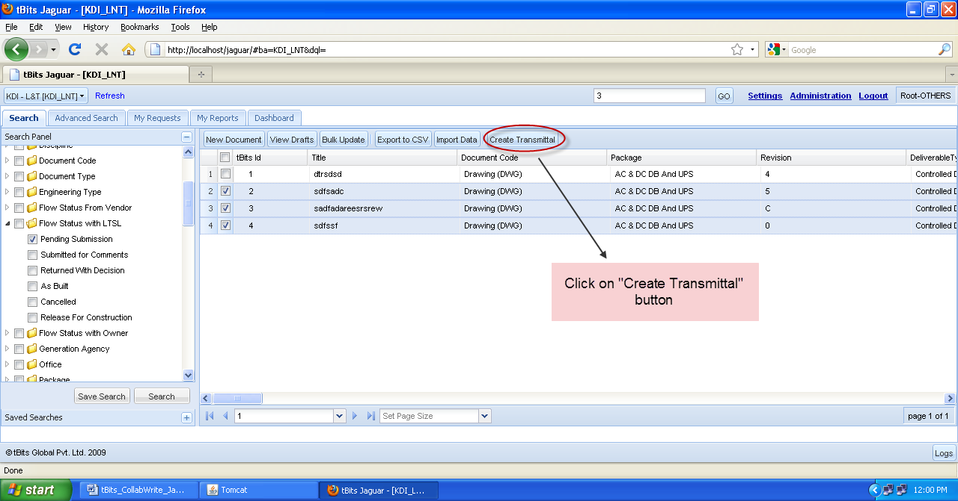
- The document controller clicks on create transmittal. Immediately, a new panel opens [Step – 1 of transmittal process] which asks the document controller
  - to verify the circulation list [the system gives a prefilled list based on contractual submission lists.
  - Add new users in addition to the predefined circulation lists by selecting the users from tBits or by giving their email ID’s.
  - Give remarks that have to go inside the transmittal letter under the Remarks Text Box.
  - Modify the predefined email Body that goes to the users.
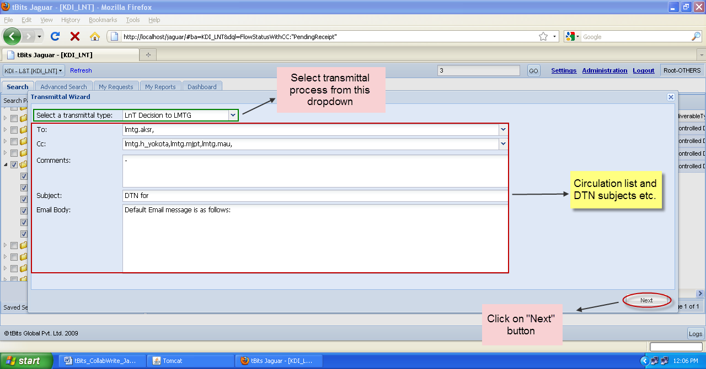

- Step – 2 of transmittal process: the transmittal file selection and updation – if required – for the related metadata.
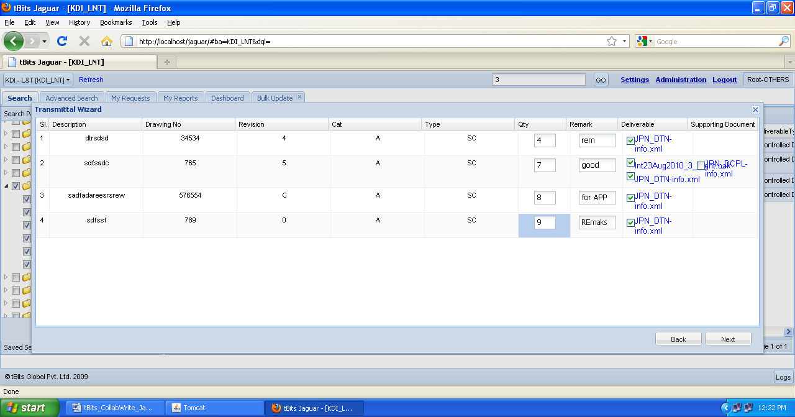
- Step – 3 of transmittal process: selection of circulation list details:
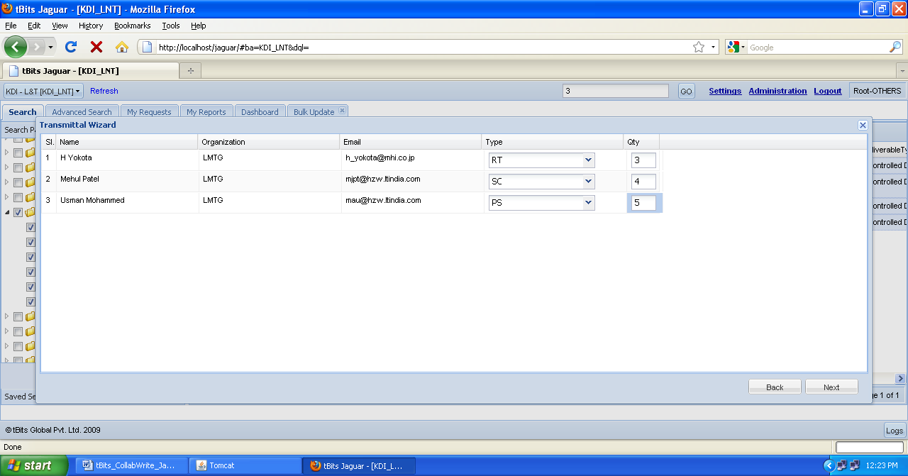
- Step – 4: Preview the Document Transmittal Letter
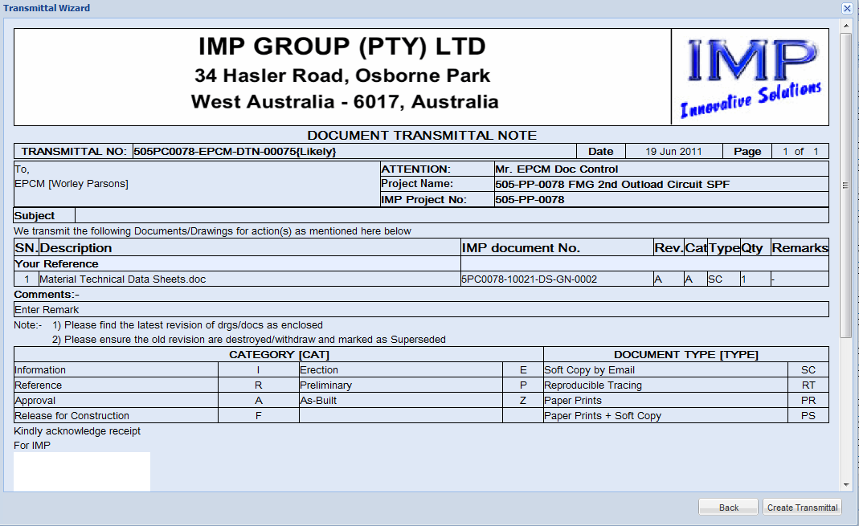

- Step – 5: Click on Create Transmittal

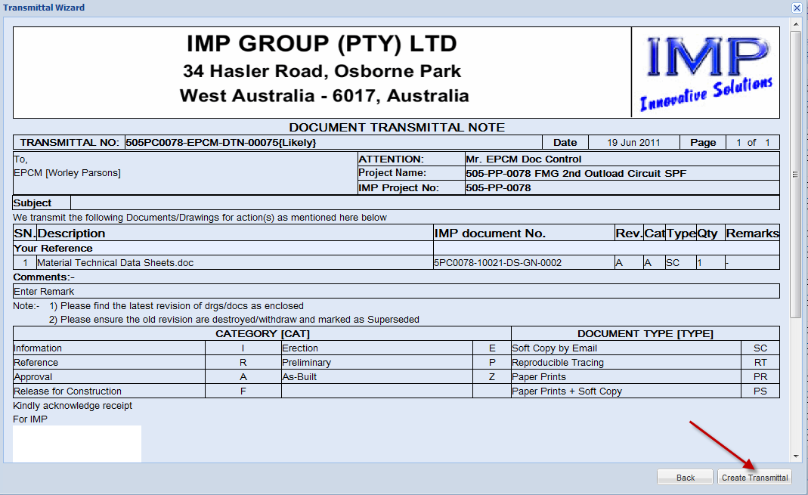
  - When the person clicks on create transmittal, the tBits system
    - Gets the DTN number that is to be given to the DTN.
    - Puts the DTN Number inside the DTN
    - Formats the complete DTN in accordance with the standards of Look & Feel as given by the customer including the paging related issues.
    - Create the DTN Letter & along with the enclosed attachments, emails the same to the circulation lists as selected during the process.
    - Updates the internal & related document control registers with the appropriate status.

- Step – 6: Confirmation of Successful DTN Creation
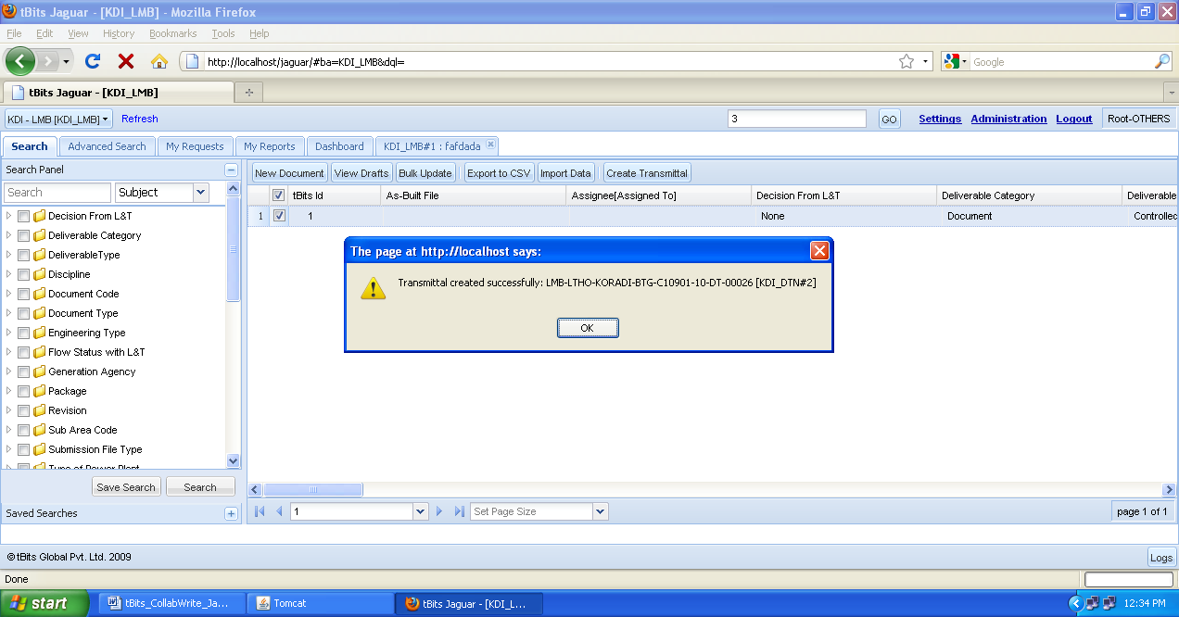
- The transmittal letter is generated & along with the required attachments is available in the DTN business area of the said firms to which the DTN was sent.
