ransbit Technologies

tBits
A workflow management and issue tracking system…

Authors | Revision | Date
Ritesh, Sandeep | 1.0 | 13 March 2007
Anand, Anuj, Kanu, Santosh | 1.1 | 03 May 7, 2007

1. Purpose 3
2. Overview Of tBits 4
3. Keys Features Of tBits 5
4. Terminology In tBits 7
4.1. Glossary 7
4.2. tBits Look 10
4.3. Color in tBits 10
4.4. Legend: Icons and Abbreviations 11
5. System Architecture And Technical Specifications 13
5.1 Hardware 13
5.2 Software 13
6. User Manual 14
6.1. New Request 15
6.2. Search 18
6.3. Advanced Search 25
6.4. All Domain Search 28
6.5. My Request 29
7. Administrator Manual 31
7.1. Properties 32
7.2. Fields 32
7.3. Roles 32
7.4. BA Users 32
7.5. Manage Fields 32
7.6. All Users 32
7.7. Administrator (tBits default) 33
7.8. Send announcements 33
7.9. Help 33
8. How To’s 51
8.1. How to Raise a Request using Web Interface? 51
8.2. How to Update a Request through the Web? 53
8.3. How do you Search for a Request? 54
8.4. How do you Search for a Request using Advanced Search? 56
8.5. Where can I see what Requests I had Raised? 58
8.6. How To Raise A Request using the Email Interface? 58
8.7. How to use Inline User Commands (IUCs) while updating request or raising new requests through Email. 59
8.8. What are the Keyboard Shortcuts used in tBits? 60
8.9. How can you add Extended Fields? 61

Purpose

tBits is an Enterprise wide Issue Tracking and Workflow management solution that enables the organization to do ‘managed communication’ and collaborate effectively to achieve their objectives. The ‘managed communication’ can happen in between
- Teams
- Departments
- Client & Service Providers
- Government & Citizens
- Onshore and Offshore development teams

The processes in an organization can take care of the routine tasks. Exceptions to the processes require collaboration among various members to resolve them.

Some of the examples of the cases that usually require human intervention and group collaboration include

- Issues pertaining to software development, deployment and testing including bug tracking
- Project tasks.
- Event Management.
- Customer (both internal and external) complaints.
- Requests for help, clarification, support, representations, etc.

In global world of today, with onshore, offshore, client development teams collaborating together to devise solutions, efficient exception handling implies lesser delays, reduced costs and increased productivity.

Overview Of tBits
tBits solution platform enables organization to raise cases/exceptions and track their status (please recall as to how many emails you do simply raising exceptions and responding to them) so that those events are closed in the specified constraints.

Examples of tBits in action include

- IT project management – where onshore, offshore and client teams interact.

- Support – where clients raise their exceptions or requests to be catered by the support department. Examples – Commercial Tax Department, Government of Andhra Pradesh for dealing with applications and requests that come from citizens.

- Task delegation, Monitoring and Tracking – widely used in organizations for delegating tasks to various people, monitor and track their progress continuously till they are resolved. Examples – Project Tasks, IT-enabled services in the domain of Accounting Receivables, Medical Billing and Collections for disputed invoices etc.

- Event Management – Say Business Case competition – People make submissions about their research papers, these are then assigned to experts in their field, clarifications sought, resubmissions done and then decision reached.

Transparency Objectivity and Accountability in Organization: The solution enables the top management track and monitor tasks and contributions of all employees.
The scheduled reports give timely feedback and warning to top management about the current performance of organization and possible lapses that may happen resulting in proactive result oriented actions with transparency, Objectivity and Accountability percolating at all levels.
The possible applications of tBits include employee appraisals, Organization-wide knowledge capture and dissemination, R&D department for future product development etc.

Keys Features Of tBits

- Complete Integration with MS-Outlook: System sends email notifications to concerned people based on issue type, category, severity and other parameters as per organizational business rules.

The end users can perform the tasks and simply reply to those emails as is done conventionally. Their response is captured by the system and cases updated. Proficient users of tBits don’t even need to go to the web-version at all to perform their tasks.

Another major benefit is lower learning curve and rapid adoption of tBits.

- Proactive Management and Business Reporting: If the exceptions and requests are not completed within the specified parameters of the person raising them, then reminders, warning notifications and escalation notifications are sent to the group.

Management can be opt for scheduled reports & customized reports based on the data.

- Compliance with Business Rules: tBits enable you to define business rules as per your organizational requirements. These business rules are used for assigning business cases and sending notifications, alarms and reports to the concerned users. The rules can be changed anytime.

With evolving organizational needs, you may want to capture more data and complete flexibility is offered to devise new fields in the database on the fly at any time.

- Flexibility and Scalability of Solution: tBits offer flexibility both in terms of solution architecture and business requirements. The solution is scalable enough to meet the requirements of big multinational companies. The solution has been stress tested successfully.

Technology Platform – Java, MS-SQL Express Edition Database (Available – Free of Cost.)

Reference Customers:

Name of Organization | Application
Center for Entrepreneurship Development, Indian School Of Business | Event Management
Department of Commercial Taxes, Government of Andhra Pradesh | Technical Support  Internal Workflow management
The IndUS Entrepreneurs, TiE, Hyderabad | Event Management  Project Management
Global Social Venture Capital – organized by UC-Berkley, Columbia Business School, Indian School of Business & London School of Business | Knowledge Management
Aliens Group – A major construction company based out of Hyderabad, India | Project management &  Customer Support

Terminology In tBits

Glossary
A Request is the basic unit within tBits. Each request corresponds to a bug, a doubt, a feature, a work request, a proposal, a specification, a request for clarification, a task, etc.
- Domain: A project, group, or department in the organization.
- Business Area: Business Area and Domain are synonyms and can be used interchangeably.
- Domain Prefix: A unique prefix associated with each Domain. For example, Sys refers to Systems.
- Request: An entry in tBits representing a task or question submitted by a user (the logger) in a particular Domain.
- Submitted By: User submitting a request.
- Assigned To: The person or people to whom a request is assigned. This person is responsible for acting on the request. You must be under the category Assigned To for a Domain in order to be assigned a request in tBits.
- Analyst: A person authorized to act on requests submitted to a particular Domain.
- Administrator: A person authorized to make changes to the configurable settings of a Domain , such as adding analysts for that Domain. The tBits development team can make any change to any Domain configuration.
- tBits Database : tBits database runs on MS SQL and all actions performed on requests are recorded in this database.
- Request Field: Each request has various pieces of information associated with it and recorded in request fields. Standard Fields are common to all Domains , and some Domains also have Custom Fields which are created to meet the specific needs of that Domain. A List Type Field is a field with predefined values; for example, the severity values are typically Critical, High, Medium and Low.
There are various fields in a request; some request fields which are defined in a default Domain are as detailed in this table. We sometimes refer to these as Standard Fields:

Field Name | Explanation | List Type | Set by Users
Assigned To | A comma- or semicolon-separated list of the users to whom the request is assigned. The Primary Assigned To is designated by an asterisk (*) before the name. | No | Yes
Category | Category the request belongs to. Categories are defined for each Domain. | Yes | Yes
Description | The body of the message associated with each update. | No | Yes
Due Date | In some Domains, a due date is supported, or even required. | No | Yes
Last updated by | Person who last updated the request. | No | No
Logged Date | The date and time the request was originally logged. | No | No
Submitted By | A comma- or semicolon-separated list of the users who submitted the request. | No | Yes
Private | Set this request to private if checked. | No | No
Request Number | Number or ID of the request. This is set by tBits when the request is logged. | No | No
Request Type | The type of request. The request types are defined for each Domain. | Yes | Yes
Severity | Severity of the request. See Prioritizing Requests. | Yes | Yes
Status | The Status is used to track the progress of a request. The exact statuses in use vary between Domains . | Yes | Yes
Subject | The subject should be composed in a way to allow other users to find relevant information easily. In most Domains , the subject line can be changed by analysts. | No | Yes
Subscribers | A comma- or semicolon-separated list of the users who are subscribers to this request. | No | Yes
Summary | A summary can be specified for a request; this is displayed as part of the request header. | No | Yes
Update Date | The date and time the request was last updated. | No | No
This is not an exhaustive list, but does include most of the commonly used fields. Some fields can be set by any user, some can be set only by analysts in that Domain, and some are set by tBits. Fields that cannot be set by users are greyed out in the user interface. Refer to the Permissions section for more details of access to request fields.
A list type field has predefined values which you can select. For example, the Severity values are typically Critical, High, Medium, and Low.
Request fields can be configured to the needs of a particular Domain, both with respect to the exact values permitted for a field, as well as which fields are defined. For instance, the Category field has different defined values depending on the domain. Some domains have extra fields (or custom fields). For example, the Proprietary Domain has fields to track the estimated and actual time to complete the task.
- The Category and Request Type are used by the analysts in a domain to manage the kinds of requests which they receive and need to act on. In general, the category is used to express the part of the application which should be addressed if the domain is for a product, and the groups with which the domain works if the domain provides a service, and the request type is used to express the sort of action that needs to be taken. For example, the categories for a product could include Database, Scripts, Server and Web UI. The request types could include Bug, Development, Issue, and QA.
- The Status is used to track the progress of a request, for instance, from Pending to Open to Active to Awaiting Response or Pending QA to Closed. The exact statuses in use vary between Domains.
- The Severity can be set by the Submitted By of a request to indicate the urgency of the problem presented in the request.
- The Submitted By, Assigned To, and Subscribers are all fields which take user IDs. The difference between adding a user to the Subscriber list and to the CC list is that the Subscriber is a perpetual assignment, and the CC a one-time assignment: that is, someone added in the CC field for an update to a request will receive email for that update only, and not on subsequent updates. The subscribers receive all email associated with that request.
11. Request Number: A unique numeric identifier is assigned each request in a particular Domain. In combination with the Domain prefix, this can be used to uniquely identify a request. For example, Sys#67330 refers to request number 67330 in the Systems.
12. Smart Tag: A notation for creating hyperlinked references to requests and to particular updates in any Domain.
- Subscriber: A person (can even be an external client) added as a subscriber to a request receives all email notifications generated when there is activity in tBits related to that request.
14. Update: A change to any of the request fields attached to the request and/or an addition to the body of the request.

tBits Look
tBits has the following main interfaces:
- A generalized Search interface, with two search levels plus interfaces for your own requests and for searching in all Domains
- A Search Results page
- A Request Details page
- The Add Request page
There are also pages which can be used to configure your personal settings.

Color in tBits
tBits uses color to notify you of the status of requests and updates. Request updates can be outlined in one of three colors:
- The outline color of new updates is ochre: new update color
- The outline color of updates which you have read is grey: read update color
- The outline color of the first update is the Domain theme color. The default theme color is blue: default Domain theme color
The Domain theme color is also used for headers in the web interface; for example, the Systems Domain has defined an unusual theme color.
If a request has a severity of Critical, the request number is displayed in bold font and red color. The outline colors actually used depend on whether you are using the email or the web interface, and on whether you have set the Domain to track read and unread requests for you.

- In email:
  - The most recent update is always outlined in the new update color.
  - The first update is outlined in the Domain theme color.
  - Other updates between the first and the most recent are outlined in grey.
- In the web interface:
  - All unread updates are outlined in the new update color.
  - The first update, if read, is outlined in the Domain theme color.
  - Other read updates are outlined in grey.
There are also colors used to convey the severity of a request when exporting to Excel.

Legend: Icons and Abbreviations

The tBits Legend in the Search Results page gives an overview of the meaning of the icons and the most commonly used abbreviations in tBits.

Icon | Email version | Meaning
 |  | This request is past its due date but not yet closed.
 | ↓ | The severity of this request is very low.
 | ↓ | The severity of this request is low.
 | ! | The severity of this request is high.
 |  | The severity of this request is critical.
 | Not applicable | You have never viewed this request.
 | Not applicable | This request has subrequests which are not currently displayed. Click on the icon to view the fully expanded tree.
 | † | This request is private.

Common abbreviations in tBits include these:
Abbreviation | Meaning
TQL | tBits Query Language
IUC | Inline Update Command

System Architecture and Technical Specifications

5.1. Hardware
Machine with at least 256 MB RAM should be able to run tBits.

5.2. Software
tBits is written in Java 1.5 and it uses Microsoft SQL Server as the database.
So before installing tBits make sure that the machine has Java 1.5 and Microsoft SQL Server 2000 or 2005. tBits runs on Windows, Solaris and Linux.

Mails generated from tBits can be best viewed in Microsoft Outlook even though the system is checked with yahoo mail and gmail.

User Manual
The tBits home page is shown below which displays the various features for the user like:
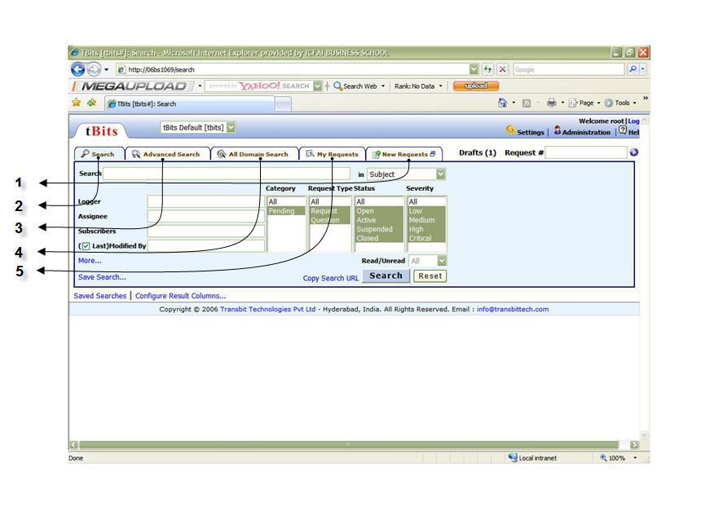
Where:

1) New requests
2) Search
3) Advanced Search
4) All Domain Search
5) My requests.

The applications and use of all these features are dealt with in detail below.

New Request
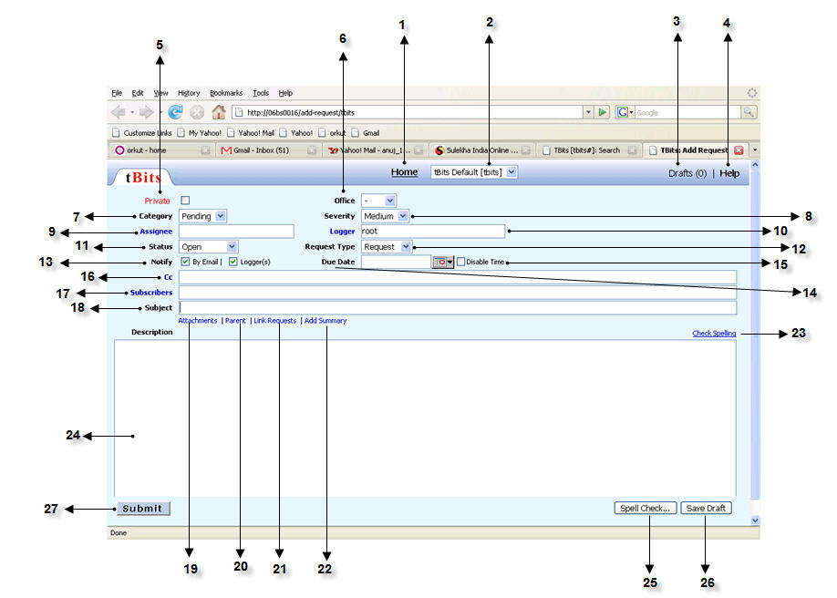

This tab lets you submit a new request that needs to be taken action on. The various fields let you classify and categorize the request in detail for better tracking and following, thus streamlining the work-flow and improving efficiency and productivity. The various links and fields on this page are:

- Home: It is the link to the home page which is also the search page.
- Business Area Field: This field lets you define the business area to which the new request belongs. This will route the request to the concerned business area and maintain the relevance of the request.
- Drafts: This link takes you to the drafts saved earlier. Useful if there are many requests of a repetitive nature. The request draft saves all the fields of a request that are given values. Very similar to saving a mail draft.
- Help: Link to the tBits help documentation for all the help you need.
- Private: Checking this field will restrict the request to the concerned business area desired. Other business areas and hence users will not be able to access and update the request. Keeping this area unchecked will mean that a request is public and hence of a general nature. Everyone can access such requests.
- Office: This field is useful in case the organization has presence in different locations geographically. Helpful in sorting out requests on the basis of offices.
- Category: This is the category to which a request belongs. Category of a request may be ‘pending’ or it may belong to a particular project. Category can be defined as per the departmental and organizational needs.
- Severity: It defines how important and/or urgent a request is. Levels can be defined as per your needs. This helps in prioritizing your work and increasing your efficiency and productivity.
- Assignee: A person who is responsible to take action on the request that you are submitting. In other words, a request is ‘assigned to’ the person defined in the assignee field.
- Logger: A person who is submitting the request. He has logged in the system and is the initiator of the request.
- Status: The request status denotes what the current status of the request is. The request can be at any stage of being processed. So if the request is successfully handled, the status can be changed to ‘closed’.
- Request Type: It denotes the type of request. A request may be a blog, a question, a general query, a clarification, or a complaint etc. depending upon the issues faced by the department and organization.
- Notify: There are two check boxes here. If you check the ‘By Email’ box, all the users concerned with this request mentioned in the ‘assignee’, ‘cc’ and ‘subscribers’ fields are notified about the request by email. Uncheck this box if you don’t want to notify by email. Checking the ‘Logger(s)’ box will notify the logger about the request by email.
- Due Date: If the request has a finite deadline by which it should be completed, mention it in the due date field. The system will then keep a track of this request and generate notifications if the request is not processed by that time.
- Disable time: Checking this box will disable the time associated with the due date from being displayed on the screen.
- Cc: You can notify any user about a particular update by typing that user’s name in this field. The user will then be notified about that particular update or request only and not the entire thread of a request. This is useful if you want to inform your superior about the final outcome of a request without troubling him about the intermediate steps in the process.
- Subscribers: If you want a user or users to be kept informed about the progress of a request, type the name in this field. All such users will be informed about each and every update that takes place with respect to this request. You can add, remove or change subscribers at any point in time.
- Subject: The subject field is similar to the subject filed in email. Write a relevant subject line to enhance the meaning of the request.
- Attachments: This link allows you to attach files to the request just like an email.
- Parent: If this request is a subrequest of some other request, you can give the number of that parent request by clicking on this link. If you want the present request to be made a parent request, just give ‘0’ (zero) in the parent field. By default every request is a parent request.
- Link Requests: Clicking on this link will enable you to link requests to each other for easy referral. This is done if there are similar requests you want others to refer to and take action accordingly.
- Add Summary: You can write a short summary for a long request/report to facilitate understanding of it by other users. This saves time and is easy to understand.
- Check Spelling: Check the spelling of words to make your request proper and formal.
- Description: This is the field where you write the main body of your request.
- Spell check: Another utility to check spellings and make sure that your request is in proper English.
- Save Draft: If your request is of a common nature and frequently used, you can save a draft and make the necessary minor modifications to it for each new request and send it. This saves a lot of time and effort. All the fields of the request are also saved along with the description of the request.
- Submit: Click this button to submit the request to the system so that action may be taken on it depending on its nature.

Search
The tBits Search interface has four tabs: Search, Advanced Search, All Domain Search, and My Requests. From the Search interface, you can search for a request based on any of the request fields or text stored for that request
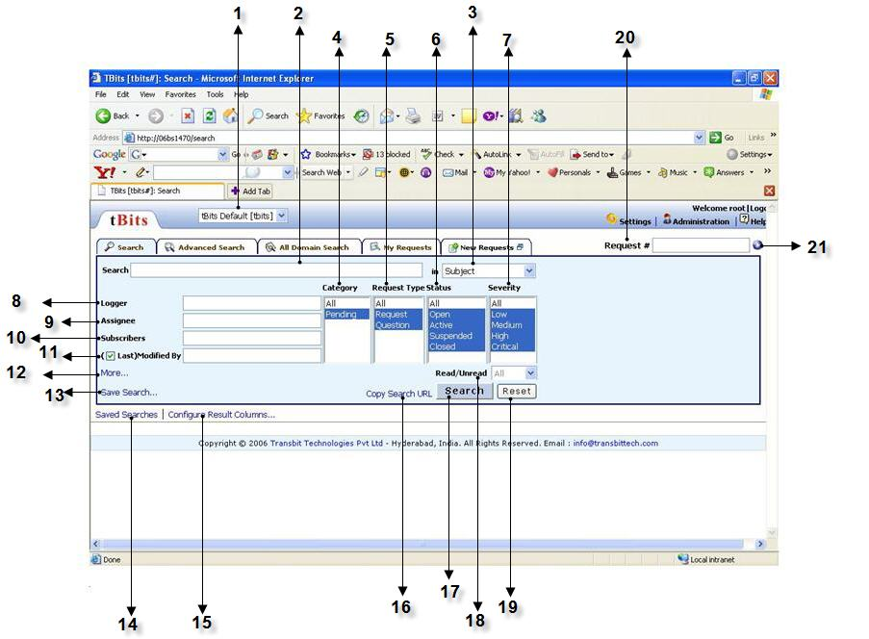
It is the default search level. It provides access to the most important search fields: allowing you to search by Request Number, by a search string, specifying what aspects of a request you want to search, and the Domain you want to search. It also provides the ability to search by the standard fields for all Domains, as well as by the person who last updated the request.
- Business Area: Wherein you can select the business area/domain for searching your request.
- Search: The search text box where you can mention the keywords you are looking for in your request.
- In this text box you can mention the fields like Subject, All text, Summary, Text+Attachments specifying where you want to look for the keywords.
- Category: The request belongs to which categories are defined for each Domain like whether the request is pending or not.
- Request Type: The type of request you search like in the form of a question or a simple issue. The request types are defined for each Domain.
- Status: The Status is used to track the progress of a request like Open, Closed, Active and Suspended which means what is the state of the request at the moment. The exact statuses in use vary between Domains.
- Severity: It can be set by the Submitted By of a request to indicate the urgency of the problem presented in the request like Low, High, Medium, and Critical.
- Logger: The user who log in.
- Assignee: The person or people to whom a request is assigned. This person is responsible for acting on the request. You must be under the category Assigned To for a Domain in order to be assigned a request in tBits.
- Subscriber: A person (can even be an external client) added as a subscriber to a request receives all email notifications generated when there is activity in tBits related to that request.
- (Last) Modified by: Person who last updated the request
- More:
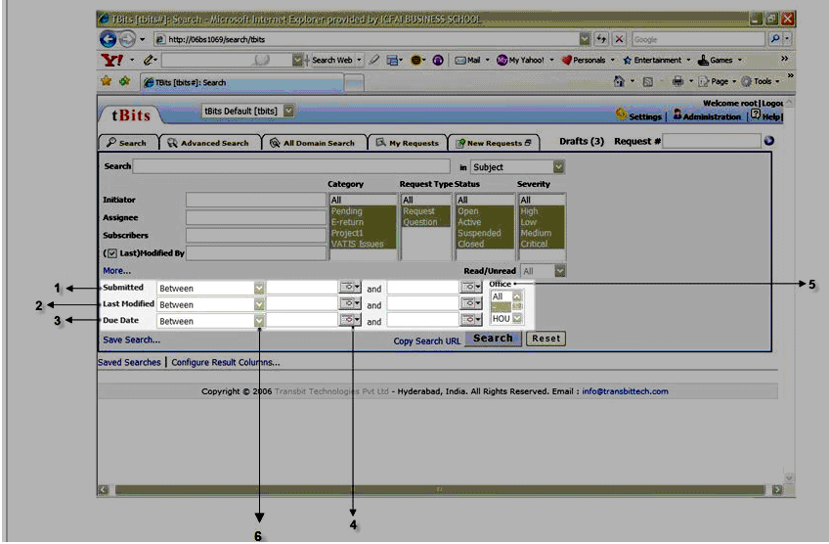
The ‘more’ hyperlink allows the user to refine the search further by letting him specify the dates on which a request was worked upon or updated. The criteria that can be set includes:

12.1. Submitted: It lets you select dates on which a request was submitted to the system. So for e.g. when you select ‘between’ by clicking on the ‘drop down’ arrow, you can search for requests submitted between two given dates.
12.2. Last modified: This option allows you to search for requests based on the dates on which they were last modified.
  - . Due Date: Lets you search for requests based on the due dates set for those requests.
  - . Calendar: Click on this icon to use the calendar to just select the dates you need to search, instead of typing them yourself!
  - . Office: This field is useful if you have offices across different geographical locations using tBits.
  - . The drop-down arrow: The ‘submitted’, ‘last modified’ and ‘due date’ options all have a drop down arrow which provides various options which help define specific criteria for searching requests on the basis of dates. Select these options to search for any particular request. These include:

    - On
    - Before
    - After
    - Between
    - Today
    - Tomorrow
    - Yesterday
    - Last week
- Last year
- Next week
- Next month
- Next year
- Last ‘n’ hours
- Last ‘n’ days
- Last ‘n’ weeks
- Last ‘n’months
- Last ‘n’ years
- Next ‘n’ hours
- Next ‘n’ days
- Next ‘n’ weeks
- Next‘n’months
- Next ‘n’ years
- Is empty
- Is not empty

- Save Search: This link helps you to save the search you have just performed. It is very useful if the search is routine and repetitive in nature.
- Saved Search: The search made for a request one or more times can be saved for future reference as and when required.
- Configure results Column: This helps you to customize your search results according to the fields required in the final layout by adding or deleting the existing columns.
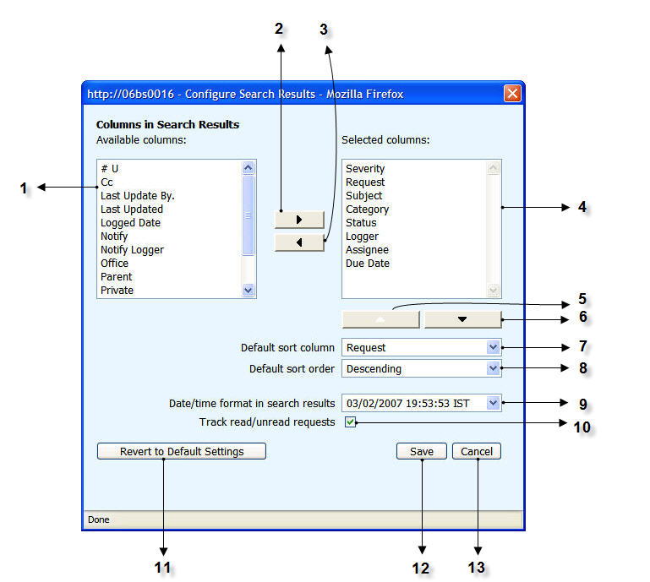
It is a hyperlink in tBits that helps the user to customize the search requests results table with the required fields for a good representation and simplified interpretation of the results.

  - Available Columns: It displays all the columns that are available to the user to be displayed in the search request results table like:

  - # U
  - Cc
  - Due Date
  - Last Updated By
  - Last updated
  - Logged date
  - Notify
  - Notify Logger
  - Office
  - Parent
  - Private
  - Request
  - Type
  - Subscribers
  - To

  - Add Button: This helps to add up the columns that a user needs by selecting the required columns from the list mentioned above.
  - Remove Button: Contrary to the Add Button, the Remove Button helps the user to remove a particular column from the search request results table.
  - Selected Columns: It displays all the selected columns by the user in the search request results table.
  - Shift Up Button: It helps the user to shift up a particular column according to the required priority of the column as desired in the search request result table.
  - Shift Down Button: It helps to shift down a column to customize the search request result table by the user.
  - Default Sort Column: It helps the user to sort out the request results table according to the various available fields like:
  - Severity
  - Subject
  - Request
  - Category
  - Status
  - Logger
  - Assignee

  - Default Sort Order: It is provided to help the user sort the results table in the required order, i.e., either ascending or descending.
  - Date/time format in Search Results: It helps the user to select the required format for the display of the dates with or without the time. Click on the drop down arrow for the various available formats.
  - Track Read/Unread requests: tBits helps the user keep a track of the various read/unread requests through Emails or the Web Browser. So on checking this option the user can keep a track of the various read/unread requests too.
  - Revert to Default Settings: This tab allows the user to revert back to the previous page and do away with the custom settings as and when required by the user.
  - Save: This helps the user to save the custom settings for the search request results table.
  - Cancel: Through this you can cancel the page and view the search request results table.

16. Copy search URL: This helps you save the URL link for a search request made so that you can directly open the search result window anytime in future by just typing the URL in the browser’s address bar.
17. Read/Unread: It helps you to specify whether to search for a request which has been read before or not.
- Search: This bar when pressed initiates the search to give the required search results.
- Reset: This bar helps you reset the various fields once again for a new search for another request.
- Request: Here you specify the unique request number which directly displays the required request.
- Hit this button to initiate the search for request with the mentioned request number.

Advanced Search
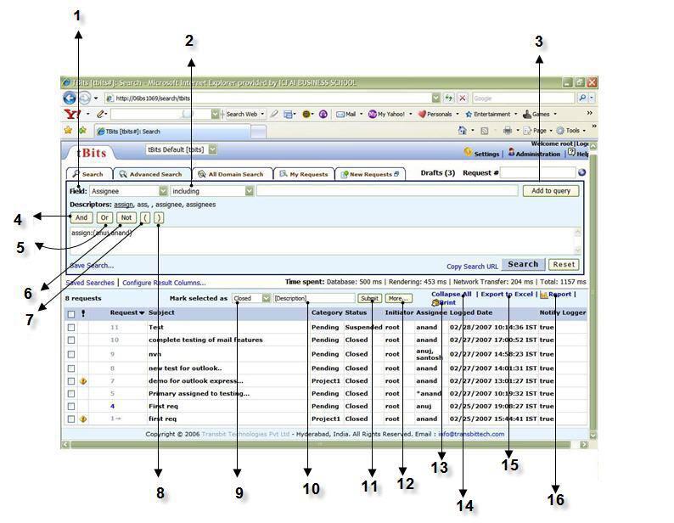 It is the most comprehensive access level. It provides all of the access that Search does, and adds the ability to search by the date and time the request was submitted and/or last updated as well as by the custom fields for that Domain. It also includes a TQL Builder. The various fields available in this feature are:
- Field: Each request has various pieces of information associated with it and recorded in request fields. Standard Fields are common to all Domains, and some Domains also have Custom Fields which are created to meet the specific needs of that Domain. A List Type Field is a field with predefined values; for example, the severity values are typically Critical, High, Medium and Low.
- This text box gives various conditional parameters like Equals, Not equal to, Greater than, Less than, Greater than or equal to ,Less than or equal to, Between ,Including, Excluding to search for a request with the specific requirements.
- Add to Query: It adds the fields described above (in 1 and 2) into the text box available below to help you form a refined search.
- And, 5. Or, 6. Not, 7. Opening bracket 8. Closing bracket – All these are the logical operators that provide you with the flexibility of carrying out a more specific search for a request .For example:
dueby: 03/05/2007 AND logger: anuj OR logger: priya NOT suja
- Mark Selected As: This helps the user to change the characteristic feature of the selected request to any of the following according to the requirement of the user anytime:
  - Closed
  - Private
  - Public
  - Read
  - Unread
- Description: Here the user can give a new description while updating the marked request.
- Submit: Clicking on this tab will let you execute with the desired changes and viewing the update of the marked request.
- More: This feature helps the user to carry out bulk updates of several marked requests thus saving lot of time and effort required in updating individual requests.
- Print: tBits also provides the user the option of getting a print out of the search request results print for further use thus enhancing the flexibility of usage.
- Collapse All: This helps the user to do away with the view of subrequests just below the requests. Contrary to this function is performed by ‘Expand All’ function which will again display the subrequests below the various requests.
- Report to Excel: tBits also provides the flexibility of importing the entire table of requests into an excel sheet to carry out further operations on the data.
- Report: The user can form a report out of the requests with the help of various graphical representations which will further enhance the interpretation of results.

All Domain Search

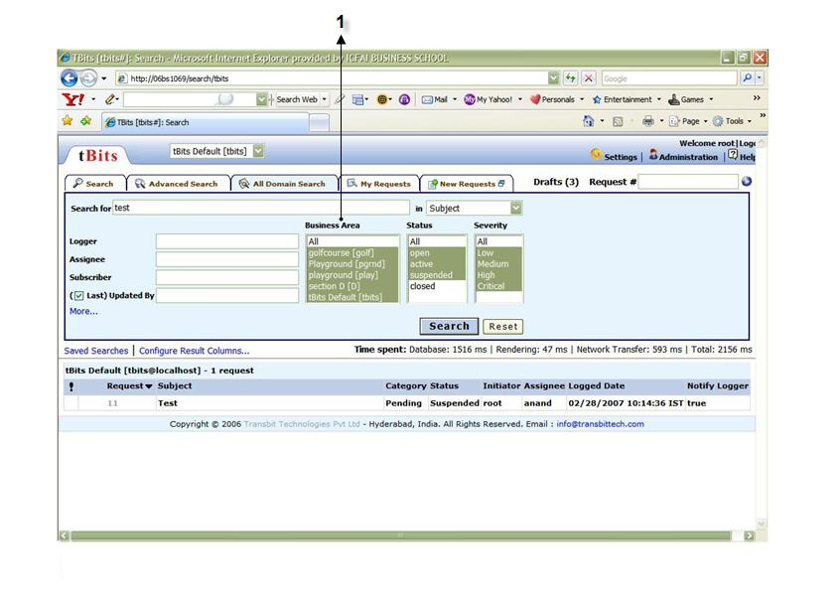

It allows a search of all Domains at once. The interface is similar to the Search panel, but allows you to search in all the Domains in this tBits database in a single operation.

  - Business Area: As the name suggests a user can go in for searching a request in the respective business areas/domains as and when required through this feature of tBits.

My Request
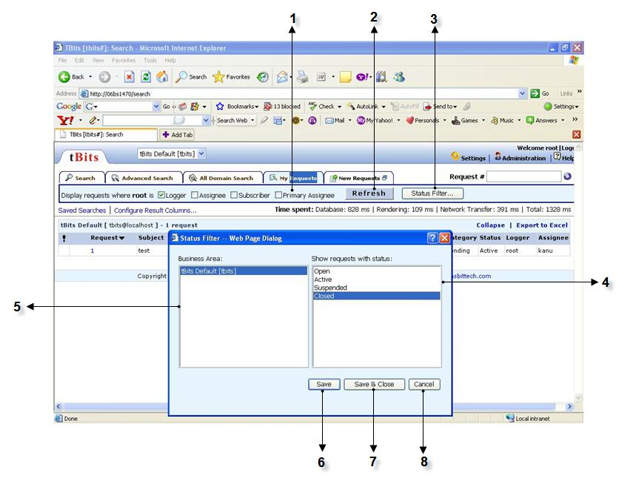

The ‘My Request’ tab helps you to search for requests which are in some way or the other related to you. You may be a logger of a request, or an assignee etc. ‘My Request’ helps you to identify all such requests thereby streamlining your search, saving your time and effort and increasing your efficiency. The important fields to be understood here are:

- Primary Assignee: There are situations when a task is assigned to a group or a team with one person responsible for the success of that task. Such a person is termed as a ‘primary assignee’. A request can have multiple assignees. In such cases, the user name preceded by an asterisk mark (*) is the primary assignee who is primarily responsible for the request.
- Refresh: This button refreshes the search with the changed criteria.
- Status Filter: Click on this button to select the status of the requests you want to search. This means that you can search for all ‘Active’ requests.
- Status Selection box: This box contains all the available status options of requests. You can select the status option you want.
- Business Area: Select the Business area/Domain in which you want to search for requests.
- Save: You can save the selected business area and status option selected in the status filter page. This makes them the default criteria for the next search.
- Save and Close: Performs the same function as above in 6 along with closing the status filter page.
- Cancel: Cancels the changes made in the status filter page.

Administrator Manual

In tBits, there are several kinds of administrator.

Administrator
The Domain administrator is indicated as an Admin role in the interface. An administrator can manage Categories, Assigned To, and roles of users within the Domain. An Administrator can assign all the roles to users except for Permission Admin and Administrator role.

Permissions Administrator
If a user is Permissions Administrator for a domain, user can configure complete domain. The Permissions Administrator is indicated as a PermissionAdmin in the interface. A Permission Administrator can also mark or unmark users as Domain administrator and Permissions Administrator.

Superuser
Superuser is the Permission Administrator for all domain. That means superuser can configure all domains. is the most powerful entity in the system. For security reasons, no option on the interface is kept to make a user superuser. It can be done using direct access to the database only.

tBits Development Team
The tBits development team can make any change in the Domain configuration.

Administrator manual: Note that only a few options can be set by the Domain Administrator; most must be set by the tBits development team. The Domain Administrator can only manage the categories, category Assigned Tos, and analysts, and assign various roles to users of the Domain. These can be set from the Users and Manage views of the Admin interface. There is a link to the Admin interface from the tBits Main page, as well as from the request details page.

Administrator:
When one clicks on the link Administration it opens a page as shown below.

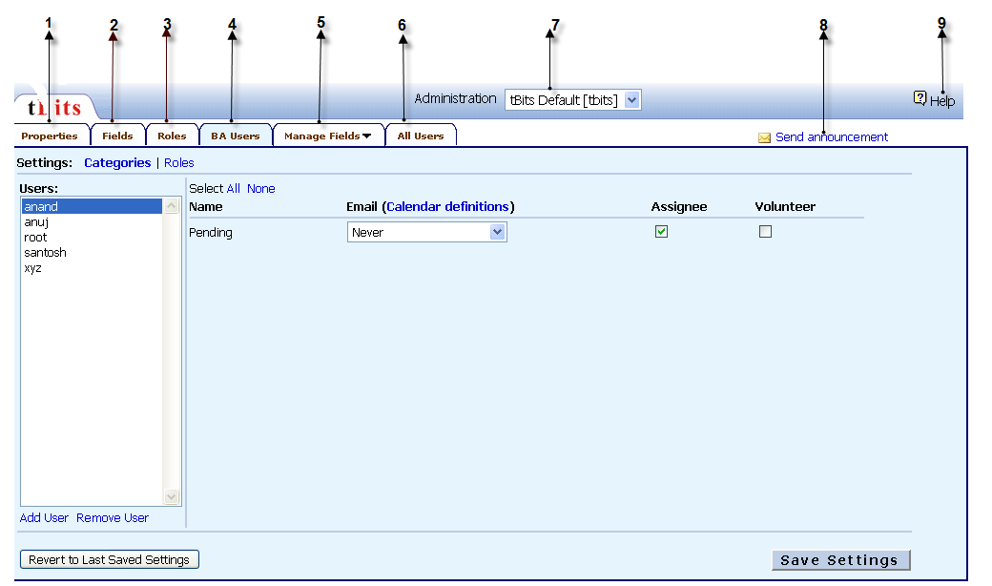

It by default open in the sub category called BA users. This page contains the following details

Properties

Fields

Roles

BA Users

Manage Fields

All Users

Administrator (tBits default)
It indicates the domain in which the administrator is working. Here the changes are made to the default domain of tBits. The domain can be changes by selecting from the dropdown box besides it. (The domain should be created first to be selected)

Send announcements
This will start composing a mail to all the administrators of all the active business areas.

Help
This will open the help document for your understanding and better usage of the system

7.1. Properties
The Properties tab is used to define most of the characteristics of a Domain.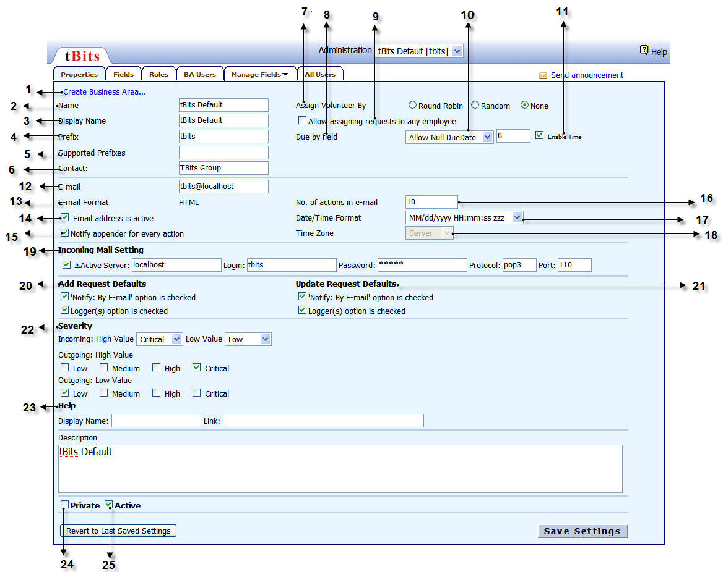

- Create business area: It creates a new business area. On clicking on that link, it will ask the name and the prefix of the new business area to be created.
- Name: It is that name of the business area on which you are currently working on.
- Display name: It is the name by which the business area would be displayed.
- Prefix: A unique prefix associated with each Domain. For example, Sys refers to Systems. The prefix must have a minimum of three characters. So, for example, "sta" or "stat" or "statu" are unique prefixes for the field "status" in the standard Domain configuration. Note that "sub" is defined as a descriptor for "subscribers" in the standard tBits configuration, so, although normally "sub" would be ambiguous as it matches both "subscribers" and "subject", in fact, "/sub" can be used to mean "/subscribers". Minimal matching applies to the descriptors for list type field values as well, so "/sta:clos" matches "sta" to "status" and "clos" to "closed".
- Supported prefixes are an alternative name to the corresponding prefix given.
- Contact: If you believe you need a new business rule for a Domain you manage, you need to contact the tBits development team.
- Assign volunteer by: The volunteer setting allows Domains which receive a large volume of requests to automatically assign the volunteer analysts to new requests in an impartial, round-robin fashion, or by random selection. To avoid automatic assignment, you can set your status to On Vacation from the Settings page. A request is assigned automatically if the request is given auto as the Assigned To. The assignment method is set on the Properties page in the Admin area. If the assignment method is none then automatic assignment of requests is disabled.
- Due by field column gives us the following options:
- Disable due date
- Allow null due date
- Mandatory due date
- Allow assigning requests to any employee: If it is checked then, any action taken would be assigned to people other than those who are marked as assignee in the business area. If this is not checked then the particular request can be assigned only to those who are marked as assignees.
- Due Date: Overdue items are shown with indicators in the request interface and in the requests. Additionally, the due dates of a Domain can be configured to be mandatory, optional (with or without a default due date), or disabled.
- Available/mandatory/set-by-default
The due date is pre-populated with the default value specified in the Domain configuration. Users cannot clear the value in this field, so every request is associated with a due date.
- Available/optional/set-by-default
The due date is pre-populated with the default value specified in the Domain configuration. Users are given the choice to clear the value in the field. If the due date is cleared, the request is not associated with any due date. Users can set or clear the value at any point during the lifetime of requests in this Domain.
- Available/optional/not-set-by-default
The due date is empty by default. Users can choose to specify a due date to associate with a request. The due date can be set or cleared at any point during the lifetime of requests in this Domain.
- Unavailable
The due date field is not shown when submitting or updating a request.

Only the tBits development team has change permission for the due date field.
If the Domain’s due date configuration option is changed to mandatory (the first option above) and if the due date is null, then the first time a person authorized to change the due date subsequently appends to the request, he or she must enter a due date. The Domain can be configured to use just a date, without a time, or to use a date and time.
If the due date configuration is one of the optional configurations, then in the Add Request page and the Update Request page there is a Clear/Set Default label next to the Due Date.
It indicates the number of responses or the number of actions taken in a particular mail. (i.e in response to a particular query)
- Enable time: If it is checked, then you have time displayed along with the date.
- Email: It gives the email id of the BA.
- Email format: It gives the email format. The administrator for a Domain can configure the email notification settings for each list type field separately. There can be an email notification setting for each Category, Severity, Request Type, and Status in the Domain. For example, you can set it up so that someone gets mail for all requests with Critical Severity.
- Email address is active: If it checked, it implies that the email id is activated.
- Notify appender for every action: If it is checked, then every action which is taken is notified through a email.
- No of actions in email: It indicates the number of responses or the number of actions taken in a particular mail. (i.e in response to a particular query)
- Date /Time format: Gives the Date format or None
- Time Zone: The time zone can be set to server time or to browser time, namely, the time zone in which you are working. The abbreviations for time zones which you commonly will see are:
  - EDT: Eastern Daylight Savings Time (winter time in North East USA ; IST minus 9.5 hours)
  - EST: Eastern Standard Time (summer time in North East USA; IST minus 10.5 hours)
  - IST: Indian Standard Time
- Incoming mail setting: These give the mail settings for the BA.
- Add request defaults: Use the /mail descriptor to specify whether to notify by email (Yes) or not (No).
List requests which are submitted by any member of the mailing list.
If there are any mailing lists which are part of this mailing list, they are expanded as well.
- Update request defaults: Show requests for which notification is sent for the latest update
Adds the list of loggers in addition to the existing ones
- Severity: When you log a request, it's important to assign it an appropriate severity code to indicate the degree of urgency. Please use the following guidelines:
Severity | Issue
Critical | Technical emergency that disrupts the firm's business and must be addressed immediately.
High | Major problem that should be addressed as soon as possible.
Medium | Normal request.
Low | Non-critical request or general question.

Note: Sometimes your requests may be re-prioritized depending on current workload and other outstanding requests.
- Help: If any display name is written in this tab, then it would be displayed on the top of the page and the link would be given below it.
- Private: A type marked as Private can be viewed only by authorized users.
- Active: A type is Active if it can be selected. If a type is to be retired from use, it cannot be deleted if any requests have been marked with that type. However, it can be made Inactive. In that case, new requests and updates to requests cannot be marked with that type.

7.2 Fields 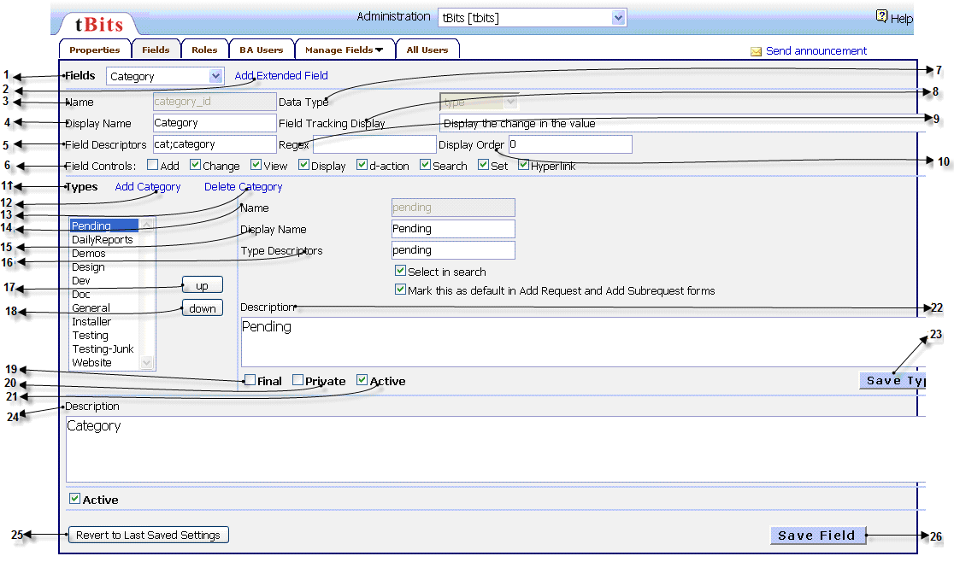

- Fields: The Fields tab is used to define all the fields of a Domain
- Add Extended Field: You can add an additional field here to the fields already present.
On clicking on this link, you will have to give the following details of the new field entered.
2.1 Field: It asks for the name of the new field to be entered.
2.2 Type: It gives the type of the field which is entered. For example: bit, date, time, integer, real, text etc.
2.3 Submit: It saves the new field and its corresponding type which is created.
- Name: Gives the respective Field name
- Display name: It is the name by which the given field would be displayed to the user. If you type text in one of these fields, tBits provides a best-matched drop down hint list from among all the users and mailing lists present in the database in the format "DisplayName <user_ID >" or "LastName FirstName <user_ID> Auto complete matching is based on the first name, the last name, or the email address. So, for example, if you type john, you will be presented with users for whom the first name, the last name, or the email ID starts with john.
- Field Descriptors: For list type field descriptors, here are some valid and invalid examples:
Valid examples:
/cat: backups |  | transfer to "backup" category
/sev:critical |  | mark this request with critical severity
/status: CLOSED |  | close this request
/cat: Remote Setups |  | move to category "Remove Setups" (if this was the display name)
/open |  | equivalent to /status:open: mark the status as open
Invalid example:
/cat: back_up | no match (it should be "backups")

- Field Controls is for controlling the fields.
For example,
Set: we set a new date, then at the next time the old date would be cleared and it will display a blank.
D-action is responsible for taking commands through mails.
Hyperlink links that particular link to its main page or its referred page.
- Data Type gives the type of data stored. Eg: if it is text, numeric etc.
- Field Tracking Display displays the change in value
- Regex field can be used for a custom field to restrict field values to those that matched the specified Perl regular expression.
- Display order no: If the field is a list type field, then the list types and their relative display order can be specified
- Types: Is a list type.
- Add category helps you to add an additional type to that particular field list.
- Delete Category helps you to delete any type in the existing list of that particular field.
- Name: It is the name of the new type added.
- Display name is name of the type added, which would be displayed to the user.
- Type Descriptors: Both IUCs and TQL make use of type descriptors which provide access to the value of the type stored within that particular field.
- Up: It shifts the selected field 1 step up.
- Down: It shifts the selected field 1 step down.
- Final: A type marked as Final is a type which, once set, cannot be changed. Anyone can set a request to have this type, but no one can change the field value after that. New requests cannot be set to a final type. This type is shown in light grey in the search results and request details pages.
- Private: A type marked as Private can be viewed only by authorized users.
- Active: A type is Active if it can be selected. If a type is to be retired from use, it cannot be deleted if any requests have been marked with that type. However, it can be made Inactive. In that case, new requests and updates to requests cannot be marked with that type.
- Description is the body of the message associated with each update.
- Save Type: It saves any changes done in the existing type or if any new type is added.
- Description is the body of the message associated with each field update.
- Revert to last saved settings: It restores and saves the settings which were saved before the updating.
- Save field: It saves any changes done in the existing field or if any new field is added.

7.3 Roles
It gives the administrator a clear picture about the roles of the system user , their, liberties, etc. also the right to change certain things

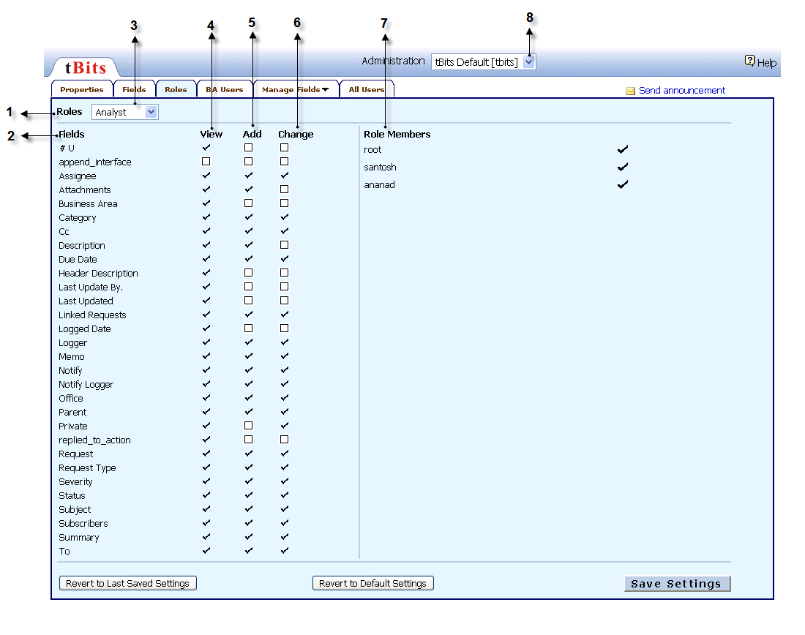
- Roles: It shows the roles that the administrator has assigned or set with his right to do so. This are configured at the beginning and even on the fly if required.
- Fields: This is the list of all the fields that appear in the system and are created by the administrator.
This box here shows the rights of the role which is currently being viewed.
- View: This column shows the fields that can be viewed by a particular role. For e.g. the role here is analyst. Now we can see that the analyst can view all the fields that appear in the system, other than “append interface” which is not checked in the view column.
- Add: This column shows the fields that the current role can add. For eg. The analyst can add all the fields which are checked but not fields which are not checked. So in this case he can add assignee, attachments etc but not u#, append interface, business area etc which are not checked.
- Change: This shows the field that a role can change. E.g. the analyst which is shown in the box can only change those fields which are checked in that column.
- Role members: this shows how many users exit for a given role. For e.g. for the role of analyst there are three user root, santosh and anand.
- Administration This shows the default Business area for which the administrator is doing modifications.

7.4. BA Users:

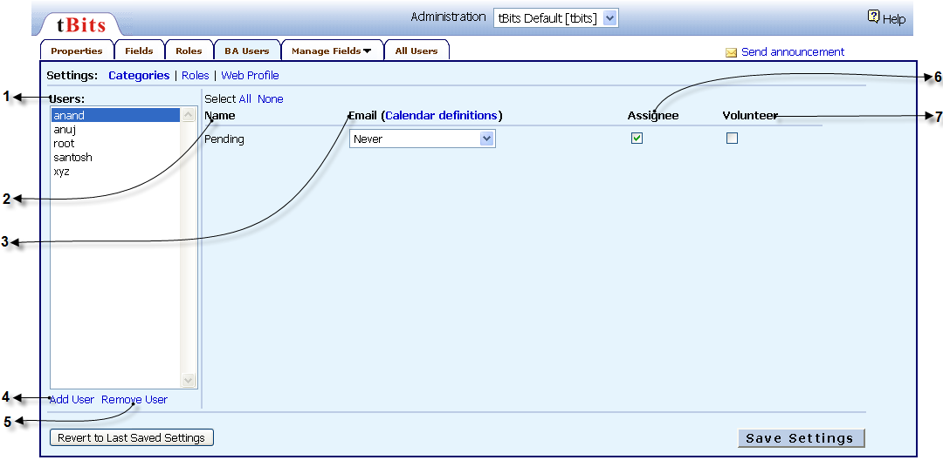

7.4.1 Categories: set as the default page under BA users. It will show the screen as in the screen shot given above. For BA users there are three settings: categories, roles, web profile

1. Users: These are the total number of users in that particular business area.
2. Pending: Never - It shows that for the pending request never send an email Always - It shows that a pending request is always send by email
NYC help desk off hours – for request with this label only will be sent by email.
HYD help desk off hours – will notify by mail for request label with this name.

3. Email (Calendar definitions) : There is the ability to define calendars (e.g. "Outside Singapore Helpdesk hours") to allow different notification rules during the day versus off-hours. Explanations of the calendar options and a list of holidays are available by clicking on the calendar definitions link on the Admin page.
4. Add User: On clicking on this tab, a window will appear where you need to enter the name of a user which already exists in the user list created under the all user tab. Once added the new user will appear in the column of the users here.
5. Remove User: To remove the user from the BA users list.
6. Assignee: when this box is check it will make the user visible to the customer or the system users who can select the assignee.
7. Volunteer. When this box is checked it will put the BA user in the round robin. And make him an auto assignee. Generally used where all BA users are of the same level and same kind of job is to be performed by them. A BA user can be assigned to be a volunteer only if he is also an assignee.

7.4.2 Roles:
It gives the administrator a clear picture about the roles of the system user , their, liberties, etc. also the right to change certain things
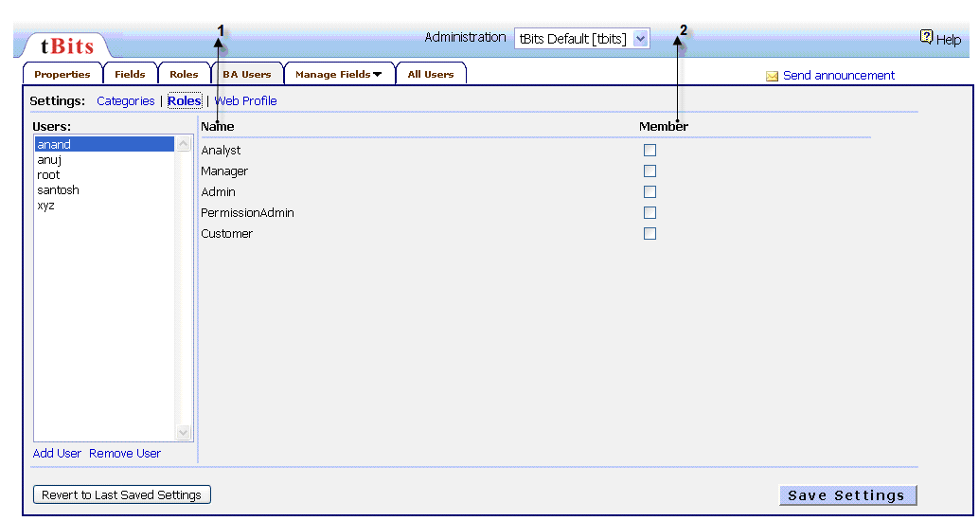

1. Name: It gives the different roles available for a member. It takes one or more of the following roles:

- Analyst
- Manager
- Admin
- Permission Admin
- Customer

2. Member: If the a particular box is checked it implies that the user is a member of the corresponding role.

7.4.3. Web Profile:

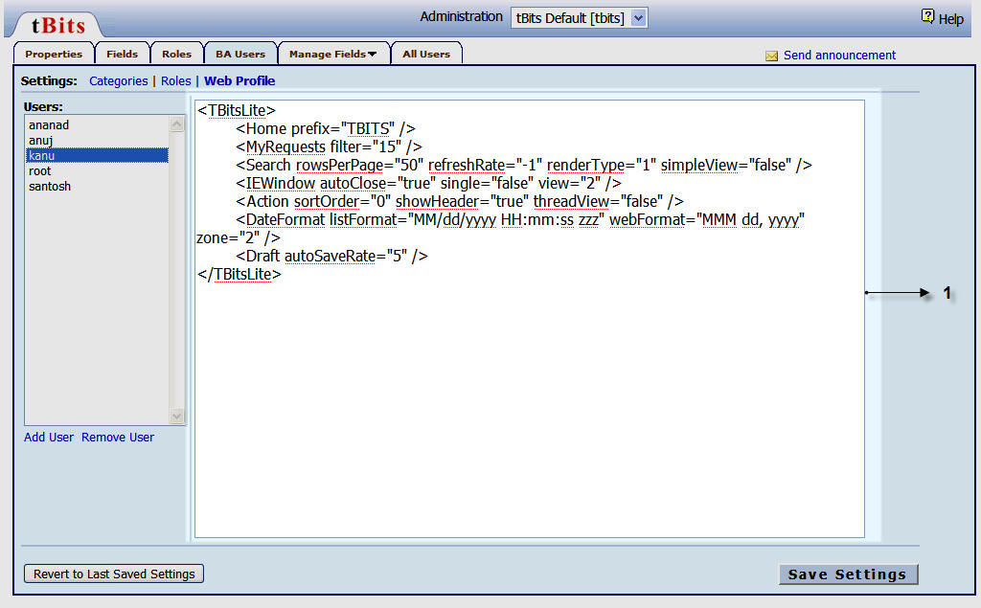

Web Profile Window: Details of the user are stored here.

This window shows the changes made by any user in their setting. So these changes can be seen by the administrator. For every user who has saved the setting has his/her web profile window updated.

7.5. Manage fields
When you click on the “manage fields” tab on the main screen of the administration module. You will find a pop up appearing in the same page as shown in the figure
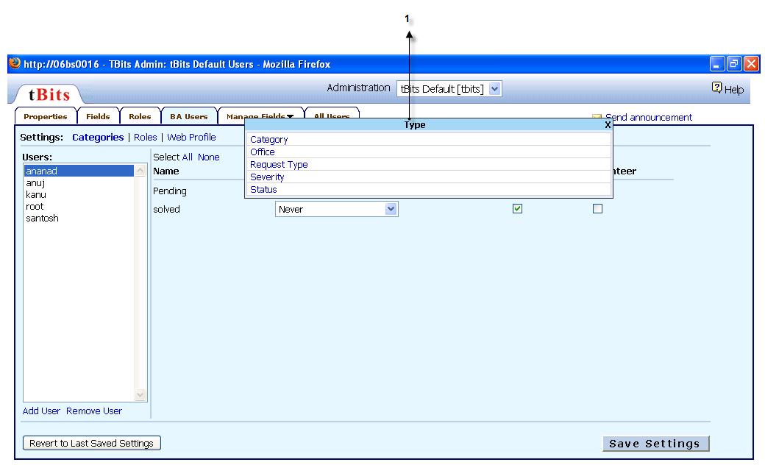

  - Type: it is the type of fields that you want to manage. Here the list shows the types as:

Category
- Office
Request type
Severity
- Status

Once you have selected any of the fields that exist it open a new screen where in you can manage and change the setting for that fields.

7.6. All Users:

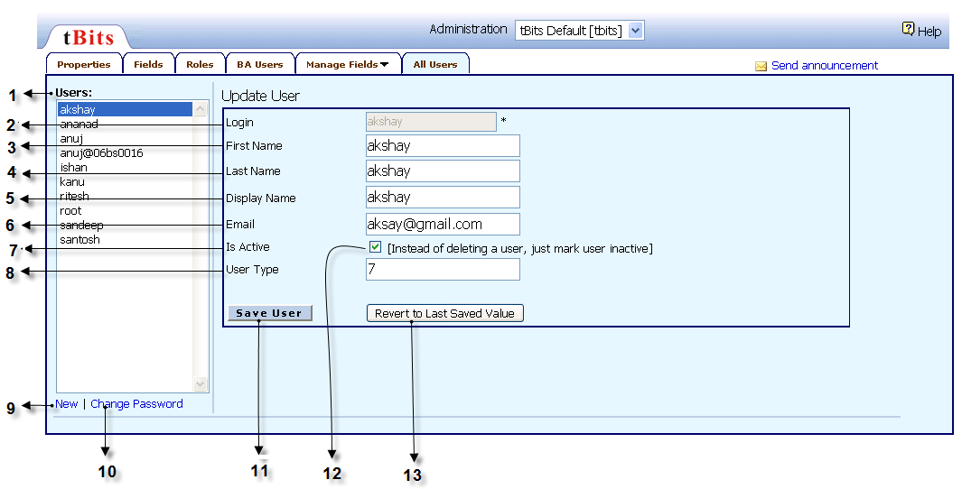

- Users: It is a list of all the users that has been created by the administrator till date
- Login: It is the login name as assigned by the administrator for the user which is highlighted in the block under the column of user (when a new user is to be created this fields will be shown empty)
- First name: It is the first name of the user whose name is highlighted in the block
- Last name: It is the last name of that user
- Display name: It is the name which is displayed to everyone for that user.
- Email: It is the email id of for the user which is to be linked to this system and to which the notifications are to be sent.
- Is active: It shows us the status of the user.
- User type: the number shows the type of user defined by the admin: For eg. 7 represents internal users and 9 represents external users.
- New: To create a new user. This will make all the above fields (2 to 8) blank to feed the data of the new user

- Change password: to enter the password for a user or to change the password for an existing user.
- Save user: this is to save entries made for the new user.
- When it is checked, it gives the authority to the administrator to make a user active or inactive as per requirement.
- Revert to last saved value: It gives the user the flexibility to revert to the last settings, in case he has made some erroneous change and saved it.

How To’s

How to Raise a Request Using Web Interface?
A request can be raised through the system following these easy steps:
- After logging in through your username and password, click on the ‘New Requests’ tab.
- You will be directed to a new page.
- Check the ‘Private’ box if you want the message to be viewed by users in your business area only. If it is a general issue you wish everyone to see or refer to, don’t check this box.
- Select the relevant office you want to send the request to from the ‘Office’ field. This is useful if you have offices spread geographically connected by ‘tBits’.
- Select the primary category of your request using the ‘Category’ field.
- Select the severity of the request using the ‘Severity’ field. This will help you prioritize your requests according to their importance and various other constraints like time limit, nature of content in the request etc. Thus you can organize your work load more efficiently.
- Every request is meant for some user who will take some action on that request. This user is the Assignee for that request. You can assign multiple users to a single request. Give the name of the user whom you want to assign the request to, in the ‘Assignee’ field. An ‘auto-complete’ function displays the list of all the assignees designated by the administrator, name starting from the letter you typed. You can then select the assignee for this request.
NOTE: There are situations when a group or a team is given the collective responsibility of a request but there is a team leader or a user who is primarily responsible for that request. Such a user is a ‘Primary Assignee’, and can be marked by an ‘asterisk’ sign (*) before the user name in the ‘Assignee’ field.
- Give the name of the logger who is the initiator of the request. This will be you in almost all cases.
- Set the status of the request according to what stage of processing the request. So after fully processing a request you may wish to mark it as ‘Closed’.
- Specify the type of your request. It can be a request, a question, a complaint, a grievance, etc.
- Select the ‘notify by email’ check box if you want the assignee, Cc and subscribers to be notified by email about your request. Select the ‘Logger(s)’ check box if you want the system to send you a copy of the request you just submitted by email.
- If you want any user to see this particular request but not the subsequent or previous updates on it, type that username in the Cc box.
- If you want any users to be kept up-to-date about your request at every stage of processing, type the username in the ‘Subscribers’ box.
- Mention the subject in the subject line as you do in an email. The subject line should reflect the nature of the request for more clarity.
- Attach any file if you wish by clicking on the ‘Attachments’ link.
- If this request is a sub-request of any other request, you can specify the ‘Parent’ link by clicking on the ‘Parent’ link. Every request by default is a parent request.
- If there exists similar requests posted previously, you may want to refer to them. In such cases, you may link that request to your request by clicking on the ‘Link Requests’ link.
- Sometimes, it may be prudent to add a short and precise summary for a lengthy and complicated request or issue to enhance the other users’ clarity and understanding. This can be done by clicking on the ‘Add Summary’ link.
- Write the body of the request in the description field.
- Spell check it to remove any accidental errors in spelling.
- You may also want to save the request as a draft. This is particularly useful if the request is of a fixed format and nature and repetitive. All the fields set bby you get saves along with the request description and attachments.
- click on the ‘Submit’ button to submit the request you have just composed.

How to Update a Request through the Web?
Updating a request can be done by following the given steps:
- You can search for any particular request through the powerful search functions provided in the system.
- If you point the cursor on the Request number, you will get three options:
  - View Request: click on this option to view the request with all it’s updates. Thereafter, you can click on the ‘Update Request’ button that takes you to the update request page.
  - Update Request: Clicking on this link will directly take you to the ‘Update Request’ page.
  - Add Sub-request: If you want to add a sub-request to any particular request, click on this link. It will take you to the ‘Update Request’ page and the parent request field will be automatically set to the request number.
- You can also click on the subject line of the request. This will let you view the entire request with all it’s updates. Thereon you can click on the ‘Update Request’ link to update the request.
- Once you go the the ‘Update Request’, you can make changes to any field of the request the same way you do when you create a new request. The ‘Update Request’ page is the same as the ‘New Requests’ page.
- All the changes you make to the request like changing the severity level, or adding or removing assignees are logged by the system to help you keep an accurate track of the request at any point of time.

How do you search for a request?
Search is the default search level. It provides the ability to search by the standard fields for all Domains, as well as by the person who last updated the request.
First specify the Domain, as the fields are cleared on changing Domains
You can execute search request in one of the following ways:

By specifying the search string:
1. Specify a search string which applies to the parts of the request specified.
2. Specify the location from where you want to search the request from the pull-down menu to the right of the search string
For example, you can specify the subject, the summary, or all text
3. All words are "and"ed together; that is, all the words specified must be present in the text for search to select a request.
4. You can select values for any of the request fields as well. The various data you provide for the request fields are also "and"ed; that is, all must be present for search to select a request.
5. You can search for any character within the subject of a request, but within the description of a request, only for alphanumeric characters.

By specifying the request number #
Every request has a unique request number. If this is specified, a single request is displayed and other search fields are ignored.
1. Enter a number in the Request field.
2. If you know the Domain prefix and request number, you can specify the Domain prefix, then #, then a request number to display the request without selecting the Domain
For instance, you could have the Domain 'B' open, but if you enter A#123 in the Request field, then 'A' Domain request 123 is opened.
To Save your Search results:
You can click on Save Search, to save a search. You then give it a name, which you can select later. The saved search applies only to the Domain which was open when you saved the search. This feature is described in detail below:
1. Make your search using the search interface, and click on the Save Search tab (at the bottom of the search interface)
2. A dialog asking you to name your search will appear
3. Provide a name.
4. Check the checkbox next to Set as default if you wish the search parameters provided in this search to be set by default whenever you use the search interface.
5. Check the checkbox next to Mark as shared if you wish to share this search with other users of this Domain. By default the search is private; it cannot be shared with other users.
6. Domain analysts can check the checkbox next to Mark as public to make the search public. It will be displayed with other saved searches for any user of this Domain.
7. Click Save.
Note:
- The search is saved for you for this Domain. This feature is particularly useful for creating a default set of search parameters.
- There cannot be two saved searches of the same name for a single user or within a Domain. If there is both a user-defined search and a Domain search with the same name, the user-defined search is given priority.
- You can save a search as a shared search or a public search, so it can be used by other users of the Domain as well. By default it is saved as a private search, visible only to you. A shared search can be accessed by other users, but only if you inform them of its existence. tBits only displays the searches you have defined yourself and public searches.
Important Notes about Search
- You can enter multiple request numbers, Submitted by, Assigned To, subscribers, etc. by separating them with a comma or a semicolon. tBits uses a comma to separate entries within a field, so it will provide a new drop-down selection menu for selecting a possible entry after each semicolon or comma. Once you have clicked Search, it will also understand entries separated by a comma or semicolon.
- If you enter "" (two double quotes with nothing between them) into any search field, you will receive results whose corresponding entries are blank. Note that if you just leave a field blank, your search will simply ignore that field, rather than return entries for which the entry is blank.
- You can use a comma (,) to escape autocompletion if you need to enter a value that does not exist in the list used for autocompletion (for example, finding requests assigned to users who no longer work here).

How do you search for a request using advanced search?
1. Select a field name; depending on the values supported for that field.
2. For list type fields like the Category or Severity, you can select Including or Excluding
3. Select one or more values to include or exclude in the search. However, if you select All, then no query is added, as Including All is equivalent to not specifying the field.
4. For fields which take an email ID, such as the Subscriber and Submitted By fields, you can select Including or Excluding. You can enter the email ID; auto complete is enabled for this.
5. For fields with a boolean value like Private or Notify by email, select True or False.

6. For fields which take a date like Logged Date or Due Date, select an indicator for the way you would like to specify the time.
- If you select On, Before, or After, then select a date with the date browser.
- You can select a specific day like Today, Yesterday, or Tomorrow.
- You can select a date range like Last week or Next year.
- You can select a date range like Last 'n' months or Next 'n' hours. You will be prompted for a value for n; use that to specify how many hours (or days, weeks, months or years).
7. You can specify a text field like Subject. Select the type of match you would like: Exact phrase, All the words, Any of the words, None of the words. Enter the text to search for in the text box.
8. You can specify that a field has a value by selecting: is not empty, or that a value has not been specified by selecting is empty.
9. If you have to search for any member of a mailing list in your search, select Including members of. To exclude them, select Excluding members of. This selection exhaustively expands any nested mailing lists to include the actual members in the search. If you want to search for specification of the mailing list itself, then select Including.
10. When you have specified the search criteria for a field, click ‘Add to query’; the resulting query is displayed in the query text box. You can build up a query by repeating this process as often as you like. You can also type directly in the query text box, or you can use the provided logical and grouping buttons to your command: And, Or, Not, (, ). When your query is complete, click Search to conduct the specified search.

Where can I see what requests I had raised?
The My Requests page provides an easy way to view the requests associated with you in all the Domains by following the given steps:
1. Use the checkboxes next to Display requests where to instruct the page to display requests with you in a different role (Submitted By, Subscriber, Assigned To, and/or Primary Assigned To). The result is that you will see requests for which you have any of the roles selected.

How To Raise A Request Using The Email Interface?
‘tBits’ allows you to update and raise new requests through MS Outlook. You should, however, know the email id of the domain to which you are sending the request.
One can set the following fields using the email interface:
- Subject: The subject of the mail message becomes the subject of the request.
- Body: The body of the message becomes the body of the request.
- Severity: The default severity is medium. The severity can be increased using the exclamation point icon in Outlook. The severity can be decreased using the down arrow icon in Outlook. The exact mapping of these Outlook settings to tBits severities is configurable in each Domain, so the high severity icon might map to High in one Domain and Critical in another. You can also set the severity via IUCs.
- Subscribers: Any user added in the To: field of a new request submitted by email becomes a subscriber to that request; a user in the CC: field receives that message only, and not subsequent replies. On replies to a request, however, no subscribers are added from the To: or the CC: fields of the email. If you specify other users on a reply, they receive only that mail message.
- Note: To avoid sending duplicate email, use the IUC /sub or /cc in the body of the message rather than using the To: or CC: field in email.
- Attached files: Any files attached to the email message are attached to the request as well.
You can set or update other fields via the web interface; alternatively, you can set them within the description text or via email using IUCs.

How to use Inline User Commands (IUCs) while Updating Request or Raising New requests through email.
Inline User Commands (IUCs) are a very easy way to set or change various fields in a request without using the web interface. These are designed to assist the email interface to map all the fields to the fields available in the web interface.

Acceptable values vary with the kind of field which is to be updated. For fields which take a single value, the value must have the notation:
/descriptor:value
For a field which can accept more than one value, the value can be absolute or relative, as defined in the following table:
Notation | Description
/descriptor:value_or_list | Appends value to the existing list if not present.
/descriptor:+value_or_list | Appends value to the existing list if not present.
/descriptor:-value_or_list | Removes the value from the existing list if present.
/descriptor:=value_or_list | Clears the existing list and sets the field value to the new list specified. This notation can be used for fields which take a single value also.
For absolute notation, specify a slash and one of the descriptors, followed by a colon (:), an equal sign (=) and/or white space and then a value. If there are multiple values, separate them with a comma, a semicolon, or white space. For example:
/category:purchasing
/status closed
/Assigned To = jones bart

What are the keyboard shortcuts used in tBits?
There are two sets of keyboard shortcuts.
  - On the search View
KEY | Action
CTRL+1 | Switches to TQL Mode: A special mode which is only for the advanced users
CTRL + 2 | Switches to ‘Simple Search Interface’
CTRL + 3 | Switches to ‘Advanced Search’
CTRL + 4 | Switches to ‘All Domain Search’
CTRL + 5 | Switches to ‘My Requests’

  - On the individual Request details Page
KEY | Action
CTRL+ALT+O | Opens Options/Settings
CTRL+ALT+A | Opens Add Request Form
CTRL+ALT+Left Arrow | Go to previous request
CTRL+ALT+Right Arrow | Go to next request
CTRL+ALT+U | Toggle the update mode.
CTRL+ALT+H | Help
CTRL+ALT+M | My Requests
CTRL+ALT+X | Expand/Collapse
CTRL+ALT+Y | Toggle Highlighting

How can you add extended field?
Only Administrator (a permission admin or super user) can add an extended field.
If you are the administrator then follow the given steps to add a field.
1. Once you login as administrator click on the “Administration” link on the top right corner of the main page (search page).

2. Now you enter the BA user module. Click on the fields tab which is in the same line as BA user tab and second from left.

3. Now you have the Fields page in front. Just below the fields tab u have the link “Add extended field” click on this.

4. A window opens after doing this. It contains two labels fields and type.
A. Field: It has a blank space on the right where you need to enter the name of the field that you want to create.
B. Type: It has a dropdown box besides it. This by default has the field type as bit. Field type signifies which kind of data is to be entered under the field name created.

For example. If you are creating a field called Birth date then its type is usually date.
If you are creating a field called Name then its type is text.
# Refer the administrator manual for detail of all the types shown here.

