**LntDocumentDrawingNumberGeneration Rule**

**Configuration…**

1. Set the system id and field name of the field for which you want to generate the number in the table trn_drawing_number_field.
2. Then set the following properties in the app properties tab in admin panel of tbits.
3. lntdcr.documentNumber.fieldNames (comma separated list of fields name)
4. lntdcr.documentNumber.isApplyRule (true or false)
5. lntdcr.drawingNumber.isApplyRule (true or false)
6. lntdcr.drawingNumber.fieldNames (comma separated list of fields name)

**How to generate …**

For automatic generating of the document or drawing number you have to tick the “Gen Ltp Std no” check box field in the request. Then number will be generated automatically in the field which you have stated in the trn_drawing_number_field.

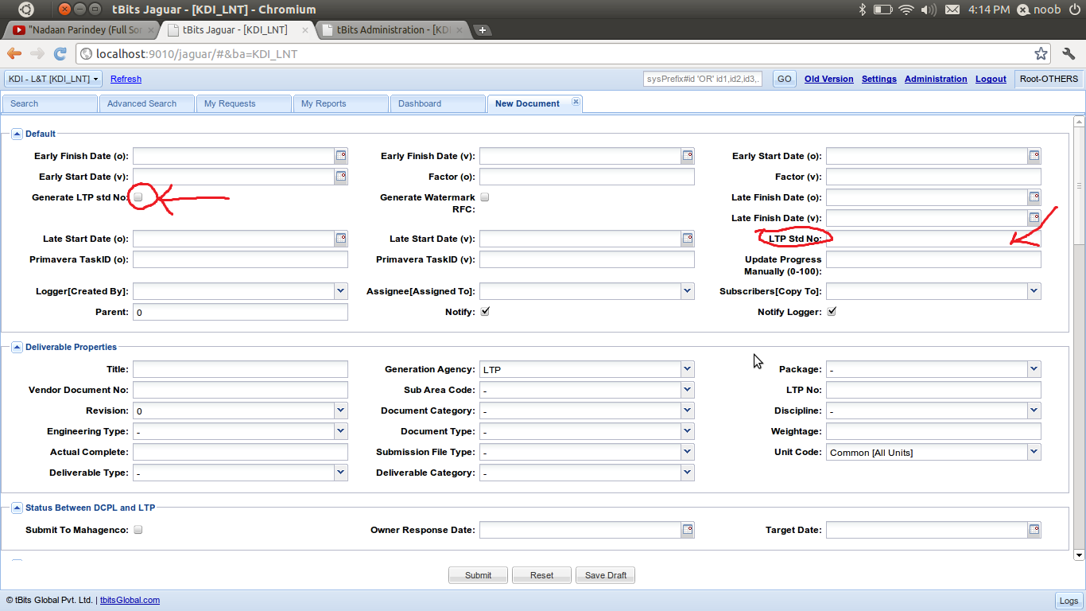

**How it is generating….**

When you submit the request a pre rule is executed on the request if you have ticked the “GenLtpStdNo” field then based on your app properties values a string will be generated and we also update the max_ids table with this generated value and then check for the uniqueness in the rule itself after that if number is unique then we set that number in that field and if the number is not unique then we increment the number and update the max_ids table and again check for uniqueness untill we get the unique number then we set that number in the configured field.