**How to schedule database backup on windows**

Step-1

Goto Start🡪 Administrative tools 🡪Task Scheduler

Step-2

In task scheduler goto Action🡪create task

Create task window will open in that window we have to schedule the backup.

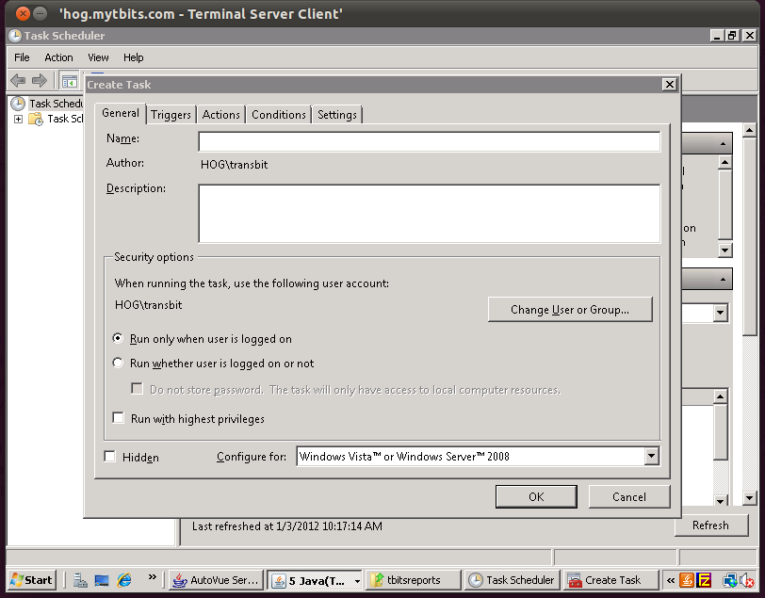

Step-3

In above window give the name and description of your backup and then click on trigger tab .

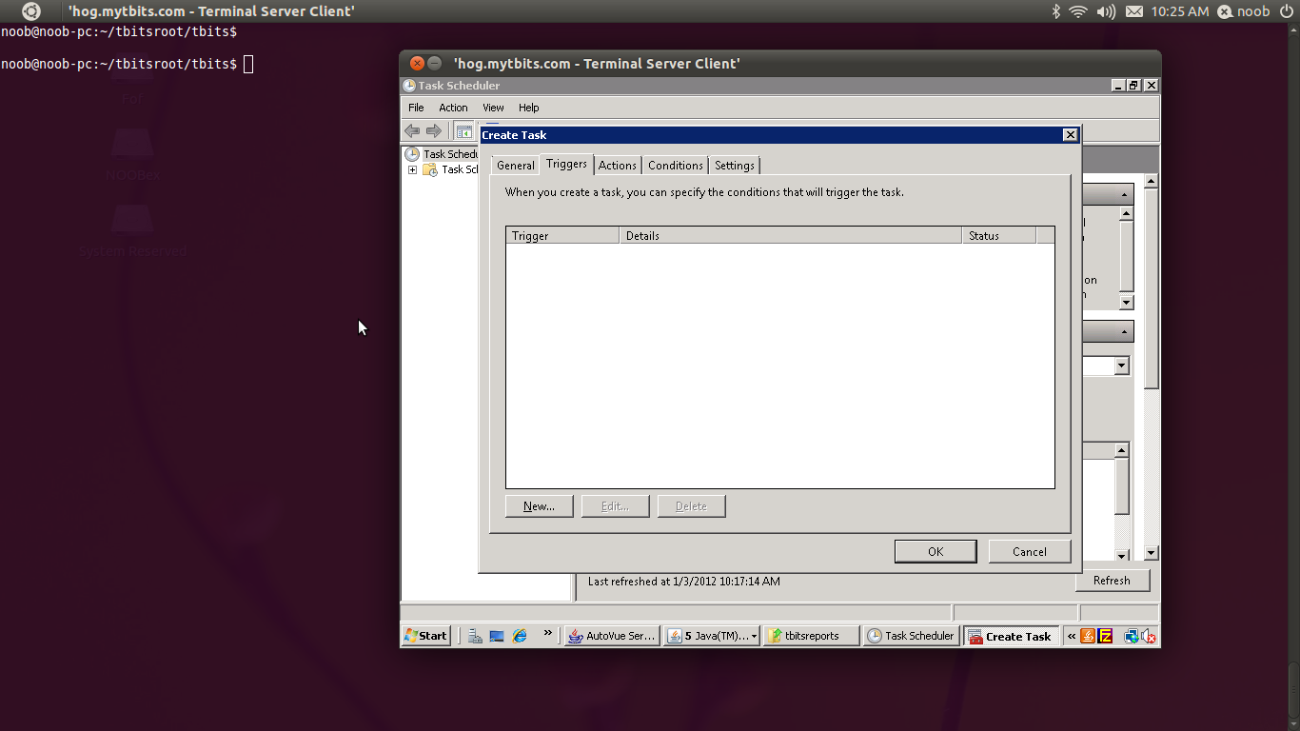

Step-4

In trigger tab click on new button. One new window will appear, in the new window set the begin of task mode. After that set the start time of the task. In advance setting you can more specify how your task should be scheduled ? And then click ok.

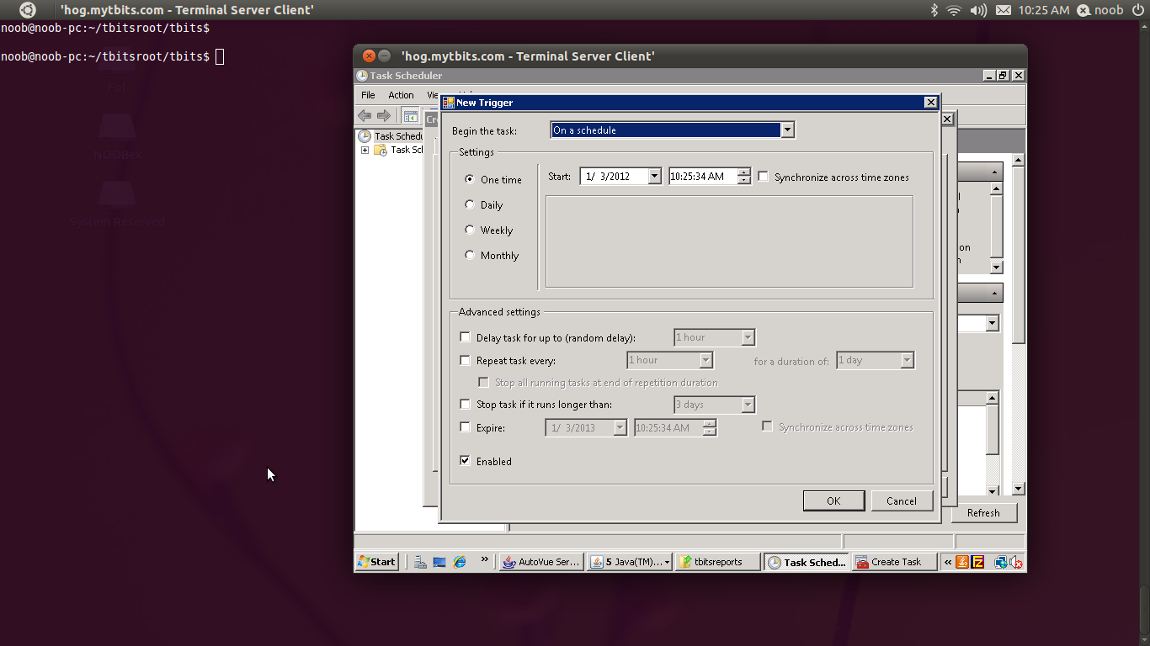

Step-5

Then click on the action tab and click on new button new window will open. In this window you will define the action of your task and select the program to be execute that program may be an exe aor may be some sort of script.

In our case it is a batch file we give the path of the batch file . and then click ok and then again click on ok in main window.

Your task ready to run….

