**Uniqueness checking of a particular field in tbits.**

If you want that your field should contain unique value in all request then you have to tick the ”Request Unique Control” check box and if you want that your field should contain unique value in all actions then you have to tick the “Action Unique Control” check box in the Field controls tab in admin panel. You can tick multiple fields as unique.

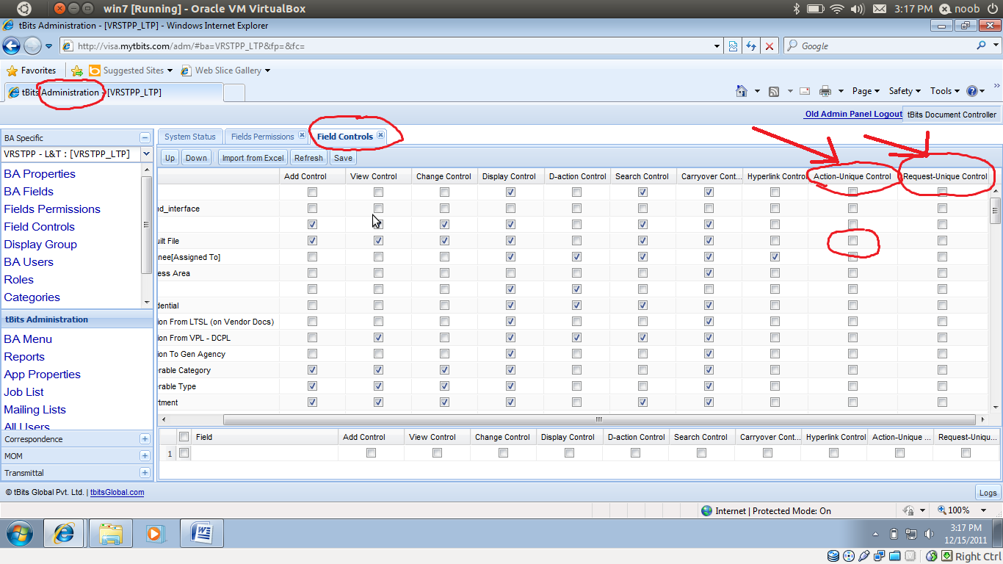

**Constarints…..**

Uniquness rule is only applicable to the **int**  , **string** and **real** type fields.

**How Uniqueness Works………**

After adding the request we check some constraints against the request and then we execute the pre rules after that we check the uniqueness based on your configuration in field control tab. If you have entered the same value in the unique value field then tbits will show a error message on the top of the request wizard with appropriate error string. Then you can edit that field value and submit again after this again we will check the uniqueness until you give a unique value to that field.