|  |
| --- |
| **tBits Collabwrite -** Engineering Document Control and Project Monitoring System |
| **Project Correspondence Module - IMP**  **User’s Guide - Version – PCM – 6.2** |
| **Document No – PowerDocs-PCM-User-Guide, R0** |

© Copyright 2010 - TransBit Technologies

Confidential computer software. Valid license from TransBit Technologies required for possession, use or copying. The information contained herein is subject to change without notice. The only warranties for TransBit Technologies products and services are set forth in the express warranty statements accompanying such products and services. Nothing herein should be construed as constituting an additional warranty. TransBit Technologies shall not be liable for technical or editorial errors or omissions contained herein.

# About This Document

The document is intended to give a comprehensive overview of the tBits CollabWrite – Project Correspondence Module. The document explains the process of

1. Initiating the Correspondence for external agencies by people listed in the Project Correspondence Protocol.
2. Initiating the Correspondence for external agencies by the team members who have been delegated the responsibility by the team-members mentioned in the Correspondence Protocol.
3. Initiating a Draft Correspondence for approval by team members.
4. Approving a Draft Correspondence and releasing the same to the external agencies.
5. Replying to a Correspondence. Forwarding the correspondence to yourself via email.
6. The Reports that are available to the users. The necessary MIS reports as circulated to the management are also detailed under the reports section.

# Intended Audience

The intended audience for the manual are people aware of the generally accepted practices of doing the project correspondence across industry segments. As the document details the process from first principles, the document is self sufficient to give an overview of the complete process and product to any one reading the document with no prior experience.

Some sections of the document may have references to the basic tBits User Guide.

# Document Organization

The document is organized as follows:

1. Business Process Overview
2. Overview of Basic Operating Procedure for PCM Module including the process to be followed for most common activities, applicable business rules, reports generated etc.

# More Information on tBits-CollabWrite

More information on tBits CollabWrite is available at

A. Firm’s Website – <http://www.tBitsGlobal.com>

B. Basic Operations User Guide – Version 6.2

# TransBit Technologies Encourages Your Comments

TransBit Technologies welcomes your comments on this document. Please provide your comments and suggestions via email to [feedback@tBitsGlobal.com](mailto:feedback@tBitsGlobal.com)

# Note on Cross Browser Performance of tBits CollabWrite & browser features

**The Corporate standard of Larsen & Toubro Limited is Microsoft Internet Explorer.**

tBits is a rich interactive application built using the industry standard Google WebToolKit [http://code.google.com/webtoolkit/]. The benefits that the GWT provides includes rich application interactiveness, speed and assurance of web-based application working across all types of browser and operating system environment. The details of the platform are available at <http://code.google.com/webtoolkit/overview.html>

Browsers offer a limitation in their ability to handle the interactiveness and flexibility that is provided by usage of JavaScript. The test for the W3C standards for javascript are available at <http://en.wikipedia.org/wiki/Acid3> and the test for the said browser can be done at http://acid3.acidtests.org/

Modern Browsers vary in their performance in handling the JavaScript. tBits is guaranteed to work on all browser environments but the performance may vary due to inherent constraints provided by the browsers. The performance is best on Google Crome, Mozilla Firefox and IE – 8 in the respective order.

Some of the issues that users may experience due to browser limitations include

1. **Stop Script Error in IE – 8**: The reasons for the above error and its resolutions has been detailed by the Microsoft in <http://support.microsoft.com/kb/175500>.
2. **Perceived slowness in loading of the drafts or data in IE – 8:** Lot of time is consumed by the browser in loading the results on the interface. This is prominent in IE-8 and consequently in tBits, we have limited the number of results in the search page to 25. Google Crome and Mozilla Firefox are very efficient in their client side rendering and may appear as faster as compared to the IE to the end user.
3. **Pop-Up Blocker** – For showing the pdf files for PCM and Agenda, we have to open a new window or tab, users should allow pop-ups from tBits server. If they fail to do so and allow the pop-up, IE completely refreshes the complete browser and may lead to loss of data if the user has not saved draft.
4. **Very Large Number of records in the EditGrid of Meeting, Agenda or Bulk Edit: IE – 8** has a limitation in number of rows that it can handle. We will request the users to have less than 25 rows in general. If the number of rows in the meeting agenda are greater than 25, then browser may become unpredictable. We will suggest the users to have separate meeting in case the number of points being discussed are more than 30.

Any of the above 4 points are not applicable if the user is using the Mozilla Firefox or Google Crome.

**Time taken for the first time login:** When the user first time comes to tBits, javascript is loaded and cached in the browser for future reuse. Hence, when the same user again comes back to the system, the time required is much less as compared to the time required for the first time login. Internet Explorer – 9 would eliminate most of the constraints as listed above and is scheduled for beta release in September 2010 and would be atleast 10 times faster that IE-8 and the performance results have been publically shared by Microsoft at the following link: <http://ie.microsoft.com/testdrive/benchmarks/SunSpider/Default.html>

Also note – All modern browsers come along with inbuilt spellcheck.

Note on Performance of Browser based Rich Text Editors

Any text box in tBits is by default Rich Text Editor enabled. The Rich Text Editor used by tBits CollabWrite is the same as is used by leaders in the web-content creation portals as wordpress.com and also used by various other firms for their application RTE requirements including Oracle, IBM and Adobe.

Please note – The RTE Editor is NOT an installed application as MS Word or Open Office and should not be compared in terms of performance with respect to the installed applications.

Most of the commonly used features as is available in the RTE editors in application as Gmail, Yahoo Mail etc are available in tBits RTE. In addition, some additional features as paste from Word [to bring the content from MS Word into RTE (essentially conversion of a .doc/.docx format as used in MS Word into HTML format as is required in the internet browser)], Tables are handled by RTE as is being made available by tBits and are not even possible in established RTE as is provided by Gmail or Yahoo Mail.

Please note – on account of being in Internet Browser and by virtue of it running in browser and it being NOT an installed application, the user experience and availability of features and in some exceptional cases – the output – may not exactly be the same as what the user expects from document authoring application as MS Word or Open Office Applications.

The current RTE being used in tBits CollabWrite is the best possible RTE under today’s technological landscape and No Further improvement/enhancement in the features provided will be directly possible as the limitations are imposed by the browsers. As the browsers support for the HTML standards increase, there is a possibility that gradually as browsers improve, the performance and outputs from RTE would also correspondingly improve but would still take time.

An example of the above development is Microsoft’s support for HTML 5 in its upcoming release of IE-9.

If the features as are provided by the document authoring applications are absolutely necessary for the user for his work, then we request the users to create the said content in the document authoring applications and attach the same as attachment into tBits. Examples of such features may include insertion of images, tables including pivot tables, paste formatting, multiple columns, keyboard shortcuts etc.

# Note on Email Integration of tBits

tBits can be enabled for 2-way email integration for any of the Business Area’s. The 2-way email integration enables the users to reply to the email received from tBits and the reply in that case would be imported into tBits and appended to the conversation thread. The reply works on the basis of system generated tags that form the part of the subject-line and the email body of the email message. If the end user removes these tags or creates a new email, then the incoming email will not be appended to the discussion and a new discussion would be created.

To prevent the above from happening, the following basic ground rules are required:

A. Preferably - all the users should use the web-based interface as there are many rules that are applicable including the protocol and numbering generation – functionality that can’t be achieved using the email.

The above implies that tBits will NOT be generating any Correspondence Number for the incoming correspondence or PDF file if the action has been taken from the web-based interface, the user will have the opportunity to provide the correspondence number and have the automated file generated.

B. Incase the Owner / Owner’s Consultant – refuses the usage of the web-based interface, then they should follow the basic discipline of atleast replying to the email that they have received without tampering with the tBits generated tag. Under the above case, the email received by the tBits would get appended to the said discussion without any human intervention, however, the Correspondence Number and PDF File will not be generated. When the IMP user replies to the correspondence received, then in the references, rather than the number of the correspondence coming, the reference would be shown as “Email Dated:” followed by the date.

Please further note – The If the incoming email user belongs to the 2 protocols, then the system will NOT be able to automatically select the protocol and would mark the protocol as others.

C. If the agency is indiscipline enough that they can’t adhere to the simple rule of replying to the email that they have received, then a new correspondence thread would get initiated in the tBits when they send the email to the project ID subject to 2 way email integration being enabled.

It would then be the responsibility of the IMP personal to mark the thread ID of the previous correspondence by updating the new discussion that has been initiated. In that case, the thread ID marked by the IMP personal would be made the child of the latest correspondence that is being replied. The references of the current discussion and the immediate child whose reference has been given by the user, would be considered for the generation of the latest three correspondence references.

In all the summary of all the scenario’s for handling of emails is as follows:

**Way Forward**: As the best interface to reduce the effort for all parties is a web-based interface, the following way forward would be adopted in the project.

A. All the users – particularly the vendors – would be required to come to the web-based interface for submission/creation of their correspondences to IMP.

The benefits of web-based interface for organizations:

1. Instant acknowledgement.

2. No going back by IMP as there is no possibility of missing correspondences, unread emails etc.

3. Reduction in Risk as protocol/business rules would be enforced.

**Limitations of the web-based interface:**

1. Organizational Preferences. Email is more convenient and is a shortcut for getting the work completed.

2. Training would have to be imparted and vendors need to be supported.

**B. In case of Owners and Owner’s Consultants**, the above methodology would have to be tried but there are changes that they would refuse to abide by a system that is owned by a party with whom that have an inherent conflict of interest. In the above case, the following is proposed:

1. The owners and Owner’s Consultant would be given the common email ID to which they can respond. An Example of a common email ID – [malwa@lntpower.com](mailto:malwa@lntpower.com) – would receive all emails. The emails would then be validated by the correspondence controller and necessary correspondence threads updated and emails deleted from the inbox.

**The benefits of the above approach:**

A. No change in the behavior of the owner or owner’s consultant.

B. Protection against SPAM as the human is performing the filtering operation on the emails that are coming to the common project mailbox.

C. The limitation of the emails coming in from the users who are not the part of the communication protocol is resolved with no new addition of users happening into tBits.

**The drawbacks of the above approach are**

A. Dependency on a correspondence controller who may commit mistakes and a possibility of delay.

B. Filing work would be substantial.

**C. Later, after a couple of months – when the setup has been stabilized, with vendors doing most of their transactions using web-based system, we will change the project common email ID to the BA ID, where we will perform the 2-way email integration with the following limitation:**

1. All the emails that come to the project inbox would be fetched by tBits. All the emails that are reply to the emails that were sent by tBits would be accepted and the concerned discussions would be updated.

2. All the emails that are found to generate a new correspondence thread, would be logged into a different BA for the correspondence controller to act.

The benefits for the above approach would be as follows:

A. Drastic reduction in the amount of filing that will have to be done by the correspondence controller.

B. The protection against SPAM would be available as the potential emails that would have created a new discussion thread would be subject to a human review. The above proposed solution where there is a restricted manual intervention would be the optimal solution for the 2-way email integration and would be implemented after 2 months from the date of Go-Live of the correspondence module.

# Support Information

If you have any queries or require support for any module of tBits-CollabWrite, please contact the below

# Contact Information

If at any time you have questions or concerns regarding tBits Collabwtite, call or e-mail us.

## General Inquiries

Telephone: +91-998-547-4558

E-mail: info@tbitsglobal.com

Web Site: http://www.tBitsGlobal.com

## Customer Support

Email: support@tbitsglobal.com

# Mandatory Information to be provided at the time of seeking support

Support may be required at various time by the end users from the IT or system administration team. We will request the user to mandatorily provide the following information at the time of seeking support.

1. **Screenshot of the error** that they received: Use the Print Screen button on the keyboard and save the screenshot as .png file.
2. **The steps to replicate the error:** If possible, provide the steps to the admin team to replicate the problem. If the problem can be replicated then it can be easily solved.
3. **The local logs on the browser** should be copy pasted in the email.
4. **Copy paste the log in the email that you are sending**

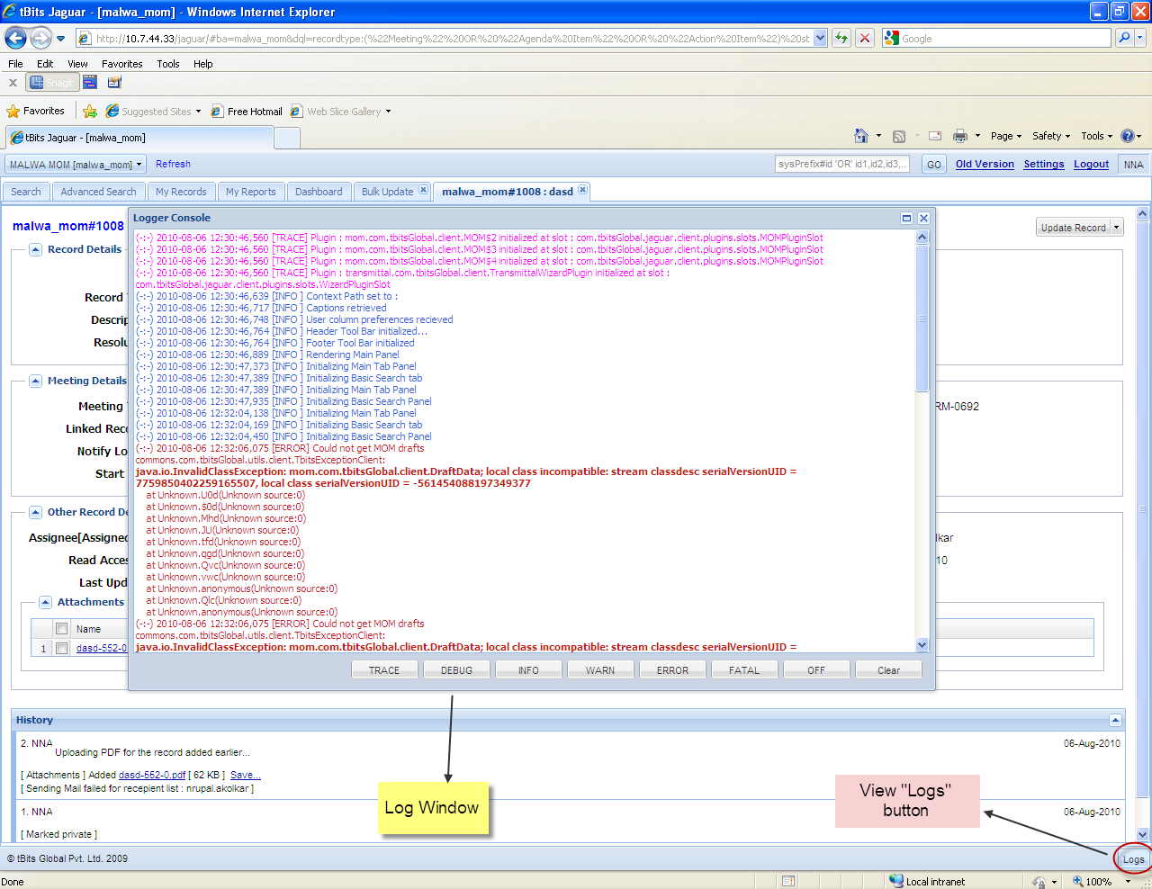

### Screenshot showing location of client side logs

**The copied section would be as follows:**

(-:-) 2010-08-06 12:31:09,054 [TRACE] All Types in Field : Meeting Type selected

(-:-) 2010-08-06 12:31:09,054 [TRACE] All Types in Field : Agency selected

(-:-) 2010-08-06 13:44:14,623 [FATAL] StatusCodeException --> Status Code : 400

(-:-) 2010-08-06 13:44:16,748 [FATAL] User has been logged out.   
com.google.gwt.user.client.rpc.InvocationException:

    at Unknown.CW(Unknown source:0)  
    at Unknown.vad(Unknown source:0)  
    at Unknown.qgd(Unknown source:0)  
    at Unknown.Qvc(Unknown source:0)  
    at Unknown.vwc(Unknown source:0)  
    at Unknown.anonymous(Unknown source:0)  
    at Unknown.Qlc(Unknown source:0)  
    at Unknown.anonymous(Unknown source:0)

(-:-) 2010-08-06 13:44:44,607 [FATAL] StatusCodeException --> Status Code : 503

**We request users to provide the above details for speedy resolutions of their issues.**

# General Topics

## Key terminology

**Project Correspondence (PCM):** It refers to correspondence that takes place between project participating agencies post order complying to Correspondence Protocols, Numbering systems as is defined in the Project Correspondence Procedure document.

**Correspondence Protocol:** The formal methodology used for correspondence between the two organizations that provide the following details:

1. List of people from each of the organizations who can write correspondences related to the various matters to their counterpart.
2. The mandatory list of participants in a correspondence – “To”, “CC” – when a correspondence on a particular matter is being sent.
3. The letter head formats on which the correspondence would have to be sent.

**Type of users in a Project Correspondence:**

1. **Correspondence Protocol User [Direct Users]:** People who are available in the protocol – The people who are available in the protocol can directly write to the other organization. They can directly write a correspondence without seeking any approval.
2. **Correspondence Delegated Users [Delegated Users]:** Set of people who have been authorized by the people in the correspondence protocol list who can on their behalf send directly the correspondence. The people can directly write to the other organization by assuming the identity of the people who have delegated them the rights to write a correspondence.
3. **Project Team Members:** People in the project team who can draft a correspondence that should be released by the people in the designated roles totheir counterparts. These set of users can’t directly write to the other organization.

## Acronyms

BA = Business Activity Area

PD = Project Director

## PM = Project Manager

**Special Note on Reports:**

Please consider and evaluate all reports/output formats enclosed in this manual from the perspective of being indicative templates. The actual report may differ in number of pages depending upon the actual dataset.

# Introduction to tBits-CollabWrite Project Correspondence Management Module

Interchange of communication related to the various aspects of the project is a very common activity that takes place in a project. These communications are sent by the designated people to their counterparts in the organizations as a letter that meets the organizational requirements as letter head, numbering systems and adhering to the rules as have been mutually agreed and detailed in the project coordination procedure.

The correspondences are done on the various subjects including the delays and are used for contractual purposes. Hence, proper documentation and tracking of the correspondences including the response by date are required.

The overall objective of the implementation of tBits-CollabWrite Project Correspondence Module [PCM] are as follows:

1. Enable a method to enforce the communication protocol.
2. Enable the delegation of writing the project correspondence to several people as is authorized by the Project Director.
3. Tracking all incoming and outgoing project correspondences.
4. Ensuring that the complete chain of correspondences on a subject are tracked to their logical conclusion.
5. To have complete correspondence of Project at single location which can be retrieved at any time.

# How tBits CollabWrite Project Correspondence Management Assists Project Teams?

The project correspondence module assists the project teams as follows:

1. Enforcement of the protocol and numbering systems as detailed in the project coordination procedure. .
2. Enables the delegation of authority.
3. Monitoring & closure of all correspondences that are related to the issues.

# What are the various roles and permissions given in the PCM Module?

The various roles that have been configured in the tBits for the project teams are as follows:

**Static Users:**

1. **User** – Any user defined in the user table and have not access into the BA.
2. **BAUser** – Any member of the BA to whom the BA should be shown. This includes complete internal and external participants of the project. These participants can only the see fields as are required by them to see and they can’t see confidential.

**Dynamic Roles:**

1. **Logger** – The person who created the record.
2. **Assignee** – The person who is assigned to the record.
3. **Subscriber** – The person who is affected by the record.
4. **Read Access to** - The external people who can view the view and can’t make any changes. No emails would be sent to these users.

**Note:** For getting the complete details on the permissions, please contact your application administrator.

1. The permissions of all the users are given in the annexure.
2. The permissions of the following users are same = Logger, Assignee and Subscriber.
3. The permissions of the following roles are also same = Project Manager, Project Director.
4. The User, BAUsers, Project Team Members, PM, PD, “Read Access To” doesn’t get the email notifications.
5. Only the Logger, Assignee and Subscriber get the email notifications for all correspondences.

For IOM’s, the view permissions are available to Logger, assignee, subscriber and view access which is to be manually defined by the person who is creating the IOM.

# How to select an appropriate PCM Business Area?

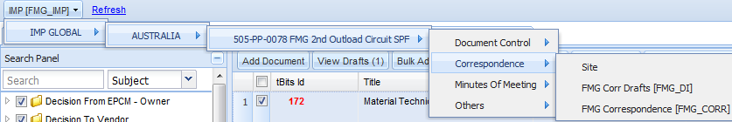

### Screenshot #1: Selection of Business Area of PCM

After you successfully login into the system, a drop-down menu is available at the top left of the webpage from where a user can select an appropriate PCM business area.

**Note -** The user can access only those business areas to which user has got the privilege to access.

**Note –** The Business Area dropdown may comprise of one or many project specific Business Area, including – Engineering Documents [Document Control Register, Document transmittal notes], Correspondence, MoM, etc.

# What are the various business areas available for correspondence?

For the complete management of the correspondence process, there are 2 business area’s per project – One for **‘Correspondence’ [Referred as ‘Corr’]** and One for **‘Drafts’ [Referred as ‘DI’ or ‘Discuss Internally’]**. All Users except for IMP Users, would have access only to the Correspondence BA. All IMP users would have access to Drafts BA.

The overall objectives of the ‘Correspondence’ BA are as follows:

1. It is a single BA where all outward and incoming correspondences are available for the users.
2. The complete conversation threads for a matter that was discussed with the multiple parties would be available in this BA.
3. Every thing is controlled in terms of access rights and permissions with internal project team be able to view all the correspondences except for commercial or contractual.

The overall objectives of the ‘Drafts’ BA are as follows:

1. This is an internal BA where the drafts and the associated discussions are available for the users. The user from the correspondence BA can take any incoming correspondence and initiate a discussion internally for the creation of a response by including several people from his projects or capability centers.
2. All the drafts can be reviewed by the people and then released to the external people by the authorized people.
3. The access to the drafts BA is only to the project team members.

# What are the various fields in the Draft BA and what is their significance?

The complete structure of the drafts BA is given in Annexure-1

# How do you create a new Draft and submit the same for approval?

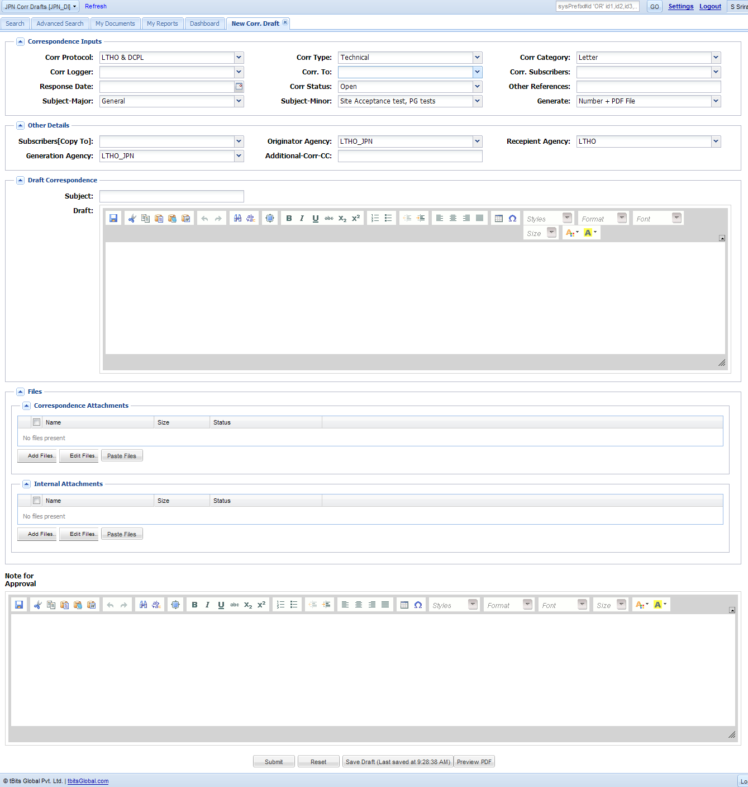

To create a new draft, follow the following process:

A. Select Drafts BA.

B. Select New Draft Correspondence Tab.

C. Select Corr Protocol – this will define the agency to which the current logger is authorized to create a draft for.

D. Select Correspondence Type [Technical Commercial Etc]

F. Select Correspondence Category [Letter, Email etc]

G. Select from the predefined list of correspondence loggers. The moment you select the correspondence logger, the Corr To and Corr subscribers fields are auto populated.

H. The user may optionally want to also select the “Response Date”.

I. Correspondence Status – This field essentially shows the Draft Status - Weather the same is Open, Closed,

J. The following fields are automatically selected based on the Corr Logger and Protocol.

* Recipient Agency[Correspondence Receiving Firm]
* Generation Agency [Correspondence Creating Firm]

K. Usually, if the user is generating the correspondence, ‘Generate’ would be selected to Number + Pdf File.

Draft Body

If the user wants to enclose the attachments to be sent along with the correspondence, then he uploads the same to “Correspondence Attachments”. If he wants to put in attachments for internal justification of the draft, then he uses “Internal Attachments Field”

Finally – the logger creates the “Notes for Approval” for the correspondence and submits the same for approval.

The above process marks the completion of the creation of a draft and submission for internal approval.

Once the draft is submitted, then

1. The Corr Logger is automatically made the “Assignee” of the draft and the email is sent to him for approval. The logger of the draft is also notified by email along with the draft subscribers.

# How do you select the name of the person who would be approver of your draft?

The Corr Logger is the approver of any draft that is created.

# Who can release the draft?

The people who are authorized to send the correspondence – including Direct Users or Delegated Users release the draft to the customer. For any other user, the submission of the correspondence would be disallowed.

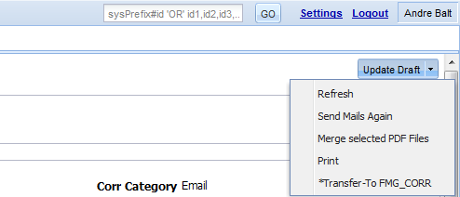

The draft is released by the assignee by clicking on the field “ Transfer To – FMG_Corr” icon in the draft:

# How do you use the feature of discuss internally?

Many times there are correspondences on which we have to have an internal discussion done and after the discussion to create a draft response. tBits offer a feature where an internal discussion for creation of a draft can be initiated by clicking the button of “Transfer to DI”. When the person clicks on the “Transfer to DI”, the add draft page opens were the following values are pre-selected.

The correspondence from where the draft originated, is linked to the the draft request. When the person clicks on “Create Correspondence” from this draft, the draft goes and sits on top of the correspondence discussion from where it originated.

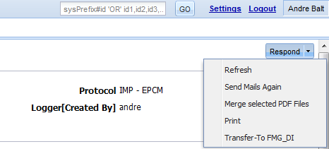

The above feature ensures that all the drafts and their respective correspondence threads are interlinked and the user can get a holistic picture for all transactions done on a particular issue with the corresponding party.

The transfer from DI to Corr and from Corr to DI works in exactly the same manner – i.e the add forms open with there are particular values that are pre-filled.

The complete list of the values that get transferred in each of the processes are as follows:

When the correspondence is sent on the draft, then the corresponding draft is automatically updated with its status being marked as “Closed”. The relationship between the two is maintained by Linked Correspondences / Linked Drafts field.

# What fields are copied from Corr to DI when the internal discussion / draft creation on the correspondence is initiated?

The following fields are copied from the Corr to DI when the transfer happens from drafts to corr BA>

|  |  |  |  |
| --- | --- | --- | --- |
| **Field Mapping Between  DI  & Corr Business Areas** | | | |
| **From Ba** | **From Field** | **To Ba** | **To Field** |
| FMG_Corr | Protocol | FMG_DI | Corr Protocol |
| FMG_Corr | Corr. Type | FMG_DI | Corr Type |
| FMG_Corr | Subject | FMG_DI | Subject |
| FMG_Corr | Generation Agency | FMG_DI | Generation Agency |
| FMG_Corr | Corr. Category | FMG_DI | Corr Category |
| FMG_Corr | Assignee[Assigned To] | FMG_DI | Corr. To |
| FMG_Corr | Subscribers[Copy To] | FMG_DI | Corr. Subscribers |
| FMG_Corr | Recepient Agency | FMG_DI | Recepient Agency |
| FMG_Corr | Subject-Minor | FMG_DI | Subject-Minor |
| FMG_Corr | Subject-Major | FMG_DI | Subject-Major |
| FMG_Corr | Originator Agency | FMG_DI | Originator Agency |

|  |  |  |  |
| --- | --- | --- | --- |
| **Field Mapping Between  DI  & Corr Business Areas** | | | |
| **From Ba** | **From Field** | **To Ba** | **To Field** |
| FMG_DI | Corr Protocol | FMG_Corr | Protocol |
| FMG_DI | Originator Agency | FMG_Corr | Originator Agency |
| FMG_DI | Corr Type | FMG_Corr | Corr. Type |
| FMG_DI | Subject | FMG_Corr | Subject |
| FMG_DI | Generation Agency | FMG_Corr | Generation Agency |
| FMG_DI | Corr Category | FMG_Corr | Corr. Category |
| FMG_DI | Corr. Subscribers | FMG_Corr | Subscribers[Copy To] |
| FMG_DI | Corr Logger | FMG_Corr | Logger[Created By] |
| FMG_DI | Draft | FMG_Corr | Correspondence Content |
| FMG_DI | Recepient Agency | FMG_Corr | Recepient Agency |
| FMG_DI | Additional References | FMG_Corr | Additional References |
| FMG_DI | Correspondence Attachments | FMG_Corr | Correspondence Attachments |
| FMG_DI | Additional-Corr-CC | FMG_Corr | Additional-Corr-CC |
| FMG_DI | Response Date | FMG_Corr | Response Date |
| FMG_DI | Subject-Major | FMG_Corr | Subject-Major |
| FMG_DI | Subject-Minor | FMG_Corr | Subject-Minor |
| FMG_DI | Corr. To | FMG_Corr | Assignee[Assigned To] |

# What is the process of creating a correspondence?

To create a new correspondence directly into the Corr BA by the Direct and Delegated users, the following process is to be followed:

A. Select Correspondence BA.

B. Select New Correspondence Tab.

C. Select Corr Protocol – this will define the agency to which the current logger is authorized to create a draft for.

D. Select Correspondence Type [Contractual,Commercial Etc]

F. Select Correspondence Category [Letter, Email etc]

G. Select from the predefined list of loggers. The moment you select the logger, the Assignee and Subscribers fields are auto populated.

H. The user may optionally want to also select the “Response Date”.

I. Correspondence Status – This field essentially shows the correspondence threadStatus - Weather the same is Open, Closed, Information, Reopen.

J. The following fields are automatically selected based on the Corr Logger and Protocol.

* Recipient Agency [Correspondence Receiving Firm]
* Generation Agency [Correspondence Creating Firm]

K. Usually, if the user is generating the correspondence, ‘Generate’ would be selected to Number + Pdf File.

Draft Body

If the user wants to enclose the attachments to be sent along with the correspondence, then he uploads the same to “Correspondence Attachments”.

The above process marks the completion of the creation of a correspondence and its submission to the other party.

Once the correspondence is submitted, then

1. The Corr Logger is automatically made the “Assignee” of the draft and the email is sent to him for approval. The logger of the draft is also notified by email along with the draft subscribers.

# Who all create a correspondence in the correspondence BA?

The Direct Users and Delegated Users can directly create the correspondence in the Correspondence BA. No other users is allowed to create a Correspondence directly.

# How to reply to a correspondence?

The process of responding to the correspondence is as follows:

A. Open the correspondence that you have received and Click “Respond” on the Correspondence Conversation.

B. The follow the same process as that is applicable for the creation of a new correspondence.

# How can an external agency using its own numbering system submit the correspondence to IMP Limited?

The external agency can submit the correspondences in the following 2 manners:

1. Using their numbering system but generating the correspondence pdf File via tBits: Use the option for “Specific number + PDF file” in the generate.

2 Using the scanned file and putting the same into tBits with number or file generation: Use the option for “No Number + No PDF file” available under generate.

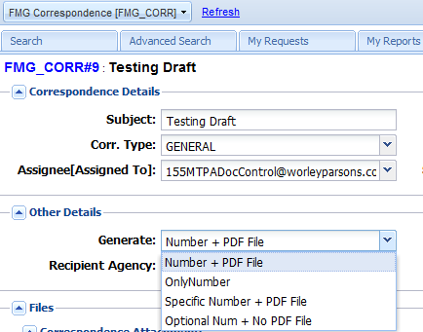

# How to forward a correspondence to yourself?

There would be several scenario’s where a correspondence needs to be forwarded to the people who are NOT users of tBits. In the installation that has been for the IMP Limited, auto-addition of the users is NOT allowed. Hence, it will NOT be possible for the users to forward a correspondence to any external party who is not a part of tBits.

To prevent the constraint that is imposed by the above rule, there are 2 options that are available to the user for forwarding the correspondence:

A. The email that was received by the Logger, Assignee or Subscriber of the Correspondence can be forwarded using the email client.

B. If the person has not received the email, then he can email the correspondence to himself and then forward the email using the native mail client.

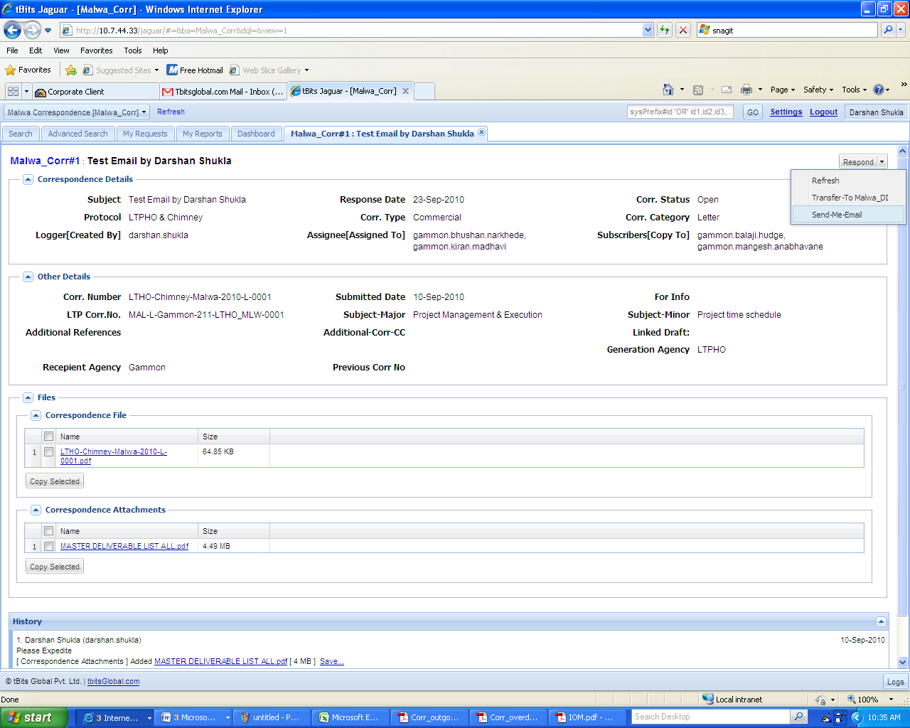

# What reports are available to the user?

The following three reports are available to the user:

* + - 1. **Incoming Correspondence Register**: The Incoming Correspondence Register shows all the correspondences that are received by IMP Limited in the specified duration for the respective agencies. The format of the report is detailed in Annexure - 2
      2. **Outgoing Correspondence Register:** The Outgoing Correspondence Register shows all the correspondences that are sent by IMP Limited in the specified duration to the respective agencies. The format of the report is detailed in Annexure - 3
      3. **Overdue Correspondence Report:** The overdue correspondence report shows the list of correspondences that are overdue for response from either IMP Limited or the Recipient Agencies.The format of the report is detailed in Annexure – 4

# Is the email reply for the correspondence available?

Please see the “Note the email integration of tBits” the correspondence BA as above.

# Is any number generated when the other agency replies from email?

Please see the section “Note the email integration of tBits” above.

When a response from an email arrives, then

A. The protocol is set subject to user being in only a single protocol else the protocol is set to default.

B. NO PDF is generated i.e there is no automatic generation of the correspondence file.

C. NO CORRESPONDENCE Number is Generated.

# Discussion on the scenarios of response to correspondences.

The complete discussion on the various scenario’s for the reply from email are detailed under the section of 2-way email integration of tBits.

## Scenario 1: The IMP Users and Other External users use tBits web-based interface for creation and reply of correspondences.

## Scenario 2: IMP users use web-based interface for generation of correspondences but external agencies replies to emails received from PCM module.

## Scenario 3: IMP users use web-based interface for generation of correspondences but external agencies creates new emails rather than replying to the emails received from PCM module.

The above three scenario’s for the reply by various methods is listed in the section: “Note the email integration of tBits”

## Scenario 4: IMP users use web-based interface for generation of correspondences but external agencies uses paper based system for replying to the correspondences.

If the other organization used the paper based responses, then these responses would be managed as follows:

A. The email response received are scanned and the concerned correspondence numbers updated with the response received using the web-based interface.

# How you do interpret the output format of correspondence?

The complete output format is annotated and is available for reference in annexure – 5.

# How many preceding correspondence would be available as reference in the correspondence file?

The latest 3 references would be available in the Auto-Generated References. There is no restriction on the manual references.

If the user specifies the value of the Previous Correspondence Thread, then also the system specifies the latest three references only in the auto-generated references table. The latest three references are generated on the basis of time stamp.

# What are the various “Generate” options available in tBits and when they should be used.

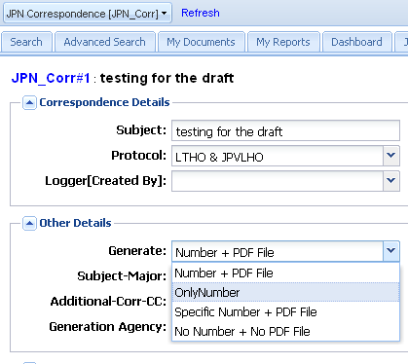

|  |  |  |
| --- | --- | --- |
| **S.No** | **Option Value** | **Description** |
| 1 | Number + Pdf File | To be used as default, tBits will generate both the correspondence number and associated pdf file |
| 2 | Only Number | To be used when the correspondence Category is selected as Email. Only number is generated but No pdf file is generated. The method can also be used for blocking the number and generating the correspondence outside the tBits system and then upload the scanned copy of the correspondence into the tBits at a later date. |
| 3 | Specific Number + PDF File | tBits generates a correspondence file with prespecified number. To be used for import of data, or regularization of the system if the letter has gone from outside the tBits. This would be a preferred option by the external agencies would be using the system as an interfacing mechanism but would continue to follow their existing in-house system for the creation of the correspondences. |
| 4 | No Number + No PDF File | This is an option to be selected when you are putting in a historical data and where you are specifying all the metadata attributes including the correspondence number and no file is to be generated. This option would be used when you close a correspondence thread by marking the status as "Closed" or trying to update a correspondence record for a response received via paper or alike.  The option will be useful for external agencies who would want to put their correspondences into the system along with the number but would not be interested in creating the pdf or the number using the tBits.  This method would also be used when the IMP Team updates the system on behalf of their counterpart incase they receive hard copy of the correspondences. |