

Report submitted to
School of Electrical and Electronics Engineering
Department of Electronics and Communication
Ramdeobaba University, Nagpur
Session 2025-26
Computer Communication Networks Lab – [24EE05PR0403]
IV Semester Section: A
Batch : A2

TOPIC: Aeronautical Telecommunications Network Using Cisco Packet Tracer

Submitted By :
Name | Roll no. | Signature
Achyut Bhosale | 19
Rachit Sanadya | 31

Guide Name: Prof. Puja S. Agrawal
No. | Title | Page No.
1 | Introduction | 3
2 | Objectives of the project | 3-4
3 | Important Concepts | 4-5
4 | Configuration of Major Components Used | 6-7
5 | Working of Project | 8-9
6 | Simulation Result & Conclusion | 10-13
7 | Future Scope | 13
8 | References | 13
TABLE OF CONTENTS

1.Introduction
The Aeronautical Telecommunications Network (ATN) is a global communication system designed to support the exchange of digital data between aircraft and ground-based systems such as air traffic control (ATC) and airport authorities. It plays a vital role in modern aviation by enabling efficient, reliable, and secure communication necessary for safe air traffic management.
With the rapid growth of air traffic, traditional voice-based communication systems became insufficient to handle the increasing demand for accurate and timely information exchange. To overcome these limitations, ATN was developed as a data communication network that uses standardized protocols to transmit messages related to flight operations, navigation, and control.
ATN supports various types of communication, including controller–pilot data link communication (CPDLC), automatic dependent surveillance (ADS), and other air traffic services. It ensures seamless connectivity between aircraft and ground stations, even in remote and oceanic regions, by utilizing multiple communication technologies such as VHF data links and satellite communication.
In this project, the concept of the Aeronautical Telecommunications Network is simulated using Cisco Packet Tracer. The network consists of routers representing ATC and ground stations, wireless devices representing aircraft, and servers for data management. By implementing IP addressing and routing techniques, the project demonstrates how communication is established between aircraft and ground systems.
Thus, ATN forms the backbone of modern aviation communication systems, enhancing safety, efficiency, and coordination in global air traffic operations.
2. Objectives of the project
The primary objectives of this Aeronautical Telecommunications Network are:
- To understand the working of Aeronautical Telecommunication Networks (ATN): Analyze communication between aircraft, Air Traffic Control (ATC), and ground stations.
- To simulate real-world aviation communication using Cisco Packet Tracer: To simulate real-world aviation communication using Cisco Packet Tracer:
- To design an efficient network topology: Create a structured architecture connecting wireless and wired components.
- To implement proper IP addressing scheme: Assign unique IP addresses to all devices in the network.
- To understand subnetting concepts: Divide the network into logical segments for better management.
- To configure routing between networks: Enable communication using static routing techniques.
- To implement network security using firewall (ASA): Protect internal network from unauthorized access.
- To demonstrate wireless communication: Simulate aircraft communication using wireless router/access point.
- To test network connectivity using ping and troubleshooting tools: Verify successful communication between all devices.
- To gain practical knowledge of network configuration: Understand real-time configuration of routers, switches, and firewalls.
3. Important Concepts
3.1 Cisco Packet Tracer ATN Components
Component | Cisco PT Device | Function
Aircraft System | Laptop-PT | Represents aircraft communication unit (wireless data transmission)
Wireless Communication | WRT300N Wireless Router | Provides wireless connectivity between aircraft and ground network
ATC Router | ISR4331 Router | Manages routing and communication between different networks
Firewall | ASA 5505 | Ensures network security by filtering and controlling traffic
Multilayer Switch | 3560-24PS Switch | Connects multiple devices and manages LAN communication
Ground Workstations | PC-PT | Represents ATC staff systems accessing the network
Server | Server-PT | Stores flight data and provides network services
Printer | Printer-PT | Used for printing reports and communication logs
LAN Connection | Ethernet (Fast/Gigabit) | Connects devices within the local network
WAN Connection | Gigabit Ethernet | Connects router and firewall for external communication
IP Addressing | IPv4 Addressing | Enables communication between devices using unique IPs
Routing Method | Static Routing | Controls packet forwarding between networks

3.2 Network Communication Logic
The Network Communication Logic of this Aeronautical Telecommunication Network (ATN) project describes how data flows between different components such as aircraft, Air Traffic Control (ATC), and ground systems.
In this system, communication begins from the aircraft (laptops) which are connected wirelessly through the wireless router. The wireless router acts as an access point and forwards the data to the multilayer switch, which serves as the central device in the local network.
The switch then sends the data to the ASA firewall, which ensures secure communication by filtering and controlling incoming and outgoing traffic. After passing through the firewall, the data is forwarded to the core router (ISR4331), which handles routing between networks.
The router directs the data to the appropriate destination, such as other ground systems or external networks. Within the local network, devices like PCs, servers, and printers communicate through the switch using IP addressing.
The communication is enabled using IPv4 addressing and static routing, ensuring that each device can correctly send and receive data. The firewall adds a layer of security, while the wireless router enables aircraft-to-ground communication.
Thus, the overall communication flow can be summarized as:
Aircraft (Laptop) → Wireless Router → Switch → Firewall → Router → Destination
3.3 Communication Protocols
In this Aeronautical Telecommunication Network (ATN) project, various communication protocols are used to enable reliable and efficient data transfer between network devices.
The primary protocol used is the Internet Protocol (IP), specifically IPv4, which provides logical addressing to all devices in the network. Each device such as PCs, servers, routers, and wireless devices is assigned a unique IP address to ensure proper communication.
The Transmission Control Protocol (TCP) is used to ensure reliable data transmission. It establishes a connection between sender and receiver, ensures data delivery, and handles error checking. For faster communication where reliability is less critical, the User Datagram Protocol (UDP) may also be used.
The Address Resolution Protocol (ARP) is used to map IP addresses to physical MAC addresses within the local network. This helps devices communicate correctly over Ethernet.
The Internet Control Message Protocol (ICMP) is used for network diagnostics and testing. In this project, ICMP is used through the ping command to verify connectivity between devices.
The network also uses Ethernet protocol for wired communication within the LAN, and Wi-Fi (IEEE 802.11) for wireless communication between aircraft (laptops) and the wireless router.
Routing between networks is achieved using static routing, which defines fixed paths for data transmission.
4. Configuration of Major Components Used
4.1 ATC Router Configuration
The ATC Router (ISR4331) is responsible for managing communication between the internal network and external network.
- Configured GigabitEthernet interface:
  - G0/0/0 → IP Address: 10.0.0.2/24 (Connected to ASA Firewall)
- Enabled the interface using:
  - no shutdown
The router forwards data between networks and ensures proper communication in the system.
4.2 ASA Firewall Configuration
The ASA 5505 firewall provides security by controlling and filtering traffic between internal and external networks.
- Configured VLAN interfaces:
  - VLAN 1 (Inside) → 192.168.1.1/24
  - VLAN 2 (Outside) → 10.0.0.1/24
- Assigned ports:
  - Ethernet0/0 → Outside
  - Ethernet0/1 → Inside
- Set security levels:
  - Inside → 100
  - Outside → 0
- Configured default routing:
  - Route to external network via 10.0.0.2
4.3 Wireless Router Configuration
The wireless router (WRT300N) enables wireless communication for aircraft systems.
- Router IP Address: 192.168.1.5
- Subnet Mask: 255.255.255.0
- Default Gateway: 192.168.1.1
- DHCP: Disabled
- Connected laptops (aircraft devices) wirelessly
- Ensured all devices are in the same subnet (192.168.1.0/24)
4.4 PC Configuration (Ground Systems)
Ground PCs represent ATC operators and airport systems.
- Assigned IP addresses:
  - PC0 → 192.168.1.2
  - PC1 → 192.168.1.3
  - PC2 → 192.168.1.4
- Subnet Mask: 255.255.255.0
- Default Gateway: 192.168.1.1
4.5 Server Configuration
The server provides services such as flight data storage and communication.
- IP Address: 192.168.1.10
- Subnet Mask: 255.255.255.0
- Default Gateway: 192.168.1.1
4.6 Printer Configuration
The printer is used for printing reports and communication logs.
- IP Address: 192.168.1.20
- Subnet Mask: 255.255.255.0
- Default Gateway: 192.168.1.1
4.7 Laptop Configuration (Aircraft Systems)
Laptops simulate aircraft communication systems.
- Assigned IP addresses:
  - Laptop0 → 192.168.1.6
  - Laptop1 → 192.168.1.7
- Subnet Mask: 255.255.255.0
- Default Gateway: 192.168.1.1
- Connected wirelessly via wireless router

5. Working of Project
5.1 System Architecture Flowchart
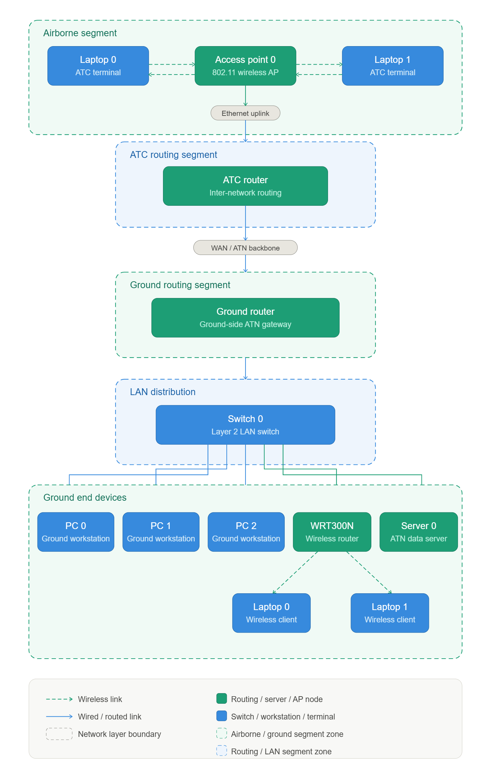
5.2 Operational Flow of Aeronautical Telecommunications Network (ATN)
The operational flow of the Aeronautical Telecommunications Network (ATN) describes the complete sequence of data communication between aircraft, Air Traffic Control (ATC), and ground systems, ensuring secure and efficient transmission.
- Aircraft Data Generation
The aircraft systems (represented by laptops) generate communication data such as flight status, navigation details, and request messages for ATC.
- Wireless Communication Establishment
The generated data is transmitted wirelessly using Wi-Fi (IEEE 802.11 protocol) to the wireless router, which acts as an access point for aircraft communication.
- Data Aggregation at Multilayer Switch
The wireless router forwards the data to the multilayer switch (3560), which acts as a central device for managing and forwarding data within the local network.
- Security Enforcement at ASA Firewall
The switch sends the data to the ASA Firewall, where advanced security policies are applied.
The firewall filters traffic based on security levels (inside: 100, outside: 0) and ensures that only authorized packets are allowed.
- Routing Decision at ATC Router
The secured data is forwarded to the ATC Router (ISR4331).
The router analyzes the destination IP address and makes routing decisions to forward the data correctly.
- Controlled Data Flow Between Networks The router ensures proper data flow between internal and external networks using configured interfaces and routing logic.
- Delivery to Ground Systems The data is transmitted back through the firewall and switch to reach the intended destination devices such as ground PCs, server, or printer.
- Data Processing and Service Response The destination system processes the received data.
For example, the server may provide flight data services, and PCs may display ATC information.
- Return Communication Path
The response is transmitted back through the same secure path:
Ground Device → Switch → Firewall → Router → Wireless Router → Aircraft
- Network Verification and Monitoring
The communication is verified using ICMP (ping) commands to ensure successful packet delivery.
This step helps in troubleshooting and validating network
5.3 Sample Data Flow of ATN
A sample data flow demonstrates how data is transmitted between aircraft and ground systems.
For example, a laptop (aircraft) sends a ping request to the server:
192.168.1.6 → 192.168.1.10
The data flows through the following path:
Aircraft → Wireless Router → Switch → Firewall → Router → Server
The server processes the request and sends a reply back through the same path.
The communication is successfully verified using ping with 0% packet loss, indicating proper network functionality.
6. Simulation Result & Conclusion
6.1 Simulation
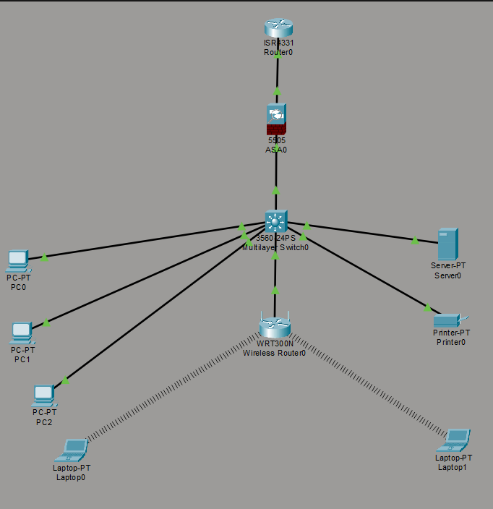

Results
Performance Metrics:
Parameter | Observed in Project | Critical Condition | Status
Connectivity | All devices successfully connected | Link down / no connectivity | Working
Packet Delivery | 100% success (0% packet loss) | Packet loss > 0% | Stable
Latency | < 1 ms (observed in ping) | High delay (>100 ms) | Low
Routing | Correct communication via router & ASA | No route / incorrect routing | Proper
Wireless Signal | Laptops connected successfully | Disconnected / weak signal | Strong
Server Response | Immediate reply from server | No response / timeout | Fast
Network Availability | Continuous during simulation | Network failure | Active

Key Observations:
- All network devices such as PCs, server, wireless router, switch, firewall, and router were successfully connected and configured.
- End-to-end connectivity was verified using the ping command, and all devices responded successfully.
- The network achieved 0% packet loss, indicating reliable data transmission.
- The response time was very low (less than 1 ms), showing efficient communication.
- The ASA firewall successfully secured the network by controlling traffic between internal and external networks.
- Wireless communication between laptops (aircraft systems) and the network was successfully established.
- The router correctly forwarded packets, ensuring proper communication between all devices.
- The server responded instantly to requests, confirming proper service configuration.
Figure 1: Successful Ping Result
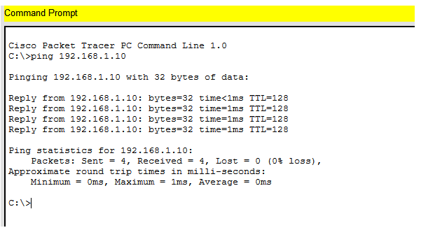
Figure 2: Router Interface Status
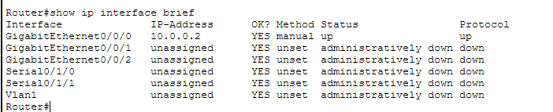

Figure 3: Simulation Mode Packet Flow
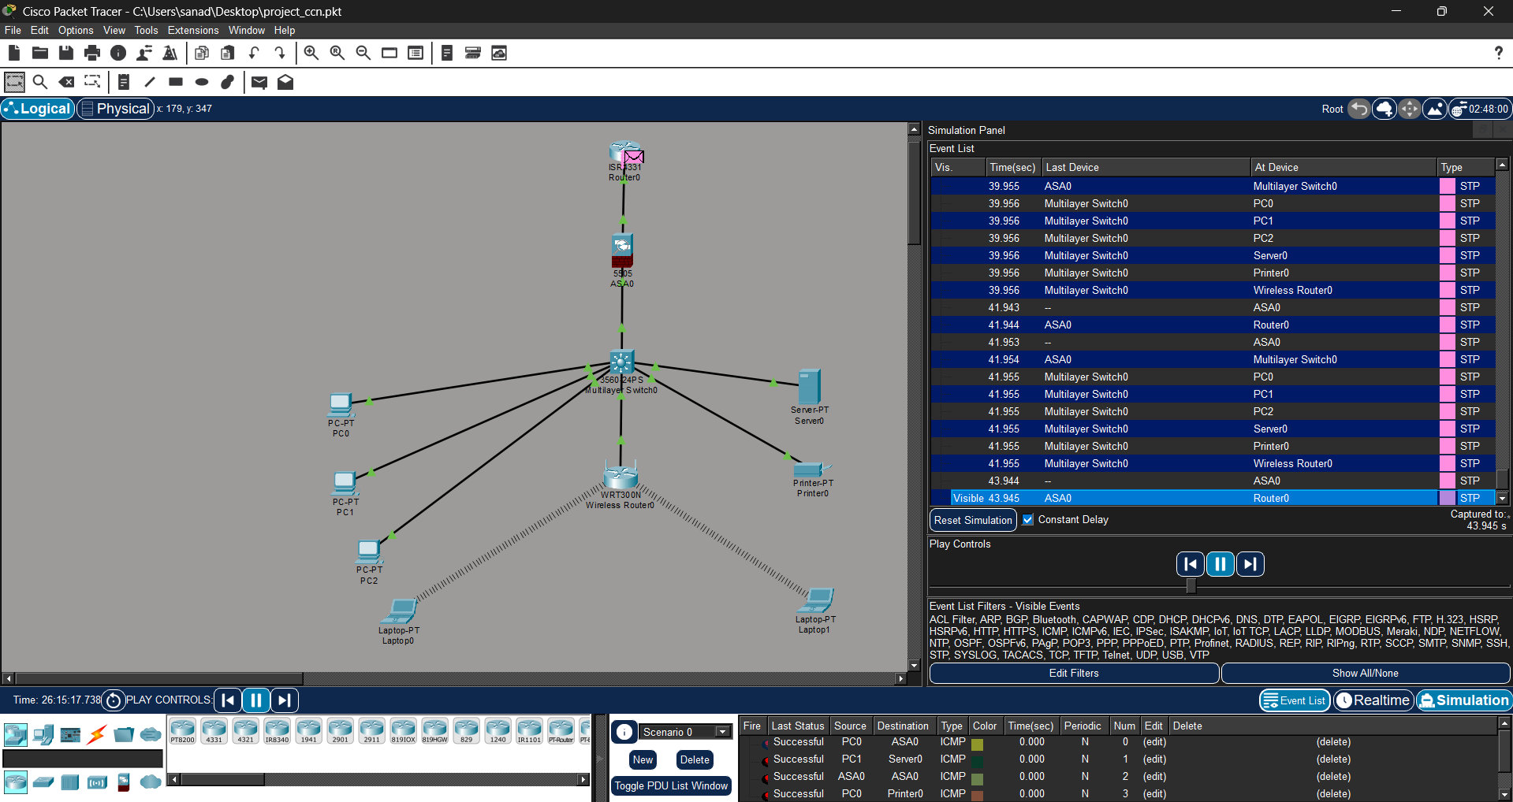

6.2 Conclusion
The Aeronautical Telecommunications Network (ATN) was successfully designed and implemented using Cisco Packet Tracer. The project demonstrated how communication between aircraft and ground systems can be achieved using fundamental networking concepts such as IP addressing, routing, and wireless communication.
The network enabled reliable data exchange between aircraft (laptops) and ground devices (PCs and server) through the ATC and ground routers. Static routing was effectively used to establish communication between different subnetworks. The successful ping results confirmed end-to-end connectivity with minimal delay and no significant packet loss.
This project highlights the importance of ATN in modern aviation, ensuring efficient, secure, and reliable communication. It also provided practical understanding of real-world networking concepts and their application in aviation systems.
7. Future Scope
- Implementation of Dynamic Routing Protocols
Replace static routing with protocols like OSPF or EIGRP for better scalability and automation.
- Integration with Real-Time Data Systems
Connect the network with real-time flight tracking and monitoring systems.
- Enhanced Security Mechanisms
Implement firewalls, encryption, and access control lists (ACLs) to improve network security.
- Use of Advanced Communication Technologies
Incorporate satellite communication (SATCOM) and advanced aviation data links.
- Scalability of Network
Expand the network to include multiple airports, aircraft, and control centers.
- Implementation of QoS (Quality of Service)
Prioritize critical aviation data to ensure faster and reliable communication.
- Cloud Integration
Store and manage aviation data using cloud-based services for better accessibility.
- Automation and AI Integration
Use AI for predictive analysis, traffic management, and fault detection.
8. References
- Forouzan, B. A., Data Communications and Networking, McGraw-Hill Education.
- Kurose, J. F., & Ross, K. W., Computer Networking: A Top-Down Approach, Pearson.
- ICAO Documents on Aeronautical Telecommunications Network (ATN).
- TN/IPS Standards for Aviation Communication..
- GeeksforGeeks – Networking Concepts.
- TutorialsPoint – Computer Networks Basics.

