Cloud Computing: The Backbone of Modern Business

In today's digital era, cloud computing is more than a tech buzzword - it's a strategic enabler for innovation, scalability, and cost efficiency. Here's a breakdown of what it really means, and why it matters.

# What is Cloud Computing?

The on-demand delivery of computing services - servers, storage, databases, networking, software - over the internet. No physical hardware. Just flexibility, speed, and scale.

# Core Cloud Service Models:

1. IaaS (Infrastructure as a Service)
   * Rent IT infrastructure - servers, virtual machines, storage, networks - from cloud providers. Example: AWS EC2, Microsoft Azure VM

Cut infrastructure costs by up to 30% (Gartner)

1. PaaS (Platform as a Service)
   * Provides tools to develop, test, and deploy applications without managing the underlying infrastructure. Example: Google App Engine, Heroku

Reduces development time by 50% on average (IDC)

1. SaaS (Software as a Service)
   * Access software applications via the web, without installation. Example: Salesforce, Microsoft 365, Dropbox

78% of enterprises use at least one SaaS app (Better Cloud)

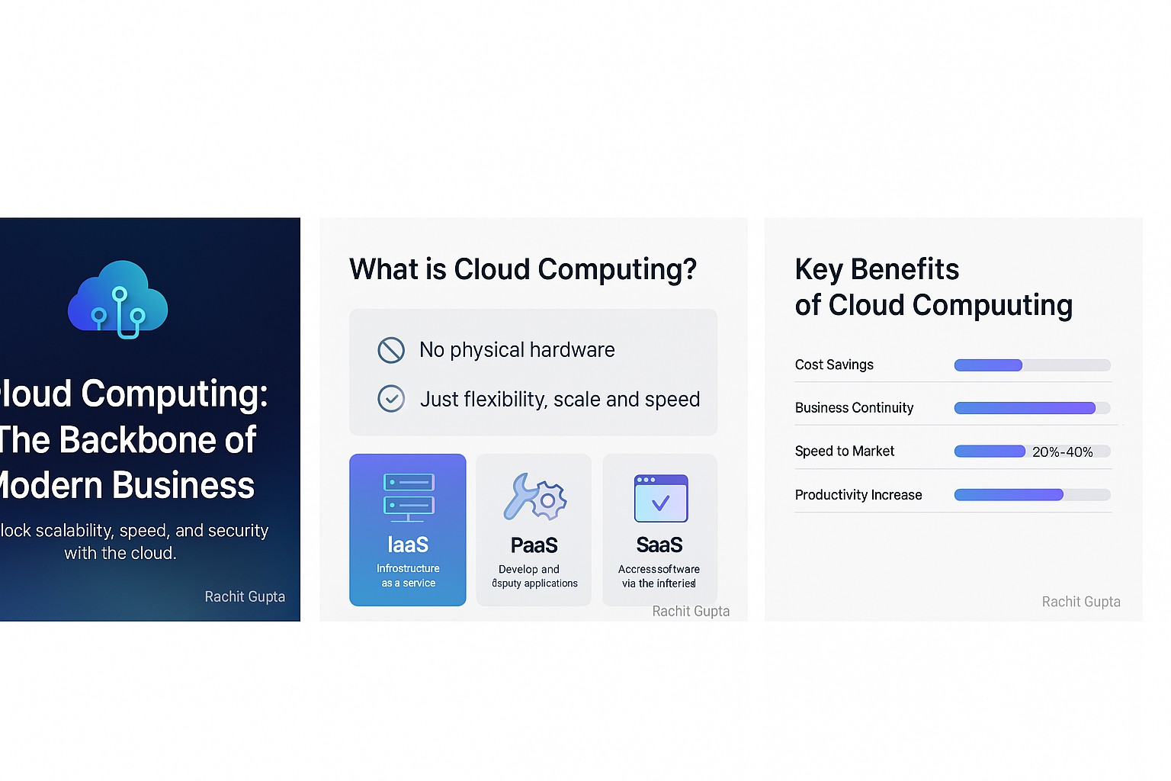

# Key Benefits of Cloud Computing:

* + Scalability: Scale up or down based on demand.
  + Cost Savings: Pay-as-you-go model. No CAPEX.
  + Business Continuity: Cloud backups improve recovery times by up to 96%.
  + Security: 94% of businesses reported an improvement in security after migrating to the cloud (Microsoft).
  + Speed to Market: Cloud adopters launch new products 20-40% faster.
  + Collaboration: Teams can work from anywhere. Boosts productivity by 30% (Forbes).

# The Future is Cloud:

By 2025, over 85% of businesses will have shifted to cloud-first strategies (Gartner). Are you ready to ride the wave?