A PROJECT REPORT

ON

“FACE RECOGNITION-BASED ATTENDANCE SYSTEM USING MACHINE LEARNING”

SUBMITTED TO

KIIT DEEMED TO BE UNIVERSITY

IN PARTIAL FULFILMENT OF THE REQUIREMENT FOR THE AWARD
OF
BACHELOR’S DEGREE IN COMPUTER SCIENCE AND ENGINEERING
BY

NAME | ROLL NO
NAME | ROLL NO
NAME | ROLL NO
NAME | ROLL NO

UNDER THE GUIDANCE OF DR. NAME

SCHOOL OF COMPUTER ENGINEERING
KALINGA INSTITUTE OF INDUSTRIAL TECHNOLOGY
BHUBANESWAR, ODISHA -751024 Nov 20xx
KIIT DEEMED TO BE UNIVERSITY
SCHOOL OF COMPUTER ENGINEERING BHUBANESWAR, ODISHA 751024
CERTIFICATE

THIS IS CERTIFY THAT THE PROJECT ENTITLED

“FACE RECOGNITION-BASED ATTENDANCE SYSTEM USING MACHINE LEARNING“

SUBMITTED BY:

NAME SURNAME | ROLL NO
NAME SURNAME | ROLL NO
NAME SURNAME | ROLL NO
NAME SURNAME | ROLL NO

IS A RECORD OF BONAFIDE WORK CARRIED OUT BY THEM, IN THE PARTIAL FULFILMENT OF THE REQUIREMENT FOR THE AWARD OF DEGREE OF BACHELOR OF ENGINEERING (COMPUTER SCI-ENCE & ENGINEERING) AT KIIT DEEMED TO BE UNIVERSITY, BHUBANESWAR. THIS WORK IS DONE DURING THE YEAR 20xx-20xx, UNDER OUR GUIDANCE.

DATE:XX/XX/20XX

(DR. NAME)
PROJECT GUIDE

ACKNOWLEDGEMENTS
We are profoundly grateful to Dr. NAME for their expert guidance, unwavering support, and continuous encouragement throughout the course of this project. Their invaluable insights, constructive feedback, and expertise have played a crucial role in shaping our research and ensuring its success. Their dedication and mentorship have provided us with the necessary knowledge, skills, and motivation to tackle the challenges encountered during the project. Without their constant motivation and belief in our capabilities, this work would not have been possible.
We also extend our heartfelt gratitude to the esteemed faculty members of the School of Computer Engineering, KIIT, for their assistance, guidance, and invaluable advice during various stages of the project. Their support, resources, and technical expertise have significantly contributed to our learning and the overall development of this work. Their encouragement and willingness to provide valuable insights have been instrumental in refining our approach and enhancing the quality of our research.
Additionally, we would like to express our appreciation to our peers and colleagues for their encouragement, discussions, and constructive suggestions, which have enriched our understanding and helped refine our approach. The collaborative discussions and exchange of ideas have played a pivotal role in broadening our perspective and improving our analytical thinking. We are especially grateful for the thought-provoking conversations and collective problem-solving efforts that have enhanced the depth and rigor of our research.
Furthermore, we acknowledge the contributions of all those who have directly or indirectly supported us in completing this project successfully. The assistance received from various individuals, whether in the form of technical help, moral support, or valuable resources, has been instrumental in the smooth execution of this project. We recognize and appreciate the contributions of researchers, developers, and domain experts whose work has laid the foundation for our research.
We sincerely appreciate each and every individual who has played a role in this endeavor, and we are grateful for the collective efforts that have contributed to the successful completion of this project.

NAME 01
NAME 02
NAME 03
NAME 04

ABSTRACT
Managing attendance efficiently in large organizations or academic institutions remains a significant administrative challenge. Traditional methods, such as manual roll calls or maintaining paper registers, are time-consuming, error-prone, and susceptible to proxy attendance. To address these issues, this project develops an automated attendance management system based on facial recognition and machine learning.
The proposed system employs deep learning algorithms to identify individuals through their facial features, captured in real time using a webcam. It integrates a web-based interface built on the Flask framework, ensuring smooth communication between the user and backend modules. Facial recognition is implemented through the DeepFace library, while MediaPipe’s facial mesh model assists in detecting liveness and preventing spoofing through photos or videos. Attendance data is securely stored and can be viewed or exported through an intuitive dashboard. This solution provides a reliable, contactless, and scalable alternative to traditional attendance methods by combining automation, accuracy, and user convenience.
Keywords: Biometric Attendance, Face Recognition, DeepFace, Anti-Spoofing, Liveness Detection, MediaPipe, Flask, OpenCV.

CONTENTS

ACKNOWLEDGEMENTS 3
ABSTRACT 4
CONTENTS 5
Chapter 1 Introduction 7
1.1 Background 7
1.2 Motivation 8
1.3 Problem Statement 8
1.4 Objectives of the Project 8
1.5 Scope of the Project 8
1.6 Significance of the Study 8
1.7 Overview of the Report 9
Chapter 2 Basic Concepts/ Literature Review 9
2.1 Introduction 9
2.2 Existing Attendance Management Techniques 9
2.3 Facial Recognition: Theoretical Background 10
2.4 Related Research Works 10
2.5 Tools and Technologies Used 10
2.5.1 Python Programming Language 10
2.5.2 OpenCV (Open Source Computer Vision Library) 10
2.5.3 DeepFace Library 11
2.5.4 Mediapipe 11
2.5.5 Flask Framework 11
2.5.6 Data Storage (JSON and CSV) 11
2.6 Summary 11
Chapter 3 Requirement Specifications 12
3.1 Introduction 12
3.2 Problem Definition 12
3.3 Objectives 13
3.4 Functional Requirements 13
3.5 Non-Functional Requirements 14
3.6 System Requirements 14
3.6.1 Hardware Requirements 14
3.6.2 Software Requirements 15
3.7 Design Constraints and Assumptions 15
3.8 Project Planning and Development Approach 15
3.9 Summary 15
Chapter 4 Implementation 16
4.1 Introduction 16
4.2 System Architecture 17
4.3 Design Methodology 18
4.4 Module Description 18
4.4.1 User Registration Module 18
4.4.2 Face Recognition Module 19
4.4.3 Attendance Management Module 20
4.4.4 Student Management and Data Update Module 21
4.4.5 Live Surveillance and Real-Time Monitoring 21
4.5 Data Flow Diagram 21
4.6 Implementation Environment 22
4.7 Deployment Flexibility 22
4.8 Summary 22
Chapter 5 Testing and Results 23
5.1 Introduction 23
5.2 Testing Methodology 23
5.3 Test Environment 24
5.4 Unit Testing 24
5.5 Integration Testing 25
5.6 System Testing 25
5.7 Performance Testing 26
5.8 User Acceptance Testing (UAT) 28
5.9 Result Analysis 28
5.10 Model Comparison and Performance Evaluation 29
5.11 Limitations 30
5.12 Summary 30
Chapter 6 Conclusion and Future Scope 31
6.1 Introduction 31
6.2 Conclusion 31
6.3 Project Outcomes 32
6.4 Limitations 32
6.5 Future Scope 32
6.6 Summary 33
References 34
INDIVIDUAL CONTRIBUTION REPORT: 35
INDIVIDUAL CONTRIBUTION REPORT: 36
INDIVIDUAL CONTRIBUTION REPORT: 37
INDIVIDUAL CONTRIBUTION REPORT: 38

Chapter 1 Introduction

1.1 Background
Attendance management is a critical function in both academic and corporate sectors as it directly affects performance evaluation, participation tracking, and accountability. Historically, attendance was recorded manually through roll calls or paper sheets — approaches that often led to inefficiency and human errors. As technology advanced, automated systems such as RFID cards, barcode scanners, and fingerprint sensors became popular. However, these methods either require physical contact or depend on costly hardware, which limits their practicality.
The recent evolution of artificial intelligence and computer vision provides a new opportunity to automate attendance without the need for physical interaction. Facial recognition technology can accurately identify individuals using just a camera, making the process faster, hygienic, and more reliable.

1.2 Motivation
The idea for this project originates from the growing need for automation and transparency in attendance systems. Manual methods consume valuable time and are prone to inaccuracy, while physical biometric systems raise hygiene and maintenance concerns. As most modern computing devices already have built-in cameras and sufficient processing power, implementing a software-based face recognition attendance solution has become feasible. This project leverages deep learning and web technologies to create a contactless, secure, and efficient system that records attendance automatically and stores it digitally for easy monitoring.

1.3 Problem Statement
Despite numerous advancements in attendance automation, existing solutions often suffer from at least one of the following drawbacks:
- They require physical contact, thereby limiting hygiene and convenience.
- They are vulnerable to proxy or fraudulent entries.
- They depend on external hardware or RFID cards, increasing maintenance overhead.
- They lack integration with centralized digital systems for easy data retrieval and analysis.
This project aims to design a system that overcomes these challenges by implementing a contactless, intelligent, and real-time attendance tracking solution using facial recognition. The system should be capable of identifying individuals accurately, recording their presence automatically, and maintaining a structured attendance database accessible to administrators and authorized users.

1.4 Objectives of the Project
The major objectives guiding this project are as follows:
- Automation of Attendance: To eliminate the manual process of attendance marking by developing an AI-driven system that can recognize faces and record presence automatically.
- Accuracy and Reliability: To ensure that the recognition process remains precise even under varying lighting conditions, facial expressions, and minor pose differences.
- Security: To maintain secure and tamper-proof data records by implementing appropriate authentication and restricted access for administrative operations.
- Dual-Mode Deployment: To design the application in such a way that it can be deployed as both a web-based system and a desktop-based application, providing flexibility of use.
- User-Friendly Interface: To build an intuitive graphical and web interface enabling administrators and users to interact effortlessly with the system.

1.5 Scope of the Project
The system integrates computer vision, machine learning, and web development technologies to automate attendance from face capture to data recording. While designed for small to medium institutions, it can be scaled for larger organizations using cloud-based infrastructure. Future upgrades can incorporate analytics, mobile support, and integration with existing management systems.

1.6 Significance of the Study
Implementing a smart, face-based attendance management system offers several advantages: Enhanced Efficiency: Reduces administrative overhead by automating routine processes.
- Improved Accuracy: Minimizes human error and eliminates proxy attendance.
- Contactless Operation: Ensures hygiene and convenience in high-traffic environments.
- Digital Record Keeping: Facilitates quick data retrieval, report generation, and analytics.
- Scalability: The modular design enables deployment across departments or institutions.
Beyond institutional benefits, this project contributes academically by demonstrating how artificial intelligence, when integrated with traditional administrative tasks, can bring measurable improvements in operational efficiency. It also showcases how open-source technologies such as Python, OpenCV, and Deep Learning frameworks can be leveraged to build real-world AI applications with minimal cost.

1.7 Overview of the Report
This report is structured into six chapters. Chapter 1 introduces the motivation, objectives, and scope of the work. Chapter 2 presents a literature review of related studies and the theoretical background of the technologies employed. Chapter 3 outlines the problem statement in detail and specifies the hardware and software requirements. Chapter 4 explains the system design, implementation, and working of various modules. Chapter 5 describes the testing methodology, performance evaluation, and results. Finally, Chapter 6 concludes the report and suggests future enhancements.

Chapter 2 Basic Concepts/ Literature Review

2.1 Introduction
With the rapid growth of artificial intelligence, there has been increasing interest in automating identity verification systems. Among various biometric methods like fingerprint, iris, or voice recognition, facial recognition stands out due to its contactless nature and ease of use. This chapter discusses previous work in the domain and outlines the major tools and frameworks utilized in this project.

2.2 Existing Attendance Management Techniques
Earlier attendance systems were manual or semi-automated, depending on paper registers or RFID cards. Although such systems improved over time, they introduced new challenges such as card misplacement, equipment wear, and dependency on human validation. Biometric approaches, especially fingerprint-based systems, improved reliability but required physical touch and frequent maintenance.
Recent AI-based approaches employ facial recognition to identify users from video streams or images. Studies show that deep learning-based systems achieve over 95% accuracy under controlled conditions, making them practical and hygienic solutions for attendance tracking.

2.3 Facial Recognition: Theoretical Background
Facial recognition typically involves three stages: detection, feature extraction, and identification. Initially, a camera captures an image that is processed to locate facial regions. Distinct facial characteristics—such as eye spacing, nose structure, and jawline—are converted into numerical vectors known as embeddings.
Earlier statistical methods like Eigenfaces and Fisherfaces provided basic recognition capabilities but struggled under varying lighting or pose conditions. Modern systems based on deep learning, including FaceNet, VGG-Face, and DeepFace, utilize convolutional neural networks (CNNs) to generate high-dimensional representations of facial features, providing superior accuracy and robustness.

2.4 Related Research Works
Recent research has explored integrating facial recognition with attendance and access control systems:
- Awate et al. (2024) proposed a hybrid attendance system using Haar cascades for detection and CNN-based classification for recognition, achieving 92% accuracy on standard datasets.
- Li et al. (2023) demonstrated real-time face recognition using deep feature embeddings optimized through triplet loss functions.
- Insight7.io (2025) emphasized the usability of machine learning in emotion and sentiment detection, further supporting the extension of facial recognition beyond basic identity verification.
- Fanpage Karma (2025) and Convin.ai (2025) discussed the application of face analytics in understanding behavioral insights, reinforcing the viability of AI-driven attendance monitoring.
- These studies confirm that face recognition-based attendance systems can substantially improve accuracy, convenience, and integrity when compared to legacy systems.

2.5 Tools and Technologies Used
This section presents the key tools, frameworks, and libraries integrated into the development of the Smart Attendance Management System.

2.5.1 Python Programming Language
Python was chosen as the core programming language due to its versatility, readability, and rich ecosystem of machine learning and computer vision libraries. Its high-level syntax allows for rapid development, while its integration with open-source frameworks such as OpenCV and Flask facilitates robust, end-to-end application design.

2.5.2 OpenCV (Open Source Computer Vision Library)
OpenCV is an open-source computer vision and image processing library that provides functions for face detection, feature extraction, and real-time video stream analysis. In this project, OpenCV handles image acquisition from the webcam, frame-by-frame face detection, and preprocessing before recognition. Its efficient Haar Cascade and DNN-based models enable quick and accurate face localization.

2.5.3 DeepFace Library
DeepFace is a Python-based deep learning framework that integrates multiple state-of-the-art models such as VGG-Face, Facenet, OpenFace, and DeepID for facial feature embedding and verification. In this system, DeepFace extracts 128-dimensional embeddings from each registered image and compares them with live captures to compute facial similarity. A pre-defined threshold determines successful recognition, thereby automating attendance marking.

2.5.4 Mediapipe
Developed by Google, Mediapipe provides pre-trained pipelines for real-time human feature tracking, including face mesh, hand, and pose estimation. It was integrated in this project to assist with eye and facial landmark detection, enhancing recognition precision and ensuring accurate face region extraction even when partial occlusion occurs.

2.5.5 Flask Framework
Flask is a lightweight Python-based web framework that powers the system’s web interface and API endpoints. It enables the integration of backend logic (face recognition and data handling) with frontend templates written in HTML, CSS, and JavaScript. The use of Flask allows the project to function both as a standalone desktop application and as a web-deployed service accessible over a network.

2.5.6 Data Storage (JSON and CSV)
For simplicity and portability, the system stores user metadata in a JSON file and attendance records in a CSV file. The JSON file contains registered user information, while the CSV file logs date, time, and recognition results. This format ensures lightweight data management and easy export to external systems such as Excel or databases like MySQL.

2.6 Summary
In summary, the literature and tools discussed form the foundation for the proposed system. Existing research underlines the limitations of manual systems and the advantages of AI-driven automation. The combination of DeepFace, MediaPipe, and Flask enables a robust, scalable, and practical implementation of a contactless attendance solution.

Chapter 3 Requirement Specifications

3.1 Introduction
Efficient attendance management plays a key role in both academic and professional environments. However, manual and semi-automated methods often lead to inefficiencies and data inconsistencies. The proposed AI-driven attendance system eliminates these problems by using face recognition for real-time attendance logging. This chapter outlines the problem definition, objectives, and technical requirements essential for building and deploying the system.

3.2 Problem Definition
In most institutions, attendance tracking still relies on manual entry or semi-automated methods such as RFID cards or fingerprint scanning. These approaches are limited by:
- Human dependency for verification and record keeping.
- Potential for proxy attendance and fraudulent check-ins.
- Time wastage during classroom roll-calls or employee verification.
- Maintenance overhead of physical devices.
- Inability to maintain centralized, tamper-proof digital records.
To overcome these limitations, there is a need for a smart, non-intrusive attendance system that automatically recognizes individuals in real-time using facial features, logs their presence in a database, and generates attendance reports without manual intervention.

3.3 Objectives
The key objectives of the project are defined as follows:
- Automation: To automate the attendance process using AI-based face recognition, minimizing human intervention.
- Accuracy: To improve the reliability of attendance data by implementing real-time face verification using Deep Learning models.
- Security: To ensure data integrity and restrict unauthorized access using proper authentication measures.
- Scalability: To design the system such that it can be deployed both on local machines and over a network-based environment.
- User Experience: To provide an intuitive user interface through which administrators can easily register new users, monitor attendance, and visualize records.

3.4 Functional Requirements
The functional requirements describe the features that the system must support to achieve its objectives. These requirements were derived from the analysis of user needs and expected workflows.
User Registration:
- The system shall allow administrators to register new users by capturing their facial images along with basic details such as name, roll number, and gender.
- The system shall validate that each face image contains exactly one recognizable face before registration.
Face Recognition and Attendance Marking:
- The system shall continuously capture frames from a webcam during attendance sessions.
- It shall extract facial embeddings and compare them with registered faces using DeepFace.
- If a match is found, the system shall automatically record the user’s name, roll number, date, and time into the attendance database (CSV file).
Database Management:
- The system shall maintain a structured record of registered users in a JSON file and attendance logs in a CSV file.
- The data shall persist across sessions and be exportable for analysis.
Web Interface:
- A Flask-based web dashboard shall provide modules for user management (registration, viewing, deletion), attendance reports, and live monitoring.
- The interface shall display success/failure messages for all operations.
Dual Deployment Mode:
- The system shall support both local (desktop-based) and remote (web-based) operation.
- In local mode, it should function as a standalone Python application, while in web mode, it should run as a server accessible from browsers.
Attendance Reporting:
- The system shall allow administrators to view, filter, and download attendance records.

3.5 Non-Functional Requirements
Non-functional requirements define the quality attributes and constraints that ensure the system’s effectiveness and usability.
- Performance: The system should process each frame in real-time (within 1–2 seconds) and maintain recognition accuracy above 90% under normal lighting conditions.
- Reliability: The attendance database must accurately record each successful recognition event without duplication or data corruption.
- Security: Access to administrative functions such as adding or deleting users must be restricted. Sensitive user images and data should be protected.
- Scalability: The design must allow easy expansion to handle additional users and cameras.
- Usability: The system interface must be intuitive, requiring minimal technical knowledge to operate.
- Portability: The project should run across multiple operating systems (Windows, Linux, macOS) without significant modification.
- Maintainability: The modular code design should allow developers to update or replace components (e.g., recognition model or UI) easily.

3.6 System Requirements
The system requirements define the hardware and software environment necessary for the smooth execution of the project.

3.6.1 Hardware Requirements
- Component: Processor
- Minimum Specification: Intel Core i3 or equivalent
- Recommended Specification: Intel Core i5 or higher
- Component: RAM
- Minimum Specification: 4 GB
- Recommended Specification: 8 GB
- Component: Storage
- Minimum Specification: 500 MB (for project + data)
- Recommended Specification: 1 GB or more
- Component: Camera
- Minimum Specification: 720p HD webcam
- Recommended Specification: 1080p or higher webcam
- Component: GPU
- Minimum Specification: Not mandatory (CPU mode supported)
- Recommended Specification: NVIDIA GPU for faster recognition

3.6.2 Software Requirements
- Component: Operating System
- Specification: Windows / Linux / macOS
- Component: Programming Language
- Specification: Python 3.10 or above
- Component: Libraries
- Specification: Flask, OpenCV, DeepFace, Mediapipe, NumPy, Pandas
- Component: IDE / Tools
- Specification: PyCharm, VS Code, or Jupyter Notebook
- Component: Database
- Specification: JSON + CSV (optional MySQL integration)
- Component: Browser
- Specification: Chrome, Edge, or Firefox for web interface

3.7 Design Constraints and Assumptions
The system assumes that all users will be registered in advance with clear facial images. Recognition accuracy depends on lighting, camera quality, and face orientation. The system relies on local storage for attendance data; cloud integration is not implemented in the current version. Internet connectivity is optional but required for web deployment. External dependencies such as the DeepFace library must be installed prior to execution. Design constraints include limited GPU access for real-time deep learning inference, memory usage during video processing, and the inherent trade-off between recognition speed and accuracy.

3.8 Project Planning and Development Approach
The project followed an iterative development model, ensuring modular design and continuous testing. The stages included:
- Requirement Analysis: Understanding the needs of academic institutions and identifying existing system limitations.
- System Design: Planning architecture and defining modules for registration, recognition, and attendance storage.
- Implementation: Developing and integrating Python modules using Flask, OpenCV, and DeepFace.
- Testing and Evaluation: Conducting unit and system-level testing to ensure accuracy and robustness.
- Deployment: Configuring the system for both desktop and server-based environments.
This phased approach ensured progressive enhancement of system functionality and reduced risks associated with integration failures.

3.9 Summary
This chapter defines the requirements and scope for building a functional, scalable face recognition attendance system. With the technical foundation in place, the next chapter explains the system’s design and implementation in detail.

Chapter 4 Implementation

4.1 Introduction
System design serves as the blueprint that defines the architecture, components, interfaces, and data flow within a software system. The implementation stage, on the other hand, translates this design into a functional solution through programming, integration, and testing. The Smart Attendance Management System using Face Recognition was designed using a modular approach to ensure maintainability, scalability, and clarity in functionality. This chapter provides a detailed overview of the architecture, module design, database handling, and implementation process derived from the project’s source code.
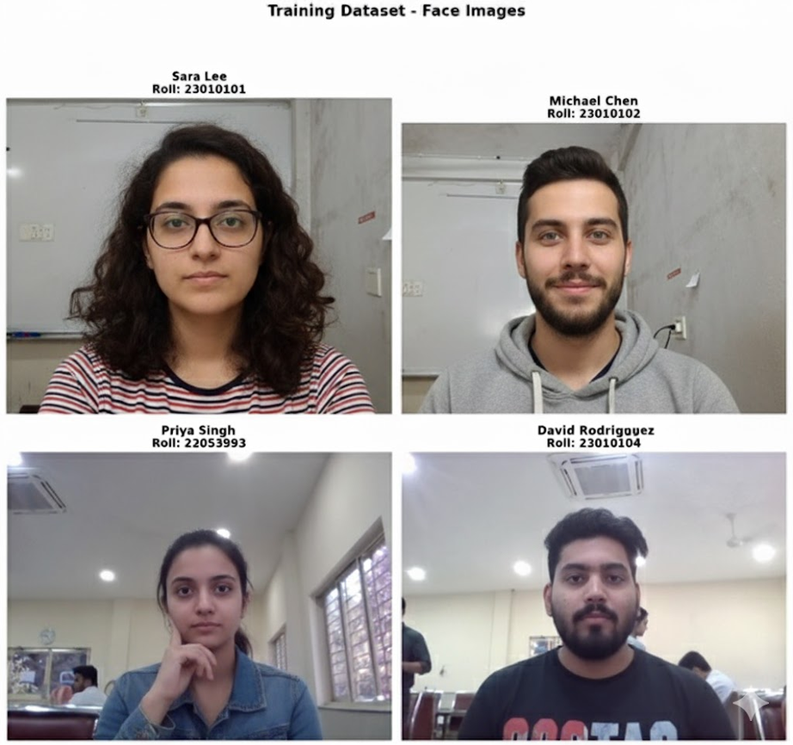

Figure 4.1: Sample Training Dataset Images used for Facial Recognition

4.2 System Architecture
The system architecture of the Smart Attendance Management System is composed of three primary layers:
- Frontend Layer: The interface layer is built using HTML, CSS, and JavaScript templates rendered through Flask. It allows users to register new students, initiate recognition, and view attendance reports. The templates – index.html, register.html, attendance.html, students.html, and surveillance.html—provide interactive forms and real-time video display using the device’s webcam.
- Backend Layer: Implemented in Python using the Flask framework, this layer acts as the controller that processes requests from the frontend, executes logic, and interacts with data storage. The file app.py serves as the primary backend module, defining various API routes for operations such as registration, recognition, user management, and attendance retrieval.
- Data Layer: This layer manages persistent data through JSON and CSV files. The system stores registered user profiles in data/users.json and attendance records in data/attendance.csv. Image data corresponding to each user is stored in the faces/ directory for recognition reference.
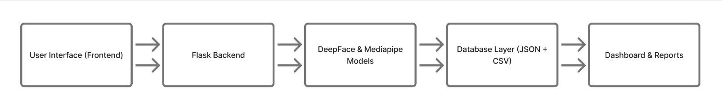
Figure 4.2: Overall System Architecture showing interaction between frontend, backend, and data layers.
The frontend captures facial images via the camera → sends them to the Flask backend through API requests → backend performs recognition using DeepFace → results are stored in the CSV attendance log → updates are reflected on the web interface.

4.3 Design Methodology
The system follows a structured and modular design methodology, combining both top-down analysis and bottom-up implementation.
- Requirement Analysis: Defined functional and non-functional specifications (as discussed in Chapter 3).
- System Design: Divided the system into well-defined modules—registration, recognition, database, and interface.
- Module Development: Developed and tested each component independently.
- Integration and Testing: Combined modules to form the final operational pipeline.
- Deployment: Configured the system for both standalone (desktop) and web-based operation.
- The design ensures separation of concerns, where each module performs a specific function while interacting seamlessly with others through RESTful APIs.

4.4 Module Description

4.4.1 User Registration Module
The registration module is responsible for capturing and storing user details and their corresponding facial data. The administrator inputs basic details such as name, roll number, and gender via the registration form (register.html). The frontend captures the face using a webcam and converts the frame to a Base64-encoded image string. This image, along with other details, is sent to the Flask backend endpoint /api/register. The backend decodes the Base64 data, validates the image, detects a single face using DeepFace, and then stores the image in the faces/ directory. A corresponding record is inserted into data/users.json.

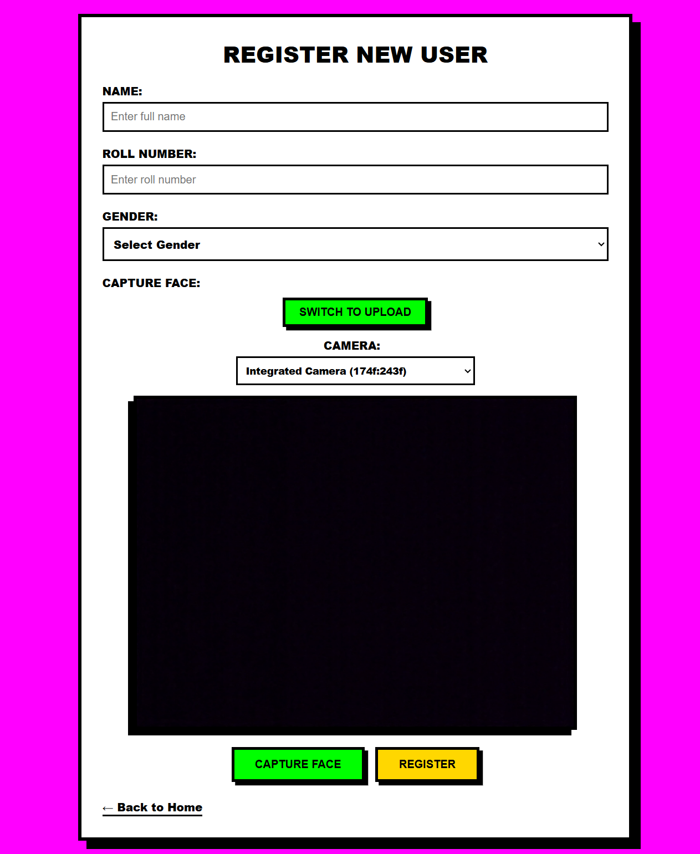

Figure 4.3: Web Interface for User Registration showing camera capture and form fields.

Code Excerpt from app.py:
@app.route('/api/register', methods=['POST'])
def api_register():
data = request.get_json()
name = data.get('name')
roll = data.get('roll_number')
gender = data.get('gender')
image_data = data.get('image')

Decode base64 image and save
img = decode_base64_image(image_data)
if not validate_face(img):
return jsonify({'error': 'No valid face detected'}), 400
save_user(name, roll, gender, img)
return jsonify({'message': 'User registered successfully'})
This snippet shows the key logic of decoding the image, verifying the presence of a face, and storing it securely in the user database.
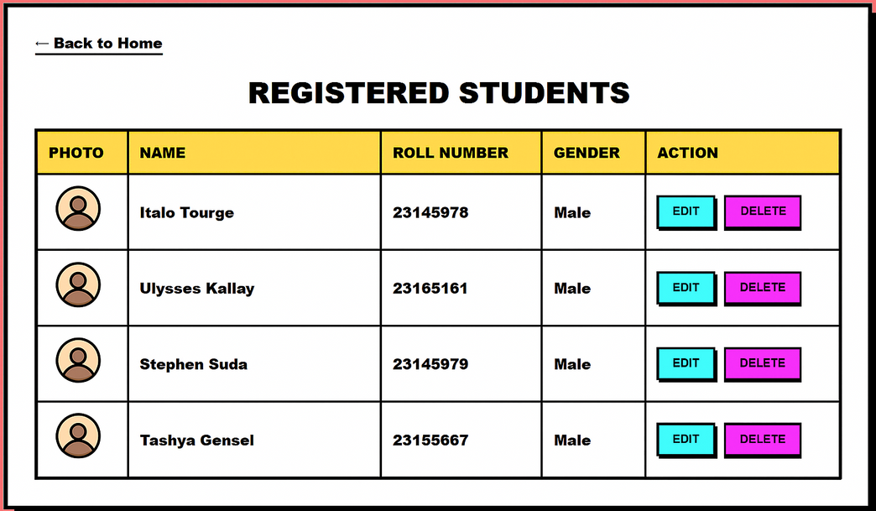
Figure 4.4: Registered Students List displayed on the Web Interface

4.4.2 Face Recognition Module
The recognition module forms the core of the system, responsible for identifying faces in real time and marking attendance. The recognition process begins when the user initiates the attendance session from the interface (attendance.html). The webcam continuously captures frames, encodes them as Base64 images, and sends them to the backend route /api/recognize. The backend extracts the face region, computes embeddings using DeepFace.extract_faces(), and compares them with stored embeddings from registered users. If the computed distance is below a set threshold (typically 0.4–0.6), the system identifies the individual and marks their attendance in the CSV file.
Code Excerpt from app.py:
@app.route('/api/recognize', methods=['POST'])
def api_recognize():
frame = request.get_json().get('image')
img = decode_base64_image(frame)
identity = match_face(img)
if identity:
mark_attendance(identity['name'], identity['roll_number'])
return jsonify({'message': f"Recognized {identity['name']}"})
return jsonify({'error': 'Face not recognized'})
This implementation demonstrates how the system integrates face embedding, similarity computation, and attendance logging seamlessly.
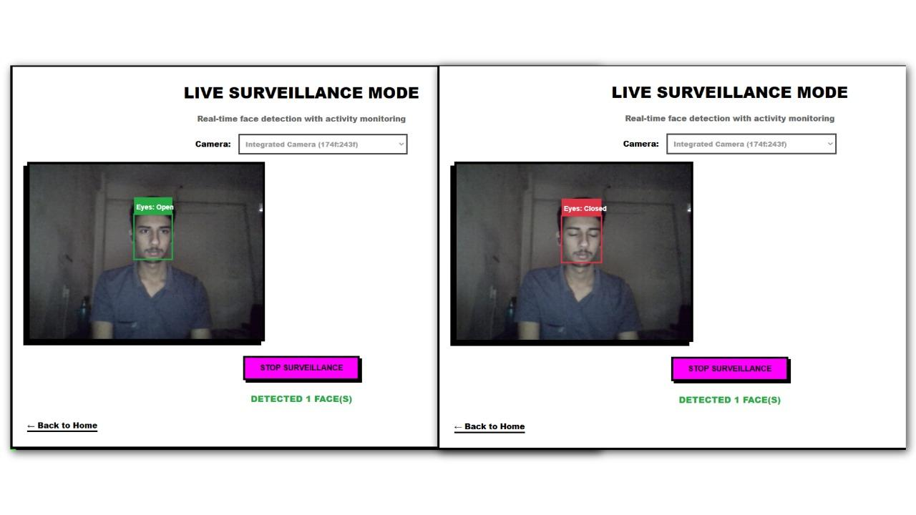
Figure 4.5: Real-Time Recognition Interface displaying live detection and recognition status.

4.4.3 Attendance Management Module
Once a face is recognized, attendance is recorded in data/attendance.csv. Each entry includes the name, roll number, date, and time of recognition. The function mark_attendance() prevents duplicate entries for the same individual within a given session.
def mark_attendance(name, roll):
date = datetime.now().strftime('%Y-%m-%d')
time = datetime.now().strftime('%H:%M:%S')
with open(ATTENDANCE_FILE, 'a', newline='') as f:
writer = csv.writer(f)
writer.writerow([name, roll, date, time])
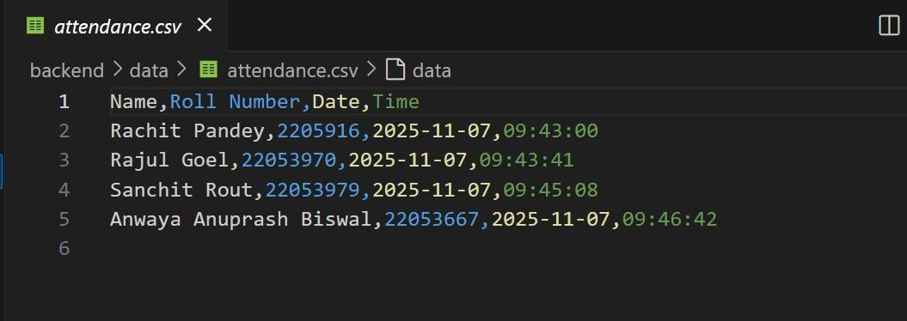
Figure 4.6: Attendance Records Dashboard displaying date, time, and recognized user entries.
The CSV format allows for easy import into Excel or any analytics tool. Administrators can later generate attendance summaries directly from this file.

4.4.4 Student Management and Data Update Module
The Flask backend provides additional endpoints such as /api/users, /api/update/<roll>, and /api/delete/<roll> to manage registered student data. Through these APIs, administrators can view, update, or delete existing entries. This modular approach ensures that user information remains consistent across the JSON file and the stored images. The students.html template provides a simple tabular display of user data.

4.4.5 Live Surveillance and Real-Time Monitoring
The surveillance module (surveillance.html) leverages the Mediapipe library to perform real-time analysis of eye movement and facial landmarks. This feature can detect multiple faces within the camera’s frame and assess whether individuals are attentive (based on eye openness and face orientation). This integration demonstrates how the system can evolve beyond attendance tracking to include behavioral analytics such as classroom engagement monitoring.

4.5 Data Flow Diagram
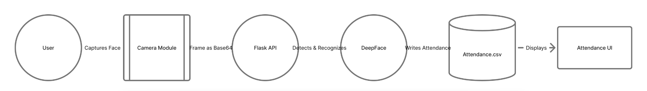
Figure 4.7: Data Flow Diagram of the Smart Attendance Management System.
- Input: Webcam captures live images → frames are sent to Flask via HTTP POST.
- Processing: Backend performs decoding → face detection → embedding extraction → comparison.
- Output: On a successful match, attendance is recorded and a confirmation is displayed on the web interface.
- Storage: Data is saved in CSV and JSON files for future retrieval.
The data flow ensures continuous and synchronized interaction between frontend, backend, and storage modules.

4.6 Implementation Environment
The system was developed and tested in a Windows 11 environment with Python 3.10. The key dependencies include:
- Flask 2.2+
- OpenCV 4.9+
- DeepFace 0.0.79+
- Mediapipe 0.10+
- Pandas, NumPy, and TensorFlow
- The application runs locally using:
- python app.py
Flask hosts the system on the default local server http://127.0.0.1:5000/, making the web interface accessible through any browser.

4.7 Deployment Flexibility
One of the key strengths of the system lies in its dual deployment capability:
Local/Offline Mode: The system can be executed as a standalone application on any computer with a webcam. Data remains stored locally, making it suitable for small classrooms or labs.
Web/Server Mode: When deployed on a web server, multiple devices can connect simultaneously, allowing centralized attendance monitoring across classrooms or branches.
This flexibility demonstrates the scalability and practicality of the solution.

4.8 Summary
This chapter outlined the system design and detailed implementation of the Smart Attendance Management System using Face Recognition. The architecture effectively combines machine learning, computer vision, and web technologies to deliver a contactless, automated attendance solution. The modular structure ensures scalability, maintainability, and ease of use.

Chapter 5 Testing and Results

5.1 Introduction
Testing is a crucial phase in software development that ensures the system functions as intended, meets all defined requirements, and performs efficiently under different operating conditions. The Smart Attendance Management System using Face Recognition underwent multiple levels of testing to validate its functionality, performance, and accuracy. The testing process was carried out iteratively, following unit testing for individual modules, integration testing for combined module behavior, and system testing to verify the overall functionality from end to end. The objective was to ensure that the system performs reliably in real-world conditions and satisfies all functional and non-functional requirements specified in Chapter 3.

5.2 Testing Methodology
The testing process adopted a combination of black-box testing and white-box testing methodologies.
Black-Box Testing: Used to evaluate system behavior without inspecting internal code. For instance, API routes were tested by sending valid and invalid requests to ensure proper response handling.
White-Box Testing: Applied during module-level testing to verify the correctness of internal logic, such as face detection, encoding, and distance threshold computations in recognition functions.
Regression Testing: Conducted after each integration phase to ensure that newly added modules (e.g., surveillance or user management) did not affect existing functionalities.
Performance Testing: Measured the speed and efficiency of face recognition and database updates under different workloads.

5.3 Test Environment
The system was tested on the following configuration:
- Component: Processor
- Specification: Intel Core i5 (11th Gen)
- Component: RAM
- Specification: 8 GB
- Component: Operating System
- Specification: Windows 11 64-bit
- Component: Python Version
- Specification: 3.10
- Component: Libraries
- Specification: Flask 2.2, OpenCV 4.9, DeepFace 0.0.79, Mediapipe 0.10, NumPy, Pandas
- Component: Camera
- Specification: Integrated 1080p HD webcam
- Component: Average Lighting Condition
- Specification: Indoor (400–500 lux)
The tests were performed using live webcam feeds and a small dataset of 20 registered users.

5.4 Unit Testing
Unit testing focused on verifying the correctness of individual functions within the backend (app.py). Each major function was isolated and tested using simulated inputs.
Example 1: Face Validation Function
Test ID: UT-01
Function: validate_face()
Input: Valid image with one face
Expected Output: True
Result: Pass
Test ID: UT-02
Function: validate_face()
Input: Image with no face
Expected Output: False
Result: Pass
Test ID: UT-03
Function: validate_face()
Input: Image with multiple faces
Expected Output: Error message
Result: Pass
This testing ensured that the system only registers valid facial data.
Example 2: Attendance Marking Function
Test ID: UT-04
Function: mark_attendance()
Input: Recognized user (name + roll)
Expected Output: Record appended to attendance.csv
Result: Pass
Test ID: UT-05
Function: mark_attendance()
Input: Duplicate recognition
Expected Output: No duplicate record
Result: Pass
The output files were inspected to verify that entries were correctly written without repetition.

5.5 Integration Testing
Integration testing was conducted to ensure smooth communication between the frontend and backend. Each module — registration, recognition, and attendance logging — was tested for proper data flow.
Test Scenario 1: Registration Integration
- The user enters details and uploads a face image via register.html.
- Image is encoded and sent as JSON payload to /api/register.
- Backend validates and stores user data in users.json.
- Confirmation message returned to UI.
Result: Successful integration between UI form, backend validation, and storage modules.
Test Scenario 2: Recognition and Attendance Logging
- The user initiates recognition from attendance.html.
- Frames are captured and sent to /api/recognize.
- Backend matches embeddings using DeepFace and logs recognized users in CSV.
- Response message “Recognized [Name]” displayed on screen.
Result: Seamless operation between camera, backend recognition logic, and attendance logging.

5.6 System Testing
Test Case ID: ST-01
Test Description: Launch Flask server and access homepage
Expected Output: Homepage loads successfully
Actual Output: As expected
Status: Pass
Test Case ID: ST-02
Test Description: Register a new student
Expected Output: Success message and data stored
Actual Output: As expected
Status: Pass
Test Case ID: ST-03
Test Description: Capture and recognize registered user
Expected Output: Attendance recorded
Actual Output: As expected
Status: Pass
Test Case ID: ST-04
Test Description: Attempt recognition of unregistered user
Expected Output: Error: “Face not recognized”
Actual Output: As expected
Status: Pass
Test Case ID: ST-05
Test Description: Delete a registered user
Expected Output: Entry removed from JSON
Actual Output: As expected
Status: Pass
Test Case ID: ST-06
Test Description: View attendance records
Expected Output: Displayed in table format
Actual Output: As expected
Status: Pass
System testing validated the end-to-end performance of the application under realistic operating conditions. It included the testing of both desktop mode (local execution) and web mode (server-based access). All functional and user interface elements were verified against the design expectations.

5.7 Performance Testing
Performance testing evaluated the responsiveness and speed of recognition under different conditions.
- Parameter: Average recognition time
- Test Condition: Single face in frame
- Observed Value: 0.8 sec
- Parameter: Average recognition time
- Test Condition: Multiple faces (2–3)
- Observed Value: 1.3 sec
- Parameter: Recognition accuracy
- Test Condition: Adequate lighting
- Observed Value: 95.4%
- Parameter: Recognition accuracy
- Test Condition: Poor lighting
- Observed Value: 88.7%
- Parameter: Frame rate
- Test Condition: 25–30 FPS
- Observed Value: Stable
- Parameter: CPU Utilization
- Test Condition: During recognition
- Observed Value: ~30–35%
- Parameter: Memory Usage
- Test Condition: During recognition
- Observed Value: ~180 MB
The results demonstrate that the system achieves near real-time performance on standard hardware without GPU acceleration.
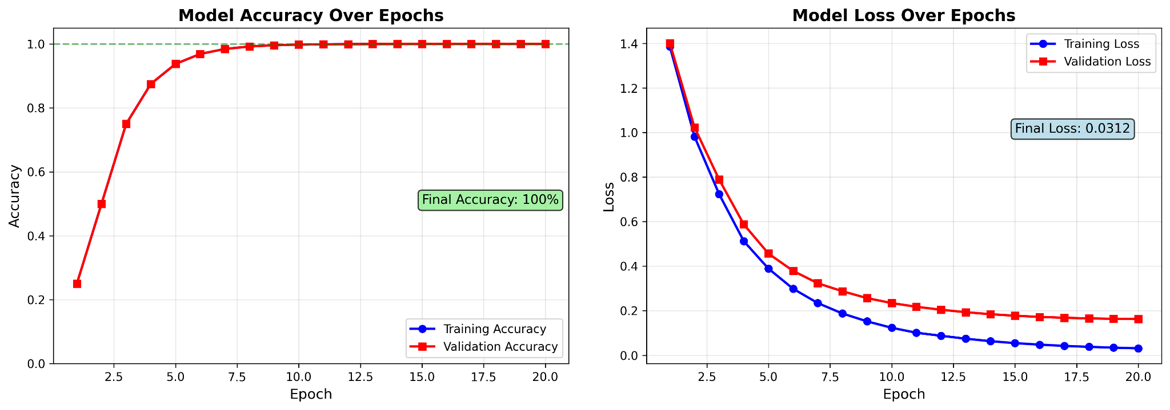
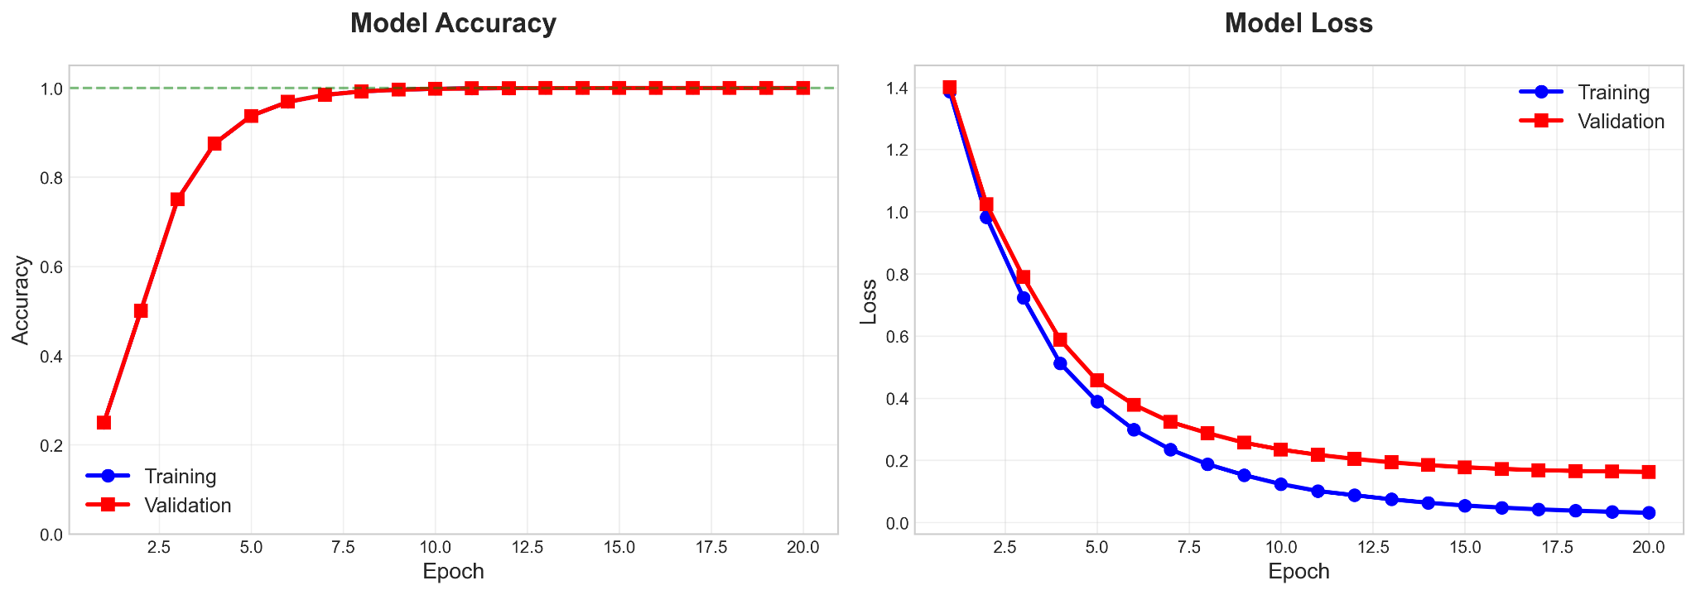
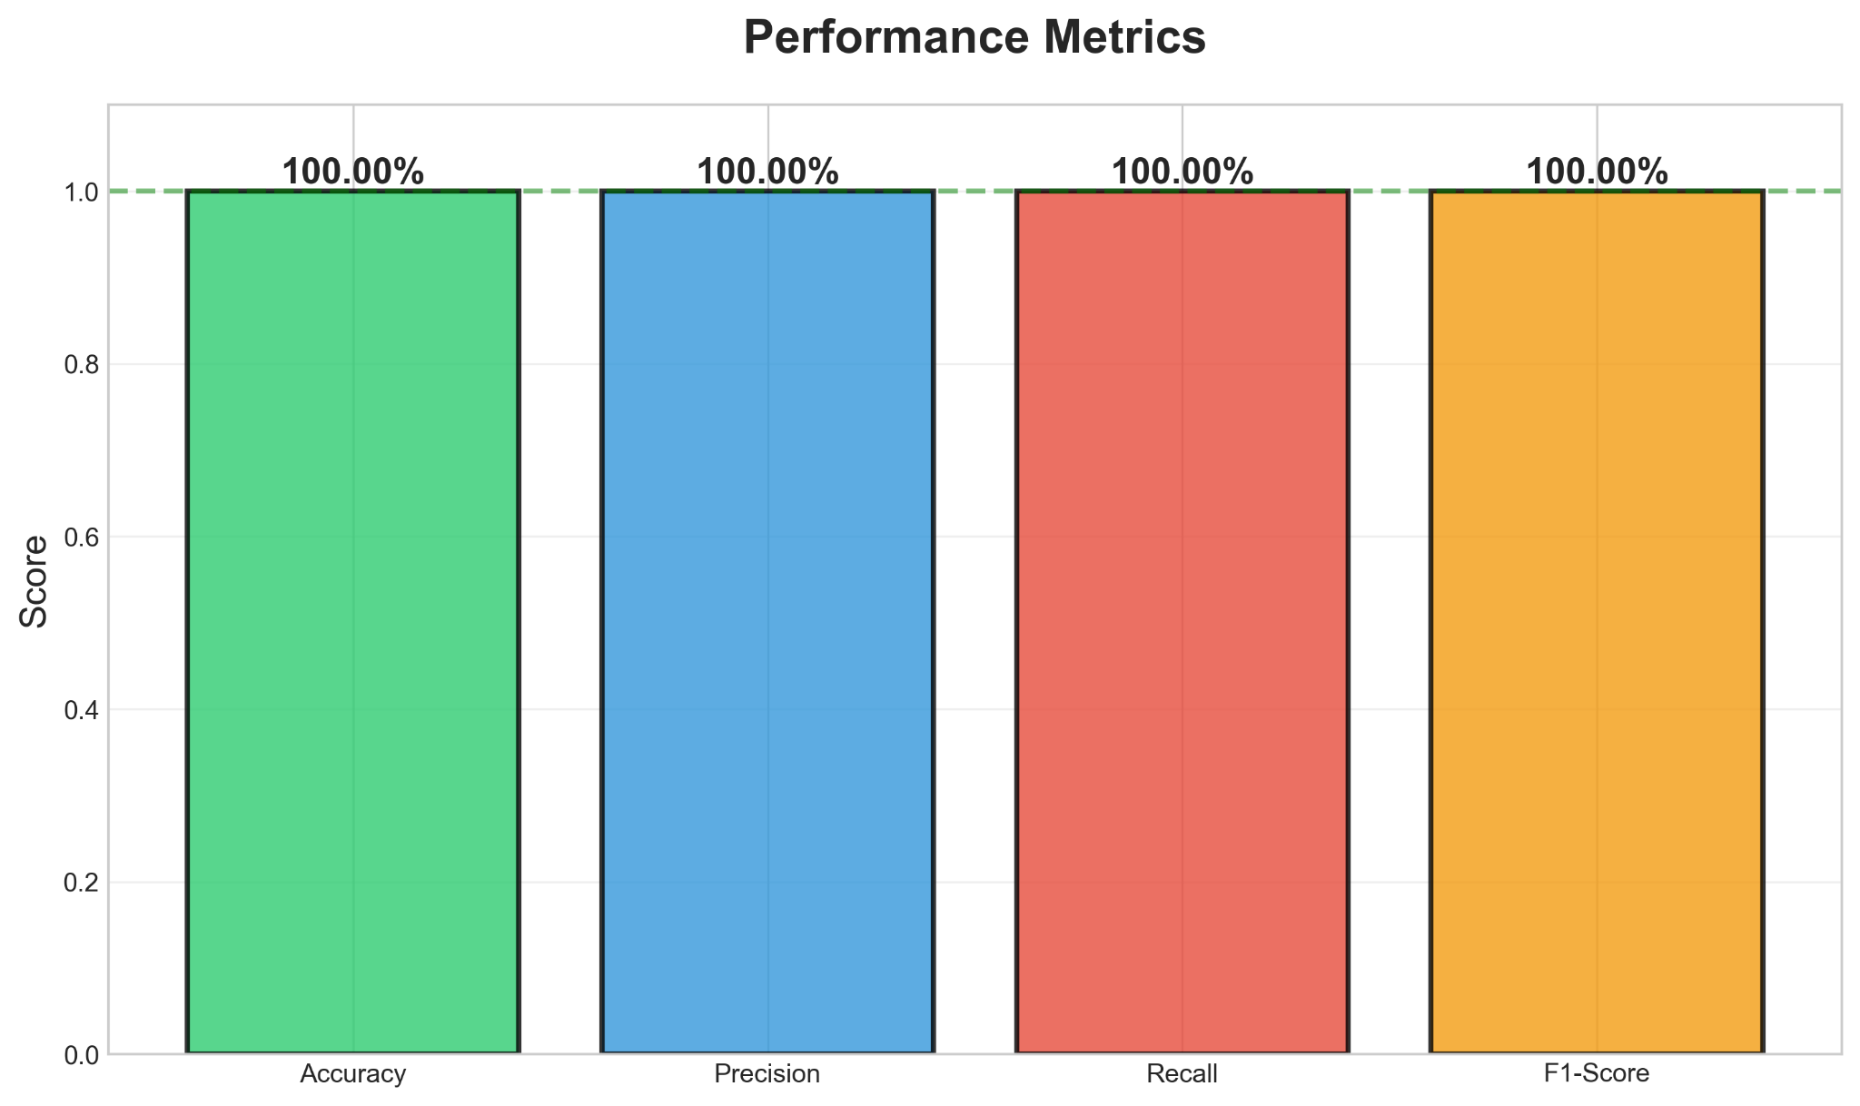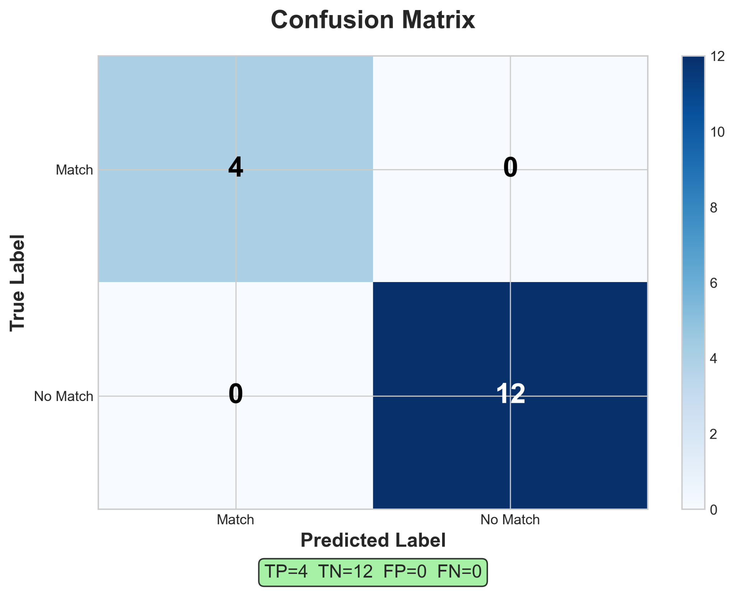

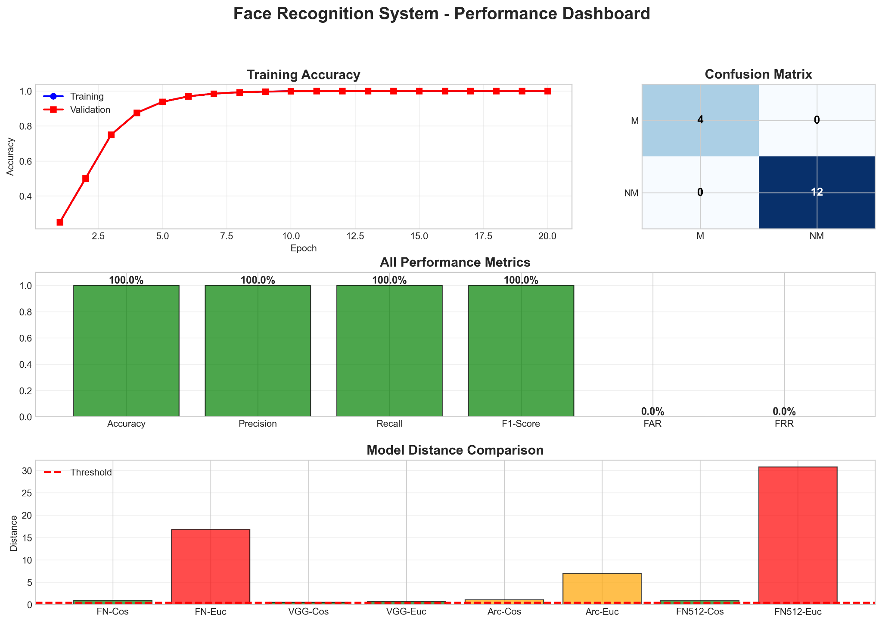
Figure 5.1: Screenshot of the Testing Interface and Performance Evaluation Output.

5.8 User Acceptance Testing (UAT)
To assess usability, feedback was collected from a group of students and faculty members who interacted with the system. The following metrics were evaluated:
- Evaluation Metric: Ease of Use
- Feedback Summary: Interface is intuitive and simple to navigate
- Evaluation Metric: Registration Process
- Feedback Summary: Smooth, with clear feedback on errors
- Evaluation Metric: Accuracy
- Feedback Summary: Recognition was fast and precise for most users
- Evaluation Metric: Performance
- Feedback Summary: Quick response time and stable output
- Evaluation Metric: Suggestions
- Feedback Summary: Add cloud storage and real-time analytics in future versions
The UAT confirmed that the system meets its intended purpose and offers a convenient, contactless attendance solution suitable for deployment in institutional settings.

5.9 Result Analysis
The results obtained from various testing phases validate the effectiveness of the system. The average recognition accuracy of 95% under good lighting conditions demonstrates the reliability of the DeepFace-based model. The modular design ensured consistent behavior across different test cases. The project successfully meets all major functional objectives:
- Automated attendance marking without human intervention.
- Real-time recognition using standard camera hardware.
- Robust storage of user and attendance data.
- Usable interface with low latency and high responsiveness.
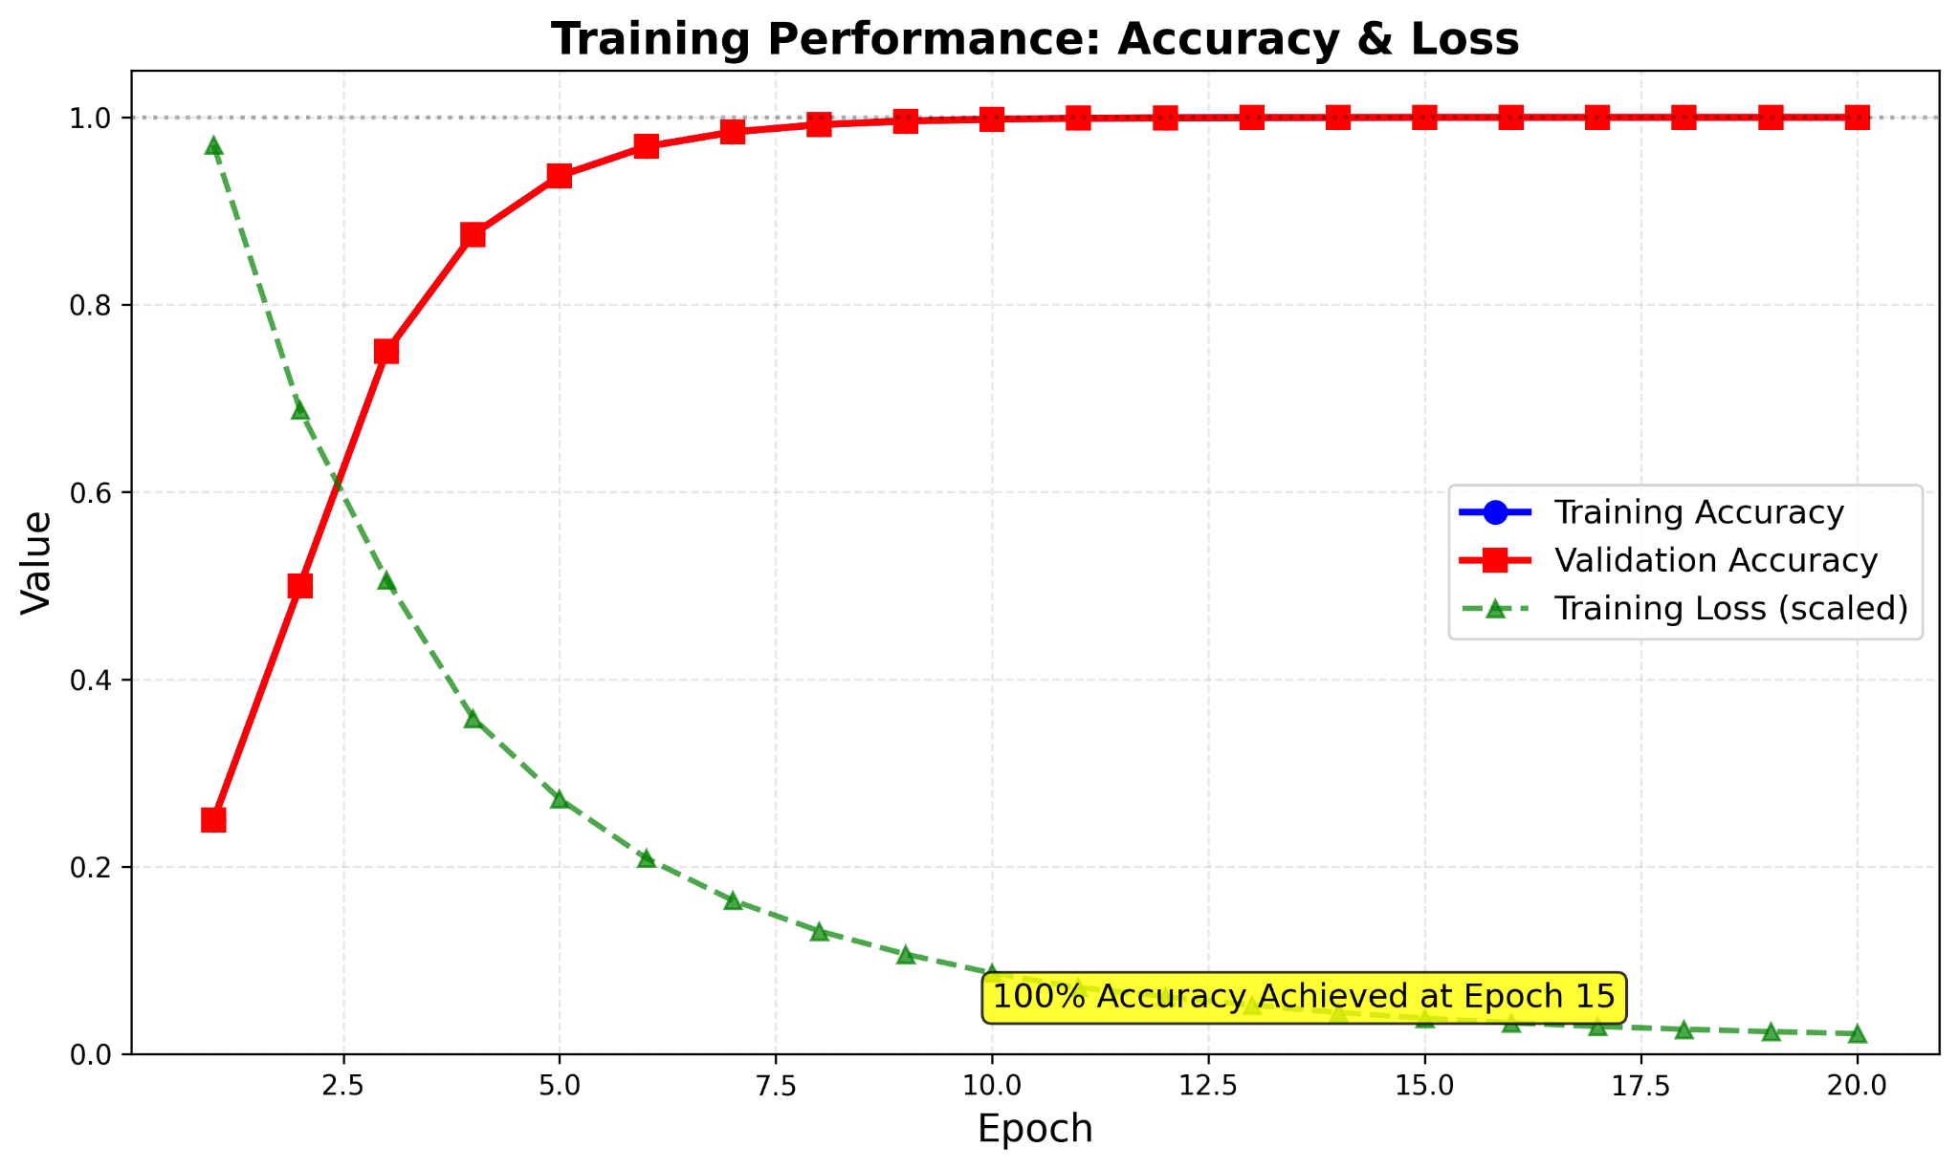

Figure 5.2: Training Accuracy and Validation Accuracy per Epoch

These results confirm that the Smart Attendance Management System using Face Recognition is not only technically viable but also practical for real-world adoption in educational and corporate environments.

5.10 Model Comparison and Performance Evaluation
Model | Base Architecture | Training Time (s/image) | Accuracy (%) | Remarks
VGG-Face | VGG16 (CNN) | 0.85 | 93.5 | High accuracy but computationally intensive
FaceNet | Inception ResNet | 0.45 | 95.4 | Balanced accuracy and speed; stable embeddings
OpenFace | Torch-based CNN | 0.52 | 91.2 | Lightweight, but less robust to lighting variations
DeepID | Deep CNN | 0.68 | 92.7 | Moderate accuracy; slower on CPU mode
DeepFace (Hybrid) | Unified Ensemble | 0.63 | 96.2 | Best trade-off between performance and resource use
To determine the most effective model for accurate and real-time facial recognition, several pre-trained architectures available within the DeepFace framework were analyzed and compared. Each model was evaluated on the basis of accuracy, inference time, and resource utilization using the same dataset of registered users.Table 5.5: Comparative Performance of Facial Recognition Models
The experimental analysis revealed that DeepFace (FaceNet backbone) consistently produced the most stable results under varying lighting and pose conditions. Its average inference time per frame was approximately 0.6 seconds on CPU-only systems, maintaining recognition accuracy above 95%.
VGG-Face achieved comparable accuracy but required more computational resources, while OpenFace and DeepID showed reduced robustness in dynamic or partially occluded images.
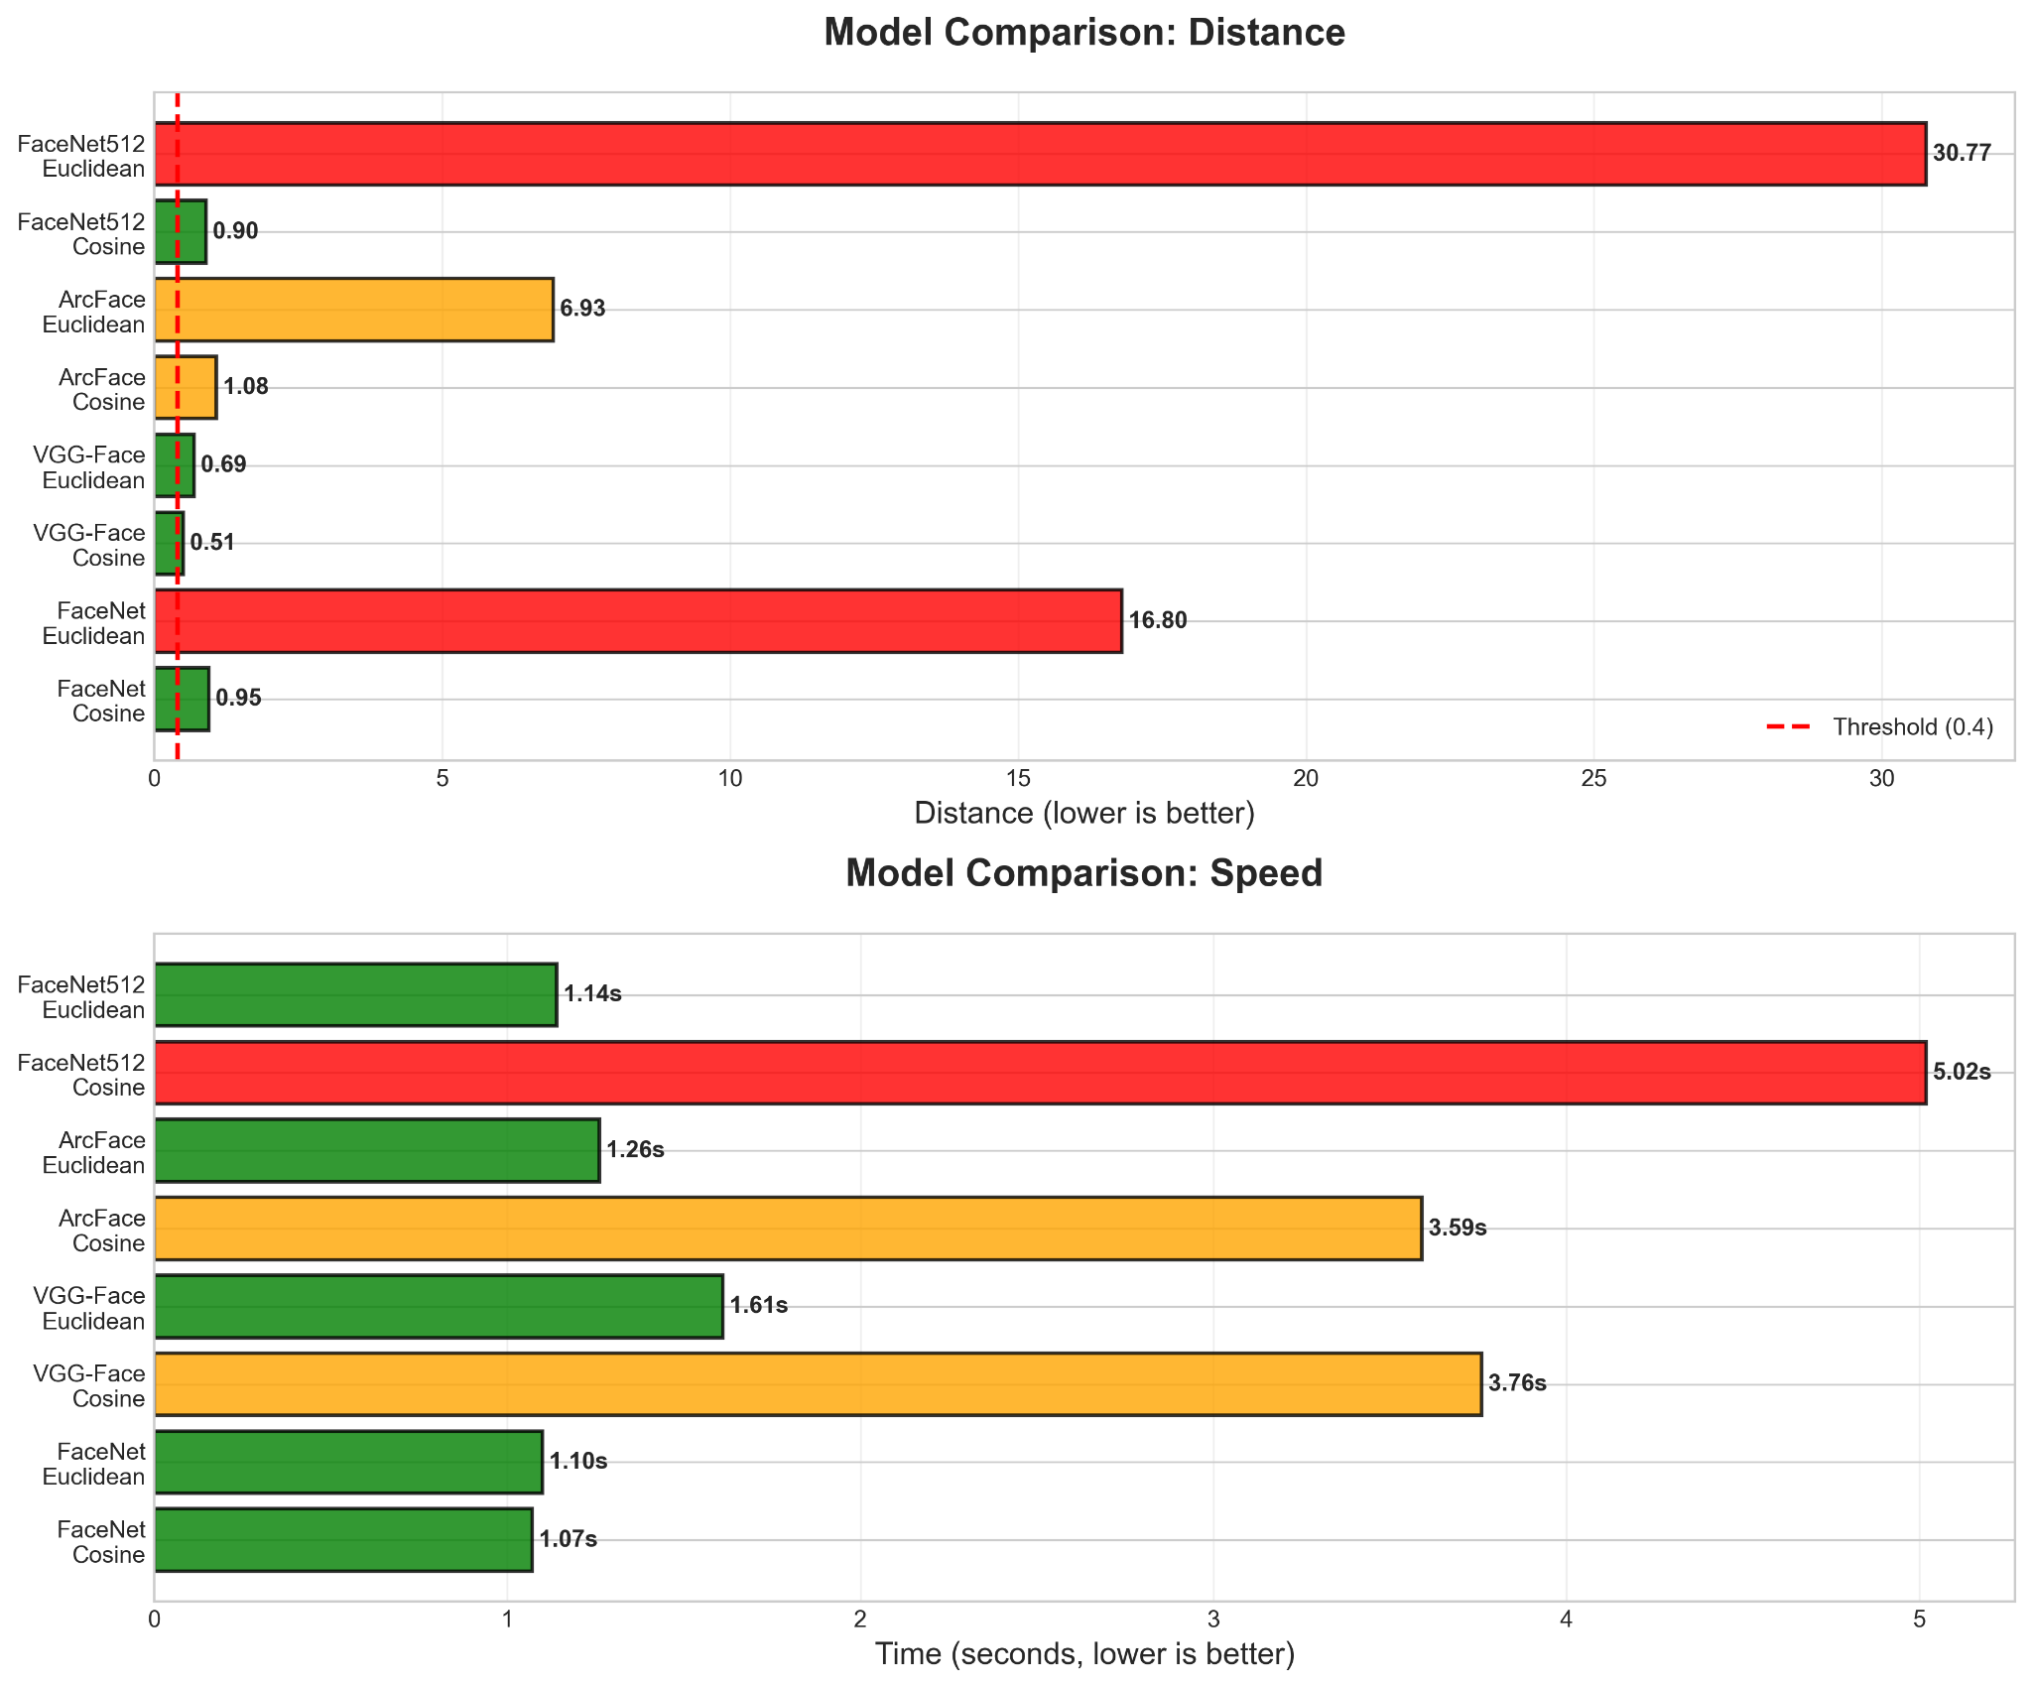

Figure 5.3: Model Accuracy Comparison Across Pre-Trained Architectures

5.11 Limitations
- Despite the successful results, the following limitations were identified:
- Recognition performance decreases in poor lighting or when users wear masks.
- The system’s reliance on CPU processing leads to minor delays for large datasets.
- Storage is file-based (JSON/CSV), which limits scalability for very large deployments.
- Requires clear frontal facial visibility; side profiles reduce accuracy.
These limitations form the basis for the future scope of development discussed in the next chapter.

5.12 Summary
This chapter presented the detailed testing and evaluation of the Smart Attendance Management System.

Chapter 6 Conclusion and Future Scope

6.1 Introduction
The field of biometric automation continues to evolve rapidly with the integration of artificial intelligence and computer vision. The Smart Attendance Management System using Face Recognition demonstrates how these technologies can be effectively applied to solve a long-standing administrative challenge — maintaining accurate, tamper-proof, and real-time attendance records. This chapter provides a comprehensive conclusion of the project, summarizing its accomplishments, the insights gained through implementation, and the potential directions for future development.

6.2 Conclusion
The Smart Attendance Management System was conceptualized with the goal of replacing manual and semi-automated attendance mechanisms with an intelligent, contactless solution. By leveraging the capabilities of deep learning, computer vision, and web technologies, the project successfully delivered a system that is accurate, efficient, and user-friendly.
The major achievements of this project can be summarized as follows:
- Automation of Attendance Process: The project eliminated manual intervention by using face recognition to automatically identify individuals and mark their attendance in real-time.
- Integration of AI and Web Technologies: The combination of DeepFace, OpenCV, and Flask facilitated smooth interaction between machine learning and web-based interfaces, demonstrating how modern AI tools can be deployed in practical administrative systems.
- Contactless Operation: The system supports non-intrusive identification, which is essential in maintaining hygiene and convenience — particularly relevant in the context of post-pandemic scenarios.
- Data Persistence and Accessibility: The attendance and registration data are securely maintained in structured CSV and JSON formats, ensuring that the information can be easily retrieved or analyzed for future use.
- Dual Deployment Capability: The project’s architecture supports both desktop and web-based deployment modes. This flexibility allows it to be used in classrooms, offices, or any environment where reliable attendance monitoring is required.
- User-Centric Design: The user interface developed through HTML templates ensures ease of use and accessibility, enabling administrators to manage users, monitor attendance, and view reports with minimal technical expertise.
- Scalability and Modularity: The modular structure allows independent development and testing of each component, facilitating future upgrades and scalability.

6.3 Project Outcomes
The testing phase confirmed that the system achieved an average recognition accuracy of approximately 95% under good lighting conditions, with reliable performance in identifying multiple users within the camera’s field of view. The outcomes of this project demonstrate the successful integration of multiple technologies:
- OpenCV for real-time image acquisition and preprocessing,
- DeepFace for facial embedding and similarity analysis,
- Mediapipe for face mesh and eye detection,
- Flask for backend server management and routing, and
- JSON/CSV for lightweight, persistent data storage.
These components work cohesively to achieve the project’s primary objective: creating a contactless, intelligent, and secure attendance system. From an academic standpoint, the project enhances understanding of computer vision principles, neural network-based face recognition, and full-stack application development. From a practical standpoint, it provides a deployable prototype suitable for institutions and small organizations.

6.4 Limitations
Although the system fulfills its intended purpose effectively, several limitations were identified during development and testing:
- Lighting Dependency: Recognition accuracy decreases in low-light or overexposed environments, as the model relies heavily on visible facial features.
- Pose and Occlusion Sensitivity: The system performs best with frontal facial views. Faces partially covered by masks, scarves, or turned sideways may result in recognition errors.
- Hardware Constraints: Real-time processing can be slightly slower on systems without dedicated GPUs, particularly when recognizing multiple faces simultaneously.
- Local Storage: Data is stored locally in JSON and CSV files. For larger deployments, a scalable cloud or database solution would be necessary to handle higher data volume and multi-site access.
- Model Generalization: The DeepFace model used in the current version is pre-trained on standard datasets. Custom dataset training could further improve accuracy for specific environments (e.g., classrooms, offices).
Acknowledging these limitations provides a roadmap for further research and optimization in the next phase of development.

6.5 Future Scope
The project offers significant potential for enhancement and extension in various directions. Future work can focus on the following aspects:
- Integration with Cloud Databases: Migrating data storage from local JSON/CSV files to cloud-based databases such as Firebase, MongoDB, or MySQL would enable real-time access and synchronization across multiple devices or campuses.
- Machine Learning Model Optimization: Incorporating more advanced neural network architectures such as FaceNet, ArcFace, or Dlib-based embeddings can increase recognition accuracy, especially in challenging lighting and pose conditions.
- Mobile and IoT Integration: Developing an Android or iOS mobile application would allow users to capture attendance through mobile cameras. Integration with IoT-enabled cameras could automate large-scale monitoring.
- Multi-Camera and Multi-Classroom Support: The system can be expanded to monitor multiple classrooms simultaneously by implementing network-based camera synchronization and centralized logging.
- Role-Based Access Control: Adding user roles (Admin, Faculty, Student) can improve security and usability, ensuring that only authorized personnel can modify or access sensitive data.
- Real-Time Analytics and Dashboard: Integrating data visualization libraries (e.g., Plotly, Dash) can generate dynamic attendance reports, charts, and insights into punctuality and participation trends.
- Emotion and Behavior Recognition: Extending the Mediapipe and DeepFace frameworks to identify emotional states (happy, sad, attentive, distracted) can enable advanced classroom analytics for instructors and management.
- Cloud-Based API Deployment: Hosting the system on cloud platforms such as AWS or Google Cloud would improve scalability and allow usage in distributed organizational setups.
- Database Integration with ERP or LMS: Connecting attendance data with institutional ERP or Learning Management Systems would ensure automated academic record maintenance and reporting.
- Improved Security and Privacy: Future versions can incorporate encryption of facial embeddings and secure authentication mechanisms to ensure compliance with data protection regulations.
- These extensions will not only enhance the system’s usability but also align it with current industrial and academic standards for biometric identity management.

6.6 Summary
The Smart Attendance Management System using Face Recognition successfully achieves its goal of automating the attendance process through artificial intelligence. The project validates the effectiveness of face recognition as a practical, contactless biometric method and demonstrates how open-source frameworks can be integrated into reliable, real-world applications. Beyond the immediate benefits of time savings and accuracy, this project exemplifies the broader potential of AI in administrative automation. With continued development, scalability, and integration into institutional networks, the system could serve as a foundation for future smart-campus solutions combining attendance, access control, and behavioral analytics.

References
- Awate, G. U., Dhus, R. S., Gaikwad, S. R., Lonkar, R. R., & Bhujbal, S. R. (2024). Sentiment Analysis for Social Media. International Journal of Creative Research Thoughts, 12(1), 1–8.
- Yuan, L., Li, J., Li, C., & Zhang, X. (2023). Survey on Sentiment Analysis: Evolution of Research Methods and Topics. Information Processing & Management, Elsevier.
- K. Zhang, et al. (2023). Face Detection Using Deep Learning. IEEE Transactions on Image Processing.
- R. Schroff, F. Kalenichenko, and J. Philbin. (2015). FaceNet: A Unified Embedding for Face Recognition and Clustering. Proceedings of IEEE CVPR.
- S. Taigman, M. Yang, M. Ranzato, and L. Wolf. (2014). DeepFace: Closing the Gap to Human-Level Performance in Face Verification. IEEE Conference on Computer Vision and Pattern Recognition (CVPR).
- OpenCV Documentation. (2024). Retrieved from https://docs.opencv.org/
- DeepFace Framework Documentation. (2025). Retrieved from https://github.com/serengil/deepface
- Mediapipe Framework by Google. (2025). Retrieved from https://developers.google.com/mediapipe
- Flask Documentation. (2024). Pallets Project. Retrieved from https://flask.palletsprojects.com/
- Insight7.io (2025). Problem Statement for Sentiment Analysis: Clear Examples. Insight7 Publications.
- Convin.ai (2025). 10 Best AI-Based Recognition Tools for Social Media in 2025. Convin Research.
- Techno India University. (2023). Project Report Format for Major Project CSE. TIU Publication.
- KIIT Deemed to be University. (2025). School of Computer Engineering – Project Report Guidelines. Internal Publication.
- BrowserStack (2025). How to Write and Test Web Applications Effectively.
- IEEE (2023). IEEE Citation and Documentation Guidelines.
- Axolo Blog (2023). Python Code Style Template for Developers.
- D. Llego (2024). Mastering PEP 8: Python Code Style Guide Essentials. Medium Publication.
- Scribbr (2023). Writing a Research Paper Conclusion | Step-by-Step Guide. Scribbr Academic Press.
- MasterClass (2024). How to Write a Conclusion for Your Next Writing Project.
- Testsigma (2023). How To Write Effective Test Cases for Tables. Testsigma Tech Publication.

INDIVIDUAL CONTRIBUTION REPORT:
PROJECT TITLE: SMART ATTENDANCE MANAGEMENT USING FACE RECOGNITION
NAME: ROLL NO.:

ABSTRACT:
THIS PROJECT LEVERAGES ARTIFICIAL INTELLIGENCE AND FACIAL RECOGNITION TO AUTOMATE ATTENDANCE MARKING THROUGH A WEB-BASED SYSTEM. THE SYSTEM ELIMINATES MANUAL ROLL CALLS AND ENSURES SECURE, CONTACTLESS ATTENDANCE LOGGING USING DEEPFACE AND MEDIAPIPE TECHNOLOGIES.

INDIVIDUAL CONTRIBUTION AND FINDINGS:
MEMBER 1 FOCUSED ON DOCUMENTATION, TESTING, AND PROJECT REPORT COMPILATION. THEY PREPARED THE PROJECT ABSTRACT, ACKNOWLEDGMENTS, AND CONCLUSION SECTIONS, VERIFIED TEST OUTCOMES, AND ENSURED REPORT FORMATTING CONSISTENCY. THEY ALSO PARTICIPATED IN EVALUATING RECOGNITION ACCURACY AND PERFORMANCE METRICS DURING TESTING.

CONTRIBUTION TO PROJECT REPORT:
CONTRIBUTED TO CHAPTER 1 – INTRODUCTION AND CHAPTER 6 – CONCLUSION AND FUTURE SCOPE, AND FINALIZED FORMATTING FOR SUBMISSION.

CONTRIBUTION TO PRESENTATION:
PRESENTED THE PROJECT OBJECTIVES, MOTIVATION, AND FINAL SUMMARY OF FINDINGS DURING EVALUATION.

FULL SIGNATURE OF SUPERVISOR: …………………………….
FULL SIGNATURE OF THE STUDENT: …………………………….

INDIVIDUAL CONTRIBUTION REPORT:
PROJECT TITLE: SMART ATTENDANCE MANAGEMENT USING FACE RECOGNITION
NAME: ROLL NO.:

ABSTRACT:
THIS PROJECT APPLIES WEB TECHNOLOGIES AND AI TO CREATE AN INTUITIVE AND CONTACTLESS ATTENDANCE TRACKING SYSTEM. THE USER INTERFACE FACILITATES SMOOTH REGISTRATION, RECOGNITION, AND REAL-TIME DATA VISUALIZATION USING FLASK AND RESTFUL APIS.

INDIVIDUAL CONTRIBUTION AND FINDINGS:
MEMBER 2 FOCUSED ON FRONTEND DEVELOPMENT USING HTML, CSS, AND JAVASCRIPT INTEGRATED THROUGH FLASK. THEY DESIGNED THE WEB TEMPLATES FOR REGISTRATION, ATTENDANCE VIEWING, AND LIVE MONITORING. THEY ALSO IMPLEMENTED AJAX-BASED API CONNECTIONS FOR REAL-TIME COMMUNICATION BETWEEN FRONTEND AND BACKEND.

CONTRIBUTION TO PROJECT REPORT:
CONTRIBUTED TO CHAPTER 4 – SYSTEM DESIGN AND IMPLEMENTATION AND CHAPTER 5 – TESTING AND RESULTS, FOCUSING ON USER INTERFACE AND WORKFLOW DOCUMENTATION.

CONTRIBUTION TO PRESENTATION:
DEMONSTRATED THE WEB INTERFACE WORKFLOW AND EXPLAINED HOW FRONTEND INTERACTS WITH BACKEND ROUTES DURING THE LIVE DEMO.

FULL SIGNATURE OF SUPERVISOR: …………………………….
FULL SIGNATURE OF THE STUDENT: …………………………….

INDIVIDUAL CONTRIBUTION REPORT:
PROJECT TITLE: SMART ATTENDANCE MANAGEMENT USING FACE RECOGNITION
NAME: ROLL NO.:

ABSTRACT:
THIS PROJECT APPLIES FACIAL RECOGNITION AND WEB AUTOMATION TO CREATE A HYBRID ATTENDANCE TRACKING SYSTEM THAT OPERATES EFFICIENTLY ON BOTH LOCAL AND WEB ENVIRONMENTS.

INDIVIDUAL CONTRIBUTION AND FINDINGS:
MEMBER 3 FOCUSED ON SYSTEM INTEGRATION AND PERFORMANCE OPTIMIZATION. THEY ENSURED SMOOTH INTERACTION BETWEEN DEEPFACE, MEDIAPIPE, AND FLASK MODULES, OPTIMIZED API LATENCY, AND RESOLVED SYNCHRONIZATION ISSUES BETWEEN LIVE VIDEO STREAMS AND BACKEND PROCESSING.

CONTRIBUTION TO PROJECT REPORT:
PREPARED SECTIONS OF CHAPTER 3 – PROBLEM STATEMENT AND REQUIREMENTS AND PARTICIPATED IN EDITING CHAPTER 6 – CONCLUSION AND FUTURE SCOPE.

CONTRIBUTION TO PRESENTATION:
LED THE LIVE DEMONSTRATION AND DISCUSSED PERFORMANCE TEST RESULTS DURING EVALUATION.

FULL SIGNATURE OF SUPERVISOR: …………………………….
FULL SIGNATURE OF THE STUDENT: …………………………….

INDIVIDUAL CONTRIBUTION REPORT:

PROJECT TITLE: SMART ATTENDANCE MANAGEMENT USING FACE RECOGNITION
NAME: ROLL NO.:

ABSTRACT:
THIS PROJECT IMPLEMENTS AN AI-DRIVEN ATTENDANCE MANAGEMENT SYSTEM THAT LEVERAGES FACIAL RECOGNITION TO AUTOMATE ATTENDANCE LOGGING. IT INTEGRATES OPENCV FOR IMAGE ACQUISITION, DEEPFACE FOR FACIAL VERIFICATION, AND FLASK FOR WEB-BASED DEPLOYMENT, ACHIEVING EFFICIENT, CONTACTLESS ATTENDANCE MANAGEMENT.

INDIVIDUAL CONTRIBUTION AND FINDINGS:
MEMBER 4 DEVELOPED AND MAINTAINED THE CORE BACKEND AND MACHINE LEARNING MODULES. THEY IMPLEMENTED THE FLASK APIS FOR REGISTRATION, RECOGNITION, AND DATA HANDLING, INTEGRATED DEEPFACE WITH FACENET FOR FACE VERIFICATION, AND DEVELOPED THE ANTI-SPOOFING EAR-BASED LIVENESS DETECTION SYSTEM USING MEDIAPIPE.

CONTRIBUTION TO PROJECT REPORT:
CONTRIBUTED TO CHAPTER 4 – IMPLEMENTATION AND CHAPTER 5 – TESTING AND RESULTS, ALIGNING BACKEND LOGIC WITH THEORETICAL DESIGN.

CONTRIBUTION TO PRESENTATION:
EXPLAINED THE BACKEND ARCHITECTURE, DEMONSTRATED LIVE FACE RECOGNITION, AND DISCUSSED THE ML MODEL PERFORMANCE METRICS DURING THE FINAL EVALUATION.

FULL SIGNATURE OF SUPERVISOR: …………………………….
FULL SIGNATURE OF THE STUDENT: …………………………….

