**Problem Statement 1: To find the U.S. state with highest and lowest no. of deaths reported**.

**Coronavirus** is a family of viruses that can cause illness, which can vary from *common cold* and *cough* to sometimes more severe disease. **Middle East Respiratory Syndrome (MERS-CoV)** and **Severe Acute Respiratory Syndrome (SARS-CoV)** were such severe cases with the world already has faced. **SARS-CoV-2 (n-coronavirus)** is the new virus of the coronavirus family, which first *discovered* in 2019, which has not been identified in humans before. It is a *contiguous* virus which started from **Wuhan** in **December 2019**. Which later declared as **Pandemic** by **WHO** due to high rate spreads throughout the world. Currently (on the date 20 May 2020), this leads to a total of *300K+ Deaths* across the globe, including *90K+ deaths* alone in the USA.

**Data Analysis:**

This Dataset contains an aggregation of each USA State-level data.

**Field description:-**

* **Province_State** - The name of the State within the USA.
* **Country_Region** - The name of the Country (US).
* **Last_Update** - The most recent date the file was pushed.
* **Lat** - Latitude.
* **Long_** - Longitude.
* **Confirmed** - Aggregated confirmed case count for the state.
* **Deaths** - Aggregated Death case count for the state.
* **Recovered** - Aggregated Recovered case count for the state.
* **Active** - Aggregated confirmed cases that have not been resolved (Active = Confirmed - Recovered - Deaths).
* **FIPS** - Federal Information Processing Standards code that uniquely identifies counties within the USA.
* **Incident_Rate** - confirmed cases per 100,000 persons.
* **People_Tested** - Total number of people who have been tested.
* **People_Hospitalized** - Total number of people hospitalized.
* **Mortality_Rate** - Number recorded deaths * 100/ Number confirmed cases.
* **UID** - Unique Identifier for each row entry.
* **ISO3** - Officialy assigned country code identifiers.
* **Testing_Rate** - Total number of people tested per 100,000 persons.
* **Hospitalization_Rate** - Total number of people hospitalized * 100/ Number of confirmed cases.

**EDA Concluding Remark:**

* After removing all the Null/Missing values, we will check which Features are relevant for our analysis.
* We will drop the columns that are not necessary for our analysis.
* Now we will check different Features v/s States.

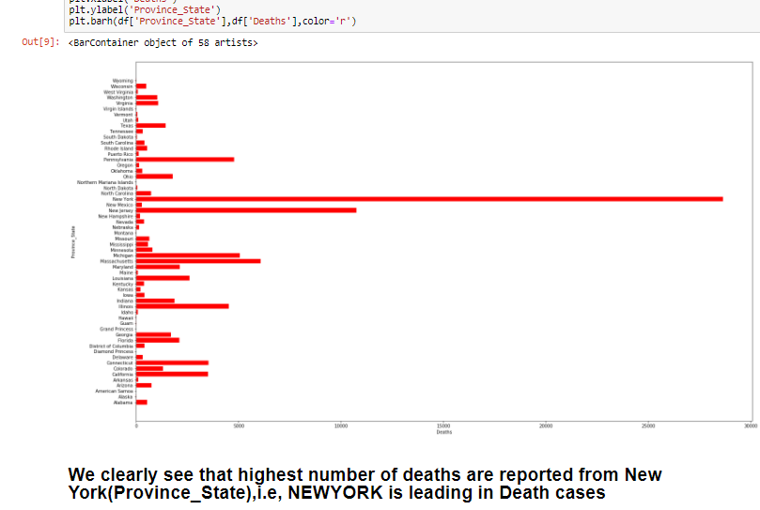

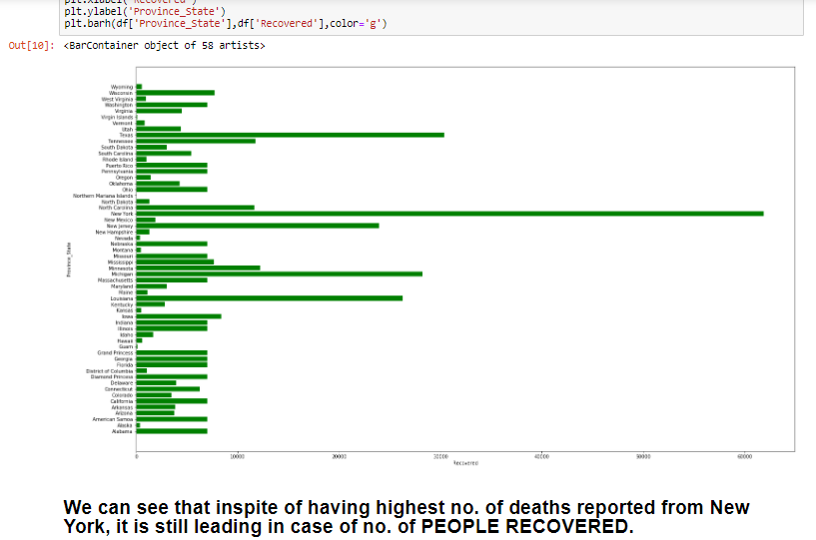

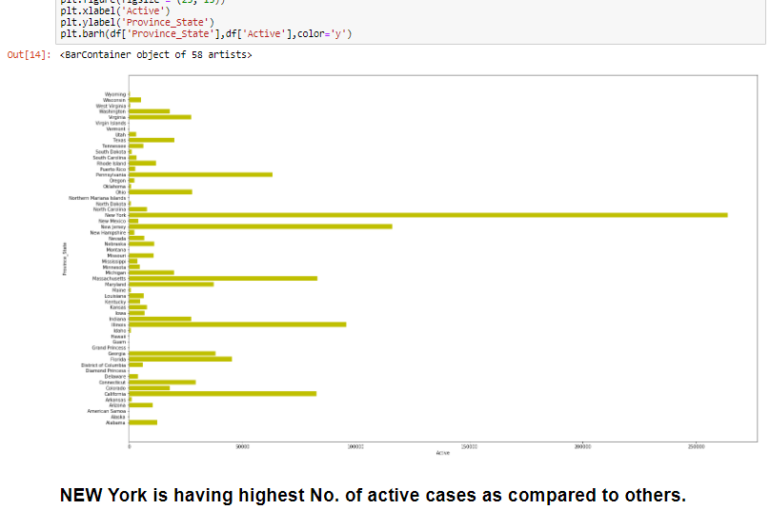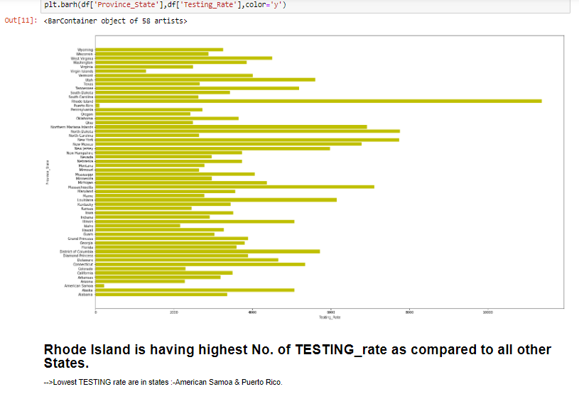

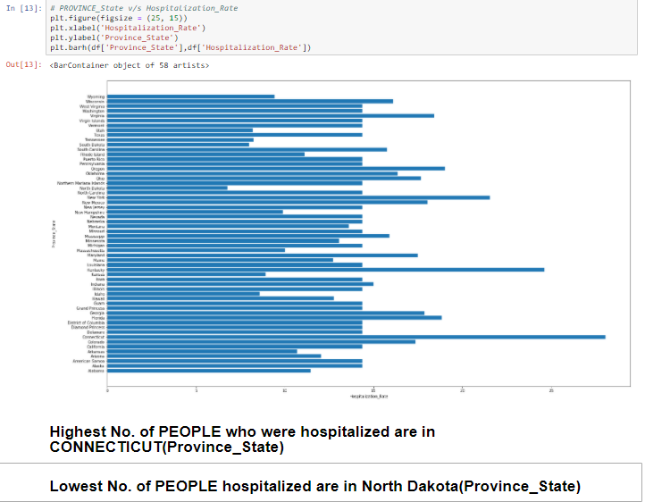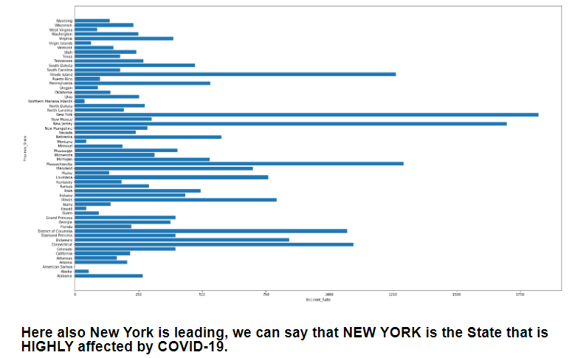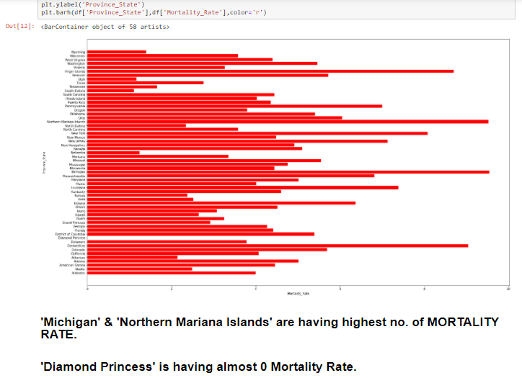

* 'Confirmed' is having highest Std.Deviation among all other features.
* Average 'Deaths' cases are 1161.
* Average 'Recovered' cases are 7007.
* Average No. of 'Active' cases are 20,070.

**Pre-Processing Pipeline:**

Scaling the Input data i.e, X.

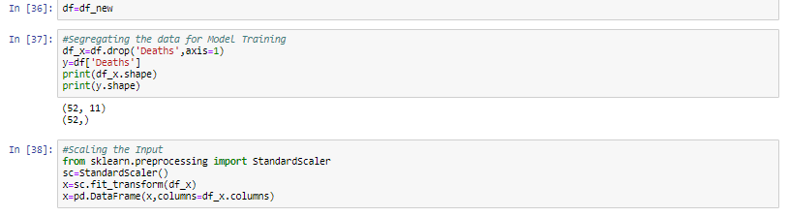

**Building Machine Learning Models:**

* Now we will divide our dataset into train and test.
* After segregating the dataset, we will find the best model for the dataset.

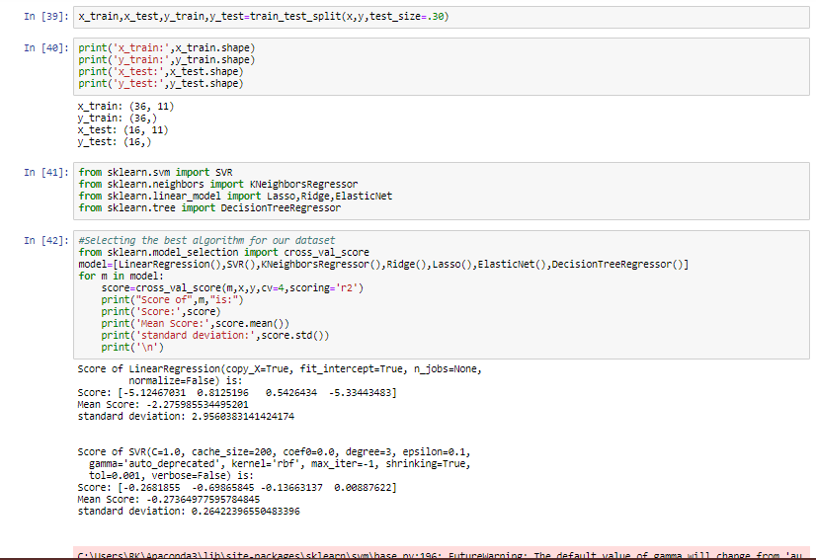

* Once we have got the best algorithm for our analysis, we will find the best parameters for the same.

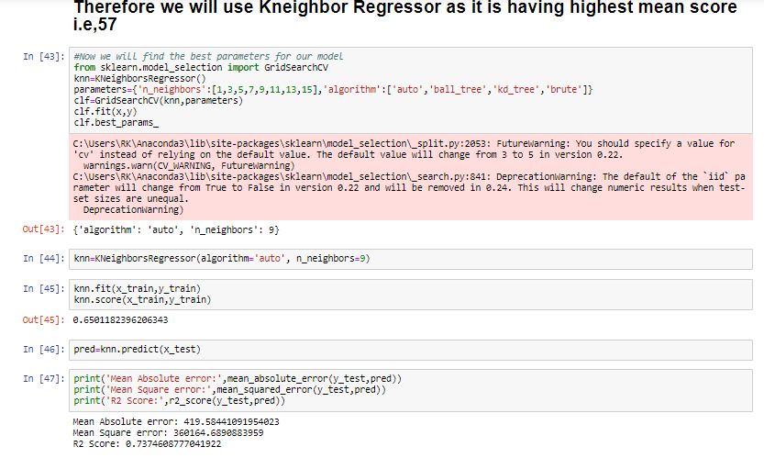

**CONCLUSION:**

* **The State which is most affected by COVID-19 is NEW YORK.**
* **New York is leading in no. of DEATHS cases inspite of having high recovery rate.**
* **Highest No. of People were hospitalized in ‘Connecticut’.**

**Problem Statement 2:** Predicting the cost of the food served by the restaurants across different cities in India.

**Data Analysis:**

Size of training set: **12,690** records

Size of test set: **4,231** records

Size of training set: **12,690** records

Size of test set: **4,231** records

**FEATURES:**

**TITLE:**The feature of the restaurant which can help identify what and for whom it is suitable for.

**RESTAURANT_ID:**A unique ID for each restaurant.

**CUISINES:**The variety of cuisines that the restaurant offers.

**TIME:**The open hours of the restaurant.

**CITY:**The city in which the restaurant is located.

**LOCALITY:**The locality of the restaurant.

**RATING:** The average rating of the restaurant by customers.

**VOTES:**The overall votes received by the restaurant.

**COST:** The average cost of a two-person meal.

**EDA Concluding Remark:**

* ‘FINE DINNING', 'Club', 'Fine Dinning Bar', 'Fine Dinning Lounge' & 'Cocktail bar, Casual Dinning' are most expensive .
* Pan shop & Sweet shop, bakery are cheapest among all.

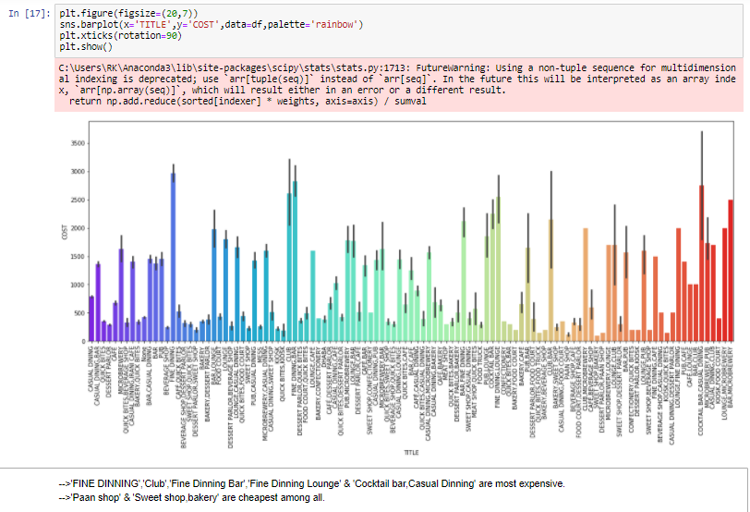

* CHENNAI, BANGALORE & Kerala are the most expensive 'CITY' interms of FOOD cost.

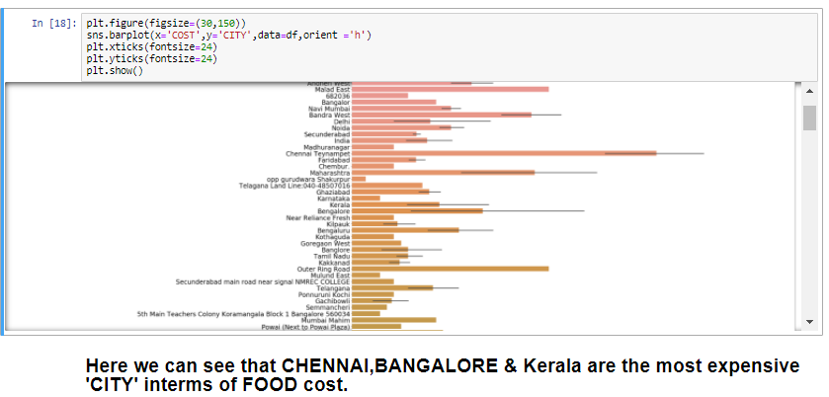

* **As the rating is increasing towards '5' cost is also increasing .i.e, they have +ve correlation.**

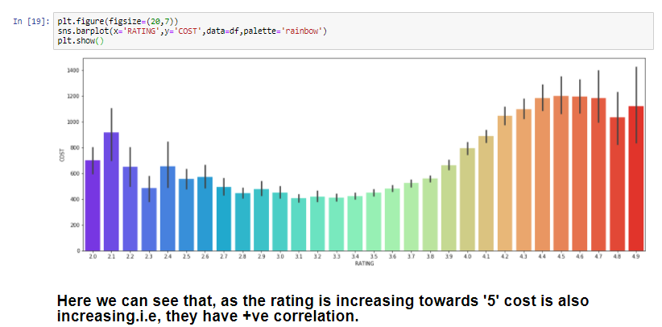

* **Average cost for FOOD is 682.**
* **Min. cost for FOOD is 50.**
* **Max. cost for FOOD is 14000.**

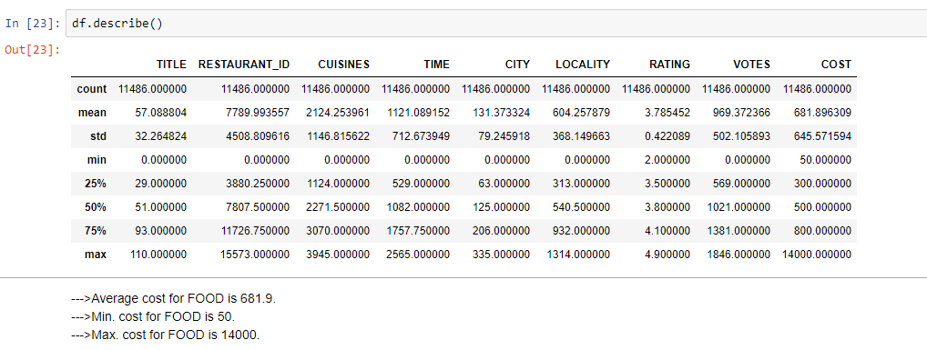

**Pre-Processing Pipeline:**

**Scaling the Input data i.e, X**

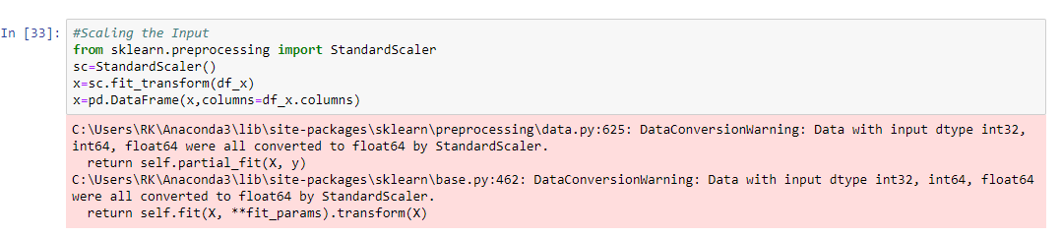

**Building Machine Learning Models:**

* **Now we will divide our dataset into train and test.**
* **After segregating the dataset, we will find the best model for the dataset.**

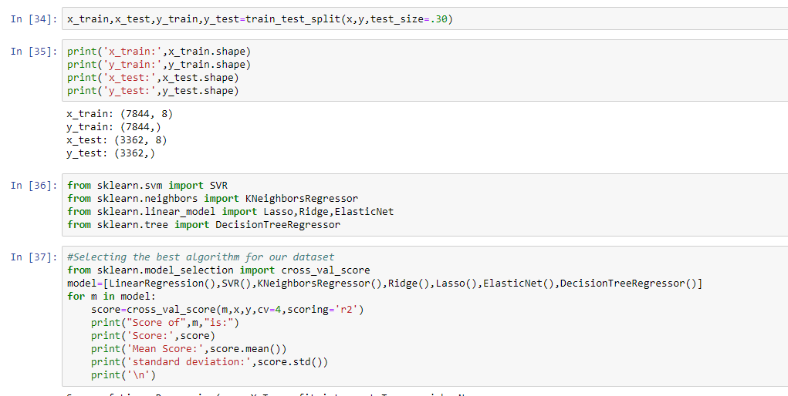

* **Here the best algorithm is Random forest tree.**

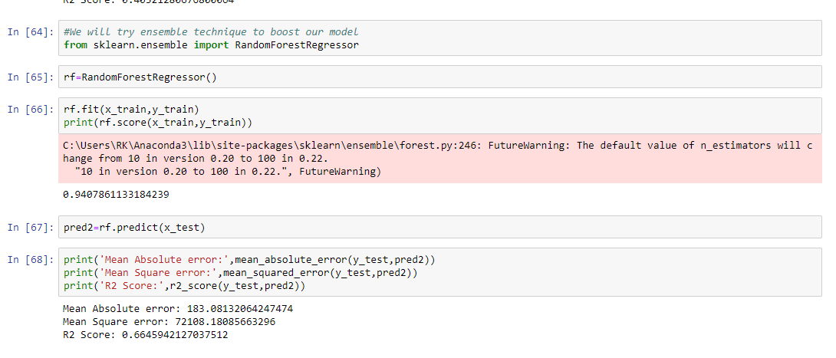

**CONCLUSION:**

* **‘FINE DINNING', 'Club', 'Fine Dinning Bar', 'Fine Dinning Lounge' & 'Cocktail bar, Casual Dinning' are most expensive .**
* **CHENNAI, BANGALORE & Kerala are the most expensive 'CITY' interms of FOOD cost.**
* **Also, as the rating increases towards '5' cost of food is also increasing .**