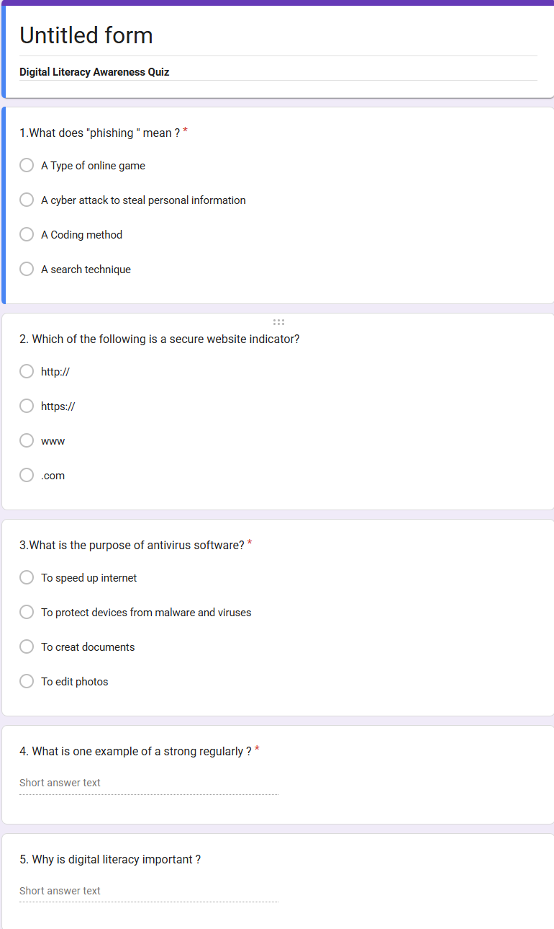

Response view of screenshot:
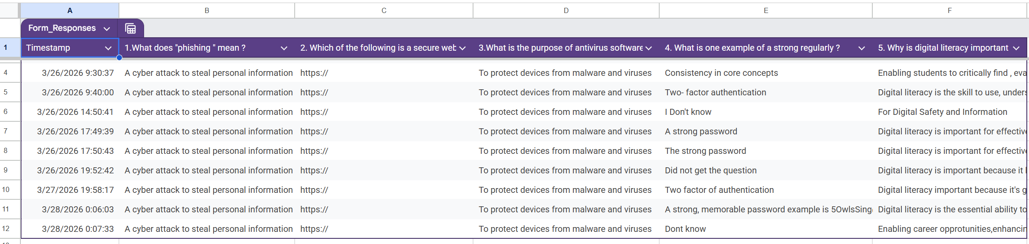
project Report
For this task, I used Google Forms as the primary platform to create a Digital Literacy Awareness Quiz. Google Forms is easy to use and allows quick creation of quizzes with different types of questions such as multiple choice and short answer. I designed a quiz consisting of five questions to test basic awareness about online safety, password security, phishing, and digital platforms used for education.
While building this form, I practised structuring questions clearly, selecting appropriate answer types, and setting correct answers for automatic grading. I also learned how to share the form link with others, making it useful for conducting real-time quizzes among my batchmates.
These tools are highly beneficial academically because they help in conducting surveys, quizzes, and assessments efficiently. As a Digital Ambassador, I can use Google Forms to spread awareness about cyber safety and digital literacy. It also enhances my technical skills, improves communication, and helps in organizing information effectively. Overall, this activity has made me more confident in using digital tools for educational and awareness purposes.

