Internship Project

Report:

# BuddyTap

**Submitted by:**

* Rachit Goel
* Prerit Kohli
* Shreya Garg

# Includes:

* Introduction
* Functionality
* Description and Use
* Use Cases
* Phase description
* Tools and technologies used

Introduction:

The purpose of this project is to introduce an Android Application with the feature of geo-intelligence.

How do we feel when a person we know , randomly comes and say ‘Hi’. We are glad to meet people, and love such surprizes. **BuddyTap** is an application which actually can increase such instances. Why to meet friends with a prior meeting.

Using BuddyTap enables us to meet someone unplanned. Application is designed as per the user, a person can know his current location, he can save his location, he can form a friend group and see the location of the friends.

Application is designed in such a flexible way that it can handle the future requirements of the users.

Agile methodology was implemented to carry out the project.

Functionalities:

* Reduce Cost and Time:

When a person is feeling bored and wants to hang out with his friends, normally he calls every one or drops a message to know where the friends are.

This involves cost and time both, also a person has to remember the location of everyone he has called.

Using BuddyTap can help in saving time and cost. Also possibility to lie vanishes. A person can know the exact location of his friends with no time and no cost.

* Forming Group:

A person can form and join the groups as per the requirement.

* Tagging location:

Location can be tagged and a person can keep records of the last visits.

Description And Use:

As the name says it all, BuddyTap is designed to Tap your friends. A user can form the groups and accordingly the locations can be retrieved.

BuddyTap enables the user to locate their friends in real time. It also provides the facility to save the users own location to keep the track of his travels.

The application saves the two most important things- Time -Cost.

Use Cases:

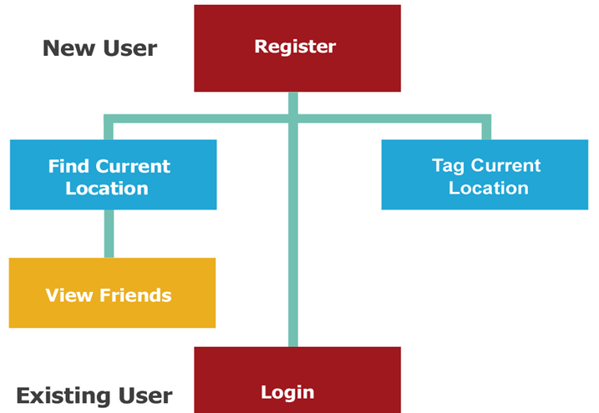

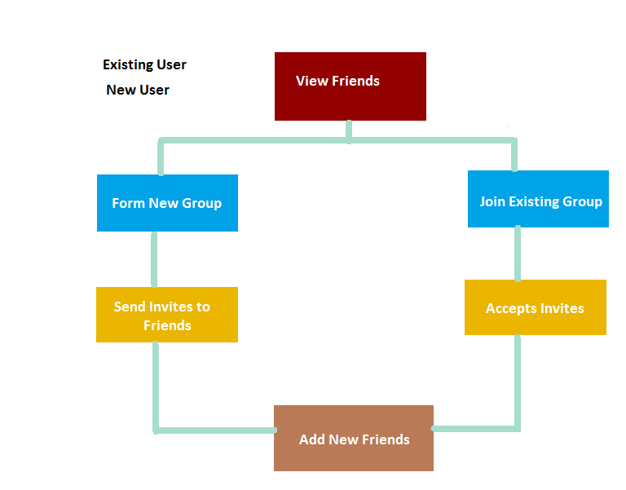

Work Flow description:

A new user registers himself and then the user can see his location. If GPS is OFF, user will be asked to switch it ON.

-> he tags himself

-> and creates a group or join a group (if he has the unique code, ie, if someone has asked him to join the group)

-> each group has a unique ID and name.

Phase description:

The project was completed in three major phases.

Phase 1:

* User Interface
* Requirement analysis- Listed the required software and tools for the project.

Phase 2:

* Current Location- Involving retrieving the location, incorporate maps.

Phase 3:

* Forming groups- Forming groups via unique group ID.

Tools And Technology:

Technology:

**Client Side**

* + - Java –platform independent
    - Android Application Development

**Server Side**

* + PHP for web services - easy, quick
  + MySQL
  + JSON is used for network payload – mobile friendly

Tools:

**Client Side**

* + Eclipse IDE.
  + Android SDK with MySQLite.
  + Adobe Photoshop CS5