Banana problem unit -4 OS assessment
NAME-Rachith.M
SRN-PES2UG24CS392
SECTION-G
Githublink- https://github.com/rachithm88/PES2UG24CS392-PES-VCS.git
PHASE 1
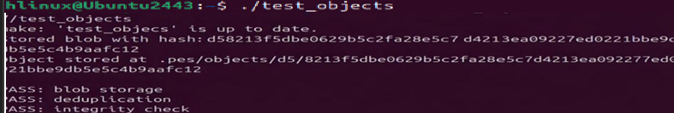

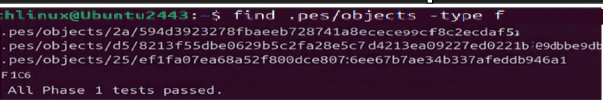
PHASE 2
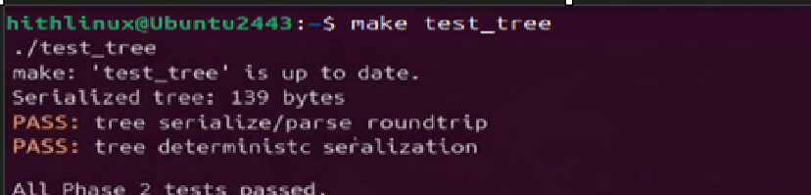

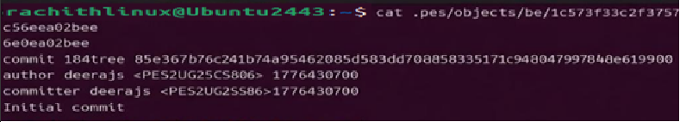

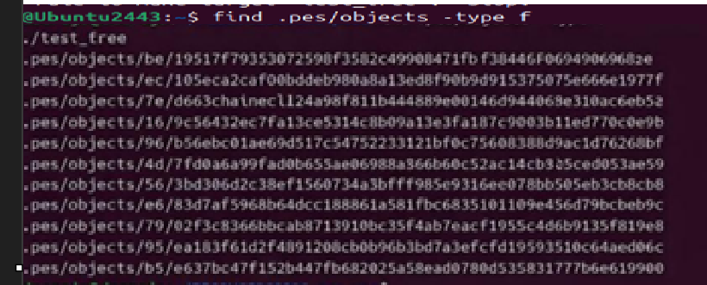
PHASE 3

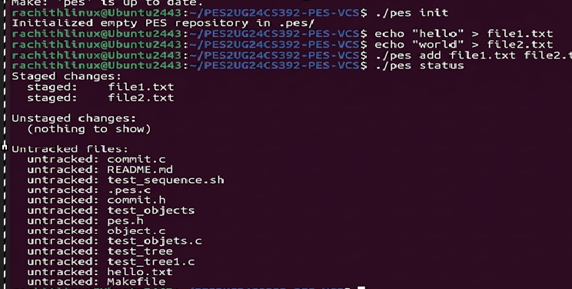

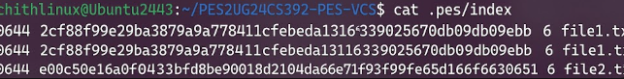
PHASE 4
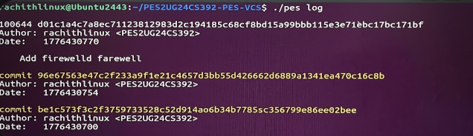
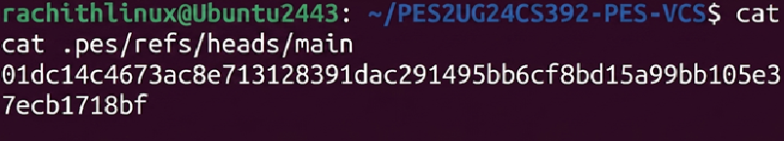
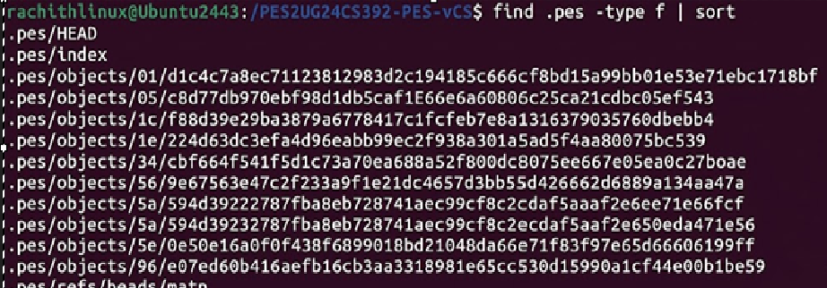

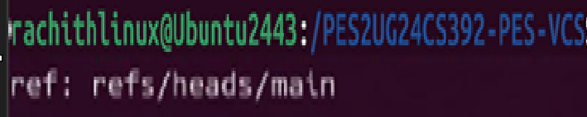

PHASE 5 & 6
Q5.1 — Branch Checkout Mechanism
Question: A branch in Git is just a file in .git/refs/heads/ containing a commit hash. Creating a branch is creating a file. Given this, how would you implement pes checkout — what files need to change in .pes/, and what must happen to the working directory? What makes this operation complex?
Answer: In PES, a branch is represented as a file in .pes/refs/heads/ containing a commit hash. To implement pes checkout , the following steps are required:
Steps: 1. Update HEAD
• Modify .pes/HEAD to point to the target branch: ref: refs/heads/
2. Load Target Commit
• Read the commit hash from .pes/refs/heads/ • Load the corresponding commit object from the object store
• Create directories for tree objects
• Write file contents for blob objects
3. Update Index
• Rewrite .pes/index to match the checked-out tree so the staging area reflects the new state
Complexity: This operation is complex because: It involves replacing the entire working directory Must handle: File overwrites File deletions Directory structure changes Must ensure that uncommitted changes are not lost

Q5.2 — Detecting Dirty Working Directory Question:
When switching branches, how would you detect a "dirty working directory" conflict using only the index and the object store?
Answer: To detect a dirty working directory, the following comparisons are made:
Steps:
- Compare Index vs Working Directory
• For each file in the index:
•Use stat() to compare:
• Modification time (mtime)
• File size
• If they differ → file is locally modified
- Compare Index vs Target Branch
• Load the target branch’s tree
• Compare file hashes with index entries
- Conflict Condition
• A conflict occurs if:
• The file is modified locally, AND
• The same file differs in the target branch
- Action-
Abort checkout to prevent overwriting uncommitted changes
Reason: The index represents the last staged state. Any mismatch between the working directory and index indicates uncommitted changes.

Q5.3 — Detached HEAD State
Question: What happens if commits are made in a detached HEAD state? How can they be recovered?
Answer: In a detached HEAD state:
• .pes/HEAD contains a commit hash directly instead of a branch reference
Behavior:
• New commits can still be created
• No branch points to these commits
• These commits become unreachable from normal history
Recovery:
Create a new branch pointing to the commit: pes branch pes checkout This attaches the commits back to the repository history
Q6.1 — Garbage Collection Algorithm
Question: Describe an algorithm to find and delete unreachable objects. What data structure would you use? Estimate objects visited for a large repo.
Answer: Algorithm: 1. Collect Root References • Read all branch heads from .pes/refs/heads/
2. Traverse Reachable Objects • Use DFS or BFS to traverse: • Commits → parent commits • Commits → trees • Trees → blobs and subtrees
3. Mark Reachable Objects • Store all visited hashes in a set
4. Delete Unreachable Objects • Scan .pes/objects/ • Delete objects not in the reachable set
Data Structure: • Hash Set • Provides fast lookup (O(1)) to check reachability
Estimated Objects: For: • 100,000 commits • 50 branches You would visit: • All commits + trees + blobs ◻ Approximate total: 300,000 – 500,000 object
Q6.2 — Garbage Collection Race Condition
Question: Why is running garbage collection concurrently with a commit dangerous? How does Git avoid this? Answer: Problem: Garbage collection (GC) may delete objects that are in the process of being committed. Race Condition:
1. Commit process: • Writes new blobs, trees, and commit objects • These objects are not yet referenced
2. GC runs simultaneously: • Only considers objects reachable from branches • Deletes newly created but unreferenced objects
3. Commit finishes: • Updates branch reference to deleted objects • Repository becomes corrupt

How Git Avoids This:
1. Atomic Updates • Uses rename() for safe updates
2. Write Before Reference • Objects are written before updating branch pointers
3. Locking Mechanisms • Prevent concurrent modifications
4. Grace Period • Recently created objects are not deleted immediate

