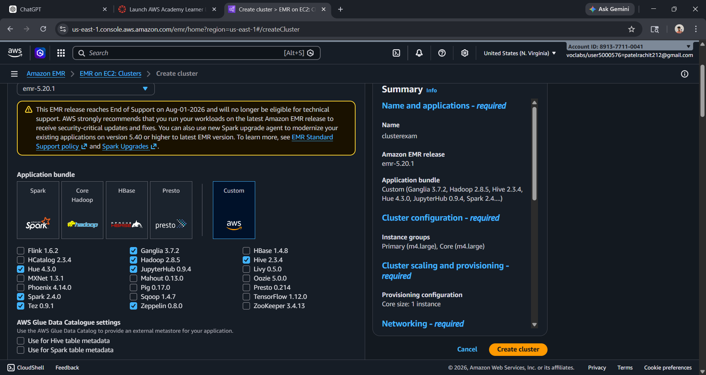
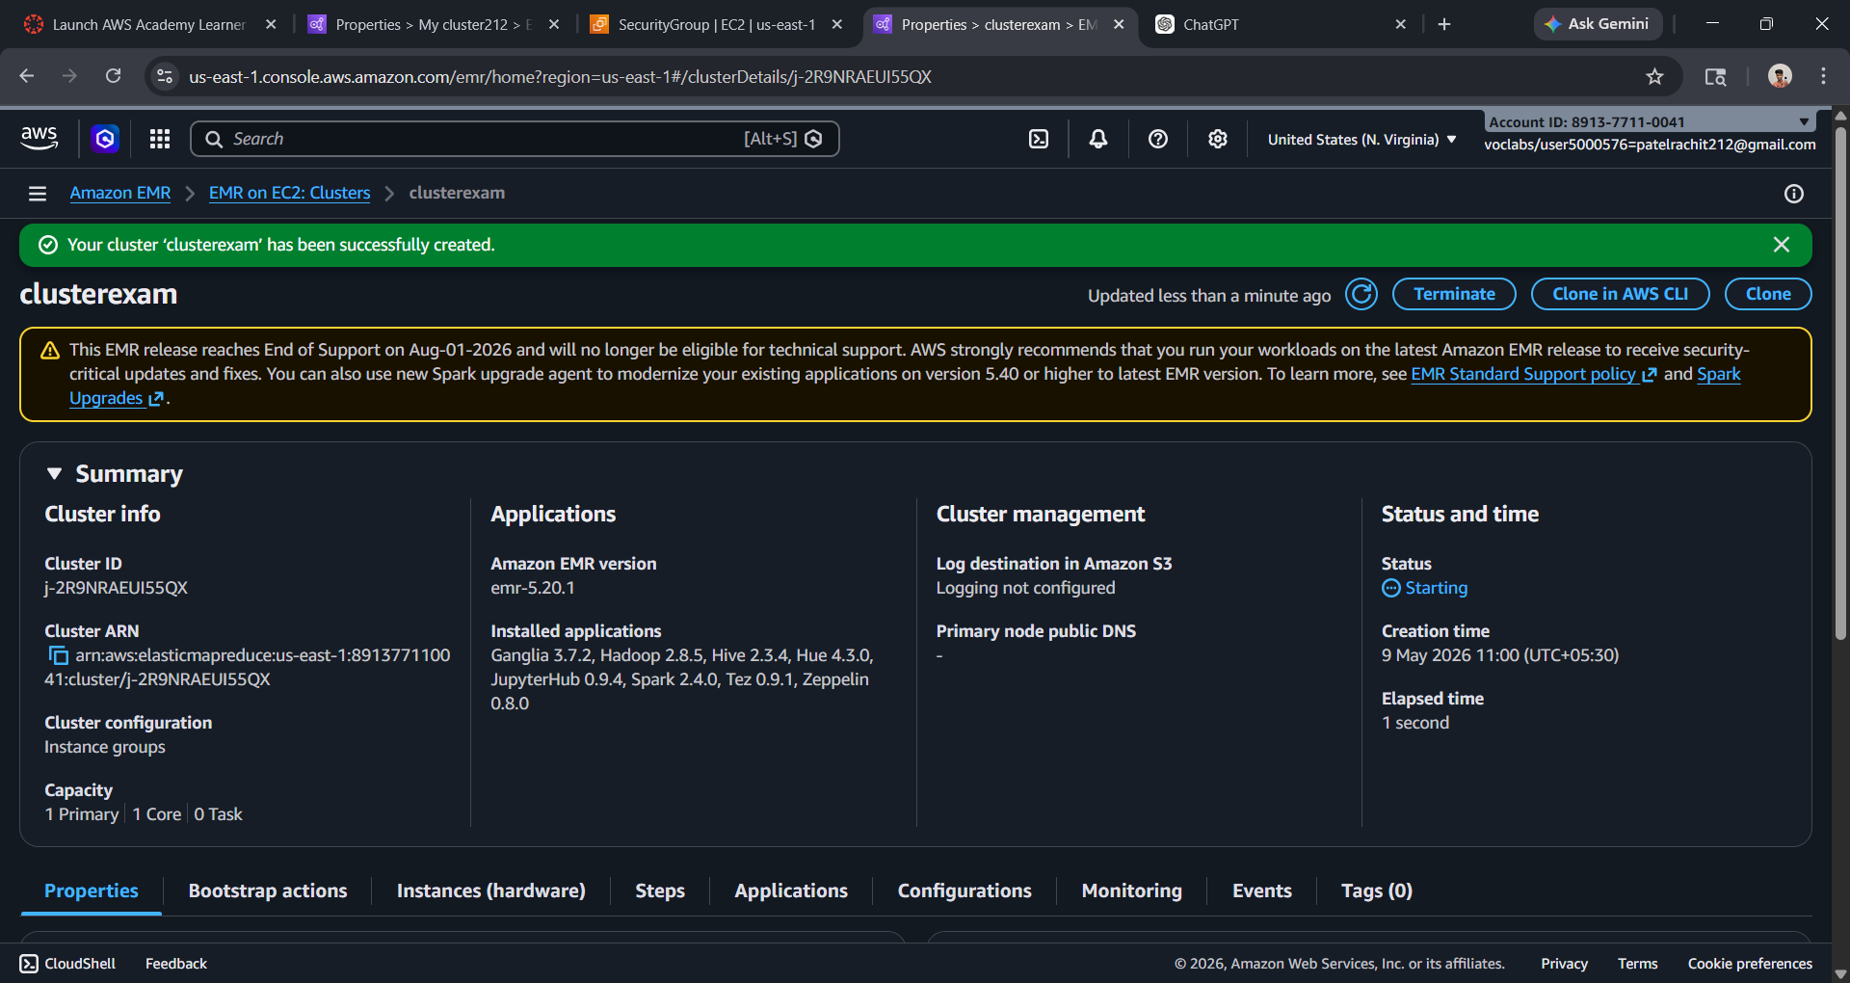
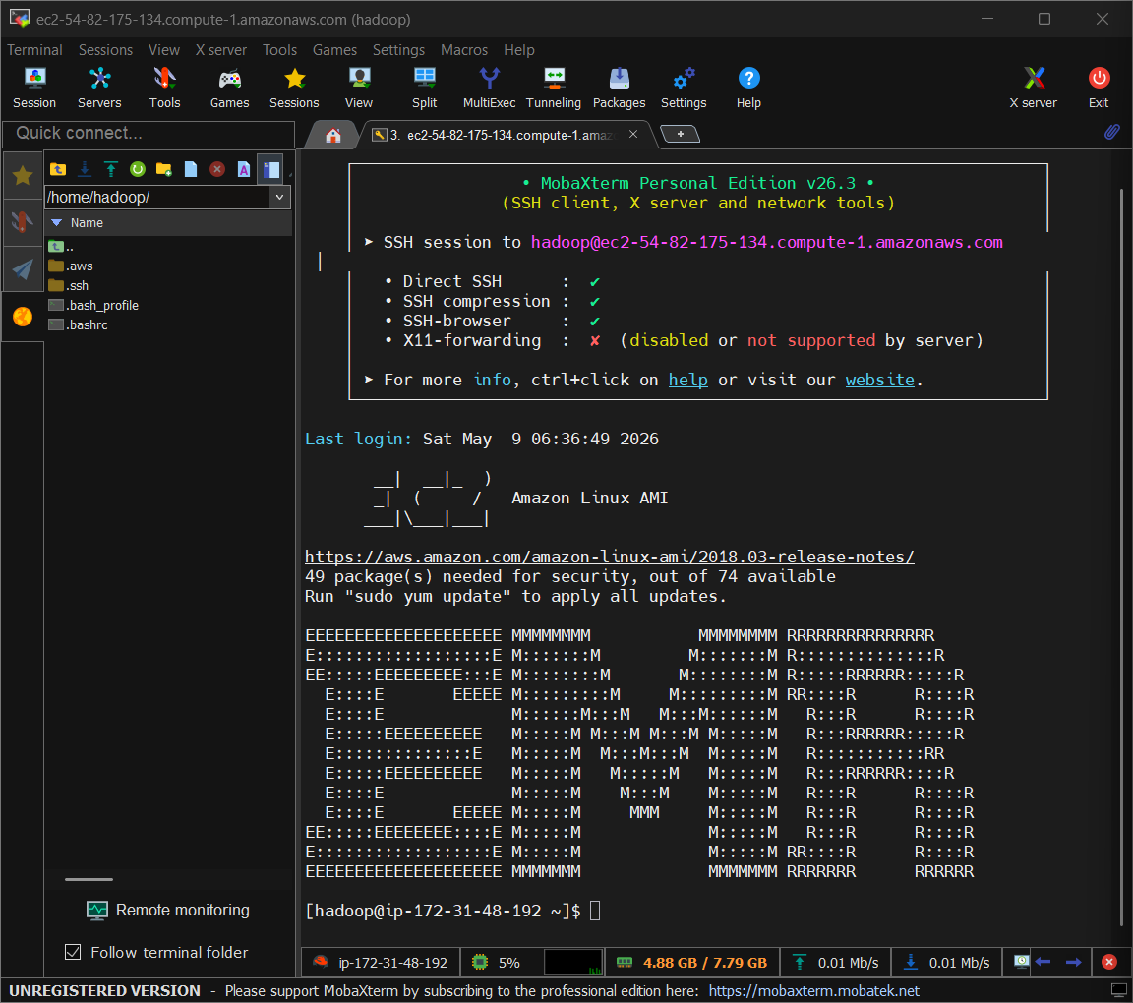

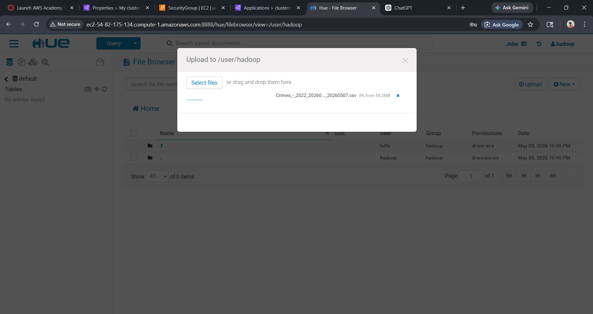
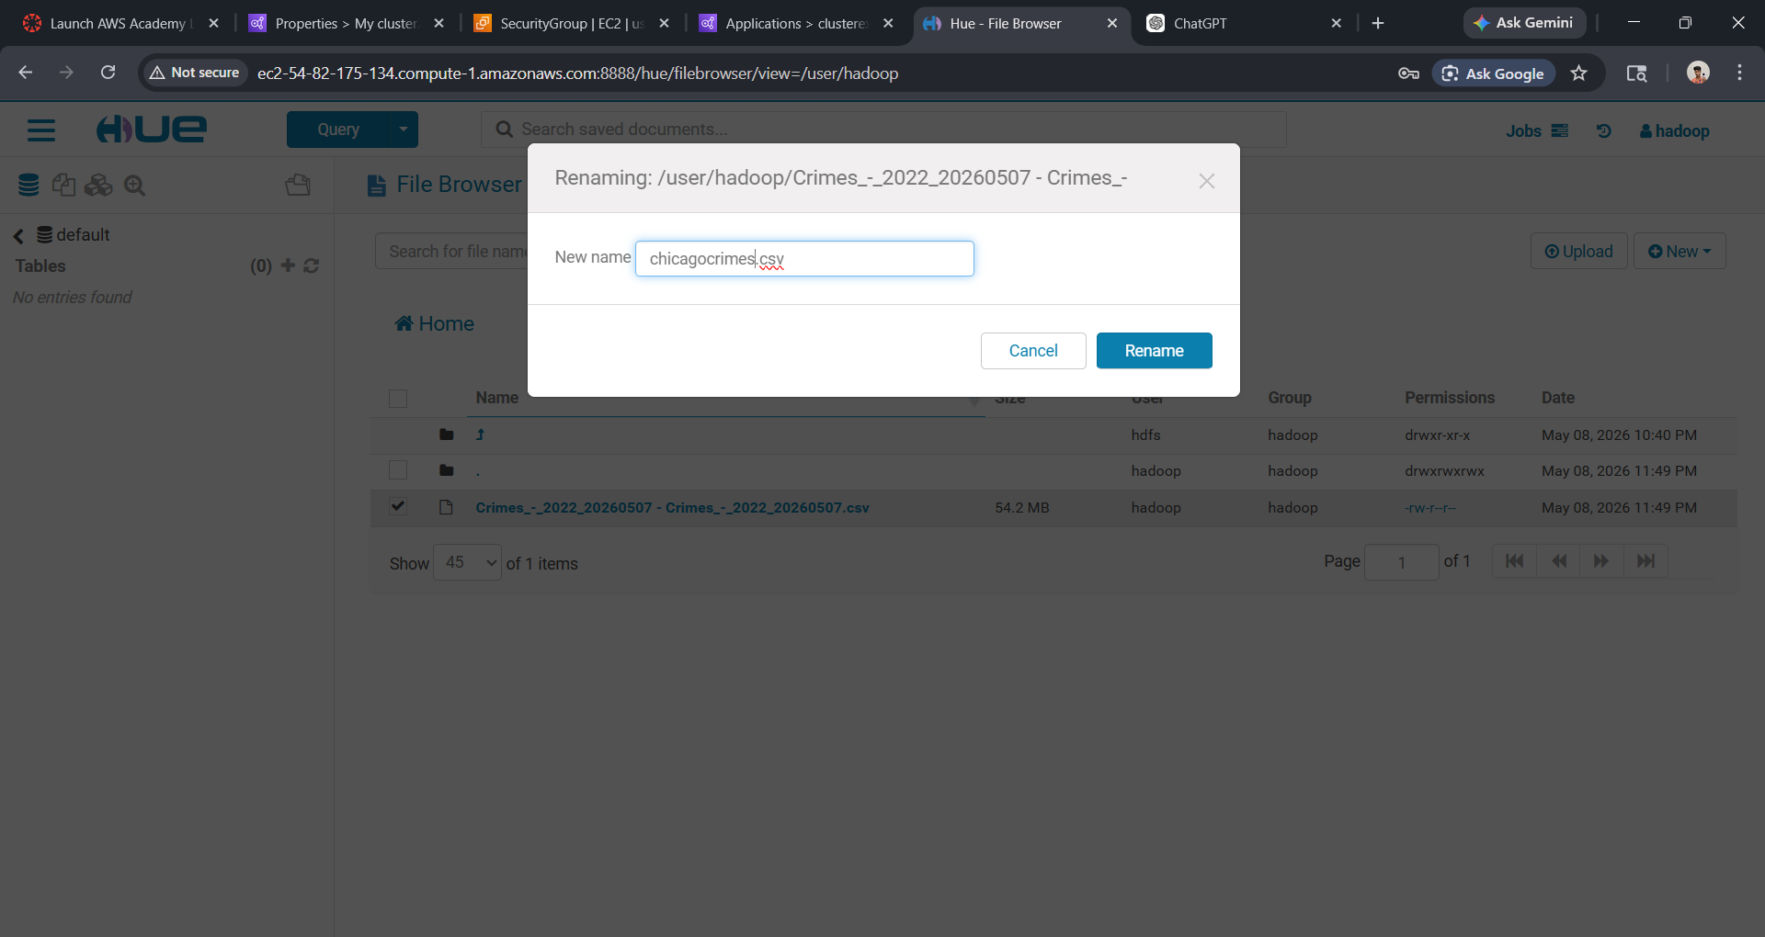
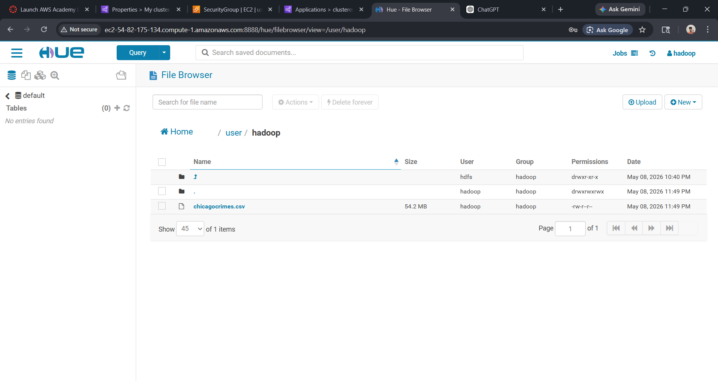
now using emr hive thorugh mobaxtesm and hue where i have uploaed the csv chicagocrimes.csv in /user/hadoop

part b
table create in with partionitong
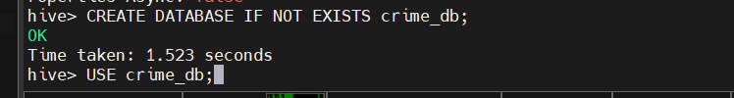
c.using hive shell create an external staging table named crimes_raw with the flowing schema:
crime_id INT,
case_number STRing,
crime_date string
block string,
primary_type sting,
description string,
location_desc string
arrest string,
domestic string,
beat int,
district int
ward int,
community_area int,
crime_year int,
latitude double,
longitude double

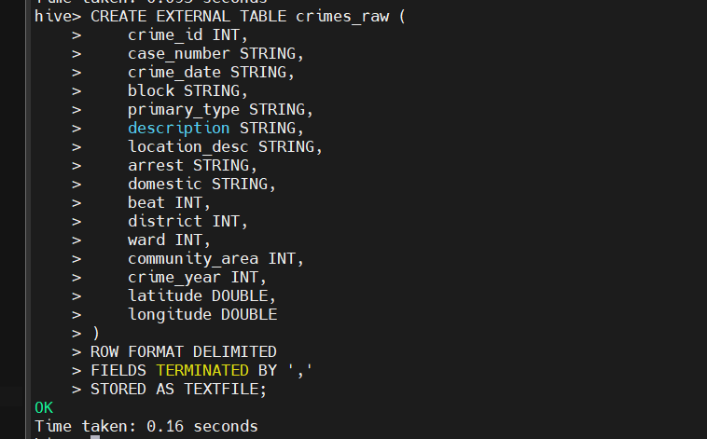
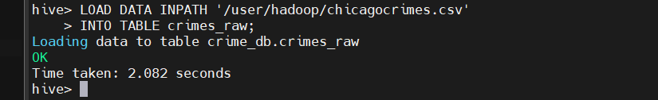
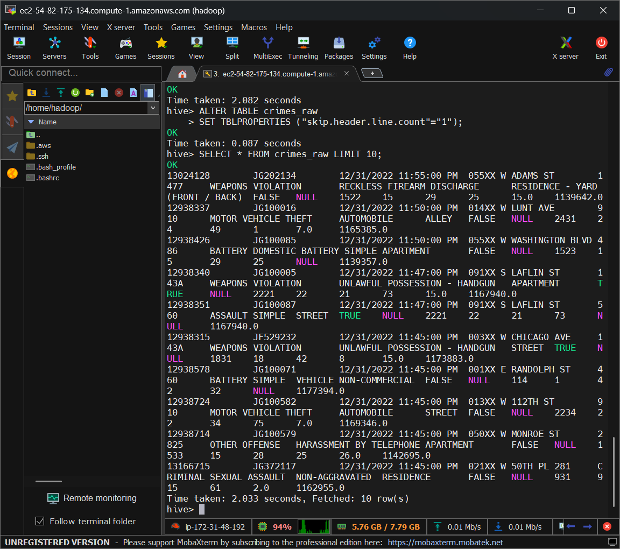

d. create a partitioned and bucketed table named crimes_partitioned , partioned by crime_year and bucketed by district into 4 buckets .load data form crimes_raw into this table
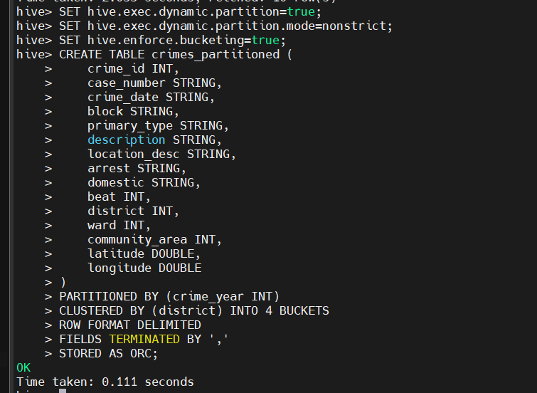
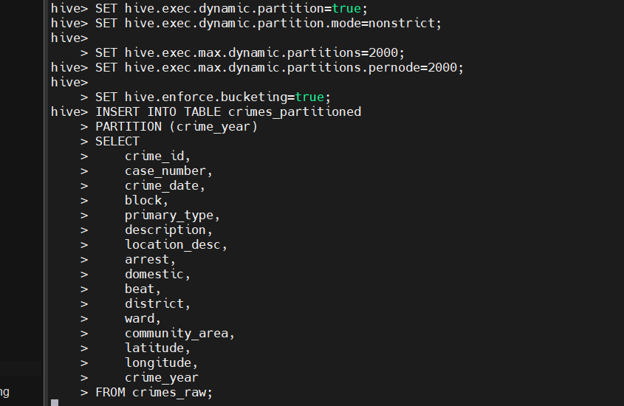
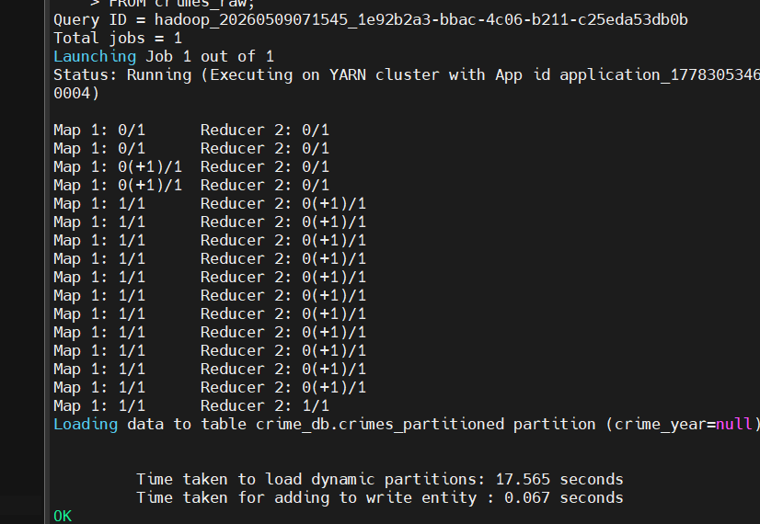

Part c
Write and execute on partitioned table
1.count the total number of crime records in the dataset
2.find the top 5 most frequently occurring crime types (primary_type) , ordered by count descending
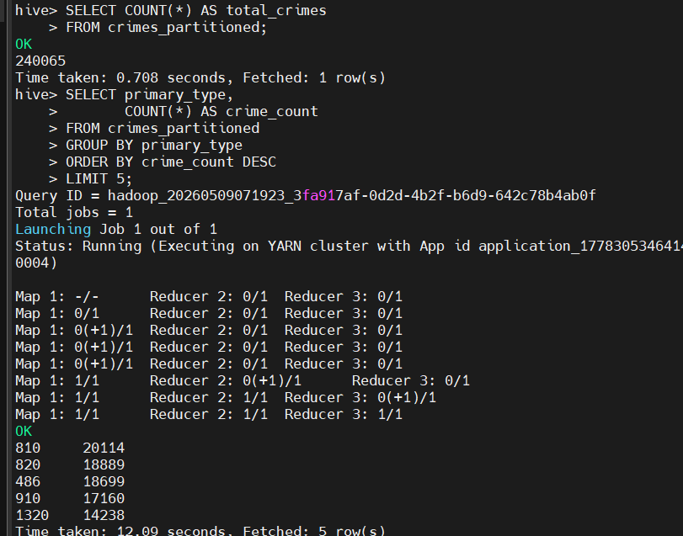

3.calculate the total number of crimes per year (crime_year),ordered by year ascending
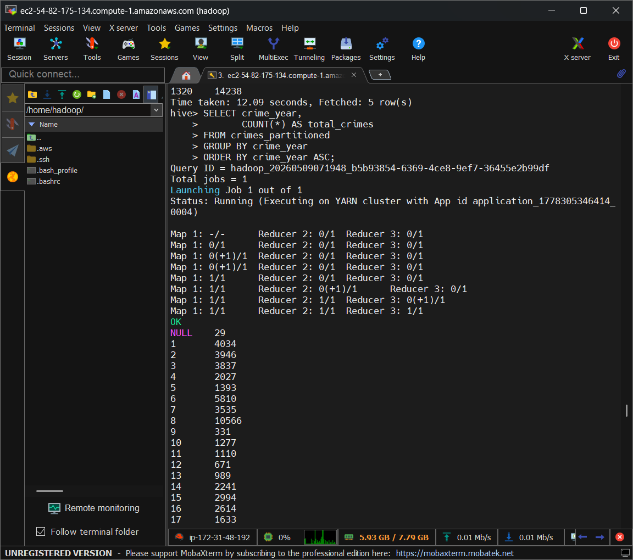
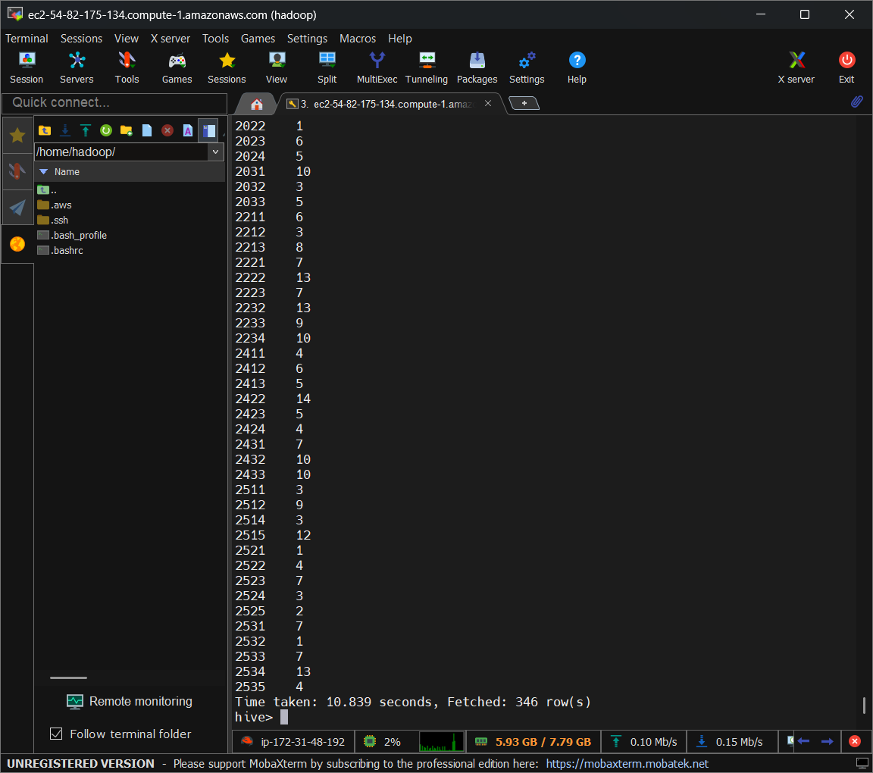

4.find the number of crimes where an arrest was made (arrest =”true’)grouped by primary_type.show only crime types with more than 50 arrests.
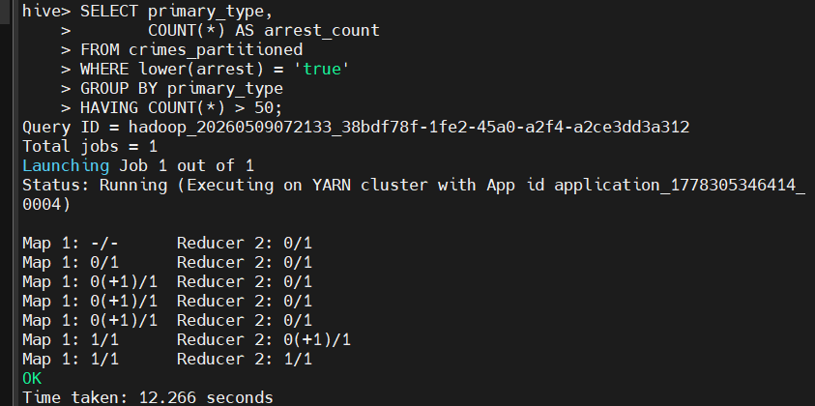

5.using a query on the partitioned table , retrieve all crimes for crime_year=2020.demostrate that hive performes partition pruning by noticing the number of partitons scanned in that output

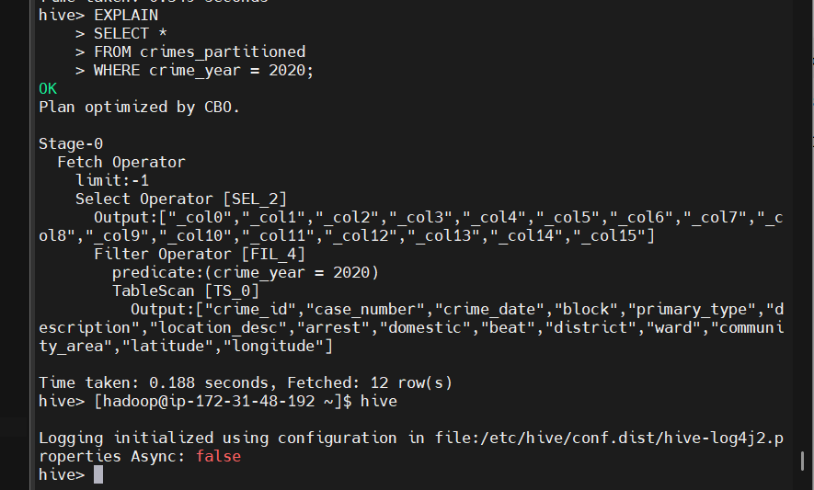

6. find the top 3 disticts with the highest number of domestic crimes (domestic=”true”).order by count descding

