Evaluation-Protocol Leakage in Cuffless Blood Pressure Estimation from PPG: How Much It Inflates Accuracy, and How Much Brief Personalization Recovers, Across Five Model Architectures
[Author names and affiliations removed for blind review; see separate title page]
Abstract
Background. Photoplethysmography (PPG)-based cuffless blood pressure (BP) estimation is often evaluated with splits that allow clips from the same patient on both sides of training and testing, inflating apparent accuracy relative to the scenario that matters for deployment: a genuinely new user, such as an older adult wearing a consumer watch for ongoing BP awareness.
Research aim. How much does evaluation-protocol leakage inflate accuracy; is the inflation architecture-dependent; what does correcting BP-value class imbalance cost and buy per architecture; and how much does brief few-shot personalization recover, including under a calibration/evaluation split genuinely separated in time rather than only in clip identity?
Methods. Five models spanning classical (Random Forest, Gradient Boosting) and deep (1D-CNN, ResNet1D, Transformer) architectures were trained on PulseDB's VitalDB subset (1,164 subjects) and evaluated under four protocols differing only in which patients/clips appear in the test set, with PPG-DaLiA as an external, label-free check. Personalization fit a per-subject affine correction from k = 1-25 calibration clips, scored on storage-order and chronological held-out clips.
Results. The calibration-free accuracy gap, relative to same-patient testing, ranged from 1.09x (Transformer) to 2.28x (ResNet1D), confirming architecture-dependence. BP-bin weighting recovered 4-18 mmHg in the rare, critical high-BP range, costing 0.2-2.8 mmHg mean error depending on architecture. Twenty-five calibration clips cut diastolic MAE by a fifth to a half, within 0.3 mmHg of each model's physiological ceiling; systolic spread stayed above the AAMI threshold regardless, and under chronological calibration no model met that threshold at any size tested.
Conclusions. Evaluation-protocol choice changes cuffless-BP accuracy by more than published architecture progress on this benchmark, and that effect is itself architecture-dependent. Personalization recovers most of the physiologically recoverable diastolic error but not systolic spread, and part of its apparent benefit reflects short-term signal continuity rather than stable calibration.
Keywords: cuffless blood pressure; photoplethysmography; evaluation leakage; personalization; wearable sensors
Introduction
Hypertension affects an estimated 1.3 billion adults worldwide, yet fewer than a quarter have it adequately controlled (World Health Organization [WHO], 2023), and its prevalence rises sharply with age — from roughly 27% below age 60 to over 74% above age 80 (Oliveros et al., 2020). The population most burdened by hypertension is also the population least served by cuff-based self-monitoring: the number of adults aged 60 and over is projected to double, from roughly 1 billion in 2020 to 2.1 billion by 2050 (WHO, 2025), and gerontechnology research consistently identifies unobtrusive, continuous physiological monitoring as central to supporting independent aging in place (Olmedo-Aguirre et al., 2022). A wrist-worn device capable of estimating blood pressure (BP) from photoplethysmography (PPG) — the same optical pulse sensor already present in most consumer smartwatches — would let an older adult track BP trends during ordinary daily activity, without the burden of a cuff, addressing a documented gap between measurement frequency and the clinical value of trend awareness in this population.
The physiological basis for this approach is well established: the time it takes a pressure pulse to travel between two arterial sites (pulse transit time, PTT) is related to arterial stiffness and, through it, to BP (Mukkamala et al., 2015), and a PPG waveform's morphology — not only its timing relative to a second sensor — carries additional information correlated with BP (Elgendi et al., 2019). Translating this relationship into an accurate estimator has become predominantly a machine-learning problem over the past decade, with reported architectures spanning classical regression on hand-crafted pulse-wave features, convolutional networks operating on the raw waveform, U-Net-style encoder-decoders, and most recently transformers conditioned on patient demographics (Arjomand et al., 2024; Chen et al., 2024; Huang et al., 2024; Shen et al., 2026). Reported mean absolute errors (MAE) on large public benchmarks span roughly 4-13 mmHg depending on the study (Huang et al., 2024; Moulaeifard et al., 2025; Shen et al., 2026). However, as this study demonstrates, the evaluation protocol underlying these numbers varies sharply across studies, and protocol choice alone can move a single model's reported MAE by more than the apparent improvement from several years of published architecture progress on the same benchmark.
Within this landscape, the five architectures compared here sit at different points. Tree ensembles on hand-crafted features remain a competitive, GPU-free baseline in several studies despite their simplicity. Convolutional and residual networks on the raw waveform are the most widely benchmarked deep family: Moulaeifard et al. (2025) compare several such architectures (including XResNet1d101, used as a reference point below) under both calibrated and calibration-free evaluation on this same VitalDB subset, reporting a similar calibrated-versus-uncalibrated gap for a single architecture to the one this study measures across five. Encoder-decoder and attention-augmented hybrids (Chen et al., 2024; Huang et al., 2024) add cross-scale or cross-channel feature fusion on top of a convolutional backbone, and Chen et al.'s (2024) rU-Net additionally reports fine-tuning on a new subject's own labelled segments — the closest published precedent for the personalization step evaluated here, though without checking calibration/evaluation temporal separation. Transformer architectures conditioned on patient demographics (Arjomand et al., 2024; Shen et al., 2026) report the strongest published calibration-free numbers on this benchmark to date, which is part of why the Transformer's full evaluation across all four protocols — completed only in the latter stage of this study, see Discussion — mattered enough to revise this study's own working conclusion about which architecture has the smallest leakage gap.
The central methodological hazard is patient-level leakage: if clips from a given patient's recording appear on both sides of a train/test split, a model can partially learn that patient's individual PPG-to-BP mapping rather than the general physiological relationship, and its reported accuracy on "new" clips from that same patient does not reflect its accuracy on a genuinely new patient. This is not unique to blood pressure estimation: a review of machine-learning-based science found leakage of this general kind in at least 294 papers across 17 scientific fields, frequently sufficient to overturn a paper's central claim once corrected (Kapoor & Narayanan, 2023). Within cuffless BP specifically, a recent methodological review recommends that every study report performance stratified by whether test subjects were seen during training, alongside several other standardized evaluation steps, as a minimum bar for cross-study comparability (Elgendi et al., 2024). PulseDB (Wang et al., 2022), the benchmark used throughout this study, ships three official protocols precisely to make the seen/unseen distinction testable: a leaky split in which both patient and clips may overlap between training and testing, a calibration-based split in which test patients were seen during training but the specific test clips were held out, and a calibration-free split in which the test patients never appear in training at all. A fourth protocol, built by PulseDB specifically to meet the Association for the Advancement of Medical Instrumentation's (AAMI) sampling requirements under the AAMI/ESH/ISO universal validation standard (Stergiou et al., 2018), selects an additional unseen-patient cohort spanning the full BP range. Despite this infrastructure, many published cuffless-BP comparisons report a single accuracy number without always making clear which of these regimes it reflects, making it difficult for a reader to judge how much of a reported gain reflects a genuinely better model rather than a more lenient test.
A second, related methodological question concerns personalization. The motivating use case for this class of device — an older adult who wants ongoing BP awareness without a cuff — plausibly tolerates a short calibration step against a reference device, after which the wearable operates calibration-free. Prior work fine-tuning on a small number of a new subject's own labelled segments (Chen et al., 2024) reports substantial error reduction, but does not test whether the calibration segments selected are drawn close in time to the segments being scored — raising the possibility that apparent personalization gains partly reflect short-term signal continuity (the same within-session physiological state or sensor-contact condition) rather than a stable per-patient calibration that would survive to a later use of the device. This concern echoes a session-leakage finding independently reported for PPG-based BP evaluation by Tae et al. (2026), using a change-point-aware buffered evaluation protocol on a different dataset; the present study raises the same concern specifically for calibration-based personalization on PulseDB.
This study addresses four questions on PulseDB's VitalDB subset, extended with an external, label-free wearable dataset (PPG-DaLiA; Reiss et al., 2019) as a distribution-shift check: (1) how much does calibration-free evaluation reduce apparent accuracy relative to same-patient testing, across a representative range of architectures from classical ensembles to a demographic-conditioned transformer; (2) is this reduction architecture-dependent; (3) what does correcting for the skewed, normotensive-heavy distribution of training BP values cost and buy, per architecture; and (4) how much of the calibration-free gap does brief few-shot personalization recover, and does that recovery survive a genuinely chronologically separated calibration/evaluation split rather than one separated only by clip identity. Addressing these questions together, on the same five models and the same benchmark, allows this study to report not only whether a given accuracy number is favourable, but how much of it is attributable to evaluation protocol rather than to the model.
Methods
Datasets
Models were trained and evaluated on the VitalDB-derived subset of PulseDB (Wang et al., 2022), comprising 10-second, 125 Hz PPG and ECG segments with paired systolic and diastolic BP (SBP, DBP) labels, band-pass filtered and minimum-maximum scaled to [0, 1] by PulseDB's own release pipeline. The training pool contained 419,040 clips from 1,164 subjects after a 10% subject-disjoint validation hold-out (46,440 clips) used for best-checkpoint selection. Four official PulseDB test splits were used, detailed under Protocols below. An independent wearable dataset, PPG-DaLiA (Reiss et al., 2019; 15 volunteers, wrist-worn sensor, ordinary daily activity, no BP labels), served as an external check on whether PulseDB-trained models produce physiologically plausible and internally consistent output when applied to a free-living, consumer-grade recording; PPG-DaLiA's own heart-rate labels were used as a secondary sanity check on signal quality, since no comparable sanity check is possible for BP.
Protocols
Four protocols, differing only in which patients and clips were assigned to the test set, were applied to every model with training otherwise held fixed: leaky (clips drawn at random from the full subject pool, so a given patient's clips may appear in both training and test); calibration-based (test subjects were seen during training; only specific held-out clips differ); calibration-free (144 subjects never seen during training); and AAMI (116 subjects, unseen, selected by PulseDB to span the full clinical BP range). Calibration-free is the protocol most representative of a genuinely new user and is treated throughout as the primary evaluation.
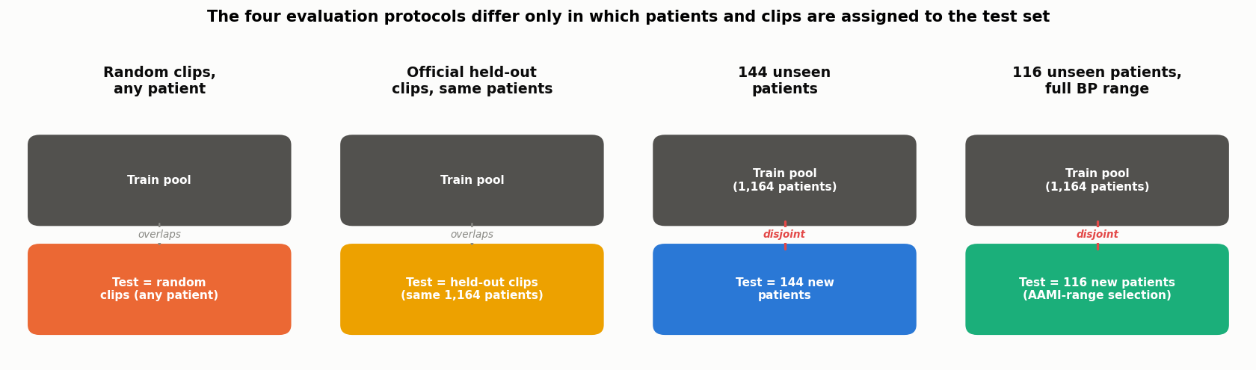
Figure 1. Study design: the four evaluation protocols differ only in which patients and clips are assigned to the test set. Leaky and calibration-based test on previously seen patients; calibration-free and AAMI test on genuinely unseen ones.
Models
Five architectures were compared. Random Forest and Gradient Boosting were trained on 61 hand-crafted morphological and demographic features per clip (300 trees / 500 boosting rounds respectively). 1D-CNN (five convolutional blocks, 381,186 parameters) and ResNet1D (eight residual blocks across four stages, ResNet-18 style, 2.19M parameters) operated on the raw two-channel (ECG + PPG) waveform. The Transformer (1.41M parameters) followed the patch-10 self-attention architecture with demographic FiLM conditioning and a morphology-classification auxiliary head reported by Shen et al. (2026), reproduced as closely as the published description allows: PPG-only input, per-clip z-score scaling, Adam optimizer (weight decay 1e-8, fixed learning rate 2e-5), batch size 32. Two deliberate deviations from that recipe were made for cross-model budget parity and simplicity: a single joint network predicting both SBP and DBP (rather than two independent networks), and 50 training epochs (rather than 100). The auxiliary morphology label itself is this project's own composite of three PPG-morphology proxies, since the source paper cites an aggregation rule from unspecified prior work. Classical models and CNN/ResNet1D used AdamW (weight decay 1e-4) with a OneCycle learning-rate schedule; ResNet1D and 1D-CNN's primary calibration-free result used a schedule decoupled from total epoch count (fixed 20-epoch anneal, regardless of the 50-epoch total budget), to avoid confounding "more training" with "a differently shaped learning-rate curve" when comparing training budgets. For every model, the best-validation-checkpoint was used for test-set scoring; final-epoch weights were never used unless they coincided with the best checkpoint.
Table 1. Architecture and training configuration summary.
Model | Input | Params | Optimizer | Epochs / batch
Random Forest | 61 hand-crafted features | 300 trees | n/a | n/a
Gradient Boosting | 61 hand-crafted features | 500 rounds | n/a | n/a
1D-CNN | raw ECG+PPG waveform | 381,186 | AdamW | 50 / 256
ResNet1D | raw ECG+PPG waveform | 2.19M | AdamW | 50 / 256
Transformer | raw PPG waveform (z-score) | 1.41M | Adam | 50 / 32

BP-bin weighting
Training BP values in PulseDB are heavily skewed toward the normotensive range (71.7% of training clips fall in 90-130 mmHg systolic; only 0.7% exceed 170 mmHg), which can bias a model toward predicting near the population mean — accurate on average, but least accurate exactly where a cuffless monitor's clinical value is highest. A weighted-loss correction, inversely proportional to each BP bin's training frequency (up to 24.7x for the rarest bin), was applied during training for every model and compared against an otherwise identical unweighted run, so that its cost and benefit could be measured directly rather than assumed.
Personalization
Per-subject personalization fit an affine correction, corrected = a x predicted + b, from k = 1, 3, 5, 10, or 25 of a held-out subject's own calibration-free test clips, with a and b fit by least squares on those k clips alone and applied to the subject's remaining clips. Three ways of selecting which k clips to use were compared (first in storage order, random, and spread evenly through the recording); results below use the first-k selection, matching a literal reading of a short calibration step. Because PulseDB's released calibration-free test file does not carry a session or case identifier (confirmed directly by inspecting its fields), a genuinely cross-session personalization test is not possible on this data; instead, two readings of "first k clips" were compared. The naive reading takes the first k clips in the file's storage order; a direct check found storage order uncorrelated with true recording time (r = 0.01, using PulseDB's segment-index field), so this selection scatters calibration clips across the full recording session, placing an evaluation clip within roughly 3 minutes of a calibration clip on average — plausibly close enough for a model to exploit short-term signal continuity rather than a stable physiological calibration. The chronological reading instead sorts by the genuine segment-index field, takes the true earliest k clips as calibration, and scores only clips later in the same session (approximately 70 minutes later on average) — the strongest cross-time test this single-session dataset supports, though not a literal cross-session test.
Evaluation metrics and statistical treatment
MAE, mean error (bias), and error standard deviation (SD) were computed separately for SBP and DBP on every run. AAMI pass/fail status required bias within +/-5 mmHg and SD within 8 mmHg jointly; British Hypertension Society (BHS) grade (O'Brien et al., 1990) required, for grade A, 60% of predictions within 5 mmHg, 85% within 10 mmHg, and 95% within 15 mmHg of true BP (grade D otherwise fails all three). Three training seeds were run for calibration-free (all five models) and, to test whether the architecture-dependence finding below is a seed artefact, for calibration-based and leaky protocols on the two convolutional architectures specifically. Where three seeds exist, 95% confidence intervals use a t-distribution (df = 2); single-seed results are reported descriptively, without a confidence interval, and are flagged as such in Results.
Results
The calibration-free gap is large and architecture-dependent
Table 2 reports MAE for every model under every protocol. Relative to the average of leaky and calibration-based performance (both of which test on previously seen patients), calibration-free accuracy was 1.09 to 2.28 times worse, depending on architecture (Figure 2). The Transformer showed the smallest gap (1.09x: 14.13 mmHg seen-patient average versus 15.44 mmHg calibration-free), not because it is uniformly the most accurate architecture — it is in fact the worst of the five on the calibration-based protocol specifically (13.80 mmHg) — but because it does not benefit from already-seen patients to the same degree the other four architectures do. ResNet1D showed the largest gap (2.28x: 6.12 mmHg seen-patient average versus 13.96 mmHg calibration-free), the sharpest instance of a pattern visible to a lesser degree in Random Forest and Gradient Boosting: strong apparent accuracy on seen patients that does not transfer to new ones. This architecture-dependence held up under a three-seed check on the two convolutional architectures' calibration-based and leaky results specifically (standard deviations 0.25-0.90 mmHg across seeds, an order of magnitude smaller than the gaps separating architectures).
Table 2. Mean absolute error (SBP / DBP, mmHg) by model and protocol. * = three-seed mean. † = single schedule-fixed run (1D-CNN/ResNet1D calfree-weighted only; see Methods), not seed-averaged. (w) = BP-bin weighted (the primary number); (u) = unweighted (comparable to prior published numbers, which do not apply this correction). Unmarked cells are single seed-0 runs.
Model | calfree (w) | calfree (u) | calbased | leaky | AAMI
Random Forest | 12.77/8.39* | 12.81/8.59* | 7.14/4.11 | 7.47/4.34 | 19.67/12.24
Gradient Boosting | 14.67/8.98* | 12.76/8.33* | 10.20/6.03 | 10.29/6.13 | 17.44/11.14
1D-CNN | 14.89/9.04† | 13.01/8.34 | 10.15/6.55* | 10.36/6.80* | 16.53/11.20
ResNet1D | 13.94/8.94† | 13.21/8.53 | 6.71/4.26* | 6.41/4.03* | 17.70/11.40
Transformer | 15.81/8.71* | 12.89/7.91* | 13.90/8.06* | 13.90/7.96* | 17.03/10.15

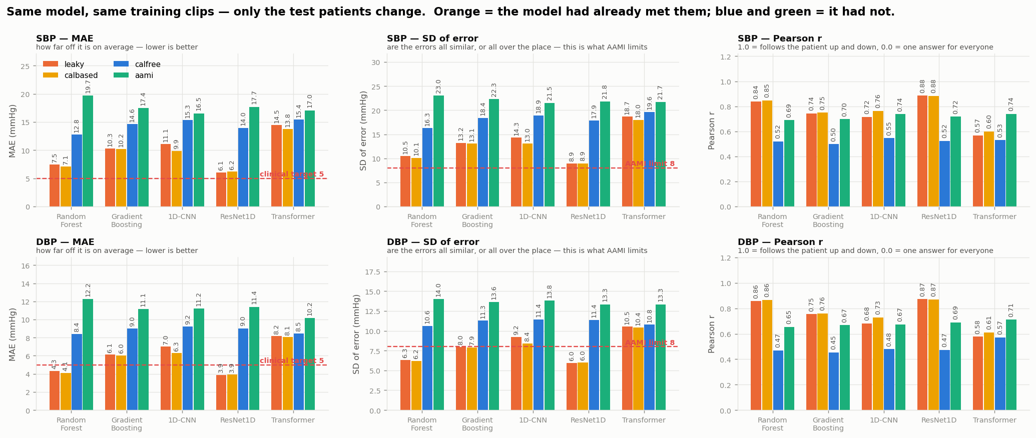
Figure 2. Known-patient (leaky/calibration-based average) versus calibration-free accuracy, all five models, SBP and DBP. Orange/yellow bars test on previously seen patients; blue/aqua bars test on unseen patients.
Table 3 reports the full clinical metric set — correlation, AAMI pass/fail, and BHS grade — for the calibration-free (weighted) result. Pearson r is modest across the board (0.45-0.57), confirming that none of the five models track an individual patient's BP up and down reliably on unseen patients; the Transformer's DBP correlation (0.57) is the highest of any model/target pair, consistent with it carrying the least calibration-free penalty overall. Every model fails BHS grade D (the lowest) and AAMI on calibration-free, for both targets — the correlation and grade numbers tell the same story as the MAE numbers above, from a different angle.
Table 3. Full clinical metric set, calibration-free (weighted), all five models.
Model | SBP r | SBP AAMI | SBP BHS | DBP r | DBP AAMI | DBP BHS
Random Forest | 0.518 | FAIL | D | 0.468 | FAIL | D
Gradient Boosting | 0.497 | FAIL | D | 0.454 | FAIL | D
1D-CNN | 0.546 | FAIL | D | 0.479 | FAIL | D
ResNet1D | 0.525 | FAIL | D | 0.473 | FAIL | D
Transformer | 0.530 | FAIL | D | 0.570 | FAIL | D

BP-bin weighting trades overall accuracy for high-BP coverage, with no single best answer
BP-bin weighting's effect was architecture-specific rather than uniformly beneficial. It cost essentially nothing for Random Forest (-0.18 mmHg overall, i.e. a negligible net improvement) while recovering 4.05 mmHg of error in the above-170-mmHg band; it cost the Transformer the most overall (+2.77 mmHg) while recovering the second-most in that same high-BP band (16.41 mmHg, behind only the CNN's 17.52 mmHg). Below 130 mmHg systolic (72% of test clips), the unweighted model was frequently equal or better; above 150 mmHg, weighting's benefit was consistent and clinically meaningful across every architecture tested. No single weighted/unweighted choice dominated across architectures, which is why both are reported throughout this study rather than collapsed to one number (Figure 3): the overall cost is small and architecture-specific, while the high-BP benefit is an order of magnitude larger for every architecture, consistent with weighting's cost being concentrated in the crowded normotensive middle of the training distribution and its benefit in the sparse, clinically critical extremes.
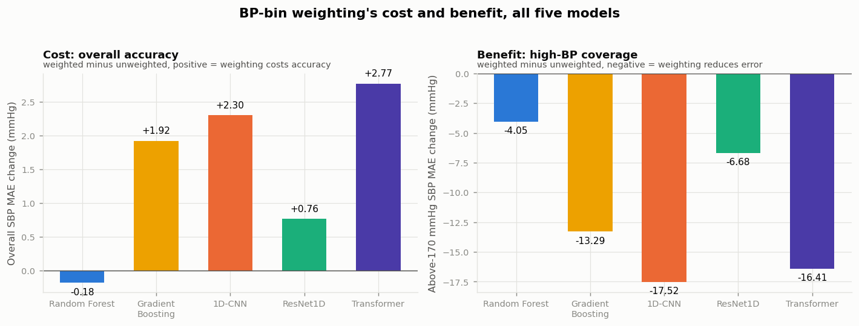
Figure 3. BP-bin weighting's cost (overall SBP MAE change) and benefit (above-170 mmHg SBP MAE change), weighted minus unweighted training, all five models.
Against the literature
Figure 4 compares this study's calibration-free, unweighted results (matching how prior published numbers were measured, since the BP-bin weighting above is not standard practice) against four prior studies on the same VitalDB subset. The Transformer's unweighted result (12.67 mmHg SBP, three-seed mean 12.89, SD 0.32) was the closest match to the current best published number, Shen et al.'s (2026) demographic-conditioned transformer (12.17 mmHg) — within half a point of it, and ahead of every other architecture tested here as well as of Moulaeifard et al.'s (2025) XResNet1d101 benchmark (12.70 mmHg). The 1D-CNN's unweighted result (13.01 mmHg, three-seed mean 13.04, SD 0.12) was close behind. Taken together with the architecture-dependence finding above, the gap between four years of published architecture progress on this benchmark — roughly 12.17 to 13.67 mmHg across the four prior studies compared here — is smaller than the 1.09x-2.28x gap this study measures from evaluation protocol alone on a single model architecture. This is evidence about this benchmark specifically, not a general claim about the field, since it reflects four studies rather than an exhaustive literature search.
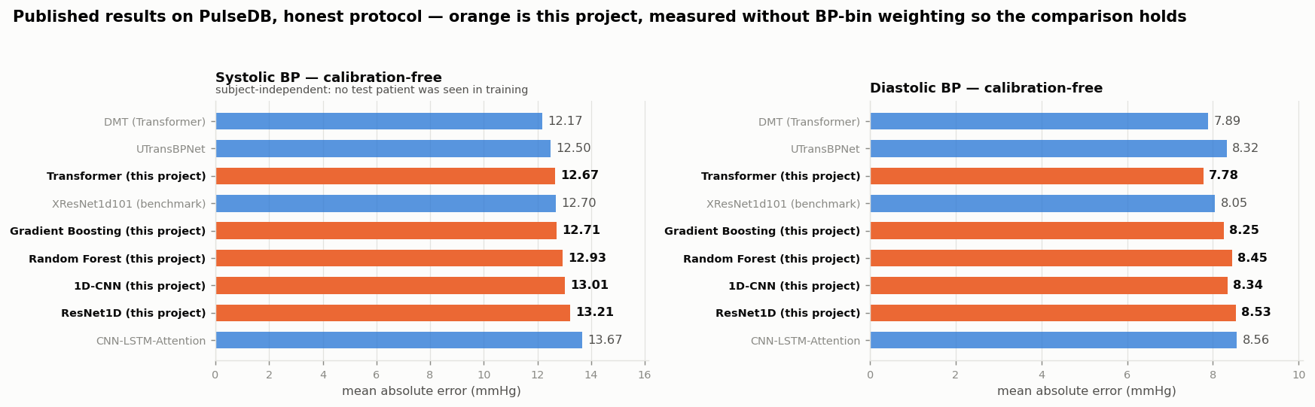
Figure 4. Calibration-free SBP MAE, this study (orange, unweighted) against four prior studies on the same PulseDB VitalDB subset (blue).
An unseen-patient test set does not guarantee AAMI-compliant sampling
Because nearly every calibration-free AAMI pass/fail claim in this and comparable studies is computed on the calibration-free test split, whether that split itself satisfies AAMI/ISO 81060-2's own sampling requirement for reference-BP coverage was checked directly (Table 4). It does not: the calibration-free split fails the standard's requirement on three of its four BP-range criteria for both SBP and DBP (for example, only 1.5% of subjects reach 160 mmHg systolic, against a 5% requirement). PulseDB's AAMI-specific split, built explicitly to span the full clinical range, passes every criterion. This indicates that AAMI pass/fail claims computed on the calibration-free split describe performance on a population skewed toward normal-to-low BP, and that the AAMI-specific split is the methodologically appropriate one to carry AAMI framing specifically, independent of which split is otherwise preferred for leakage control.
Table 4. AAMI/ISO 81060-2 sampling-coverage check, calibration-free versus AAMI-specific test splits.
Requirement | calfree_test (n=144) | aami_test (n=116)
N >= 85 | PASS (144) | PASS (116)
SBP <=10 mmHg in >=5% | PASS (21.3%) | PASS (15.6%)
SBP >=160 mmHg in >=5% | FAIL (1.5%) | PASS (21.5%)
SBP >=140 mmHg in >=20% | FAIL (10.3%) | PASS (42.6%)
DBP <=60 mmHg in >=5% | PASS (41.2%) | PASS (24.5%)
DBP >=100 mmHg in >=5% | FAIL (0.3%) | PASS (10.5%)
DBP >=85 mmHg in >=20% | FAIL (4.1%) | PASS (31.5%)
An external, label-free wearable check
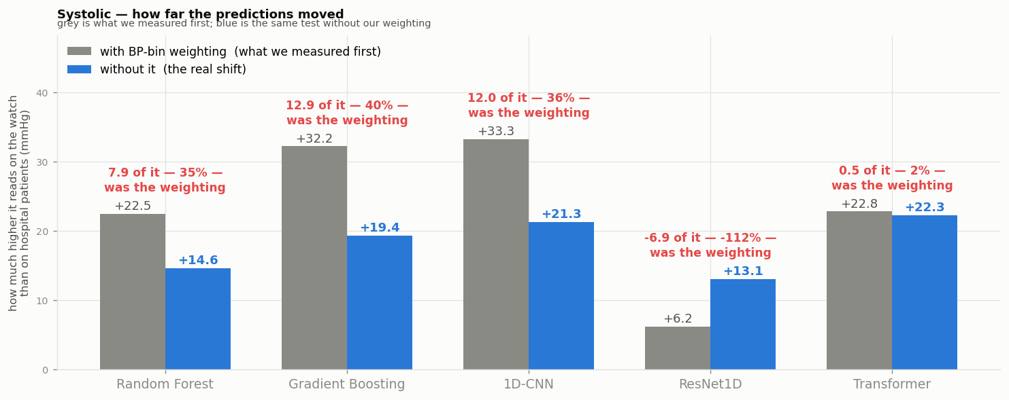
Figure 5. Predicted SBP shift from PulseDB to PPG-DaLiA, weighted versus unweighted training, all five models.
On PPG-DaLiA, every model's mean predicted SBP across the 15 volunteers exceeded the healthy-adult norm, and models still separated individuals by 2.1-9.6 mmHg (true between-subject spread: 11.8 mmHg), indicating the shift onto this external device-and-population combination does not collapse all subjects to a single value (Figure 5). The fraction of the apparent shift attributable to BP-bin weighting itself (rather than to the new device/population) ranged from 2% (Transformer) to 40% (Gradient Boosting) across four of the five models; ResNet1D was a reversed outlier, where weighting reduced rather than enlarged the apparent shift. Heart-rate MAE, the only metric on this dataset with ground truth, was 13.06 bpm in low-motion activity segments (sitting, lunch, working, driving) and 33.35 bpm in high-motion segments (cycling, stairs, walking, table soccer, transient) using this study's generic pulse detector, against 8.69 bpm reported by Reiss et al. (2019) using a dedicated denoiser on the same data — a reminder that the BP numbers above likely carry additional, unmeasured error from signal-processing choices beyond the BP-estimation model itself.
A second, independent label-free check is the fraction of each model's PPG-DaLiA predictions that fall outside physiologically plausible clinical range (SBP outside 70-200 mmHg or DBP outside 40-120 mmHg; Table 5). No model ever predicts DBP above SBP for the same clip. Beyond that, the rate of out-of-range predictions spans two orders of magnitude by architecture, from 0.5% (Transformer) to 29.7% (Gradient Boosting); the two classical ensembles produce an implausible prediction on roughly one clip in four to one in three, while the three deep models stay under 3.4%. This is a plausibility check rather than an accuracy check — it does not require true labels and cannot confirm a prediction is correct, only flag predictions that are certainly wrong — and it reinforces this study's feature-representation finding that representation choice affects out-of-distribution behaviour beyond what calibration-free MAE alone shows.
Table 5. Physiologically implausible predictions on PPG-DaLiA (% of clips outside SBP 70-200 mmHg or DBP 40-120 mmHg), all five models. DBP exceeding SBP on the same clip: 0.0% for every model.
Model | SBP out of range | DBP out of range | Any
Random Forest | 0.0% | 27.2% | 27.2%
Gradient Boosting | 13.8% | 25.7% | 29.7%
1D-CNN | 2.0% | 2.2% | 3.4%
ResNet1D | 0.0% | 0.8% | 0.8%
Transformer | 0.3% | 0.5% | 0.5%

Personalization closes most of the diastolic gap, not the systolic one
Table 7 and Figure 6 report personalization results. Under the naive (storage-order) calibration split, 25 clips reduced diastolic MAE by 20-51% across the five models (e.g. Random Forest: 8.38 to 4.81 mmHg), and every model passed AAMI's diastolic criterion from roughly five calibration clips onward. This recovery came within 0.3 mmHg of each architecture's physiological ceiling (Table 6) — the best possible constant per-subject offset, computed directly from each subject's true held-out labels and therefore unreachable in real deployment, but useful to show the remaining room (e.g. 1D-CNN: raw SBP MAE 15.32 mmHg, oracle ceiling 9.03 mmHg, realised 25-clip result 7.74 mmHg). Across all five models, 33-41% of raw SBP error and 40-46% of raw DBP error was this kind of fixable, constant per-subject offset; the remainder reflects within-subject BP variability that a constant correction cannot track, since systolic BP varies more within one subject's own recording (SD 13.9 mmHg, 1D-CNN) than it does between different subjects (11.8 mmHg).
Table 6. Personalization ceiling: raw MAE versus the oracle (true-label) per-subject offset, all five models.
Model | SBP raw->oracle | SBP recov. | DBP raw->oracle | DBP recov.
Random Forest | 12.76->8.48 | 33% | 8.38->4.98 | 41%
Gradient Boosting | 14.63->8.77 | 40% | 9.00->5.15 | 43%
1D-CNN | 15.32->9.03 | 41% | 9.20->5.00 | 46%
ResNet1D | 13.96->9.01 | 35% | 9.03->5.46 | 40%
Transformer | 15.44->9.34 | 39% | 8.47->4.94 | 42%

Under the chronological calibration split, the picture changed substantially. Diastolic MAE still improved (e.g. Random Forest: 8.38 to 7.32 mmHg), but no model met AAMI's spread criterion at any calibration size from 1 to 25 clips, for any of the five architectures — a consistent finding, not a mixed one. Bias stayed under 2 mmHg throughout under this split, so the AAMI shortfall reflects error spread specifically, not a systematic offset the correction failed to remove. The gap between the two splits' outcomes is consistent with the storage-order split allowing the correction to exploit short-term signal continuity (an average 3-minute gap between a calibration and an evaluation clip) that does not persist across the roughly 70-minute gap the chronological split enforces — the same general concern Tae et al. (2026) raise for PPG-based BP evaluation, observed here in the specific context of few-shot personalization.
Table 7. Diastolic MAE (mmHg) at k=0 and k=25 calibration clips, naive (storage-order) versus chronological split, all five models. Pass/fail is AAMI status at k=25.
Model | k=0 | k=25 naive | AAMI (naive) | k=25 chron. | AAMI (chron.)
Random Forest | 8.38 | 4.81 | PASS | 7.32 | FAIL
Gradient Boosting | 9.00 | 4.74 | PASS | 7.11 | FAIL
1D-CNN | 9.20 | 4.51 | PASS | 7.25 | FAIL
ResNet1D | 9.03 | 4.83 | PASS | 7.38 | FAIL
Transformer | 8.47 | 4.40 | PASS | 6.68 | FAIL

Table 8 gives the full chronological-split sweep underlying this claim: SDE never approaches AAMI's 8 mmHg spread bound at any tested k, for any model, including the largest calibration set tested (k=25, best case 8.75 mmHg, Transformer).
Table 8. Chronological-split DBP MAE / SDE across the full calibration-size sweep (mmHg), all five models. AAMI requires SDE <= 8 mmHg; no cell meets this.
Model | k=1 | k=3 | k=5 | k=10 | k=25
Random Forest | 9.58/12.74 | 11.97/18.96 | 9.46/12.68 | 8.65/11.86 | 7.32/9.68
Gradient Boosting | 9.11/11.84 | 13.11/27.74 | 9.23/12.32 | 7.95/10.53 | 7.11/9.47
1D-CNN | 10.11/13.30 | 11.51/17.35 | 9.39/12.89 | 8.20/10.99 | 7.25/9.75
ResNet1D | 10.54/13.59 | 11.10/15.61 | 9.41/12.68 | 8.44/11.17 | 7.38/9.47
Transformer | 9.60/12.59 | 10.38/14.81 | 8.38/11.23 | 7.60/10.08 | 6.68/8.75

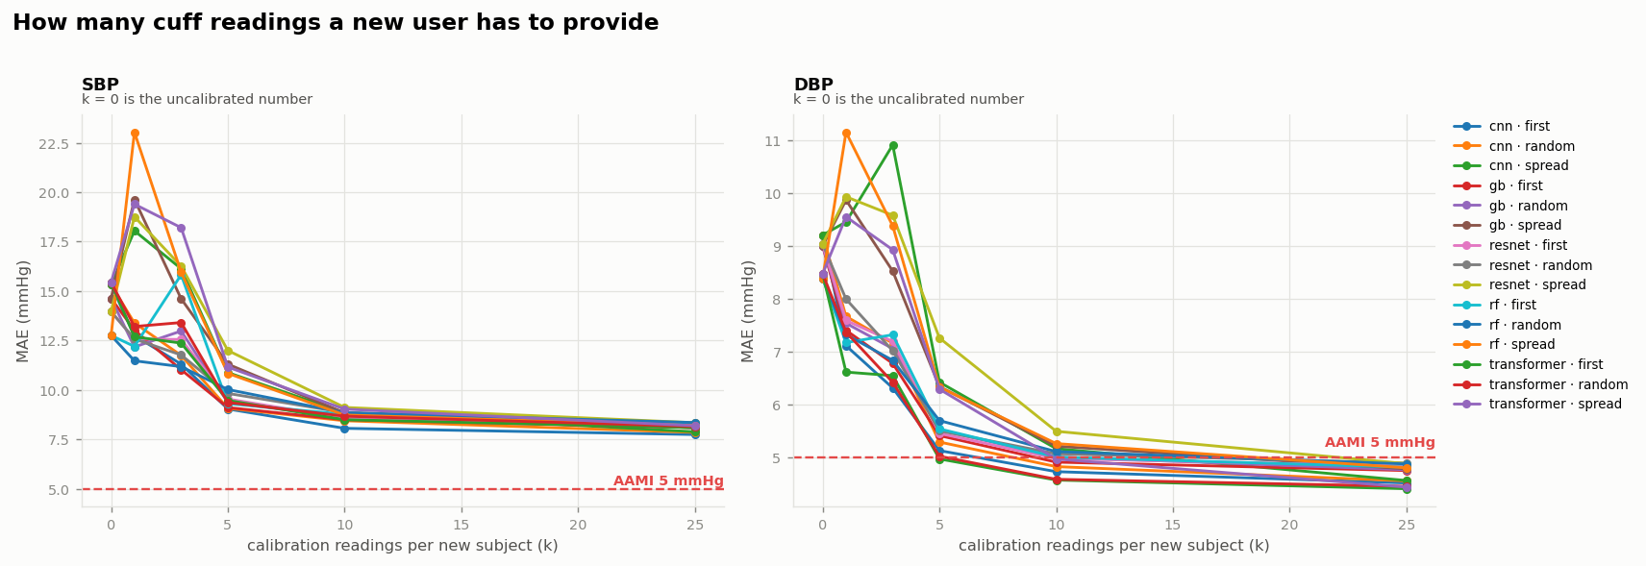
Figure 6. Error reduction as a function of calibration-clip count (k = 0-25), all five models. Most recoverable error is gone by k=5; two models show a brief worsening at k=3, indicating 2-3 clips is too few to fit a stable correction.
Discussion
This study's central finding is that evaluation-protocol choice is not a minor methodological detail for cuffless BP estimation: on a single benchmark, moving from same-patient to unseen-patient testing changed apparent accuracy by 1.09x to 2.28x depending on architecture, a larger effect than the gap separating the best and weakest architecture-progress results compared against in this study. Because this effect is architecture-dependent, a protocol-blind comparison across studies that use different architectures and different (or unstated) protocols risks attributing evaluation-protocol leniency to genuine architectural improvement. Readers and reviewers of cuffless-BP work would benefit from comparisons that hold protocol fixed, as this study attempts, or that at minimum state the protocol explicitly enough for a reader to judge comparability. This sits within a broader, field-spanning pattern: leakage of essentially this kind — information about the test set reaching the model indirectly, rather than through a frankly mislabelled split — has been documented across at least 17 scientific disciplines using machine learning, frequently large enough to overturn a study's central claim once corrected (Kapoor & Narayanan, 2023). The present results are consistent with that pattern holding in cuffless BP estimation specifically, and support the standardized evaluation reporting Elgendi et al. (2024) recommend for the field: in particular, their recommendation that studies report accuracy stratified by whether test subjects were seen during training, rather than a single pooled number.
This finding also revises this study's own earlier working conclusion. An initial analysis, run before the Transformer's evaluation across all four protocols was complete, suggested the Transformer had the largest calibration-free gap of the five architectures. With the complete evaluation, the opposite is true: the Transformer has the smallest gap, and ResNet1D the largest. The direction of the underlying finding — that the model most accurate on previously seen patients is not necessarily the most honest about new ones — holds under either data state, but which specific architecture it is true of does not, which is itself a caution about drawing architecture-level conclusions before every architecture's evaluation is complete.
The AAMI sampling-coverage finding (Table 4) has a direct, practical implication for how this and comparable studies should report AAMI compliance: the test population most commonly used for calibration-free AAMI claims is itself skewed toward normal-to-low BP and does not meet AAMI's own high-BP coverage requirement, independent of model accuracy. This is a property of the test-set construction, not of any model evaluated against it, and would not have been visible from accuracy numbers alone.
The personalization results have a specific and testable implication for deployment: a brief calibration step recovers most of the fixable diastolic error, but only under evaluation conditions this study's chronological-split analysis suggests may not represent later use of the device. Diastolic AAMI compliance achieved under the naive, storage-order split did not survive a genuinely time-separated evaluation, at any calibration size tested. Systolic error's spread did not reach AAMI compliance under either split, and the ceiling analysis indicates why: within-subject systolic variability exceeds between-subject variability on this benchmark, so no constant per-subject correction — however well calibrated — can close that particular gap. Closing it would require modelling beat-to-beat variation rather than a per-subject offset, which is beyond this study's scope.
Several design choices strengthen confidence in these conclusions specifically. Every comparison central to this study's main claims holds the dataset, the clip-level feature pipeline, and the checkpoint-selection rule fixed, varying only the one factor each question is about — protocol for the leakage-gap finding, weighting for the cost/benefit finding, and calibration-clip timing for the personalization finding — so observed differences are not confounded by incidental pipeline changes across comparisons, as can happen when results are pooled across separately published studies. The architecture-dependence finding was checked against seed variance directly (three seeds, two architectures, two protocols) rather than assumed stable from a single run, and the personalization ceiling analysis grounds the practical recommendations in a computable upper bound rather than intuition about how much calibration "should" help. Five architectures spanning three model families (tree ensembles, convolutional networks, and attention) is also a wider sweep than most single-architecture evaluations in this literature, which is what makes the architecture-dependence finding possible to state at all.
Several limitations qualify these conclusions. First, PulseDB's released calibration-free test file does not carry a session or case identifier, so the chronological split used here, while the strongest cross-time test this dataset supports, is a within-session rather than a literal cross-session test; the personalization-recovery figures above should be read as an upper bound on what a genuinely separate-visit calibration would achieve. Second, neither PulseDB (hospital/ICU patients) nor PPG-DaLiA (15 healthy, free-living volunteers, none over 60) is a close demographic match for the motivating use case of an older, ambulatory, consumer-wearable user; PulseDB's patients are not wearing a consumer-grade sensor, and PPG-DaLiA's volunteers are neither old enough nor hypertensive enough to stress-test the clinically relevant range. This reflects what is publicly available for this task rather than a flaw specific to this study, but it means the present results should be read as evidence about measurement methodology, not as a direct estimate of real-world accuracy in the target population. Third, several comparisons reported above (weighted versus unweighted, naive-split versus chronological-split personalization, and leaky/calibration-based results for Random Forest and Gradient Boosting) reflect single training runs rather than seed-averaged estimates, and are reported descriptively rather than with a confidence interval; this study makes on the order of hundreds of such comparisons in total, and none of the confidence intervals reported are corrected for multiple comparisons. Fourth, the Transformer's auxiliary morphology label is this study's own composite proxy, since the source architecture's published description cites an unspecified prior aggregation rule for its own label; this and other unavoidable reproduction choices (a single joint SBP/DBP network, 50 rather than 100 training epochs) mean the remaining gap to the originally published Transformer result should not be attributed to architecture alone.
Finally, the session-leakage concern this study raises for personalization is consistent with, rather than a first report of, independent work: Tae et al. (2026) identify the same general mechanism — temporal proximity between calibration and evaluation data inflating apparent accuracy — for PPG-based BP estimation generally, addressed there through a change-point-aware buffered evaluation protocol on a different dataset. The present study's contribution is a direct demonstration of the same mechanism specifically within few-shot personalization on PulseDB, using the dataset's own (if imperfect) temporal ordering field.
Conclusion
Across five architectures spanning classical ensembles to a demographic-conditioned transformer, evaluation-protocol leakage inflated apparent cuffless-BP accuracy by 1.09x to 2.28x, an effect that is architecture-dependent and, on this benchmark, larger than several years of reported architecture progress. Twenty-five real calibration clips recovered most of the physiologically fixable diastolic error — but this recovery, and the AAMI compliance it enabled, did not survive a genuinely chronologically separated calibration/evaluation split, and systolic error's spread remained above the AAMI threshold regardless of calibration. Future work on cuffless BP estimation for home and wearable use should report evaluation protocol explicitly enough for cross-study comparison, verify that any test split used for AAMI compliance claims meets the standard's own sampling requirements, and test personalization gains under evaluation conditions separated in time from calibration, not only in clip identity. For the gerontechnology use case that motivates this work — unobtrusive, continuous BP awareness supporting independent aging in place (Olmedo-Aguirre et al., 2022) — these distinctions are not academic: a device whose validated accuracy depends on a lenient test protocol, or whose personalization benefit does not survive to a later day's use, will not deliver the trend awareness older users and their caregivers would reasonably expect from it.
Data and Code Availability
PulseDB is available from the original authors (Wang et al., 2022); this study uses the VitalDB-derived subset only. PPG-DaLiA is available from the UCI Machine Learning Repository (Reiss et al., 2019). Neither dataset is redistributed here. The processing and training pipeline, trained model checkpoints, and the exact scripts used to produce every number, table, and figure in this manuscript are available at [repository URL to be added on acceptance]. PulseDB's VitalDB portion is released under a non-commercial, share-alike licence, which constrains redistribution of derived data but not of code or of the results reported here; compatibility with a specific target venue's own data policy has not yet been checked and should be verified before any venue-specific submission.
References
Arjomand, A., Boudesh, A., Bayatmakou, F., Kent, K. B., & Mohammadi, A. (2024). TransfoRhythm: A transformer architecture conductive to blood pressure estimation via solo PPG signal capturing (arXiv:2404.15352). arXiv. https://arxiv.org/abs/2404.15352
Chen, J., Zhou, X., Feng, L., Ling, B. W.-K., Han, L., & Zhang, H. (2024). rU-Net, multi-scale feature fusion and transfer learning: Unlocking the potential of cuffless blood pressure monitoring with PPG and ECG. IEEE Journal of Biomedical and Health Informatics. https://doi.org/10.1109/JBHI.2024.3483301
Elgendi, M., Fletcher, R., Liang, Y., Howard, N., Lovell, N. H., Abbott, D., Lim, K., & Ward, R. (2019). The use of photoplethysmography for assessing hypertension. npj Digital Medicine, 2, 60. https://doi.org/10.1038/s41746-019-0136-7
Elgendi, M., Haugg, F., Fletcher, R. R., Allen, J., Shin, H., Alian, A., & Menon, C. (2024). Recommendations for evaluating photoplethysmography-based algorithms for blood pressure assessment. Communications Medicine, 4, 134. https://doi.org/10.1038/s43856-024-00555-2
Huang, Y., He, Y., Song, Z., Gao, K., & Zheng, Y. (2024). Validation of deep learning models for cuffless blood pressure estimation on a large benchmarking dataset. Connected Health and Telemedicine, 3(1), 300002. https://doi.org/10.20517/chatmed.2023.23
Kapoor, S., & Narayanan, A. (2023). Leakage and the reproducibility crisis in machine-learning-based science. Patterns, 4(9), 100804. https://doi.org/10.1016/j.patter.2023.100804
Moulaeifard, M., Charlton, P. H., & Strodthoff, N. (2025). Generalizable deep learning for photoplethysmography-based blood pressure estimation: A benchmarking study (arXiv:2502.19167). arXiv. https://arxiv.org/abs/2502.19167
Mukkamala, R., Hahn, J.-O., Inan, O. T., Mestha, L. K., Kim, C.-S., Töreyin, H., & Kyal, S. (2015). Toward ubiquitous blood pressure monitoring via pulse transit time: Theory and practice. IEEE Transactions on Biomedical Engineering, 62(8), 1879-1901. https://doi.org/10.1109/TBME.2015.2441951
O'Brien, E., Petrie, J., Littler, W., de Swiet, M., Padfield, P. L., O'Malley, K., Jamieson, M., Altman, D. G., Bland, M., & Atkins, N. (1990). The British Hypertension Society protocol for the evaluation of automated and semi-automated blood pressure measuring devices, with special reference to ambulatory systems. Journal of Hypertension, 8(7), 607-619. https://doi.org/10.1097/00004872-199007000-00004
Oliveros, E., Patel, H., Kyung, S., Fugar, S., Goldberg, A., Madan, N., & Williams, K. A. (2020). Hypertension in older adults: Assessment, management, and challenges. Clinical Cardiology, 43(2), 99-107.
Olmedo-Aguirre, J. O., Reyes-Campos, J., Alor-Hernández, G., Machorro-Cano, I., Rodríguez-Mazahua, L., & Sánchez-Cervantes, J. L. (2022). Remote healthcare for elderly people using wearables: A review. Biosensors, 12(2), 73. https://doi.org/10.3390/bios12020073
Reiss, A., Indlekofer, I., Schmidt, P., & Van Laerhoven, K. (2019). Deep PPG: Large-scale heart rate estimation with convolutional neural networks. Sensors, 19(14), 3079. https://doi.org/10.3390/s19143079
Shen, Y., Mathew, N., Rahimi, M., Dhakal, D., Zouridakis, G., Fu, X., & Hu, R. (2026). DMT: Demographic conditioning, morphology-enhanced transformer for cuffless blood pressure estimation from PPG signals (arXiv:2606.11125). arXiv. https://arxiv.org/abs/2606.11125
Stergiou, G. S., Alpert, B., Mieke, S., Asmar, R., Atkins, N., Eckert, S., Frick, G., Friedman, B., Graßl, T., Ichikawa, T., Ioannidis, J. P., Lacy, P., McManus, R., Murray, A., Myers, M., Palatini, P., Parati, G., Quinn, D., Sarkis, J., ... O'Brien, E. (2018). A universal standard for the validation of blood pressure measuring devices. Hypertension, 71(3), 368-374. https://doi.org/10.1161/HYPERTENSIONAHA.117.10237
Tae, Y., Park, M., Rho, G., Yoo, D., & Joo, S. (2026). Change point-aware evaluation and re-calibration of PPG-based blood pressure estimation (arXiv:2608.18639). arXiv. https://arxiv.org/abs/2608.18639
Wang, W., Mohseni, P., Kilgore, K. L., & Najafizadeh, L. (2022). PulseDB: A large, cleaned dataset based on MIMIC-III and VitalDB for benchmarking cuff-less blood pressure estimation methods. Frontiers in Digital Health, 4, 1090854. https://doi.org/10.3389/fdgth.2022.1090854
World Health Organization. (2023). Global report on hypertension: The race against a silent killer. https://www.who.int/publications/i/item/9789240081062
World Health Organization. (2025). Ageing and health. https://www.who.int/news-room/fact-sheets/detail/ageing-and-health

