Practical Activity Report
ENGINEERING DESIGN PROJECT (UTA030)
End-Semester Examination Report File
Submitted by:
102304001 | Tanav Pathak
102304002 | Anushka Tiwari
102304003 | Vishavjeet Singh
102304005 | Parth Gupta
102304007 | Rachit Saini
Bachelor of Engineering — Electrical Engineering
Second Year, Batch: 2D11/2EL1 · Lab Activity Group: 1
Submitted to:
Dr. Ashutosh Mishra
Assistant Professor (CSED)

Computer Science & Engineering Department
TIET Patiala
(July – December 2024)

Abstract
This report thoroughly explores the capabilities of the Arduino Uno R3, focusing on foundational experiments to familiarize users with the inputs, outputs, coding, and interfacing components like sensors and resistors. Through systematic experimentation, students learn Arduino programming and circuit design, enhancing their understanding. Various topics, including analog/digital inputs and outputs and sensor data acquisition, are covered, preparing participants for more complex tasks.
Additionally, the report outlines applying learned knowledge to practical scenarios, such as constructing a robotic buggy. By programming the buggy to autonomously navigate, users demonstrate Arduino principles in action. Overall, the report offers a structured educational approach, merging theory with hands-on learning, catering to educators, hobbyists, and electronics enthusiasts.

Declaration
We, Tanav Pathak, Anushka Tiwari, Vishavjeet Singh, Parth Gupta and Rachit Saini, declare that this project report is our own original work, carried out under the supervision of Dr. Ashutosh Mishra in the "Engineering Design I" computer lab. The statements made and conclusions drawn are an outcome of our own project work. We have not copied or plagiarized any part of this report from any other source. We have followed the guidelines provided by the University in writing this report. We have not submitted this project to any other university for the award of any degree.

Table of Contents
Section | Page No.
Abstract | 2
Declaration | 3
Table of Contents | 4
List of Tables | 5
List of Figures | 6
Index | 7

List of Tables
Table No. | Caption | Page No.
Table 1 | Hardware List of Experiment No. 1 | 8
Table 2 | Hardware List of Experiment No. 2 | 10
Table 3 | Hardware List of Experiment No. 3 | 12
Table 4 | Hardware List of Experiment No. 4 (a) | 14
Table 5 | Hardware List of Experiment No. 4 (b) | 18
Table 6 | Hardware List of Experiment No. 5 | 20

List of Figures
Figure No. | Caption | Page No.
Figure 1 | Nvis 3302ARD RoboCar | 8
Figure 2 | IR Sensor | 10
Figure 3 | Ultra Sonic Sensor HC-SR04 | 12
Figure 4 | ZigBee XBee Communication Module | 18
Figure 5 | Model Diagram of Gantry-Buggy | 20
Figure 6 | Demonstration of Gantry-Buggy Working | 21

Index
S. No. | Name of Experiment | Page No.
1 | Write a program to demonstrate control of a DC motor using forward, backward, left, right turn motion and clockwise / anti-clockwise rotation. | 8-9
2 | Write a program to read values of the IR sensor using analog and digital read, and convert the buggy into a normal line-follower RoboCar. | 10-11
3 | To demonstrate the use of the ultrasonic sensor by integrating a line-follower RoboCar with obstacle-avoidance capability. | 12-13
4 (a) | Write a program to read the pulse width of the gantry transmitter and trigger the stop_buggy function by detecting the individual gantry. | 14-17
4 (b) | Write a configuration program to demonstrate XBee module communication between two PC's using XCTU. | 18-19
5 | Bronze Challenge: single buggy around the track twice in a clockwise direction, under full supervisory control. Buggy can detect an obstacle, parks safely, and prints the state of the track and buggy at each gantry stop. | 20-25

Experiment 1

Objective
Write a program to demonstrate control of the DC motor of the RoboCar using forward, backward, left, right turn motion and clockwise / anti-clockwise rotation.
Software Used: Arduino IDE

Hardware Used
Table 1: Hardware List of Experiment No. 1
Sr. No. | Name of Component | Quantity
1 | Nvis 3302ARD RoboCar | 1

Theory
Nvis 3302ARD is capable of sensing the environment using various sensor modules and acts accordingly. Nvis RoboCar is a ready-assembled unit consisting of a strong chassis and wheels, with different sensor modules mounted on it. The machine is driven by DC motors which are powered by rechargeable batteries. This Nvis 3302ARD is an ATmega328P microcontroller RoboCar. We can design user-defined functions in the Arduino IDE to make the buggy move in specified directions — left, right, forward, backward, clockwise and anti-clockwise — by setting pins 5, 6, 7 and 8 on the Nvis 3302ARD RoboCar either HIGH or LOW.
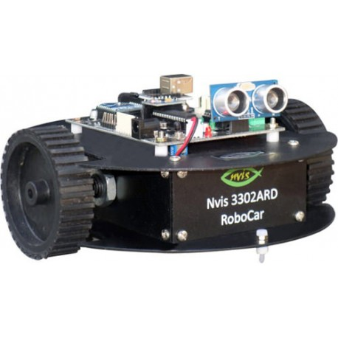
Figure 1: Nvis 3302ARD RoboCar
Code
void setup()
{
Serial.begin(9600);
pinMode(5, OUTPUT);
pinMode(6, OUTPUT);
pinMode(7, OUTPUT);
pinMode(8, OUTPUT);
}

void forward()
{
digitalWrite(5, HIGH);
digitalWrite(6, LOW);
digitalWrite(7, LOW);
digitalWrite(8, HIGH);
}

void backward()
{
digitalWrite(5, LOW);
digitalWrite(6, HIGH);
digitalWrite(7, HIGH);
digitalWrite(8, LOW);
}

void right()
{
digitalWrite(5, LOW);
digitalWrite(6, LOW);
digitalWrite(7, LOW);
digitalWrite(8, HIGH);
}

void left()
{
digitalWrite(5, HIGH);
digitalWrite(6, LOW);
digitalWrite(7, LOW);
digitalWrite(8, LOW);
}

void loop()
{
forward();
delay(2000);
backward();
delay(2000);
right();
delay(2000);
left();
delay(2000);
}

Result Analysis
According to our code, we were able to move our buggy forward, backward, right and left, with the required delay of 2 seconds after each operation.
Signature of Faculty Member

Experiment 2

Objective
Write a program to read values of the IR sensor using analog and digital read, and convert the buggy into a normal line-follower RoboCar.
Software Used: Arduino IDE

Hardware Used
Table 2: Hardware List of Experiment No. 2
Sr. No. | Name of Component | Quantity
1 | Arduino Uno Board | 1
2 | USB Cable | 1
3 | Nvis 3302ARD RoboCar | 1

Theory
An IR sensor is a device that emits and senses infrared radiation to detect aspects of the surroundings. The emitter is simply an IR LED (Light Emitting Diode), and the detector is an IR photodiode sensitive to IR light of the same wavelength emitted by the IR LED. When IR light falls on the photodiode, its resistance and output voltage change in proportion to the magnitude of the IR light received. In our buggy, the IR sensor helps it move only along the black lines of the defined path. We use the user-defined functions from the previous experiment to control the movement of the buggy on the path in the Arduino IDE, which in turn gives instructions to the IR sensor.
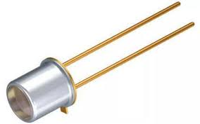
Figure 2: IR Sensor
Code
int r1, r2, r3, r4;

void setup()
{
Serial.begin(9600);
pinMode(A1, INPUT);
pinMode(A0, INPUT);
pinMode(5, OUTPUT);
pinMode(6, OUTPUT);
pinMode(7, OUTPUT);
pinMode(8, OUTPUT);
}

void loop()
{
r1 = digitalRead(A1);
r2 = digitalRead(A0);
Serial.println(r1);
Serial.print("\t");
Serial.println(r2);
Serial.print("\t");
Serial.println(r3);
Serial.print("\t");
Serial.println(r4);

if (r1 == LOW && r2 == LOW) {
digitalWrite(5, HIGH);
digitalWrite(6, LOW);
digitalWrite(7, LOW);
digitalWrite(8, HIGH);
}
if (r1 == HIGH && r2 == LOW) {
digitalWrite(5, HIGH);
digitalWrite(6, LOW);
digitalWrite(7, LOW);
digitalWrite(8, LOW);
}
if (r1 == LOW && r2 == HIGH) {
digitalWrite(5, LOW);
digitalWrite(6, LOW);
digitalWrite(7, LOW);
digitalWrite(8, HIGH);
}
if (r1 == HIGH && r2 == HIGH) {
digitalWrite(5, HIGH);
digitalWrite(6, LOW);
digitalWrite(7, LOW);
digitalWrite(8, HIGH);
}
}

Result Analysis
According to the code, our buggy moves along the black path and turns along the line at any turns in the path. Hence, we used the IR sensor to detect the path line and move our buggy accordingly.
Signature of Faculty Member

Experiment 3

Objective
To demonstrate the use of the ultrasonic sensor by integrating a line-follower RoboCar with obstacle-avoidance capability.
Software Used: Arduino IDE

Hardware Used
Table 3: Hardware List of Experiment No. 3
Sr. No. | Name of Component | Quantity
1 | Arduino Uno Board | 1
2 | USB Cable | 1
3 | Nvis 3302ARD RoboCar | 1

Theory
The HC-SR04 ultrasonic sensor is a popular and affordable device used to measure distance using sound waves. It operates on the principle of ultrasound echo. The sensor consists of two main components: a transmitter that emits ultrasonic waves at a frequency of 40 kHz, and a receiver that detects the reflected waves (echoes) when they bounce back after hitting an obstacle.
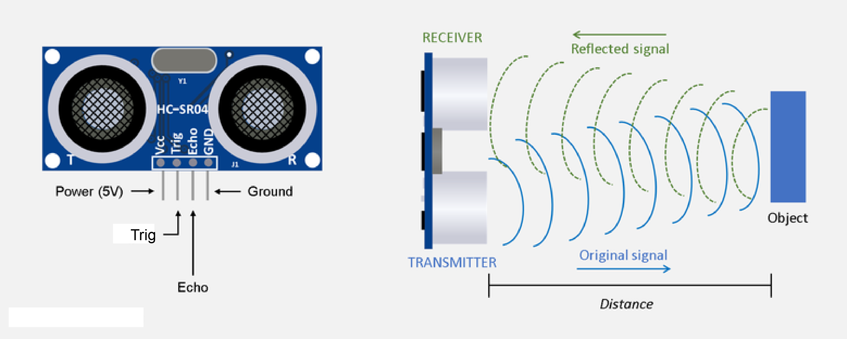
Figure 3: Ultrasonic Sensor HC-SR04
Code
#include <NewPing.h>

int t1 = A0;
int t2 = A2;
int pin5 = 5;
int pin6 = 6;
int pin7 = 8;
int pin8 = 7;
int TRIGGER_PIN = 13;
int ECHO_PIN = 12;
int MAX_DISTANCE = 200;
int irPin = 4;
int flag = 0;
int gantryCounter = 0;
int inside = 0;
static long StartTime = 0;
long intervalU = 500;
static long StartTimeG = millis();
static long CurrentTimeG = 0;
static long ElapsedTimeG = 0;
long previousMillisU = millis();
NewPing sonar(TRIGGER_PIN, ECHO_PIN, MAX_DISTANCE);
unsigned long d = 0;

void setup() {
pinMode(pin5, OUTPUT);
pinMode(pin6, OUTPUT);
pinMode(pin7, OUTPUT);
pinMode(pin8, OUTPUT);
Serial.begin(9600);
}

Result Analysis
According to our code, we were able to demonstrate the use of the ultrasonic sensor by integrating a line-follower RoboCar with obstacle-avoidance capability.
Signature of Faculty Member

Experiment 4(a)

Objective
Write a program to read the pulse width of the gantry transmitter and trigger the stop_buggy function by detecting the individual gantry.
Software Used: Arduino IDE

Hardware Used
Table 4: Hardware List of Experiment No. 4 (a)
Sr. No. | Name of Component | Quantity
1 | Arduino Uno Board | 1
2 | USB Cable | 1
3 | Nvis 3302ARD RoboCar | 1
4 | Connecting Wires | 1
5 | Receiver Circuit | 1
6 | Ultrasonic Sensor | 1

Theory
The gantries are equipped with three pulses of different bandwidth from the transmitter circuit. The range of pulses can be changed by programming the five reprogrammable pins of the ATtiny85 microcontroller used in the construction of the transmitter circuit. The receiver circuit, connected to the buggy, is programmed to perform operations like stopping the buggy when it passes a suitable gantry and receives the corresponding pulse. In this way, the buggy stops after passing the gantry that sends the matching pulse, and if the received pulse falls in the range defined by the code, the corresponding function is performed.
Code
int t1 = A0;
int t2 = A2;
int pin5 = 5;
int pin6 = 6;
int pin7 = 8;
int pin8 = 7;
int pin = 4;
int flag = 0;
unsigned long d = 0;
static int gantryCounter = 0;
static long StartTime = 0;
static long CurrentTime = 0;
unsigned long ElapsedTime = 0;
static long StartTimeG = millis();
static long CurrentTimeG = 0;
unsigned long ElapsedTimeG = 0;
long previousMillisU = millis();
long intervalU = 500;

#include <NewPing.h>
#define TRIGGER_PIN 13
#define ECHO_PIN 12
#define MAX_DISTANCE 200
NewPing sonar(TRIGGER_PIN, ECHO_PIN, MAX_DISTANCE);

void setup() {
pinMode(pin5, OUTPUT);
pinMode(pin6, OUTPUT);
pinMode(pin7, OUTPUT);
pinMode(pin8, OUTPUT);
pinMode(t1, INPUT);
pinMode(t2, INPUT);
Serial.begin(9600);
Serial.print("+++");
delay(1500);
Serial.println("ATID 3333, CH C, CN");
}

void loop() {
if (flag == 0) {
if (Serial.available() > 0) {
char s = Serial.read();
switch (s) {
case 'G': {
flag = 1;
}
}
}
}
unsigned long currentMillisU = millis();
if (currentMillisU - previousMillisU > intervalU) {
previousMillisU = currentMillisU;
detectObstacle();
}
if (flag == 1) {
gantry();
}
if (flag == 3) {
CurrentTimeG = millis();
ElapsedTimeG = CurrentTimeG - StartTimeG;
if (ElapsedTimeG < 1500) {
flag = 3;
leftBlind();
}
if (ElapsedTimeG > 1500 && ElapsedTimeG < 3500) {
flag = 3;
normalLineFollow();
}
if (ElapsedTimeG > 3500) {
stopBuggy();
Serial.print("Buggy:1 Parked");
Serial.println(ElapsedTimeG);
delay(2000);
flag = -1;
}
}
}

void gantry()
{
int r1 = digitalRead(t1);
int r2 = digitalRead(t2);
if (r1 == LOW && r2 == LOW) {
digitalWrite(pin5, HIGH);
digitalWrite(pin6, LOW);
digitalWrite(pin7, HIGH);
digitalWrite(pin8, LOW);
}
if (r1 == LOW && r2 == HIGH) {
digitalWrite(pin5, HIGH);
digitalWrite(pin6, LOW);
digitalWrite(pin7, LOW);
digitalWrite(pin8, LOW);
}
if (r1 == HIGH && r2 == LOW) {
digitalWrite(pin5, LOW);
digitalWrite(pin6, LOW);
digitalWrite(pin7, HIGH);
digitalWrite(pin8, LOW);
}
if (r1 == HIGH && r2 == HIGH) {
digitalWrite(pin5, HIGH);
digitalWrite(pin6, LOW);
digitalWrite(pin7, HIGH);
digitalWrite(pin8, LOW);
}
}

void stopBuggy()
{
digitalWrite(pin5, LOW);
digitalWrite(pin6, LOW);
digitalWrite(pin7, LOW);
digitalWrite(pin8, LOW);
}

void detectObstacle()
{
delay(50);
unsigned int distanceCm;
distanceCm = sonar.ping_cm();
pinMode(ECHO_PIN, OUTPUT);
digitalWrite(ECHO_PIN, LOW);
pinMode(ECHO_PIN, INPUT);
Serial.print("Ping: ");
Serial.println(distanceCm);
Serial.println("cm");
if ((distanceCm < 15) && (distanceCm > 0)) {
stopBuggy();
delay(1000);
}
}

Result Analysis
From this experiment, we get to understand the working of the gantry circuit along with the receiver circuit. The pulse is sent to the computer via the receiver circuit, which detects the pulse in the form of a square-wave function.
Signature of Faculty Member

Experiment 4(b)

Objective
Write a configuration program to demonstrate XBee module communication between two PCs using XCTU.
Software Used: Arduino IDE, XCTU

Hardware Used
Table 5: Hardware List of Experiment No. 4 (b)
Sr. No. | Name of Component | Quantity
1 | Arduino Uno Board | 1
2 | USB Cable | 1
3 | Nvis 3302ARD RoboCar | 1
4 | Connecting Wires | 1
5 | Receiver Circuit | 1
6 | Ultrasonic Sensor | 1

Theory
ZigBee is a standard wireless network protocol designed for low-data-rate control networks. It is layered on top of the IEEE 802.15.4 specification and provides a standard methodology for functions including network formation, messaging, and device discovery, suited to the needs of remote monitoring and control applications — with an emphasis on simplicity, reliability, low cost, and low power.
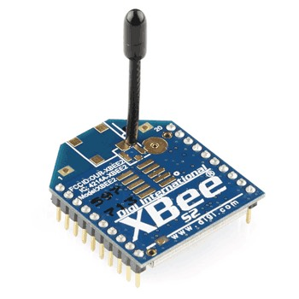
Figure 4: ZigBee XBee Communication Module
Code
void loop()
{
if (Serial.available() > 0) {
char s = Serial.read();
if (s == 'f') forward();
if (s == 'r') right();
if (s == 'l') left();
if (s == 'c') clockwise();
if (s == 'a') anticlockwise();
if (s == 's') stop();
}
}

Result Analysis
We were able to use ZigBee to control the motion of our buggy by giving it instructions remotely, through the XCTU software.
Signature of Faculty Member

Experiment 5

Objective
Bronze Challenge: Single buggy around the track twice in a clockwise direction, under full supervisory control. The buggy can detect an obstacle and parks safely. Prints the state of the track and buggy at each gantry stop.
Software Used: Arduino IDE

Hardware Used
Table 6: Hardware List of Experiment No. 5
Sr. No. | Name of Component | Quantity
1 | Arduino Uno Board | 1
2 | USB Cable | 1
3 | Nvis 3302ARD RoboCar | 1
4 | Track with three gantries (equipped with IR sensors & transmitter circuit) | 1
5 | Receiver Circuit | 1
6 | Ultrasonic Sensor HC-SR04 | 1

Theory
For the Bronze Challenge, a single buggy must be capable of following the main track twice in a clockwise direction under full supervisory control, obeying the "rules" of the track. The buggy must be capable of detecting an obstacle with the help of the ultrasonic sensor while following the track, coming to a temporary halt if it does, and proceeding automatically once the obstacle is removed. The buggy must safely park in the parking bay after the two loops. We must also display on-screen the state of the track and buggy at each gantry stop.
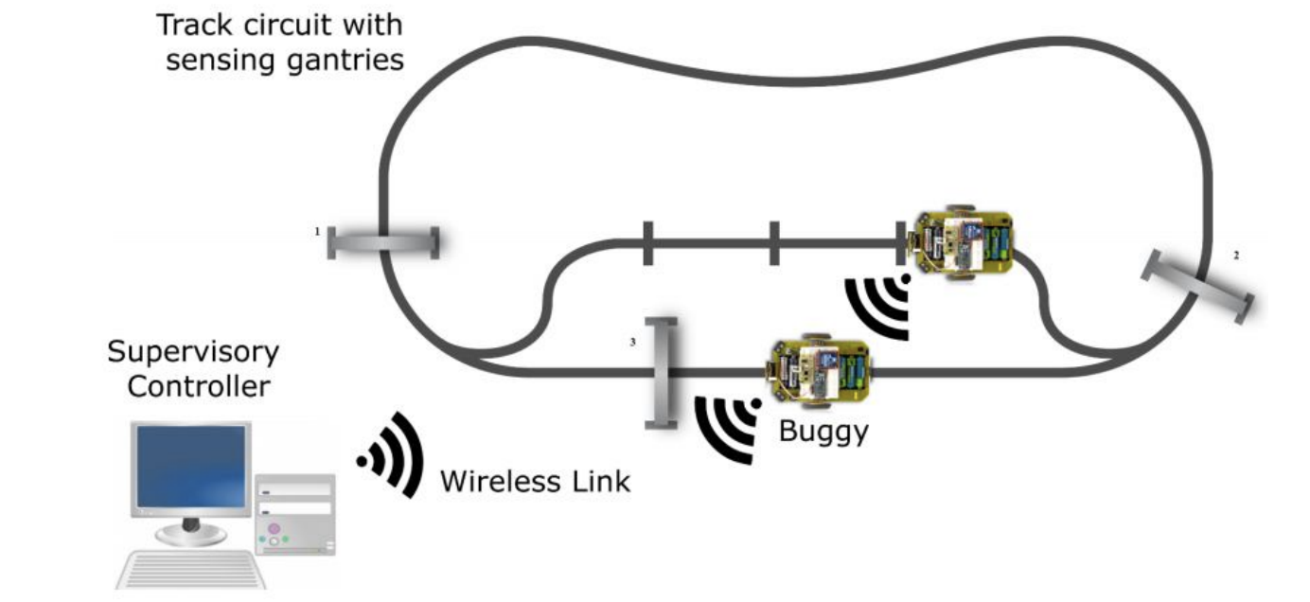
Figure 5: Model Diagram of Gantry-Buggy
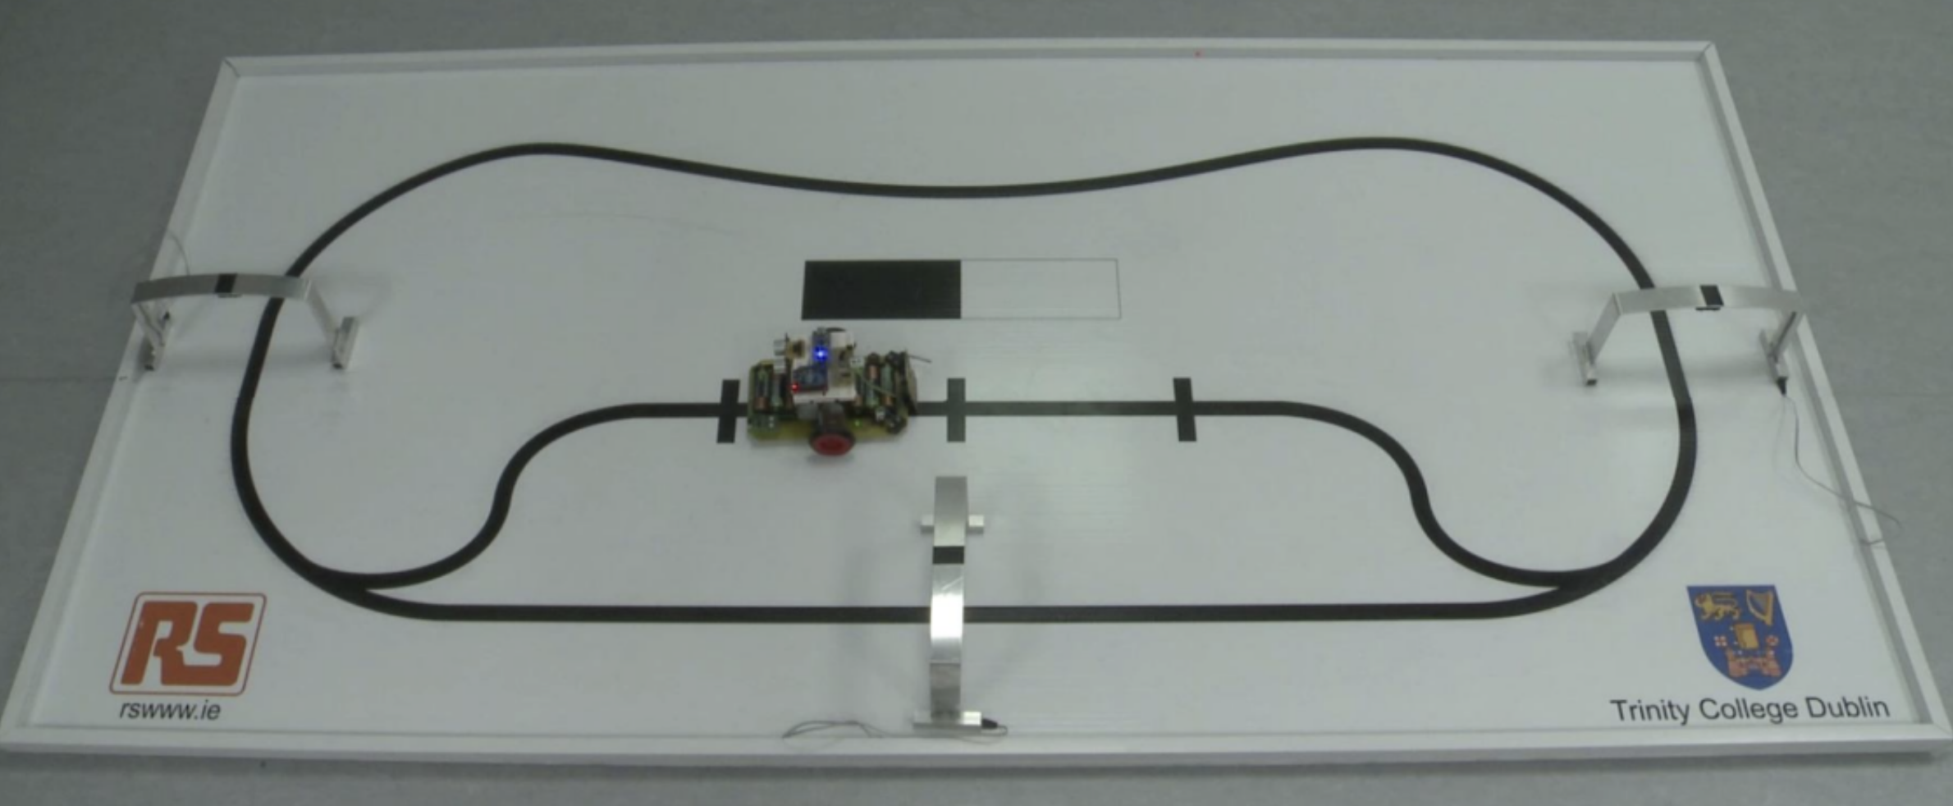
Figure 6: Demonstration of Gantry-Buggy Working
Code
(Continuing from the variable declarations and setup() shown in Experiment 4(a).)
void loop() {
if (flag == 0) {
if (Serial.available() > 0) {
char s = Serial.read();
switch (s) {
case 'G': {
flag = 1;
}
}
}
}
unsigned long currentMillisU = millis();
if (currentMillisU - previousMillisU > intervalU) {
previousMillisU = currentMillisU;
detectObstacle();
}
if (flag == 1) {
gantry();
}
if (flag == 3) {
// gantryParking();
CurrentTimeG = millis();
ElapsedTimeG = CurrentTimeG - StartTimeG;
if (ElapsedTimeG < 2500) {
flag = 3;
leftBlind();
}
if (ElapsedTimeG > 2500 && ElapsedTimeG < 6500) {
flag = 3;
normalLineFollow();
}
if (ElapsedTimeG > 6500) {
stopBuggy();
Serial.print("Buggy:1 Parked");
// Serial.println(ElapsedTimeG);
delay(200);
flag = -1;
}
}
}

void gantry()
{
int r1 = digitalRead(t1);
int r2 = digitalRead(t2);
if (r1 == LOW && r2 == LOW) {
digitalWrite(pin5, HIGH);
digitalWrite(pin6, LOW);
digitalWrite(pin7, HIGH);
digitalWrite(pin8, LOW);
}
if (r1 == LOW && r2 == HIGH) {
digitalWrite(pin5, LOW);
digitalWrite(pin6, LOW);
digitalWrite(pin7, HIGH);
digitalWrite(pin8, LOW);
}
if (r1 == HIGH && r2 == LOW) {
digitalWrite(pin5, HIGH);
digitalWrite(pin6, LOW);
digitalWrite(pin7, LOW);
digitalWrite(pin8, LOW);
}
if (r1 == HIGH && r2 == HIGH) {
digitalWrite(pin5, HIGH);
digitalWrite(pin6, LOW);
digitalWrite(pin7, HIGH);
digitalWrite(pin8, LOW);
}
if (digitalRead(irPin) == HIGH) {
StartTime = millis();
d = pulseIn(irPin, HIGH);
if (d > 500 && d < 1500) {
Serial.println("Gantry: 1");
stopBuggy();
delay(1000);
} else if (d > 1500 && d < 2500) {
Serial.println("Gantry: 2");
stopBuggy();
delay(1000);
} else if (d > 2500 && d < 3500) {
Serial.println("Gantry: 3");
gantryCounter = gantryCounter + 1;
Serial.print("The gantry Counter is: ");
Serial.println(gantryCounter);
stopBuggy();
delay(1000);
} else {
Serial.println("Gantry: Unknown");
}
if (gantryCounter >= 4) {
StartTimeG = millis();
flag = 3;
} else {
gantry();
}
}
}

void stopBuggy()
{
digitalWrite(pin5, LOW);
digitalWrite(pin6, LOW);
digitalWrite(pin7, LOW);
digitalWrite(pin8, LOW);
}

void normalLineFollow()
{
int r1 = digitalRead(t1);
int r2 = digitalRead(t2);
if (r1 == LOW && r2 == LOW) {
digitalWrite(pin5, HIGH);
digitalWrite(pin6, LOW);
digitalWrite(pin7, HIGH);
digitalWrite(pin8, LOW);
}
if (r1 == HIGH && r2 == LOW) {
digitalWrite(pin5, LOW);
digitalWrite(pin6, HIGH);
digitalWrite(pin7, HIGH);
digitalWrite(pin8, LOW);
}
if (r1 == LOW && r2 == HIGH) {
digitalWrite(pin5, HIGH);
digitalWrite(pin6, LOW);
digitalWrite(pin7, LOW);
digitalWrite(pin8, HIGH);
}
if (r1 == HIGH && r2 == HIGH) {
digitalWrite(pin5, HIGH);
digitalWrite(pin6, LOW);
digitalWrite(pin7, HIGH);
digitalWrite(pin8, LOW);
}
}

void leftBlind()
{
int r2 = digitalRead(t2);
if (r2 == LOW) {
digitalWrite(pin5, LOW);
digitalWrite(pin6, LOW);
digitalWrite(pin7, HIGH);
digitalWrite(pin8, LOW);
}
if (r2 == HIGH) {
digitalWrite(pin5, HIGH);
digitalWrite(pin6, LOW);
digitalWrite(pin7, HIGH);
digitalWrite(pin8, LOW);
}
}

void detectObstacle()
{
delay(50);
unsigned int uS = sonar.ping_cm();
unsigned int distanceCm;
pinMode(ECHO_PIN, OUTPUT);
digitalWrite(ECHO_PIN, LOW);
pinMode(ECHO_PIN, INPUT);
// Serial.print("Ping: ");
// Serial.print(distanceCm);
// Serial.println("cm");
if ((distanceCm < 15) && (distanceCm > 0)) {
stopBuggy();
delay(1000);
}
}

Result Analysis
We successfully completed the Bronze Challenge using a combination of sensors — IR sensors, the ultrasonic sensor, the receiver circuit, and the ZigBee module.
Signature of Faculty Member

