Practical Activity Report
ENGINEERING DESIGN PROJECT (UTA030)
Mid-Semester Examination Report File
Submitted by:
102304001 | Tanav Pathak
102304002 | Anushka Tiwari
102304003 | Vishavjeet Singh
102304005 | Parth Gupta
102304007 | Rachit Saini
Bachelor of Engineering — Electrical Engineering
Second Year, Batch: 2D11/2EL1
Submitted to:
Dr. Ashutosh Mishra
Assistant Professor (CSED)

Computer Science & Engineering Department
TIET Patiala
(July – December 2024)

Abstract
This report thoroughly explores the capabilities of the Arduino Uno R3, focusing on foundational experiments to familiarize users with the inputs, outputs, coding, and interfacing components like sensors and resistors. Through systematic experimentation, students learn Arduino programming and circuit design, enhancing their understanding. Various topics, including analog/digital inputs and outputs and sensor data acquisition, are covered, preparing participants for more complex tasks.
Additionally, the report outlines applying learned knowledge to practical scenarios, such as constructing a robotic buggy. By programming the buggy to autonomously navigate, users demonstrate Arduino principles in action. Overall, the report offers a structured educational approach, merging theory with hands-on learning, catering to educators, hobbyists, and electronics enthusiasts.

Declaration
We, Tanav Pathak, Anushka Tiwari, Vishavjeet Singh, Parth Gupta and Rachit Saini, declare that this project report is our own original work, carried out under the supervision of Dr. Ashutosh Mishra in the "Engineering Design I" computer lab. The statements made and conclusions drawn are an outcome of our own project work. We have not copied or plagiarized any part of this report from any other source. We have followed the guidelines provided by the University in writing this report. We have not submitted this project to any other university for the award of any degree.

Index
Sr. No. | Name of Experiment | Page No.
1 | Introduction to Arduino Microcontroller. | 4-5
2 | Write a program in Arduino to blink a LED: (a) Single LED (b) Multiple LED. | 6-12
3 | Write an Arduino program to design forward and reverse pattern (1,2,3,4,5) sequences for different colour LEDs using: (a) delay() (b) for(). | 13-20
4 | Serial Communications: Serial.begin(9600); Serial.print(); Serial.println(); Serial.read(); Serial.write(). | 21-22
5 | WAP for the following pattern using a for loop (as per requirement). | 23-24
6 | WAP for a dimmer (change in intensity of single and multiple LEDs). | 25-29
7 | WAP to change the intensity of the given LEDs for the sequence 3-5-2-1-4, in both forward and reverse order. | 30-34
8 | Write an Arduino program to design a Fibonacci series. | 35-39
9 | To demonstrate control of a DC motor using forward, backward, left, right turn motion and clockwise / anti-clockwise rotation. | 40-42
10 | Program a buggy (robot) to move in different geometric shapes: square, rectangle, circle, and hexagon. | 43-46

Experiment 1

Objective
Introduction to Arduino Uno R3 Microcontroller.

Hardware Used
Sr. No. | Name of Hardware | Quantity
1 | Arduino Uno Board | 1
Software Used: Arduino IDE

Theory
Arduino Uno R3
The Arduino Uno is a widely-used microcontroller board, ideal for both beginners and experienced developers. It is based on the ATmega328P microcontroller and operates at 5V with a clock speed of 16 MHz. The board features 14 digital I/O pins, six of which can be used for PWM output, and six analog input pins, making it versatile for a range of input and output operations. It supports several communication protocols, including UART, SPI, and I2C, allowing it to interface with various devices like sensors, displays, and other microcontrollers. Powered via USB or an external source, the Arduino Uno is often used in electronics projects, automation, robotics, and prototyping, thanks to its simplicity, flexibility, and extensive community support.
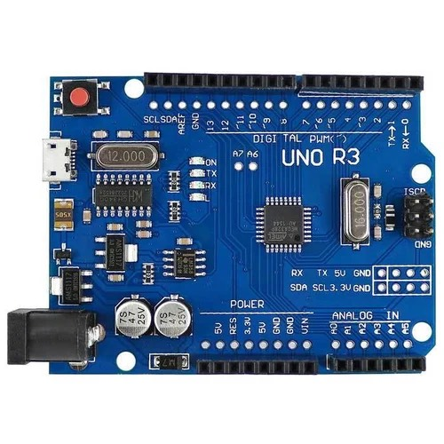

- Reset Button — restarts any code that is loaded to the Arduino board.
- AREF — stands for "Analog Reference" and is used to set an external reference voltage.
- Ground Pin — there are a few ground pins on the Arduino and they all work the same.
- Digital Input/Output — pins 0–13 can be used for digital input or output.
- PWM — the pins marked with the (~) symbol can simulate analog output.
- USB Connection — used for powering the Arduino and uploading sketches.
- TX/RX — transmit and receive data indication LEDs.
- ATmega Microcontroller — this is the brain, and is where the programs are stored.
- Power LED Indicator — this LED lights up any time the board is plugged into a power source.
- Voltage Regulator — controls the amount of voltage going into the Arduino board.
- DC Power Barrel Jack — used for powering the Arduino with a power supply.
- 3.3V Pin — supplies 3.3 volts of power to your projects.
- 5V Pin — supplies 5 volts of power to your projects.
- Ground Pins — there are a few ground pins on the Arduino and they all work the same.
- Analog Pins — these pins can read the signal from an analog sensor and convert it to digital.

Circuit Diagram
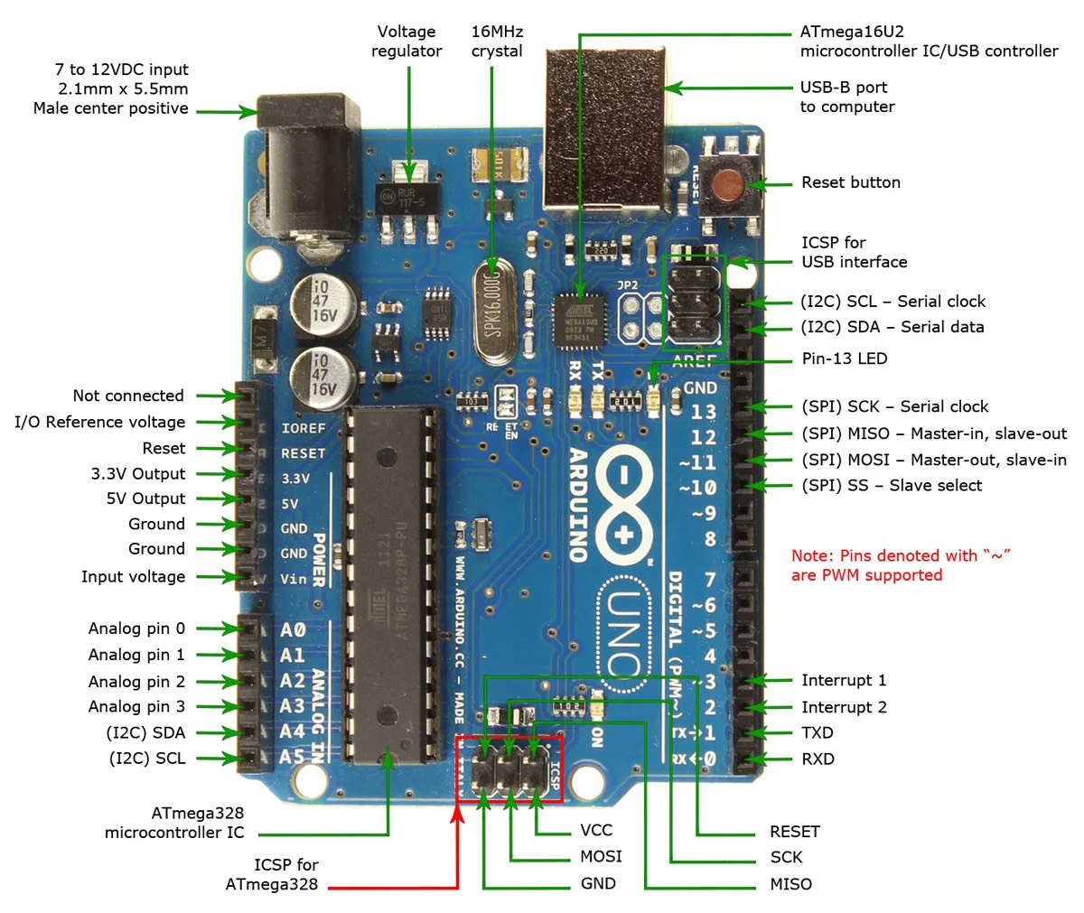
Arduino Uno R3 pin layout

Result Analysis
The Arduino Microcontroller will help us communicate with the buggy. This will enable us to code on the RoboCar and is the most important part of the experiment.
Signature of Faculty Member

Experiment 2

Objective
Write a program in Arduino to blink a LED:
- Single LED
- Multiple LED

Hardware Used
Sr. No. | Name of Hardware | Quantity
1 | Arduino Uno Board | 1
2 | Breadboard | 1
3 | Resistors (220 Ω) | 5
4 | Jumper Wires | 10
5 | LED | 5
Software Used: Arduino IDE

Theory
Resistor
Resistors are the electronic components that are used to divide voltages, modify signal levels, limit or regulate the flow of electric current in electrical circuits, etc. A resistor's primary function is to lower the voltage and reduce current flow in a specific area of the circuit. If a resistor is not used, then a lot of heat energy will be dissipated and wasted.
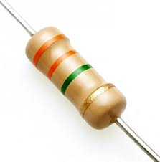
LED
A light-emitting diode (LED) is a semiconductor light source that emits light when current flows through it. Electrons in the semiconductor recombine with electron holes, releasing energy in the form of photons (energy packets).
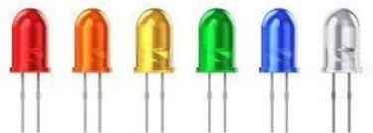

Arduino Uno Board
The Arduino Uno is a widely-used microcontroller board, ideal for both beginners and experienced developers. It is based on the ATmega328P microcontroller and operates at 5V with a clock speed of 16 MHz. The board features 14 digital I/O pins, six of which can be used for PWM output, and six analog input pins, making it versatile for a range of input and output operations. It supports several communication protocols, including UART, SPI, and I2C, allowing it to interface with various devices like sensors, displays, and other microcontrollers. Powered via USB or an external source, the Arduino Uno is often used in electronics projects, automation, robotics, and prototyping, thanks to its simplicity, flexibility, and extensive community support.

Breadboard
A breadboard is an indispensable tool for assembling and testing electronic circuits, facilitating the arrangement and connection of components such as resistors, capacitors, and LEDs. Its design allows for the temporary construction of circuits without the need for soldering, making it ideal for prototyping and experimentation. By providing a grid of interconnected sockets, a breadboard enables straightforward and reversible circuit construction, allowing engineers and hobbyists to iterate and refine their designs swiftly before transitioning to permanent circuit boards.
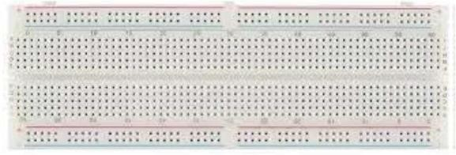
Jumper Wires
Connecting wires, also known as jumper wires, are electrical conductors employed to establish connections between separate circuits or components on printed circuit boards (PCBs). These wires enable the efficient flow of electric current, ensuring the integrated operation of electronic devices and facilitating effective signal transmission between components.
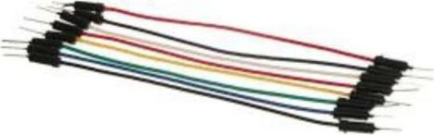

Tinkercad Diagram (2a)
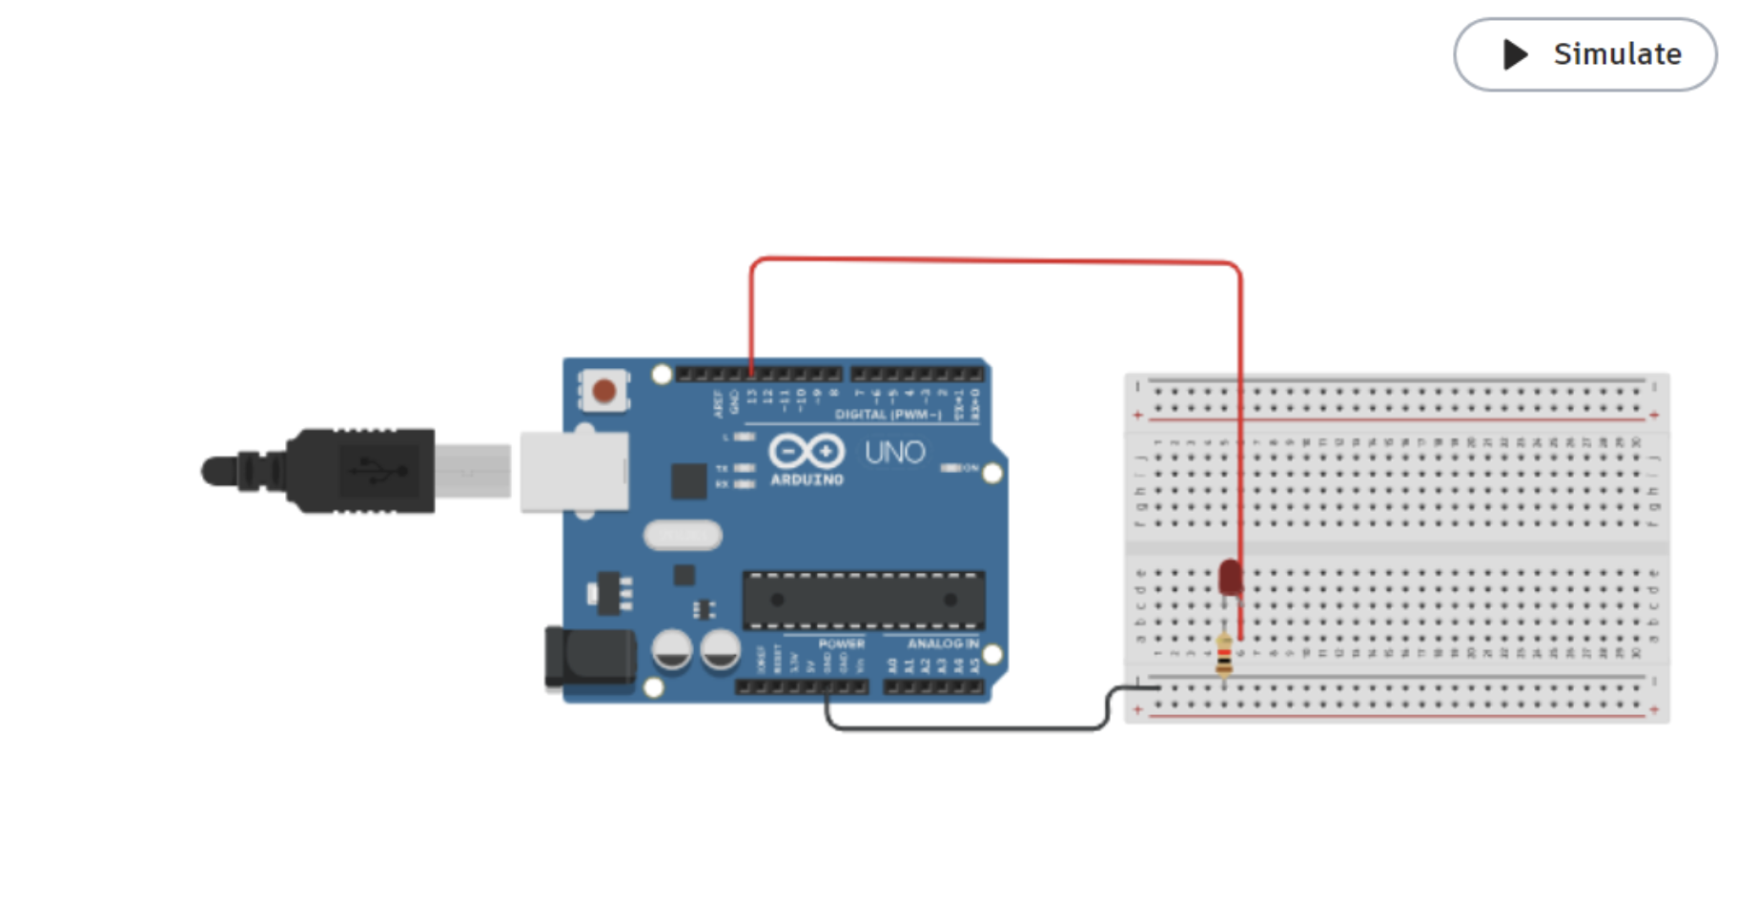

Tinkercad Diagram (2b)
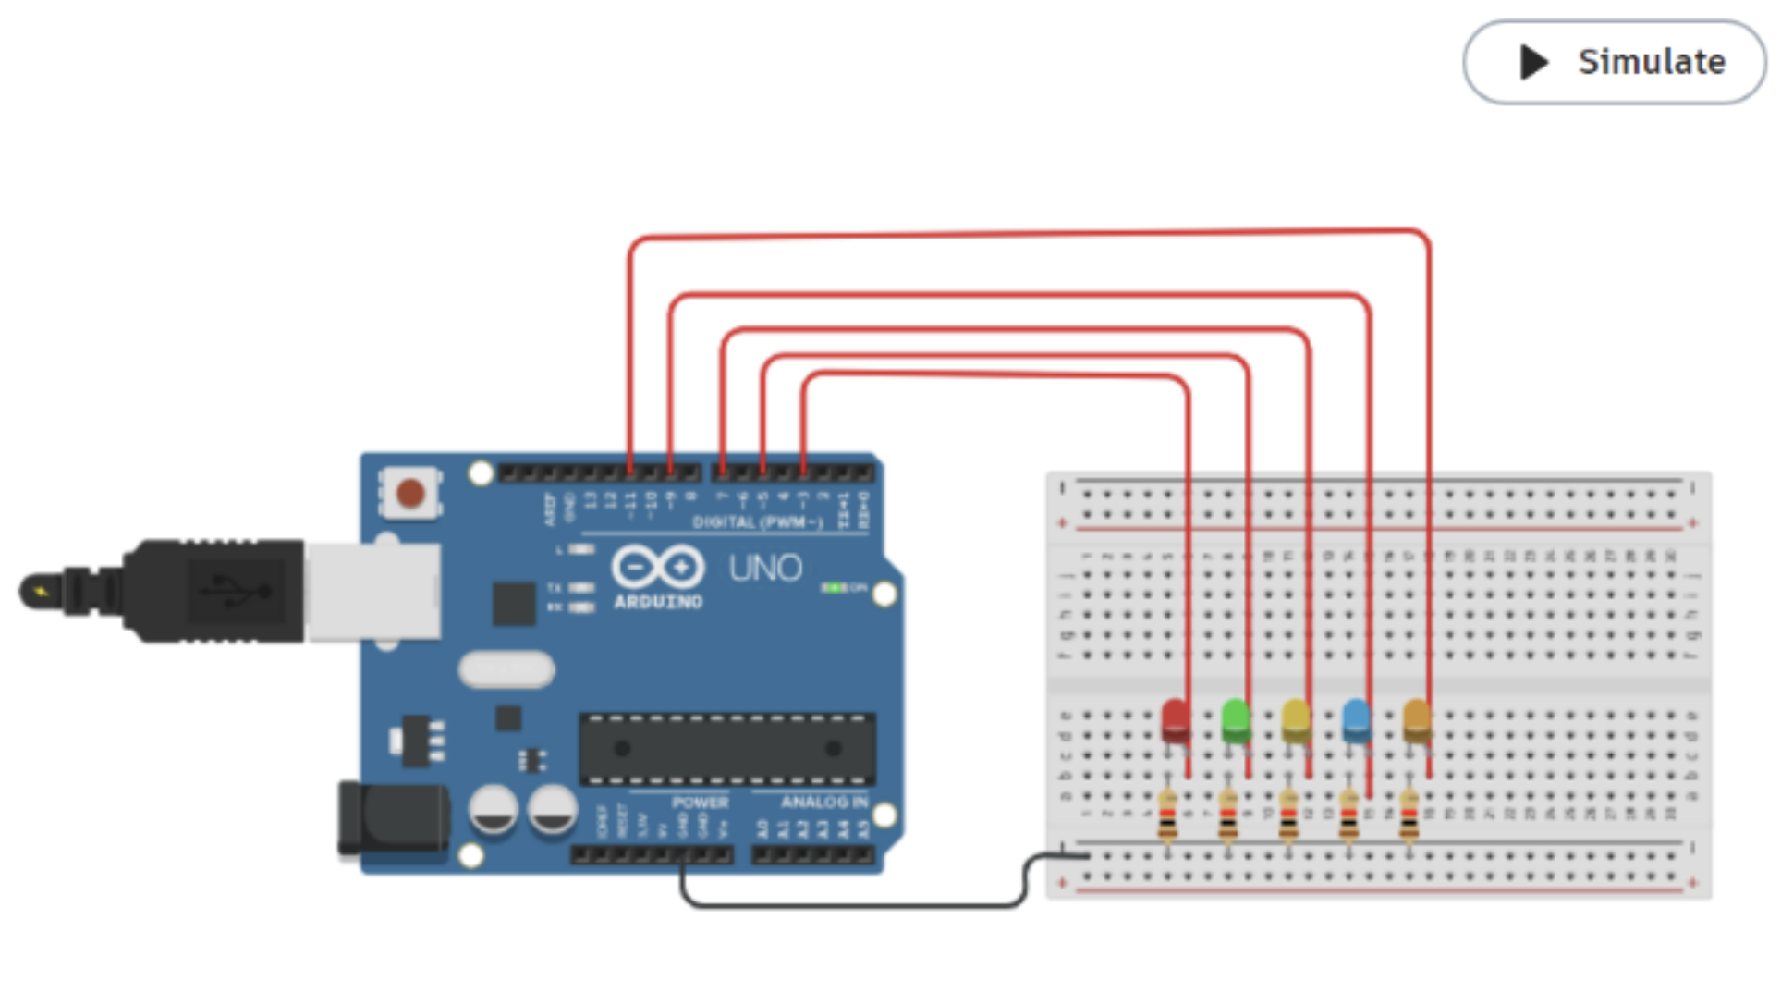

Code (2a)
void setup () {
pinMode(13, OUTPUT);
}

void loop() {
digitalWrite(13, HIGH);
delay(500);
digitalWrite(13, LOW);
delay(500);
}
Code (2b)
void setup()
{
pinMode(3, OUTPUT); pinMode(5, OUTPUT); pinMode(7, OUTPUT);
pinMode(9, OUTPUT); pinMode(11, OUTPUT);
}

void loop()
{
digitalWrite(3, HIGH); digitalWrite(5, HIGH); digitalWrite(7, HIGH);
digitalWrite(9, HIGH); digitalWrite(11, HIGH); delay(1000);
digitalWrite(3, LOW); digitalWrite(5, LOW); digitalWrite(7, LOW);
digitalWrite(9, LOW); digitalWrite(11, LOW); delay(1000);
}

Result Analysis
In this experiment we learnt how to blink a single LED and multiple LEDs using Arduino Uno R3 and a breadboard on the Arduino IDE, and simulated it on TinkerCAD.
Signature of Faculty Member

Experiment 3

Objective
To blink multiple LEDs using Arduino Uno and Breadboard.

Hardware Used
Sr. No. | Name of Hardware | Quantity
1 | Arduino Uno Board | 1
2 | Breadboard | 1
3 | Jumper Wires | 10
4 | LED | 5
5 | Resistor | 5
6 | USB Connector | 1
Software Used: Arduino IDE

Theory
Resistor
Resistors are the electronic components that are used to divide voltages, modify signal levels, limit or regulate the flow of electric current in electrical circuits, etc. A resistor's primary function is to lower the voltage and reduce current flow in a specific area of the circuit. If a resistor is not used, then a lot of heat energy will be dissipated and wasted.
LED
A light-emitting diode (LED) is a semiconductor light source that emits light when current flows through it. Electrons in the semiconductor recombine with electron holes, releasing energy in the form of photons (energy packets).
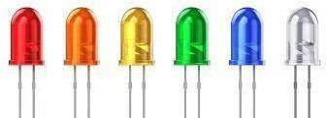

Arduino Uno Board
The Arduino Uno is a widely-used microcontroller board, ideal for both beginners and experienced developers. It is based on the ATmega328P microcontroller and operates at 5V with a clock speed of 16 MHz. The board features 14 digital I/O pins, six of which can be used for PWM output, and six analog input pins, making it versatile for a range of input and output operations. It supports several communication protocols, including UART, SPI, and I2C, allowing it to interface with various devices like sensors, displays, and other microcontrollers. Powered via USB or an external source, the Arduino Uno is often used in electronics projects, automation, robotics, and prototyping, thanks to its simplicity, flexibility, and extensive community support.

Breadboard
A breadboard is an indispensable tool for assembling and testing electronic circuits, facilitating the arrangement and connection of components such as resistors, capacitors, and LEDs. Its design allows for the temporary construction of circuits without the need for soldering, making it ideal for prototyping and experimentation. By providing a grid of interconnected sockets, a breadboard enables straightforward and reversible circuit construction, allowing engineers and hobbyists to iterate and refine their designs swiftly before transitioning to permanent circuit boards.
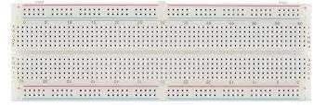
Connecting Wires
Connecting wires, also known as jumper wires, are electrical conductors employed to establish connections between separate circuits or components on printed circuit boards (PCBs). These wires enable the efficient flow of electric current, ensuring the integrated operation of electronic devices and facilitating effective signal transmission between components.
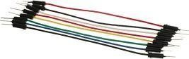

Tinkercad Diagram
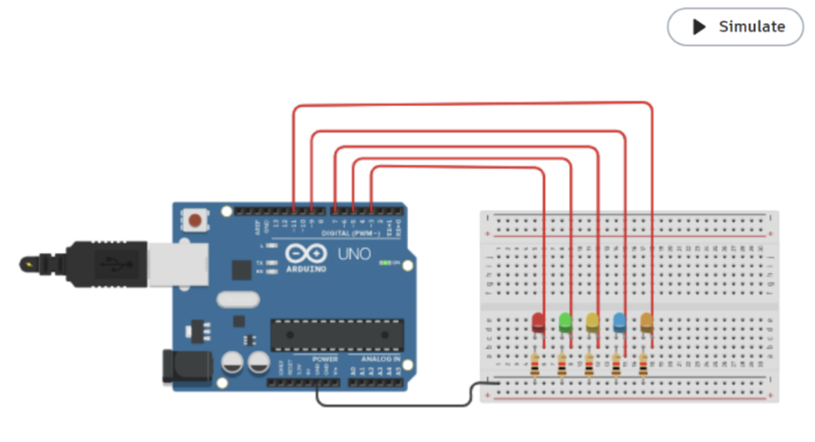

(a) By sequential digitalWrite()
void setup()
{
pinMode(13, OUTPUT); pinMode(12, OUTPUT); pinMode(11, OUTPUT); pinMode(10, OUTPUT);
pinMode(9, OUTPUT);
}

void loop()
{
digitalWrite(13, HIGH); delay(500); digitalWrite(13, LOW);
delay(500); digitalWrite(12, HIGH);
delay(500); digitalWrite(12, LOW);
delay(500); digitalWrite(11, HIGH);
delay(500); digitalWrite(11, LOW);
delay(500); digitalWrite(10, HIGH);
delay(500); digitalWrite(10, LOW);
delay(500); digitalWrite(9, HIGH);
delay(500); digitalWrite(9, LOW);
delay(500);
}

(b) By for loop
void setup()
{
for (int i = 2; i < 7; i++)
pinMode(i, OUTPUT);
}

void loop()
{
int arr[5] = {2, 3, 4, 5, 6};
for (int j = 0; j < 5; j++) {
digitalWrite(arr[j], HIGH);
delay(500);
digitalWrite(arr[j], LOW);
delay(500);
}
for (int i = 4; i >= 0; i--) {
digitalWrite(arr[i], HIGH);
delay(500);
digitalWrite(arr[i], LOW);
delay(500);
}
}

(c) By switch case
int arr[5] = {2, 3, 4, 5, 6};

void setup() {
for (int i = 0; i < 5; i++) {
pinMode(arr[i], OUTPUT);
}
}

void loop() {
// put your main code here, to run repeatedly
for (int i = 0; i < 5; i++) {
switch (i) {
case 0: digitalWrite(2, HIGH); delay(1000); digitalWrite(2, LOW); delay(1000); break;
case 1: digitalWrite(3, HIGH); delay(1000); digitalWrite(3, LOW); delay(1000); break;
case 2: digitalWrite(4, HIGH); delay(1000); digitalWrite(4, LOW); delay(1000); break;
case 3: digitalWrite(5, HIGH); delay(1000); digitalWrite(5, LOW); delay(1000); break;
case 4: digitalWrite(6, HIGH); delay(1000); digitalWrite(6, LOW); delay(1000); break;
}
}
for (int i = 0; i < 5; i++) {
switch (i) {
case 0: digitalWrite(6, HIGH); delay(1000); digitalWrite(6, LOW); delay(1000); break;
case 1: digitalWrite(5, HIGH); delay(1000); digitalWrite(5, LOW); delay(1000); break;
case 2: digitalWrite(4, HIGH); delay(1000); digitalWrite(4, LOW); delay(1000); break;
case 3: digitalWrite(3, HIGH); delay(1000); digitalWrite(3, LOW); delay(1000); break;
case 4: digitalWrite(2, HIGH); delay(1000); digitalWrite(2, LOW); delay(1000); break;
}
}
}

Result Analysis
In this experiment, we learnt how to blink single and multiple LEDs using Arduino Uno, both by using a for loop and by using switch cases.
Signature of Faculty Member

Experiment 4

Objective
Write a program using Serial Communications:
- Serial.begin(9600);
- Serial.print();
- Serial.println();
- Serial.read();
- Serial.write();
Software Used: Tinkercad Simulator or Arduino IDE

Theory
Serial communication is a crucial aspect of Arduino programming, enabling interaction between the Arduino board and external devices such as computers, sensors, and other microcontrollers. This experiment aims to provide a comprehensive understanding of serial communication through the utilization of various Serial library functions: begin(), print(), println(), read(), and write().
Serial.begin(9600)
This function initializes serial communication with a specified baud rate. Baud rate determines the speed at which data is transmitted over the serial port. In this experiment, a baud rate of 9600 is commonly used due to its compatibility with most devices.
Serial.print()
This function sends data to the serial port for transmission. It allows for the transmission of characters, numbers, and strings. Data sent using print() is transmitted as a continuous stream of characters without appending a newline character.
Serial.println()
Similar to print(), this function transmits data to the serial port. However, it appends a newline character (\n) at the end of the data, causing the cursor to move to the next line. This is useful for formatting output when reading data on the serial monitor.
Serial.read()
This function reads incoming serial data from the serial buffer. It returns the first byte of incoming serial data available, or -1 if no data is available. It's commonly used in conjunction with Serial.available() to ensure that data is available for reading before attempting to read it.
Serial.write()
Unlike print() and println(), which format data as human-readable ASCII characters, write() sends raw binary data. It is useful for sending binary data, such as sensor readings or control signals, directly to external devices.

Code
void setup() {
Serial.begin(9600);
Serial.println("Hello Arduino!");
delay(1000);
}

void loop() {
if (Serial.available() > 0) {
char incomingByte = Serial.read();
Serial.print("Received: ");
Serial.println(incomingByte);
}
}

Output
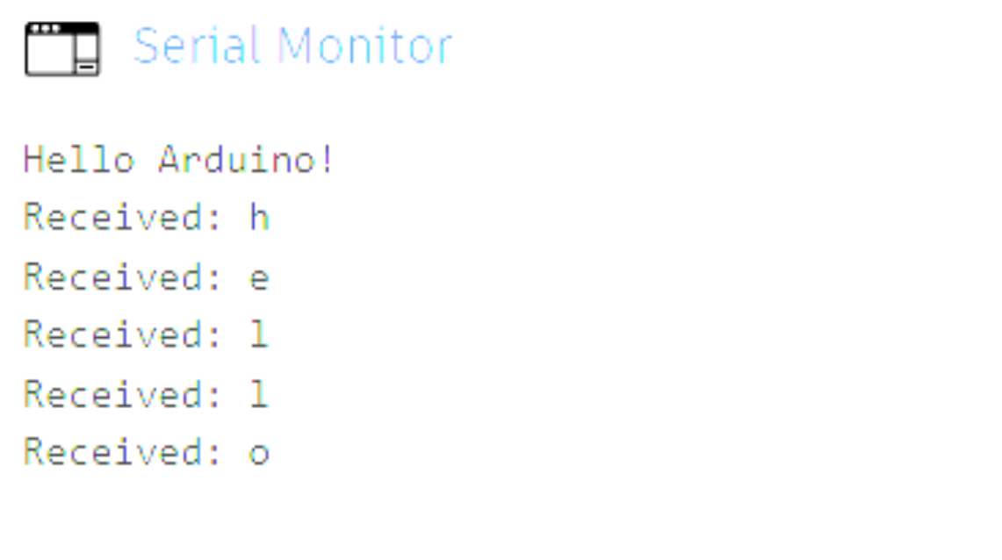

Result Analysis
In this experiment we learnt serial communication using the Arduino Uno R3 through the Arduino IDE.
Signature of Faculty Member

Experiment 5

Objective
WAP to print the following pattern using a for loop.
Roll Number: | 102304001
Name: | Tanav Pathak
Branch: | Electrical Engineering

Hardware Used
Sr. No. | Name of Hardware | Quantity
1 | Arduino Uno Board | 1
Software Used: Arduino IDE

Theory
Serial communication is a crucial aspect of Arduino programming, enabling interaction between the Arduino board and external devices such as computers, sensors, and other microcontrollers. This experiment aims to provide a comprehensive understanding of serial communication through the utilization of various Serial library functions: begin(), print(), println(), read(), and write().
Serial.begin(9600)
This function initializes serial communication with a specified baud rate. Baud rate determines the speed at which data is transmitted over the serial port. In this experiment, a baud rate of 9600 is commonly used due to its compatibility with most devices.
Serial.print()
This function sends data to the serial port for transmission. It allows for the transmission of characters, numbers, and strings. Data sent using print() is transmitted as a continuous stream of characters without appending a newline character.
Serial.println()
Similar to print(), this function transmits data to the serial port. However, it appends a newline character (\n) at the end of the data, causing the cursor to move to the next line. This is useful for formatting output when reading data on the serial monitor.
Serial.read()
This function reads incoming serial data from the serial buffer. It returns the first byte of incoming serial data available, or -1 if no data is available. It's commonly used in conjunction with Serial.available() to ensure that data is available for reading before attempting to read it.
Serial.write()
Unlike print() and println(), which format data as human-readable ASCII characters, write() sends raw binary data. It is useful for sending binary data, such as sensor readings or control signals, directly to external devices.

Code
void setup() {
Serial.begin(9600);
for (int i = 0; i < 55; i++) {
Serial.print("*");
}
Serial.println("*");
Serial.println("roll no: 102304001");
for (int i = 0; i < 44; i++) {
Serial.print("*");
}
Serial.println("*");
Serial.println("name: Tanav Pathak");
for (int i = 0; i < 50; i++) {
Serial.print("*");
}
Serial.println("*");
Serial.println("Branch: EE");
for (int i = 0; i < 48; i++) {
Serial.print("*");
}
}

void loop() { }

Output
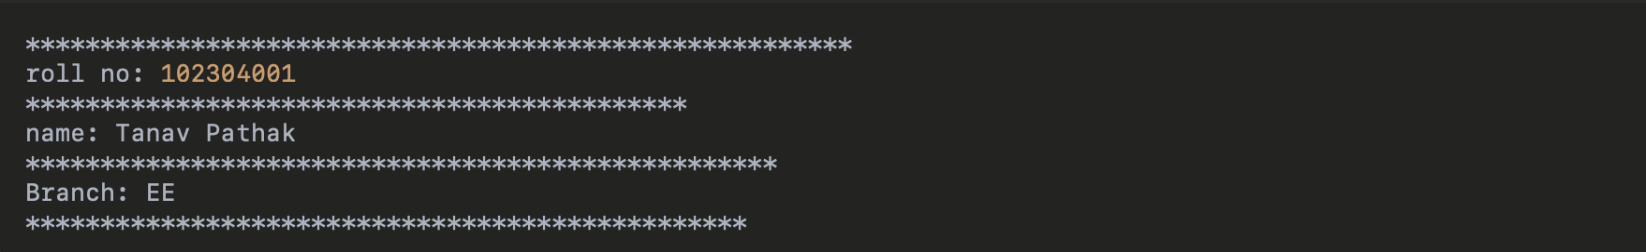

Result Analysis
In this experiment we printed the desired output design with the help of the serial monitor.
Signature of Faculty Member

Experiment 6

Objective
Write a program to change the intensity of the given LEDs. The program prompts the user to provide input through the Serial Monitor within the range of 0–255. Based on the specified input ranges, the LEDs illuminate with an intensity proportional to the given value, producing a dimming effect:
- LED 1 between 1 – 50
- LED 2 between 51 – 100
- LED 3 between 101 – 150
- LED 4 between 151 – 200
- LED 5 between 201 – 255

Hardware Used
Sr. No. | Name of Hardware | Quantity | Value
1 | Arduino Uno Board | 1 | —
2 | Breadboard | 1 | —
3 | Jumper Wires | 7 | —
4 | LED | 5 | —
5 | Resistor | 5 | 220 Ω
Software Used: Arduino IDE

Theory
Resistor
Resistors are the electronic components that are used to divide voltages, modify signal levels, limit or regulate the flow of electric current in electrical circuits, etc. A resistor's primary function is to lower the voltage and reduce current flow in a specific area of the circuit. If a resistor is not used, then a lot of heat energy will be dissipated and wasted.
LED
A light-emitting diode (LED) is a semiconductor light source that emits light when current flows through it. Electrons in the semiconductor recombine with electron holes, releasing energy in the form of photons (energy packets).

Arduino Uno Board
The Arduino Uno is a widely-used microcontroller board, ideal for both beginners and experienced developers. It is based on the ATmega328P microcontroller and operates at 5V with a clock speed of 16 MHz. The board features 14 digital I/O pins, six of which can be used for PWM output, and six analog input pins, making it versatile for a range of input and output operations. It supports several communication protocols, including UART, SPI, and I2C, allowing it to interface with various devices like sensors, displays, and other microcontrollers. Powered via USB or an external source, the Arduino Uno is often used in electronics projects, automation, robotics, and prototyping, thanks to its simplicity, flexibility, and extensive community support.

Breadboard
A breadboard is an indispensable tool for assembling and testing electronic circuits, facilitating the arrangement and connection of components such as resistors, capacitors, and LEDs. Its design allows for the temporary construction of circuits without the need for soldering, making it ideal for prototyping and experimentation. By providing a grid of interconnected sockets, a breadboard enables straightforward and reversible circuit construction, allowing engineers and hobbyists to iterate and refine their designs swiftly before transitioning to permanent circuit boards.
Connecting Wires
Connecting wires, also known as jumper wires, are electrical conductors employed to establish connections between separate circuits or components on printed circuit boards (PCBs). These wires enable the efficient flow of electric current, ensuring the integrated operation of electronic devices and facilitating effective signal transmission between components.

Code
void setup() {
pinMode(ledPin, OUTPUT);
}

void loop() {
for (int brightness = 0; brightness <= 255; brightness++) {
analogWrite(ledPin, brightness);
delay(10);
}
for (int brightness = 255; brightness >= 0; brightness--) {
analogWrite(ledPin, brightness);
delay(10);
}
}

Tinkercad Diagram

Result Analysis
In this experiment we learnt how to write a program to change the intensity of the given LEDs using our conventional Arduino Uno R3.
Signature of Faculty Member

Experiment 7

Objective
Write a program to change the intensity of the given LEDs for the sequence 3-5-2-1-4, in both forward and reverse order.

Hardware Used
Sr. No. | Name of Hardware | Quantity | Value
1 | Arduino Uno Board | 1 | —
2 | Breadboard | 1 | —
3 | Jumper Wires | 7 | —
4 | LED | 5 | —
5 | Resistor | 5 | 220 Ω
Software Used: Arduino IDE

Theory
Resistor
Resistors are the electronic components that are used to divide voltages, modify signal levels, limit or regulate the flow of electric current in electrical circuits, etc. A resistor's primary function is to lower the voltage and reduce current flow in a specific area of the circuit. If a resistor is not used, then a lot of heat energy will be dissipated and wasted.
LED
A light-emitting diode (LED) is a semiconductor light source that emits light when current flows through it. Electrons in the semiconductor recombine with electron holes, releasing energy in the form of photons (energy packets).

Arduino Uno Board
The Arduino Uno is a widely-used microcontroller board, ideal for both beginners and experienced developers. It is based on the ATmega328P microcontroller and operates at 5V with a clock speed of 16 MHz. The board features 14 digital I/O pins, six of which can be used for PWM output, and six analog input pins, making it versatile for a range of input and output operations. It supports several communication protocols, including UART, SPI, and I2C, allowing it to interface with various devices like sensors, displays, and other microcontrollers. Powered via USB or an external source, the Arduino Uno is often used in electronics projects, automation, robotics, and prototyping, thanks to its simplicity, flexibility, and extensive community support.

Breadboard
A breadboard is an indispensable tool for assembling and testing electronic circuits, facilitating the arrangement and connection of components such as resistors, capacitors, and LEDs. Its design allows for the temporary construction of circuits without the need for soldering, making it ideal for prototyping and experimentation. By providing a grid of interconnected sockets, a breadboard enables straightforward and reversible circuit construction, allowing engineers and hobbyists to iterate and refine their designs swiftly before transitioning to permanent circuit boards.
Connecting Wires
Connecting wires, also known as jumper wires, are electrical conductors employed to establish connections between separate circuits or components on printed circuit boards (PCBs). These wires enable the efficient flow of electric current, ensuring the integrated operation of electronic devices and facilitating effective signal transmission between components.

Code
void setup() {
Serial.begin(9600);
for (int i = 0; i < 5; i++) {
pinMode(ledPins[i], OUTPUT);
}
Serial.println("Enter brightness (0-255) for the 5 LEDs in sequence 3, 5, 2, 1, 4:");
}

void loop() {
if (Serial.available() > 0) {
Serial.println("Setting brightness for forward sequence.");
setBrightnessForward();
delay(1000);
Serial.println("Setting brightness for reverse sequence.");
setBrightnessReverse();
}
}

void setBrightnessForward() {
for (int i = 0; i < 5; i++) {
int brightness = Serial.parseInt();
if (brightness >= 0 && brightness <= 255) {
analogWrite(ledPins[i], brightness);
Serial.print("LED ");
Serial.print(ledPins[i]);
Serial.print(" brightness set to: ");
Serial.println(brightness);
} else {
Serial.println("Invalid brightness! Enter a value between 0 and 255.");
}
}
}

void setBrightnessReverse() {
for (int i = 4; i >= 0; i--) {
int brightness = Serial.parseInt();
if (brightness >= 0 && brightness <= 255) {
analogWrite(ledPins[i], brightness);
Serial.print("LED ");
Serial.print(ledPins[i]);
Serial.print(" brightness set to: ");
Serial.println(brightness);
} else {
Serial.println("Invalid brightness! Enter a value between 0 and 255.");
}
}
}

Tinkercad Diagram

Result Analysis
In this experiment we learnt how to write a program to change the intensity of the given LEDs for the sequence 3-5-2-1-4, in both forward and reverse order.
Signature of Faculty Member

Experiment 8

Objective
Write an Arduino program to implement a Fibonacci-series blinking of LEDs.

Hardware Used
Sr. No. | Name of Hardware | Quantity | Value
1 | Arduino Uno Board | 1 | —
2 | Breadboard | 1 | —
3 | Jumper Wires | 7 | —
4 | LED | 5 | —
5 | Resistor | 5 | 220 Ω
Software Used: Arduino IDE

Theory
Resistor
Resistors are the electronic components that are used to divide voltages, modify signal levels, limit or regulate the flow of electric current in electrical circuits, etc. A resistor's primary function is to lower the voltage and reduce current flow in a specific area of the circuit. If a resistor is not used, then a lot of heat energy will be dissipated and wasted.
LED
A light-emitting diode (LED) is a semiconductor light source that emits light when current flows through it. Electrons in the semiconductor recombine with electron holes, releasing energy in the form of photons (energy packets).

Arduino Uno Board
The Arduino Uno is a widely-used microcontroller board, ideal for both beginners and experienced developers. It is based on the ATmega328P microcontroller and operates at 5V with a clock speed of 16 MHz. The board features 14 digital I/O pins, six of which can be used for PWM output, and six analog input pins, making it versatile for a range of input and output operations. It supports several communication protocols, including UART, SPI, and I2C, allowing it to interface with various devices like sensors, displays, and other microcontrollers. Powered via USB or an external source, the Arduino Uno is often used in electronics projects, automation, robotics, and prototyping, thanks to its simplicity, flexibility, and extensive community support.

Breadboard
A breadboard is an indispensable tool for assembling and testing electronic circuits, facilitating the arrangement and connection of components such as resistors, capacitors, and LEDs. Its design allows for the temporary construction of circuits without the need for soldering, making it ideal for prototyping and experimentation. By providing a grid of interconnected sockets, a breadboard enables straightforward and reversible circuit construction, allowing engineers and hobbyists to iterate and refine their designs swiftly before transitioning to permanent circuit boards.
Connecting Wires
Connecting wires, also known as jumper wires, are electrical conductors employed to establish connections between separate circuits or components on printed circuit boards (PCBs). These wires enable the efficient flow of electric current, ensuring the integrated operation of electronic devices and facilitating effective signal transmission between components.

Code
const int numLEDs = 5;
const int ledPins[numLEDs] = {2, 3, 4, 5, 6};
const int fibonacci[5] = {1, 1, 2, 3, 5};

void setup() {
for (int i = 0; i < numLEDs; i++) {
pinMode(ledPins[i], OUTPUT);
}
}

void loop() {
for (int i = 0; i < 5; i++) {
for (int j = 0; j < fibonacci[i]; j++) {
digitalWrite(ledPins[j], HIGH);
}
delay(1000);
for (int j = 0; j < fibonacci[i]; j++) {
digitalWrite(ledPins[j], LOW);
}
delay(500);
}
}

Tinkercad Diagram
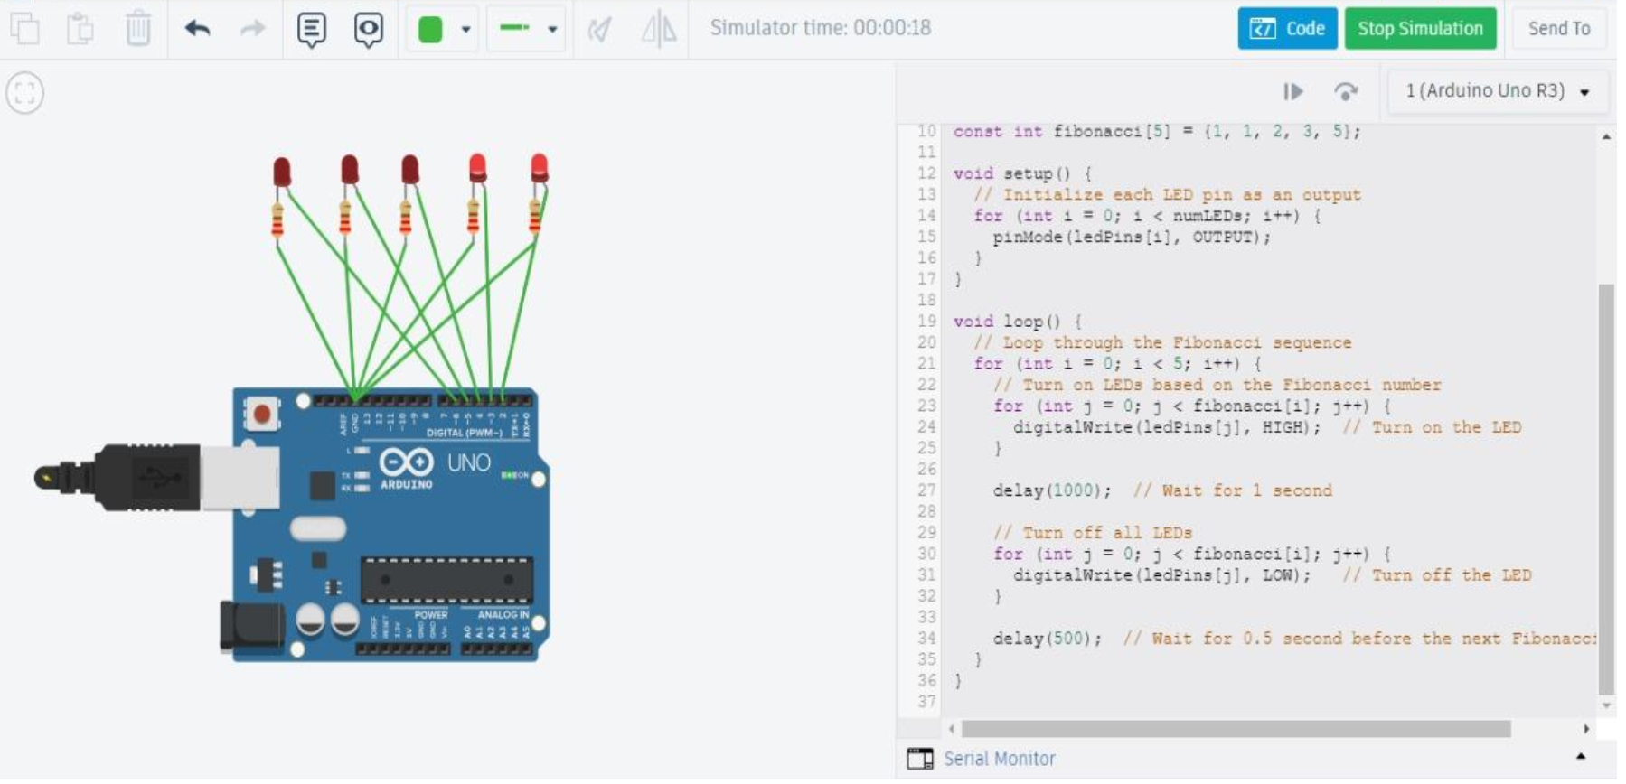

Result Analysis
This program helps generate a Fibonacci series and demonstrates how to create and manipulate LED patterns with the Arduino Uno R3 and Arduino IDE.
Signature of Faculty Member

Experiment 9

Objective
To demonstrate control of a DC motor using forward, backward, left and right turn motion, and clockwise / anti-clockwise rotation.

Hardware Used
Sr. No. | Name of Hardware | Quantity
1 | Arduino Uno Board | 1
2 | USB Cable | 1
3 | Nvis 3302ARD RoboCar | 1
Software Used: Arduino IDE

Theory
Nvis 3302ARD RoboCar
Nvis 3302ARD is capable of sensing the environment using various sensor modules and acts accordingly. Nvis RoboCar is a ready-assembled unit consisting of a strong chassis and wheels, with different sensor modules mounted on it. The machine is driven by DC motors which are powered by rechargeable batteries. This Nvis 3302ARD is an ATmega328P microcontroller RoboCar. We can design user-defined functions in the Arduino IDE to make the buggy move in specified directions — left, right, forward, backward, clockwise and anti-clockwise — by setting pins 5, 6, 7 and 8 on the Nvis 3302ARD RoboCar either HIGH or LOW.
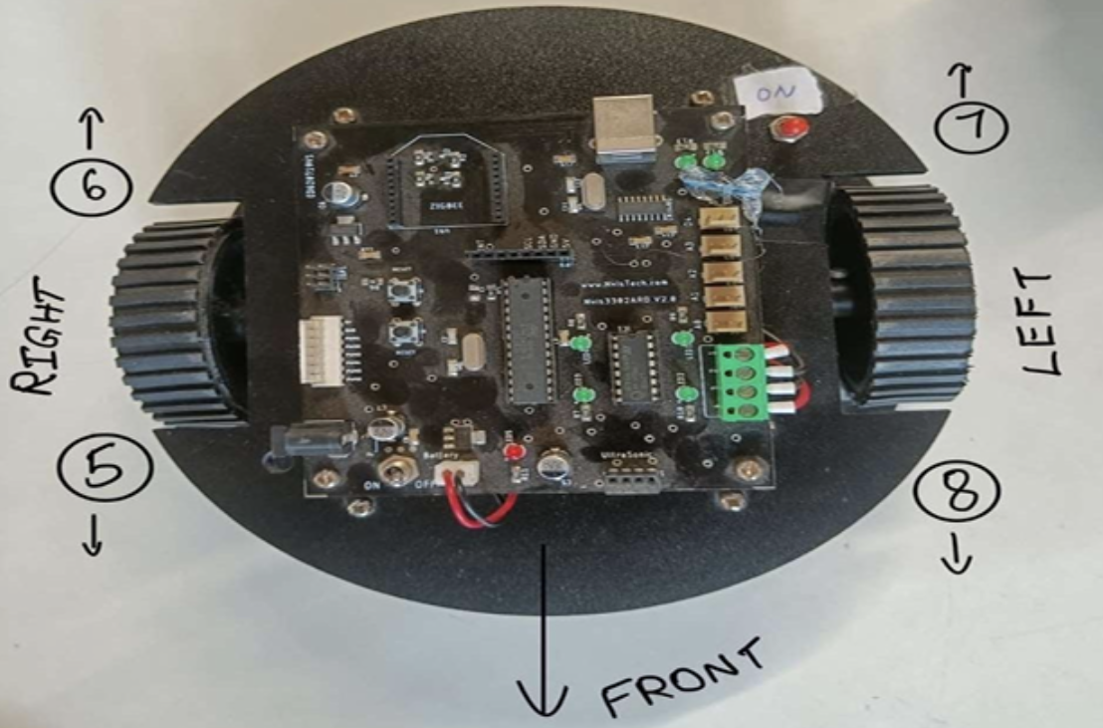
Arduino Uno Board
The Arduino Uno is a widely-used microcontroller board, ideal for both beginners and experienced developers. It is based on the ATmega328P microcontroller and operates at 5V with a clock speed of 16 MHz. The board features 14 digital I/O pins, six of which can be used for PWM output, and six analog input pins, making it versatile for a range of input and output operations. It supports several communication protocols, including UART, SPI, and I2C, allowing it to interface with various devices like sensors, displays, and other microcontrollers. Powered via USB or an external source, the Arduino Uno is often used in electronics projects, automation, robotics, and prototyping, thanks to its simplicity, flexibility, and extensive community support.

Code
void setup() {
Serial.begin(9600);
pinMode(5, OUTPUT);
pinMode(6, OUTPUT);
pinMode(7, OUTPUT);
pinMode(8, OUTPUT);
}

void forward() {
digitalWrite(5, HIGH);
digitalWrite(6, LOW);
digitalWrite(7, LOW);
digitalWrite(8, HIGH);
}

void backward() {
digitalWrite(5, LOW);
digitalWrite(6, HIGH);
digitalWrite(7, HIGH);
digitalWrite(8, LOW);
}

void right() {
digitalWrite(5, LOW);
digitalWrite(6, LOW);
digitalWrite(7, LOW);
digitalWrite(8, HIGH);
}

void left() {
digitalWrite(5, HIGH);
digitalWrite(6, LOW);
digitalWrite(7, LOW);
digitalWrite(8, LOW);
}

void anticlockwise() {
digitalWrite(5, HIGH);
digitalWrite(6, LOW);
digitalWrite(7, HIGH);
digitalWrite(8, LOW);
}

void clockwise() {
digitalWrite(5, LOW);
digitalWrite(6, HIGH);
digitalWrite(7, LOW);
digitalWrite(8, HIGH);
}

void loop() {
forward();
delay(1000);
backward();
delay(1000);
left();
delay(1000);
right();
delay(1000);
clockwise();
delay(1000);
anticlockwise();
delay(1000);
}

Result Analysis
We observed that the buggy can move forward, then backward, then left, then right, then clockwise, and finally anti-clockwise, with a gap of one second between each motion.
Signature of Faculty Member

Experiment 10

Objective
The objective of this assignment is to program a buggy (robot) to move in different geometric shapes — square, rectangle, circle, and hexagon — following these shapes using precise control of its wheels through the Arduino.

Hardware Used
Sr. No. | Name of Hardware | Quantity
1 | Arduino Uno Board | 1
2 | USB Cable | 1
3 | Nvis 3302ARD RoboCar | 1
Software Used: Arduino IDE

Theory
Nvis 3302ARD RoboCar
Nvis 3302ARD is capable of sensing the environment using various sensor modules and acts accordingly. Nvis RoboCar is a ready-assembled unit consisting of a strong chassis and wheels, with different sensor modules mounted on it. The machine is driven by DC motors which are powered by rechargeable batteries. This Nvis 3302ARD is an ATmega328P microcontroller RoboCar. We can design user-defined functions in the Arduino IDE to make the buggy move in specified directions — left, right, forward, backward, clockwise and anti-clockwise — by setting pins 5, 6, 7 and 8 on the Nvis 3302ARD RoboCar either HIGH or LOW.
Arduino Uno Board
The Arduino Uno is a widely-used microcontroller board, ideal for both beginners and experienced developers. It is based on the ATmega328P microcontroller and operates at 5V with a clock speed of 16 MHz. The board features 14 digital I/O pins, six of which can be used for PWM output, and six analog input pins, making it versatile for a range of input and output operations. It supports several communication protocols, including UART, SPI, and I2C, allowing it to interface with various devices like sensors, displays, and other microcontrollers. Powered via USB or an external source, the Arduino Uno is often used in electronics projects, automation, robotics, and prototyping, thanks to its simplicity, flexibility, and extensive community support.

Code
void setup() {
pinMode(motorLeftForward, OUTPUT);
pinMode(motorLeftBackward, OUTPUT);
pinMode(motorRightForward, OUTPUT);
pinMode(motorRightBackward, OUTPUT);
stopBuggy();
}

void loop() {
moveSquare();
delay(2000);
moveRectangle();
delay(2000);
moveCircle();
delay(2000);
moveHexagon();
delay(2000);
}

void moveForward(int duration) {
digitalWrite(motorLeftForward, HIGH);
digitalWrite(motorRightForward, HIGH);
delay(duration);
stopBuggy();
}

void turnRight(int duration) {
digitalWrite(motorLeftForward, HIGH);
digitalWrite(motorRightBackward, HIGH);
delay(duration);
stopBuggy();
}

void stopBuggy() {
digitalWrite(motorLeftForward, LOW);
digitalWrite(motorLeftBackward, LOW);
digitalWrite(motorRightForward, LOW);
digitalWrite(motorRightBackward, LOW);
}

void moveSquare() {
for (int i = 0; i < 4; i++) {
moveForward(1000);
turnRight(500);
}
}

void moveRectangle() {
for (int i = 0; i < 2; i++) {
moveForward(1000);
turnRight(500);
moveForward(2000);
turnRight(500);
}
}

void moveCircle() {
for (int i = 0; i < 360; i++) {
analogWrite(motorLeftForward, 255);
analogWrite(motorRightForward, 150);
delay(10);
}
stopBuggy();
}

void moveHexagon() {
for (int i = 0; i < 6; i++) {
moveForward(1000);
turnRight(400);
}
}

Result Analysis
This assignment demonstrates how to control the movement of a buggy in various geometric shapes using motor control with Arduino. It covers the use of basic control functions to achieve precise movement and turns.
- Square — the buggy moves in a square with four equal sides and 90-degree turns.
- Rectangle — the buggy moves in a rectangle with two longer sides and two shorter sides.
- Circle — the buggy moves in a smooth circular pattern by adjusting the speeds of the two motors.
- Hexagon — the buggy moves in a six-sided polygon, with equal-length sides and 60-degree turns at each corner.
Signature of Faculty Member

