A PRACTICAL ACTIVITY REPORT SUBMITTED
FOR ENGINEERING DESIGN PROJECT-I (UTA-030)
BY
Name of Student: Rachit Saini
Roll Number: 102304007
Class Group: 2D11/2EL1
Submitted To:
Dr. Gitanjali

DEPARTMENT OF ELECTRONICS AND COMMUNICATION ENGINEERING
THAPAR INSTITUTE OF ENGINEERING AND TECHNOLOGY
(A DEEMED TO BE UNIVERSITY), PATIALA, PUNJAB
INDIA
Session Year (July – December 2024)

Table of Contents
Sr. No. | Experiment No. | Objective
1 | 1(a) | To draw a schematic diagram of receiver to receive specified pulse width IR signals from gantries using CAD tool (Eagle).
2 | 1(b) | To design a printed circuit board layout of receiver circuit using CAD tool (Eagle).
3 | 2(a) | To draw a schematic diagram of IR sensor module circuit (required to move Buggy module on a predefined path) using CAD tool (Eagle).
4 | 2(b) | To design a printed circuit board layout of IR sensor module circuit using CAD tool (Eagle).
5 | 3(a) | To draw a schematic diagram of pulse width modulation (PWM) based transmitter for generating specified pulse width waveforms for gantries placed at different locations on the path using CAD tool (Eagle).
6 | 3(b) | To design a printed circuit board layout of pulse width modulation (PWM) based transmitter circuit using CAD tool (Eagle).

Experiment 1

Objective
1. To draw a schematic diagram of receiver to receive specified pulse width IR signals from gantries using CAD tool (Eagle).
2. To design a printed circuit board layout of receiver circuit using CAD tool (Eagle).
Software Used: Eagle Software

Components Used
Sr. No. | Name of Component | Value | Specification | Quantity
1 | Resistor | 120k Ω | Carbon Resistor with 5% Tolerance | 1x
2 | Resistor | 100k Ω | Carbon Resistor with 5% Tolerance | 1x
3 | Resistor | 22k Ω | Carbon Resistor with 5% Tolerance | 1x
4 | Resistor | 1k Ω | Carbon Resistor with 5% Tolerance | 1x
5 | Schottky Diode | BPW41N | — | 1x
6 | Male Header | 3-pin | PCB Header | 1x
7 | Operational Amplifier | LM311N | Microcontroller | 1x

Theory
1. Resistor
A resistor is a fundamental electronic component that controls the flow of electric current within a circuit. Essentially, it acts as a resistance against the current, preventing it from flowing freely. By introducing resistance, resistors help regulate voltage levels, protect delicate components, and shape the overall behavior of electronic devices.
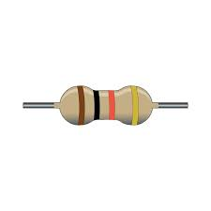
Fig. 1.1 Type of Resistor
2. Schottky Diode
A Schottky diode is a unique electronic component formed by the junction of a metal and a semiconductor. Unlike traditional diodes that use a p-n junction, this configuration provides distinct advantages. Renowned for its fast switching speed and low forward voltage drop, the Schottky diode finds applications in various electronic circuits, including high-frequency applications and power supplies.
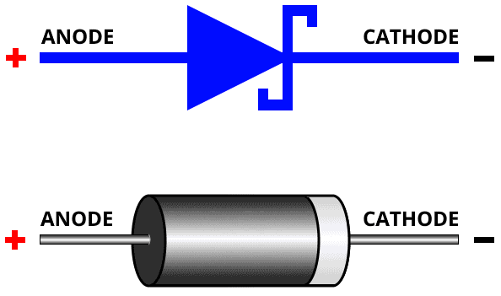
Fig. 1.2 A Schottky diode as an electrical component in the circuit
3. Male Header
Male headers are fundamental electrical connectors comprised of multiple metal pins embedded in a plastic housing. These pins, typically arranged in rows with standard spacings like 2.54mm, facilitate the connection between electronic components and circuits. Male headers offer a versatile and cost-effective solution for creating detachable interfaces, enabling easy assembly, testing, and modification of electronic systems.
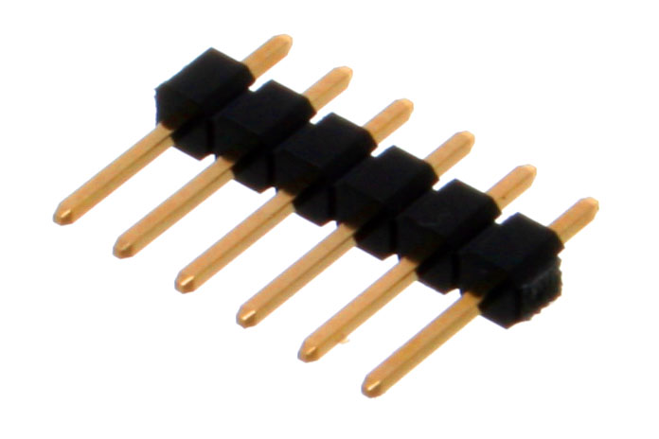
Fig. 1.3 A male header as an electrical component in the circuit

4. Operational Amplifier (LM358P)
An operational amplifier, or op-amp, is a versatile electronic component renowned for its ability to amplify weak electrical signals. Characterized by high input impedance and low output impedance, op-amps are typically integrated circuits comprising multiple transistors. Their core function is to magnify the voltage difference between their input terminals, producing a proportionally amplified output. This amplification capability, combined with their flexibility, makes op-amps indispensable in a vast array of electronic circuits and systems.
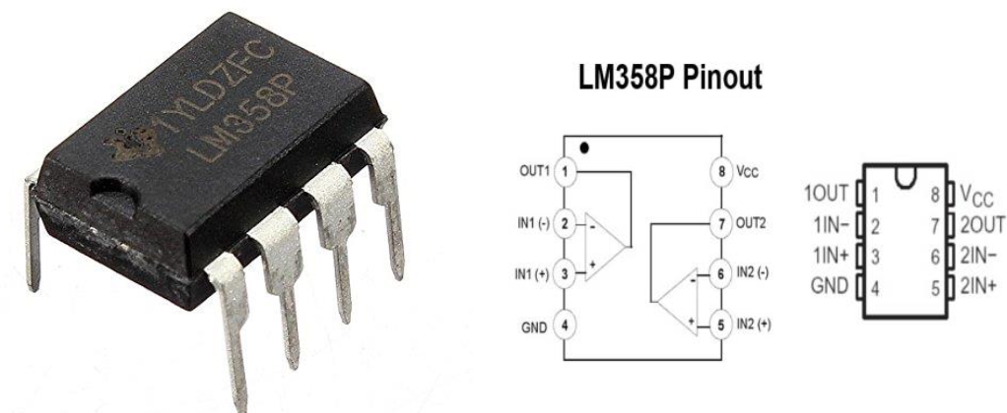
Fig. 1.4 Type of Operational Amplifier LM358P and its structure

Schematic Diagram
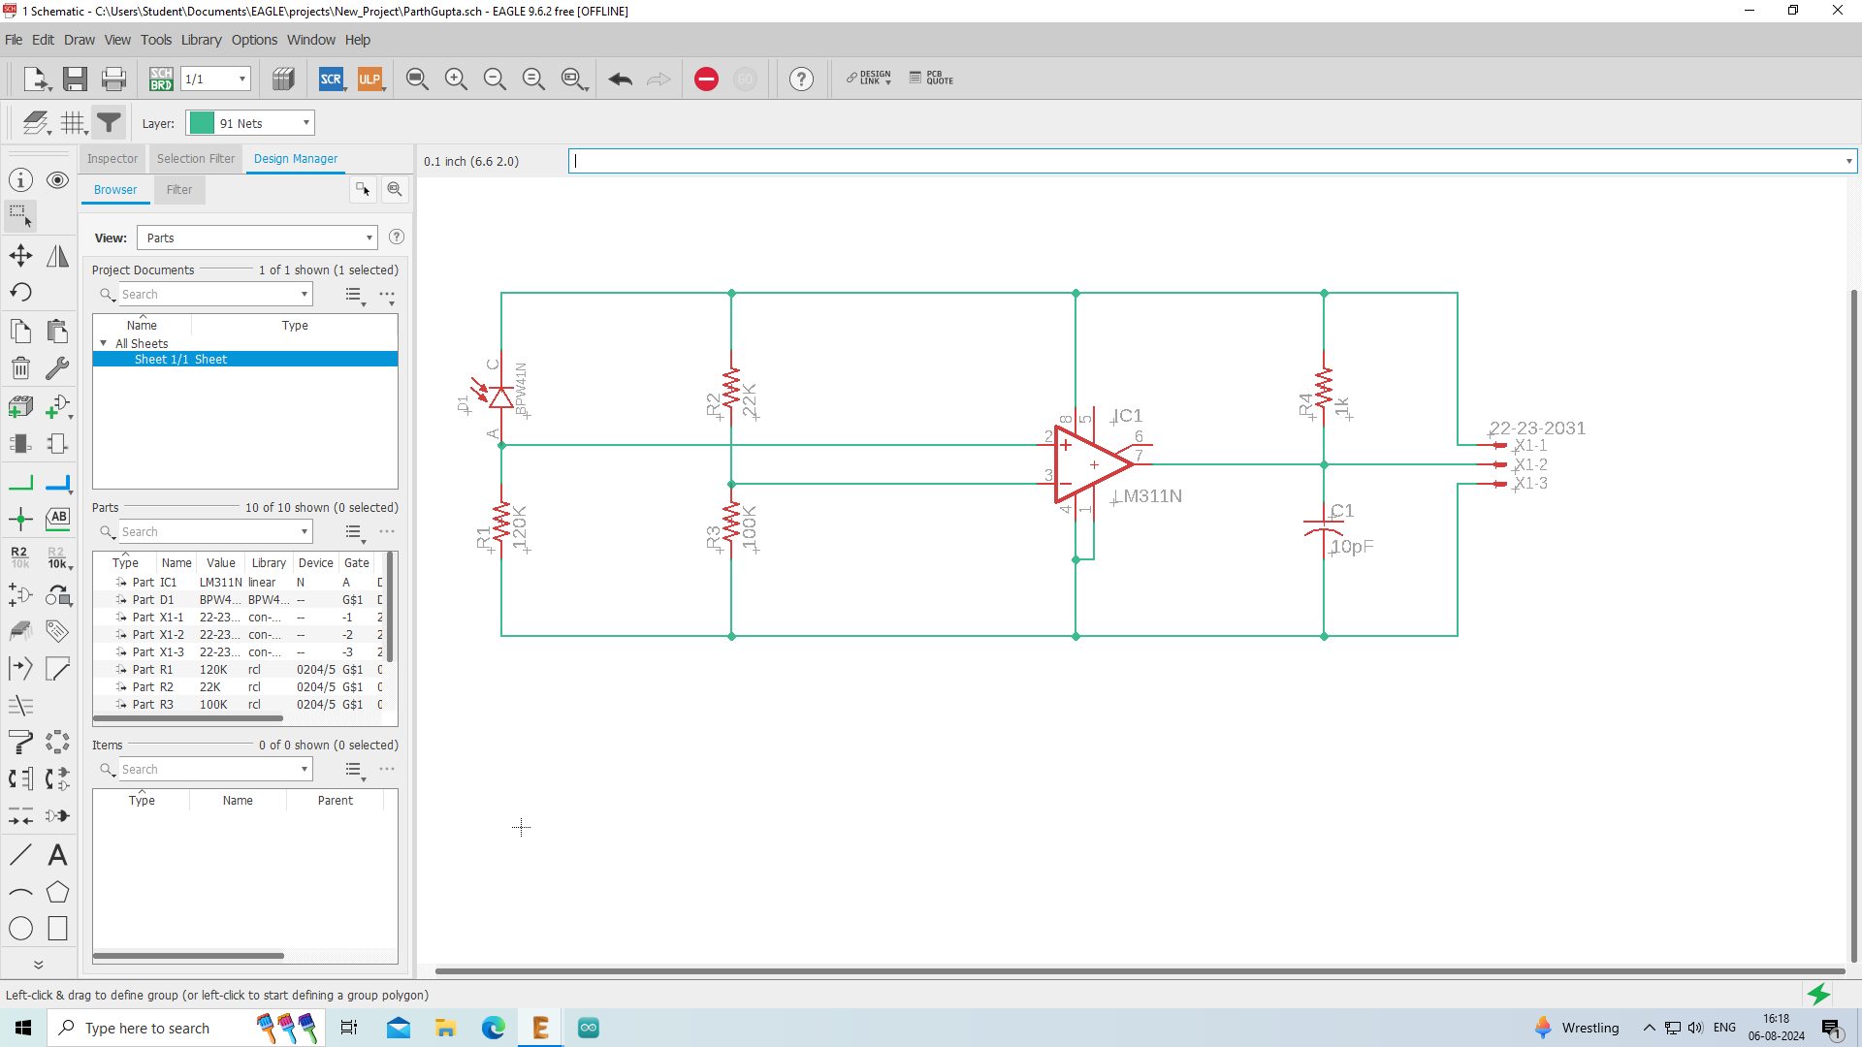
Fig. 1.5 Schematic diagram of IR circuit

Printed Circuit Board Diagram
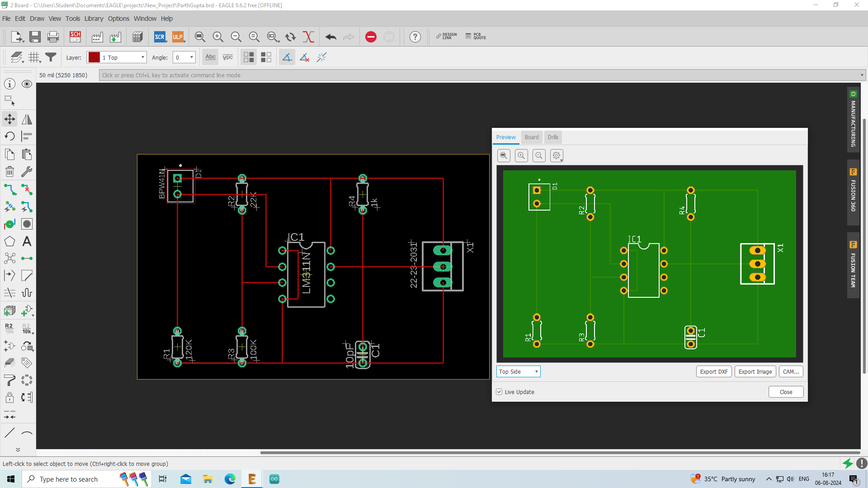
Fig. 1.6 PCB layout of IR circuit

Discussion
In this experiment, we have learnt how to draw a schematic diagram of a receiver to receive specified pulse width IR signals using CAD tool (Eagle) and how to design a printed circuit board layout of the receiver circuit using CAD tool (Eagle).
Basically, the primitives of the project course and the building components were introduced, along with how they have to be integrated in the manufacturing of the printed circuit board for the receiver-transmitter in the buggy.

References
1. https://byjus.com/question-answer/what-is-the-role-of-resistor-in-electric-circuit/
2. https://www.ablic.com/en/semicon/products/analog/opamp/intro/
Signature of Faculty Member

Experiment 2

Objective
1. To draw a schematic diagram of IR sensor module circuit (required to move Buggy module on a predefined path) using CAD tool (Eagle).
2. To design a printed circuit board layout of IR sensor module circuit using CAD tool (Eagle).
Software Used: Eagle Software

Components Used
Sr. No. | Name of Component | Value | Specification | Quantity
1 | Resistor | 220 Ω | Carbon Resistor with 5% Tolerance | 4x
2 | Resistor | 10k Ω | Carbon Resistor with 5% Tolerance | 2x
3 | Potentiometer | 10k Ω | — | 2x
4 | LED 3mm | 5V | Dome Lamp | 2x
5 | IR Transmitter | SFH482 | — | 2x
6 | IR Receiver | BPX65 | PCB Header | 2x
7 | Operational Amplifier | LM358P | Microcontroller | 1x

Theory
1. Resistor
A resistor is a fundamental electronic component that controls the flow of electric current within a circuit. Essentially, it acts as a resistance against the current, preventing it from flowing freely. By introducing resistance, resistors help regulate voltage levels, protect delicate components, and shape the overall behavior of electronic devices.

Fig. 2.1 Type of Resistor
2. IR Transmitter (SFH482)
A transmitter is an essential electronic component that converts information into a signal suitable for transmission over a distance. It acts as a bridge, transforming various inputs like sound, data, or sensor readings into electrical signals that can be propagated through different mediums. From radio waves to electrical wires, transmitters enable the seamless flow of information across vast distances.
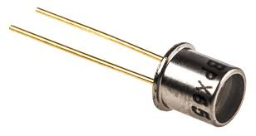
Fig. 2.2 Type of IR Transmitter
3. IR Receiver (BPX65)
Receivers are fundamental building blocks in electronic circuits, designed to detect and process incoming signals. These components play a crucial role in capturing, amplifying, and conditioning electrical signals for subsequent stages of a system. From simple radio receivers to complex communication systems, receivers are indispensable in converting electromagnetic energy into usable electrical information.
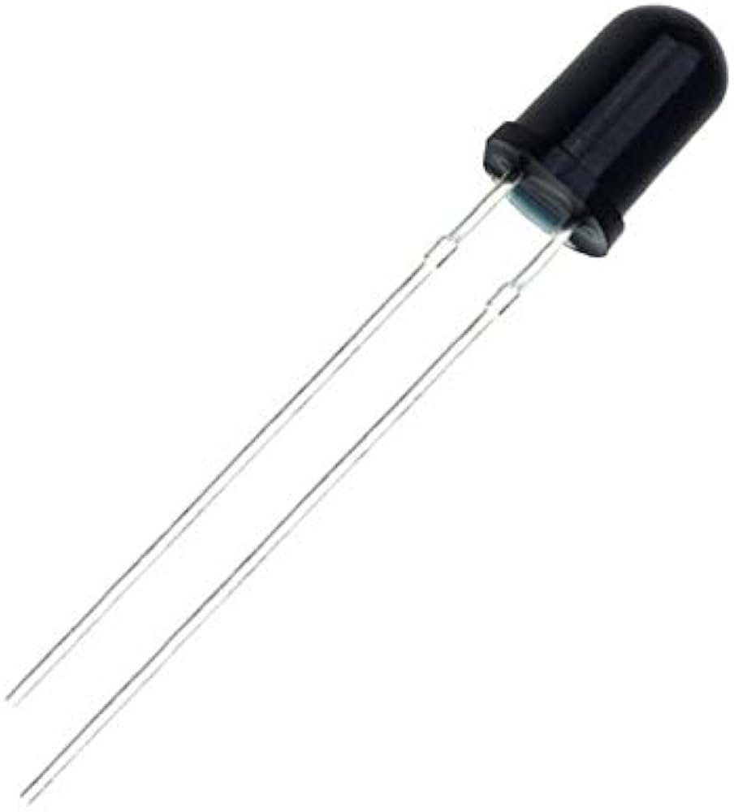
Fig. 2.3 Type of IR Receiver

4. LED 3mm
LED 3mm are small, yet versatile electronic components known as Light Emitting Diodes (LEDs). They convert electrical energy into light and are widely used for various applications due to their compact size, low power consumption, and long lifespan.
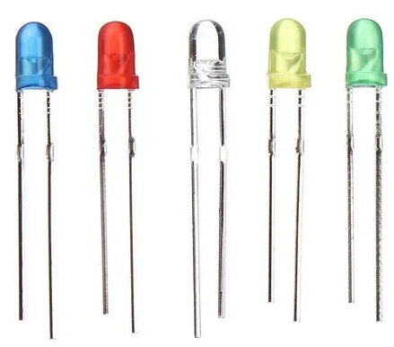
Fig. 2.4 Various types of sub-miniature standard LEDs
5. Potentiometer
A potentiometer is a variable resistor that allows for the control of electrical resistance. It consists of a resistive element with a sliding contact, known as a wiper, that can be moved along its length. By adjusting the wiper's position, the electrical resistance between the wiper and one end of the element changes, providing a means to control voltage or current in a circuit. Potentiometers find widespread applications in various electronic devices for tasks such as volume control, sensor input, and voltage division.
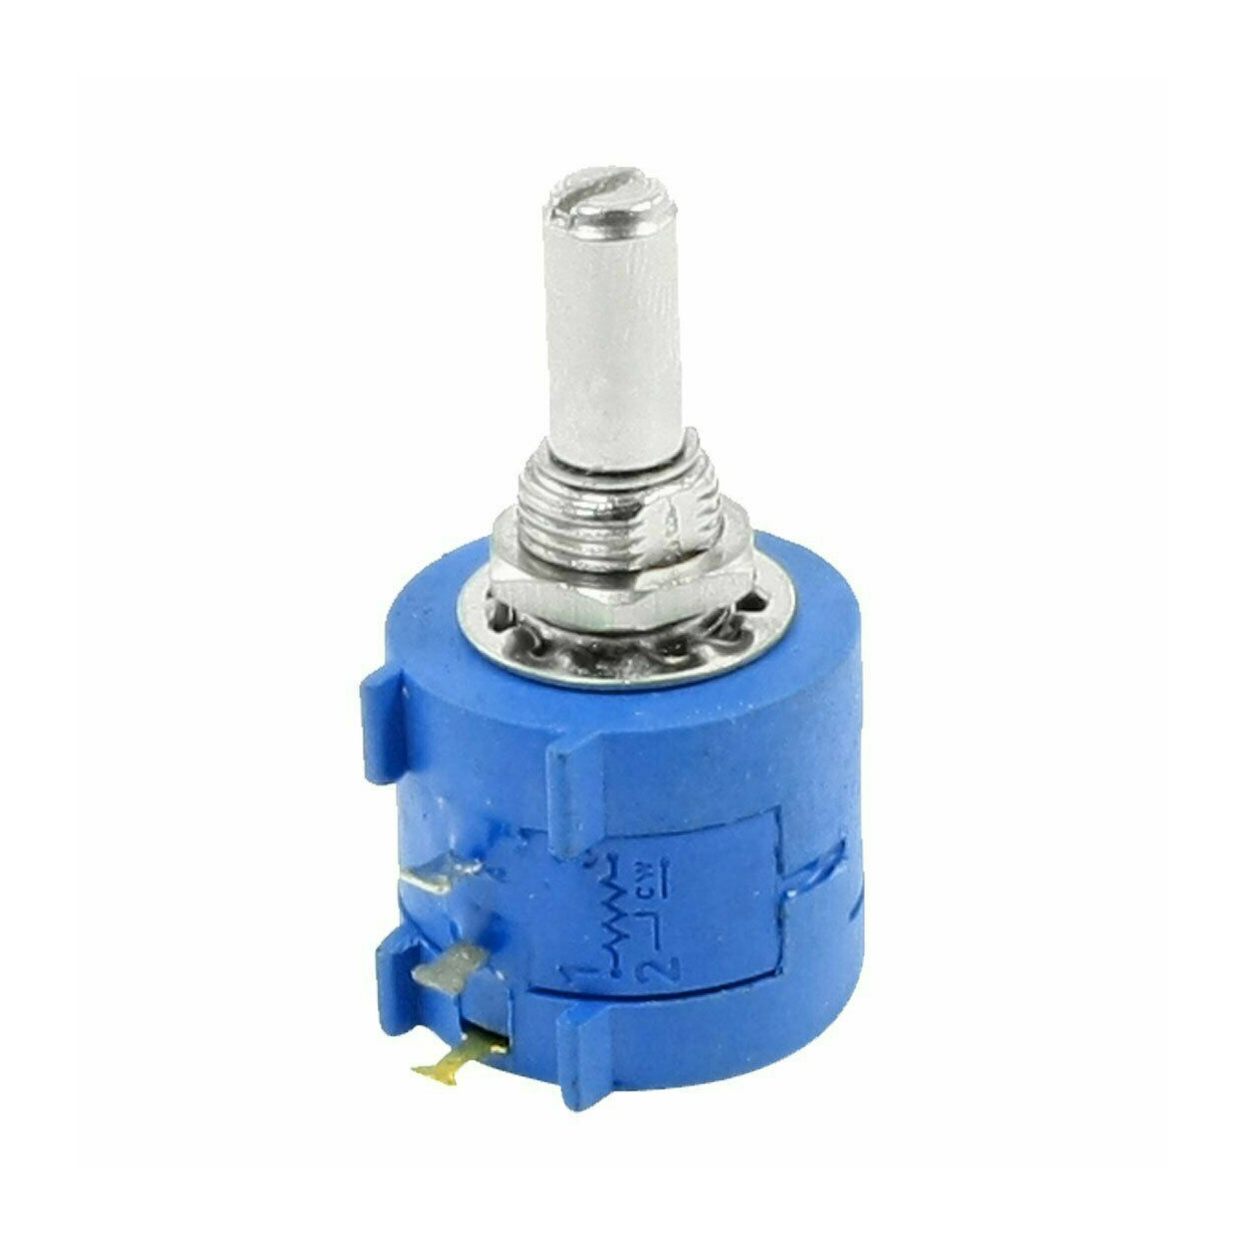
Fig. 2.5 Type of Potentiometer

6. Operational Amplifier (LM358P)
An operational amplifier, or op-amp, is a versatile electronic component renowned for its ability to amplify weak electrical signals. Characterized by high input impedance and low output impedance, op-amps are typically integrated circuits comprising multiple transistors. Their core function is to magnify the voltage difference between their input terminals, producing a proportionally amplified output. This amplification capability, combined with their flexibility, makes op-amps indispensable in a vast array of electronic circuits and systems.
Fig. 2.6 Type of Operational Amplifier LM358P and its structure

Schematic Diagram
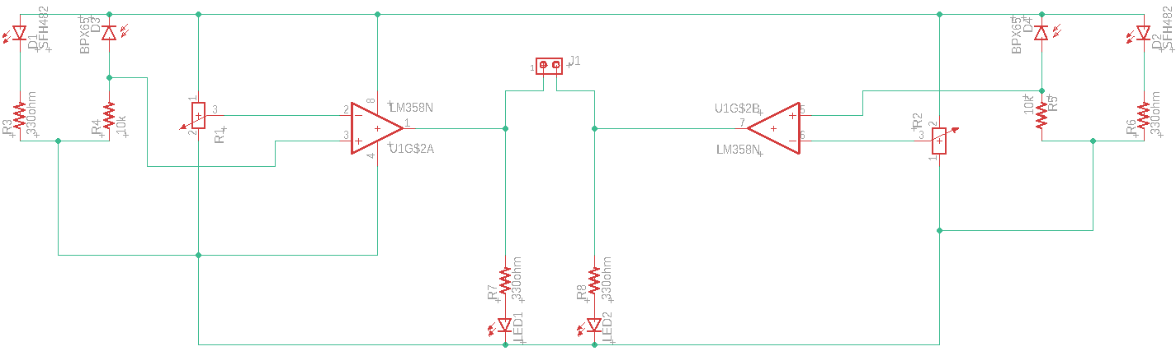
Fig. 2.7 Schematic diagram of IR sensor module circuit

Printed Circuit Board Diagram
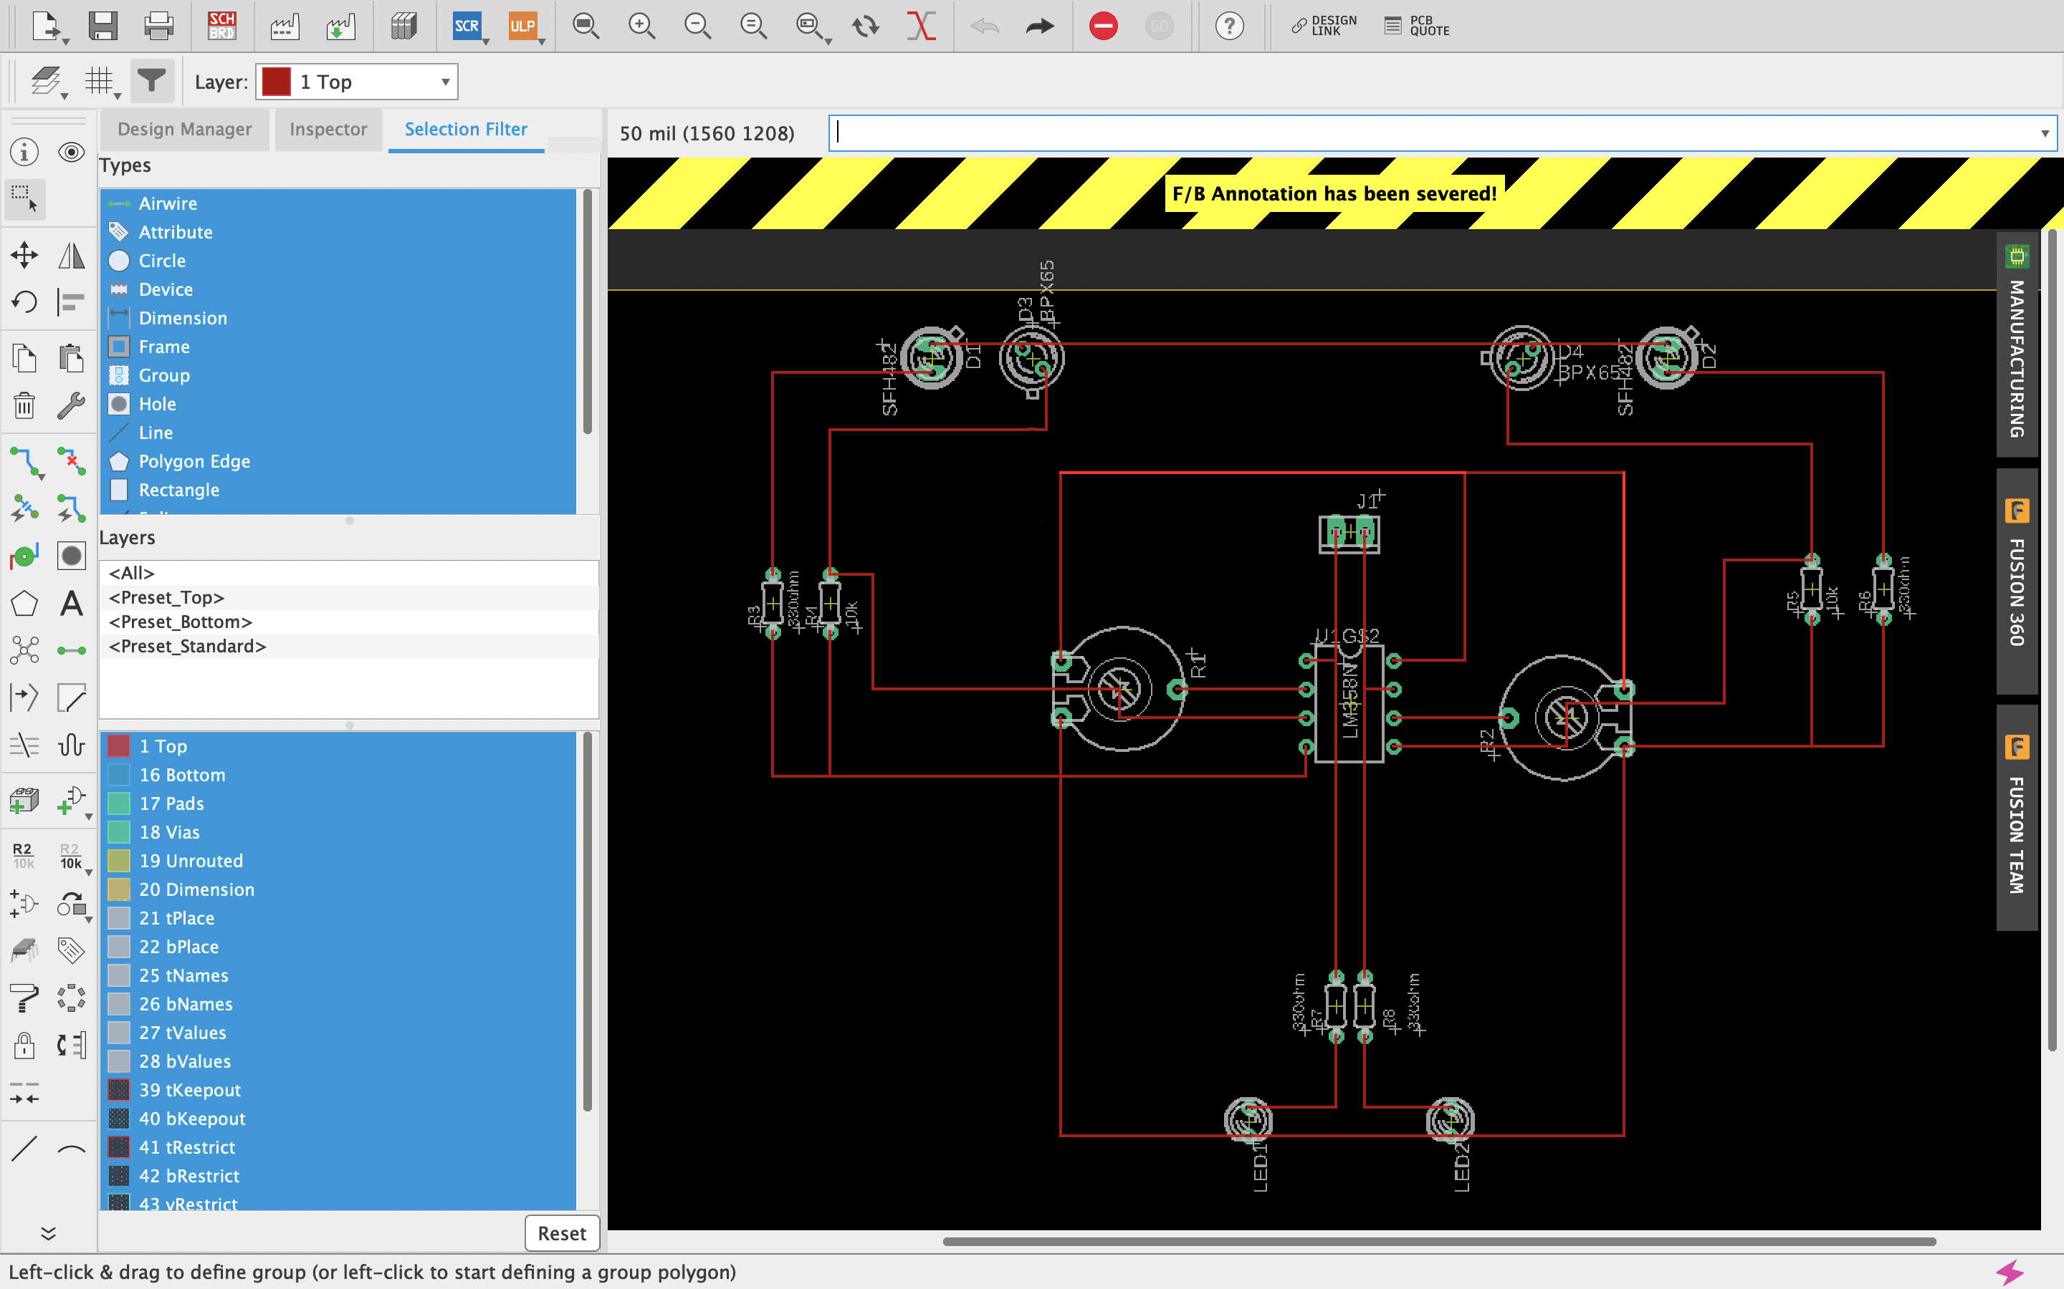
Fig. 2.8 PCB layout of IR sensor module circuit

Manufacturing — Front Side
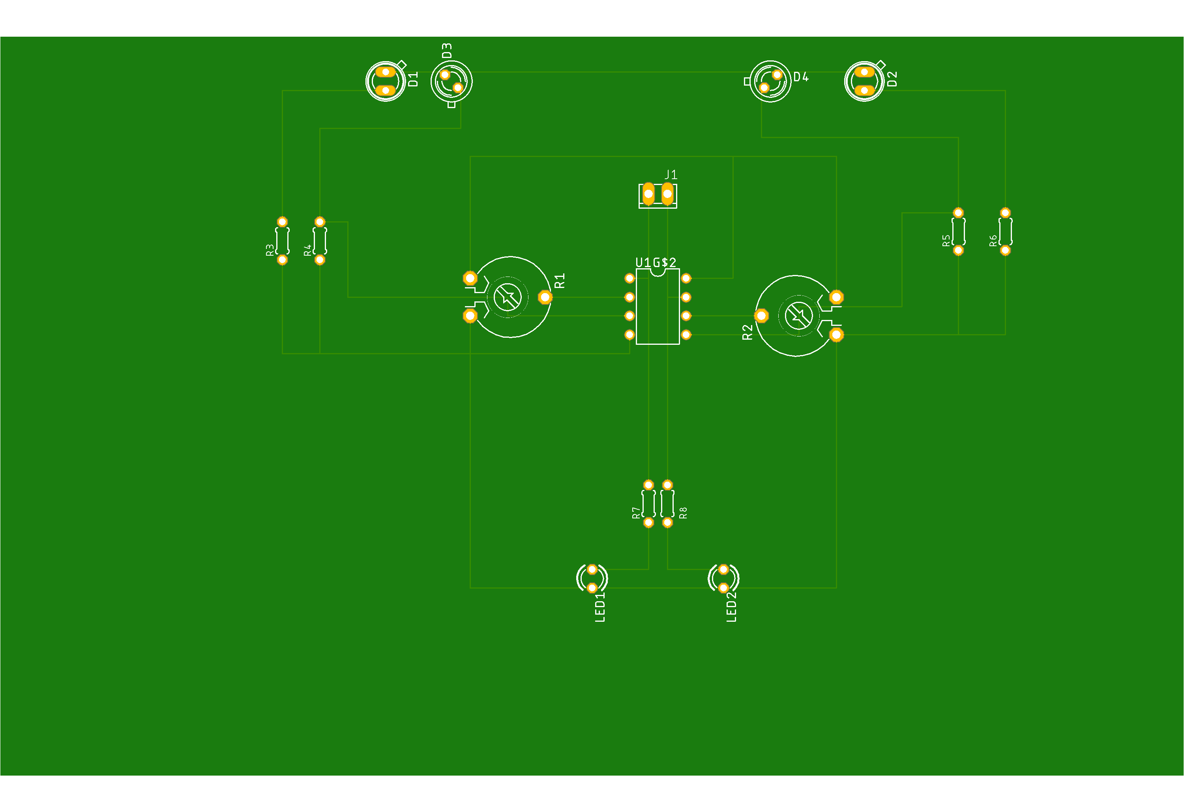
Fig. 2.9 PCB manufacturing overview, front side

Manufacturing — Back Side

Fig. 2.10 PCB manufacturing overview, back side

Discussion
Using EAGLE (CAD), we learnt to draw the schematic diagram of an IR sensor module circuit which is required to move the Buggy module along a predefined path. Since the path is designated in advance, the role of the IR transmitter and receiver becomes equally important, so we have integrated them crucially in this circuit.
After this, it was very important to design a printed circuit board layout of the IR sensor module circuit using CAD tool (Eagle) and implement the circuit for operation on the buggy over the path through appropriate communication between the receiver-transmitter module.

References
1. https://www.electricaltechnology.org/2015/01/resistor-types-resistors-fixed-variable-linear-non-linear.html
2. https://byjus.com/question-answer/what-is-the-role-of-resistor-in-electric-circuit/
3. https://www.ablic.com/en/semicon/products/analog/opamp/intro/
4. https://en.wikipedia.org/wiki/Transmitter
Signature of Faculty Member

Experiment 3

Objective
1. To draw a schematic diagram of pulse width modulation (PWM) based transmitter for generating specified pulse width waveforms for gantries placed at different locations on the path using CAD tool (Eagle).
2. To design a printed circuit board layout of pulse width modulation (PWM) based transmitter using CAD tool (Eagle).
Software Used: Eagle Software

Components Used
Sr. No. | Name of Component | Value | Specification | Quantity
1 | Resistor | 220 Ω | Carbon Resistor with 5% Tolerance | 1x
2 | Capacitor | 1000nF | Electrolytic Capacitor | 1x
3 | Capacitor | 10nF | Ceramic Capacitor | 1x
4 | DCJ0202 | NA | DC Power Jack | 1x
5 | LED 3mm | 5V | Dome Lamp | 1x
6 | IC 78L05Z | 5V | Positive Voltage Regulator | 1x
7 | 22-23-2031 | NA | PCB Header | 1x
8 | ATTINY85 | NA | Microcontroller | 1x

Theory
1. Resistor
A resistor is a fundamental electronic component that controls the flow of electric current within a circuit. Essentially, it acts as a resistance against the current, preventing it from flowing freely. By introducing resistance, resistors help regulate voltage levels, protect delicate components, and shape the overall behavior of electronic devices.
Fig. 3.1 Type of Resistor
2. Capacitor
Capacitors are essential electronic components that store electrical energy in an electrostatic field. They consist of two conductive plates separated by an insulating material, known as a dielectric. When a voltage is applied across the plates, an electric charge accumulates on them, forming an electric field between them. This stored energy can be released under certain conditions, making capacitors valuable in various applications.
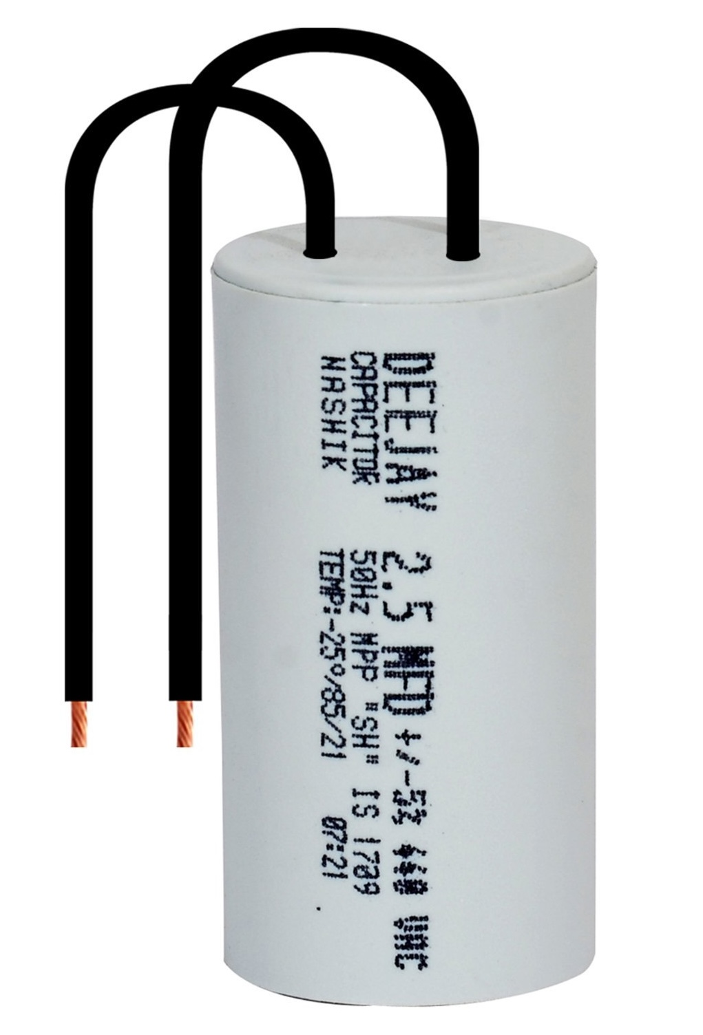
Fig. 3.2 A capacitor as a charge-storing component of the electrical circuit

3. LED 3mm
LED 3mm are small, yet versatile electronic components known as Light Emitting Diodes (LEDs). They convert electrical energy into light and are widely used for various applications due to their compact size, low power consumption, and long lifespan.
Fig. 3.3 Various types of sub-miniature standard LEDs
4. IC 78L05Z
The IC 78L05Z is a three-terminal linear voltage regulator designed to provide a stable 5V output voltage. It belongs to the 78xx series of voltage regulators, which are widely used in various electronic circuits. The "L" in 78L05Z indicates that it is a low-power version, making it suitable for applications that require a lower current rating.
Key features of the IC 78L05Z include a fixed 5V output that stays consistent regardless of input voltage fluctuations, low power consumption suitable for limited power budgets, straightforward integration with minimal external components, a wide operating voltage range from 7V to 35V, and internal overcurrent and thermal protection.
It is commonly used in power supplies providing a regulated 5V rail, in powering microcontrollers, logic gates and other digital components, as a stable voltage reference in analog circuits, and for driving LEDs at a constant current.
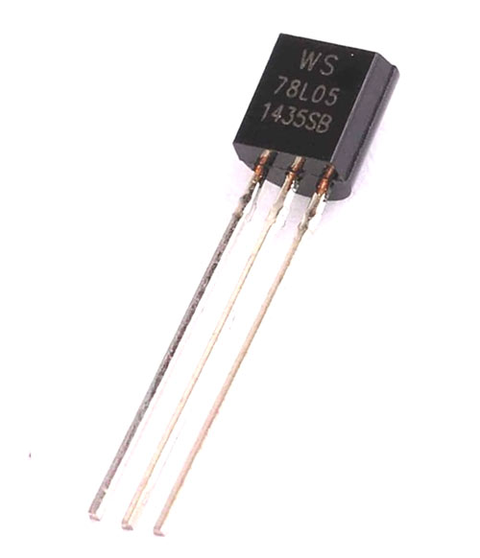
Fig. 3.4 An IC 78L05Z as a voltage regulator

5. ATTINY85
The ATtiny85 is a low-power, high-performance 8-bit microcontroller from Atmel (now part of Microchip Technology). It is a popular choice for small-scale embedded systems due to its compact size, low cost, and versatility.
Key features include an 8-bit AVR core offering efficient processing power, low power consumption ideal for battery-powered applications, a small form factor that reduces overall board size, multiple I/O pins usable for digital I/O, analog input, PWM output and communication interfaces, a built-in oscillator, and in-system programmability (ISP) for easy updates without removing the chip from the circuit.
It is commonly used in IoT devices for controlling sensors and actuators, in wearable electronics, in hobby and DIY projects, and for educational purposes in learning microcontroller programming.
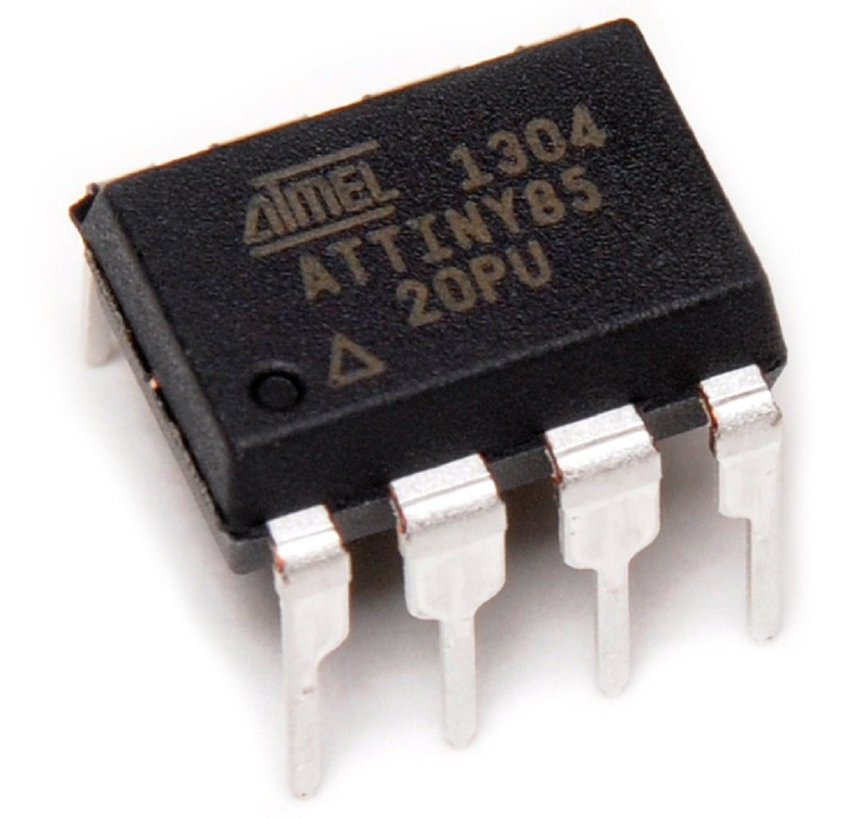
Fig. 3.5 An ATTINY85 as a microcontroller from Atmel

6. DCJ0202
DCJ0202 is a common type of electrical connector used in various electronic devices. Designed to provide a reliable connection for DC power supply, it is often found in laptops, tablets, and other portable devices. Its compact size and robust construction make it a popular choice for both consumer and industrial applications.
Key features of DCJ0202 connectors include a compact design ideal for space-constrained applications, a reliable connection that ensures stable power delivery, wide compatibility across various electronic devices, and durability built to withstand regular use and environmental factors.
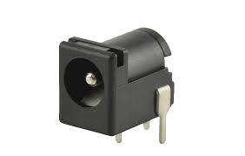
Fig. 3.6 A DCJ0202 as an electrical connector in various electronic devices
7. 22-23-2031 (MTA02-100)
The 22-23-2031 (MTA02-100) connector is a three-pin header designed for various electronic applications. It features a pitch of 0.100 inches (2.54mm) and is commonly used in robotics, automation, and other industrial settings. This connector is known for its reliability and ease of use, making it a popular choice among engineers and technicians.
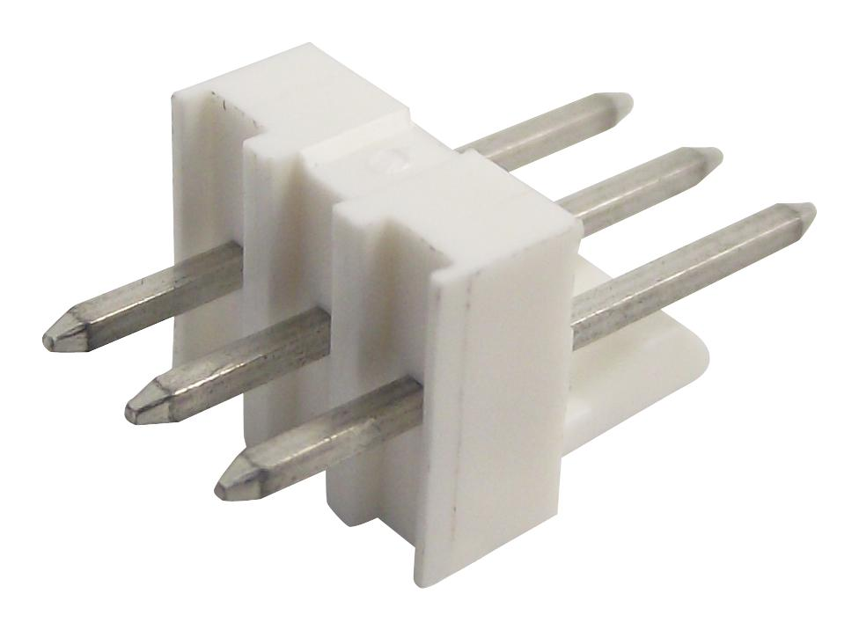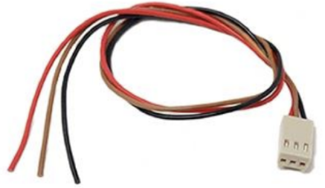
Fig. 3.7 Series 22-23-2031 (MTA02-100) connector used for various electronic applications

Schematic Diagram
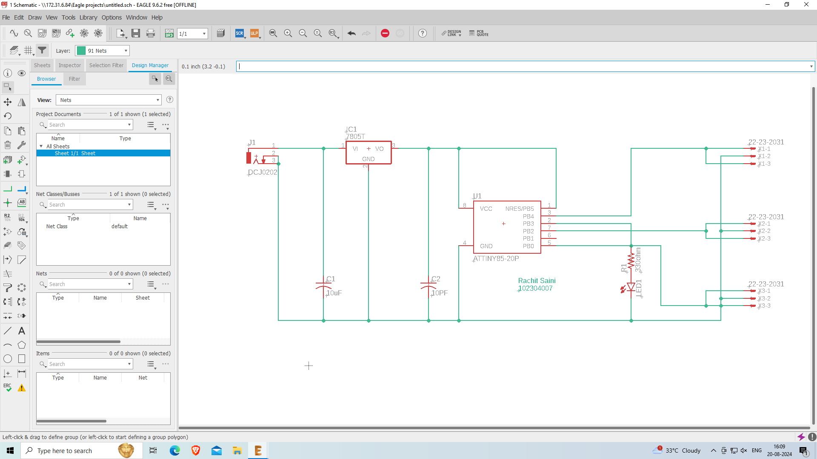
Fig. 3.8 Schematic diagram of transmitter circuit

Printed Circuit Board Layout
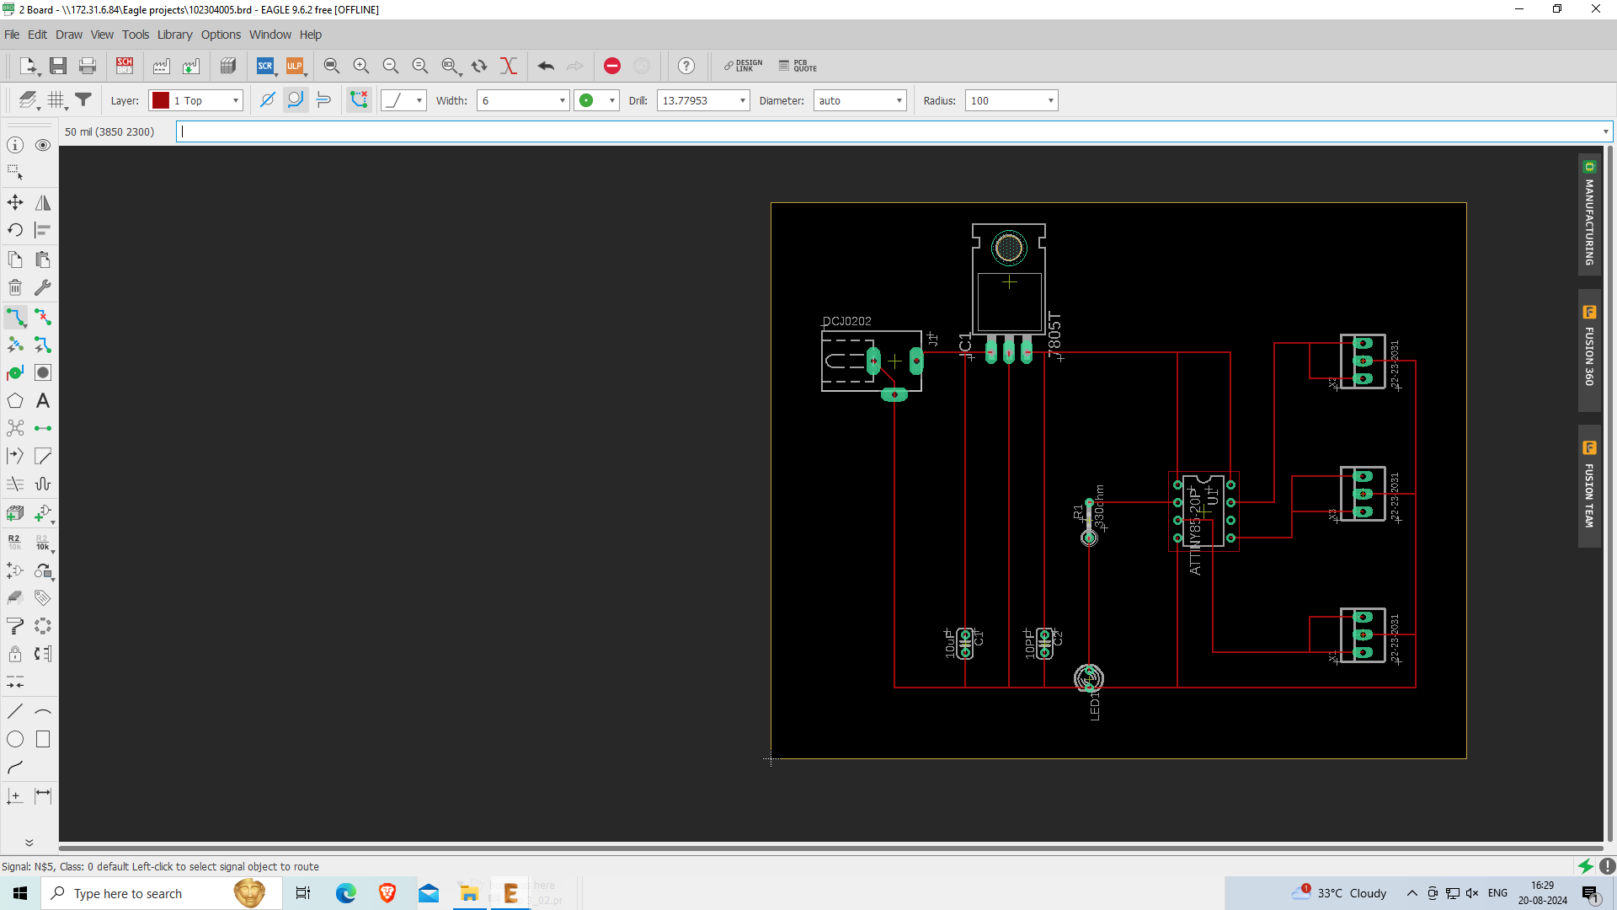
Fig. 3.9 PCB layout of transmitter circuit

Manufacturing — Front Side
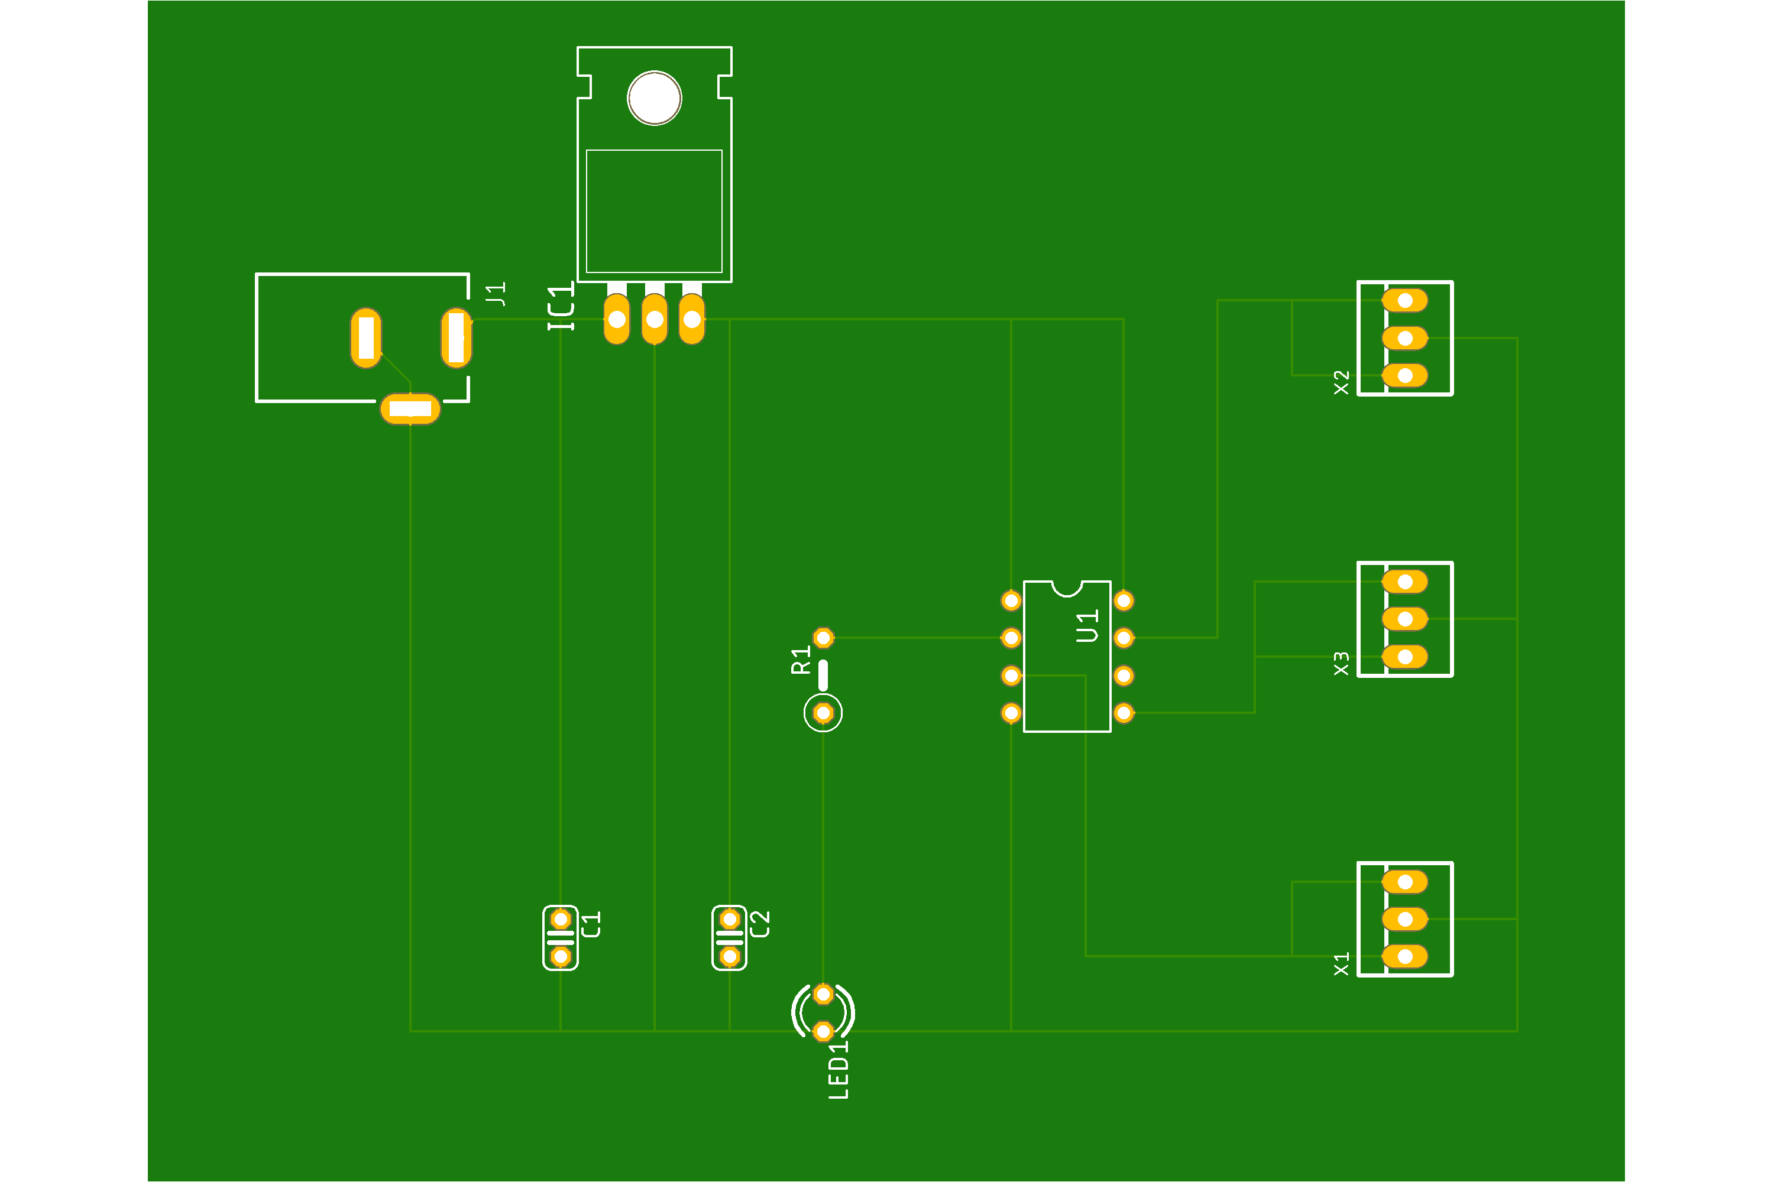
Fig. 3.10 Manufacturing layout of PCB board, front side

Manufacturing — Back Side
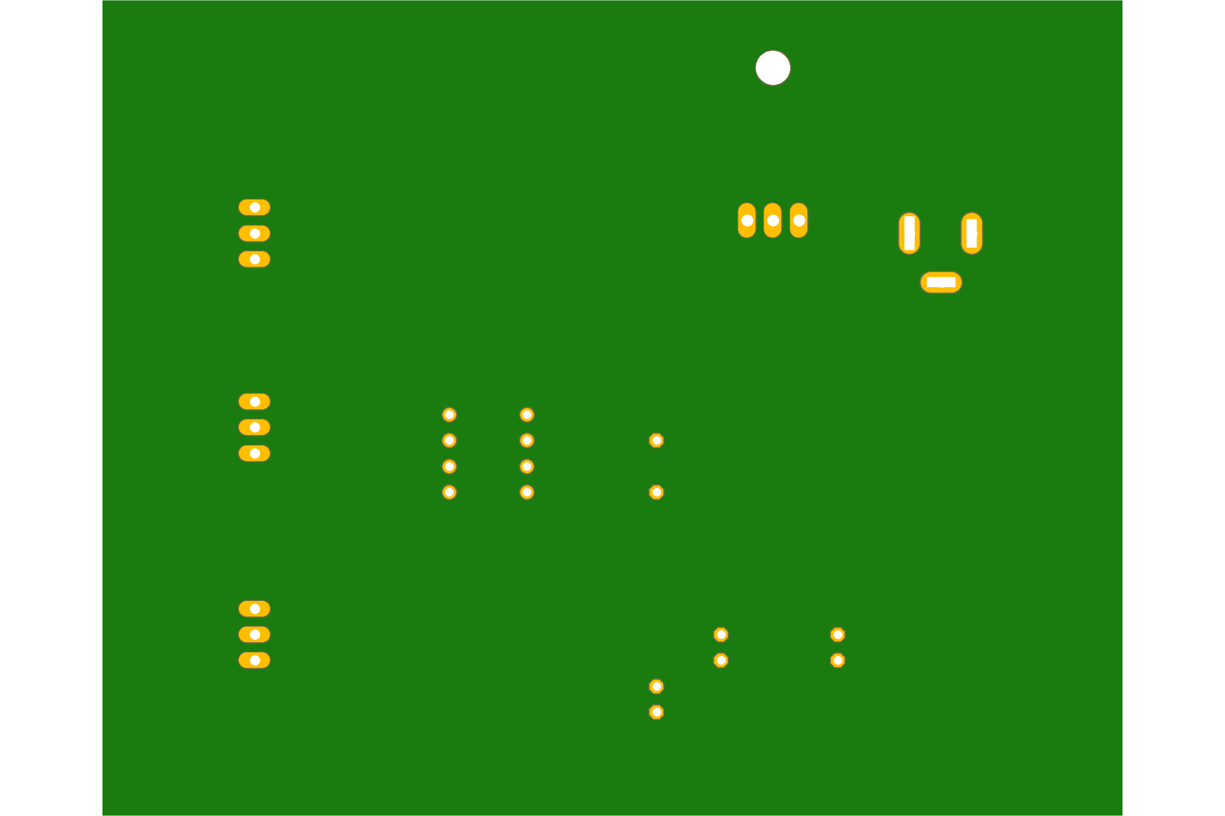
Fig. 3.11 Manufacturing layout of PCB board, back side

Discussion
Using EAGLE (CAD), we learnt to draw the schematic diagram of a pulse width modulation (PWM) based transmitter for generating specified pulse width waveforms for gantries placed at different locations on the path, required to move the Buggy module along a predefined path. Since the path is designated in advance, the role of the PWM-based transmitter becomes very important, so we have integrated it crucially in this circuit.
After this, it was very important to design a printed circuit board layout of the pulse width modulation (PWM) based transmitter and implement the circuit for operation on the buggy over the path through appropriate communication.

References
1. https://byjus.com/physics/resistor/
2. https://www.tme.eu/en/details/mx-22-23-2031/raster-signal-connectors-2-54mm/molex/22-23-2031/
3. https://www.sciencedirect.com/topics/materials-science/capacitor
4. https://components101.com/regulators/78l05-pinout-equivalent-datasheet
5. https://www.microchip.com/en-us/product/attiny85
6. https://easyeda.com/aob99/component/DCJ0202_DCJ0202-hFN5ZhzsK
Signature of Faculty Member

