*A project report on*

**E-waste Segregation and Management using Deep Learning**

#### Submitted in partial fulfillment for the award of the degree of

Bachelor of Technology in Computer Science and Engineering with Specialization in Artificial Intelligence and Robotics

*by*

# Rachit Mehul Pathak(20BRS1103)



**SCHOOL OF COMPUTER SCIENCE AND ENGINEERING**

April,2024

## ABSTRACT

With a rise in environmental concerns, E-waste (Electronic waste) management has become an essential activity in urban areas, rural areas, and outside industrial sites. Proper segregation of E- waste into distinguishable classes is very important, considering its non-biodegradable and toxic nature. The project proposes a novel approach by utilizing ResNet-50 and YOLO architectures for creating an automated E-waste management system. The project aims at detecting damaged batteries, damaged bulbs, good batteries, good bulbs, and PCB’s (Printed Circuit Boards). The suggested system provides a scalable and precise solution aimed at bolstering E-waste management practices, thereby making a positive contribution to environmental sustainability endeavors.

## ACKNOWLEDGEMENT

### It is my pleasure to express with deep sense of gratitude to Dr. Manjula V., Associate Professor, School of Computer Science and Engineering, Vellore Institute of Technology, Chennai, for her constant guidance, continual encouragement, understanding; more than all, she taught me patience in my endeavor. My association with her is not confined to academics only, but it is a great opportunity on my part to work with an intellectual and expert in the field of Artificial Intelligence.

### It is with gratitude that I would like to extend my thanks to the visionary leader Dr. G. Viswanathan our Honorable Chancellor, Mr. Sankar Viswanathan, Dr. Sekar Viswanathan, Dr. G V Selvam Vice Presidents, Dr. Sandhya Pentareddy, Executive Director, Ms. Kadhambari S. Viswanathan, Assistant Vice-President, Dr. V. S. Kanchana Bhaaskaran Vice-Chancellor, Dr. T. Thyagarajan Pro-Vice Chancellor, VIT Chennai and Dr. P. K. Manoharan, Additional Registrar for providing an exceptional working environment and inspiring all of us during the tenure of the course.

### Special mention to Dr. Ganesan R, Dean, Dr. Parvathi R, Associate Dean Academics, Dr. Geetha S, Associate Dean Research, School of Computer Science and Engineering, Vellore Institute of Technology, Chennai for spending their valuable time and efforts in sharing their knowledge and for helping us in every aspect.

In a jubilant state, I express ingeniously my whole-hearted thanks to Dr. Harini S, Head of the Department, B.Tech. CSE with Specialization in Artificial Intelligence & Robotics and the Project Coordinators for their valuable support and encouragement to take up and complete the thesis.

### My sincere thanks to all the faculty members and staff members at Vellore Institute of Technology, Chennai who helped me acquire the requisite knowledge. I would like to thank my parents for their support. It is indeed a pleasure to thank my friends who encouraged me to take up and complete this task.

Place: Chennai

Date: **Rachit Mehul Pathak**

# CONTENTS

CONTENTS iii

LIST OF FIGURES *iv*

LIST OF TABLES *v*

LIST OF ACRONYMS *vi*

CHAPTER 1 INTRODUCTION

* 1. INTRODUCTION 1
  2. PROBLEM STATEMENT 2
  3. RESEARCH CHALLENGES 2
  4. OBJECTIVES 3
  5. JUSTIFICATION OF STUDY 4

CHAPTER 2 BACKGROUND

* 1. INTRODUCTION 5
  2. LITRATURE REVIEW 5
  3. COMPARITVE ANALYSIS AND APPROACHES 10

CHAPTER 3

MODEL DESIGN AND FRAMEWORK

* 1. MODEL DESCRIPTION 16
  2. DATASET 18
  3. MODEL ANALYSIS 19

CHAPTER 4

RESULTS AND OBSERVATIONS

* 1. ENVIRONMENT SETUP 27
  2. MODEL EVALUATION 27
  3. YOLOv5 vs YOLOv8 COMPARISON STUDY 40
  4. CREATION OF USER INTERFACE 41

CHAPTER 5

CONCLUSION AND FUTURE WORK

* 1. CONCLUSIONS 46
  2. FUTURE WORK 46

REFERENCES 48

APPENDICES

* 1. APPENDIX 1 50
  2. APPENDIX 2 55

## LIST OF FIGURES

* 1. SYSTEM ARCHITECTURE FOR E-WASTE SEGREGATION MODEL 16
  2. (a) SAMPLE IMAGE DAMAGED BULB 19
     1. SAMPLE IMAGE GOOD BATTERY 19
     2. SAMPLE IMAGE PCB 19
     3. SAMPLE IMAGE DAMAGED BATTERY 19
     4. SAMPLE IMAGE GOOD BULB 19
  3. NETWORK ARCHITECTURE 20
  4. ARRANGING IMAGES IN APPROPRIATE FORMAT BEFORE RESNET-50 24
  5. IMAGE CLASSIFICATION USING RESNET-50 25
  6. IMAGE CLASSIFICATION USING YOLOv5 AND YOLOv8 26
  7. TRAINING VS VALIDATION ACCURACY FOR RESNET-50 MODEL 31
  8. PRECISION-CONFIDENCE CURVE FOR YOLOv5/v8 32
  9. DIFFERENT OBJECTS DETECTED CORRECTLY 33
  10. RECALL- CONFIDENCE CURVE FOR YOLOv5/v8 34
  11. ACCURATE DETECTIONS MADE BY YOLOv5/v8 MODEL ON VALIDATION SET 35
  12. F1 – CONFIDENCE CURVE FOR YOLOv5/v8 36,37
  13. PLOTS REPRESENTING YOLOv5 MODEL PERFORMANCE 37
  14. (a) CONFUSION MATRIX FOR YOLOv5/v8 MODEL 38
      1. CONFUSION MATRIX FOR RESNET-50 MODEL 39

* 1. PERFORMANCE METRICS FOR ALL THREE MODELS 41,42

1.16 SETTINGS THAT CAN BE ALTERED BY THE USER WHILE USING

USER INTERFACE 47

* 1. EXAMPLE ON THE WASTE RECOGNITION DASHBOARD 48

**LIST OF TABLES**

* 1. COMPARITIVE ANALAYSIS OF LITRATURE REVIEW 15
  2. CATEGORY WISE DISTRIBUTION OF IMAGES 18
  3. EVALUATION METRICS FOR RESNET-50 MODEL 30
  4. DETECTION ACCURACY FOR RESNET-50 MODEL 30
  5. DETECTION ACCURACY FOR EACH CLASS USING YOLOv5 39
  6. DETECTION ACCURACY FOR EACH CLASS USING YOLOv8 40
  7. OVERALL PERFORMANCE OF ALL THREE MODELS 41

*v*

**LIST OF ACRONYMS**

|  |  |
| --- | --- |
| E-waste | Electronic Waste |
| YOLO | You Only Look Once |
| ResNet | Residual Network |
| PVC | Polyvinyl Chloride |
| ABS | Acrylonitrile Butadiene Styrene |
| CNN | Convolution Neural Network |
| S.U.R.F | Speeded up robust features |
| IOT | Internet Of Things |
| SSD | Solid State Drive |
| SVM | Support Vector Machine |
| FGHO | Fractional Henry Gas Optimization |
| VGG | Visual Geometry Group |
| ATF | Automated Teller Dustbin |
| KNN | K-Nearest Neighbors |
| PCB | Printed Circuit Board |
| PIL | Python Imaging Library |
| GPU | Graphics Processing Unit |
| TP | True Positive |
| FP | False Positive |
| TN | True Negative |
| FN | False Negative |
| CUDA | Compute Unified Device Architecture |

#### vi

**Chapter 1**

# Introduction

### E-WASTE (ELECTRONIC WASTE) AND ITS COMPONENTS

E-waste or electronic waste is defined as the disposal of electronic waste. Electronic waste comprises of various electronic components ranging from old televisions and refrigerators to laptops and circuit boards. The amount of E-waste has been exponentially rising in this day and age of fast technological advancements. There are several components that make up e-waste, including plastics, metals, circuit boards, batteries, light bulbs, and glass components. The majority of electrical gadgets are made of metals like palladium, copper, and silver. The gadgets' chips and microcontrollers comprise of semiconductors like gallium and silicon. It may be very cost-effective and contribute to a sustainable environment to recover these metals. Additionally, these electrical gadgets are made of plastics like PVC, ABS, and polycarbonates. These plastics are used to make insulations and wires for connections of other necessary components in each electronic device. These plastics are not environmentally friendly, they are non-biodegradable and could lead to further environmental harm.

Batteries are generally used as a power source to drive such electronic parts. Lithium-ion batteries have the most widespread use, due to their rechargeability. These batteries however, can lead to heavy metal contamination and toxic waste pile up as well.

Printed circuit boards (PCBs) are commonly found in the majority of electronic devices and consist of various metals like gold, silver, copper, and aluminum. They also contain some amounts of harmful materials such as lead and mercury. Effective recycling of PCBs is imperative for the recovery of valuable metals and the prevention of environmental contamination.

### PROBLEM STATEMENT

The concerning rise of electronic garbage, or "E-waste," in modern civilization has made it a serious environmental issue that needs to be addressed right away. E-waste, which includes abandoned electronics and gadgets, contains a variety of dangerous materials that, if improperly handled and disposed of, might seriously harm both human health and the environment. The emergence and the development of deep learning, a complicated branch of artificial intelligence (AI), has brought forth a new era of pragmatic and creative solutions to address a range of difficult problems, including e-waste management.

Traditionally, waste management approaches depend on human sorting and processing, but they often face substantial challenges when it comes to classifying and managing the large and diverse range of electronic devices included in E-waste streams. Due to these obstacles, the situation lead to inadequate recycling rates and inappropriate disposal methods, worsening the effects of E-waste on the environment. Therefore, this project's main goal is to use the enhanced capabilities of deep learning methods to create a very complex model that can recognize, categorize, and categorize different forms of E-waste with high accuracy and precision. In order to meet the urgent need for all-encompassing solutions to minimize the growing issues posed by E-waste buildup, this endeavor aims to promote more effective and sustainable E-waste management techniques.

### RESEARCH CHALLENGES

Over the course of this effort, a number of research hurdles were faced and overcome. In addition to developing an effective model for the segregation and detection of e-waste, the project aimed to reduce waste, encourage recycling, and maximize reusability for its users. The intricacy of technology must also be considered when developing an E-waste segregation model. Complexity and material class make up E-waste. These materials need to be classified using technological concepts and solutions.

One of the most crucial tasks in training an E-waste segregation model is accurately determining the groups into which E-waste has to be separated. Because these things come in a variety of colors, sizes, and textures, it might be challenging to recognize them. Handling large amounts of data is also not an easy task. It requires a lot of memory and requires good data management systems. Maintaining data accuracy and accessibility is an essential task from the beginning to the end of creating an E-waste segregation model.

The solution suggested should also be cost-effective in nature. This is an important challenge to encounter, since most of the world’s population cannot afford to pay large sums of money to get access to an E-waste segregation and management model.

Before creation of the model, it is also important to take into consideration the environmental impact that the model will create. The main aim of this work is to reduce pollution and segregate waste in order to reduce environmental problems. It is also important to consider the user’s attitude regarding waste segregation and management in order to create a robust E-waste segregation and management model. Understanding consumer behavior is necessary to develop a user-friendly E-waste segregation and management model. This factor can lead to the model getting more popular and attracting wider attention of the population.

### OBJECTIVES

There are several research challenges to be resolved to ensure the seamless implementation of the project:

* + 1. The shape, sizes, and materials of all the waste components should be studied beforehand to train an efficient model.
    2. The model developed, should be incorporated with existing waste segregation technologies to create an improvised model. Creating a user-friendly interface is also important to attract a large audience and encourage municipal authorities for the usage of the model on a large scale.
    3. It is necessary to evaluate how well the waste separation system is helping the

environment by checking if it reduces harm and promotes sustainability.

* + 1. If the challenges in data collection are successfully encountered, then a concise dataset will be obtained, where computer vision models can be trained to run inferencing procedures to extract the correct classification of waste. To ensure that the user can communicate with the model efficiently, a user interface will be developed to help the user navigate through the various functionalities offered by the model and perform object detection tasks as required by the user. This will also give the user an opportunity to provide feedback for model improvement.

### JUSTIFICATION OF STUDY

Existing E-waste segregation and management models fail to demonstrate high accuracy and precision in order to develop effective waste disposal strategies. Many models, focus on specific cycles of the waste segregation process such as recycling and collection, but fail to provide a larger picture on the whole process. This leads to the need of a model, that demonstrates the importance of each and every stage of the E-waste segregation and management process. In many regions of the world, the infrastructure used to develop these highly technical models has become outdated. To create a useful model on these lines, it is important to have adequate infrastructure and facilities. Furthermore, it is important to create government and consumer awareness, by creating an effective system. Limited awareness on these fronts leads to higher contamination of recycling streams and bigger environmental problems such as pollution and global warming. Many existing works fail to account for the complexity that is associated with electronic waste. After studying the nature of these components, it would be advisable to recommend manufacturers to develop electronic devices which can be easily manufactured and disposed of after excessive usage.

Technological obsolescence is a major problem in the modern era, which can be encountered by performing research on the materials used, the shape of electronic components and reducing the toxicity of the materials used to build these electronic devices.

**Chapter 2**

# Background

### INTRODUCTION TO BACKGROUND

Every year approximately 54 million tonnes of E-waste are produced in the world. But only 18% of the E-waste collected was formally documented as collected and recycled. It is important to harness existing technologies to increase awareness and create a sophisticated E-waste segregation and management system. It is important to highlight the drawbacks of existing works in order to create an efficient model for E-waste management. This work aims at harnessing Artificial Intelligence in the domain of E- waste segregation to increase the rate of waste disposal. Deep Learning, a subset of Machine Learning, aims at creating artificial neural networks to learn from large volumes of data. In order to demonstrate E-waste segregation several Object detection models such as YOLO, CNN, ResNet, AlexNet, MobileNet, etc. are used. These frameworks yield accurate results when it comes to object detection and recognition.

### LITERATURE REVIEW

A hardware solution for garbage separation at the basic level based on a deep learning architecture was put forward. The suggested deep-learning-based hardware solution called SmartBin segregated the waste into two categories: biodegradable and non-biodegradable using image classification through a CNN System Architecture. The performance of pre- trained Convolution Neural Networks was compared for garbage classification on trashnet dataset and their working with hardware parts (example PiCam and raspberry pi etc.) was tested.

The best performance for the proposed model was obtained with the InceptionNet Neural Network having an accuracy between 96.25% to 98.15%. The speed at which the classification takes place and waste is segregated is a limitation and can be improved [9]. The research delves into the use of drones for smart waste management and efficient solution to address the challenges associated with traditional waste management systems. CNN and ResNet-50 were deployed for image classification along with feature extraction and YOLOv3 for multi object detection on Trashnet dataset (with 1593 training instances and 176 testing instances). One limitation present is the model has higher inference time as compared to other models. On the other hand, it results in an accuracy of waste prediction of 95% [6]. In [4] a YOLOv3 model was implemented using Darknet framework for waste segregation on a diverse custom dataset containing 6437 images distributed among six classes. The YOLOv3 model was used to obtain classifications on the dataset (with a split of 5278 train images and 1159 test images) and resulted in a competitive 94.99% accuracy of prediction of waste. Although, this model took large computational time in comparison to others. In [12] an IoT waste management and segregation device which identifies the wastes in the dustbins with the help of using Sensor devices is developed in the study. S.U.R.F (Speeded Up Robust Features) and KNN along with IOT are used for classification obtaining an impressive 99% accuracy on a custom dataset consisting of classes such as metals, degradable and non-degradable wastes. However, only one garbage material can be put into the bin at a time. The goal was to create a CNN model in [13], to identifies dangerous waste. Using machine learning models specifically VGG, Inception, and ResNet, the model was able to categorize different recyclable materials into three categories including batteries, syringes, and non-hazardous waste with 90% accuracy. A drawback remains that the model cannot classify objects in a pile of trash of common waste.

In this study [8], a model for waste segregation by using neural networks to classify waste images into specific categories (recyclable, non-recyclable, organic) was proposed. Five standard CNN architectures were used (VGG-16, DenseNet, InceptionNet, MobileNet and

ResNet) on the dataset. The highest accuracy was of 92.65% obtained from the Mobile- Net classifier. Although, a low testing accuracy was obtained at the end of model training for several other image classification models. Additionally, this study also put forward an onsite waste management system. In [1] the work aimed at developing a deep learning- based model for separation of biodegradable waste to reduce manual labor in waste management using the methodologies of CNN and Protobuf. The dataset used for training and testing the model was MobileNet COCO dataset where the feature extraction and classification was performed using CNN. The model gave an accuracy of prediction of waste as 94%. However, a key limitation remains that waste was segregated into only two categories namely, Biodegradable and Non-biodegradable. The study’s main goal was to create an innovative Smart Waste Management System in [5] that leverages IoT and LoRa technologies, coupled with a Tensorflow-based deep learning model. To achieve this the classification is carried out by a Tensorflow based model while the feature extraction is done using mobilenetv2 on a dataset collected by the researchers using a camera connected to a raspberry pi. The prediction accuracy obtained is 88.4% with the primary limitation being the large cost involved due to acquiring hardware for implementation of the project. In [15] the research work proposed the idea of designing a smart dustbin with an embedded system, which has been called an Automated Teller Dustbin (ATD). This was achieved by the utilization of a pre-trained CNN model-AlexNet to train and test the model with a custom dataset consisting of non-recyclable waste classes: plastic, metal, glass, paper, and E-waste of twenty images for each of the various categorized objects collected from multiple waste management shops. The results obtained give a competitive accuracy of 96% even though a small dataset was chosen for classification purposes which incorporated limited classes of non-recyclable waste. In [2] The research work focused on creation of an E-waste segregation system with IoT and deep learning optimization. This was achieved using a Custom Dataset collected through the IOT nodes. Inclusion of IoT devices ensures real-time monitoring, reduction of manual intervention and illegal dumping. The CNN model used Fractional Henry Gas Optimization (FHGO), and Horse Herd Optimization Algorithm (HOA) to extract features before making predictions. Delay, Specificity,

Sensitivity, Accuracy were computed to measure performance having values 0.666 seconds, 95%, 93%, 95% respectively. This model and research faced overfitting and computational complexities. In [7] The aim of this paper was introducing a deep learning model, Skip-YOLO, for the detection of garbage items in complex multi-scenes. The research acknowledges the complexity of domestic environments, where multiple types of garbage may coexist by working on a customized dataset to segregated recyclable garbage. A YOLOv3 model is used for classification on the dataset having a 80:20 (training: testing) spilt ratio. The researchers obtained a Precision for non-recyclable garbage as 81.48% while a Precision for other garbage as 88.77%; however, a low detection accuracy was obtained for certain object detection in the model.

In [14] The main objective of this research was to put forward a waste management system utilizing deep learning models. The SSD MobileNetV2 Quantized was used to train trashnet dataset comprising of paper, cardboard, glass, metal, and plastic for waste categorization to give an average accuracy of greater than 80%. However, the small size of the dataset does not allow to improve the CNN-based object detection model to predict more waste accurately and includes only five types of waste. This research’s goal in [10] was to build an automated waste classifier using Machine Learning and Deep Learning algorithms. The dataset used to achieve this was separated in six different classes. This research did a comparison between four algorithms, CNN, SVM, Random Forest, and Decision Tree with 90%, 85%, 55% and 65% accuracy of characterization respectively. A noticeable lower accuracy for machine learning based classification models such as decision trees and random forest is observed. In [3] the research’s primary objective was to improve the planning and efficiency of e-waste collection through the implementation of a deep learning-based object classifier using R-CNN. The data worked on was collected from local landfills with 180 training instances and 30 testing instances. The limitation here remains that the size of the data may be too small. Despite that, the R-CNN model deployed achieved an accuracy greater than 90%. In [11] the work puts forth the utility of automated machine learning in solving practical problems of Smart Waste Management system. In

particular, the binary classification of emptying of a recycling container using sensor measurements. The dataset for this was obtained from FTI (a newspaper agency in Sweden) having a 70:30 training and test data spilt. Methodology involved using ML algorithms such as random forest to improve classification accuracy. The final accuracy was 99.1% with a Recall of 98.2%.

### COMPARATIVE ANALYSIS AND APPROACHES

|  |  |  |  |  |  |  |  |
| --- | --- | --- | --- | --- | --- | --- | --- |
| Ref | Paper Title | Methodology | Algorithm Used | Dataset | Performance Measure | Limitation | Performance |
| [1] | Deep learning- based model for separation of  biodegradable waste to reduce manual labour in waste management | A deep learning-based model for separation of biodegradable waste is built to reduce manual labor in waste management using the methodologies of CNN and protobuf. | CNN,  Protobuf | mobilenet COCO  dataset | Accuracy | Waste segregated into only two categories that is Biodegradable and non- biodegradable | Waste classified with accuracy of 94%. |
| [2] | Create e- waste segregation system with IoT and deep learning optimization. | An e-waste segregation system with IoT and deep learning optimization is created.  Inclusion of IoT devices ensures real- time monitoring, reduction of manual | CNN, IOT | Custom Dataset collected through IOT nodes | Minimum Energy, Delay, Sensitivity, Specificity, Accuracy | Overfitting and computational complexities | Delay- 0.666 s  Accuracy- 95%  Sensitivity- 93%  Specificity- 95% |

|  |  |  |  |  |  |  |  |
| --- | --- | --- | --- | --- | --- | --- | --- |
|  |  | intervention and illegal dumping. |  |  |  |  |  |
| [3] | Deep learning object classifier to improve e- waste collection planning | The objective was to improve the planning and efficiency of e-waste collection through the implementation of a deep learning-based object classifier built on data collected from local landfills. | R-CNN | Custom dataset collected from local landfills | Accuracy | Small training and test size | Accuracy  >90% |
| [4] | Using YOLOv3 for waste segregation | A YoloV3 using Darknet framework is implemented for waste segregation on a diverse custom dataset containing 6437 images distributed among six classes. | Implementation of YoloV3 using Darknet framework | Custom Dataset (6437  images and distributed among six classes) | Accuracy | Large computational time as compared to other models | Accuracy- 94.99% |
| [5] | Creating an Internet of Things Based Smart Waste Management System Using LoRa and Tensorflow Deep Learning  Model | An innovative Smart Garbage Management System that leverages IoT and LoRa technologies, coupled with a Tensorflow- based deep  learning model | TensorFlow, pre-trained object detection model, MobileNetV2 | Custom dataset obtained through a camera connected to a Raspberry Pi |  | Large cost of acquiring hardware for implementation of the project | Accuracy- 88.4% |

|  |  |  |  |  |  |  |  |
| --- | --- | --- | --- | --- | --- | --- | --- |
|  |  | is created. Where classification is carried out by a tensorflow  based model. |  |  |  |  |  |
| [6] | Use of drones for smart waste management | Drones for smart waste management and efficient solution to address the challenges associated with traditional waste management systems. CNN and ResNet-50 were deployed for image classification and YoloV3 for multi object detection on 1593 training instances and 176 testing instances. | Use of CNN and ResNet-50 for image classification and YoloV3 for multi object detection | Trashnet | Accuracy | Higher inference time as compared to other models. | Accuracy- 95% |
| [7] | Using Skip- Yolo for garbage detection in complex multi-scenes | A deep learning model is introduced for the detection of garbage items in complex multi-scenes. The research acknowledges the complexity of domestic environments, where multiple types of garbage may | Skip-YOLO, YoloV3 | Custom dataset dividing garbage into recyclable garbage, non- recyclable garbage, harmful garbage, and other  garbage | Precision | Low detection accuracy obtained for certain object detection models | Precision (non- recyclable garbage)- 81.48%  Precision (other garbage)- 88.77% |

|  |  |  |  |  |  |  |  |
| --- | --- | --- | --- | --- | --- | --- | --- |
|  |  | coexist. |  |  |  |  |  |
| [8] | An Approach to Waste Segregation and Management Using Convolutional Neural Networks | A model for waste classification that uses neural networks is proposed to detect garbage images into three categories. | Comparison of 5 CNN  architectures chosen by the researchers. | Dataset consists of 3 classes- recyclable, non- recyclable and organic | Accuracy | Low testing accuracy obtained at the end of model training for several image classification models | Highest accuracy was of 92.65%  among the five models. |
| [9] | A deep learning approach- based hardware solution to categorise garbage in environment | A hardware solution for waste classification with deep learning models was put forward. The suggested hardware solution called SmartBin segregated the waste into two  categories. | Comparison of various pre- trained CNNs: AlexNet, ResNet, VGG- 16,  InceptionNet | trashnet | Accuracy | The speed of detection and waste segregation can be improved | Accuracy of proposed model varies between 96.23–  98.15% |
| [10] | Waste Management Using Machine Learning and Deep Learning Algorithms | An automated waste classifier using Machine Learning and Deep Learning techniques is built. The dataset used to achieve this was separated in six classes. | Use of ML and DL algorithms such as CNN, SVM, Random Forest,  and Decision Tree for classification | Custom dataset consisting of six classes. | Accuracy | Lower accuracy for machine learning based classification models such as decision trees and random forest | Accuracy: CNN-90% SVM-85%  Random Forest-65% Decision trees-55% |
| [11] | An Automated Machine Learning Approach for  Smart Waste | Presented the uses of machine learning for the problem of a Smart Waste Management | Using ML algorithms such as random forest to improve classification accuracy | Obtained from FTI(a  newspaper agency in  Sweden) | Accuracy, recall |  | Accuracy- 99.1%  Recall- 98.2% |

|  |  |  |  |  |  |  |  |
| --- | --- | --- | --- | --- | --- | --- | --- |
|  | Management Systems | system. In particular, the classification of emptying out of a recycling bin using sensor measurements. |  |  |  |  |  |
| [12] | Smart Garbage Segregation & Management System Using Internet of Things (IoT) & Machine  Learning (ML) | An IoT waste classifier and management device which identifies the garbage in the bins with the help of Sensor devices is developed. | Using S.U.R.F and KNN along with IOT | Custom dataset consisting of classes such as metals, degradable and non- degradable wastes | Accuracy | Only one garbage material can be put into the bin. | Accuracy- 99% |
| [13] | Segregating Hazardous Waste Using Deep Neural Networks in Real-Time Video | A model to identifies dangerous waste from other recyclable materials is created using machine learning models and can categorize different recyclable materials into three  categories. | Classification using VGG, Inception, and ResNet | Trashnet | Accuracy | Cannot classify objects in a pile of trash | Accuracy- 90% |
| [14] | A CNN-  Based Smart Waste Management System Using TensorFlow Lite and LoRa-GPS | An intelligent waste management system using deep learning model that improves the waste segregation | R-CNN | Trashnet | Accuracy | The small size of the data cannot improve the object detector to classify more waste accurately and only five types | Avg. accuracy  >80% |

|  |  |  |  |  |  |  |  |
| --- | --- | --- | --- | --- | --- | --- | --- |
|  | Shield  in Internet of Things Environment | process and enables monitoring of the status of the bin. |  |  |  | of common waste is included. |  |
| [15] | Design of a Convolutional Neural Network Based Smart Waste Disposal System | A smart bin with an intelligent embedded system, which is called an Automated Teller Dustbin (ATD) is  designed for segregation in non-recyclable waste classes. | Pre-trained AlexNet model is used for object classification and CNN for feature extraction | Custom dataset consisting of non- recyclable waste classes- - plastic, metal, glass, paper,  and e- waste | Accuracy | Small dataset is chosen for classification purposes, incorporating limited classes of non- recyclable waste | Accuracy- 96% |

**Table 1.** Comparative analysis of literature review

**Chapter 3**

# Model Design and Framework

### MODEL DESCRIPTION

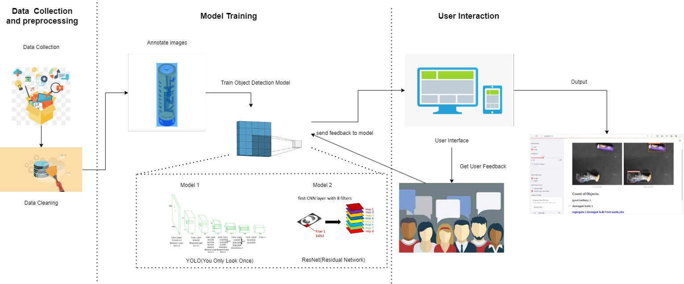

**Figure 1.** System Architecture for E-waste Segregation and Management model

A total of four models were trained to understand the impact of deep learning object detection models for the task of E-waste segregation and management. It is important to understand the pros and cons of each and every model, in order to derive the best results after model training. The YOLOv5, YOLOv8 and ResNet-50 models were chosen for object detection. Along with these models, a custom detector was created for classification of E-waste components. These models were assessed on multiple evaluation metrics such as Precision, Accuracy, Recall and F1-score, to select the most suitable one for the task of

E-waste management. The ResNet-50 model was chosen after considering all evaluation metrics due to its higher level of performance as compared to other models.

* + 1. DATA COLLECTION AND PREPROCESSING

In order to get accurate results after training a deep learning object detection model, it is really important to collect a dataset that is free of noise and unclear images. This was the first step that was taken before model training.

* + 1. IMAGE ANNOTATING

After data collection and preprocessing, it is important to annotate the images, such that they can be directly fed to the object detection models. Image annotation also leads to appropriate pre- classification of images into classes. The images in the dataset have been distributed into five classes, i.e. Damaged Batteries, Damaged Bulbs, Good Batteries, Good Bulbs and PCBs (Printed Circuit Boards).

* + 1. MODEL TRAINING

Model training is the most essential step, in order to create an effective E-waste segregation and management prototype. It is essential to tune the hyperparameters such as learning rate, batch size and number of epochs for each and every model, to get accurate results while inferencing the model after training. The models used here are YOLOv5, ResNet-50 and a custom detector comprising of multiple layers of neurons for object detection.

* + 1. USER INTERACTION

After model training, the deep learning model is fed to a user interface that is created using a python library called Streamlit. Streamlit is a web framework that is used to create effective web-based applications in the domains of Machine Learning and Computer Vision. The user can send appropriate feedback to the model after using the user interface, for model improvement.

### DATASET

The main aim of training deep learning models was to accurately detect E-waste categories and prevent wastage of materials by segregating the good products that had been improperly disposed. The dataset comprises of a total of 3943 images, that have been divided into five categories: Damaged Batteries, Damaged Bulbs, Good Batteries, Good Bulbs and PCBs (Printed Circuit Boards) as demonstrated in Table.1.

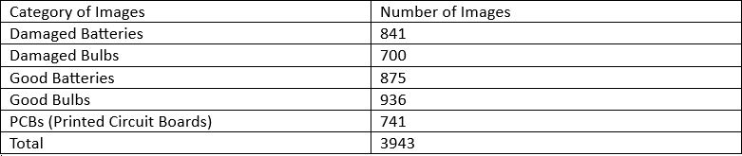

**Table 2**. Category wise distribution of images

The images have been divided in the ratio of 80-10-10 for training, validation and testing respectively. To gather PCB images, the cvl_pcb_dslr dataset was used to accumulate images. The cvl_pcb_dslr dataset is an abundant source of PCB images of various shapes, types, and sizes. All the images were resized to 640 x 640 for uniformity during model training and testing.

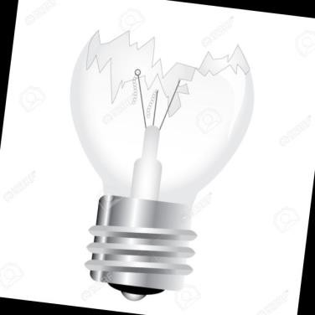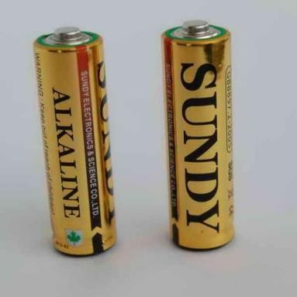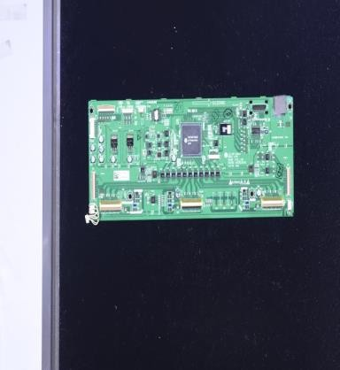

1. (b) (c)

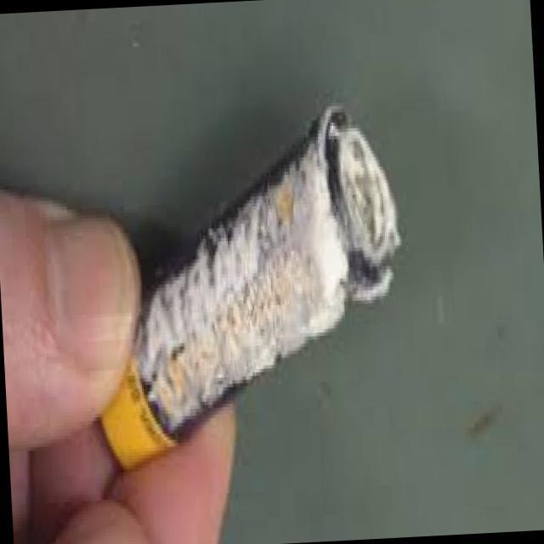 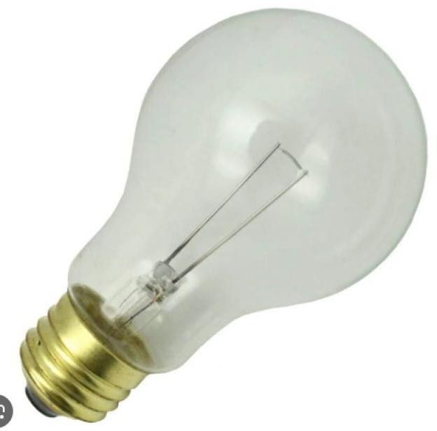

* 1. (e)

**Figure 2**. Sample images from training set (a) Damaged bulb (b) Good Batteries (c) PCB (d)Damaged Battery (e) Good bulb

### MODEL ANALYSIS

Object detection models are widely used these days in various applications such as medical imaging, thermal sensing, surveillance devices, autonomous vehicles and robots, face recognition systems and retail analytics. The selection of a model is influenced by factors like the particular needs of the application, available computational resources, and the balance desired between speed and accuracy.

To demonstrate E-waste segregation, two pre-trained deep learning models were trained for object detection. The third model used was a self-made(custom) object detection model which was specifically built to identify the five classes of E-waste: Damaged Batteries, Damaged Bulbs, Good Batteries, Good Bulbs and PCBs (Printed Circuit Boards).

The architecture of each of these models was carefully understood to understand the wide variety of functionalities and features each model has to offer. Each image in the dataset was resized to 640 by 640 in order to maintain uniformity and make correct conclusions while comparing evaluation metrics for each model.

* + 1. SELF-MADE(CUSTOM) OBJECT DETECTOR

The main components of an object detector are the regressor and classifier. The classifier is responsible for determining the class of the object present in the image, while the regressor is responsible for finding coordinates of the bounding box which is used to show the detected object.

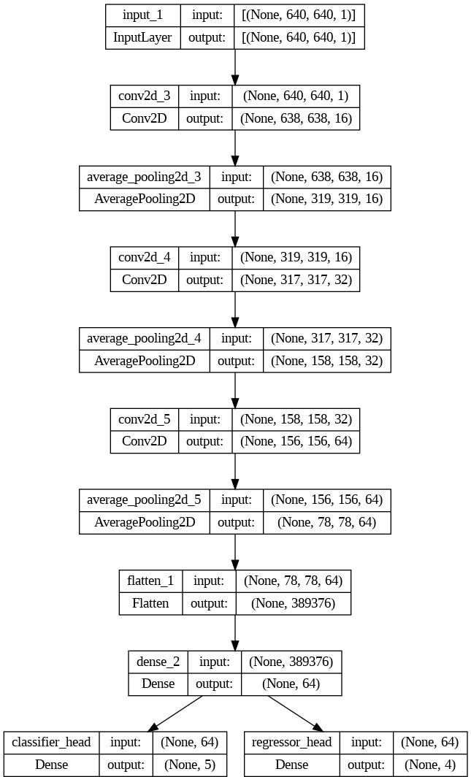

**Figure 3**. Network Architecture

The network architecture of the custom detector has been visualized using the plot_model function inside the utils package in the Tensorflow library. The above has been acquired after integration of the regressor, classifier, feature and the sequential model used to build the custom detector.

* + - 1. RESIZING IMAGES

Initially, the images were preprocessed and resized to 640 by 640 height: width ratio. The function returns the resized images along with the bounding boxes used to detect the E- waste components in the image.

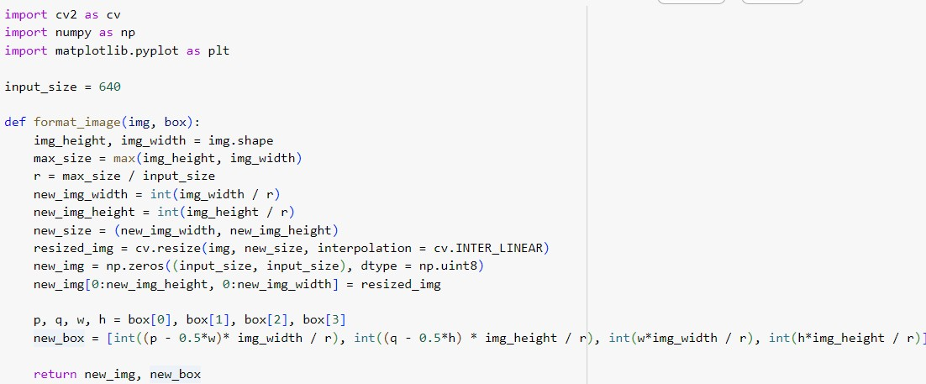

* + - 1. DEFINING THE CLASSIFIER

The classifier has been defined using the keras library offered by TensorFlow. Three sets of convolutional layers are defined using the conv2D function. The number of filters for each layer is increasing. Initially the number of filters for the first layer was 16, than 32 and finally set to 64. The ReLU activation function was used. Every convolutional layer is followed by a pooling layer (average pool size of 2 by 2) to sample the feature maps.

The Flatten function is used towards the end, in order to convert the feature maps to into flattened a one-dimensional vector. It is important to note that the number of neurons in the output layer should be the same as the number of classes.

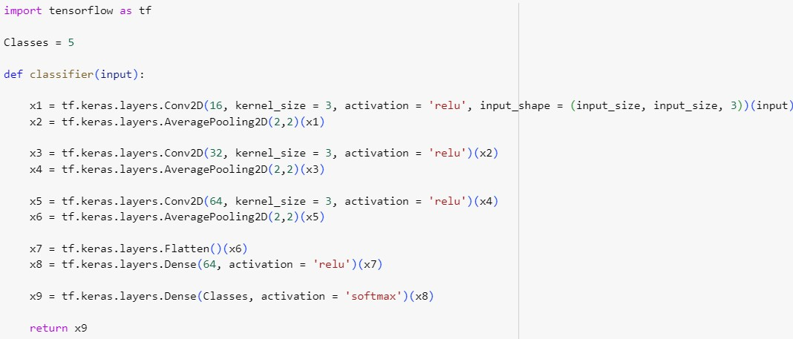

* + - 1. DEFINING THE REGRESSOR

The Regressor is responsible for predicting the coordinates of the bounding boxes, improving the localization accuracy and during the training process, the regressor is adjusted to reduce the difference between the predicted bounding boxes and the actual bounding boxes labeled in the training dataset.

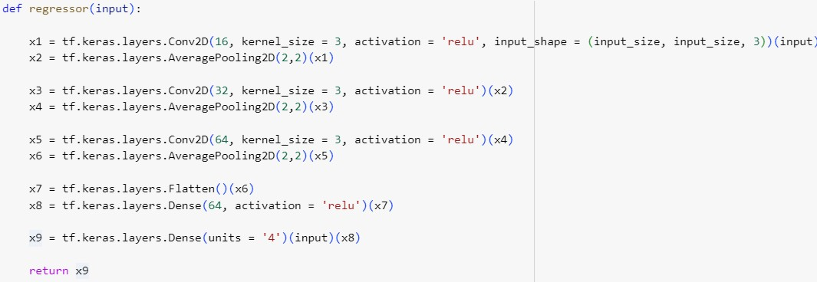

3.3.1.3 FEATURE EXTRACTOR AND SEQUENTIAL MODEL

A feature extractor is an essential component of any machine learning or deep learning model. It is used to process input data and extract relevant features from the input. It captures relevant patterns and learns from them, to make accurate prediction on the testing set.

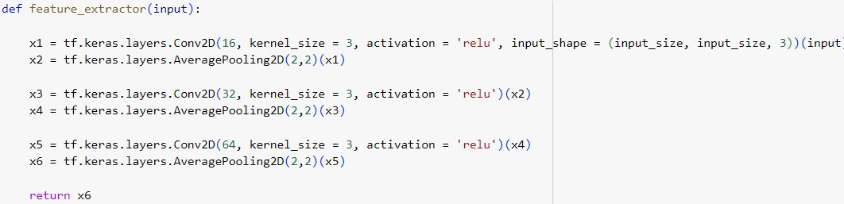

The Sequential Model is combined with the feature extractor, regressor and classifier to create the combined custom detector.

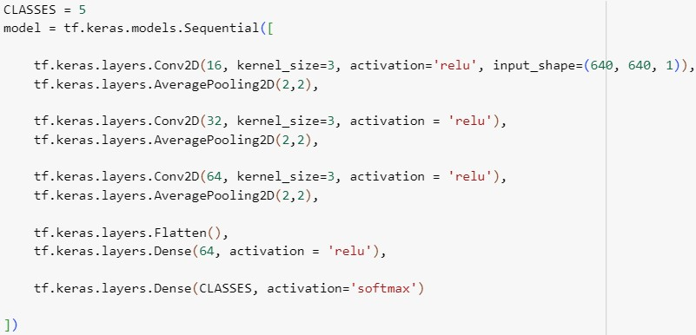

* + 1. E-WASTE CLASSIFICATION USING ResNet-50

Like other Convolutional Neural Networks (CNN’s), a ResNet-50 model extracts features from the input image. It comprises of several Residual Blocks, and each block comprises of multiple convolutional layers, normalization, and activation functions. Apart from residual blocks, a ResNet-50 consists of pooling layers such as average or max pooling layers. These feature maps are than flattened towards the end of the network and passed through either one or multiple fully connected layers. These layers are responsible for classification and assigning probabilities to each class. The last layer of the model consists of a Softmax activation function, to convert the raw scores generated by previous layers into probability values.

The algorithm used to train the ResNet-50 model for E-waste segregation is demonstrated in Algorithm 1. TensorFlow was used to customize ResNet-50 and load the model for inferencing after model training was accomplished. Before model training, the images were distributed into train, valid and test folders. Inside each folder, lies the sub-division of image into the classes: Damaged Batteries, Damaged Bulbs, Good Batteries, Good Bulbs and PCBs (Printed Circuit Boards).

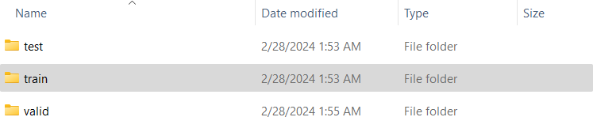

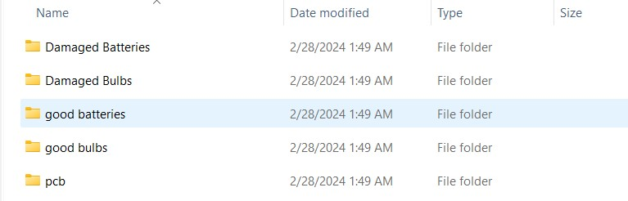

**Figure 4**. Arranging images into the appropriate format before ResNet-50 Training

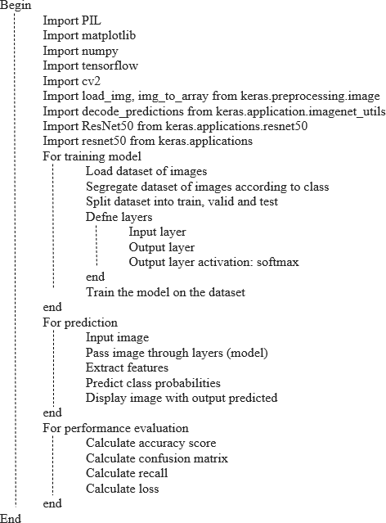

**Algorithm 1.** Image Classification using ResNet-50

3.3.2 E-WASTE CLASSIFICATION USING YOLOv5 and YOLOv8

It is a popular class of object detection algorithms, due to its high efficiency and ease of implementation. Unlike many other object recognition techniques, it performs its role in a single neural network pass. The YOLO algorithm divides every image into a network of grids. Each cell of the grid network predicts bounding boxes and confidence scores.

Following this, non-maximum suppression eliminates duplicate detections, resulting in a conclusive collection of bounding boxes accompanied by class labels and confidence values. During training, the objective is to reduce a combination of localization, confidence, and classification losses. Once the model has been trained using this algorithm, inferencing tasks can be implemented on both videos and images. This gives the user more flexibility and makes the model more versatile than other existing models and techniques.

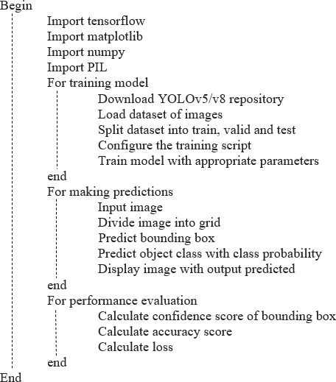

**Algorithm 2.** Image Classification using YOLOv5/v8

**Chapter 4**

# Results and Observations

### ENVIRONMENT SETUP

All the models in this work (YOLOv5, YOLOv8, ResNet-50 and the custom detector), were trained in a local windows environment, on a device with an eight core AM4 processor. In order to derive the best results, all three models were trained until convergence was observed in their accuracy scores. For the YOLOv5 and YOLOv8 models, this was seen after 260 epochs(iterations), while the ResNet-50 model showed convergence after 25 epochs, and finally the custom detector whose accuracy scores converged after a total of 100 epochs. The code to implement E-waste segregation and management was written in python. Libraries such as TensorFlow, PIL, OpenCV, NumPy and Pandas were used to complete the task on hand. In order to avoid version compatibility issues with python libraries, python version 3.11.3 was used throughout the programming section of this work.

### MODEL EVALUATION

To choose the most appropriate model for the task of E-waste segregation and management, a comparative study is necessary for all three models.

* + 1. EVALUATION METRICS
       1. PRECISION

Specifically, precision quantifies the percentage of genuine positive predictions—that is, accurately predicted positive cases—among all positive predictions produced by the model. This percentage is computed as follows:

Precision is frequently combined with other measures in deep learning to offer a more thorough assessment of model performance. For instance, to offer a fair evaluation of a model's capacity to accurately identify examples across many classes, accuracy, recall, and the F1-score are frequently combined.

* + - 1. ACCURACY

Regarding deep learning models, accuracy is a crucial parameter that is employed to assess the effectiveness of categorization algorithms. It is measured as the ratio of the number of accurate forecasts to the total number of predictions produced, and it assesses the overall accuracy of the model's predictions across all classes:

Even though accuracy offers a clear indicator of the model's overall effectiveness, it might not be enough in many situations, particularly when there is an imbalance between the classes. For instance, even when a model performs badly on minority classes, it may nevertheless obtain a high accuracy when predicting all occurrences as belonging to the majority class in a dataset where one class is far more abundant than the others.

* + - 1. RECALL

Recall is a statistic used in deep learning models to assess how well classification models perform, especially in binary classification problems. It gauges the model's sensitivity, or true positive rate, or its capacity to accurately detect every relevant occurrence of a given class.

The ratio of genuine positive predictions to all real positive cases in the dataset is used to compute recall.

A high recall score means that the model is minimizing false negatives, or cases that are mistakenly categorized as negative, while also successfully capturing a significant percentage of positive occurrences.

* + - 1. F1-SCORE

A popular statistic in machine learning and deep learning to assess how well classification models perform, especially in binary classification problems, is the F1-score. It offers a balance between recall and accuracy as the harmonic mean of these two measurements.

The following formula yields the F1-score:

Better model performance is indicated by a higher number, which falls between 0 and 1. At 1, the F1-score is at its highest, while at 0, it is at its lowest.

Because it takes into account both false positives and false negatives, the F1-score is helpful. When there is a disparity in the costs of false positives and false negatives, or when there is an imbalance between the classes, it is quite useful.

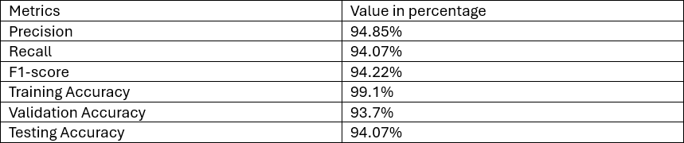

**Table 3**. Evaluation Metrics for ResNet-50 Model

According to Table 2, the ResNet-50 model showed a Precision of 94.85%, Recall value of 94.07%, an F1-score of 94.22%, a Training Accuracy of 99.1%, Validation Accuracy of 93.7% and a Testing Accuracy of 94.07%.

The model was trained for all 5 classes: Damaged Batteries, Damaged Bulbs, Good Batteries, Good Bulbs and PCBs (Printed Circuit Boards). While testing the model, images of all types were fed to the model to test its detection accuracy and efficiency. These images included objects which were tightly packed together, since landfills and other waste units have waste objects closely bound together.

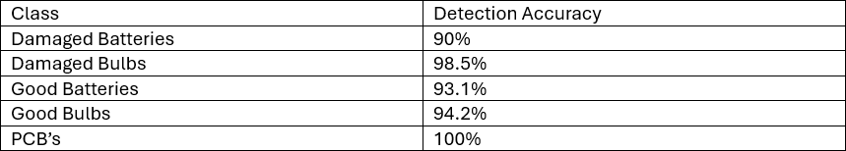

**Table 4**. Detection Accuracy for ResNet-50 Model

For ResNet-50, the detection accuracy of every class was measured as it is important to evaluate the performance of the model, identifying class imbalances and improve decision- making.

The detection accuracy of each class was measured as 90%, 98.5%, 93.1%,94.2% and 100% for Damaged Batteries, Damaged Bulbs, Good Batteries, Good Bulbs and PCBs (Printed Circuit Boards) respectively.

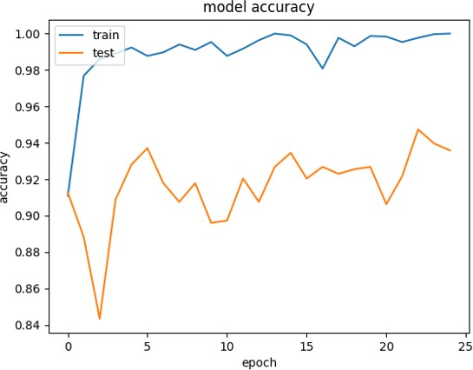

**Figure 4.** Training vs Validation Accuracy for ResNet-50 Model

The ResNet-50 model was trained for a total of 25 Epochs, until the model’s accuracy showed convergence as demonstrated below in Figure 4.

The performance of the YOLOv5 and YOLOv8 models was also evaluated.

Parameters such as precision, recall, F1-Score, and accuracy were measured to evaluate the model. Examining the precision-confidence curve provides insight into how the model's precision changes with varying confidence levels. This analysis is essential for decision- making, particularly when balancing precision and recall trade-offs or determining classification thresholds (Figure 5).

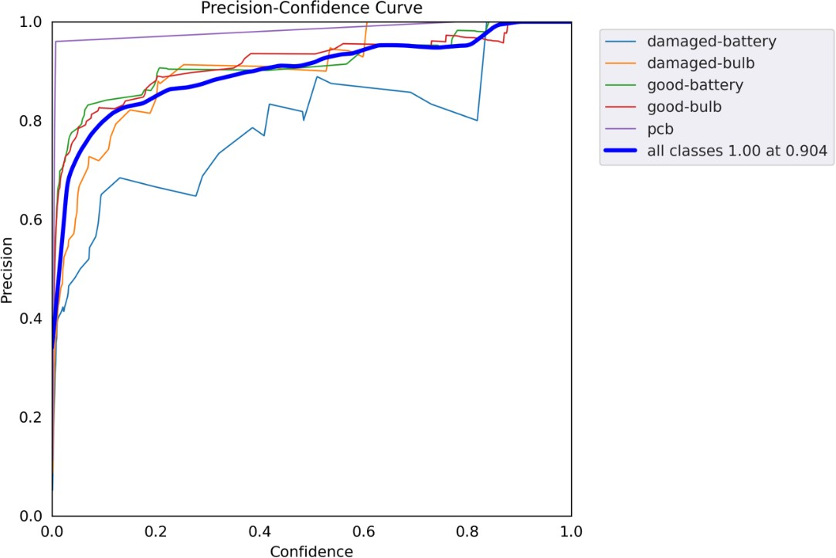

(a)

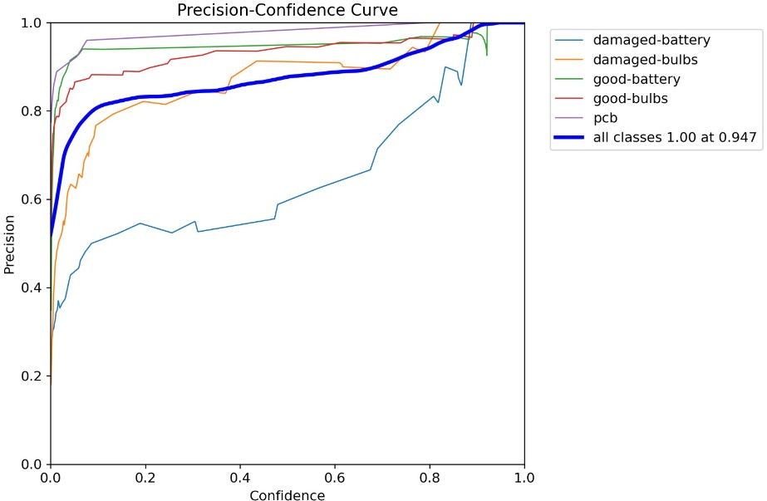

(b)

**Figure 5.** Precision-Confidence curve for (a) YOLOv5 (b) YOLOv8

Sorting model predictions based on confidence ratings and computing precision at different thresholds are necessary steps in building the curve. More predictions are accepted as genuine positives as the confidence threshold drops, which may affect both true positives and false positives and affect accuracy. Plotting the curve with confidence thresholds on the x-axis and precision on the y-axis provides information on the trade-off between recall and accuracy as the threshold changes.

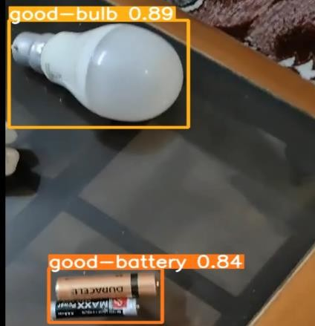 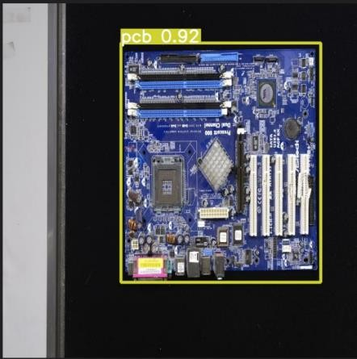

* + 1. (b)

**Figure 6.** Different objects that have been detected correctly using the YOLOv5 and YOLOv8

A visual representation of the relationship between a classification or detection model's recall, or sensitivity, and the confidence levels it uses is provided by the recall-confidence curve. While confidence thresholds determine the validity of predictions based on related confidence scores, recall measures the model's capacity to correctly identify all relevant instances of a class. More predictions are accepted as legitimate as confidence levels drop, which may have an effect on recall by affecting both true positives and false negatives. The curve shows how recollection varies with varying confidence criteria and is often displayed with recall on the y- axis and confidence levels on the x-axis. Increased recall indicates better finding of pertinent cases at a certain level of confidence. This curve is demonstrated in Figure 7.

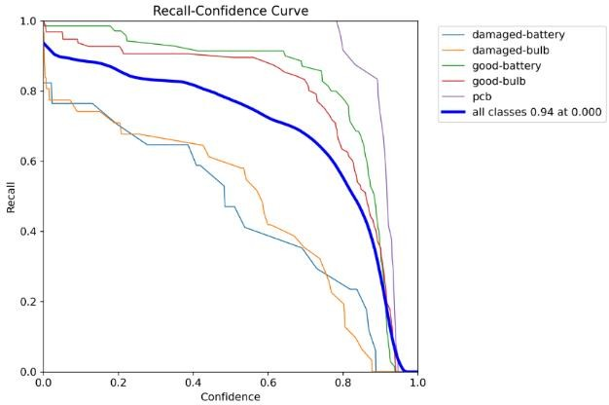

(a)

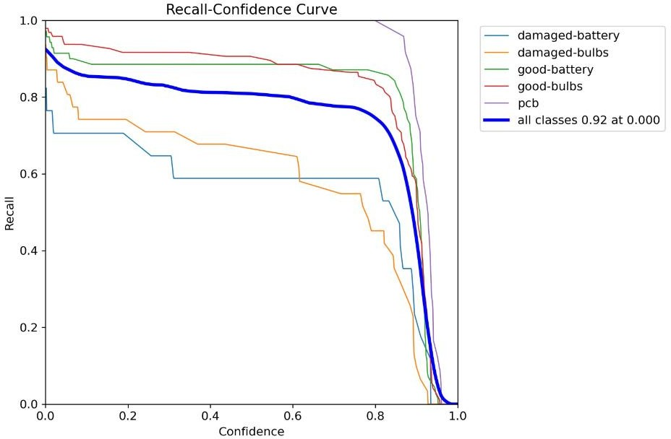

(b)

**Figure 7**. Recall-Confidence curve for (a) YOLOv5 (b) YOLOv8

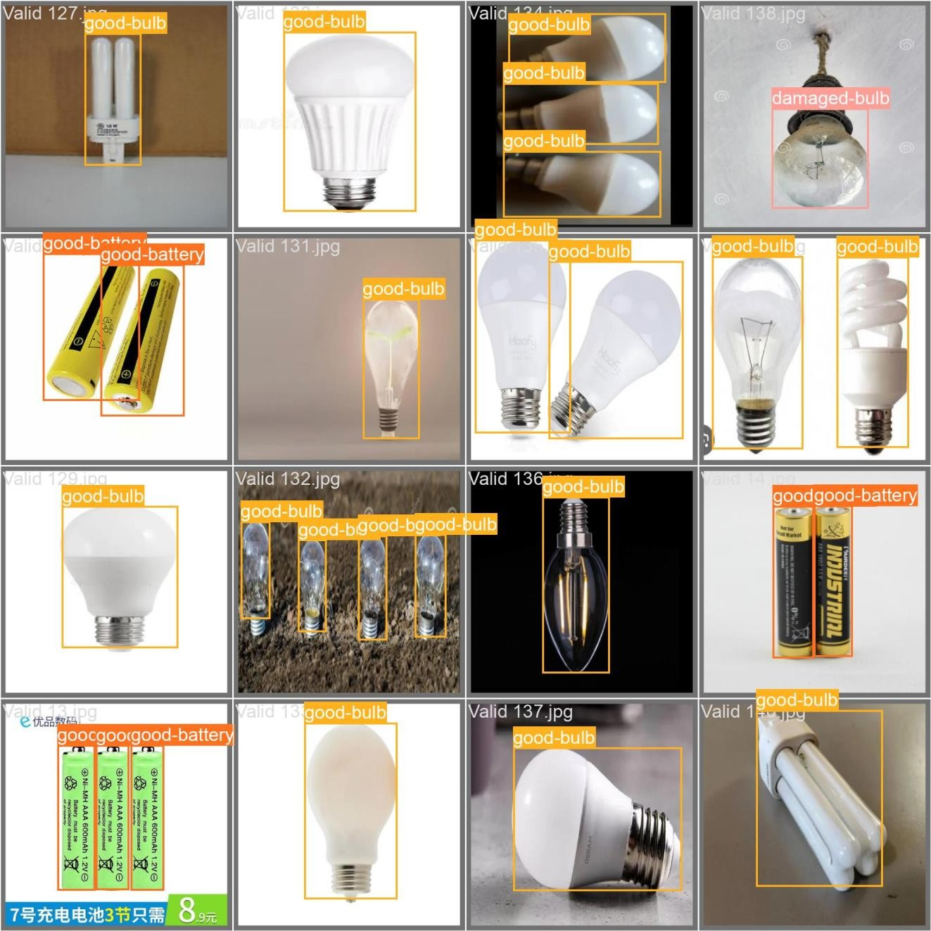

**Figure 8.** Accurate detections made by the YOLOv5/v8 models on the validation set

Figure 8 demonstrates the successful detections made by the YOLOv5 and YOLOv8 models on the validation set. The E-waste components have been vividly distinguished into the pre- determined classes before the model training process was initiated.

Furthermore, the F1-confidence graph was drawn to visualize the relationship between each and every class’s F1-score and confidence score. The link between the F1 score, a statistic that combines accuracy and recall, and the confidence levels used by a classification or detection model is shown visually by the F1-confidence curve. It provides insights into the model's overall performance across various confidence levels by demonstrating how the F1 score changes when the model's confidence criteria vary. The curve, which plots the F1 score versus confidence thresholds, makes it easier to choose the ideal threshold for a given assignment by providing an appropriate balance between precision and recall. This plot is demonstrated using Figure 9.

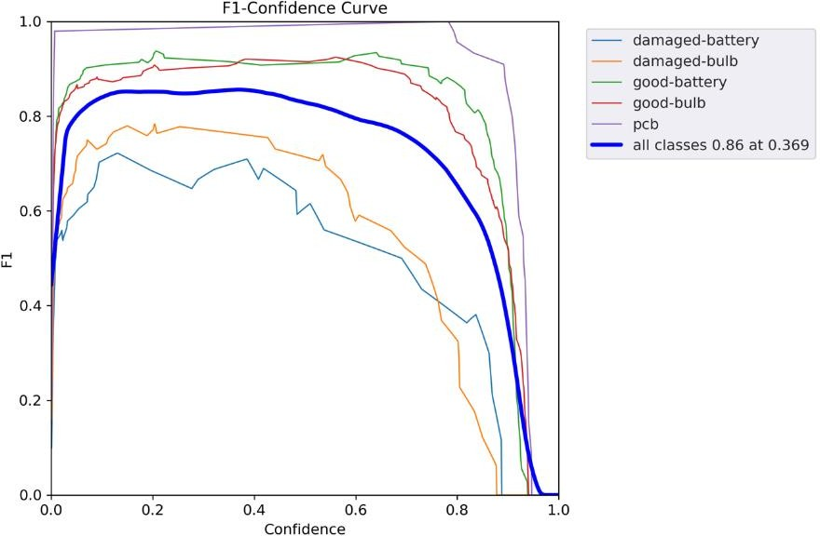

(a)

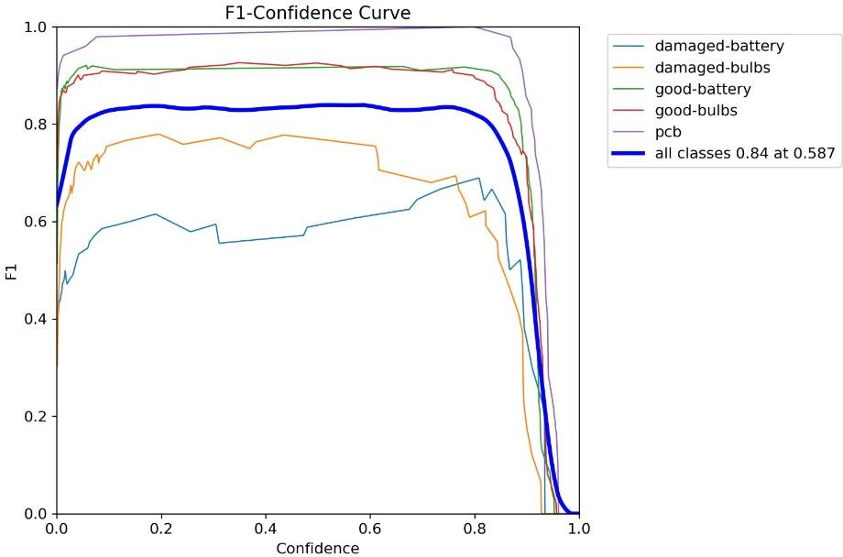

(b)

**Figure 9.** F1-Confidence curve for (a) YOLOv5 (b) YOLOv8

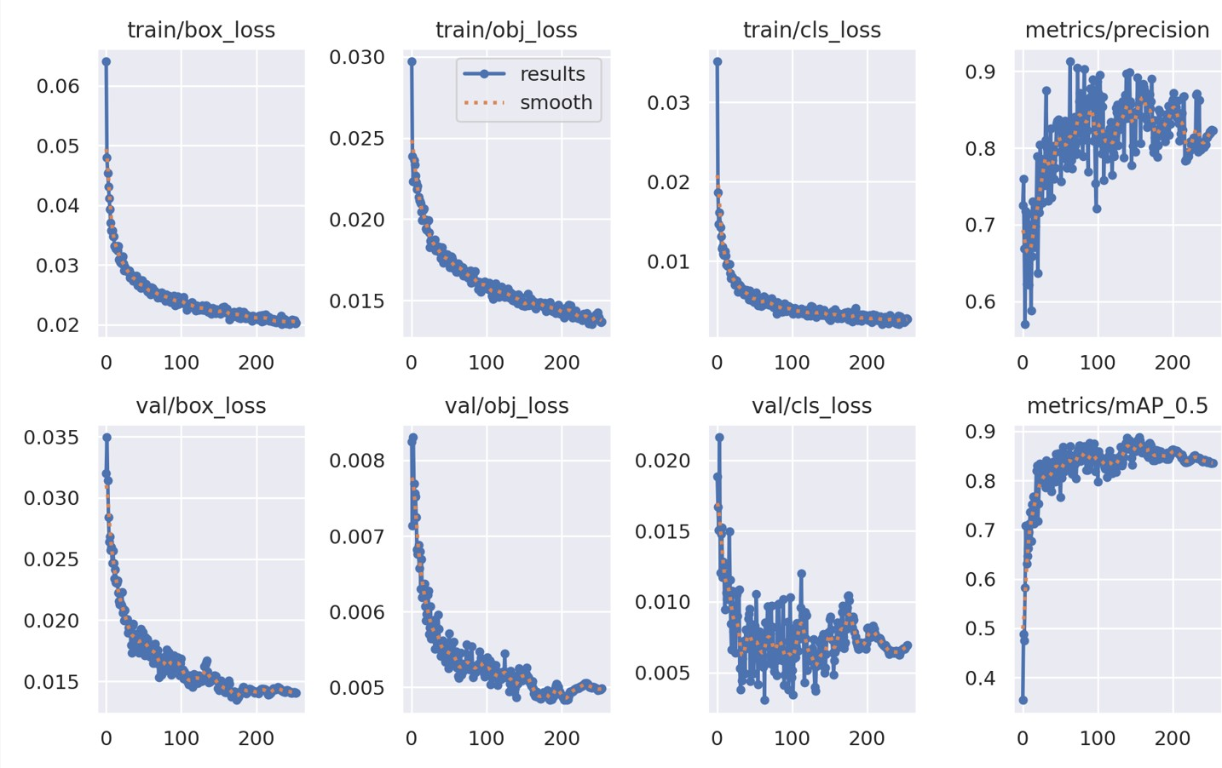

**Figure 10.** Plots representing YOLOv5 model performance

* + - 1. CONFUSION MATRIX

A tabular representation called a confusion matrix is used to compare the actual and projected classes given a dataset in order to assess how well a classification model performs. It is made up of four primary parts:

True Positives (TP): the number of correctly predicted positive class cases. True Negatives (TN): the number of correctly predicted negative class cases. False Positives (FP): the number of inaccurately predicted positive class cases.

False Negatives (FN): the number of inaccurately predicted negative class cases. These elements are arranged into a grid by the confusion matrix, where the rows are the actual classes and the columns are the anticipated classes. Every column in the matrix denotes the number or percentage of cases that fit into a specific category.

The accurate predictions are represented by the main diagonal of the matrix (TP for positive class, TN for negative class), while the misclassifications are represented by the off- diagonal entries (FP and FN).

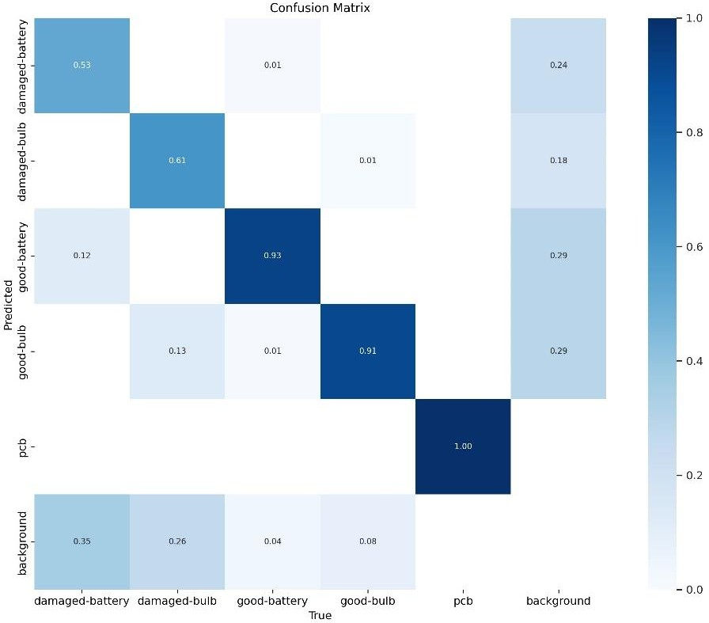

(a)

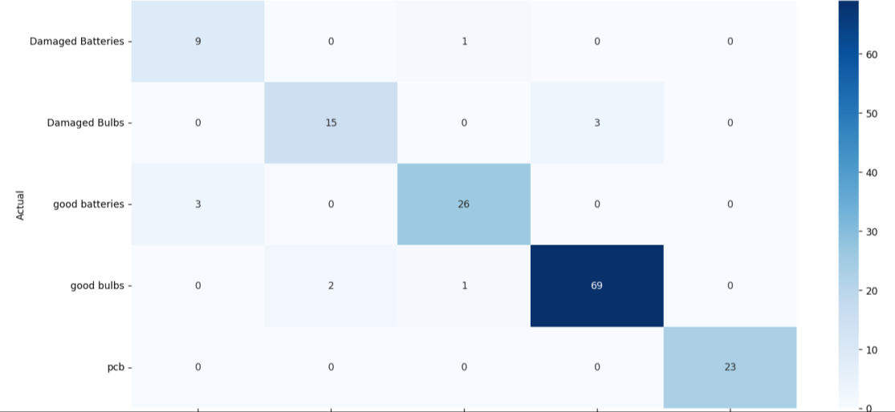

(b)

**Figure 11.** Confusion matrices for the models (a) YOLO and (b) ResNet-50

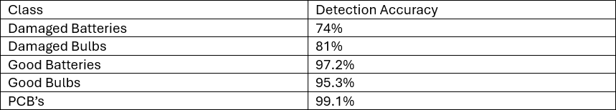The YOLOv5 model were trained for approximately 250 epochs until convergence was observed in the model’s loss and accuracy parameters. The precision and recall values of the trained YOLOv5 model were 89.1% and 83.2% respectively. The detection accuracy of each and every class was also measured as shown in Fig.9. The average detection accuracy was calculated to be 89.32%.

**Table 5.** Detection accuracy for each class using YOLOv5

For YOLOv5, the detection accuracy of every class was measured as it is important to evaluate the performance of the model, identifying class imbalances and improving decision-making. For YOLOv5, The detection accuracy of each class was measured as 74%, 81%, 97.2%,95.3%

and 99.1% for Damaged Batteries, Damaged Bulbs, Good Batteries, Good Bulbs and PCBs (Printed Circuit Boards) respectively.

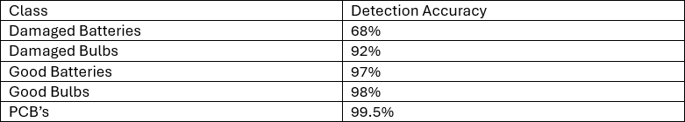

**Table 6.** Detection accuracy for each class using YOLOv8

For its successor YOLOv8, the model was trained for 150 epochs until convergence was observed. The precision and recall values were 91% and 85% respectively. The detection accuracy of each class (Damaged Batteries, Damaged Bulbs, Good Batteries, Good Bulbs and PCBs) was observed to be 68%, 92%,97%,98% and 99.5% respectively. The average detection accuracy for the model was 90.9%.

### YOLOv5 vs YOLOv8 COMPARISON STUDY

The YOLOv5 and YOLOv8 models have generated great results for the task of E-waste segregation and management. The accuracy of the YOLOv5 model was found to be

89.32%, while the detection accuracy of the YOLOv8 model was found to be 90.9%. TheYOLOv8 model is more accurate, when it comes to detecting objects and waste materials. Although, there is not a major difference in the inference time of both these models, which lies in the range of 100-200 milliseconds for each model, the YOLOv8 model was found to be slightly faster than the YOLOv5 model. The YOLOv8 model showed better precision and recall values as well. It can be stated that the overall performance of the YOLOv8 model was better than the YOLOv5 model.

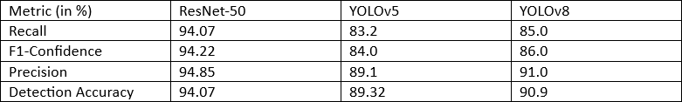

**Table 7.** Overall performance of all three models

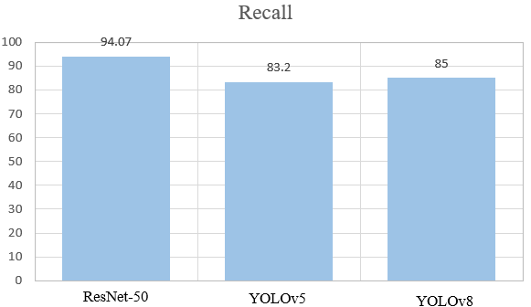

1. Recall values for YOLOv5,YOLOv8 and ResNet-50

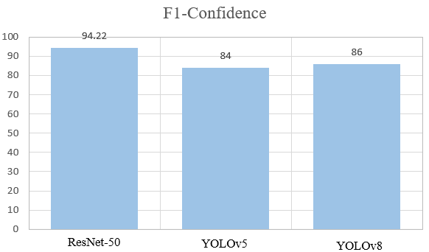

1. F1-Confidence values for YOLOv5,YOLOv8 and ResNet-50

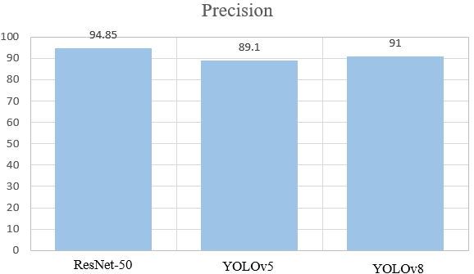

1. Precision values for YOLOv5,YOLOv8 and ResNet-50

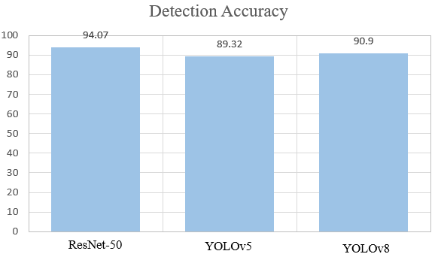

1. Detection Accuracy for YOLOv5,YOLOv8 and ResNet-50
2. Overall comparison of performance metrics

**Figure 12.** Performance metrics comparison for all three models

### CREATION OF USER INTERFACE

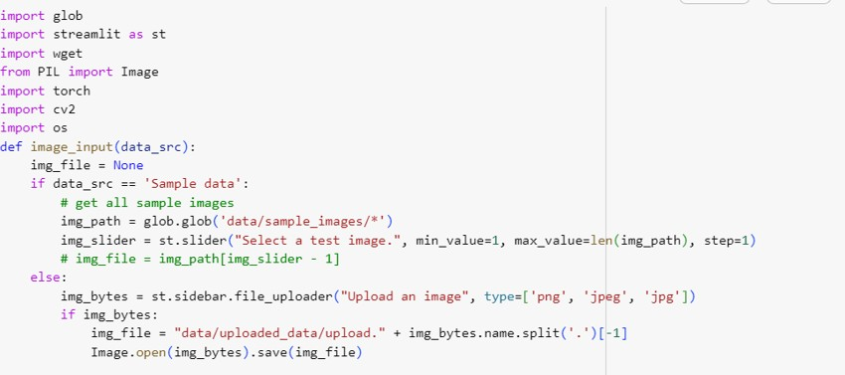After implementing both the YOLOv5 and ResNet-50 models for the purpose of segregating E-waste, a user interface was created using Streamlit. Using this interface, a user can input any image or video where waste has to be segregated. The interface also helps the user differentiate between good and damaged E-waste components such as bulbs and batteries, that would normally be very difficult to catch using the naked eye.The whole process of creating a user interface was broken down into several steps starting with importing the libraries and inputting the image for E-waste segregation and management. The user can input images in the png, jpg or jpeg formats.

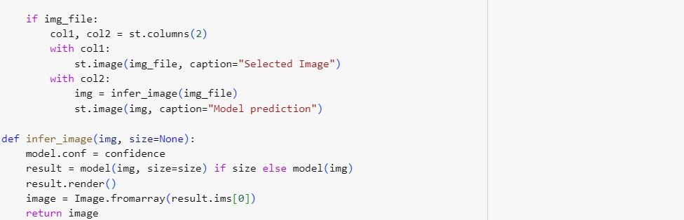

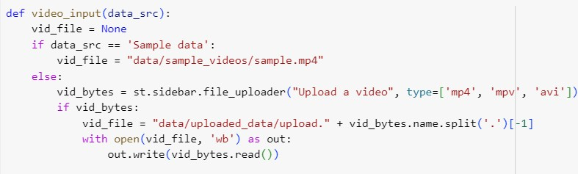This interface provides the user with flexibility to not only input images, but videos as well. The user can input a video in the mp4, mpv or avi format.

Using the OpenCv library, the video can be captured and several parameters of the video such as the frames per second (FPS) can be calculated. The height, width and FPS of the video will be shown on the top of the screen for convenience.

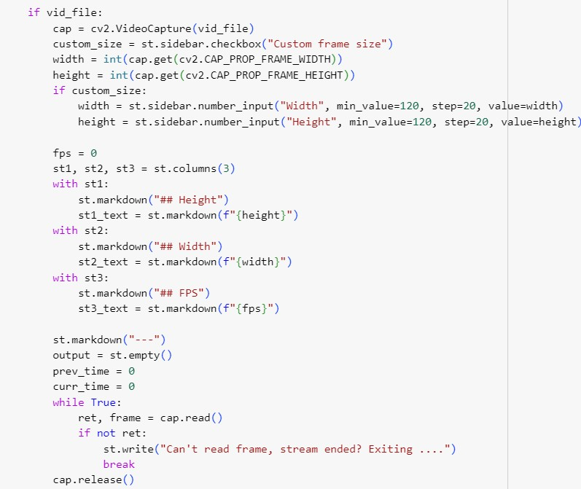

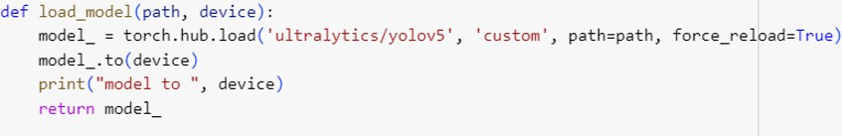Along with these options, the user also has the flexibility to choose between the pre-trained yolov5s.pt or yolov5m.pt weights files for inferencing and the weights file generated by the user after training his/her custom model.

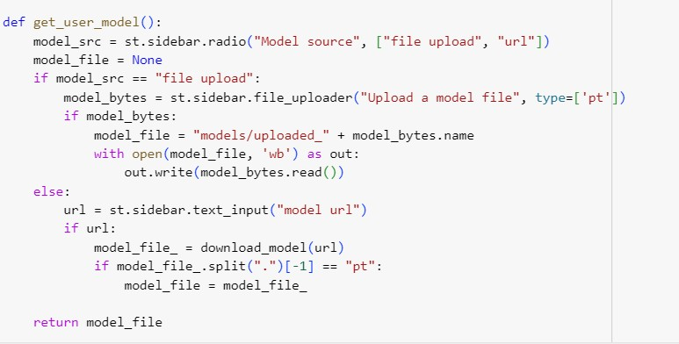

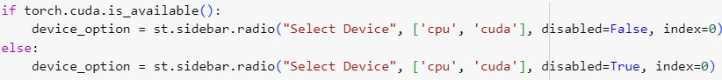It also gives the user the flexibility to choose between the CPU and CUDA option. User’s operating the application with lesser computing power or weaker GPU’s can run the application on the CPU mode. Other users with better GPU’s can integrate CUDA with their GPUs to operate the model more smoothly.

All the functionalities provided by the user interface are shown in Figure 13.

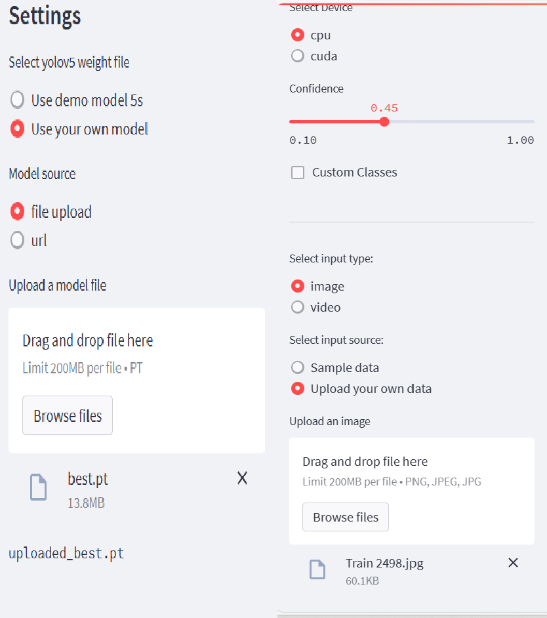

**Figure 13.** Settings that can be altered by the user while using the User interface

For demonstration purposes, the best.pt file has been uploaded as the model weights file. After training a YOLOv5 and YOLOv8 model, two types of weights files are generated: best.pt and last.pt. The best.pt file is usually used for inferencing purposes. The last.pt file can also be used for inferencing purposes but is primarily used to train large models using checkpoints, so that the user can recover his/her progress in case there is a runtime error. For inferencing an image, the CPU mode is chosen in the “Select a device” option. Furthermore, the model will detect images, which have a confidence value greater than 45%. The last setting helps the user upload an image for inferencing. The count of objects can also be determined by the user interface. Number of waste items to be segregated are also mentioned.

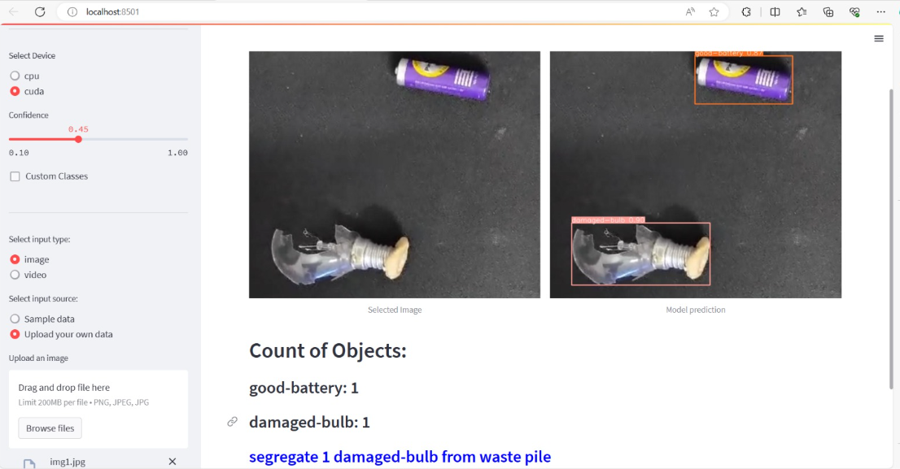

**Figure 14.** Example on the waste recognition dashboard

Figure 14 shows an example of how inferencing takes place using the user interface. The

selected image is demonstrated on the left side, while the model prediction is seen on the right

side. The user interface also gives the count of the number of objects detected, and lets the user know if any of the objects need to be segregated.

**Chapter 5**

# Conclusion and Future Work

### CONCLUSION

After using all the deep learning object detection models, the YOLOv5, the YOLOv8 and ResNet-50, it can be stated that all the models yielded impeccable results for the task of waste segregation and management. But the performance of the ResNet-50 model was slightly better as it gave a higher accuracy score of 94.07% compared to the 90.9% of the YOLOv8 and the 89.32% that the YOLOv5 models were able to yield. The work done is one of the first of its kind, where the goal was to not only aim at improvising on existing waste segregation models, but also help people avoid wastage and save money by helping them segregate good and damaged E-waste components. The custom detector on the other hand does not yield comparable results.

The user interface created, aims at collecting feedback from users, as well as providing them with a medium through which they can effectively and efficiently segregate waste at their homes and offices.

YOLO is designed for real-time object detection, which can be a more complex task compared to image classification, especially if the objects in the images are small or occluded. ResNet50 might performed better in this scenario because there are multiple objects in close proximity as in the case of E-waste. Hence, ResNet50's architecture might be better suited for achieving higher detection accuracy.

Also, the techniques used for refining the bounding box predictions and handling overlapping objects can also have an impact on performance. ResNet50 might benefit from simpler post-processing methods compared to YOLO, leading to more accurate detections in certain scenarios.

### FUTURE WORK

The future scope of this work holds significant promise for cultivating sustainable e-waste management practices. First and foremost, more categories of e-waste discarded (such as wires, monitors/laptops, mobile phones etc.) can be incorporated in the segregation model to widen the scope and effectiveness of classiﬁcation. This opens the window for exploration to exactly classify the recycling technique or disposal method, depending upon the material and properties of e-waste detected. Hence, allowing for more constructive and accurate clean-up strategies.

Additionally, the research can be expanded to include the extensive environmental impact of various waste management strategies by evaluating the energy consumption and ecological footprint associated with various deep learning methods implemented for e- waste segregation to find the most environmentally friendly and safe technique of waste management.

The improvement of detection speed and accuracy can be investigated as a part of bettering the capacity of the e-waste classification model. To increase the performance of detection in the segregator, the number of images in the training set can be increased to several thousands. Considering the time-consuming nature of densely connected networks such as those of resnet50, a light weight network can be tried to optimize the detection speed. Further, the integration of various data modalities such as image text and sensor data could be assimilated to enhance the accuracy and speed of the model. This can involve including natural language processing methodologies for analyzing the text type information related to the electronic devices and their components.

Another way the research can be augmented is by introducing hardware, a robotic arm could be programmed and linked with the model to segregate the different types of e-waste. Doing so would decrease the need for manual labor, often certain e-waste can be hazardous to human health and automating this segregation process could protect the health of the laborers. In addition, the process will be quicker and the robotic segregator will warrant superior resource planning.

Moreover, supplementary research can lead to a system being built to identify and locate the shortest distance to a bin for the purpose of efficient disposal. Real-time monitoring systems that use deep-learning algorithms to continuously analyze the e-waste coming in the bins can be worked on. These systems could provide instant feedback to waste management facilities on the levels of waste disposed in the bins enabling timely action from their side. These systems can also assist in optimizing resource allocation. With these advancements and some human effort, the existing waste management system can be upgraded to ensure healthier lifestyle and surroundings.

# REFERENCES

* + 1. R.S.Sandhya Devi, Vijaykumar VR, & M.Muthumeena (2018). Waste Segregation using Deep Learning Algorithm. International Journal of Innovative Technology and Exploring Engineering (IJITEE), 8(2S), 2278–3075.
    2. Ramya, P., V, R., & M, B. R. (2023). E-waste management using hybrid optimization- enabled deep learning in IoT-cloud platform. Advances in Engineering Software, 176,103353.
    3. Nowakowski, P., & Pamuła, T. (2020). Application of deep learning object classifier to improve e-waste collection planning. Waste Management, 109, 1–9.
    4. Kumar, S., Yadav, D., Gupta, H., Verma, O. P., Ansari, I. A., & Ahn, C. W. (2020). A novel yolov3 algorithm-based deep learning approach for waste segregation: Towards smart waste management. Electronics, 10(1), 14.
    5. Sheng, T. J., Islam, M. S., Misran, N., Baharuddin, M. H., Arshad, H., Islam, Md. R., Chowdhury, M. E. H., Rmili, H., & Islam, M. T. (2020). An internet of things based smart waste management system using lora and tensorflow deep learning model. IEEE Access, 8, 148793– 148811.
    6. Rajakumaran, G., Usharani, S., Vincent, C., & Sujatha, M. (2023). Smart Waste Management: Waste Segregation using Machine Learning. Journal of Physics: Conference Series, 2471(1), 012030.
    7. Lun, Z., Pan, Y., Wang, S., Abbas, Z., Islam, M. S., & Yin, S. (2023). Skip-YOLO: Domestic garbage detection using deep learning method in complex multi-scenes. International Journal of Computational Intelligence Systems, 16(1).
    8. Thanawala, D., Sarin, A., & Verma, P. (2020). An approach to waste segregation and management using convolutional neural networks. In Communications in Computer and Information Science (pp. 139–150). Springer Singapore.
    9. Gupta, T., Joshi, R., Mukhopadhyay, D., Sachdeva, K., Jain, N., Virmani, D., & Garcia- Hernandez, L. (2021). A deep learning approach based hardware solution to categorise garbage in environment. Complex &amp; Intelligent Systems, 8(2), 1129–1152.
    10. Sami, K. N., Amin, Z. M. A., & Hassan, R. (2020). Waste management using machine learning and deep learning algorithms. International Journal on Perceptive and Cognitive Computing, 6(2), 97–106.
    11. Rutqvist, D., Kleyko, D., & Blomstedt, F. (2020). An automated machine learning approach for smart waste management systems. IEEE Transactions on Industrial Informatics, 16(1), 384–392.
    12. N., S., Fathimal, P. M., R., R., & Prakash, K. (2019, April). Smart garbage segregation &amp; management system using internet of things(iot) &amp; machine learning(ml). 2019 1st International Conference on Innovations in Information and Communication Technology (ICIICT).
    13. Hua, D., Gao, J., Mayo, R., Smedley, A., Puranik, P., & Zhan, J. (2020, January). Segregating hazardous waste using deep neural networks in real-time video. 2020 10th Annual Computing and Communication Workshop and Conference (CCWC).
    14. Sallang, N. C. A., Islam, M. T., Islam, M. S., & Arshad, H. (2021). A CNN-based smart waste management system using TensorFlow Lite and LoRa-GPS Shield in internet of things environment. IEEE Access, 9, 153560–153574.
    15. Haque Sunny, Md. S., Roy Dipta, D., Hossain, S., Resalat Faruque, H. M., & Hossain, E. (2019, May). Design of a convolutional neural network based smart waste disposal system. 2019 1st International Conference on Advances in Science, Engineering and Robotics Technology (ICASERT).
    16. Li, H., Jin, Z., & Krishnamoorthy, S. (2021, May 22). E-Waste management using machine learning. 2021 6th International Conference on Big Data and Computing. http://dx.doi.org/10.1145/3469968.3469973.
    17. Shreyas Madhav, A., Rajaraman, R., Harini, S., & Kiliroor, C. C. (2021). Application of artificial intelligence to enhance collection of E-waste: A potential solution for household WEEE collection and segregation in India. Waste Management &amp; Research: The Journal for a Sustainable Circular Economy, 40(7), 1047–1053. https://doi.org/10.1177/0734242x211052846.
    18. Naushin, M., Saraswat, A., Abhishek, K. (2022). Deep Learning Approach to Deal with E-Waste. In: Gupta, D., Sambyo, K., Prasad, M., Agarwal, S. (eds) Advanced Machine Intelligence and Signal Processing. Lecture Notes in Electrical Engineering, vol 858. Springer, Singapore. https://doi.org/10.1007/978-981-19-0840-8_9.
    19. Mohammed Aarif, K. O., Mohamed Yousuff, C., Mohammed Hashim, B. A., Mohamed Hashim, C., & Sivakumar, P. (2022). Smart bin: Waste segregation system using deep learning‐Internet of Things for sustainable smart cities. Concurrency and Computation: Practice and Experience, 34(28). https://doi.org/10.1002/cpe.7378.
    20. Desai, Y. (2018). Segregation. International Journal for Research in Applied Science and Engineering Technology, 6(3), 537–541. https://doi.org/10.22214/ijraset.2018.3086.
    21. Sudha, S., Vidhyalakshmi, M., Pavithra, K., Sangeetha, K., & Swaathi, V. (2016, July). An automatic classification method for environment: Friendly waste segregation using deep learning. 2016 IEEE Technological Innovations in ICT for Agriculture and Rural Development (TIAR). http://dx.doi.org/10.1109/tiar.2016.7801215.
    22. Chen, J., Huang, S., BalaMurugan, S., & Tamizharasi, G. S. (2021). Artificial intelligence based e-waste management for environmental planning. Environmental Impact Assessment Review, 87, 106498. https://doi.org/10.1016/j.eiar.2020.106498.
    23. Zhou, E. P. (2022, September 30). Machine learning for the classification and separation of e-waste. 2022 IEEE MIT Undergraduate Research Technology Conference (URTC). http://dx.doi.org/10.1109/urtc56832.2022.10002242.

**Appendix 1**

# Appendices

### E-waste Classification using Mean Shift Algorithm

### Introduction

Image processing plays a pivotal role in various fields, including e-waste management. With evolution in research and development in the field, a robust and protean algorithm, Mean Shift, has gained significant popularity in recent times for its effectiveness in image segmentation and tracking.

Mean-shift algorithm can be defined as a density-based clustering algorithm used to detect clusters in a given dataset. The primary goal being to find a region of the highest density. It is specifically advantageous for datasets where the clusters have arbitrary shapes and are not well-separated by linear boundaries.

The aim of this research is to offer insights into the applications of the mean shift algorithm for electronic waste segregation.

### Background

The Mean-Shift clustering algorithm was developed by Fukunaga and Hostetler back in 1975. Mean-Shift operated by clubbing data points into clusters. In this algorithm, every feature point can potentially be a cluster center. The model will presume a circular region of interest (called a kernel) centered around one point randomly chosen. Next, once the kernel is defined, the mean of all the data points within the circle is calculated. Then, the data points will be shifted towards the mean. In other words, given a set of data points, the algorithm will iteratively assign each data point to the closest cluster centroid and the direction to the closest cluster centroid is obtained by where most of the nearby points are. So, every iteration each data point will move closer to where most of the points are and when the algorithm stops, each point is assigned a cluster.

Consequently, the location gets updated of the new centroid. This will give a vector from the previous location to the new location’s mean; this vector is known as the Mean-Shift vector. Once a new mean is found, the algorithm will keep on shifting the kernel iteratively to higher-density regions. This procedure will repeat till the Mean-Shift vector is equal to

0. That implies that the model has converged to the last cluster center and the highest density region has been reached as represented in figure 1. This model can be applied to various types of data, including but not limiting to image/video processing and object tracking.

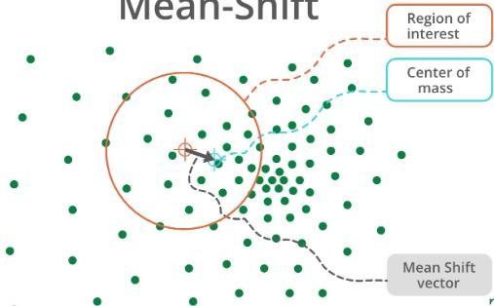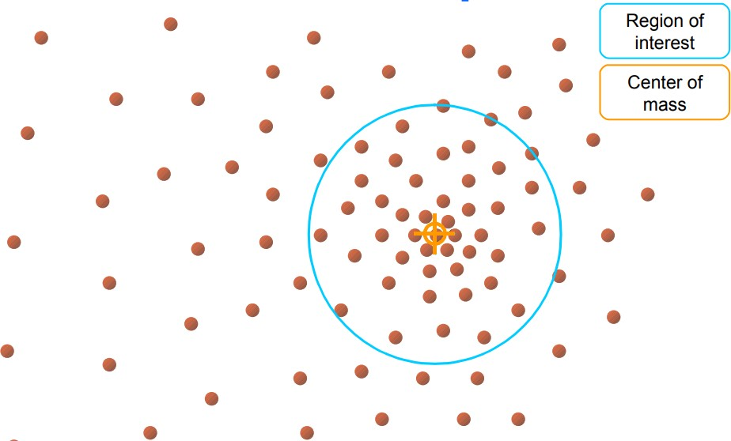

**Figure 1:** Visual representation of mean-shift algorithm procedure

### Implementation

An important application of the Mean Shift algorithm is its ability to track objects over time making it highly suitable for video analysis and surveillance. The model can flexibly adapt to changes in object appearance, scale, and orientation, providing successful tracking capabilities in dynamic surroundings. Essentially object tracking with the Mean-Shift algorithm could be divided into three stages:

Beginning with targeting the object, in the first frame the initial location of the object that must be tracked is chosen. Then the target model is visualized with a color histogram, which would move as and when the object also moves.

Step two, the model then moves the window to Finding the new location with maximum pixel density. Now, the current histogram is used to search for the best target match candidate by maximizing the similarity function.

Step three the algorithm updates the location of the target object and the histogram is updated.

Every point on the image represents one pixel. It is key to not that each pixel is a point with a particular weight. Weight to a pixel needs to be assigned because otherwise, one would not be able to apply the Mean-Shift algorithm. The crucial thing here is to understand how a chosen pixel can have weight. Considering this research’s work, assume e-waste in a video has to be tracked. In the first frame, select the initial location of the waste material that requires to be tracked. Then define an area around the target object, i.e. define the Kernel. The target model can be represented with a normalized color histogram which is weighted by distance. Note here, that if a pixel is closer to the center, it will contribute more weight whereas pixels that are further away from the center would contribute less weight.

When the target object moves, the aim is to find the best candidate location for the object (e-waste) in the second frame. Suppose more e-waste has been dumped which has caused the original center to move to a new center; the algorithm needs to find this new center of the candidate region.

This can be calculated in the same way as we did for the target mode, with a histogram. Once the target and candidate region are modelled, the degree of similarity between them is found. To do that, the difference between two histograms is computed. Using this methodology the model can track e-waste in a video.

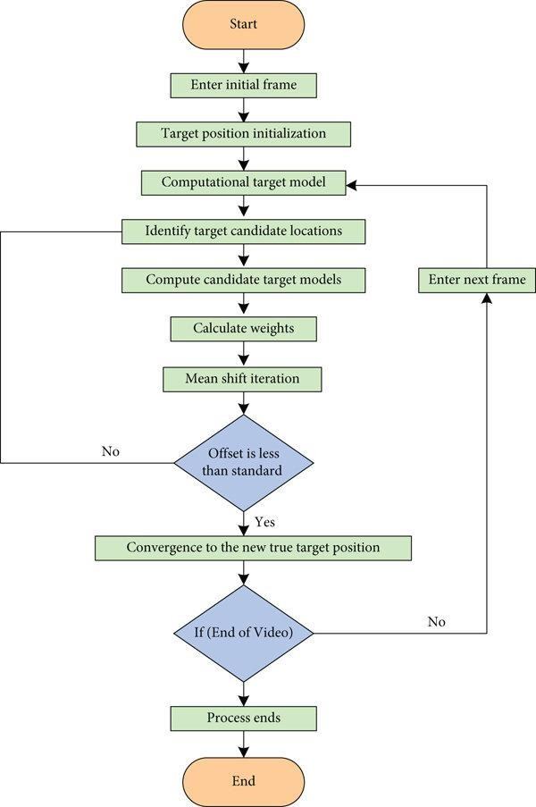

**Figure 2:** Mean-Shift Algorithm Flowchart

### Advantage

One main advantage of mean-shift algorithm is that it does not require the number of clusters to be defined beforehand. It also does not make any assumptions about the distribution of the data inputted, and can handle arbitrary shapes and sizes of clusters. Therefore, it is a non-parametric algorithm. Usually, when the distribution of data points must be analyzed, different types of parametric distributions can be used, for example in the Gaussian distribution, after the samples are obtained then the parameters can be computed. The problem in this approach however is that many a times the Gaussian distribution may not fit the data samples. If that is the case, one needs to use the non- parametric distribution. This is where the Mean-Shift algorithm comes into picture. The idea of the Mean-Shift algorithm is to find modes (peak areas) of data points that can be used for shaping a kernel-based estimate of a probability density function. The number of clusters are determined by the algorithm with respect to the given data. Additionally, the Mean Shift model is not as sensitive to initial parameterization as compared to some other clustering algorithms allowing for simplification of the algorithm's application, requiring minimal tuning for effective performance. But the algorithm can be sensitive to the choice of kernel and the radius of the kernel. Plus, it can be computationally intensive, especially with large datasets.

**Appendix 2**

### E-waste Segmentation and Mapping Using U-Net CNN

### Introduction

The applications of computer vision and deep learning models in the modern world are growing by leaps and bounds. Convolutional Neural Networks (CNNs) have revolutionized the computer vision industry, and the U-Net architecture is one such model that stands out as seminal, especially in the field image segmentation. The main idea of the implementation of this model is to employ successive contracting layers to extract features, which are immediately followed by the upsampling (or expansive) layers for achieving higher resolution outputs and segmentation map on the inputted images. The network built is a fully convolutional network. The purpose of this study is to explore the utilization of the versatile U-Net model in realms of e-waste mapping.

### Background

Developed by Olaf Ronneberger, Philipp Fischer, and Thomas Brox in 2015, the U-Net Convolution Neural Network gets its name from the “U” shape of the layers that make up the architecture of the model as seen in figure 3. The architecture is consisting of a contraction path, a bottleneck, and an expansion path. This design allows the model to capture context information through the expansive path while also maintaining high- resolution features through connections from the contracting path.

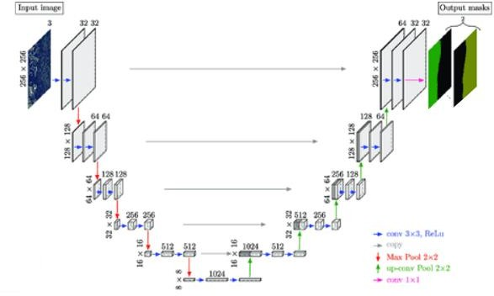

**Figure 3:** Architecture of a U-Net CNN model

The first layer in the U-Net model is the input layer, where the training images in the form of pixel matrices are entered into the model. The next levels till the bottom together are called the contraction path. Each level has a convolution layer followed by a dropout layer; a dropout layer is added to prevent the model from over-fitting although it is not mandatory to be included. Then a second convolution layer and finally a pooling layer. The number of filters set for the convolution layer and the dropout rates increases in each level in the contraction path. The bottleneck, located at the bottom performs as a bridge between the contraction and the expansion paths. It serves as a bottleneck by preserving the high-level features. After the bottleneck, comes the expansion path. Here, the levels start with a transpose convolution layer. Following that there is a convolution layer, subsequently a dropout layer and finally another convolution layer. Both the number of filters for the convolution layer along with the dropout rates decrease with each level in the expansion path. In addition, padding has been included to reduce loss of information at the borders of the image. The U-Net model is usually trained using the Relu activation function and sigmoid transformations.

### Implementation

In the case of e-waste mapping, U-Net architecture will help to understand whether electronic waste is present in a particular image or not, as well as where the waste is present. The model will give an image as the output which will highlight the area where the e-waste is dumped. For this the model built will begin with the input layer which helps to define the input to the model, for the purpose of this research that will be a dataset containing images of various electronic waste. The remaining layers are a series of basic convolutional operations.

Generally, three iterative blocks are employed namely, the convolution operation block, the encoder block, and the decoder block. The purpose of the convolution operation block is to perform the principal operation of taking the entered input and processing a double layer of convolution operations. Next step would constitute building the encoder and decoder blocks. The encoder, also called the contraction path is just a traditional stack of convolutional and max pooling layers. Here, the model will extract the features of the e- waste images inputted. The second path is the symmetric decoder also known as the expansion path which is used to enable accurate and precise localization using transposed convolutions; a transpose convolution layer is used to bring back the pooled data to its original size. This phenomenon is referred as upsampling. Thus, the decoder is responsible to bring in image back to its original size along with image segmentation. The following algorithm provides a step-by-step approach to building a U-Net architecture in python.

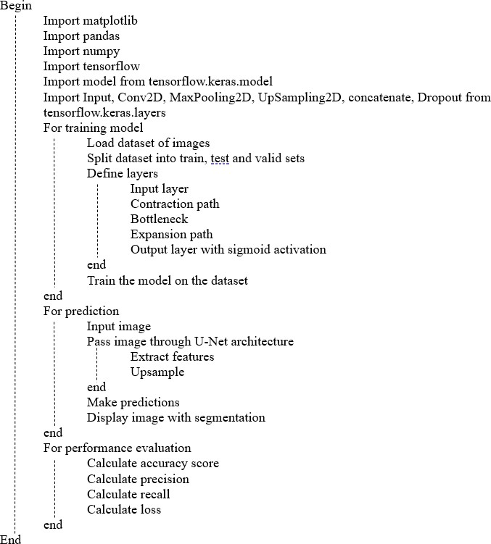

### 4.5 Advantages

**Algorithm 1:** Image Segmentation Using U-Net CNN

This model is particularly useful in image segmentation, which not only classifies the image, but also gives information on where the classification is occurring. The U-Net excels in capturing both low-level and high-level features through its contracting and expansive paths. This allows the model to learn complex relationships within the input data. Additionally, there have been many variants and upgradation of this architecture thanks to its superb performance. This allows for better results; some of these include LadderNet, U-Net with attention, the recurrent and residual convolutional U-Net (R2- UNet), and U-Net with residual blocks or blocks with dense connections.