Feature

Expense menu

Data entry
the web application to support entering multiple items in a single shopping transaction (like a real receipt)

Master Data Entry

Category management
For the Master Data → Expense Category module, I recommend following the same design language as the Expense page so the application remains consistent.
Page Layout
+----------------------------------------------------------+
| Expense Category [+ Add Category]|
+----------------------------------------------------------+

+----------------------------------------------------------+
| Search Category [_____________________] [Search] [Reset] |
+----------------------------------------------------------+

+----------------------------------------------------------+
| Category List |
+----+---------------------------+-------------------------+
| No | Category Name | Action |
+----+---------------------------+-------------------------+
| 1 | Food | Edit | Delete |
| 2 | Transportation | Edit | Delete |
| 3 | Utilities | Edit | Delete |
|... | | |
+----------------------------------------------------------+

Showing 1 - 10 of 25 records
On mobile, the table should become responsive with horizontal scrolling.

Desktop Layout
------------------------------------------------------------
Expense Category

+ Add Category

Search:
+------------------------------------+
| Search category... |
+------------------------------------+

------------------------------------------------------------
| No | Category Name | Created | Action |
------------------------------------------------------------
| 1 | Food | ... | Edit Delete |
| 2 | Fuel | ... | Edit Delete |
------------------------------------------------------------

Mobile Layout
Expense Category

[ + Add ]

Search
+----------------------+

--------------------------------
Food

Created:
2026-07-27

[Edit]
[Delete]
--------------------------------

Transportation

Created:
2026-07-27

[Edit]
[Delete]
--------------------------------
Bootstrap's .table-responsive can handle this without creating a separate mobile page.

Add Category
Clicking Add Category opens a Bootstrap modal.
---------------------------------
Add Expense Category
---------------------------------

Category Name
+----------------------------+

[Cancel] [Save]
Advantages:
- User stays on the same page
- Faster CRUD
- No page navigation

Edit Category
Same modal reused.
---------------------------------
Edit Expense Category
---------------------------------

Category Name
+----------------------------+
Food

[Cancel] [Update]

Delete Category
Confirmation modal.
Delete Category

Are you sure you want to delete

Food

This action cannot be undone.

[Cancel] [Delete]

Table Columns
Column | Description
No | Running number
Category Name | Expense category
Action | Edit & Delete buttons
I would omit category_id from the UI because it has little value for end users.

Bootstrap Components
- Card
- Table Responsive
- Modal
- Input Group
- Search Box
- Badge (optional)
- Flash Message
- Pagination (future)

Folder Structure
templates/
│
├── master/
│ ├── category_list.html
│
├── includes/
│ ├── modal_category.html
│
static/
│
├── js/
│ ├── category.js
│
├── css/
│ ├── style.css

Flask Structure
category.py (Blueprint)

GET /master/category
POST /master/category/add
POST /master/category/update/<id>
POST /master/category/delete/<id>

Service Layer
CategoryService.get_all()
CategoryService.add(category_name)
CategoryService.update(category_id, category_name)
CategoryService.delete(category_id)

Repository Layer
CategoryRepository.get_all()
CategoryRepository.insert()
CategoryRepository.update()
CategoryRepository.delete()
CategoryRepository.exists_by_name()

User Experience
- Search filters the table instantly (client-side for small datasets).
- Clicking Add Category opens a modal.
- Clicking Edit pre-populates the same modal.
- Clicking Delete opens a confirmation dialog.
- Success/error messages automatically disappear after a few seconds.
- Responsive layout works on both desktop and mobile using Bootstrap's grid and .table-responsive.
This approach is scalable and consistent with the architecture you've already established in the MyFinance project (Blueprint → Service → Repository → SQLite) and minimizes page navigation by performing all CRUD operations from a single management screen.

Expense Plan

Description
This follows the user's mental model:
- Find an item.
- Add it to the plan.
- Review total.
- Compare with historical spending

Page Structure
Given your existing architecture (models → repository → service → route → template → JavaScript), I would structure the page into three Bootstrap cards:
- Available Items
- Category dropdown
- Search box
- DataTable
- Add (+) button
- Current Plan
- Editable planning table
- Live subtotal calculations
- Grand total
- Save/Clear buttons
- Historical Comparison
- Year/month filter
- Historical items table
- Summary (total, item count, variance)
- Optional side-by-side comparison with the current plan

This organization keeps each responsibility separate, aligns with your existing CRUD architecture, and makes it straightforward to implement AJAX updates independently for the item list, current plan, and historical comparison.

Expense Planning

│
├── Header Card
│
├── KPI Cards
│
├── Planning Section
│ ├── Filter Card
│ ├── Available Items Card
│ ├── Current Plan Card
│ └── Sticky Summary Card
│
├── Comparison Card
│
├── Category Summary Card
│
└── Footer

Page Mock-Up
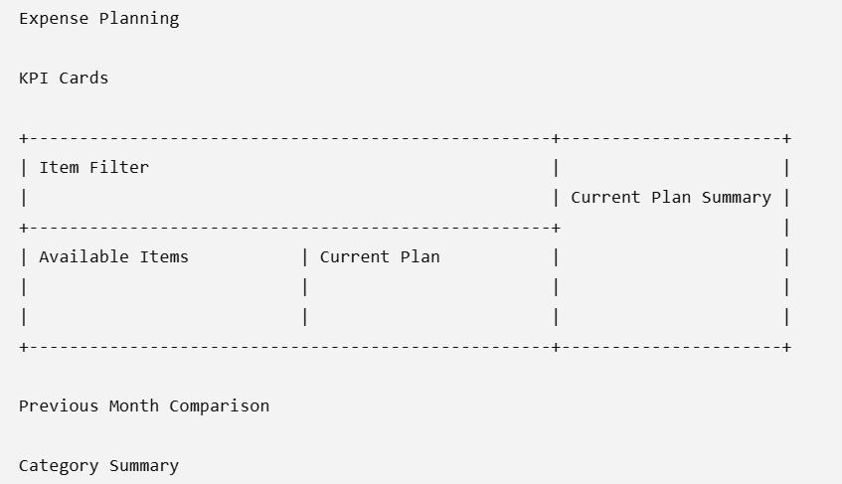

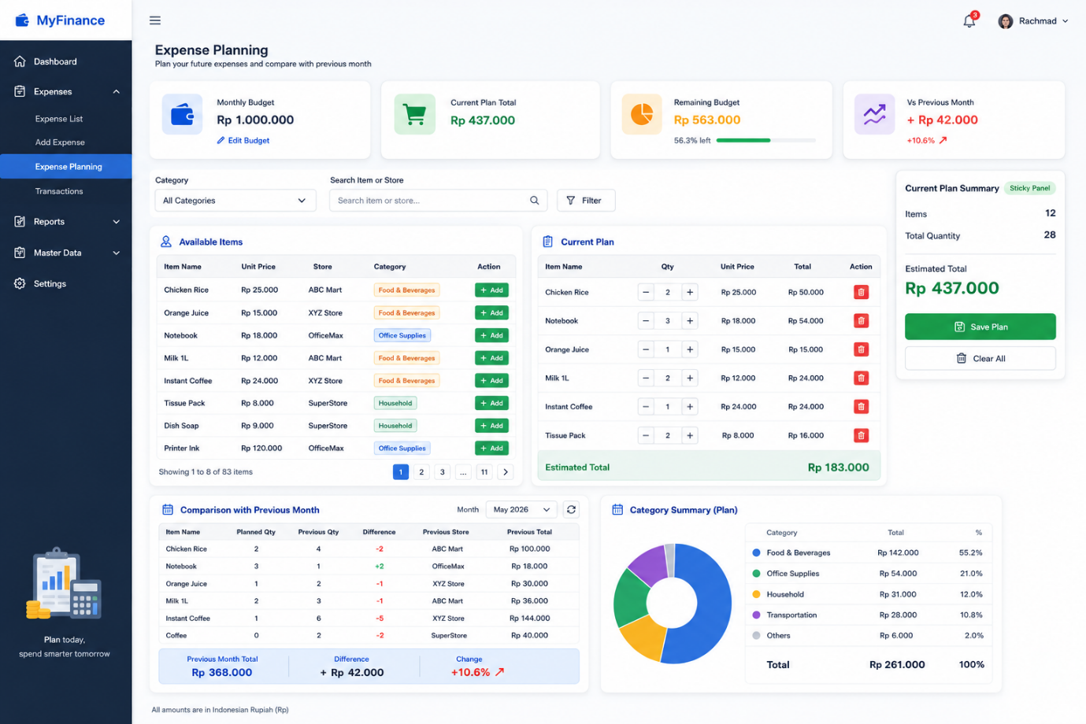

Page Section: KPI Card
KPI | Business Question
Monthly Budget | How much am I allowed to spend this month?
Current Plan | How much have I planned to spend?
Remaining Budget | How much budget is still available?
Vs Last Month | Am I planning to spend more or less than before?

Page Section: Item Filter

The filter supports:
- Category: Filter by expense category.
- Store: Filter items by preferred store.
- Search: Search by item name (or optionally store name).
- Reset: Clear all filters.

Filter behaviour
The filter should behave like a live filter, similar to e-commerce sites (Amazon, Tokopedia, Shopee) or ERP systems.
There should be no Search button.
Instead, every filter change automatically refreshes the Available Items table.
This reduces clicks and provides immediate feedback.

Page Section: Available Item
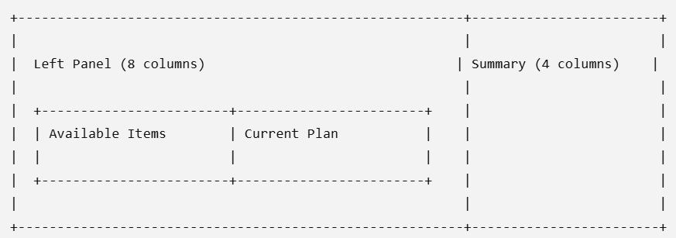
The application learns from the user's purchasing history to provide available items
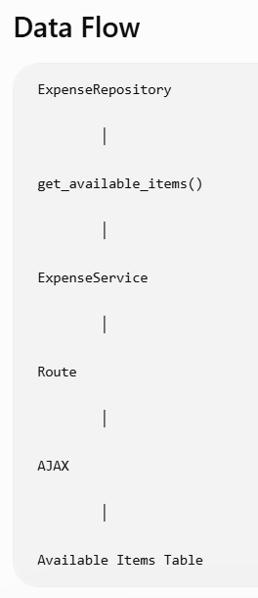
DataTables are designed for reporting, while this section is essentially an item picker. A scrollable Bootstrap list is simpler, cleaner, and closer to the user experience found in shopping carts and purchasing systems.
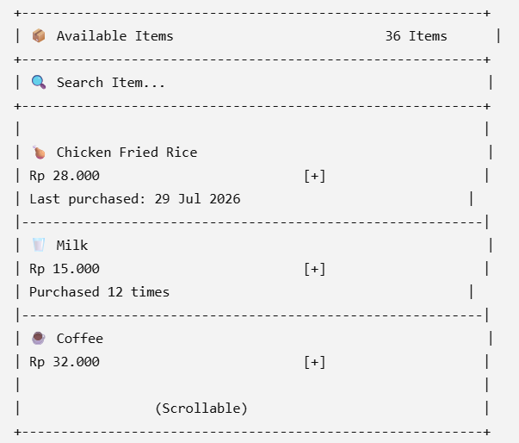
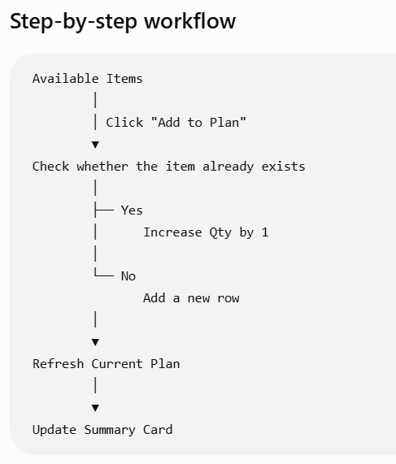

Page Section: Current Plan

Page Section: Current Plan Summary

Template

Expense entry page

Description
the Expense Entry page (expense_add.html) with support for:
- Receipt Information (header)
- Dynamic multiple-item table (detail)
- Live subtotal calculation
- Live grand total calculation
- Add/Remove item rows
- Bootstrap 5 responsive layout

Database

Table

stores
-----------------------
store_id
store_name
address
phone
created_at

expense_categories
-----------------------
category_id
category_name
description
created_at

expense_transactions
-----------------------
expense_id
transaction_date
store_id
total_amount
notes
created_at

expense_details
-----------------------
detail_id
expense_id
category_id
item_name
brand
size
quantity
unit_price
subtotal

repositories

expense_repository
Repository Status
With Parts 1 and 2 combined, the repository now provides:
Master Data
- ✅ get_all_stores()
- ✅ get_all_categories()
- ✅ get_all_payment_methods()
Header
- ✅ insert_transaction()
- ✅ get_transaction()
- ✅ update_transaction()
- ✅ delete_transaction()
Detail
- ✅ insert_detail()
- ✅ get_details_by_transaction()
- ✅ delete_details_by_transaction()
Aggregate
- ✅ get_complete_transaction()
Validation
- ✅ store_exists()
- ✅ category_exists()
- ✅ payment_method_exists()
- ✅ transaction_exists()
- ✅ receipt_exists()

Service

Expense_service
Business Validation
- ✅ Expense date
- ✅ Store existence
- ✅ Payment method existence
- ✅ Category existence
- ✅ Item validation
- ✅ Quantity validation
- ✅ Price validation
Domain Model Construction
- ✅ Form → ExpenseTransaction
- ✅ JSON → ExpenseDetail
Calculation
- ✅ Detail subtotal
- ✅ Grand total
- ✅ Discount handling
Master Data Loading
- ✅ Stores
- ✅ Categories
- ✅ Payment methods
Notice that there is still:
- No SQL
- No transaction handling
- No Flask request/response logic
Form Preparation
- ✅ load_expense_form()
Validation
- ✅ _validate_header()
- ✅ _validate_details()
Model Builders
- ✅ _build_transaction()
- ✅ _build_detail()
Calculation
- ✅ _calculate_totals()
Business Workflows
- ✅ save_expense()
- ✅ update_expense()
- ✅ get_expense()
- ✅ delete_expense()
- ✅ receipt_exists()

