Portfolio Project Structure
Recommended directory structure:
portfolio/
│
├── app.py
├── config.py
├── requirements.txt
├── README.md
│
├── instance/
│ └── portfolio.db # Optional (future use)
│
├── routes/
│ ├── __init__.py
│ ├── home.py
│ ├── data_analysis.py
│ ├── data_science.py
│ ├── course_materials.py
│ ├── research_notes.py
│ ├── portfolio.py
│ └── about.py
│
├── services/
│ ├── __init__.py
│ ├── ocr_service.py
│ ├── statistics_service.py
│ └── ml_service.py
│
├── repositories/
│ ├── __init__.py
│ └── dataset_repository.py
│
├── templates/
│ ├── layouts/
│ │ └── base.html
│ ├── home/
│ │ └── index.html
│ ├── about/
│ │ └── index.html
│ ├── data_analysis/
│ │ ├── index.html
│ │ ├── descriptive_statistics.html
│ │ ├── inferential_statistics.html
│ │ └── visualization.html
│ ├── data_science/
│ │ ├── index.html
│ │ ├── machine_learning.html
│ │ ├── clustering.html
│ │ └── explainable_ai.html
│ ├── course_materials/
│ │ ├── index.html
│ │ ├── database.html
│ │ ├── software_engineering.html
│ │ ├── operating_system.html
│ │ └── python.html
│ ├── research_notes/
│ │ ├── index.html
│ │ ├── publications.html
│ │ ├── roadmap.html
│ │ └── datasets.html
│ └── portfolio/
│ ├── index.html
│ ├── ocr/
│ │ └── index.html
│ ├── myfinance/
│ │ └── index.html
│ ├── csv_analyzer/
│ │ └── index.html
│ └── image_tools/
│ └── index.html
│
├── static/
│ ├── css/
│ ├── js/
│ ├── images/
│ ├── uploads/
│ └── downloads/
│
├── output/
│ ├── txt/
│ ├── csv/
│ └── pdf/
│
└── docs/
├── cv.pdf
├── certificates/
└── publications/
Why this structure?
- routes/: Defines the URLs and renders templates. Keep business logic out of these files.
- services/: Contains processing logic, such as OCR with PaddleOCR, statistical calculations, or machine learning workflows.
- repositories/: Handles data access. Even if you don't need a database immediately, keeping this layer makes future expansion easier.
- templates/: Organized by feature, so each section is self-contained.
- static/: Shared CSS, JavaScript, and images.
- output/: Stores generated files (e.g., OCR text, exported CSVs, PDFs) before they're downloaded.
- docs/: Keeps static documents like your CV, certificates, and publication PDFs separate from application code.

Navigation
- Home
- About
- Data Analysis (Descriptive Statistics, Inferential Statistics, Data Visualization)
- Data Science (Machine Learning, Clustering, Explainable AI)
- Course Materials (Database, Software Engineering, Operating Systems, Python Programming)
- Research Notes (Publications, Research Roadmap, Datasets)
- Portfolio (OCR Text Extractor, MyFinance, CSV Analyzer, Image Tools)

Master Template Layout
No | File | Purpose
1 | Template/layout/base.html

Base.html
Since this is your entire portfolio website, base.html should be generic enough to support all current and future pages. It should contain only the elements shared by every page:
- Bootstrap CSS
- Custom CSS
- Responsive navigation bar
- Main content container
- Footer
- Bootstrap JavaScript
- Block definitions for child templates

Portfolio Applications Page
I recommend treating Portfolio Applications as a catalog page, not an application itself. Its role is to showcase your software projects and link to each one. This scales well as you add more applications over time.
Your flow becomes:
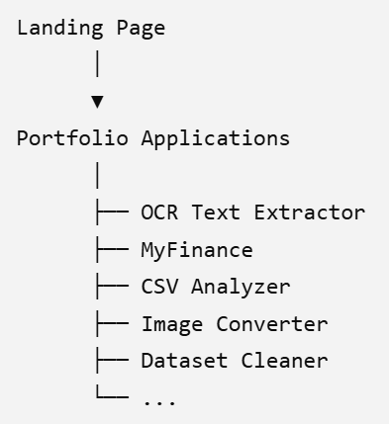

OCR Extractor
No | File | Purpose
1 | routes/ocr.py | Defines Flask routes for the OCR module
2 | services/ocr_service.py | Handles PaddleOCR processing and text extraction
3 | templates/portfolio/ocr/index.html | User interface for image upload, OCR result, and TXT download
4 | static/css/ocr.css | Module-specific styling
5 | static/js/ocr.js | Optional; only needed for enhancements such as image preview or drag-and-drop
6 | requirements.txt | Lists Python dependencies

Expected Routes
Method | Route | Endpoint
GET | /portfolio/ocr | ocr.index
POST | /portfolio/ocr/extract | ocr.extract
POST | /portfolio/ocr/download | ocr.download_txt

ocr.extract
the route should not call PaddleOCR directly. Instead, keep the route responsible for:
- Receiving the uploaded image.
- Calling the service.
- Rendering the result.

The service should handle all PaddleOCR logic.
