In that case, using a layout template (base.html) is the right architectural choice.
What changed is the scope of the project. Earlier, I assumed the OCR application would be a standalone portfolio. Now you're describing a personal portfolio website where OCR is just one of several sections. That's exactly the scenario where Flask's template inheritance is valuable.
I would organize it like this:
portfolio/
│
├── app.py
├── requirements.txt
│
├── templates/
│ ├── layouts/
│ │ └── base.html
│ │
│ ├── index.html # Landing page
│ ├── data_analysis.html
│ ├── data_science.html
│ ├── course_materials.html
│ ├── research_notes.html
│ │
│ └── tools/
│ ├── ocr_extract.html
│ ├── csv_analyzer.html
│ ├── image_converter.html
│ └── ...
│
├── static/
│ ├── css/
│ │ └── style.css
│ ├── js/
│ ├── images/
│ └── uploads/
│
└── modules/
├── ocr/
├── data_analysis/
└── ...
Landing page
Your landing page could introduce you and provide navigation to your work.
+------------------------------------------------------------+
| Navigation Bar |
+------------------------------------------------------------+

Rachmad Fitriyanto
Lecturer | Data Scientist | Researcher

--------------------------------------------------------------

Featured Sections

+---------------+ +---------------+
| Data Analysis | | Data Science |
+---------------+ +---------------+

+---------------+ +---------------+
| Course Notes | | Research |
+---------------+ +---------------+

+---------------+ +---------------+
| OCR Tool | | More Projects |
+---------------+ +---------------+

--------------------------------------------------------------

Footer
Suggested navigation
Home
│
├── Data Analysis
│ ├── Dashboard
│ ├── Statistics
│ └── Visualization
│
├── Data Science
│ ├── Machine Learning
│ ├── Clustering
│ └── Explainable AI
│
├── Teaching
│ ├── Database
│ ├── Software Engineering
│ ├── Operating Systems
│ └── Python
│
├── Research
│ ├── Publications
│ ├── Research Roadmap
│ └── Notes
│
└── Tools
├── OCR Text Extractor
├── CSV Analyzer
├── PDF Utilities
└── ...
Why this design is stronger
Instead of presenting isolated projects, you're demonstrating that you can structure and build a complete web application. A reviewer can see:
- Consistent UI using template inheritance.
- Modular Flask organization.
- Separation of concerns between templates, routes, services, and static assets.
- Multiple independent features integrated into one application.
Since I know your background from our previous discussions, I'd make the portfolio emphasize both your academic work and your software engineering skills. A structure like this aligns well with your experience:
- Home – Profile, CV, certifications, contact.
- Data Analysis – Exploratory analysis examples, dashboards, statistical methods.
- Data Science – Clustering, explainable AI, machine learning projects.
- Teaching – Lecture notes, course materials, demonstrations.
- Research – Publications, roadmap, datasets, notebooks.
- Tools – Practical web applications such as the PaddleOCR extractor, MyFinance, dataset preprocessors, and other utilities.
This presents a coherent professional profile rather than a collection of unrelated demos.

Text extraction

User Interface
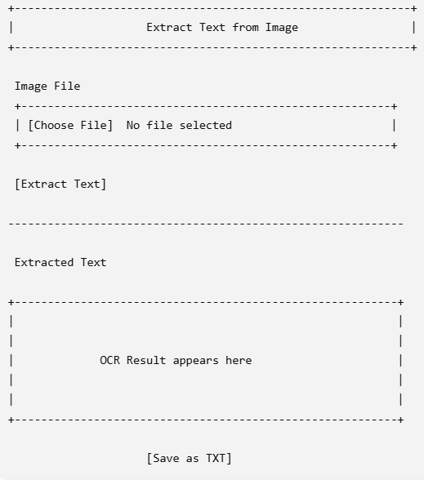

Project Folder
