***DAFTAR ERROR CODEIGNITER***

1. NOT FOUND

The requested URL was not found on this server.

Additionally, a 404 Not Found error was encountered while trying to use an ErrorDocument to handle the request.

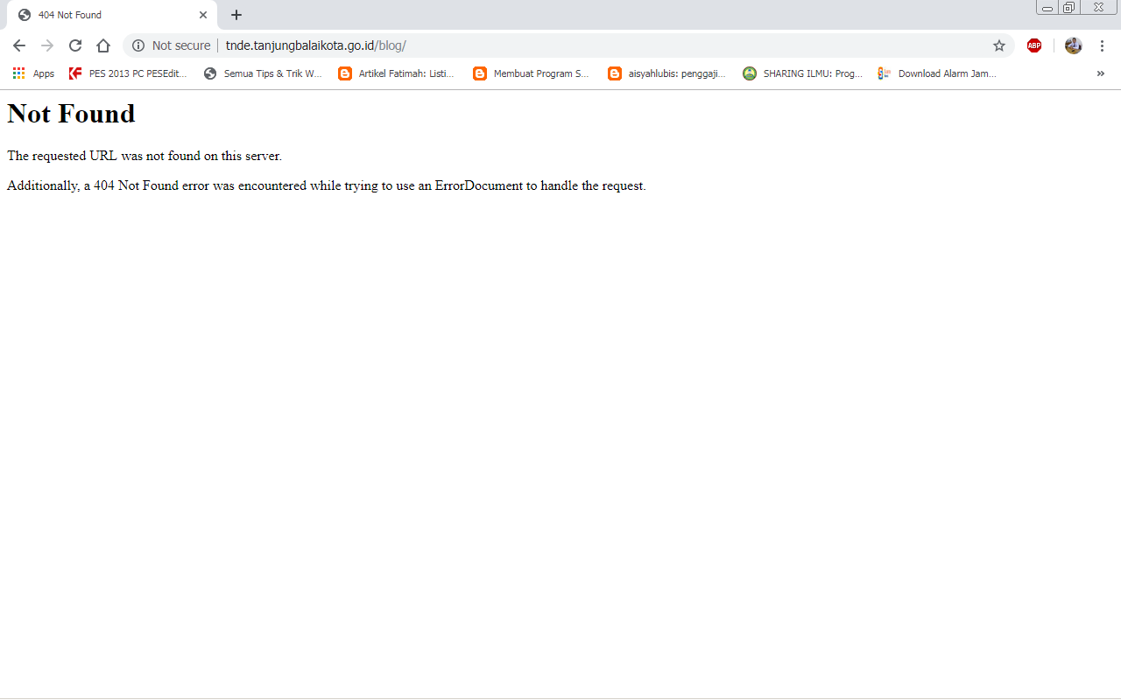

PERBAIKAN : HTACCESS nya hilang atau belum dibuat, ketik ulang dengan script :

RewriteEngine On

RewriteCond %{REQUEST_FILENAME} !-f

RewriteCond %{REQUEST_FILENAME} !-d

RewriteRule ^(.*)$ index.php/$1 [L]

Simpan dengan nama .htaccess melalui notepad dengan posisi di folder utama project, jika ini terjadi ketika selesai upload file ke hosting, upload ulang file .htaccess nya ke filemanager cpanel difolder utama project.