Nearbeat
Your city pulse
Product Requirements Document v1.1
MIT AI Hackathon 2026 · Challenge 1: Generative City-Wallet · April 2026

1. Product Overview
Nearbeat is an AI-powered generative wallet that connects a person's real-time context — location, time, daily schedule, habitual routes, spend history, and weather — to hyper-personalized local merchant offers. The tagline is: your city pulse.
Unlike static loyalty apps, Nearbeat reasons over temporal patterns: it knows you pass Cafe Rossa every Tuesday at 8:20am, that it's raining, and that you have gym at 6pm. Every offer surfaces with a one-sentence reason citing the exact signal that triggered it. That explainability is the core differentiator.

2. Signal Architecture
Nearbeat stacks three signal layers into a unified context bundle. The bundle is passed to a Claude offer agent that reasons, ranks, and returns exactly 3 personalized offers with cited explanations.

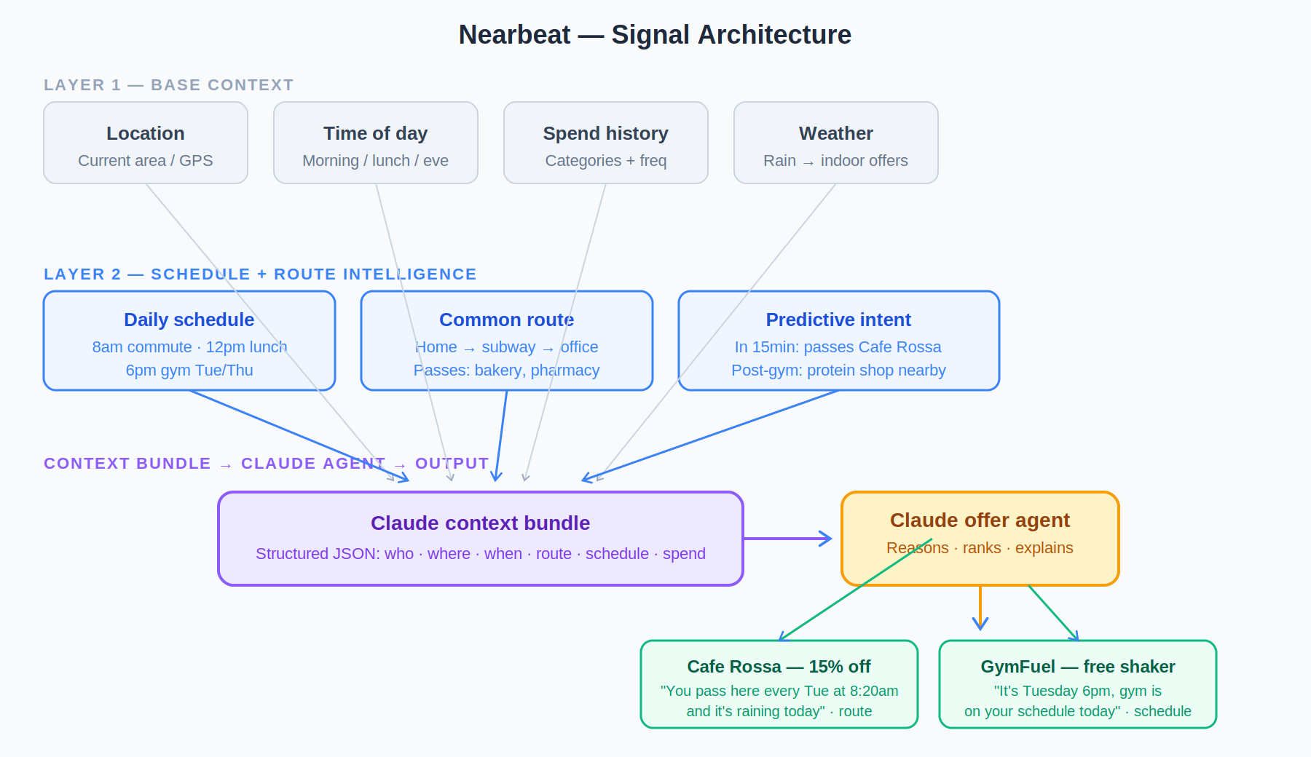

2.1 Layer 1 — Base context
- Location: current area, neighborhood, city
- Time of day: labeled (morning_commute, lunch, post_gym, etc.)
- Spend history: frequent categories, recent merchants, transaction tier
- Weather: current conditions with a code (rain, sunny, cloudy, snow)

2.2 Layer 2 — Schedule + route intelligence (differentiator)
- Daily schedule: named events with times (9am standup, 6pm gym)
- Today's route: ordered list of waypoints from current location to destination
- Upcoming waypoints: merchant or transit stops with ETA in minutes
- Recurring patterns: weekly habits (Tue/Thu gym, Wed client lunch)

2.3 Layer 3 — Predictive intent (derived)
- "In 15 minutes she passes Cafe Rossa" — from route + current time
- "It's Tuesday 6pm — gym is scheduled tonight" — from schedule + day
- "Post-gym window: protein shop is 80m from her gym" — combined signal

3. Context Bundle Schema
This TypeScript interface is the canonical contract for all persona data and the Claude API call. Populate this fully for each persona — partial bundles produce generic offers.

interface ContextBundle {
persona: { name: string; occupation: string; age_bracket: "20s"|"30s"|"40s" };
temporal: {
current_time: string; // "8:05am Tuesday"
current_date: string; // "YYYY-MM-DD"
time_of_day_label: "morning_commute"|"lunch"|"afternoon"|"evening"|"post_gym"|"morning";
};
location: { current_area: string; city: string; neighborhood: string; };
route: {
route_today: string[];
upcoming_waypoints: Array<{
name: string; eta_minutes: number; type: "merchant"|"transit"|"destination";
}>;
common_routes: Array<{ label: string; days: string[]; passes: string[]; }>;
};
schedule: {
today: Array<{ time: string; event: string; }>;
recurring_patterns: Array<{ days: string[]; pattern: string; }>;
};
spend_history: {
frequent_categories: string[];
recent_merchants: string[];
avg_transaction: "low"|"medium"|"high";
};
environment: { weather: string; weather_code: "rain"|"sunny"|"cloudy"|"snow"; };
merchants_nearby: Array<{
id: string; name: string;
category: "coffee"|"food"|"health"|"retail"|"services"|"baby"|"grocery";
distance_meters: number; on_route: boolean;
available_offer: { type: "discount"|"freebie"|"upgrade"|"loyalty"; description: string; value: string; };
}>;
}

4. Claude Offer Agent — System Prompt
Copy this verbatim into lib/claude.ts. The key constraints are: exactly 3 offers, every reason must cite a named signal, JSON-only output.

You are Nearbeat, an AI offer agent embedded in a smart city wallet.
You receive a JSON context bundle: location, time of day, daily schedule,
habitual route, upcoming waypoints, spend history, nearby merchants.

Your job: return EXACTLY 3 personalized offers from merchants_nearby.

Rules:
1. Each offer must feel earned, not generic.
2. Every offer MUST cite a specific signal (schedule, route, weather, habit).
3. Reason = 1 sentence, max 20 words, second person ("you").
4. Rank by: (a) on route today, (b) time/schedule match, (c) spend history.
5. Only use merchants in merchants_nearby. Only use offers in available_offer.
6. Prefer on_route=true merchants with eta_minutes < 30.

Return JSON only — no preamble, no markdown fences:
{
"offers": [{
"merchant_id": "string",
"merchant_name": "string",
"offer": "string",
"reason": "string",
"signal_used": "route"|"schedule"|"weather"|"spend_history"|"habit"
}]
}

5. Design System
Nearbeat uses a dark-first UI — deep navy backgrounds give a premium wallet feel while making the colorful signal badges pop. The visual hierarchy is: merchant name → offer value → reason text → signal badge.

5.1 Color palette
Token | Name | Hex | Usage | Example
--nb-bg | Midnight | #0F172A | App background, nav bar | ●
--nb-surface | Surface | #1E293B | Cards, context bar, modals | ●
--nb-border | Border | #334155 | Dividers, card borders | ●
--nb-muted | Muted | #64748B | Secondary text, labels | ●
--nb-text | Primary text | #F1F5F9 | Main body text on dark bg | ●
--nb-blue | Nearbeat Blue | #3B82F6 | Primary CTA, active tabs, persona avatar | ●
--nb-green | Offer Green | #10B981 | Offer value text, success states | ●

5.2 Signal badge colors
Each offer card shows a color-coded pill indicating which signal drove the recommendation. This is the visual proof of intelligence — judges see immediately that AI is reasoning, not guessing.

Signal | Color | Hex | Badge bg (20% opacity) | Trigger example
ROUTE | Blue | #3B82F6 | EFF6FF | on_route=true, eta<30min
SCHEDULE | Purple | #8B5CF6 | EDE9FE | event matches time window
HABIT | Amber | #F59E0B | FEF3C7 | recurring_pattern matches day
WEATHER | Red | #EF4444 | FEE2E2 | weather_code = rain/snow
SPEND | Green | #10B981 | D1FAE5 | category in frequent_categories

5.3 Typography
Element | Font | Size | Weight | Color token
App wordmark | Arial | 24px | 700 | --nb-blue
Merchant name | Arial | 18-22px | 700 | --nb-text (#F1F5F9)
Offer value | Arial | 15px | 600 | --nb-green (#10B981)
Reason text | Arial | 12px | 400 | --nb-muted (#64748B)
Section labels | Arial | 10-11px | 700 + tracking | --nb-muted uppercase
Context bar text | Arial | 11-13px | 400/700 | --nb-text / --nb-muted

5.4 Spacing system
Base unit is 4px. All padding, gaps, and margins are multiples of 4.
Token | Value | Tailwind | Used for
space-1 | 4px | p-1 | Icon padding, tight badge internal gap
space-2 | 8px | p-2 | Badge padding, small internal gaps
space-3 | 12px | p-3 | Card section divider gap
space-4 | 16px | p-4 | Card internal padding, card-to-card gap
space-6 | 24px | p-6 | Screen horizontal margin (16px phone = px-4)

5.5 Border radius
Element | Radius (Tailwind) | Notes
Signal badge pill | rounded-full (9999px) | Always pill shape
Claim button | rounded-full (9999px) | Full pill for primary CTA
Offer card | rounded-2xl (16px) | Generous rounding, premium feel
Context bar | rounded-xl (12px) | Slightly tighter than cards
Merchant hero block | rounded-xl (12px) | Inside detail sheet
Avatar circle | rounded-full | Persona avatar, always circular

6. UI Mockups

6.1 Wallet home screen + offer feed
The home screen has four zones: (1) context bar showing persona, location, time and weather; (2) offers section label; (3) three offer cards with signal badges; (4) persona switcher tabs at the bottom. The key demo interaction is tapping a persona tab and watching all three cards regenerate.

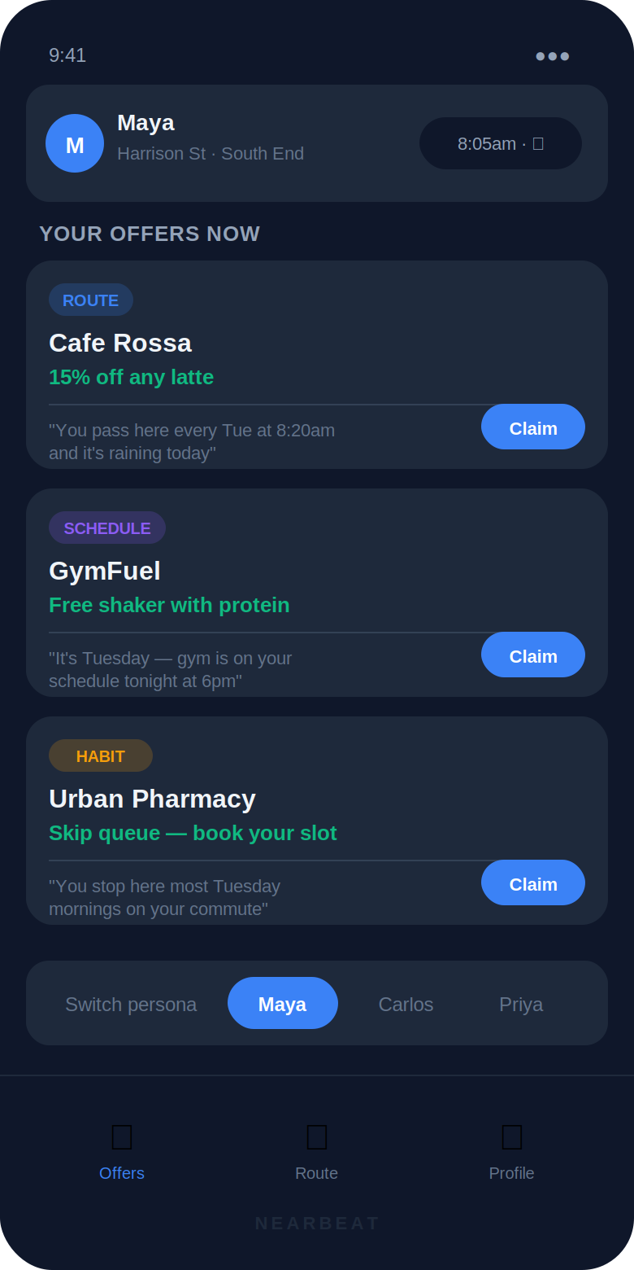

6.2 Offer detail view + design tokens reference
Tapping any offer card opens a detail sheet. It shows the merchant hero block, the offer highlighted in green, the AI reason with a left-border quote style, the signal badges used, and the Claim CTA. The right panel shows the complete design token reference including colors, typography scale, spacing, and border radius.

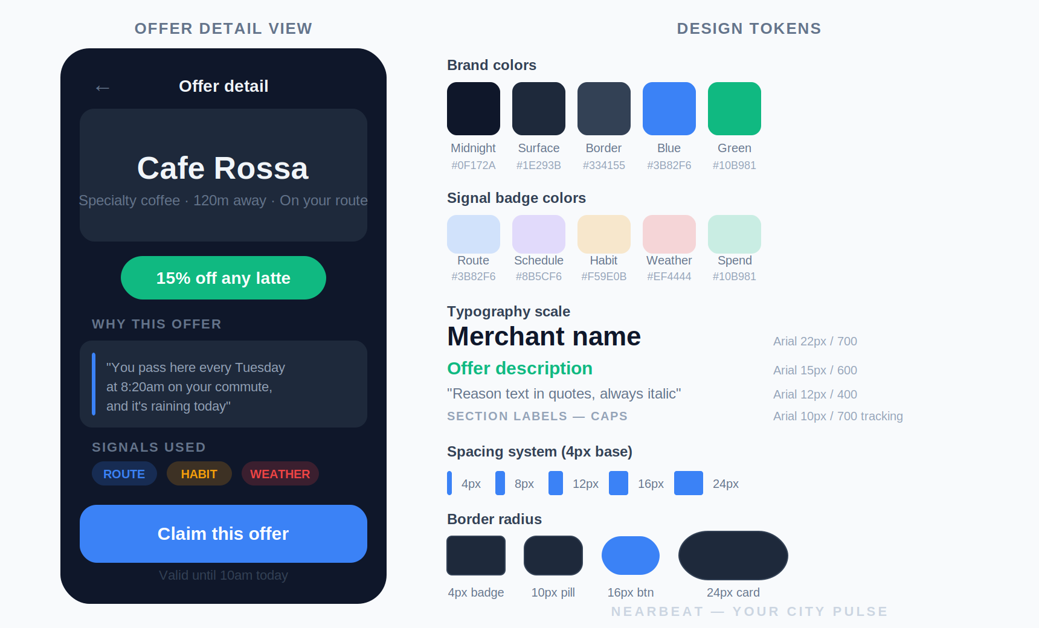

6.3 Component checklist for Claude Code
- ContextBar.tsx — persona avatar, name, location, time, weather pill
- OfferCard.tsx — signal badge, merchant name, offer text (green), reason (muted), claim button
- OfferFeed.tsx — 3 OfferCard stack with skeleton loading state (3 gray placeholder cards)
- PersonaSwitcher.tsx — tab row: Maya | Carlos | Priya, active tab = blue pill
- ClaimModal.tsx — full-screen confirmation: checkmark, 'Offer claimed!', merchant name, expiry
- ContextBar should update instantly on persona switch — no loading state
- OfferFeed should show skeleton on switch, then fade in new cards

7. Feature Scope
Feature | Description | Priority
Persona switcher | Toggle 3 personas, instant context update | P0 — must ship
Live offer feed | 3 cards: merchant, deal, AI reason | P0 — must ship
Context bar | Time, location, weather strip | P0 — must ship
Signal badge | Color-coded pill per signal type | P1 — strong demo
Skeleton loading | 3 placeholder cards while fetching | P1 — strong demo
Claim modal | Mock confirmation on offer tap | P1 — strong demo
Pre-cache offers | Load all 3 persona offers on app mount | P1 — latency fix
Route mini-map | SVG schematic of today's route | P2 — if time
Real payments / GPS | Out of scope — mock only | Out of scope

8. Tech Stack
Layer | Choice | Reason
Framework | Next.js 14 (App Router) | API routes + React in one repo
Styling | Tailwind CSS + shadcn/ui | Wallet UI without custom CSS time sink
AI | Claude claude-sonnet-4-5 (Anthropic SDK) | Best context reasoning for signals
Streaming | Vercel AI SDK useChat / streamText | Typing animation hides latency
State | React useState + useEffect | No Redux needed at demo scale
Data | Hardcoded TS files (personas + merchants) | Zero DB setup, instant iteration
Deploy | Vercel (one-click from GitHub) | Live URL for judges in minutes

9. 2-Minute Demo Script
- Open app — Maya persona loaded. Read context bar aloud: "8:05am, Harrison Street, light rain, Tuesday."
- Point to offer 1 reason: "You pass here every Tuesday at 8:20am and it's raining today." — signal badge says ROUTE. This is the moment.
- Point to offer 2: GymFuel, SCHEDULE badge. Read: "It's Tuesday — gym is on your schedule tonight at 6pm." Let that land.
- Switch to Carlos. Context bar changes: 12:10pm, Financial District, sunny Wednesday. Watch offers regenerate.
- Maru Sushi surfaces — ROUTE badge. "You have client lunch at 12:30pm and Maru Sushi is 5 minutes away." Different person, completely different city.
- Switch to Priya. Park-side Saturday morning. Green Market + Little Bloom. HABIT badge on Green Market: "Saturday grocery run — you're here most weekends."
- Tap claim on any offer. Mock confirmation. Close: "This is what it looks like when the city actually knows you."

Nearbeat — Your city pulse · PRD v1.1 · MIT AI Hackathon 2026 · Solo build by Rachmawaty Sudirman

