**IIT Kharagpur**



NIRF Ranking: 1

NIRF score: 89.41

Location: Kharagpur, West Bengal 721302

NAAC Grading: A+

Website: <http://www.iitkgp.ac.in/>

**Delhi University**

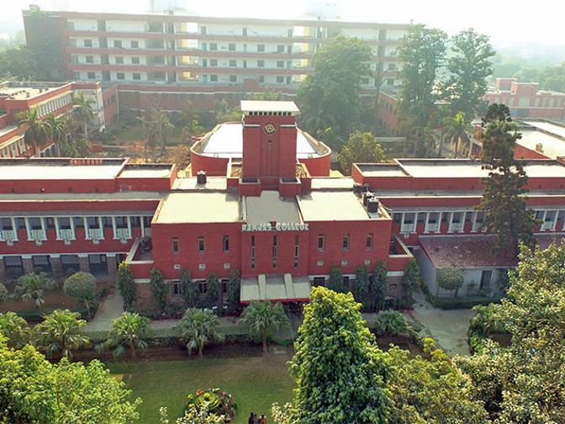

NIRF Ranking: 2

NIRF score: 87.61

Location: Benito Juarez Marg, South Campus, South Moti Bagh, New Delhi, Delhi 110021

NAAC Grading: A+

Website: <http://www.du.ac.in/du/uploads/COVID-19/>

**IIT Madras**

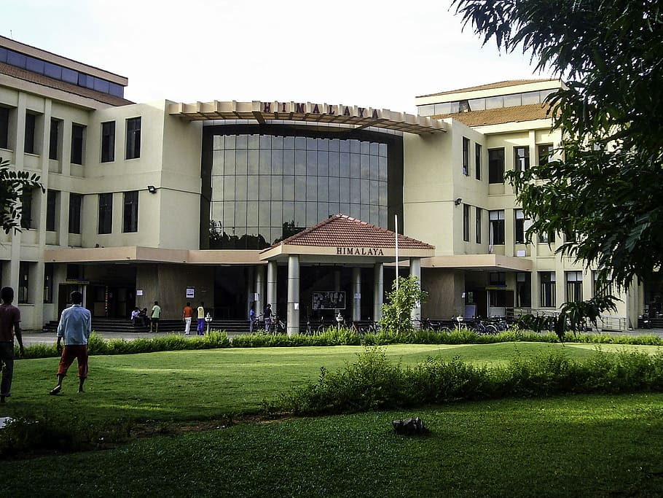

NIRF Ranking: 3

NIRF score: 83.91

Location: Indian Institute Of Technology, Chennai, Tamil Nadu 600036

NAAC Grading: A+

Website: <https://www.iitm.ac.in/>

**VIT Vellore**

NIRF Ranking: 4

NIRF score: 82.02

Location: VIT, Vellore Campus, Tiruvalam Rd, Katpadi, Vellore, Tamil Nadu 632014NAAC Grading: A+

Website: <https://vit.ac.in/>



**NIT Trichy**

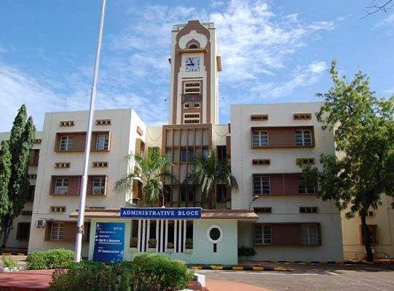

NIRF Ranking: 5

NIRF score: 81.07

Location : Tanjore Main Road, NH67, near BHEL, Tiruchirappalli, Tamil Nadu 620015NAAC Grading: A

Website: <https://www.nitt.edu/>

**NIT Warangal**



NIRF Ranking: 6

NIRF score: 78.68

Location: National Institute of Technology Campus, fathimanagar, Telangana 506004

NAAC Grading: A

Website: <https://www.nitw.ac.in/>

**Pune University (Savitribai phule)**

  
NIRF Ranking: 7

NIRF score: 77.22

Location: Ganeshkhind Rd, Ganeshkhind, Pune, Maharashtra 411007

NAAC Grading: A+

Website: <http://www.unipune.ac.in/>

**PANJAB UNIVERSITY**



NIRF Ranking: 8

NIRF score: 75.20

Location: Sector 14, Chandigarh, 160014

NAAC Grading: A

Website: <https://www.puchd.ac.in/>

**SRM DELHI**

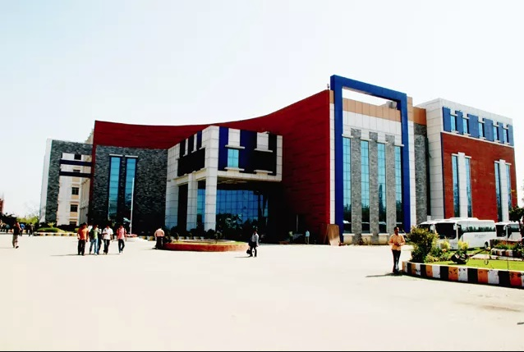

NIRF Ranking: 9

NIRF score: 74.88

Location: Plot No. 39, Rajiv Gandhi Education City Delhi-NCR Sonepat – Kundli Urban Complex, Post Office P.S.Rai, Sonipat, Haryana 131029

NAAC Grading: A

Website: <https://www.srmuniversity.ac.in/>

**VIT CHENNAI**

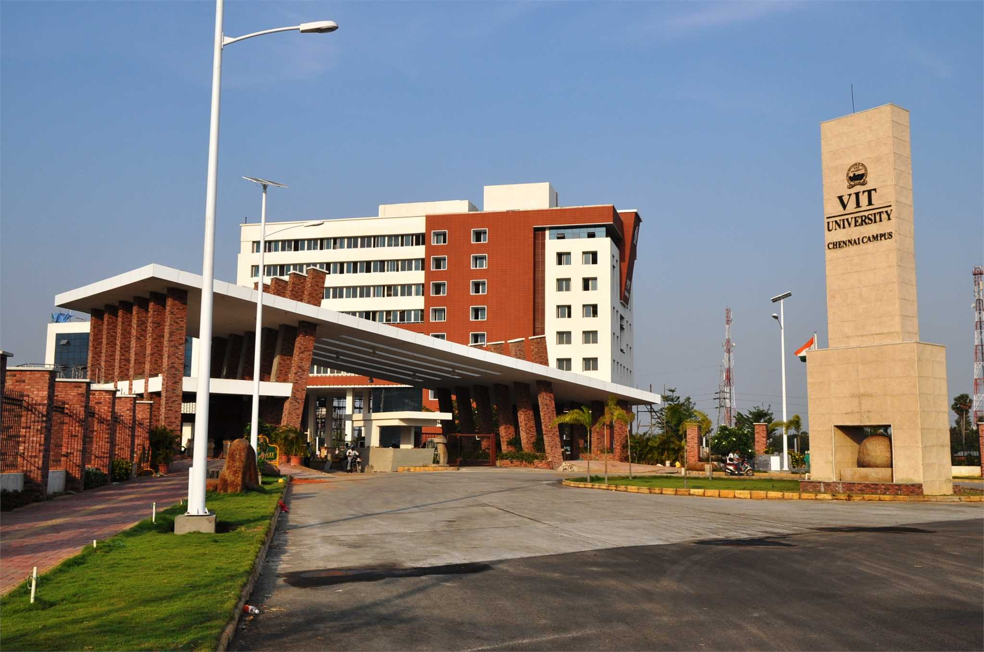

NIRF Ranking: 10

NIRF score: 73.43

Location: Kelambakkam - Vandalur Rd, Rajan Nagar, Chennai, Tamil Nadu 6001

NAAC Grading: A+

Website: <http://chennai.vit.ac.in/>