**Data Analytics For Business**

**DAB- 422**

**Capstone Project II- Sales and Revenue Analysis**

**Instructor Name:-   
Amrinder Singh**

**Submitted By:-   
Jatinder Pal Singh Batth 0812522**

**Rachna Dhico 0814805**

**Vishavjeet Singh 0814828**

Table of Contents

DAB 422 Capstone Project II 2

Topic 2 2

Data set Link: 2

Aim: 2

Abstract: 2

Data Schema 4

Data Dictionary 5

Table 1 5

Table 2 5

Table 3 6

Table 4 6

Table 5 6

Table 6 7

Table 7 7

Research Questions 8

References 8

# 

# DAB 422 Capstone Project II

## Topic 2

Data set Link:[E-Commerce Sales Dataset (kaggle.com)](https://www.kaggle.com/datasets/thedevastator/unlock-profits-with-e-commerce-sales-data)

Aim: Sales and revenue analysis.

Abstract:

This analysis focuses on improving revenue and product category performance for Amazon India, with the objective of reducing dependence on a single category and increasing revenue for the lowest of the top 3 categories. Preliminary analysis revealed key insights about Q2 2022 performance, including a decline in revenue and the dominance of the "Set" product category.

Key findings and recommendations include the need to drive interest in the "Western Dress" category and the identification of top-performing states for targeted promotions. The strategy involves implementing promotions, monitoring their impact, and analyzing their effectiveness.

The data cleaning process involved handling missing values, data type conversion, and addressing duplicate rows. Data visualization tools were imported for further analysis. To track progress, it is essential to calculate the baseline revenue percentages for the top 3 categories and set clear metrics to evaluate the success of promotional strategies.

Reducing dependence on a single category and continuous monitoring of revenue are crucial to achieving the stated objectives. Additional analysis of regional trends and close collaboration with stakeholders will enhance the effectiveness of the proposed strategies. Regular reporting will ensure transparency and alignment with the client's goals.

Data Schema

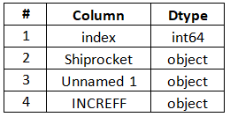

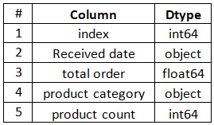

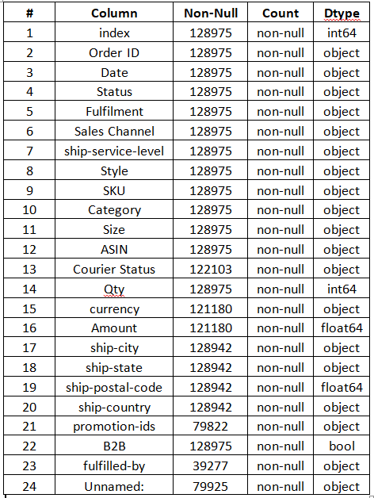

Tab

T

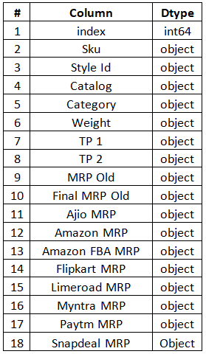Tab4

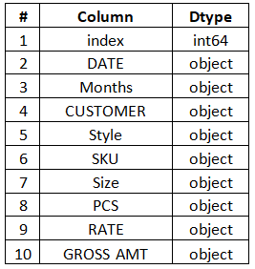

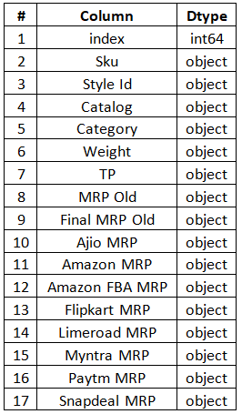

T

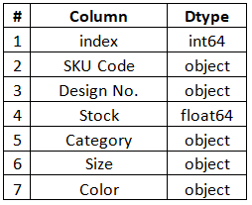

Data Dictionary

### Table 1

|  |  |  |  |  |
| --- | --- | --- | --- | --- |
| **#** | **Column** | **Non-Null** | **Count** | **Dtype** |
| 1 | index | 128975 | non-null | int64 |
| 2 | Order ID | 128975 | non-null | object |
| 3 | Date | 128975 | non-null | object |
| 4 | Status | 128975 | non-null | object |
| 5 | Fulfilment | 128975 | non-null | object |
| 6 | Sales Channel | 128975 | non-null | object |
| 7 | ship-service-level | 128975 | non-null | object |
| 8 | Style | 128975 | non-null | object |
| 9 | SKU | 128975 | non-null | object |
| 10 | Category | 128975 | non-null | object |
| 11 | Size | 128975 | non-null | object |
| 12 | ASIN | 128975 | non-null | object |
| 13 | Courier Status | 122103 | non-null | object |
| 14 | Qty | 128975 | non-null | int64 |
| 15 | currency | 121180 | non-null | object |
| 16 | Amount | 121180 | non-null | float64 |
| 17 | ship-city | 128942 | non-null | object |
| 18 | ship-state | 128942 | non-null | object |
| 19 | ship-postal-code | 128942 | non-null | float64 |
| 20 | ship-country | 128942 | non-null | object |
| 21 | promotion-ids | 79822 | non-null | object |
| 22 | B2B | 128975 | non-null | bool |
| 23 | fulfilled-by | 39277 | non-null | object |
| 24 | Unnamed: | 79925 | non-null | object |

### Table 2

|  |  |  |
| --- | --- | --- |
| # | **Column** | **Dtype** |
| 1 | index | int64 |
| 2 | Received date | object |
| 3 | total order | float64 |
| 4 | product category | object |
| 5 | product count | int64 |

### Table 3

|  |  |  |
| --- | --- | --- |
| **#** | **Column** | **Dtype** |
| 1 | index | int64 |
| 2 | Shiprocket | object |
| 3 | Unnamed 1 | object |
| 4 | INCREFF | object |

### Table 4

|  |  |  |
| --- | --- | --- |
| **#** | **Column** | **Dtype** |
| 1 | index | int64 |
| 2 | DATE | object |
| 3 | Months | object |
| 4 | CUSTOMER | object |
| 5 | Style | object |
| 6 | SKU | object |
| 7 | Size | object |
| 8 | PCS | object |
| 9 | RATE | object |
| 10 | GROSS AMT | object |

### Table 5

|  |  |  |
| --- | --- | --- |
| **#** | **Column** | **Dtype** |
| 1 | index | int64 |
| 2 | Sku | object |
| 3 | Style Id | object |
| 4 | Catalog | object |
| 5 | Category | object |
| 6 | Weight | object |
| 7 | TP | object |
| 8 | MRP Old | object |
| 9 | Final MRP Old | object |
| 10 | Ajio MRP | object |
| 11 | Amazon MRP | object |
| 12 | Amazon FBA MRP | object |
| 13 | Flipkart MRP | object |
| 14 | Limeroad MRP | object |
| 15 | Myntra MRP | object |
| 16 | Paytm MRP | object |
| 17 | Snapdeal MRP | object |

### Table 6

|  |  |  |
| --- | --- | --- |
| **#** | **Column** | **Dtype** |
| 1 | index | int64 |
| 2 | Sku | object |
| 3 | Style Id | object |
| 4 | Catalog | object |
| 5 | Category | object |
| 6 | Weight | object |
| 7 | TP 1 | object |
| 8 | TP 2 | object |
| 9 | MRP Old | object |
| 10 | Final MRP Old | object |
| 11 | Ajio MRP | object |
| 12 | Amazon MRP | object |
| 13 | Amazon FBA MRP | object |
| 14 | Flipkart MRP | object |
| 15 | Limeroad MRP | object |
| 16 | Myntra MRP | object |
| 17 | Paytm MRP | object |
| 18 | Snapdeal MRP | Object |

### Table 7

|  |  |  |
| --- | --- | --- |
| **#** | **Column** | **Dtype** |
| 1 | index | int64 |
| 2 | SKU Code | object |
| 3 | Design No. | object |
| 4 | Stock | float64 |
| 5 | Category | object |
| 6 | Size | object |
| 7 | Color | object |

Research Questions

Ques 1: What are the characteristics of the top-performing states in terms of sales revenue, and how can these characteristics be leveraged for targeted promotions?

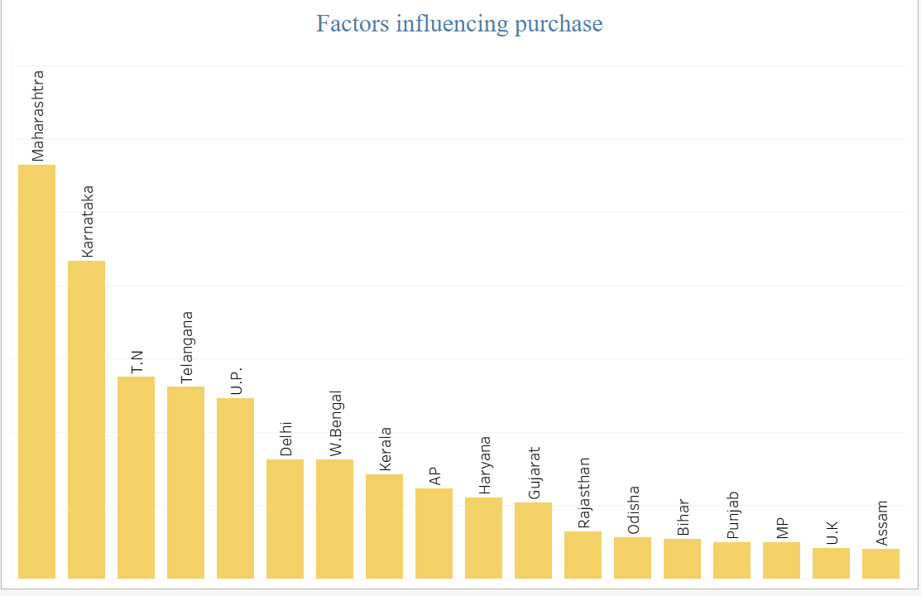

Answers : Five top-performing states are Maharashtra, Karnataka, Tamil Nadu, Uttar Pradesh & Delhi. To increase sale and revenue in particular areas we should promote the new designs ,tailoring and try to improve the service levels .

Ques 2: Which products or product categories contribute the most to revenue?

Answer: Kurtaset contribute the most to revenue.

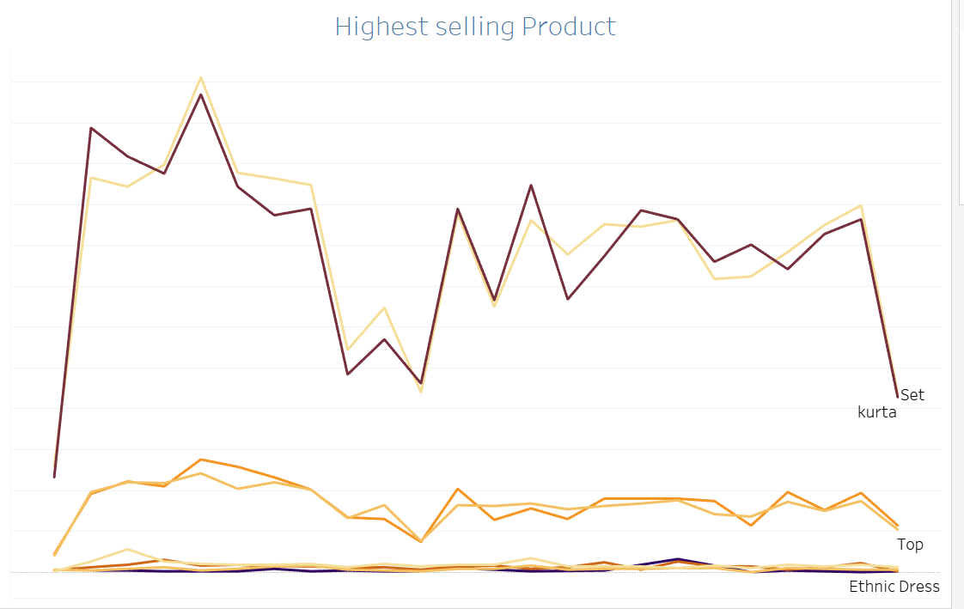

Ques 3: How do different states in India vary in their preference for specific product categories, and what factors influence these regional trends?

Answer: India has a wide range of tradition and culture. In all the parts most of the culture have different dressing styles like sarees , suits, lehngas,etc.

Ques 4: Which consumer segment contributes the most in sales?

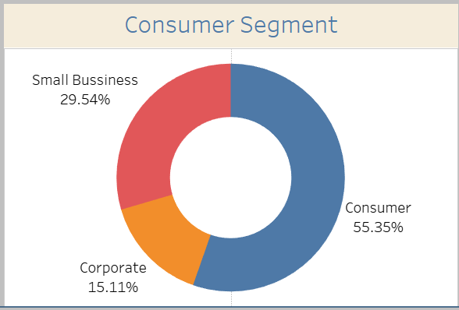

Ques 5: Which products have the highest customer satisfaction ratings, and what attributes contribute to this satisfaction?

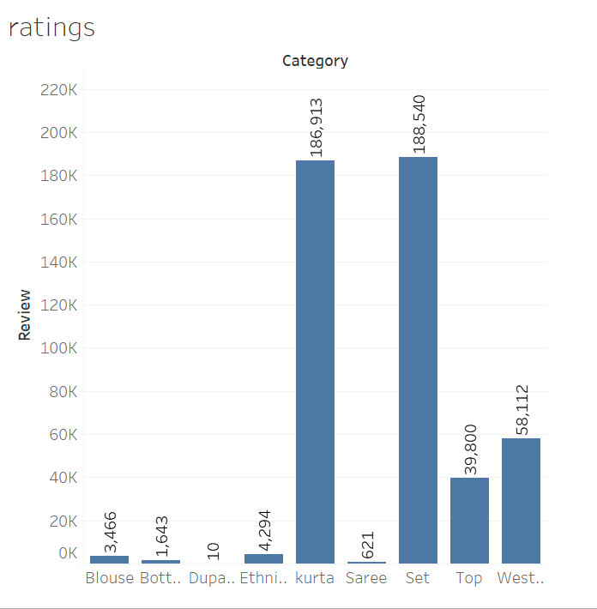

Dashboard

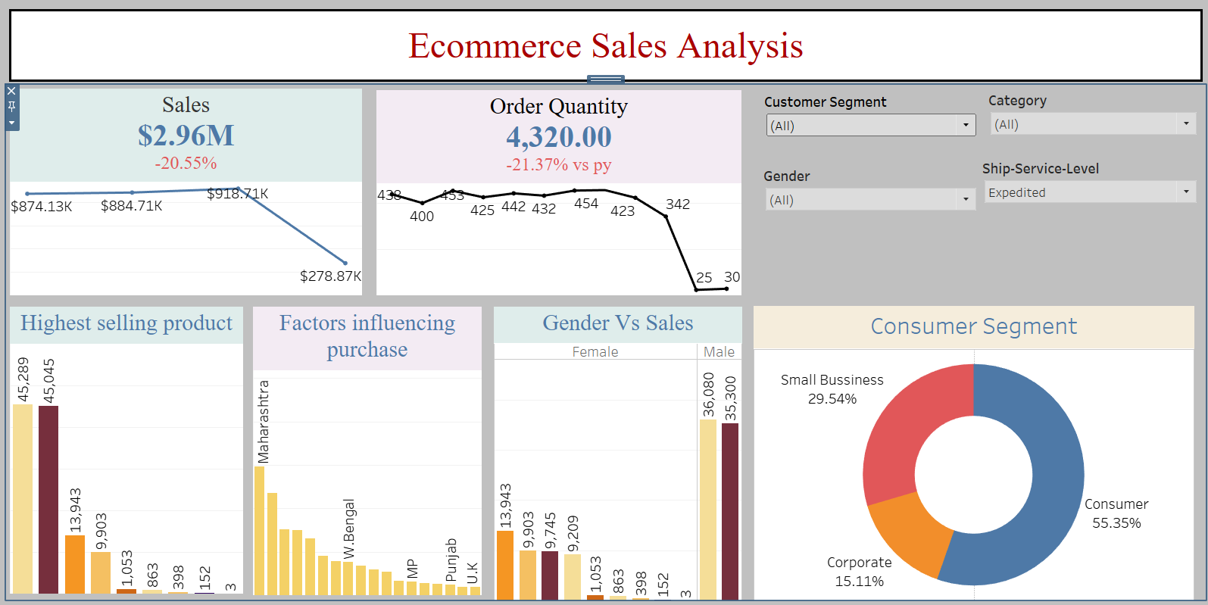

References

[E-Commerce Sales Dataset (kaggle.com)](https://www.kaggle.com/datasets/thedevastator/unlock-profits-with-e-commerce-sales-data)