Report View:

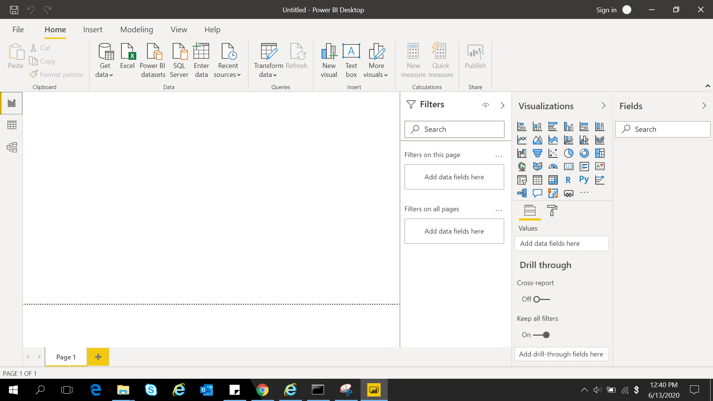

Data View:

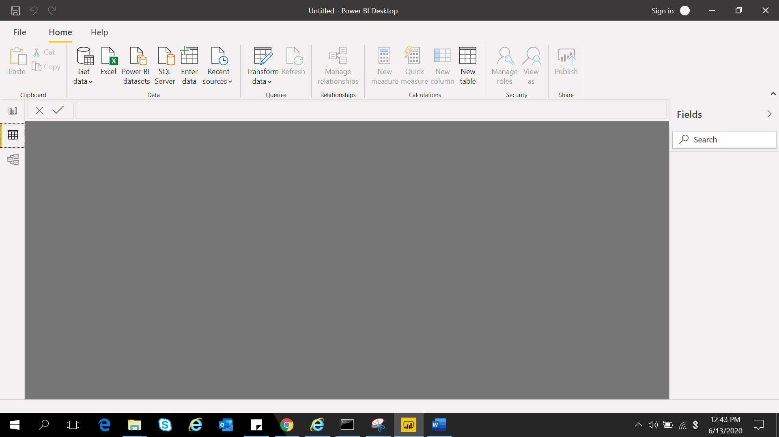

Model view:

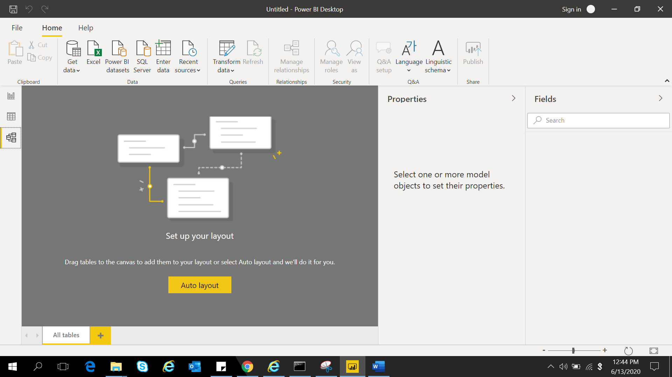

Power Query Editor:

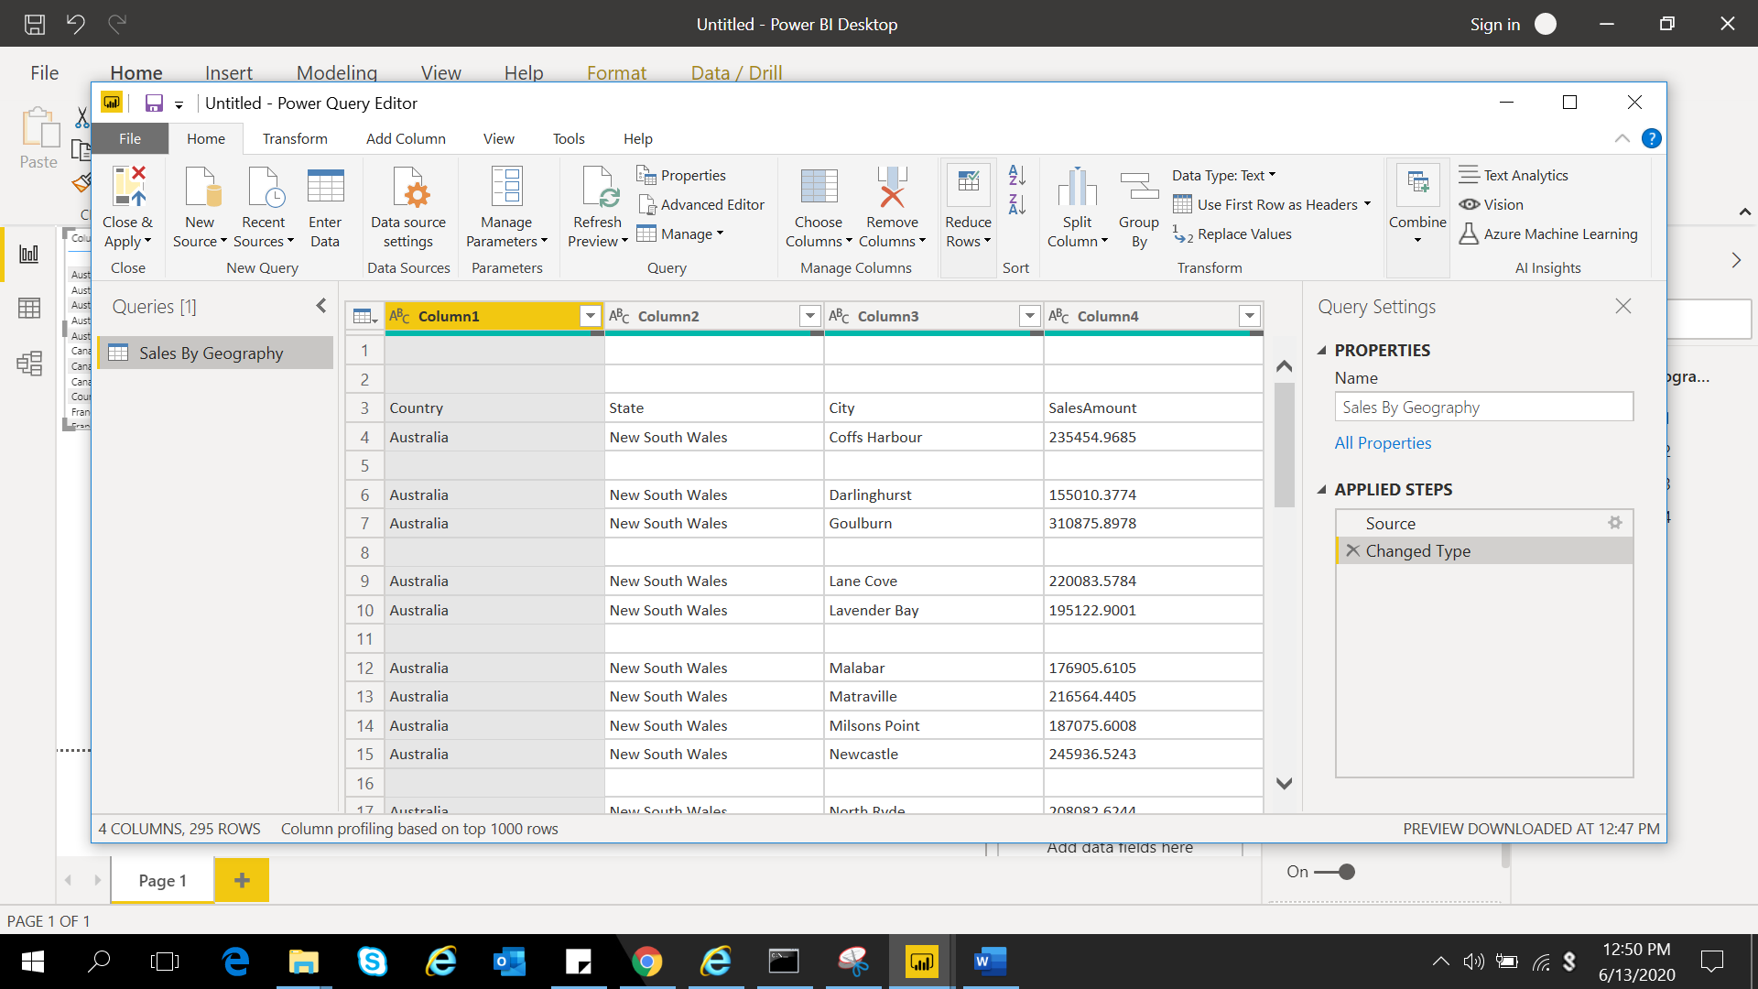

Advanced Editor:

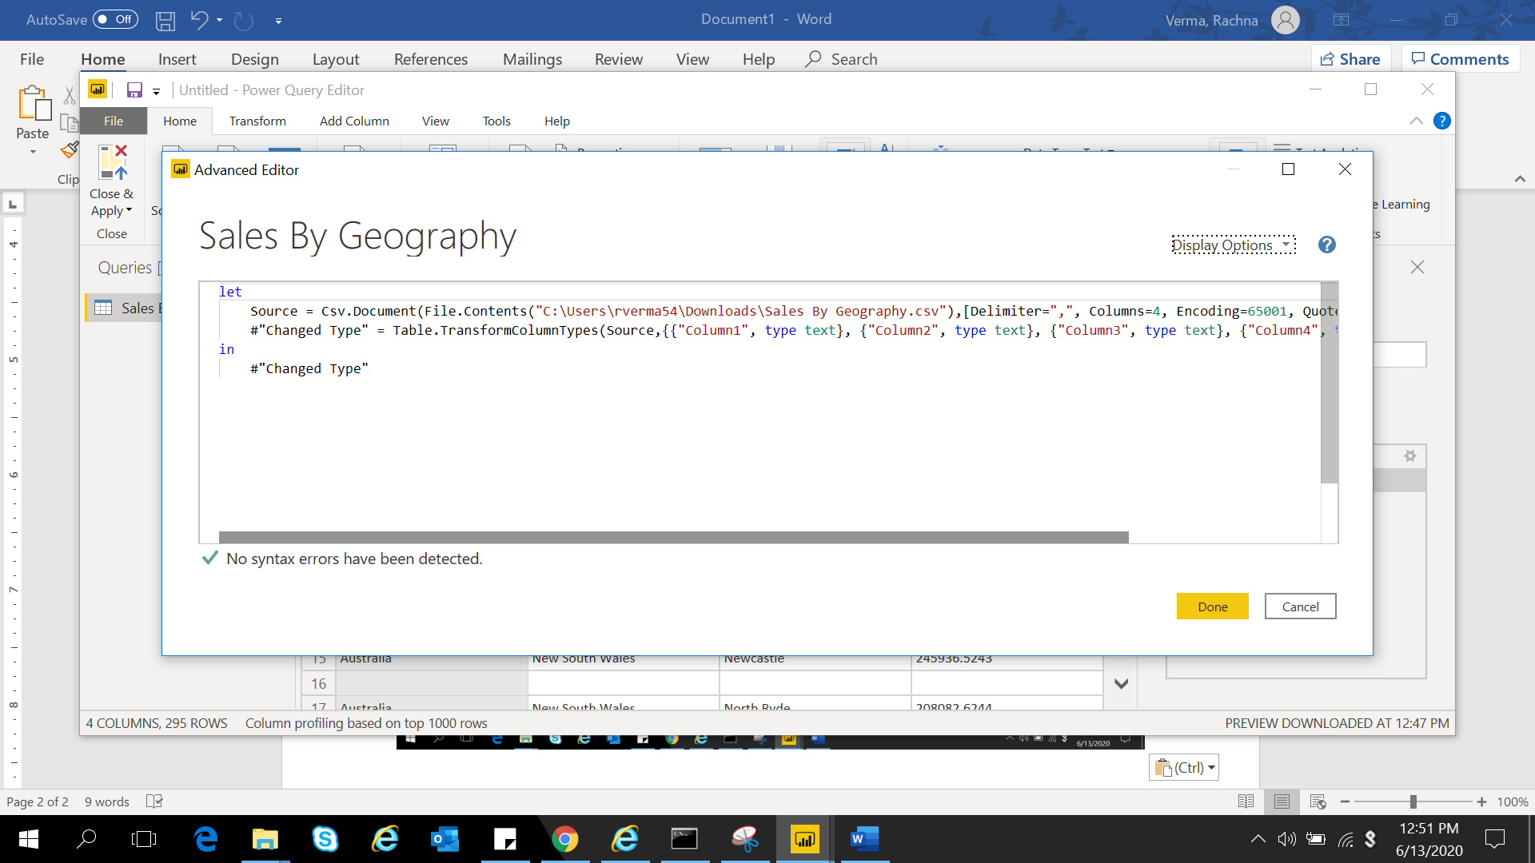

**Power BI Desktop**

Power BI Desktop is a free application that can be installed on our local computer. It lets one connect to, transform, and visualize one’s data. This data model lets us build visuals, and collections of visuals we can share as reports, with other people inside our organization.

**Power BI PRO**

Power BI Pro supports self-service and modern BI in the cloud. It can be used for collaboration, sharing and ad-hoc analysis. This is fully managed by Microsoft.

The monthly price per user for Power BI Pro is $9.99.

**Power BI Premium**

Premium version of Power is an Enterprise version. It is used for big data analytics, cloud and on-premises reporting. It provides advanced administration and deployment controls. It gives dedicated cloud compute and storage resources and allows any user to consume Power BI content.

Power BI Premium comes at a price of $4,995 per dedicated cloud compute and storage resource with annual subscription.