1. curl -i -H accept:application/json -H content-type:application/json -XPOST --user neo4j:cscie63 http://localhost:7474/db/data/transaction/commit -d '{"statements":[{"statement":"CREATE (matrix1:Movie {title:\"'"The Matrix"'\" , year:\"'1999-03-31'\" }) return id(matrix1)"},{"statement":"CREATE (matrix2:Movie {title:\"'"The Matrix Reloaded"'\" , year:\"'2003-05-07'\" }) return id(matrix2)"},{"statement":"CREATE (matrix3:Movie {title:\"'"The Matrix Revolutions"'\",year:\"'2003-10-27'\" }) return id(matrix3)"},{"statement":"CREATE (keanu:Actor {name:\"'"Keanu Reeves"'\" }) return id(keanu)"},{"statement":"CREATE (laurence:Actor {name:\"'"Laurence Fishburne"'\"})"},{"statement":"CREATE (carrieanne:Actor {name:\"'"Carrie-Anne Moss"'\" })"},{"statement":"CREATE (keanu)-[:ACTS_IN{ role:\"'"Neo"'\" }]->(matrix1)"},{"statement":"CREATE (keanu)-[:ACTS_IN {role:\"'"Neo"'\" }]->(matrix2)"}, {"statement":"CREATE (keanu)-[:ACTS_IN { role : \"'"Neo"'\"}]->(matrix3)"},{"statement":"CREATE (laurence)-[:ACTS_IN { role : \"'"Morpheus"'\" }]->(matrix1)"},{"statement":"CREATE (laurence)-[:ACTS_IN { role : \"'"Morpheus"'\" }]->(matrix2)"},{"statement":"CREATE (laurence)-[:ACTS_IN {role:\"'"Morpheus"'\" }]->(matrix3)"},{"statement":"CREATE (carrieanne)-[:ACTS_IN { role : \"'"Trinity"'\" }]->(matrix1)"}]}

( screenshot below)

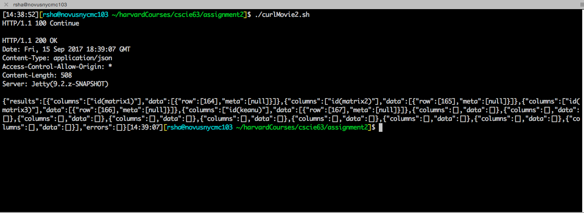

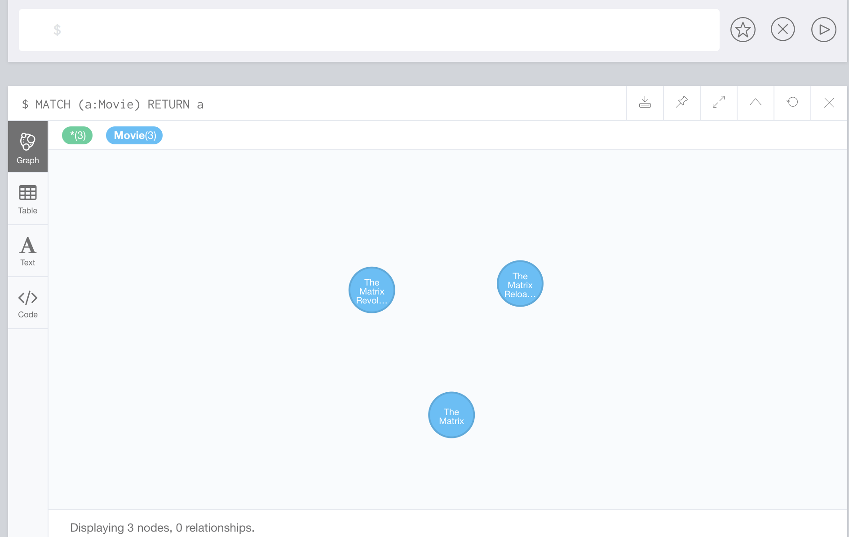

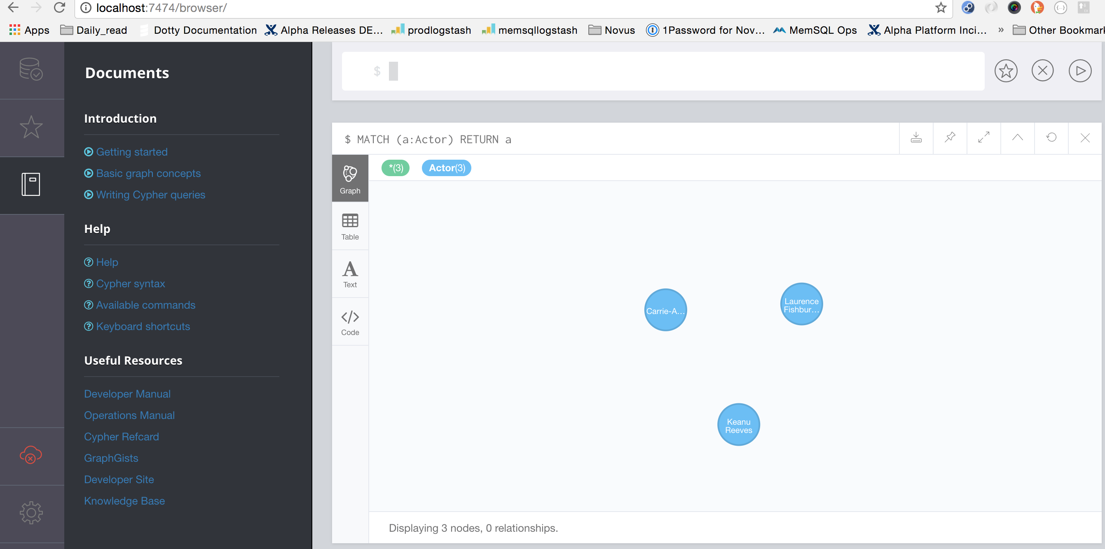

2.

curl -i -H accept:application/json -H content-type:application/json -XPOST --user neo4j:cscie63 http://localhost:7474/db/data/transaction/commit -d \

'{"statements":[{"statement":"CREATE (jWick:Movie { title : "\"'John Wick'"\"}) return id(jWick)} \

,{"statement":"CREATE (cStahelski:Director { name:"\"'Chad Stahelski'"\" }) return id(cStahelski)} \

,{"statement":"CREATE (dLeitct:Director { name:"\"'David Leitct'"\" }) return id(dLeitct)} \

,{"statement":"CREATE (wDafoe:Actor { name:"\"'William Dafoe'"\" }) return id(wDafoe)} \

,{"statement":"CREATE (mNyquist:Actor { name:"\"'Michael Nyquist'"\" }) return id(mNyquist)} \

,{"statement":"CREATE (keanu)-[:ACTS_IN]->(jWick)} \

,{"statement":"CREATE (wDafoe)-[:ACTS_IN]->(jWick)} \

,{"statement":"CREATE (mNyquist)-[:ACTS_IN]->(jWick)}]}'

3. Screenshots attached

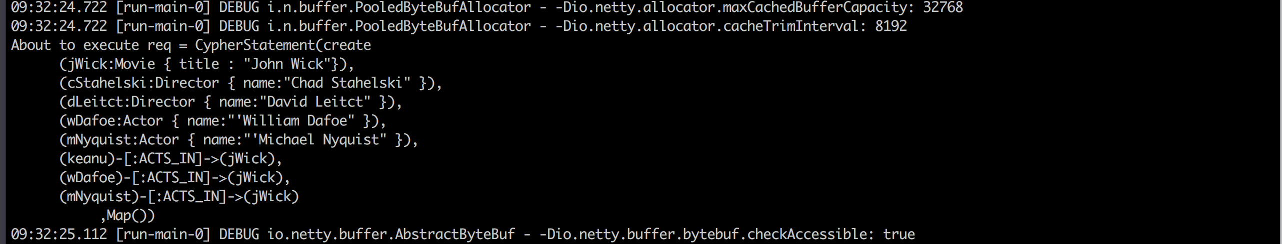

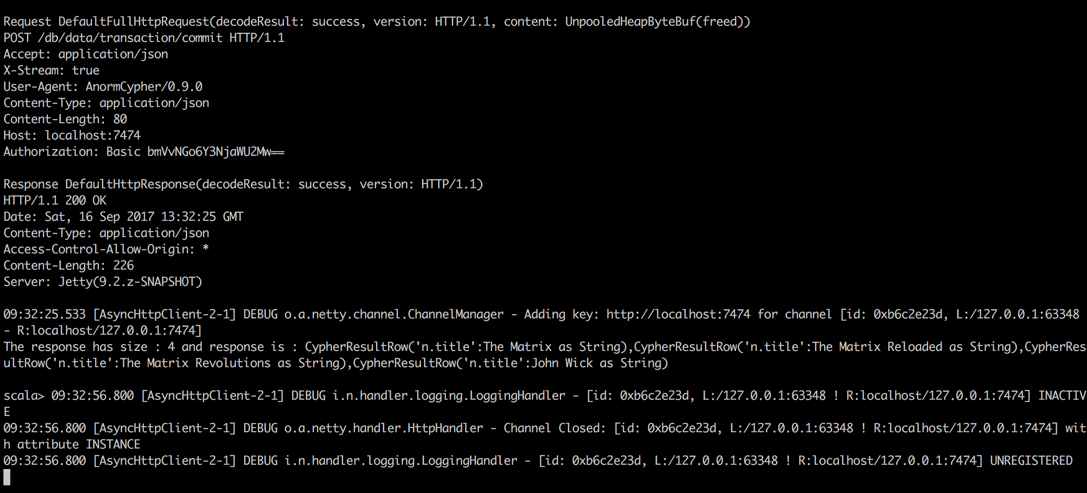





4.