**Step 1:** Right click on “SEB.Rmd” and save to a folder. If you have issues downloading as a ‘.Rmd’ file, try using Google Chrome as your web browser. Navigate to that folder, double click “SEB.Rmd” to open. RStudio should open. NOTE: need to have R and RStudio installed first.

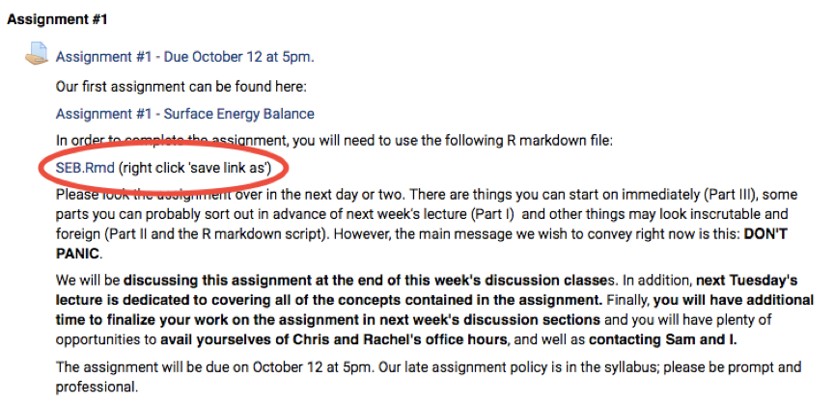

**Step2:** Type in the console window:

**install.packages(‘rootSolve’)** Hit enter.

**Install.packages(‘knitr’)** Hit enter.

You only have to do this once. You will not have to do this anytime you reopen rstudio, the rest however will not be “saved.” If you do it correctly you’ll see:

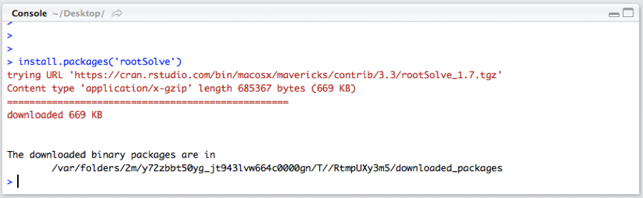

**Step3:** Click this green arrow to the “chunk,” which is the section in grey

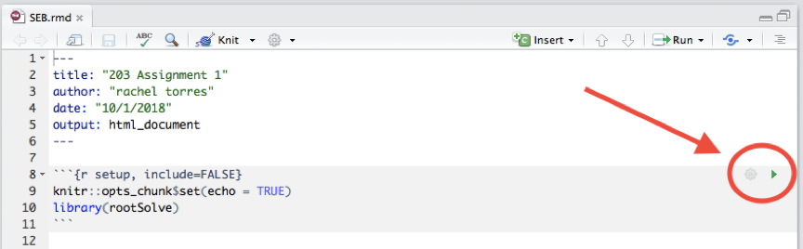

**Step 4:** Change the appropriate parameters in this chunk and then press the green arrow to run.

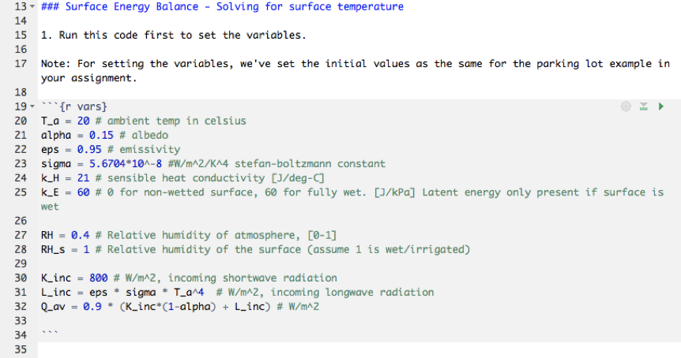

**Step 5:** Run the last chunk to get Ts, by pressing the green arrow

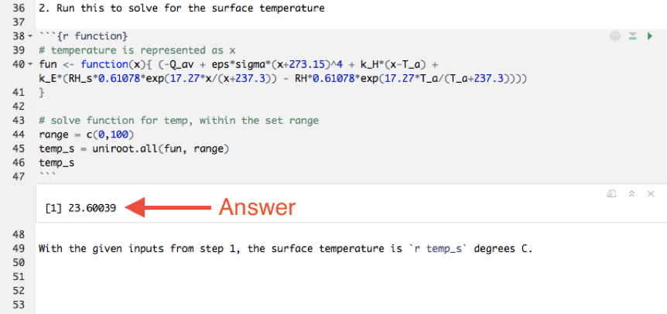

**Step 6:** Plug and chug! Keep changing the parameters in the “r vars” (step4), click run for that section, then go to the lower section and press run again for Ts (step 5). Then you have to figure out what do to for Part II #4. Good luck!